Exercise 4: ETL Pipeline with DataFrames using Apache Spark

1. Objective
- To build a complete ETL (Extract, Transform, Load) pipeline using Apache Spark DataFrames.
- To perform joins between multiple datasets.
- To calculate customer lifetime value using aggregation functions.
- To apply window functions for ranking and running totals.
- To implement advanced ETL pipeline challenges using Spark.

2. Procedure

Exercise 4: ETL Pipeline with DataFrames
- Create a Spark Session using SparkSession.builder.appName().getOrCreate().
- Read the customers.csv, orders.csv, and products.csv files into Spark DataFrames.
- Join the customer, order, and product datasets using common keys.
- Calculate the customer lifetime value by computing the total amount spent, number of orders, and average order value.
- Rank customers based on their total spending using the row_number() window function.
- Calculate the running total of customer spending using window functions.
- Save the processed results into the output directory.
- Stop the Spark Session after successful execution.

Challenge 1: Build a Complete Sales Dashboard Pipeline
- Read the customer, order, and product datasets.
- Join all datasets into a single DataFrame.
- Calculate the total revenue.
- Generate product-wise revenue.
- Generate customer-wise revenue.
- Generate city-wise revenue.
- Display the dashboard analysis.
- Stop the Spark Session.

Challenge 2: Implement Data Quality Checks
- Read all datasets into DataFrames.
- Check each dataset for null values.
- Count duplicate records in every dataset.
- Remove duplicate records using dropDuplicates().
- Create cleaned datasets for further processing.
- Display the quality check results.
- Stop the Spark Session.

Challenge 3: Create Materialized Views for Common Queries
- Read and join the customer, order, and product datasets.
- Generate customer summary statistics.
- Generate product summary statistics.
- Save the summaries as materialized views in the output directory.
- Display the generated summaries.
- Stop the Spark Session.

Challenge 4: Handle Slowly Changing Dimensions (SCD)
- Read the existing customer dimension data.
- Create updated customer records.
- Apply Slowly Changing Dimension (Type-1) by replacing existing records with updated values.
- Display the updated customer dimension.
- Save the updated customer dimension to the output directory.
- Stop the Spark Session.

3. Screenshots

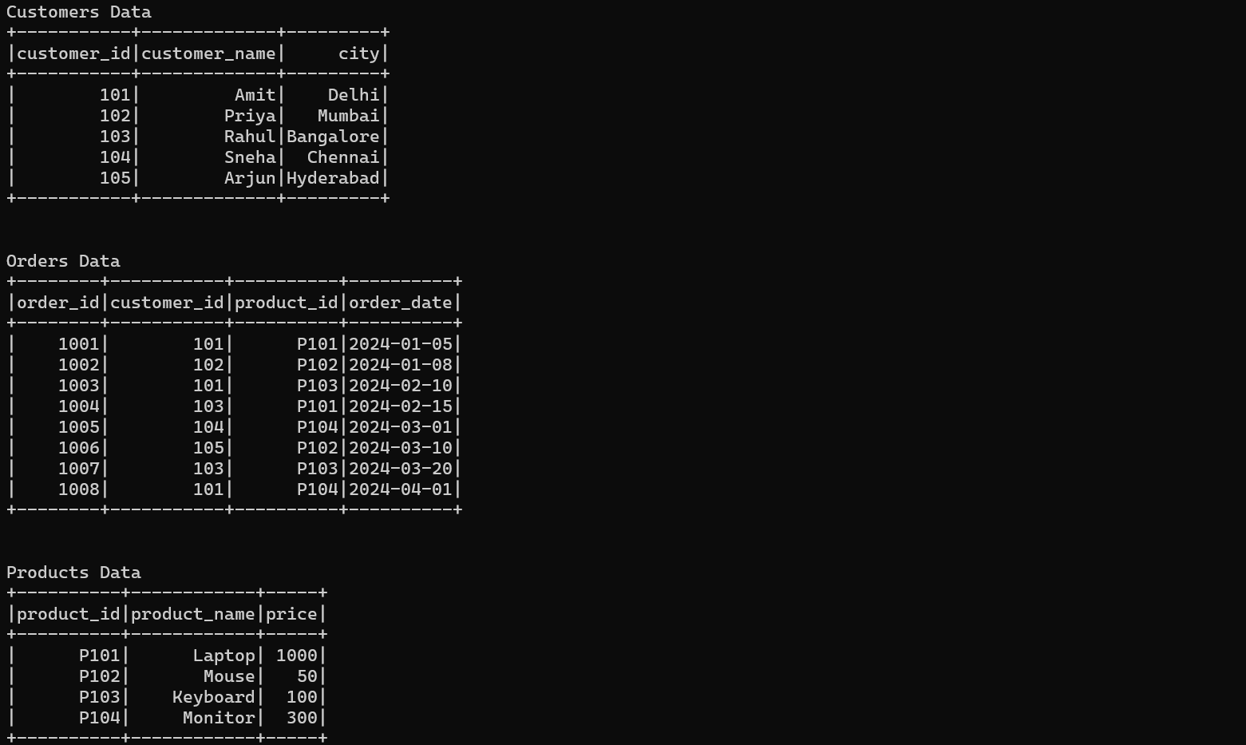
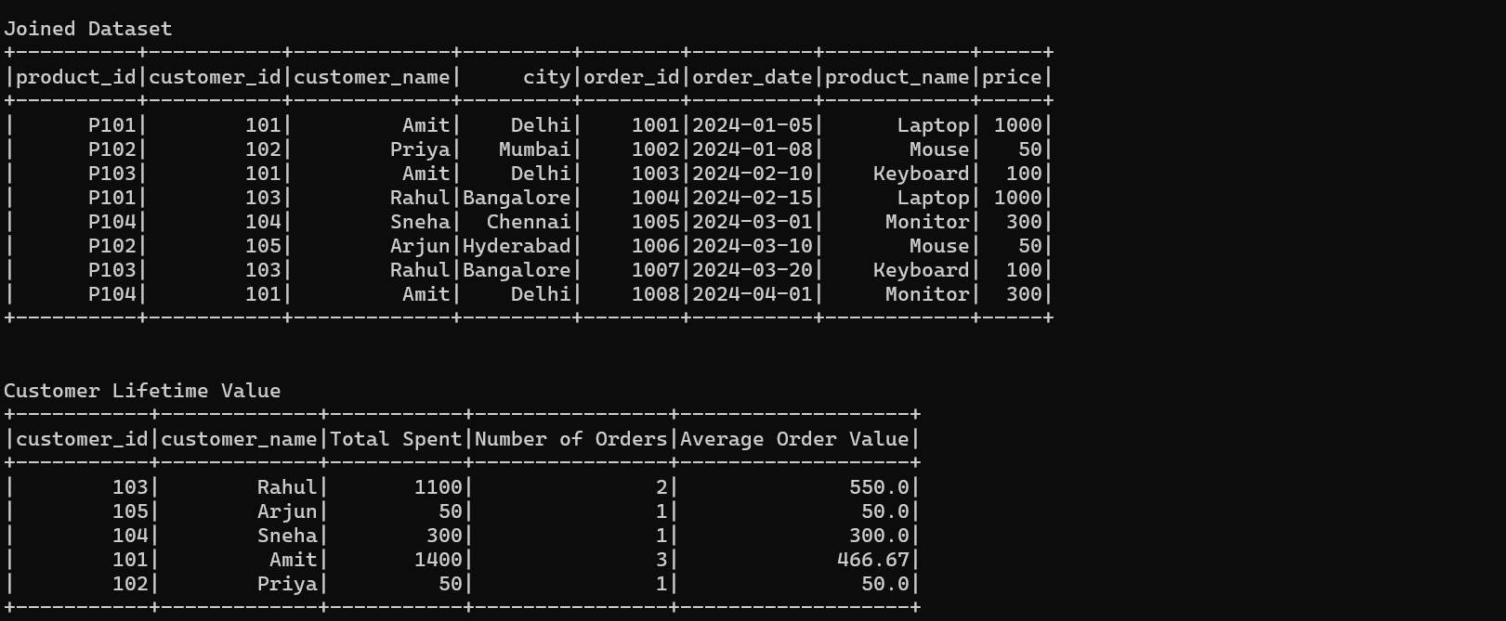
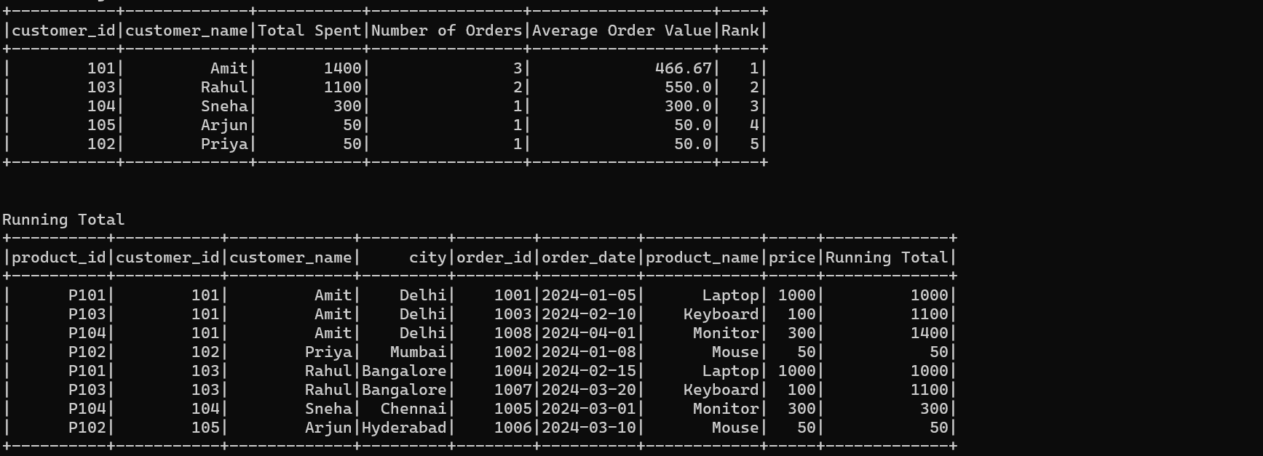
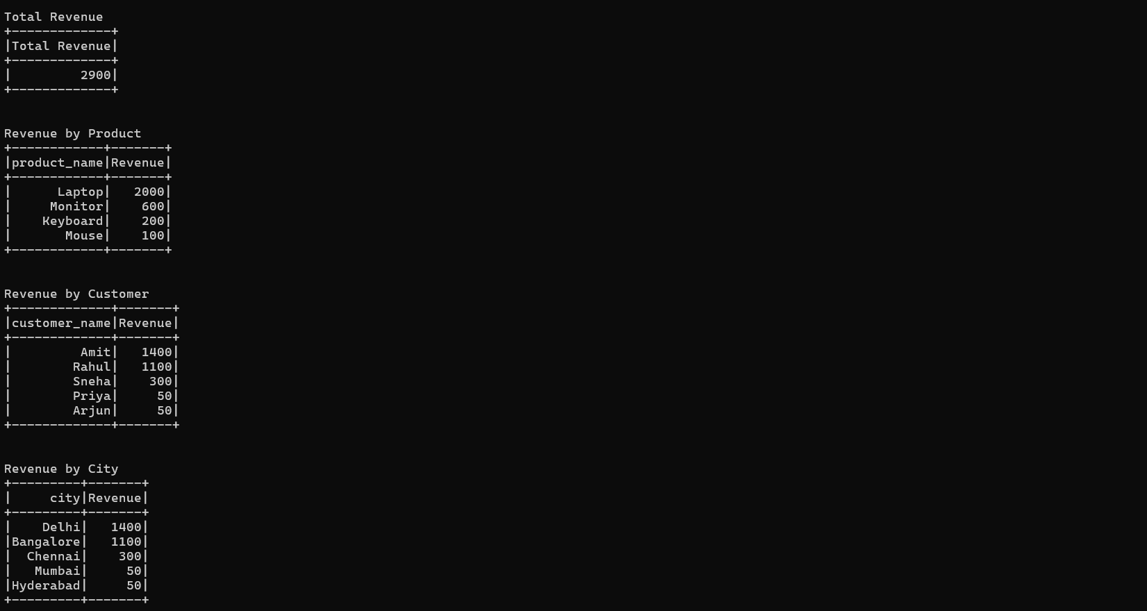
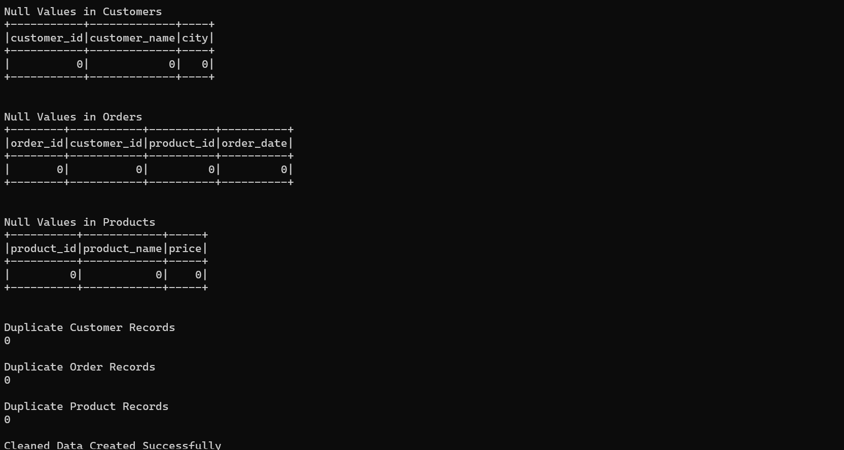
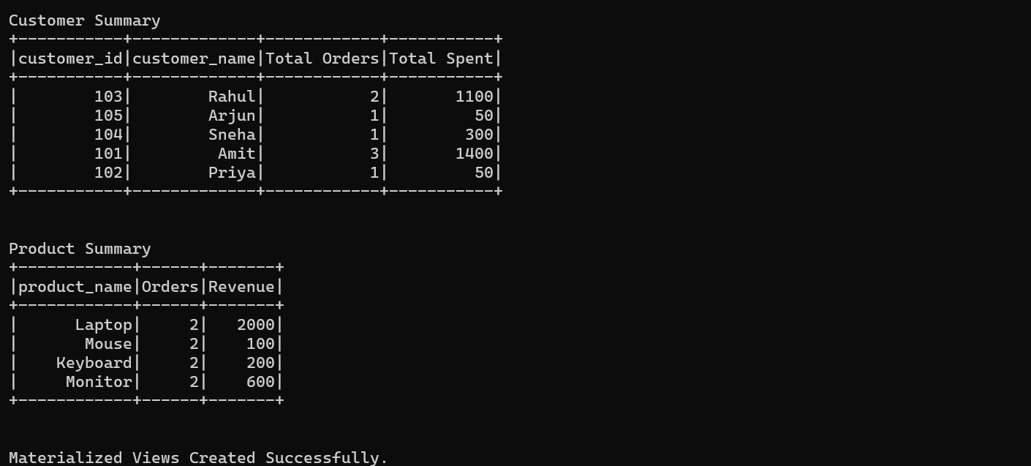
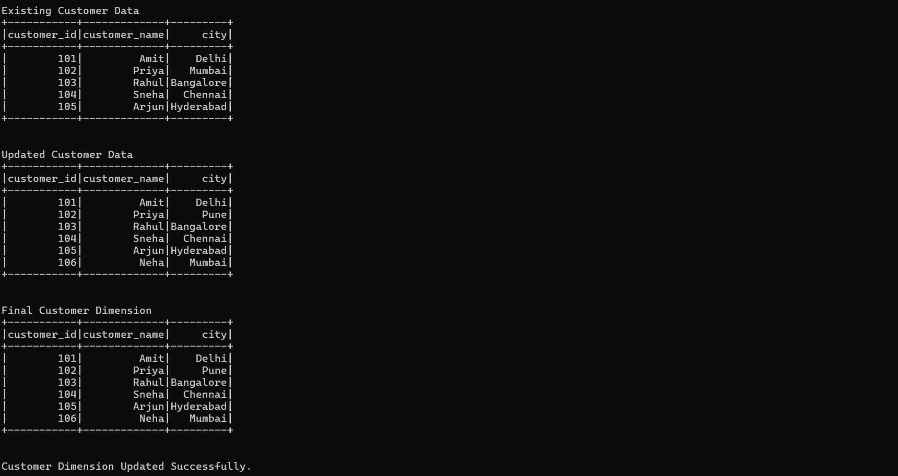

4. Conclusion
The ETL Pipeline exercise demonstrated how Apache Spark DataFrames can be used to build a complete Extract, Transform, and Load workflow. The exercise successfully integrated multiple datasets, performed joins, calculated customer lifetime value, applied window functions for ranking and running totals, and stored the processed results. The challenge tasks enhanced the ETL pipeline by implementing a sales dashboard, performing data quality checks, creating materialized views, and handling Slowly Changing Dimensions. This exercise provided practical knowledge of scalable data transformation and analytics using Apache Spark.

