Mahiransh Sharma

Fetching data from json web page in Android (Volley Library)

private void category_parseJSON() {  
  
 String url = "";  
  
 if(saveSharedPreference.getUserName(context).length() > 1)  
 {  
 String url1 = "https://martdk.com/application/welcome_category.html?user=";  
 url = url1.concat(saveSharedPreference.getUserName(context));  
 }  
 else  
 {  
 Toast.makeText(context, "Error occur in category_parseJSON()", Toast.LENGTH_SHORT).show();  
 }  
  
 JsonObjectRequest request = new JsonObjectRequest(Request.Method.POST, url, null, new Response.Listener<JSONObject>() {  
 @Override  
 public void onResponse(JSONObject response) {  
 try{  
 JSONObject jsonObject = new JSONObject(String.valueOf(response));  
 String success = jsonObject.getString("success");  
 if(jsonObject.getString("cartCount").equals("0"))  
 {  
 CountLayout.setVisibility(GONE);  
 }  
 if(jsonObject.getString("cartCount").equals(null))  
 {  
 CountLayout.setVisibility(GONE);  
 }  
 CartCount.setText(jsonObject.getString("cartCount"));  
 if(success.equalsIgnoreCase("1")) {  
 JSONArray jsonArray = response.getJSONArray("data");  
 final int[] arr_cat_id = new int[jsonArray.length()];  
 for (int i = 0; i < jsonArray.length(); i++)  
 {  
 JSONObject hit = jsonArray.getJSONObject(i);  
 String image_url_1 = hit.getString("image");  
 String image_url_2 = "https://martdk.com/image_category/";  
 String image = image_url_2.concat(image_url_1);  
 int id_for_arr = hit.getInt("id");  
 arr_cat_id[i] = id_for_arr;  
 String name = hit.getString("name");  
  
 welcomeItemArrayList.add(new WelcomeItem(image,name));  
 welcomeAdapter = new WelcomeAdapter(MainActivity.this, welcomeItemArrayList);  
 recyclerView.setAdapter(welcomeAdapter);  
  
 welcomeAdapter.setOnItemClickListener(new WelcomeAdapter.OnItemClickListener() {  
 @Override  
 public void onCatClick(int position) {  
 CategoryActivity.setCatId(arr_cat_id[position]);  
 startActivity(new Intent(MainActivity.this,CategoryActivity.class));  
 }  
 } );  
 }  
  
 }  
 }  
 catch(JSONException e)  
 {  
 e.printStackTrace();  
 }  
 }  
 }, new Response.ErrorListener() {  
 @Override  
 public void onErrorResponse(VolleyError error) {  
 error.printStackTrace();  
 }  
 });  
  
 RequestQueue requestQueue = Volley.newRequestQueue(MainActivity.this) ;  
 requestQueue.add(request);  
}

Output of above code look like this:

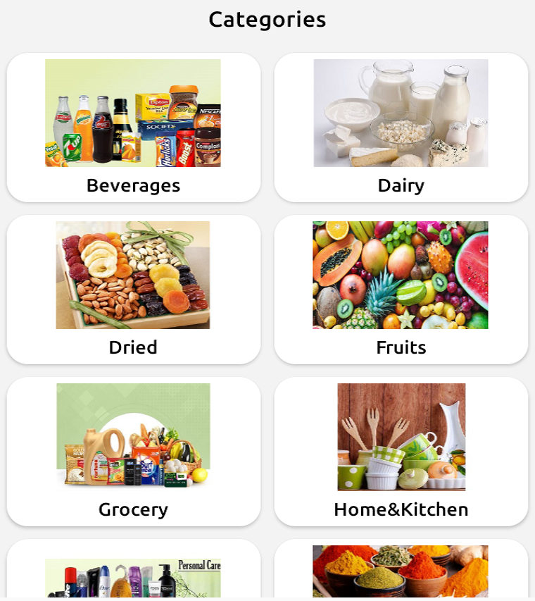

The node generated json file of above output looks like this:

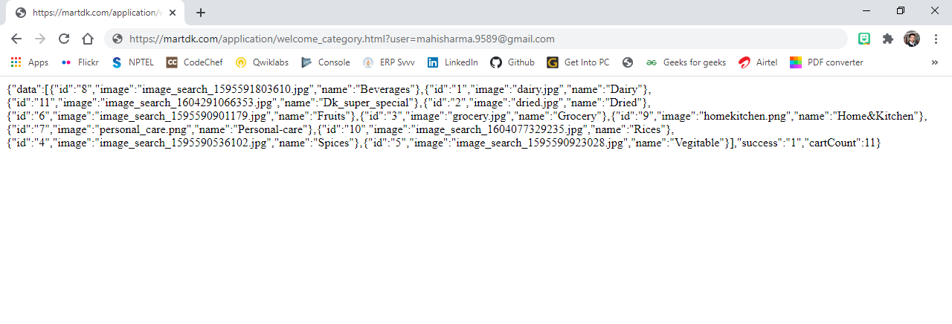

Now code on server side

Server.js file:

const express = require('express')  
const bodyParser= require('body-parser')  
const MongoClient = require('mongodb').MongoClient  
const app = express()  
const url = '***://*****/category';  
  
app.use(bodyParser.urlencoded({ extended: true }))  
app.listen(***)  
  
app.get('/welcome_category.html',(req, res) => {  
 res.sendFile(__dirname+ '/welcome_category.html')  
})  
  
const dbName = '****-***'  
let db  
  
MongoClient.connect(url, { useNewUrlParser: true, useUnifiedTopology: true }, (err, client) => {  
 if (err) return console.log(err)  
  
 db = client.db(dbName)  
 console.log(`Connected MongoDB: ${url}`)  
 console.log(`Database: ${dbName}`)  
})  
  
app.post('/welcome_category.html', (req, res) => {  
 MongoClient.connect(url,{ useNewUrlParser: true, useUnifiedTopology: true }, function(err, client) {  
 if (err) throw err  
 var operationDB = client.db(dbName)  
 operationDB.collection("****").find({}).toArray(function(err, result) {  
 if (err) throw err  
 client.close()  
 })  
 })  
 res.status(200).send(result)  
})