## Experiment: 1

## Aim: To Study About Android

## Introduction to Android.

Android is an open source and Linux-based Operating System for mobile devices such as smartphones and tablet computers. Android was developed by the *Open Handset Alliance*, led by Google, and other companies.

Android offers a unified approach to application development for mobile devices which means developers need only develop for Android, and their applications should be able to run on different devices powered by Android.

The first beta version of the Android Software Development Kit (SDK) was released by Google in 2007 where as the first commercial version, Android 1.0, was released in September 2008.

The source code for Android is available under free and open source software licenses. Google publishes most of the code under the Apache License version 2.0 and the rest, Linux kernel changes, under the GNU General Public License version 2.

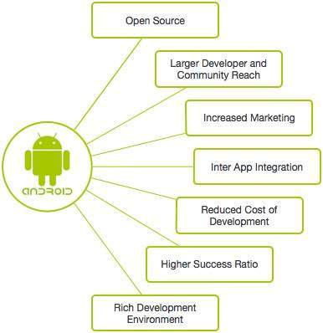

## Features of Android

Android is a powerful operating system competing with Apple 4GS and supports great features. Few of them are listed below –

|  |  |
| --- | --- |
| Sr.No. | Feature & Description |
| 1 | Beautiful UI  Android OS basic screen provides a beautiful and intuitive user interface. |
| 2 | Connectivity  GSM/EDGE, IDEN, CDMA, EV-DO, UMTS, Bluetooth, Wi-Fi, LTE, NFC and WiMAX. |
| 3 | Storage  SQLite, a lightweight relational database, is used for data storage purposes. |
| 4 | Media support  H.263, H.264, MPEG-4 SP, AMR, AMR-WB, AAC, HE-AAC, AAC 5.1, MP3, MIDI, Ogg Vorbis, WAV, JPEG, PNG, GIF, and BMP. |
| 5 | Messaging  SMS and MMS |
| 6 | Web browser  Based on the open-source WebKit layout engine, coupled with Chrome's V8 JavaScript engine supporting HTML5 and CSS3. |
| 7 | Multi-touch  Android has native support for multi-touch which was initially made available in handsets such as the HTC Hero. |
| 8 | Multi-tasking  User can jump from one task to another and same time various application can run simultaneously. |
| 9 | Resizable widgets  Widgets are resizable, so users can expand them to show more content or shrink them to save space. |
| 10 | Multi-Language  Supports single direction and bi-directional text. |
| 11 | GCM  Google Cloud Messaging (GCM) is a service that lets developers send short message data to their users on Android devices, without needing a proprietary sync solution. |
| 12 | Wi-Fi Direct  A technology that lets apps discover and pair directly, over a high-bandwidth peer-to-peer connection. |
| 13 | Android Beam  A popular NFC-based technology that lets users instantly share, just by touching two NFC-enabled phones together. |

# Android System Architecture

The Android software stack generally consists of a Linux kernel and a collection of C/C++ libraries that is exposed through an application framework that provides services, and management of the applications and run time.

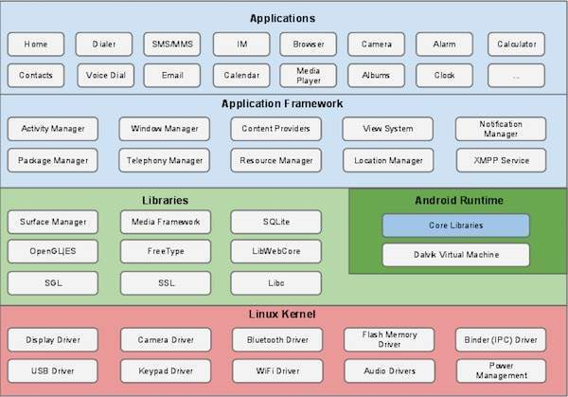

Linux Kernel:

Android was created on the open source kernel of Linux. One main reason for choosing this kernel was that it provided proven core features on which to develop the Android operating system. The features of Linux kernel are:

## Security:

The Linux kernel handles the security between the application and the system.

## Memory Management:

It efficiently handles the memory management thereby providing the freedom to develop our apps.

## Process Management:

It manages the process well, allocates resources to processes whenever they need them.

## Network Stack:

It effectively handles the network communication.

## Driver Model:

It ensures that the application works. Hardware manufacturers can build their drivers into the Linux build.

# Libraries:

Running on the top of the kernel, the Android framework was developed with various features. It consists of various C/C++ core libraries with numerous of open source tools. Some of these are:

## The Android runtime:

The Android runtime consist of core libraries of Java and ART(the Android RunTime). Older versions of Android (4.x and earlier) had Dalvik runtime.

## Open GL (graphics library):

This cross-language, cross-platform application program interface (API) is used to produce 2D and 3D computer graphics.

## WebKit:

This open source web browser engine provides all the functionality to display web content and to simplify page loading.

## Media frameworks:

These libraries allow you to play and record audio and video.

## Secure Socket Layer (SSL):

These libraries are there for Internet security.

# Android Runtime:

It is the third section of the architecture. It provides one of the key components which is called Dalvik Virtual Machine. It acts like Java Virtual Machine which is designed especially for Android. Android uses its own custom VM designed to ensure that multiple instances run efficiently on a single device.

The Delvik VM uses the device’s underlying Linux kernel to handle low-level functionality, including security, threading and memory management.

# Application Framework

The Android team has built on a known set proven library, built in the background, and all of it these is exposed through Android interfaces. These interfaces warp up all the various libraries and make them useful for the Developer. They don’t have to build any of the functionality provided by the android. Some of these interfaces include:

## Activity Manager:

It manages the activity lifecycle and the activity stack.

## Telephony Manager:

It provides access to telephony services as related subscriber information, such as phone numbers.

## View System:

It builds the user interface by handling the views and layouts.

## Location manager:

It finds the device’s geographic location.

## Categories of Android applications

There are many android applications in the market. The top categories are –

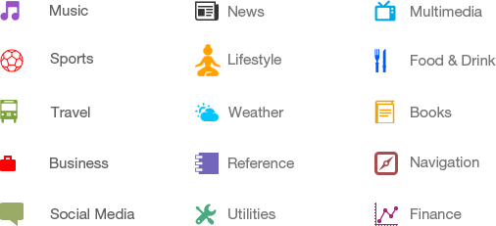

Music:

Music is an art form and cultural activity whose medium is sound organized in time. General definitions of music include common elements such as pitch rhythm. On this category we are able to create an android application.

News:

News is information that is published in newspapers and broadcast on radio and television about recent events in the country or world or in a particular area of activity. On this category we are able to create an android application.

Multimedia:

Multimedia is content that uses a combination of different content forms such as text, audio, images, animations, video and interactive content. The application is to be use to read and write those content formats.

Sports:

Sport (or sports) is all forms of usually competitive physical activity which, through casual or organized participation, aim to use, maintain or improve physical ability and skills while providing entertainment to participants, and in some cases, spectators. On this category, we are able to create analysis of sport, information of sport etc.

Lifestyle:

A way of living of individuals, families (households), and societies, which they manifest in coping with their physical, psychological and social. We are able to create improving lifestyle application.

Food and Drink:

We are able to create locating the food stall near us on map using framework.

Travel:

We are able to create locating the travelling as well the booking information near us on map using framework.

Weather:

We are able to create the information of weather as temperature, humidity etc. using framework.

Books:

The offline online as well as offline book are also available to read and analysis the data.

Business:

The business purpose application for calculating the data, analysis the products or goods in store etc.

Reference:

To refer something attached with one another. For e.g. refer a mobile compare its online price etc.

Navigation:

To navigate us on proper location where we are also able to get current as well as the destination location with path.

Social media:

To communicate with our boss, friends, relatives or colleague with in formal or informal manner.

Utility:

Some kind of utility application are also created in android. For e.g. taxi booking system.

Finance:

To define the financial analysis of company or institute.