## Experiment: 1

## Aim: To study about BIOS and layers of an operating system.

## BIOS

BIOS stand for Basic Input Output System. It is built-in software. It is the first software run by the computer when you turned on your computer system. This software is usually stored in Read Only Memory (ROM) and located on the motherboard. In modern computer systems, the BIOS contents are stored in a flash memory. It is not possible for an operating system to continue without BIOS as it is the BIOS that loads the drivers of the hard disk and primary portions of the operating system like MBR, FAT, GPT etc, into the memory to enable the operating system to continue loading itself.

When you turn on the computer, BIOS instructions are initiated. These instructions make it check the RAM and the Processor (for faults) on your computer.

1. It enumerates the RAM by checking each compartment to see if all of them are working.
2. After checking out RAM and Processor, it checks for other devices attached to the computer
3. It detects all the peripherals, including the keyboard and mouse and then checks for the boot options
4. Boot options are checked in the sequence configured in your BIOS: Boot from CD-ROM, Boot from Hard Drive, Boot from LAN, etc.
5. It checks for bootstraps on the devices in the order you or the machine vendor configured the BIOS.
6. It passes reigns of the computer to the operating system by loading the essential parts of the OS into the random-access memory (RAM) reserved for the OS, after bootstrap is located.

**The four main functions of a PC BIOS**

* **POST** - Test the computer [hardware](https://www.computerhope.com/jargon/h/hardware.htm) and make sure no errors exist before loading the operating system. Additional information on the POST is available on our [POST and beep codes](https://www.computerhope.com/beep.htm) page.
* **Bootstrap Loader** - Locate the [operating system](https://www.computerhope.com/jargon/o/os.htm). If a capable operating system is located, the BIOS will pass control to it.
* **BIOS drivers** - Low-level drivers that give the computer basic operational control over your computer's hardware.
* **BIOS setup** or **CMOS setup** - Configuration program that allows you to configure hardware settings including system settings such as computer passwords, time, and date.

## Experiment: 2

**Aim**: Case study on layered architecture of operating system.

# Layered Operating System

The operating system is split into various layers in the layered operating system and each of the layers has different functionalities. This type of operating system was created as an improvement over the early monolithic systems.

Layers in Layered Operating System

There are six layers in the layered operating system. A diagram demonstrating these layers is as follows:

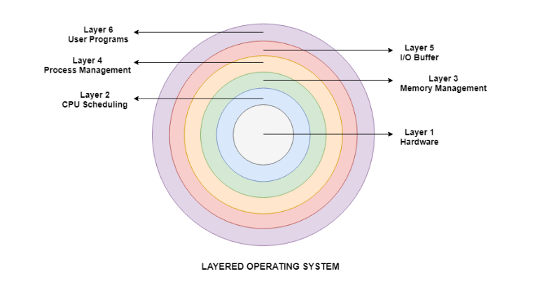

Details about the six layers are:

Hardware

This layer interacts with the system hardware and coordinates with all the peripheral devices used such as printer, mouse, keyboard, scanner etc. The hardware layer is the lowest layer in the layered operating system architecture.

CPU Scheduling

This layer deals with scheduling the processes for the CPU. There are many scheduling queues that are used to handle processes. When the processes enter the system, they are put into the job queue. The processes that are ready to execute in the main memory are kept in the ready queue.

Memory Management

Memory management deals with memory and the moving of processes from disk to primary memory for execution and back again. This is handled by the third layer of the operating system.

Process Management

This layer is responsible for managing the processes i.e. assigning the processor to a process at a time. This is known as process scheduling. The different algorithms used for process scheduling are FCFS (first come first served), SJF (shortest job first), priority scheduling, round-robin scheduling etc.

I/O Buffer

I/O devices are very important in the computer systems. They provide users with the means of interacting with the system. This layer handles the buffers for the I/O devices and makes sure that they work correctly.

User Programs

This is the highest layer in the layered operating system. This layer deals with the many user programs and applications that run in an operating system such as word processors, games, browsers etc.