Evaluating the Impact of the UK National Living Wage on Youth Employment
A Difference-in-Differences analysis using UK Labour Force Survey longitudinal data, 2013-2018

Executive Summary
This project evaluates whether the introduction of the UK National Living Wage (NLW) in April 2016 affected employment outcomes for young workers aged 18-24. The policy raised the wage floor for workers aged 25 and above, creating a useful setting to examine whether employers changed their demand for younger workers who were not directly covered by the new rate. Using Labour Force Survey Two-Quarter Longitudinal data from 2013-2015 and 2017-2018, the analysis applies a Difference-in-Differences design comparing young workers with workers aged 25-64 before and after the policy change. The preferred specification finds no evidence that the NLW reduced youth employment; instead, the controlled estimate suggests a small positive relative effect of approximately 2.1 percentage points. These findings should be interpreted cautiously because the design relies on the parallel trends assumption and because some potentially relevant controls, such as region, were limited by missing data.

Research Question
What effect did the introduction of the UK National Living Wage in April 2016 have on employment among workers aged 18-24?

Policy Context
The National Living Wage was introduced in April 2016 and initially applied to workers aged 25 and above. This age threshold created a potential substitution channel: employers facing higher wage costs for older workers may have adjusted hiring decisions toward or away from younger workers. The expected effect on youth employment was therefore theoretically ambiguous. On one hand, younger workers could have become relatively cheaper; on the other, minimum wage changes can affect overall labour demand in low-wage sectors. This project uses the policy threshold to evaluate the labour-market impact on workers aged 18-24.

Data
The analysis uses the UK Labour Force Survey Two-Quarter Longitudinal Datasets for 2013-2015 and 2017-2018. The 2016 data are excluded to avoid ambiguity around the policy introduction period. The outcome variable is a binary employment indicator based on ILO employment status. The treatment group is workers aged 18-24 and the comparison group is workers aged 25-64. The main controls are sex, marital status, education, ethnicity and disability status. Regional controls were not included in the preferred specification due to a high proportion of missing values.

Methodology
The analysis uses a Difference-in-Differences framework. The post-policy period is defined as 2017-2018, while the pre-policy period is 2013-2015. The key coefficient is the interaction between the post-policy indicator and the young-worker indicator. This coefficient estimates the differential change in employment for workers aged 18-24 relative to workers aged 25-64 after the NLW was introduced.
employed = beta0 + beta1 post + beta2 young + beta3(post x young) + epsilon
The baseline model includes only the treatment, time and interaction terms. The preferred model adds controls for observable characteristics that may affect employment independently of the policy. Standard errors are robust. The identification strategy relies on the parallel trends assumption: in the absence of the policy, youth and adult employment would have followed similar trajectories.

Main Results
The baseline model finds no statistically significant differential change in youth employment following the introduction of the NLW. After adding controls, the interaction coefficient becomes positive and statistically significant. The preferred estimate suggests that youth employment increased by approximately 2.1 percentage points relative to older workers after the policy was introduced.
Variable | Baseline | With Controls
Post | 0.0193***  (0.00181) | 0.0162***  (0.00166)
Young | -0.158***  (0.00402) | -0.191***  (0.00413)
Post x Young | 0.00885  (0.00687) | 0.0208***  (0.00670)
Observations | 261,983 | 260,410
R-squared | 0.0113 | 0.168
Note: Robust standard errors in parentheses. * p < 0.10, ** p < 0.05, *** p < 0.01.

Model Validity and Robustness
A formal pre-trends test using only pre-policy data fails to reject the null that the youth-year interactions are jointly zero, supporting the parallel trends assumption. The graphical pre-trends check also shows that youth and adult employment moved broadly in parallel before the policy change. The event study provides further support: the pre-2016 interaction terms are small and statistically insignificant, while the 2017 and 2018 interactions are positive and significant.
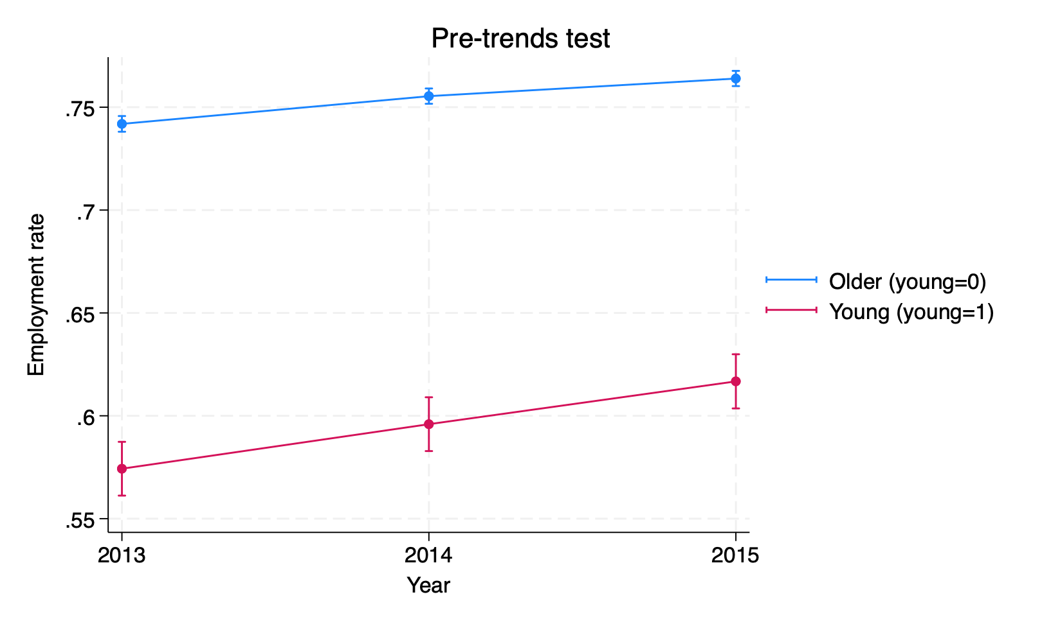
Figure 1. Pre-trends check for youth and older-worker employment rates.
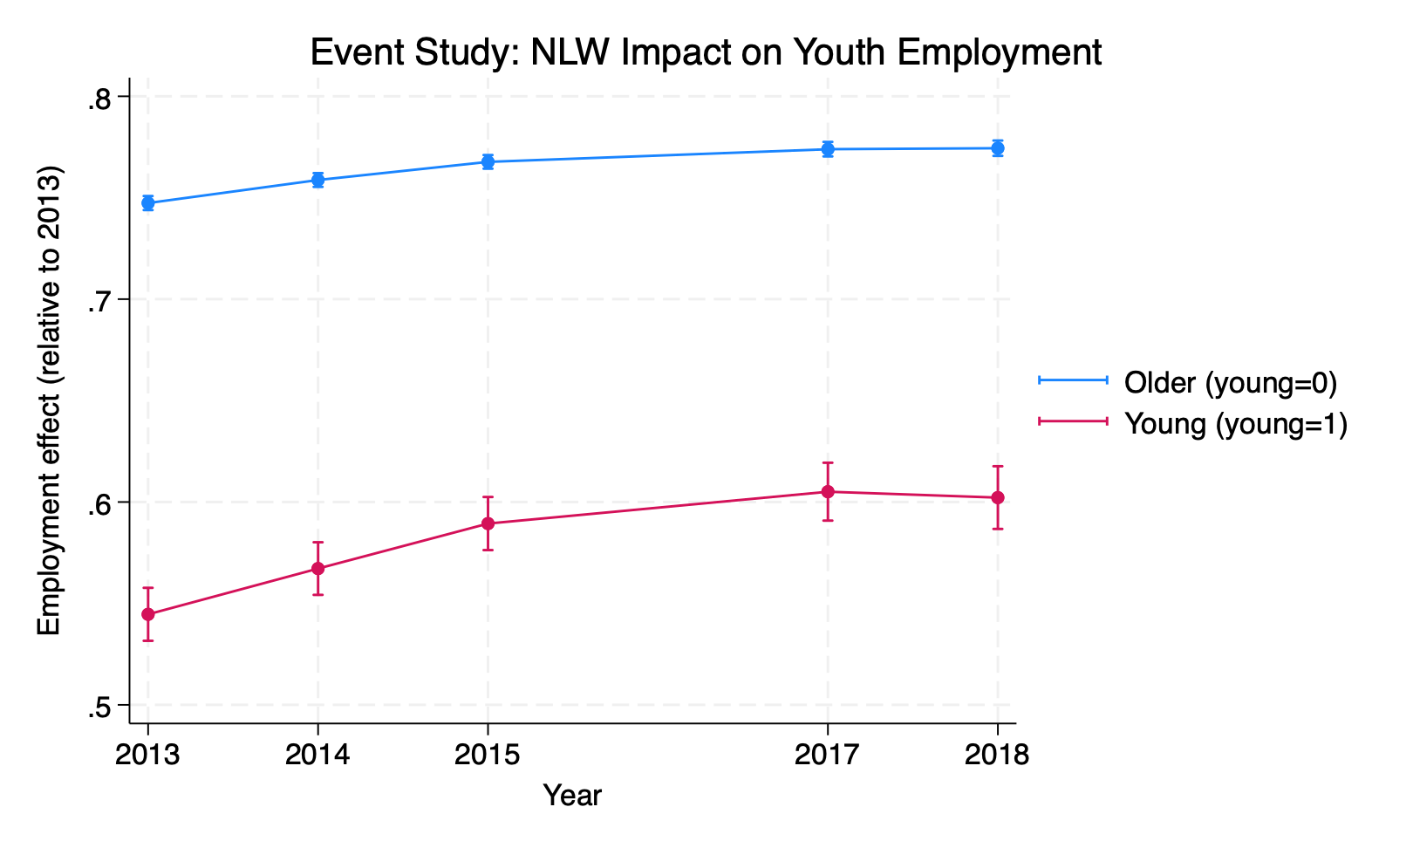
Figure 2. Event study plot of employment outcomes by age group over time.
Robustness checks indicate that the estimated effect remains positive across alternative specifications, including adding full-time or part-time status, narrowing the comparison group to workers aged 25-40, and simplifying the control set by excluding ethnicity.

Robustness Checks
Specification | FT/PT Controls | Age <= 40 Sample | Simplified Controls
Post x Young | 0.0105*  (0.00596) | 0.0131*  (0.00695) | 0.0198***  (0.00676)
Observations | 230,515 | 100,657 | 260,548
R-squared | 0.0673 | 0.184 | 0.163
Note: Robust standard errors in parentheses. * p < 0.10, ** p < 0.05, *** p < 0.01.

Interpretation
The results do not support the concern that the 2016 NLW reduced youth employment. One possible interpretation is labour-labour substitution: because the NLW increased wage costs for workers aged 25 and above, some employers may have increased relative demand for younger workers who were not directly covered by the new rate. The results are also consistent with wider evidence that moderate minimum wage increases often have limited aggregate employment effects. However, the findings are specific to the UK labour market and the age-based design of the 2016 policy.

Limitations
The main limitation is that Difference-in-Differences relies on the parallel trends assumption, which can be tested but not proven. The analysis controls for several observable characteristics, but unobserved factors such as local labour demand shocks, firm-level hiring strategies or sectoral changes may still affect the results. The exclusion of 2016 avoids policy timing ambiguity but prevents analysis of immediate short-run adjustment. In addition, robust rather than clustered standard errors may understate uncertainty if employment shocks are correlated within regions, sectors or time periods.

Conclusion
Overall, the analysis finds no evidence that the introduction of the UK National Living Wage reduced employment among workers aged 18-24. The preferred controlled specification suggests a small positive relative effect of around 2 percentage points, supported by pre-trends checks, event study evidence and robustness tests. The results imply that concerns about immediate negative employment effects on young workers may have been overstated in this context, although further research using firm-level data and clustered inference would strengthen the evidence base.

Skills Demonstrated
- Econometric policy evaluation
- Difference-in-Differences estimation
- Regression analysis with controls
- Pre-trends testing
- Event study interpretation
- Robustness checks
- Stata programming
- Clear communication of quantitative findings

Selected References
Bell, D.N.F. and Blanchflower, D.G. (2011). Young people and the Great Recession.
Card, D. and Krueger, A. (1994). Minimum Wages and Employment: A Case Study of the Fast-Food Industry in New Jersey and Pennsylvania.
Clarke, S. and D'Arcy, C. (2016). Low Pay Britain 2016. Resolution Foundation.
Cribb, J. et al. (2021). The distributional and employment impacts of nationwide minimum wage changes. Institute for Fiscal Studies.
Dube, A., Lester, T. and Reich, M. (2010). Minimum Wage Effects Across State Borders.
Fidrmuc, J. and Tena, J.D. (2013). National Minimum Wage and Employment of Young Workers in the UK.

