1. **Transformations**

The torchvision. transforms module provides various image transformations you can use. . We use transforms to perform some manipulation of the data and make it suitable for training torchvision module of PyTorch provides transforms for common image transformations. These transformations can be chained together using Compose

* ToTensor

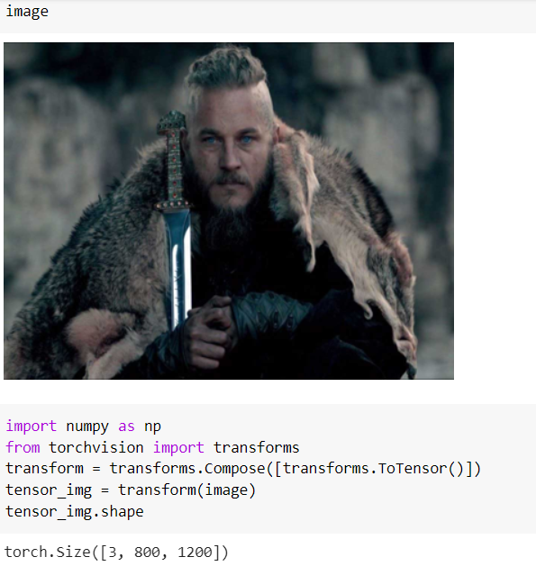

* Normalize
* CenterCrop
* RandomRotation



* Grayscale

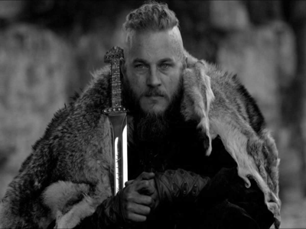

* GaussianBlur



**2. ImageFolder**

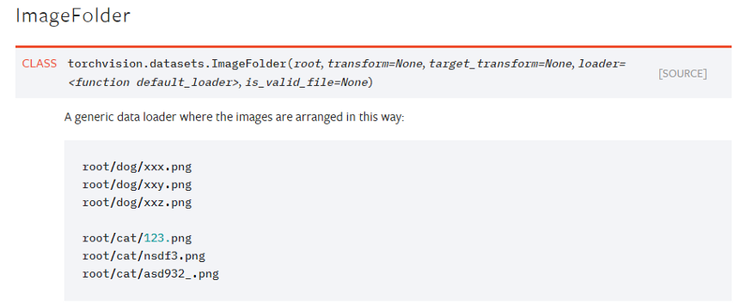

**Resnet**

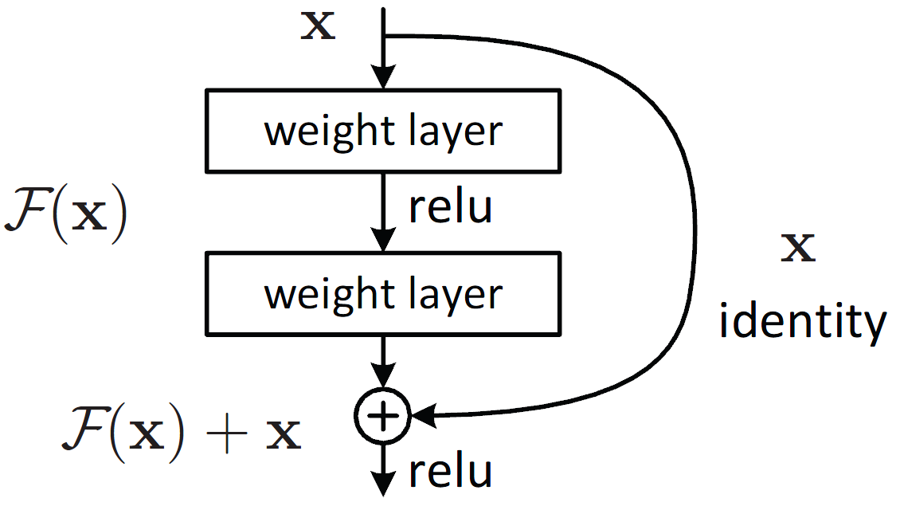

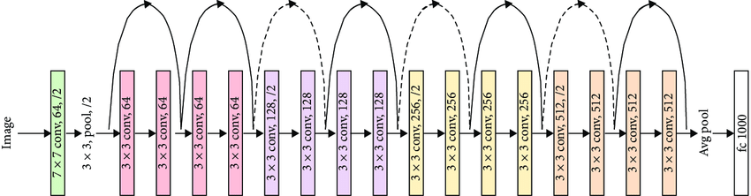

Classification:

Architecture:

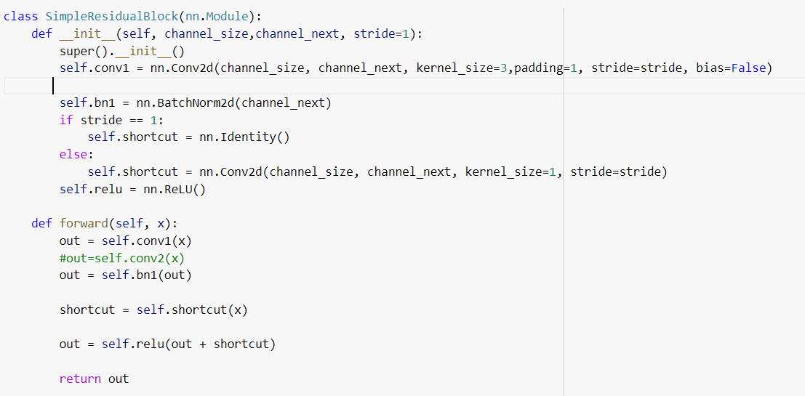

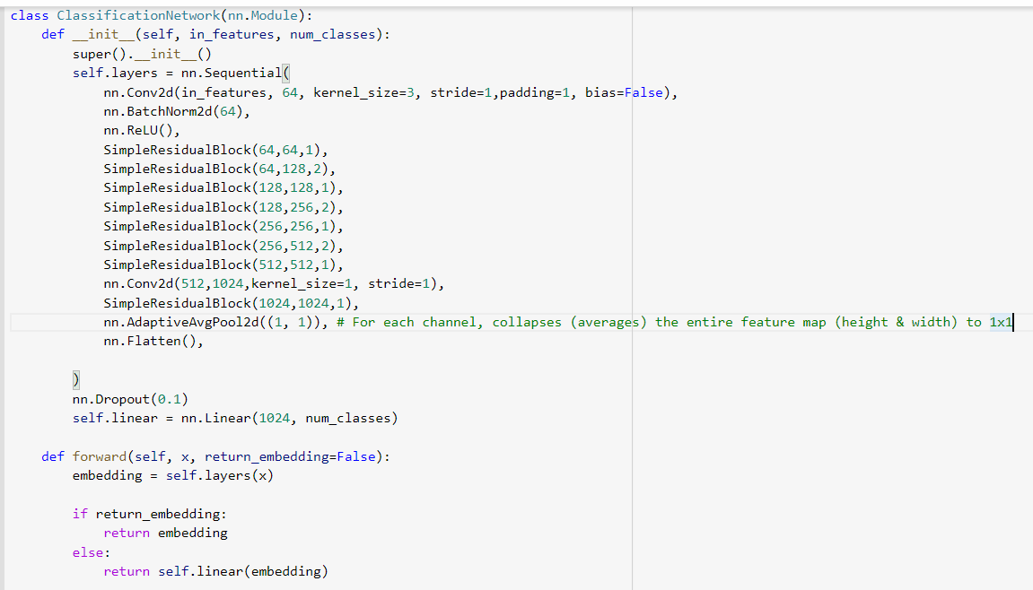

Constant learning rates:

learningRate = 0.01

learningRate = 0.025

learningRate = 1e-2

Training accuracy 90

Validation accuracy 48 to 60

Used Learning rate scheduler :

Training accuracy 80

Validation accuracy 65

After increasing num of filters:

Validation accuracy 71