COLLEGE PLACEMENT INTELLIGENCE
& PREDICTION SYSTEM
Business Intelligence and Predictive Analytics Project Report

Prepared by: Poluru Mahitha Choudary
Dataset: Placement_Data_Full_Class.csv
Development Environment: GitHub Codespaces

1. Abstract
This project, titled “College Placement Intelligence & Prediction System,” is a Business Intelligence and Predictive Analytics project developed to analyze college placement outcomes and identify patterns in student placement data. The project uses the Placement_Data_Full_Class.csv dataset, which contains academic performance, educational background, work experience, MBA specialization, placement status, and salary information for 215 students. The project performs data preprocessing, Key Performance Indicator (KPI) analysis, exploratory and diagnostic analysis, placement analysis, salary analysis, and correlation analysis. A Logistic Regression machine-learning model is used to estimate the probability of student placement based on selected pre-placement characteristics. An interactive Streamlit dashboard was developed to present placement KPIs, analytical visualizations, salary insights, key business insights, and placement probability predictions. The project is intended to support data-driven understanding of placement outcomes and provide useful decision-support information for students and placement-related activities.

2. Introduction
College placement is an important outcome for both students and educational institutions. Placement data contains useful information about students’ academic performance, work experience, specialization, entrance test performance, placement status, and salary. Analyzing this information can help institutions understand placement outcomes and identify patterns across different student characteristics.
Educational institutions can use placement analytics to monitor indicators such as placement rate, number of placed students, average salary, highest salary, and academic performance. Business Intelligence provides methods for converting raw data into meaningful information through data preprocessing, visualization, Key Performance Indicators, and analytical reporting. Predictive analytics complements descriptive analysis by estimating placement probability from selected student characteristics. Therefore, this project combines BI and Predictive Analytics to provide a data-driven view of college placement outcomes.

3. Problem Statement
Raw student placement data contains information about academic performance, work experience, specialization, placement status, and salary. However, this information needs to be analyzed systematically to identify placement patterns and generate useful decision-support insights.
This project transforms raw placement data into meaningful Business Intelligence information, calculates important KPIs, studies placement and salary patterns, and develops a Logistic Regression model to estimate placement probability. An interactive Streamlit dashboard presents the analysis, predictions, and business-oriented insights in an understandable format.

4. Objectives
- To analyze student placement data using Python-based data analytics techniques.
- To calculate important placement Key Performance Indicators (KPIs).
- To study placement patterns across different student characteristics.
- To analyze salary patterns among placed students.
- To build a Logistic Regression model for placement prediction.
- To estimate the probability of placement for individual students.
- To develop an interactive Business Intelligence dashboard using Streamlit.
- To generate business-oriented insights and recommendations based on the analytical findings.

5. Dataset Description
The project uses the Placement_Data_Full_Class.csv dataset. It contains information related to college students and their placement outcomes.
Property | Value
Dataset Name | Placement_Data_Full_Class.csv
Rows | 215
Original Columns | 15
Column | Description
sl_no | Serial number of the student
gender | Student gender
ssc_p | SSC percentage
ssc_b | SSC board
hsc_p | HSC percentage
hsc_b | HSC board
hsc_s | HSC specialization
degree_p | Degree percentage
degree_t | Degree type
workex | Work experience status
etest_p | Entrance test percentage
specialisation | MBA specialization
mba_p | MBA percentage
status | Placement status
salary | Salary of placed students
Salary is unavailable for students who were not placed, which is expected because salary is an outcome associated with placement.

6. Technologies Used
Technology | Purpose
Python | Main programming language for analysis, machine learning, and application development.
Pandas | Loading, cleaning, transforming, and analyzing the dataset.
NumPy | Numerical operations and data processing.
Matplotlib | Creating analytical visualizations.
Seaborn | Creating statistical visualizations such as correlation heatmaps.
Scikit-learn | Preprocessing, train-test splitting, Logistic Regression, and model evaluation.
Jupyter Notebook | Organizing and executing the analytics and machine-learning workflow.
Streamlit | Developing the interactive Business Intelligence dashboard.
GitHub Codespaces | Cloud-based development environment used for the project.

7. Data Preprocessing

7.1 Data Loading
The CSV dataset was loaded using Pandas and stored in the project's data folder. The dataset dimensions and column names were checked after loading.

7.2 Data Inspection
The dataset shape, column names, data types, missing values, duplicate records, and descriptive statistics were examined. The dataset contains 215 rows and 15 original columns.

7.3 Removing Unnecessary Column
The sl_no column was removed because it is only a serial identifier and does not provide meaningful information for placement analysis or prediction.

7.4 Missing Values
The main missing values occur in salary for students who were not placed. This is expected because salary information is available only for placed students. Salary analysis was therefore restricted to placed students with available salary information.

7.5 Feature Preparation
Placement status was converted to a binary target: Placed = 1 and Not Placed = 0. Numerical features were standardized with StandardScaler and categorical features were encoded using OneHotEncoder for the Logistic Regression model.

8. Exploratory Data Analysis
Exploratory Data Analysis was performed to understand placement outcomes and identify patterns across work experience, academic performance, entrance test performance, MBA specialization, salary, and numerical-variable relationships. These results describe associations in the dataset and do not establish causation.

8.1 Placement Status
The placement status distribution shows that 148 of 215 students were placed and 67 were not placed. The overall placement rate is 68.84%.
Figure 1: Placement Status Distribution
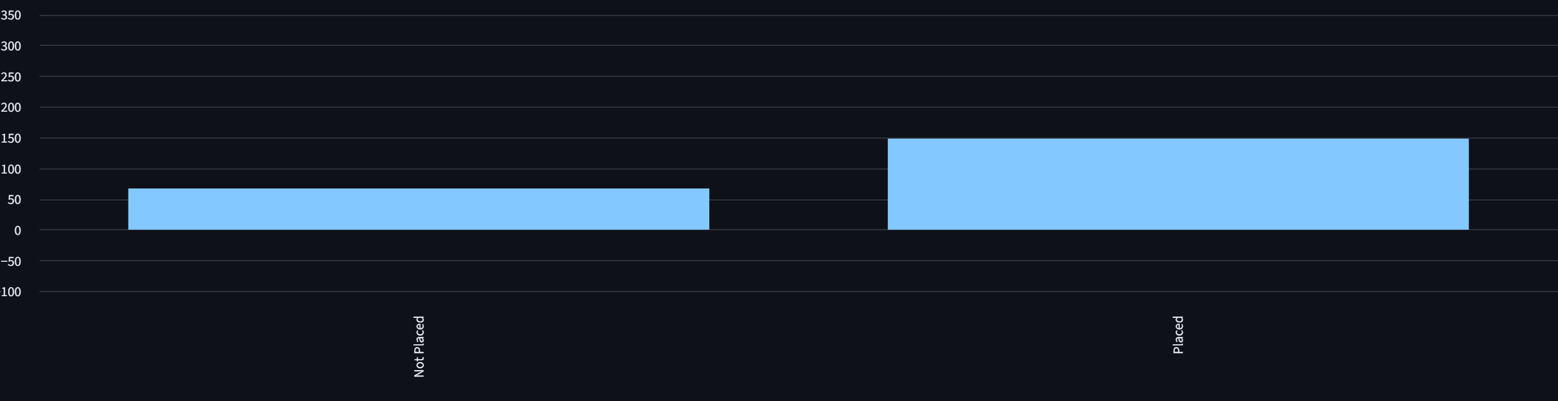

8.2 Placement Rate by Work Experience
The observed placement rates were No: 59.57%; Yes: 86.49%. The difference indicates an association between work experience and placement outcomes in this dataset, but it does not establish causation.
Figure 2: Placement Rate by Work Experience
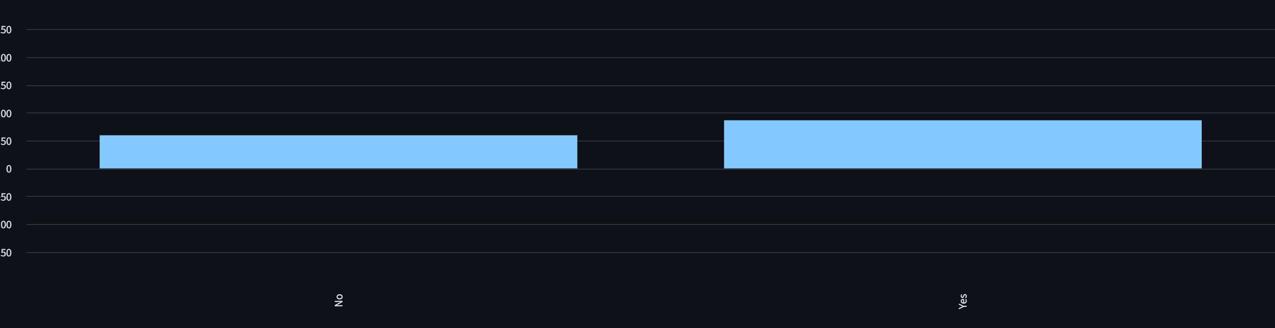

8.3 Placement Rate by Degree Percentage
Placement rates vary across degree-percentage groups. The observed pattern in this dataset shows higher placement rates in the higher degree-percentage groups. This is an association and not proof of a causal effect.
Figure 3: Placement Rate by Degree Percentage
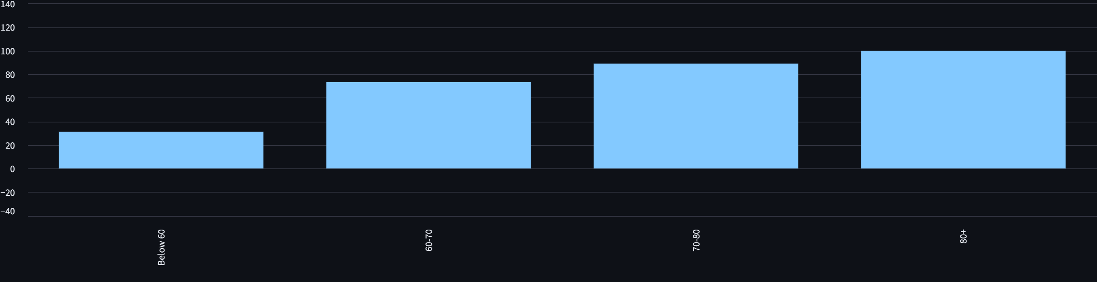

8.4 Placement Rate by Entrance Test Score
Entrance test percentage was divided into score ranges to compare placement rates across performance groups. The chart shows differences in historical placement outcomes across the score categories.
Figure 4: Placement Rate by Entrance Test Score
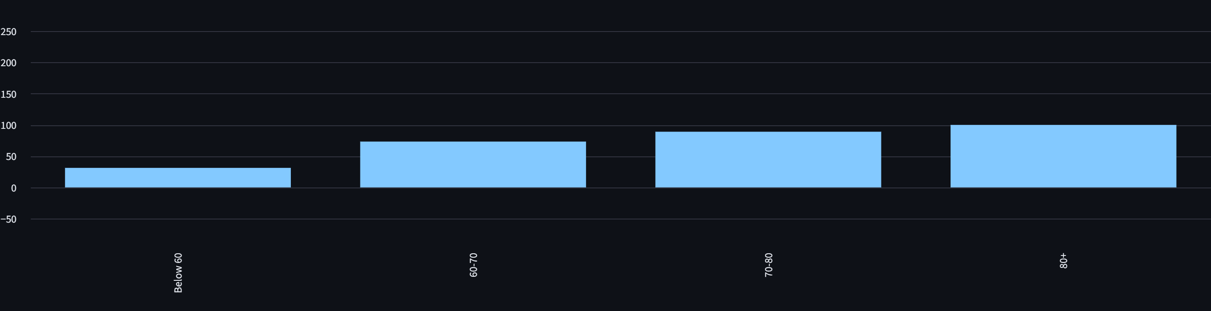

8.5 Placement Rate by MBA Specialization
Placement rates differ across MBA specialization groups. This comparison describes historical placement outcomes across the specialization categories in the dataset.
Figure 5: Placement Rate by MBA Specialization
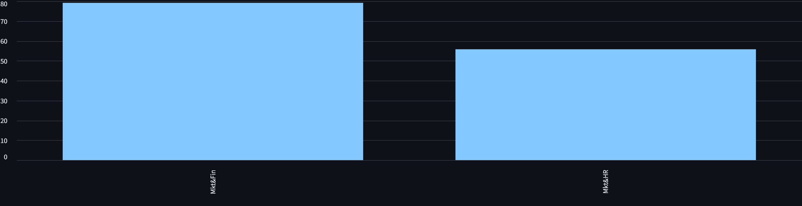

8.6 Salary by MBA Specialization
Average salary was calculated only for placed students with available salary information. The results show differences in average salary across MBA specialization groups. These differences describe historical patterns and do not establish that specialization alone determines salary.
Figure 6: Average Salary by MBA Specialization
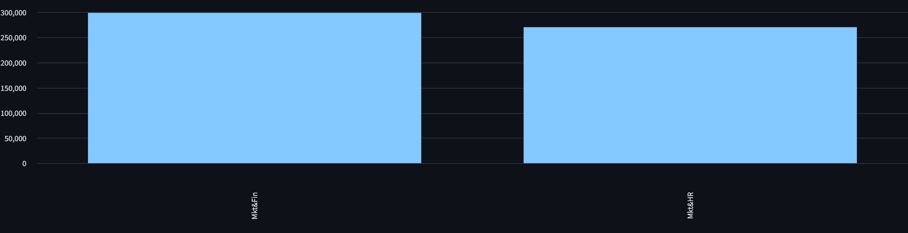

8.7 Correlation Analysis
A correlation heatmap was used to examine relationships among numerical variables. Correlation indicates statistical association and does not prove causation. Salary-related correlations should be interpreted carefully because salary is observed primarily among placed students.
Figure 7: Correlation Heatmap
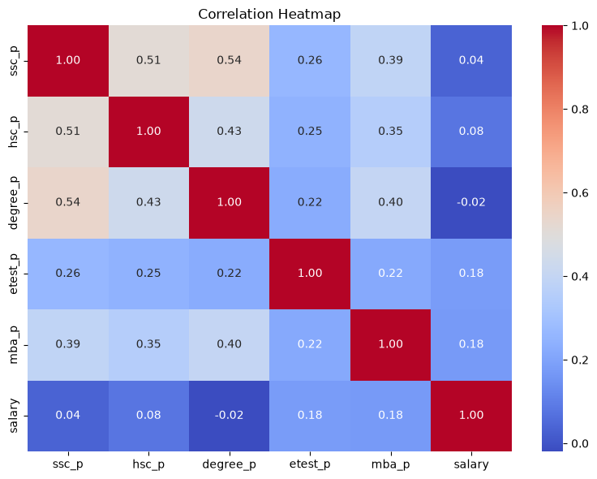

9. Key Performance Indicators
KPI | Value
Total Students | 215
Placed Students | 148
Placement Rate | 68.84%
Average Salary | 288655.41 (dataset units)
Highest Salary | 940000.00 (dataset units)
Average SSC | 67.30%
Average HSC | 66.33%
Average Degree | 66.37%
Average MBA | 62.28%
The dataset contains 215 students, with 148 placed students and a placement rate of 68.84%. The average and highest recorded salaries are reported in the dataset's original salary units.

10. Predictive Analytics
A Logistic Regression model was built to predict placement status. Placed students were coded as 1 and Not Placed students as 0. An 80:20 train-test split was used, producing 172 training records and 43 testing records.
Numerical features: SSC percentage, HSC percentage, Degree percentage, entrance test percentage, and MBA percentage.
Categorical features: gender, SSC board, HSC board, HSC specialization, degree type, work experience, and MBA specialization.
StandardScaler was used for numerical features and OneHotEncoder was used for categorical features. The processed data was passed to Logistic Regression through a Scikit-learn pipeline.
Salary was excluded from the prediction features because it is an outcome associated with placement and may not be available before placement. Including it could introduce outcome-related information into the prediction process.

11. Model Evaluation
Metric | Result
Accuracy | 86.05%
Precision | 92.86%
Recall | 86.67%
The model achieved 86.05% accuracy, 92.86% precision, and 86.67% recall on the selected test set. These results describe performance on this particular testing subset and should not be treated as a guarantee for other datasets.
Figure 8: Confusion Matrix
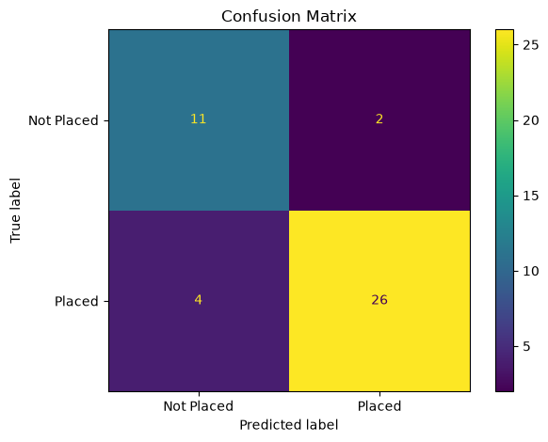
The confusion matrix contains True Negative = 11, False Positive = 2, False Negative = 4, and True Positive = 26. These values show the correct and incorrect classifications made on the test set.
A classification report can also be included as an appendix or screenshot if required by the submission guidelines.

12. Placement Probability and Risk Categorization
The Logistic Regression model generates a placement probability between 0 and 1. A value closer to 1 represents a higher model-estimated probability of belonging to the Placed class.
Probability | Project-Defined Category
>= 70% | Lower Risk
40% - <70% | Medium Risk
<40% | Higher Risk
These categories and thresholds are defined for this project and are not universal standards. They are intended only to make model outputs easier to interpret as decision-support information. A probability is an estimate, not a guarantee of future placement.
Figure 9: Predicted Placement Probability Distribution
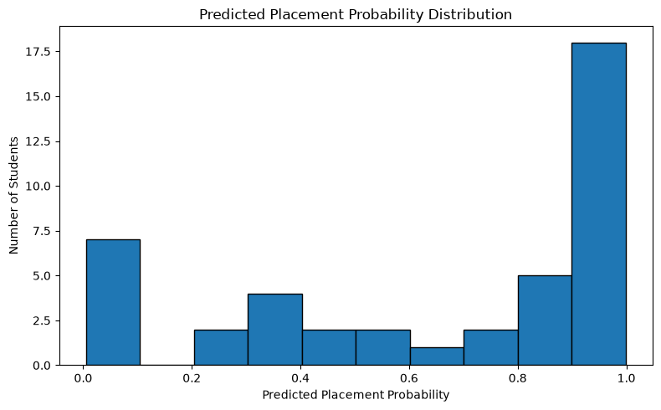

13. Streamlit Dashboard
An interactive Streamlit dashboard was developed to present the project results in a Business Intelligence format.

13.1 Executive Overview
The Executive Overview presents KPI cards for total students, placement rate, average salary, and highest salary.

13.2 Diagnostic Analysis
This section presents placement-rate comparisons by work experience, MBA specialization, and degree-percentage groups.

13.3 Placement Prediction
The prediction form accepts selected student characteristics and returns an estimated placement probability and project-defined risk category.

13.4 Salary Analysis
Salary distribution and average salary by MBA specialization are presented for placed students.

13.5 Key Business Insights
The dashboard converts analytical results into concise, understandable findings for decision support.
Dashboard screenshots should be inserted in this section after running the Streamlit application.

14. Business Insights

14.1 Work Experience
Fact: No work experience: 59.57% placement rate; Yes work experience: 86.49% placement rate.
Insight: Placement outcomes differ between work-experience groups in the analyzed data.
Hypothesis: Relevant practical exposure may help students develop experience that is useful during recruitment; this is a hypothesis, not a demonstrated causal effect.
Recommendation: The placement cell could encourage relevant internships, projects, or practical experience opportunities.

14.2 Academic Performance
Fact: Placement rates vary across degree-percentage groups, with higher observed placement rates in the higher degree-percentage groups in this dataset.
Insight: Degree performance is associated with different historical placement outcomes.
Hypothesis: Academic performance may form one component of a student's recruitment profile; this analysis does not establish causation.
Recommendation: Academic and placement support can be targeted toward areas where historical data indicates lower outcomes.

14.3 Entrance Test Performance
Fact: Placement rates vary across entrance-test score groups.
Insight: Entrance test performance shows an association with historical placement outcomes.
Hypothesis: Assessment preparation may be relevant to recruitment readiness; this is a hypothesis.
Recommendation: Placement preparation programs could include structured aptitude and assessment practice.

14.4 MBA Specialization
Fact: Placement rates and average salaries differ across MBA specialization groups.
Insight: Specialization groups show different historical placement and salary patterns.
Hypothesis: Differences may relate to the types of roles represented in the historical recruitment data, although the dataset does not establish the cause.
Recommendation: Placement teams could monitor specialization-level outcomes and provide role-oriented career guidance.

14.5 Salary Patterns
Fact: The average recorded salary among placed students is 288655.41, and the highest recorded salary is 940000.00, in the dataset's original salary units.
Insight: Salary outcomes vary across placed students and specialization groups.
Hypothesis: Salary variation may reflect differences in roles, organizations, student profiles, or other factors not represented in the dataset.
Recommendation: Salary analysis can be used as historical decision-support information when reviewing placement outcomes.

15. Recommendations
- Monitor placement KPIs regularly to track changes in placement outcomes.
- Encourage relevant practical experience, internships, and project work.
- Provide additional support where historical patterns indicate lower placement outcomes.
- Use academic performance analysis to identify areas for student support.
- Include structured aptitude and assessment preparation in placement-readiness activities.
- Review specialization-level placement and salary patterns when planning career guidance.
- Use predictive probabilities as decision-support information rather than guarantees.

16. Limitations
- The dataset contains only 215 students.
- The dataset may not represent every college, institution, region, or recruitment environment.
- Historical data may not reflect future placement conditions.
- Observed associations do not establish causation.
- Model predictions are estimates and depend on the data and features used.
- Risk thresholds are project-defined and are not universal standards.
- Salary information is available only for placed students.
- Larger and more recent datasets could improve future analysis.

17. Future Scope
- Use larger and more recent placement datasets.
- Include data from multiple colleges or academic years.
- Evaluate additional machine-learning algorithms.
- Add interactive dashboard filters.
- Include company-level analysis when company information is available.
- Deploy the Streamlit dashboard online.
- Implement model monitoring and periodic retraining.
- Explore more advanced predictive and prescriptive analytics.

18. Conclusion
The College Placement Intelligence & Prediction System demonstrates how Business Intelligence and Predictive Analytics can be combined to analyze student placement outcomes. The project follows the workflow Data Cleaning → BI Analysis → KPI Development → Predictive Modeling → Dashboard → Business Insights.
The analysis found a 68.84% placement rate among 215 students. A Logistic Regression model was developed to estimate placement outcomes and achieved 86.05% accuracy on the selected test set. The project also provides placement probabilities and project-defined risk categories through an interactive Streamlit dashboard.
The system provides a structured way to understand historical placement data and supports data-driven discussion while recognizing the limitations of a small historical dataset.

19. References
- Placement_Data_Full_Class.csv — Kaggle campus placement dataset used for the project.
- Python Documentation — https://docs.python.org/
- Pandas Documentation — https://pandas.pydata.org/docs/
- NumPy Documentation — https://numpy.org/doc/
- Matplotlib Documentation — https://matplotlib.org/stable/
- Seaborn Documentation — https://seaborn.pydata.org/
- Scikit-learn Documentation — https://scikit-learn.org/stable/
- Streamlit Documentation — https://docs.streamlit.io/

