**SOFTWARE REQUIREMENTS SPECIFICATION**

**FOR E-MEDICINE**

Technical Story Card

Revision History

|  |  |  |  |
| --- | --- | --- | --- |
| Version No. | Date | Prepared by / Modified by | Significant Changes |
| 1 | 23/10/2021 | Ayan Ghosh |  |
| 2 | 23/10/2021 | Barnali Dey |  |
| 3 | 23/10/2021 | Deepika |  |
| 4 | 23/10/2021 | Rishitha CH |  |
| 5 | 23/10/2021 | V.NagaMahitha |  |

Glossary

|  |  |
| --- | --- |
| Abbreviation | Description |
| BSC | Business Story Card |
| TSC | Technical Story Card |
|  |  |
|  |  |
|  |  |
|  |  |

TABLE OF CONTENTS:

1.INTRODUCTION

2.OBJECTIVE

3.SCOPE OF CHANGE

4.LIST OF IMPACTED MODULES

4.1 FUNCTIONAL REQUIREMENTS

4.2 NON-FUNCTIONAL REQUIREMENTS

5.DESIGN AND DETAILED TECHNICAL UPDATES

5.1 USE CASE DIAGRAM

5.2 DATA FLOW DIAGRAM

5.3 ENTITY RELATIONSHIP DIAGRAM

6.REQUIREMENTS

7 REFERENCES

1.INTRODUCTION

People need medicine when they become sick and unable to enjoy their normal life. People have to go in the pharmacy for buying medicine. But sometimes they can’t get the proper medicine due to the lack of easy availability. So, the patients have to search for the desired medicine in every medicine shop which wastes their time and energy. Sometimes, in emergency cases, the condition of patients become very serious without taking medicine at the right time.

Online Medicine Shop will give the opportunity to buy proper medicine sitting at home without any trouble. There are many medicine shops in every city but online medicine shop is very rare. The online medicine shop is operated over the internet. It will bring comfort to every buyer and seller of the medicine. The seller can manage the shop, store the details and relevant information of the medicine and sell the medicine in one system easily. The customer can see, search, buy medicine and give review about the service quality in this website. So, Online Medicine Shop will create a convenient way of selling and buying medicine and will make our life easier and hassle free.

**2.OBJECTIVE:**

The main objective is to manage the details of customer, vendor, medicine, stock, order and sell the medicine in online. In this technological era, everything becomes very faster. People love to enjoy a comfortable life. This online medicine shop will bring many facilities to our life. The seller can easily sell the medicine and preserves the records and documents of the medicine. And the profit will be high also. That’s why, Online Medicine Shop is developed where the management of the medicine shop is web based through which one can manage a medicine shop easily from anywhere at any time.

**3.SCOPE OF CHANGE:**

When we have enough required staffs to operate the business, then we will run this in city first for a week as a piloting basis. Then we will move to all over the country. It is predictable that due to the demanding situation for the COVID-19 this system will be sustainable in the market. We will search for sponsors to share our business plan with investors and they may find benefits in it to invest. Then we will do advertising for our service to attract more clients. This way we can scale up the business more. This is how our site will start growing and there will be a day when people can’t think of buying medicines without our site.

With consumer lifestyles having undergone an unprecedented transformation due to COVID-19, consumer demand patterns can be seen shifting primarily towards purchasing essentials. While supply chain and procurement strategies around the response for COVID-19 are still evolving, the long-term impact on businesses is yet to be seen. They want to facilitate faster delivery of products ordered by the customers. They want their customers to get things delivered at their desired location instead of making them come physically to their store. It is just for giving them a highly positive online shopping experience. The rapid growth of e-commerce has affected offline retailers negatively. The majority of them now see e-commerce as a threat to their business. So, if we talk about E-Medicine, it is the right time to dig into e-commerce. With the move into the digital platform, many of the vendors will have an option to list and sell their medicines online. The predicted global e-medicine market will grow to reach around 128 billion dollars by 2023. It is the right time to dig into the e-commerce industry and stand out among those entrepreneurs who are ready to change the world.

**4.LIST OF IMPACTED MODULES:**

**4.1 FUNCTIONAL REQUIREMENTS:**

This section provides requirement overview of the system. Various functional modules that can be implemented by the system will be-

1. **Registration:**

User must be registered and they should create their account. They can edit their account if needed.

Un-registered user can’t place order. They can only check the available medicines.

1. **Log in:**

User will log in by entering the valid user id Ans Password. There should be a forget Password option, if user forget the password. Hear user’s authenticity will be validated.

1. **Search:**

Staff, customer and Admin can search for the required information / medicines needed.

Customer can search medicine according to age as some medicine is dedicated for certain age-group.

1. **Medicine:**

The admin can add, delete or modifies the details of the Medicine.

Admin will provide the details of the medicine like the company name, type of the medicine etc. to the website.

Admin can add, update, delete the details of the medicine.

Admin can announce offers of the medicine in this online medicine shop.

1. **Review/ Feedback:**

Customer can give the review on the service after signing in to the website.

1. **Recruit:**

Admin can add or delete Staffs and deliveryman.

Deliveryman details can be managed by the admin.

Admin can assign deliveryman to deliver the medicines to the customer.

1. **Order:**

Customer can buy or place order more than one product at a time.

Customer can make their Wishlist of medicine.

1. **Payment module:**

Customers can pay through online and offline.

1. **Report generation:**

Depending upon the organizational needs following reports can be generated

Daily, Weakly & Yearly based report of medicine sold, inventory and stock and salaries of staff.

## 4.2 NON-FUNCTIONAL REQUIREMENTS:

Following Non-Functional Requirements will be ---

1. Secure access to consumer’s confidential data.
2. 24X7 availability**.**
3. Better component design to get better performance at peak time.
4. Flexible service-based architecture will be highly desirable for future extension. Non-Functional Requirements define system properties and constraints. Various other non-functional requirements are……….

## Security

* + **Reliability**

## Maintainability

* + **Portability**

## Extensibility

* + **Reusability**

## Compatibility

* + **Resource Utilization**

## 5 DESIGN AND DETAILED TECHNICAL UPDATES:

### 5.1.1 USE OF CASE DIAGRAM

The use of Case Diagram is a graphic depiction of the interactions among the elements of E-Medicine System. It represents the methodology used in system analysis to identify, clarity, and organize system requirements of E-Medicine system. The main actors of E-Medicine system in the use case diagram are: Super Admin, System User, Shopkeepers, customers, who perform the different type of use cases Manage Medical shop, Manage Medicine, manage stocks, manage company, manage sells, Manage users and full E-Medicine system operation

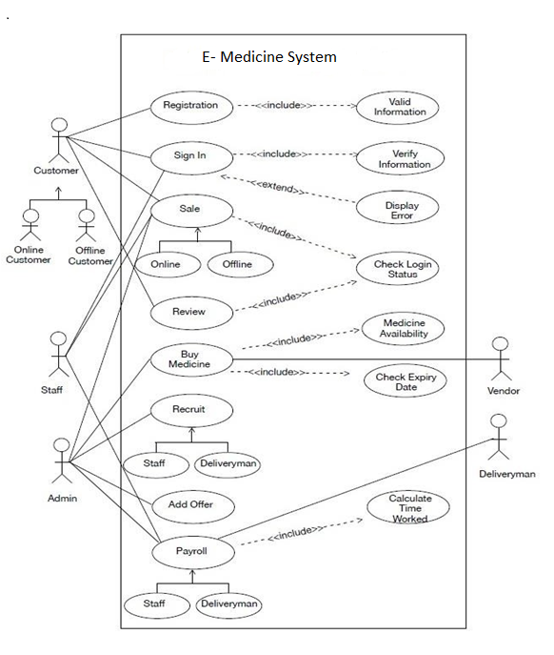

**5.1.2 DATA FLOW DIAGRAM:**



LEVEL 1 DFD:

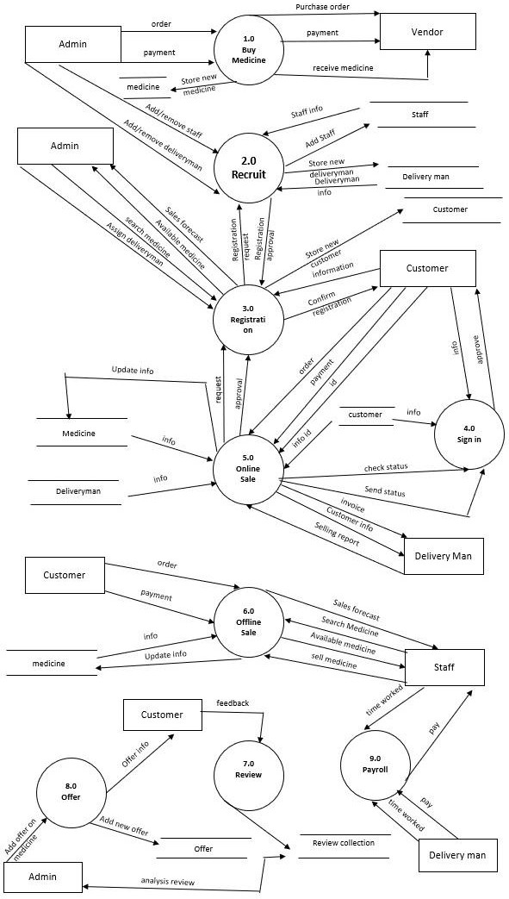

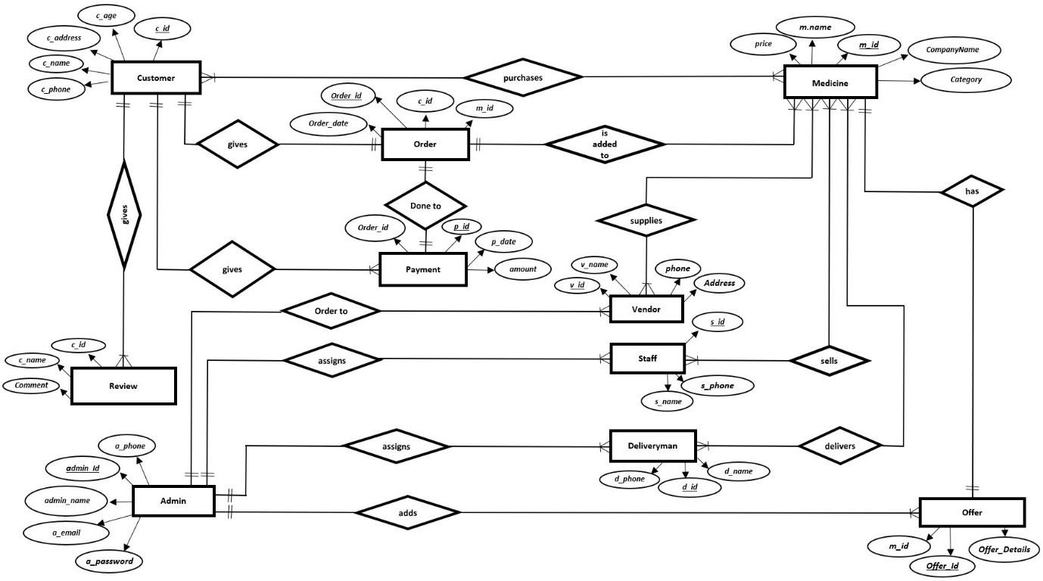**5.1.3 ENTITY RELATIONSHIP DIAGRAM**

6.REQUIREMENTS:

Hardware/Software Interface:

This section lists the minimum hardware and software requirement needed to run the system efficiently.

Hardware Interface:

• intel core processor.

• 60 MB free hard-drive space

• 128 MB RAM

Software Interface:

• Operating System windows (Vista/7 or above)

• Web Browser: IE 10 or above, Google Chrome.

• Drivers: Java Runtime Environment

**7.REFERENCES:**

1. Virtual Private Server.

https://en.wikipedia.org/wiki/Virtual_private_server

2.https://www.scirp.org/journal/paperinformation.aspx?paperid=106664