1.Get me the IP address of a particular domain (guvi.in). How do I find my CPU/memory usage of my server?. Test the connectivity between 2 nodes?

IP Address of guvi.in

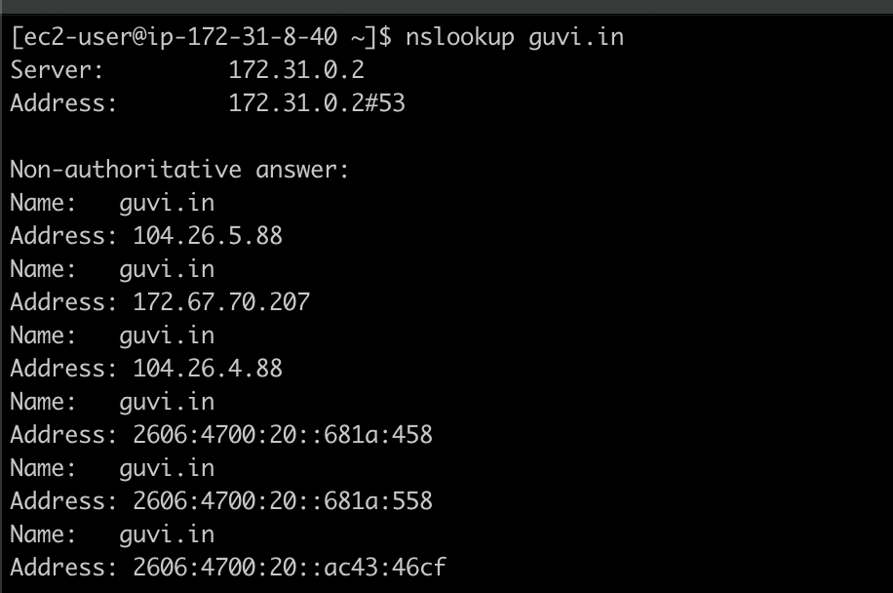

CPU/Memory usage of server

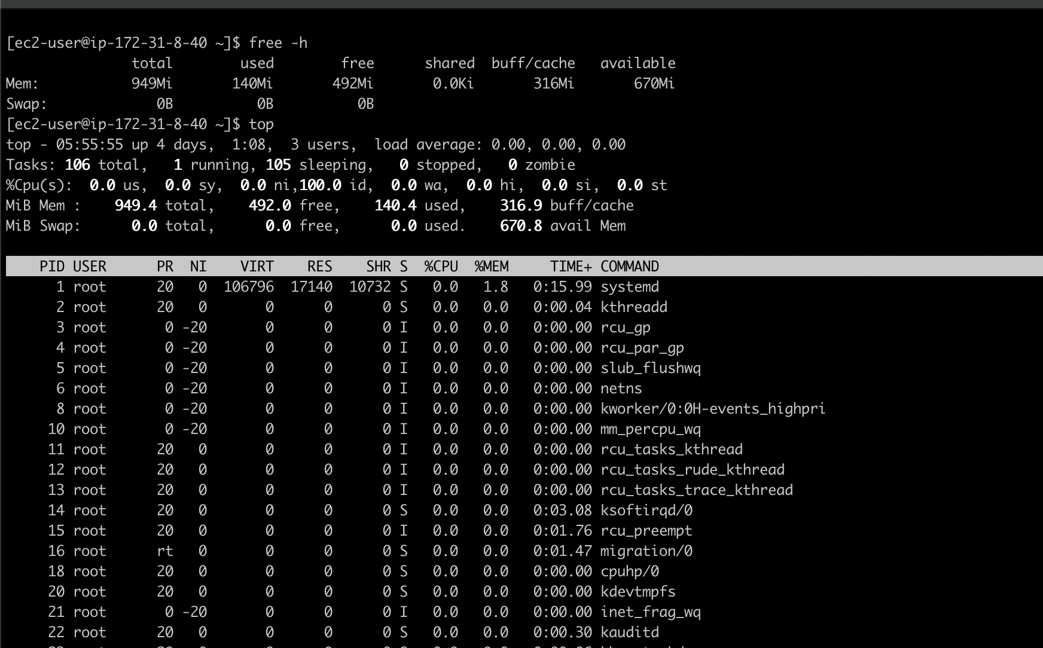

Connectivity between 2 nodes.

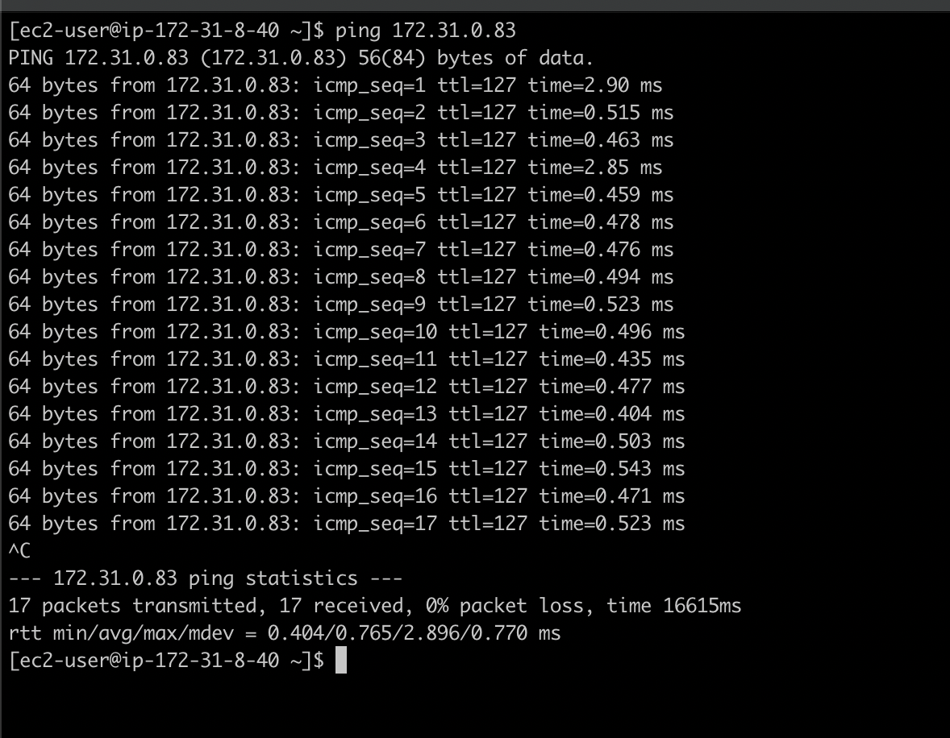

2.I have deployed an application in guvi.com:9000, and logs show my app is running, but I’m unable to view the page. Check whether my port is open or not ?

Ran telnet guvi.com 9000, got connect timed out error message which indicates there is no port 9000 open. Please find the below screenshot.

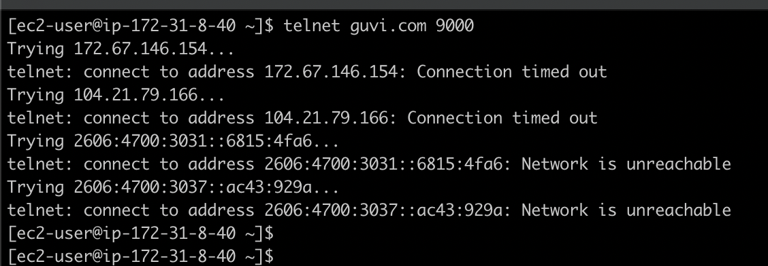

Further to find on which port guvi.com is running , installed nmap utlity and ran below command to find the port number.

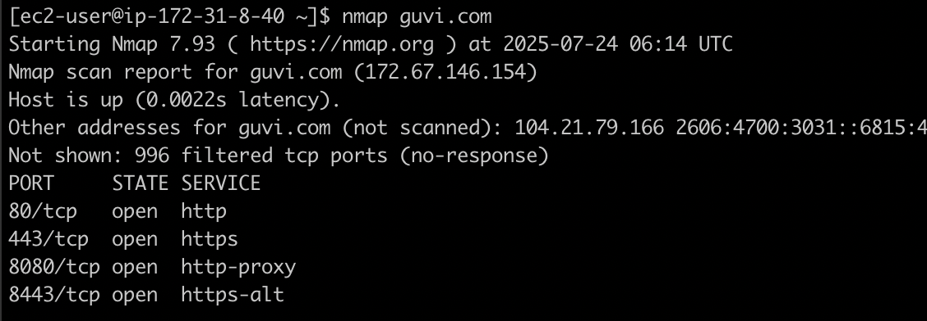

And ran telnet command to check the same.

