TASK – 1
JAVA FILE HANDLING UTILITY
Project Title : Java File Handling Operations
Name : Fazeela Muskan M
Course : Java Programming
Date : 14-04-2026

Objective
- The objective of this project is to perform file handling operations in java such as reading, writing, and modifying text files.
Tools & Technologies Used
- Java (JDK)
- Visual Studio Code (VS Code)
- Operating System : Windows
Project Description
This project demonstrates file handling in Java. It allows the user to:
- Write data into a file
- Read data from the file
- Modify existing file content
The program uses FileWriter for writing and Scanner for reading operations.
Program Explanation
1. writeFile():
This method creates a file and writes text into it using FileWriter.
2. readFile():
This method reads the file line by line using Scanner and displays the content.
3. modifyFile():
This method reads existing content, replaces specific words, and updates the file.
Source Code
import java.io.*;
import java.util.*;

public class FileHandlingutility {

// Method to write to file
public static void writeFile(String filename) {
try {
FileWriter writer = new FileWriter(filename);
writer.write("Hello Everyone!\n");
writer.write("This is a Java File Handling utility.\n");
writer.write("let's get into it!");
writer.close();
System.out.println("File written successfully.\n");
} catch (IOException e) {
System.out.println("Error writing file.");
}
}

// Method to read from file
public static void readFile(String filename) {
try {
File file = new File(filename);
Scanner reader = new Scanner(file);

System.out.println("Reading File Content:\n");
while (reader.hasNextLine()) {
String data = reader.nextLine();
System.out.println(data);
}
reader.close();
System.out.println();
} catch (FileNotFoundException e) {
System.out.println("File not found.");
}
}

// Method to modify file content
public static void modifyFile(String filename) {
try {
File file = new File(filename);
Scanner reader = new Scanner(file);
StringBuilder content = new StringBuilder();

// Read existing content
while (reader.hasNextLine()) {
content.append(reader.nextLine()).append("\n");
}
reader.close();

// Modify content (replace word)
String modifiedContent = content.toString().replace("Java", "Advanced Java");

// Write updated content back
FileWriter writer = new FileWriter(filename);
writer.write(modifiedContent);
writer.close();

System.out.println("File modified successfully.\n");

} catch (IOException e) {
System.out.println("Error modifying file.");
}
}
public static void main(String[] args) {
String filename = "demo.txt";

writeFile(filename);
readFile(filename);
modifyFile(filename);
readFile(filename);
}
}
Output
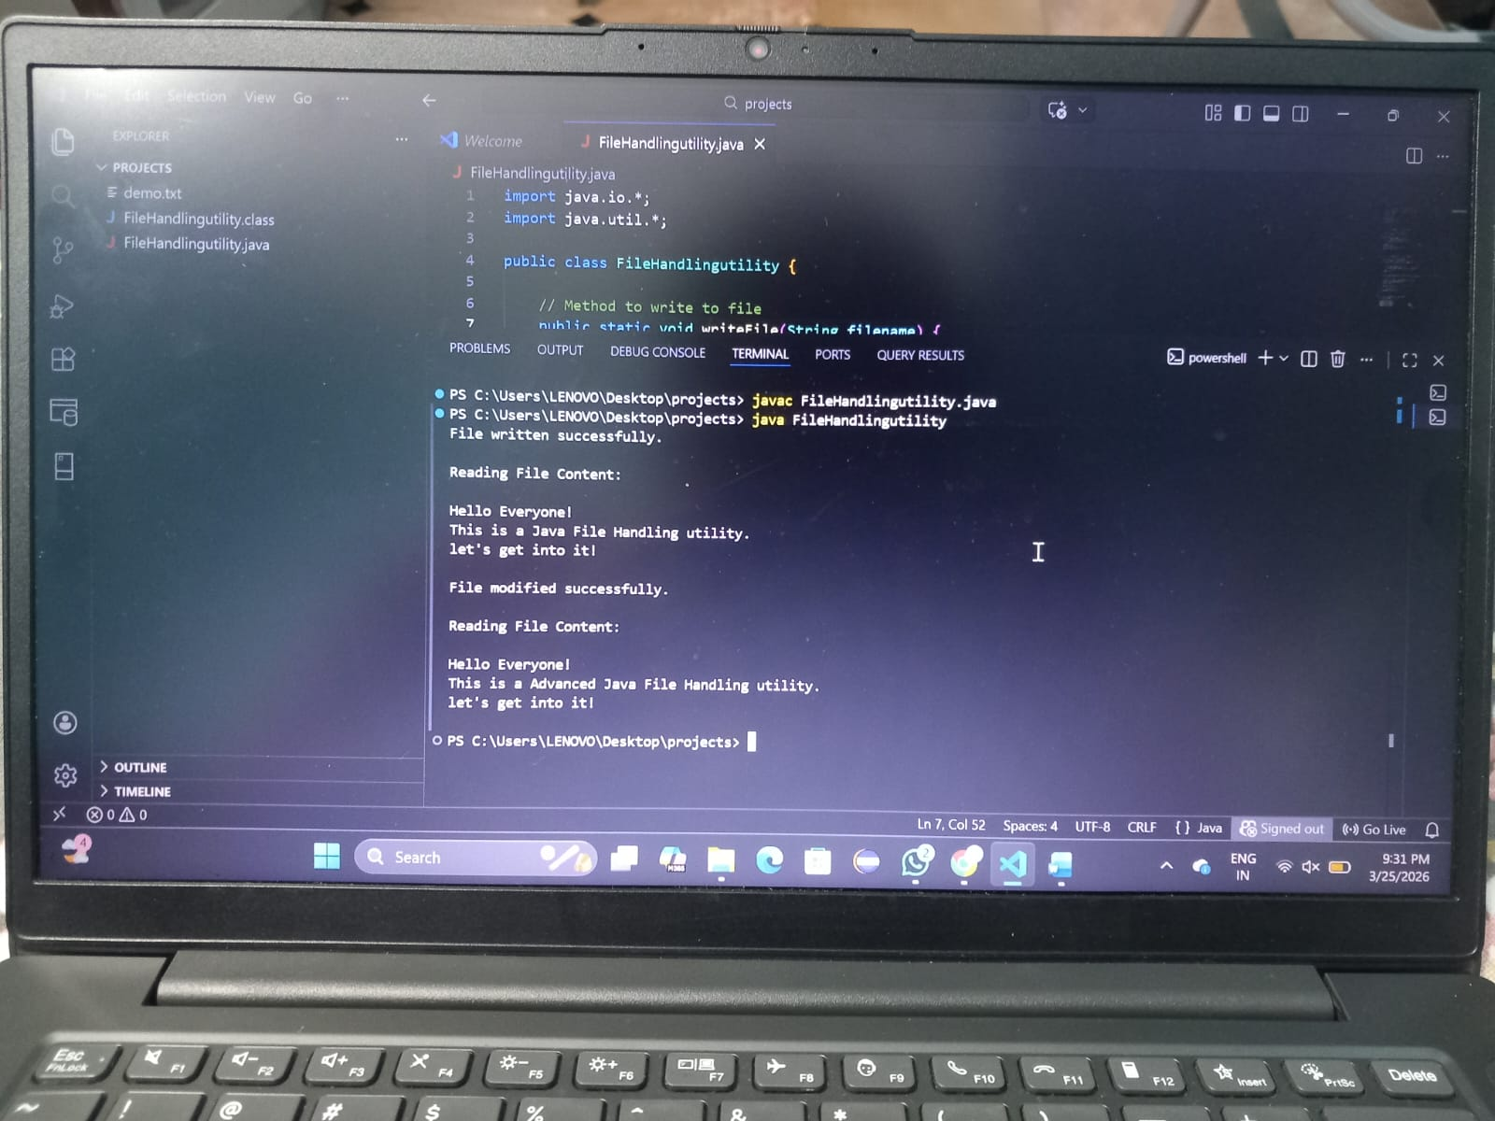

Conclusion
This Project helped in understanding how file handling works in java .It demonstrated reading, writing, and modifying files effectively.

