TASK -2
Title : REST API Client using Java
Objective :
To develop a Java application that consumes a public REST API, retrieves weather data, parses JSON responses, and displays the information in a structured format.
Tools & Technologies Used :
- Java (JDK 11 or above)
- VS Code / IntelliJ IDEA
- Open-Meteo API
- JSON Library (org.json)
Methodology :
API Selection
- Used Open-Meteo public API to fetch weather data.
HTTP Request Handling
- Used HttpClient class in Java to send a GET request.
Receiving Response
- The API returns data in JSON format.
JSON Parsing
- Used JSONObject from org.json library.
- Extracted required fields such as:
  - Temperature
  - Wind Speed
  - Wind Direction
  - Time
Displaying Output
- Displayed the extracted data in a structured format.
Source Code :
import java.net.URI;
import java.net.http.HttpClient;
import java.net.http.HttpRequest;
import java.net.http.HttpResponse;

import org.json.JSONObject;

public class WeatherApp {

public static void main(String[] args) {
try {
String url = "https://api.open-meteo.com/v1/forecast?latitude=17.7&longitude=83.3&current_weather=true";

HttpClient client = HttpClient.newHttpClient();

HttpRequest request = HttpRequest.newBuilder()
.uri(URI.create(url))
.GET()
.build();

HttpResponse<String> response = client.send(request, HttpResponse.BodyHandlers.ofString());

// 🔥 JSON Parsing starts here
JSONObject json = new JSONObject(response.body());
JSONObject weather = json.getJSONObject("current_weather");

double temp = weather.getDouble("temperature");
double wind = weather.getDouble("windspeed");
int direction = weather.getInt("winddirection");
String time = weather.getString("time");

// ✅ Clean Output
System.out.println("=== Weather Report ===");
System.out.println("Time: " + time);
System.out.println("Temperature: " + temp + " °C");
System.out.println("Wind Speed: " + wind + " km/h");
System.out.println("Wind Direction: " + direction + "°");

} catch (Exception e) {
e.printStackTrace();
}
}
}

Sample Output :
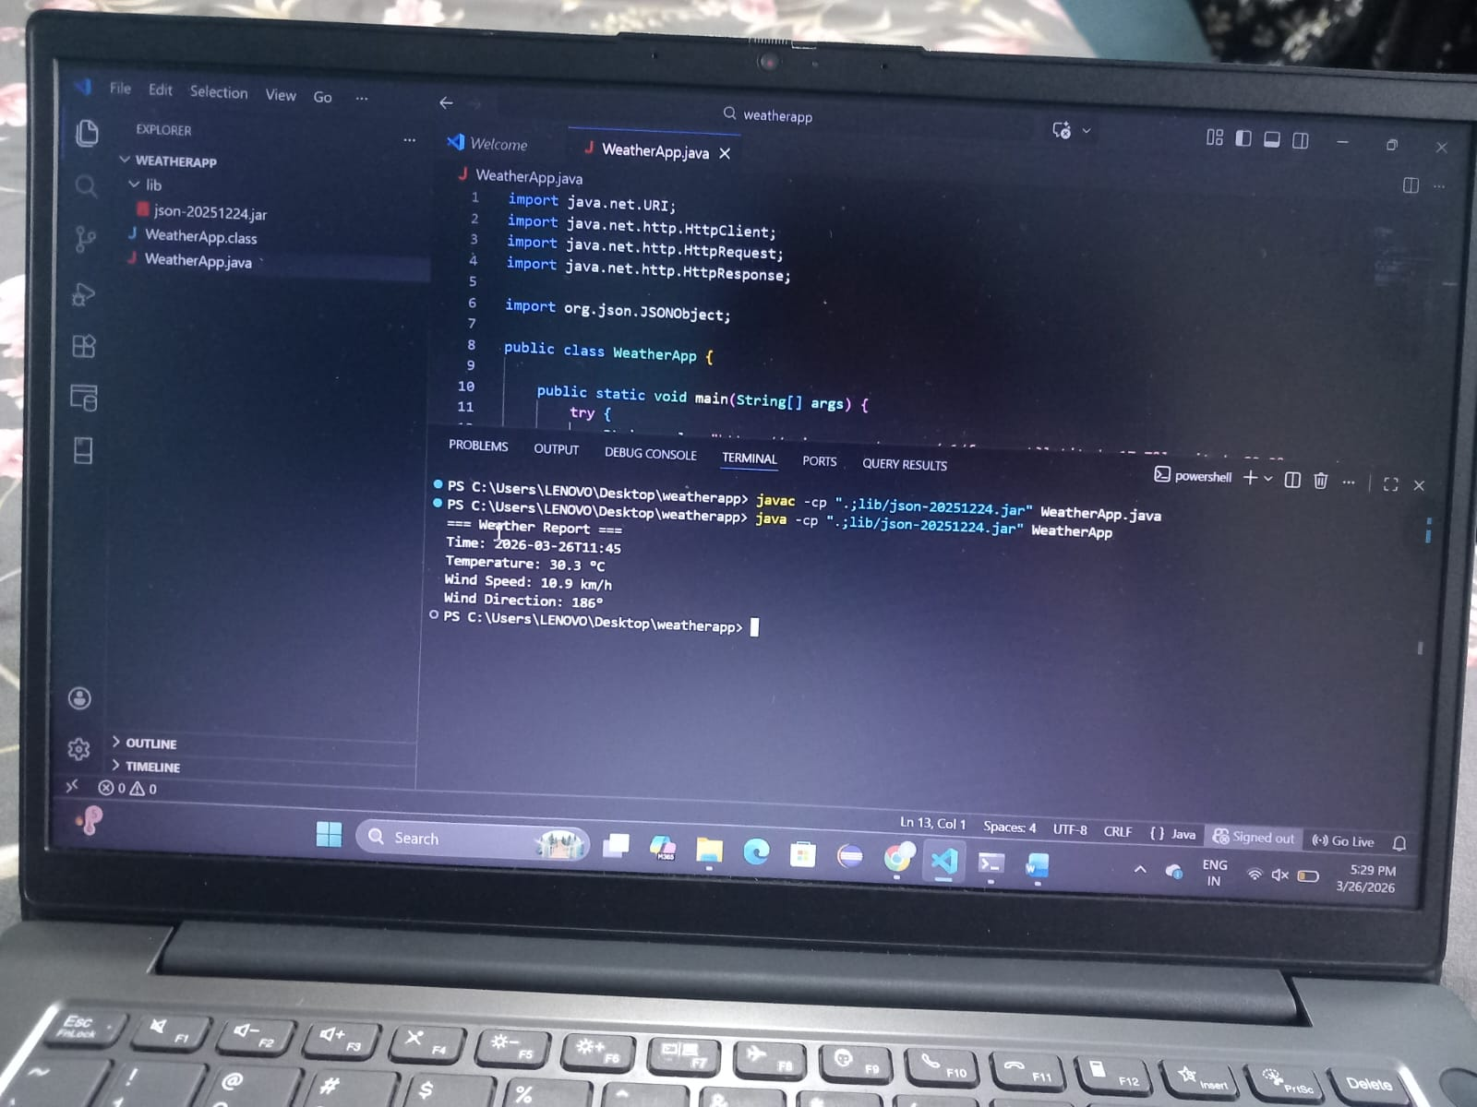
Conclusion :
This project demonstrates how to consume a REST API in Java, handle HTTP requests, parse JSON responses, and display data in a structured format. It helps in understanding real-world API integration.

