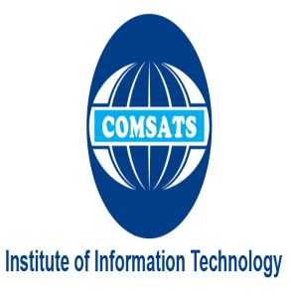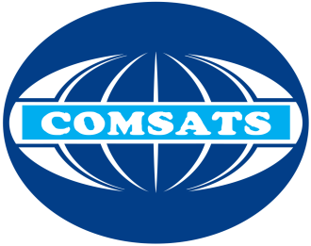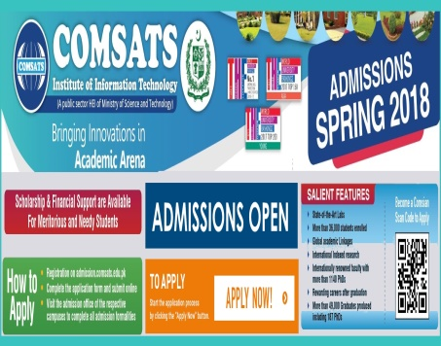

**Introduction**

COMSATS Institute of Information Technology (CIIT) started its journey in 1998, and established its first campus at Islamabad in April 1998. In August 2000, in recognition of CIIT's achievements, the Federal Government granted it the status of a Degree Awarding Institute (DAI) through promulgation of its Charter. The CIIT, besides its principal campus at Islamabad, has six other fully functional campuses and a Virtual Campus. It is also exploring the opportunity for opening an overseas campus in the Gulf region.The CIIT is now slated for up gradation as a university by the name of ‘COMSATS University’ through an Act of the Parliament.

Presently, CIIT is regarded as a reputable quality tertiary educational institution. As per Higher Education Commission (HEC), it ranks at number 2 in research productivity and at number 1 in Information Science & Technology amongst 140 DAIs and Universities of Pakistan. Q.S - a world ranking agency has also awarded a three stars rating out of five, a unique distinction to the only Pakistani University. Recently, the same agency has also ranked CIIT among the 250 band of all the universities of Asia.

CIIT has established academic and professional linkages with reputed universities and organizations across the world. So far 150 Memoranda of Understanding and Agreements have been signed. The prestige of CIIT internationally has also been enhanced by the fact that it has been organizing regular international events like Pak-China Business Forum, Frontiers of Information Technology Conference and Vice Chancellors’ Forum of the Islamic Countries.

**Download forms**

**Videos**

**Gallery**

Name: Mah Gul (027)