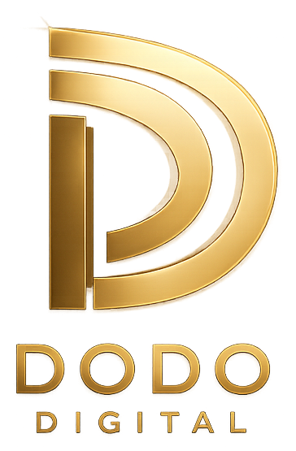
CLIENT PROPOSAL
Digital Solutions That Help Your Business
Look Better, Reach More People & Grow Online
Content • Short-Form Video • Web Design • AI Automation
PREPARED FOR | [Client Name]
BUSINESS | [Business Name]
PREPARED BY | Dodo Digital
DATE | [Date]
dododigital.com • [Email] • [Phone / WhatsApp]

01 The Opportunity
Your business already has something valuable to offer. The challenge is making sure your online presence communicates that value as clearly and professionally as you deliver it in person.
Right now, you may be losing potential customers because:
- Your social media isn't consistent or on-brand.
- Your content doesn't capture attention in the first few seconds.
- Your short-form videos aren't optimized for how people actually watch.
- Your website doesn't clearly explain what you offer or why it matters.
- Repetitive day-to-day tasks are eating time that should go toward growth.
- Potential customers have to work too hard to understand how to contact or buy from you.
That's where Dodo Digital comes in.
We help small businesses build a professional online presence through content, short-form video, simple business websites, and AI automation, without the cost or complexity of a large agency.

02 What We'll Help You Achieve
Our goal isn't simply to “make posts” or “build a website.” It's to help your business grow with a digital presence that actually works for you.

Look Professional
Create a consistent, trustworthy digital presence across every platform your customers see.
Get Attention
Use engaging social content and short-form video to stop the scroll and capture new customers.
Make It Easy To Choose You
Present your services clearly so visitors understand what you offer and exactly what to do next.
Work Smarter With AI
Automate the repetitive parts of your business, like bookings, FAQs, and follow-ups, so nothing falls through the cracks.
Save You Time
You focus on running your business. We handle the digital execution, start to finish.

03 What We Do
Four core services, built to work together, so your online presence grows as one connected system rather than a set of disconnected tools.

01 | Content & Social Media  Branded posts, story designs, and captions that keep your business visible and consistent across platforms.
02 | Short-Form Video  Scroll-stopping edits for Reels, TikTok, and Shorts, complete with captions, music, transitions, and platform-ready formatting.
03 | Simple Business Websites  A clean, mobile-friendly website that clearly explains what you offer and makes it easy to get in touch.
04 | AI Automation  Smart, simple automations for chat responses, lead follow-up, and appointment reminders that save you hours every week.

04 Your Recommended Package
[ PACKAGE NAME ]
What's included:
Social Media Content
✓ Branded posts designed for your platforms
✓ Story designs
✓ Captions written for engagement
✓ Basic content planning / calendar
Short-Form Video
✓ [X] edited short-form videos
✓ Captions / subtitles
✓ Music and transitions
✓ Platform-ready formatting (TikTok, Reels, Shorts)
Website
✓ [X]-page responsive website
✓ Services / information sections
✓ Contact section
✓ Social media links
✓ Mobile-friendly design
AI Automation
✓ [X] automated workflow(s) (e.g. inquiry replies, booking reminders, lead capture)
✓ Basic setup and testing
✓ Simple handover so you can manage it going forward

05 Why This Package
You don't need to invest in everything at once. This package focuses on the highest-impact areas first:
Content → Attention → Trust → Conversion
Your social media attracts attention. Your videos give people a reason to stop and engage. Your website gives interested customers a place to learn more and take the next step. And AI automation makes sure no lead or question goes unanswered while you're busy running the business.
Together, these create a stronger digital presence than any one service working alone.

06 The Investment
Instead of purchasing each service separately, you're getting everything together as one streamlined package.

Social Media Content | Included
Short-Form Video Editing | Included
Business Website | Included
AI Automation Setup | Included
Professional Design | Included
Revisions | [X] rounds
Delivery Timeline | [X] days / weeks
Total Investment | $[PRICE]
A 50% deposit secures your project start date, with the balance due upon delivery.

07 What This Saves You
Hiring separate people for content, video editing, website development, and automation means:
- More communication back and forth
- More coordination between freelancers
- Inconsistent styles across your brand
- More time spent managing projects instead of running your business
With Dodo Digital, one team handles your entire digital experience from start to finish.
✓ One point of contact
✓ One consistent brand
✓ One streamlined process

08 Our Process
01 | Discover  We learn about your business, audience, goals, and brand.
02 | Plan  We determine which content and digital assets will have the biggest impact.
03 | Create  We design your content, edit your videos, build your website, and set up your automations.
04 | Review  You review the work and request your included revisions.
05 | Deliver  Everything is delivered ready for you to use, with a simple handover.

09 What You Can Expect
You won't have to wonder:
- “What should I post?”
- “How should my business look online?”
- “How do I make my videos more professional?”
- “Where should customers go to learn more about my business?”
- “How can I keep up without hiring a full team?”
We'll help turn those questions into a clear, professional digital presence that works for you around the clock.

10 The Dodo Digital Promise
We're a growing digital service brand, so our goal is simple: do excellent work, communicate clearly, and make sure you feel confident with what you're paying for.
If something doesn't meet the agreed requirements, we'll work with you to correct it within the scope of the project.
No unnecessary complexity. No confusing packages. No agency jargon.
Just clear deliverables and professional execution.

11 Ready To Get Started?
If you're ready to improve your business's online presence, the next step is simple.

1 | Reply “LET'S START”
2 | We'll confirm the package and project details with you.
3 | We'll send onboarding information and begin work.


THANK YOU
Let's make your business look as good online as it does in real life.
DODO DIGITAL
Digital Solutions for Growing Businesses
[Email] • [Phone / WhatsApp] • [Website / Portfolio]

