Whenever you see this screen and you don’t have root password to get into the server.

* Go to vCenter and reset the host
* Text

  Description automatically generated
* When you see this screen press “e”
* 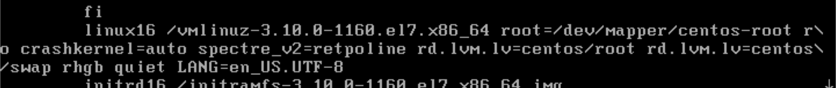
* At the end of the line linux16 after UTF-8 write “init=/bin/bash” and press “ctrl+x”
* Text

  Description automatically generated
* When you see this screen write “mount -o remount,rw /” and hit Enter

Option 1

* Passwd root
* Change a password
* Sudo su –
* Cat /var/log/boot.log | grep -I failed
* Fix the error
* Exit from root
* exec /sbin/init (to reboot)

Option 2

* touch /fastboot and hit Enter
* exec /sbin/init (to reboot in a single user mode)