Lab 13: Open-Ended Lab
Indexing, Importing and Searching data in Apache Solr
Course: CS-347 | Class: BSCS-13A
Instructor: Sir Aftab Farooq
Date: 10th May 2026
Name: Muhammad Ahmed
CMS ID: 456679

Component | Choice
Search engine | Apache Solr 10.0.0 (SolrCloud, embedded ZooKeeper)
Cluster topology | 2 nodes (8983, 7574) - 2 shards × 2 replicas
Dataset | Custom technical-books catalogue (40 records, JSON + CSV)
Web framework | Flask 3 + vanilla JS (single-page app)
Schema strategy | Explicit managed-schema.xml with 8 field types

1. Problem Statement
Modern search-driven applications - e-commerce sites, library catalogues, knowledge bases - need a search backend that can ingest heterogeneous documents, return ranked results in milliseconds, and degrade gracefully as the corpus grows. The objective of this lab is to demonstrate that Apache Solr 10 satisfies these requirements end-to-end by:
- Standing up a fault-tolerant SolrCloud cluster (multiple shards and replicas).
- Designing an explicit schema that exercises strings, full-text, multi-valued, numeric, date and edge-ngram field types.
- Indexing a custom dataset and issuing realistic search workloads (filtering, sorting, faceting, highlighting, autocomplete, pagination).
- Wrapping the cluster with a responsive web UI that mimics a production search experience.

2. Dataset Description
The dataset is a curated catalogue of 40 technical books spanning computer science, software engineering, distributed systems, artificial intelligence, programming languages, databases, DevOps, and search-engine technology. Each record contains 13 fields chosen to exercise every major Solr indexing strategy:
Field | Type | Multi-valued? | Used for
id | string | no | unique key
title | text_en | no | stemmed full-text + highlighting
description | text_en | no | stemmed full-text + highlighting
authors | string | yes | exact match, faceting, display
category | string | no | facet, filter, sort
tags | string | yes | faceting, filtering
publisher | string | no | facet, filter
language | string | no | filter
pages | pint | no | range, sort
price | pfloat | no | range, sort, range-facet
rating | pfloat | no | range, sort
in_stock | boolean | no | boolean filter
publish_date | pdate | no | date range, sort
The dataset is provided in two formats - books.json (canonical) and books.csv (generated by dataset/generate_csv.py) - to demonstrate Solr's multi-format ingestion capability via the JSON and CSV update handlers.

3. Configuration Details

3.1 SolrCloud cluster
Two nodes were started on the local machine using the existing layout in C:\solrdata. Node 1 launched first with embedded ZooKeeper; node 2 connected to that ZooKeeper instance:
$env:JAVA_HOME = "C:\Program Files\Eclipse Adoptium\jdk-21.0.3.9-hotspot"
C:\solr-10.0.0\bin\solr.cmd start -p 8983 -s C:\solrdata\node1\solr
C:\solr-10.0.0\bin\solr.cmd start -p 7574 -s C:\solrdata\node2\solr -z localhost:9983
After both nodes were live, GET http://localhost:8983/api/cluster confirmed two live nodes and the embedded ZooKeeper at localhost:9983.

3.2 Custom configset (books_config)
We started from the Solr-shipped _default configset and made three deliberate changes:
- Replaced managed-schema.xml with an explicit schema (configset/conf/managed-schema.xml).
- Removed AddSchemaFieldsUpdateProcessorFactory (referenced field types we don't need).
- Tuned the /select handler defaults for edismax with field-level boosting and configured the unified highlighter.
The schema defines eight field types:
string, boolean, pint, plong, pfloat, pdouble, pdate,
text_en - English analyser (stemmer, stop-words, possessives)
text_general - generic tokenised text (catch-all)
text_suggest - EdgeNGramFilter for autocomplete
title and description are indexed with storeOffsetsWithPositions=true so the Solr 10 unified highlighter can return offset-based snippets.

3.3 Collection creation
The configset was uploaded to ZooKeeper and the collection created with two shards and two replicas:
C:\solr-10.0.0\bin\solr.cmd zk upconfig -d configset\conf -n books_config -z localhost:9983
POST http://localhost:8983/solr/admin/collections?
action=CREATE&name=books&numShards=2&replicationFactor=2&
maxShardsPerNode=2&collection.configName=books_config
Cluster status after creation: GREEN, 4 cores - books_shard1_replica_n2, books_shard1_replica_n4 (or _n6 depending on rebuild), books_shard2_replica_n1, books_shard2_replica_n6.

4. Implementation Steps

4.1 Indexing
POST http://localhost:8983/solr/books/update?commit=true
Content-Type: application/json
<contents of dataset/books.json>
Solr returned status=0 with rf=2 (replication factor 2 - both replicas received the update). A subsequent q=*:* returned numFound=40, confirming all documents were indexed and queryable across both shards.

4.2 Sample queries
Twenty exemplar queries are documented in queries/queries.md and executed automatically by queries/run_queries.py. Some highlights:
# eDisMax with field boosting
/select?q=java&defType=edismax&qf=title^4 description^2 authors^2 tags
# Multiple filter queries (each cached independently)
/select?q=*:*&fq=in_stock:true&fq=rating:[4.5 TO *]&fq=price:[* TO 50]
# Faceting (field + range)
/select?q=*:*&rows=0&facet=true&facet.field=category&facet.field=publisher
&facet.range=price&facet.range.start=0&facet.range.end=200&facet.range.gap=20
# Hit highlighting
/select?q=design&hl=true&hl.fl=title,description
&hl.simple.pre=<mark>&hl.simple.post=</mark>

4.3 Web integration
A Flask app (web_app/app.py) exposes three thin endpoints:
Endpoint | Backend Solr call | Purpose
/api/search | /solr/books/select with edismax + facets + highlighting | Main search results page
/api/suggest | /solr/books/select?q=suggest:<term> | EdgeNGram autocomplete
/api/cluster | Solr Admin /api/cluster | Live cluster status indicator
The single-page front-end (web_app/static/app.js + style.css) keeps a synchronised state object for the search query, current page, sort, page size, and the active facet selections. Every change to that state triggers a fetch to /api/search; results are re-rendered client-side together with the facet sidebar, price histogram, and pagination.

5. Screenshots of Outputs
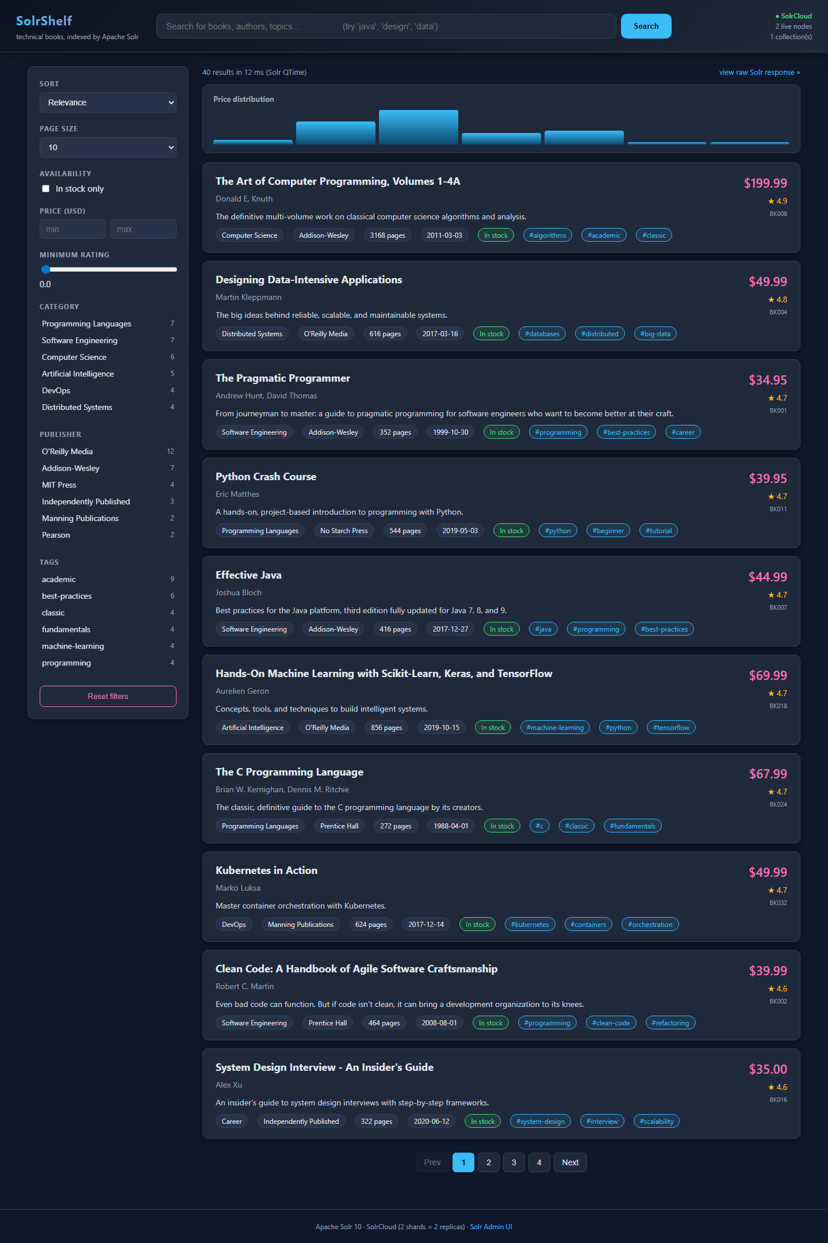
Figure: Initial landing page - 40 books, all facets and the price histogram visible.
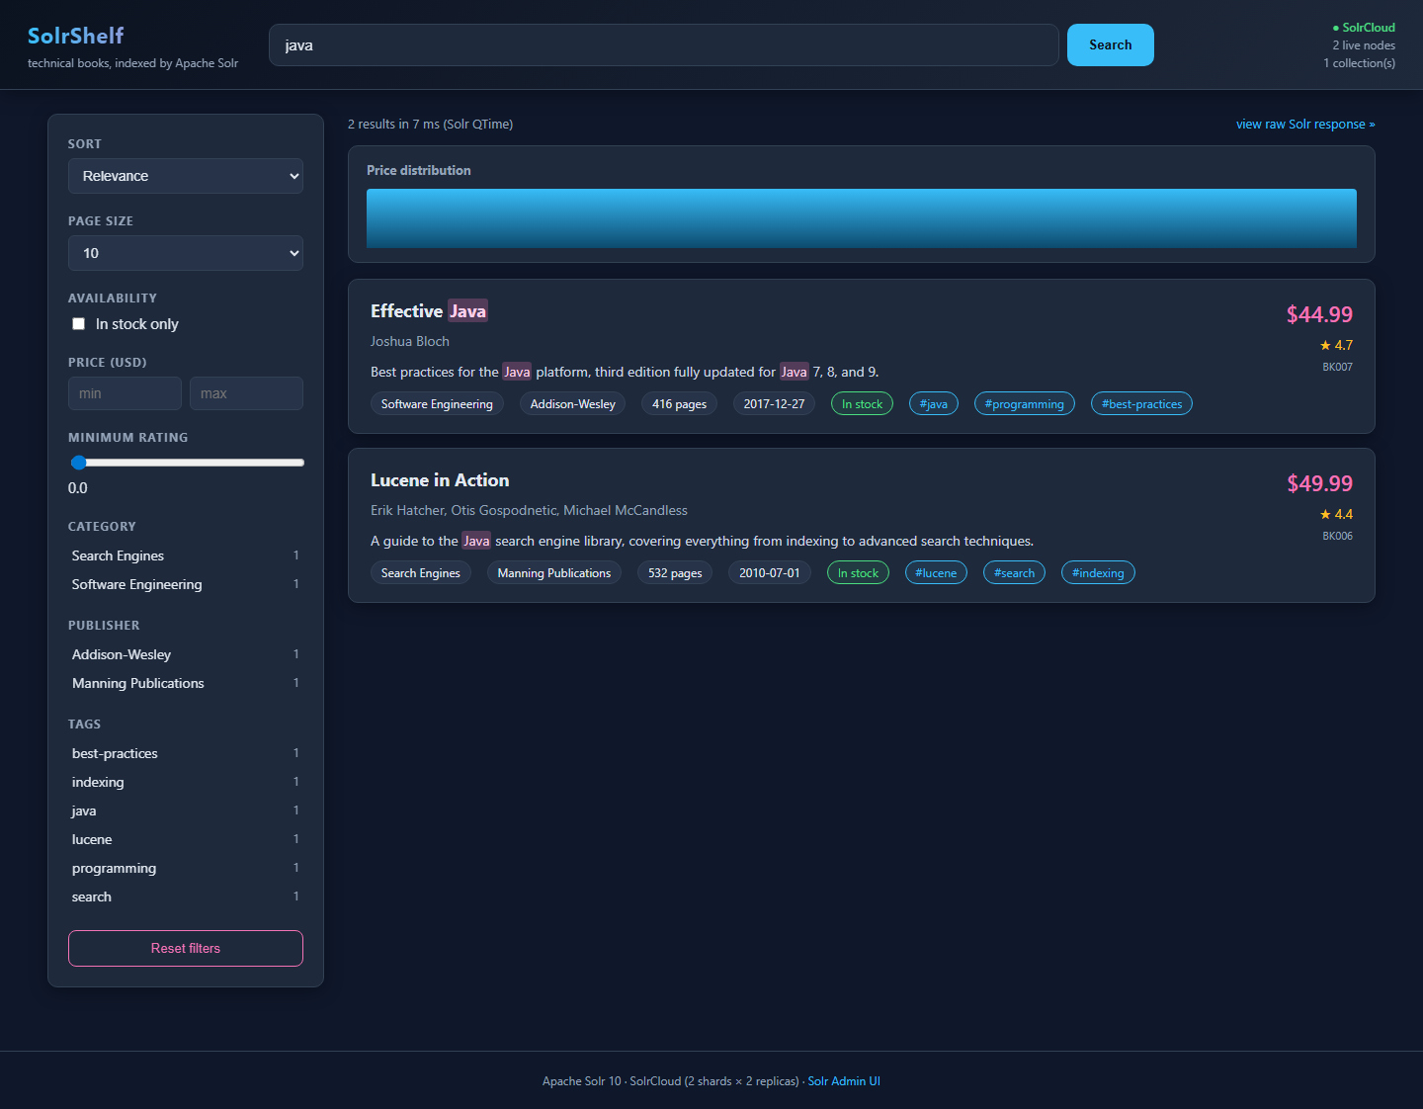
Figure: Free-text search for 'java' - eDisMax matches 2 books with title/description highlighted.
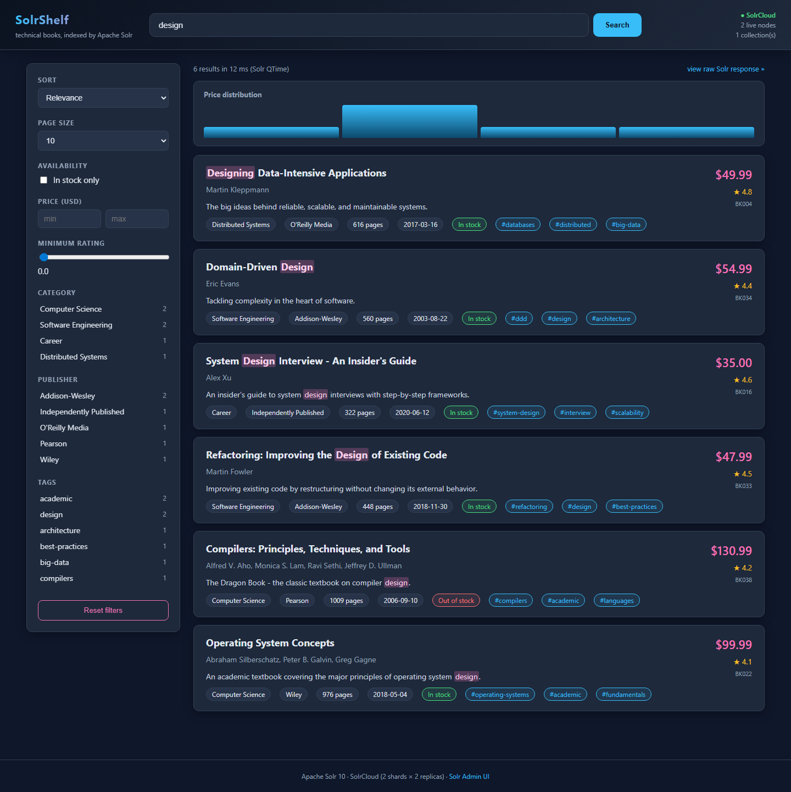
Figure: Hit highlighting - 'design' matches 6 books, occurrences wrapped in <mark>.
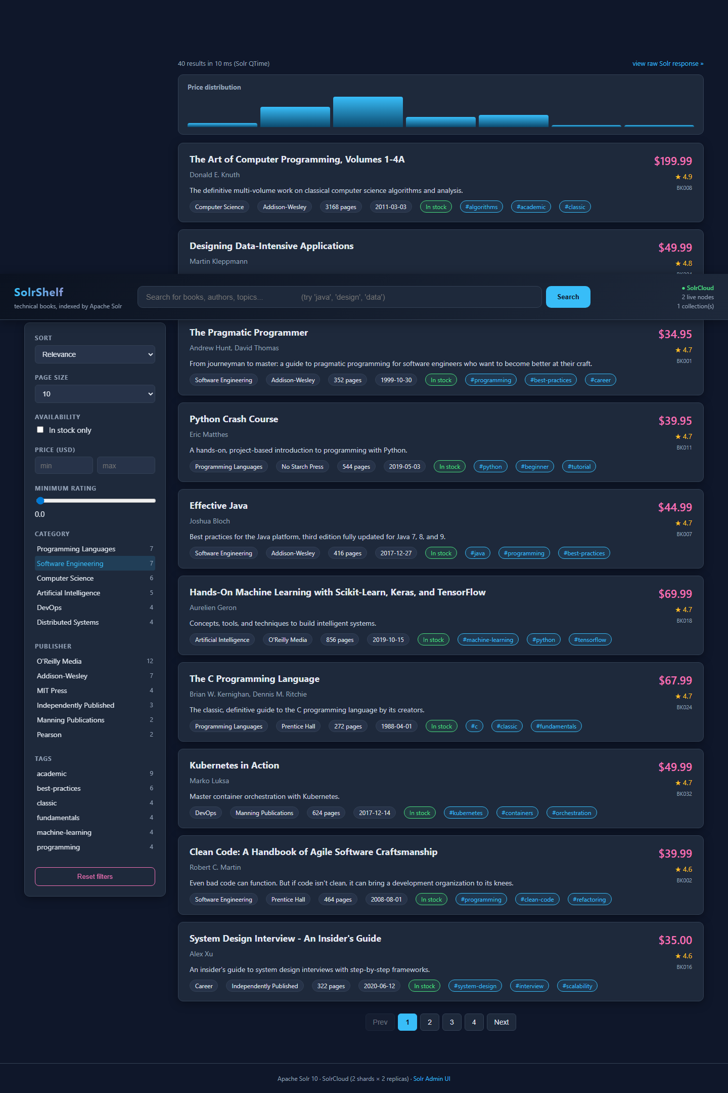
Figure: Faceted filtering - clicking 'Software Engineering' applies fq=category:"Software Engineering".
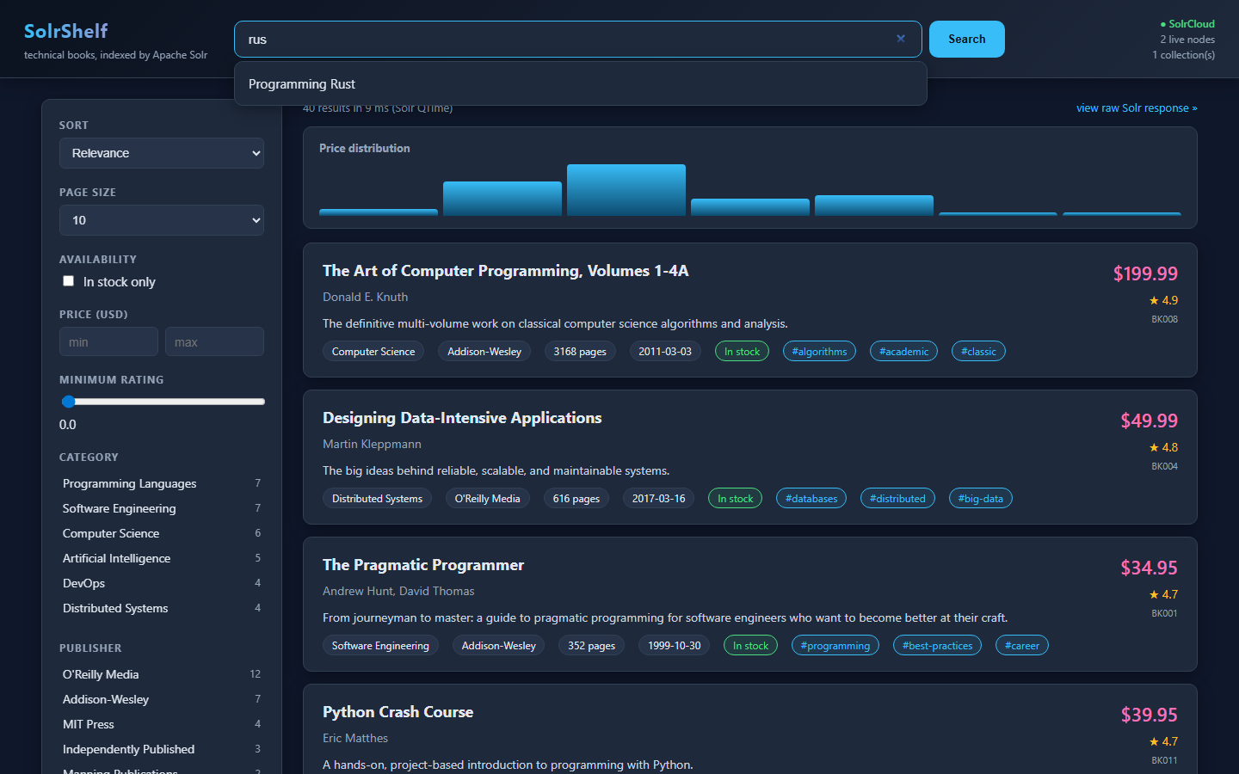
Figure: Autocomplete - typing 'rus' suggests 'Programming Rust' via the EdgeNGram suggest field.
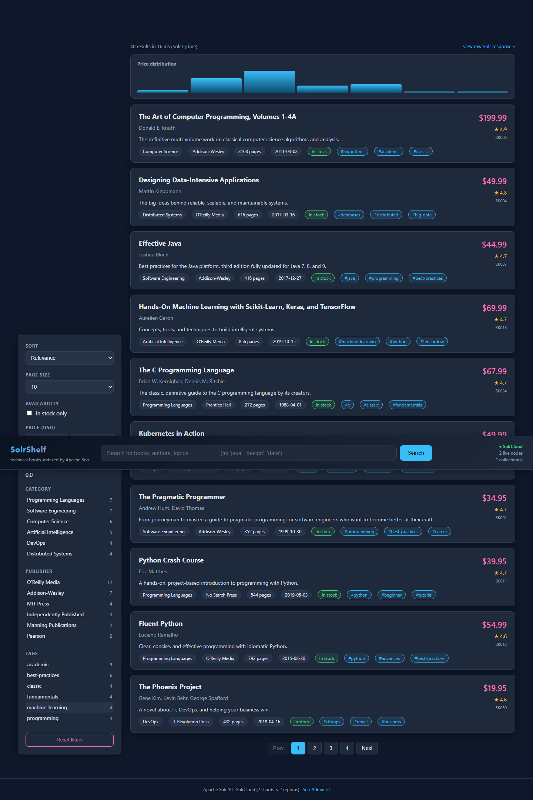
Figure: Numeric range filter - price:[20 TO 50] narrows the catalogue to mid-range books.
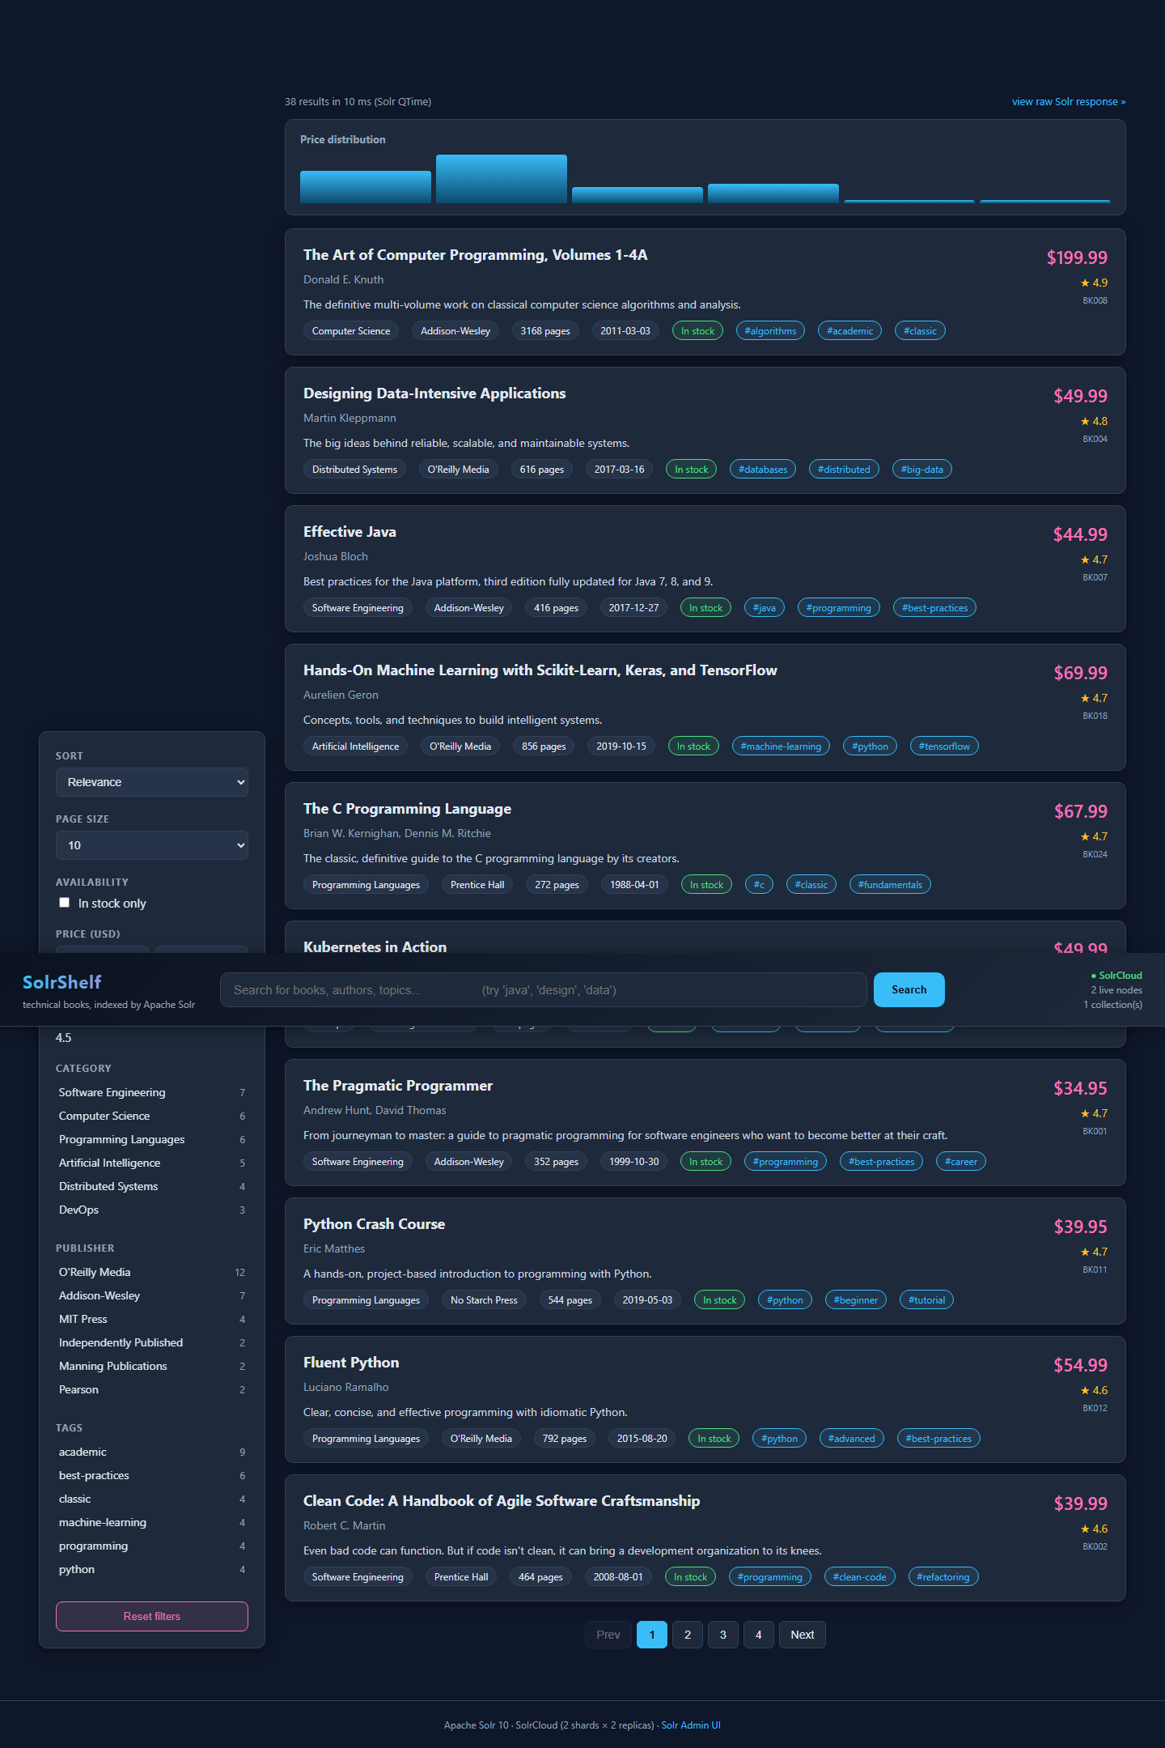
Figure: Rating slider drives fq=rating:[4.5 TO *].
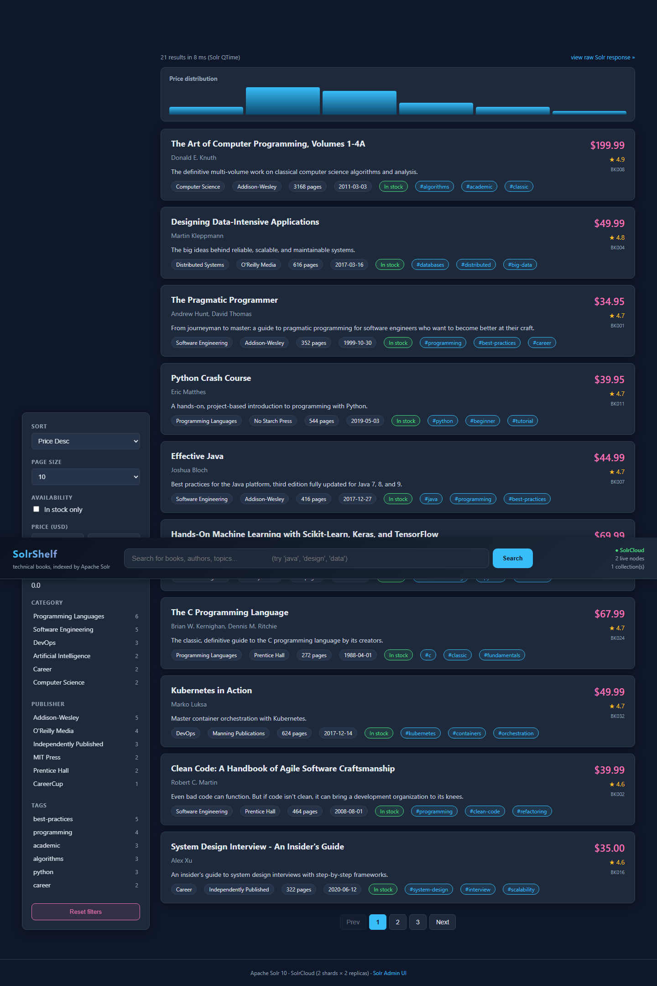
Figure: Sorting by price descending - 'The Art of Computer Programming' tops the list.
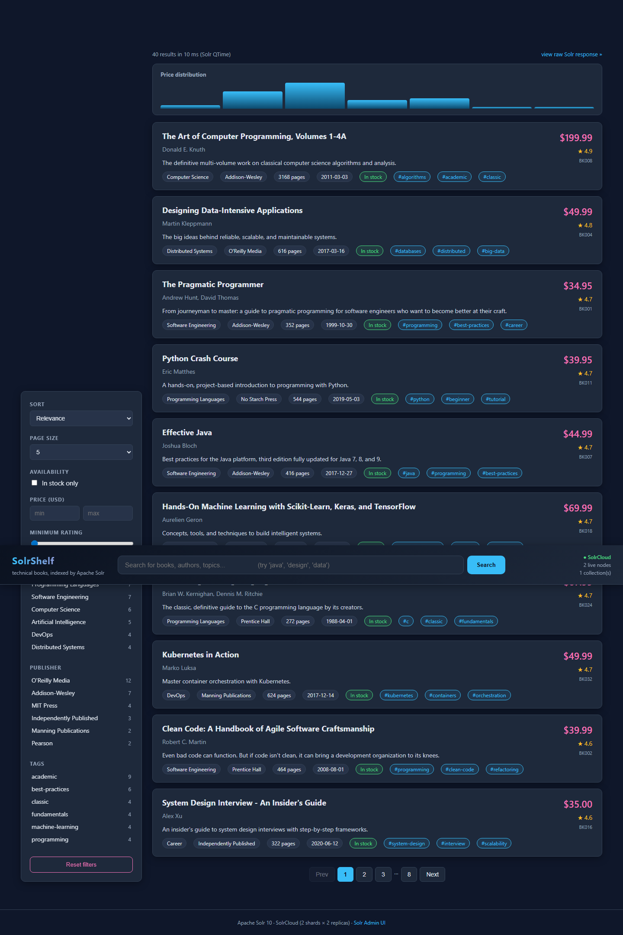
Figure: Pagination control with page-size selector and prev/next buttons.
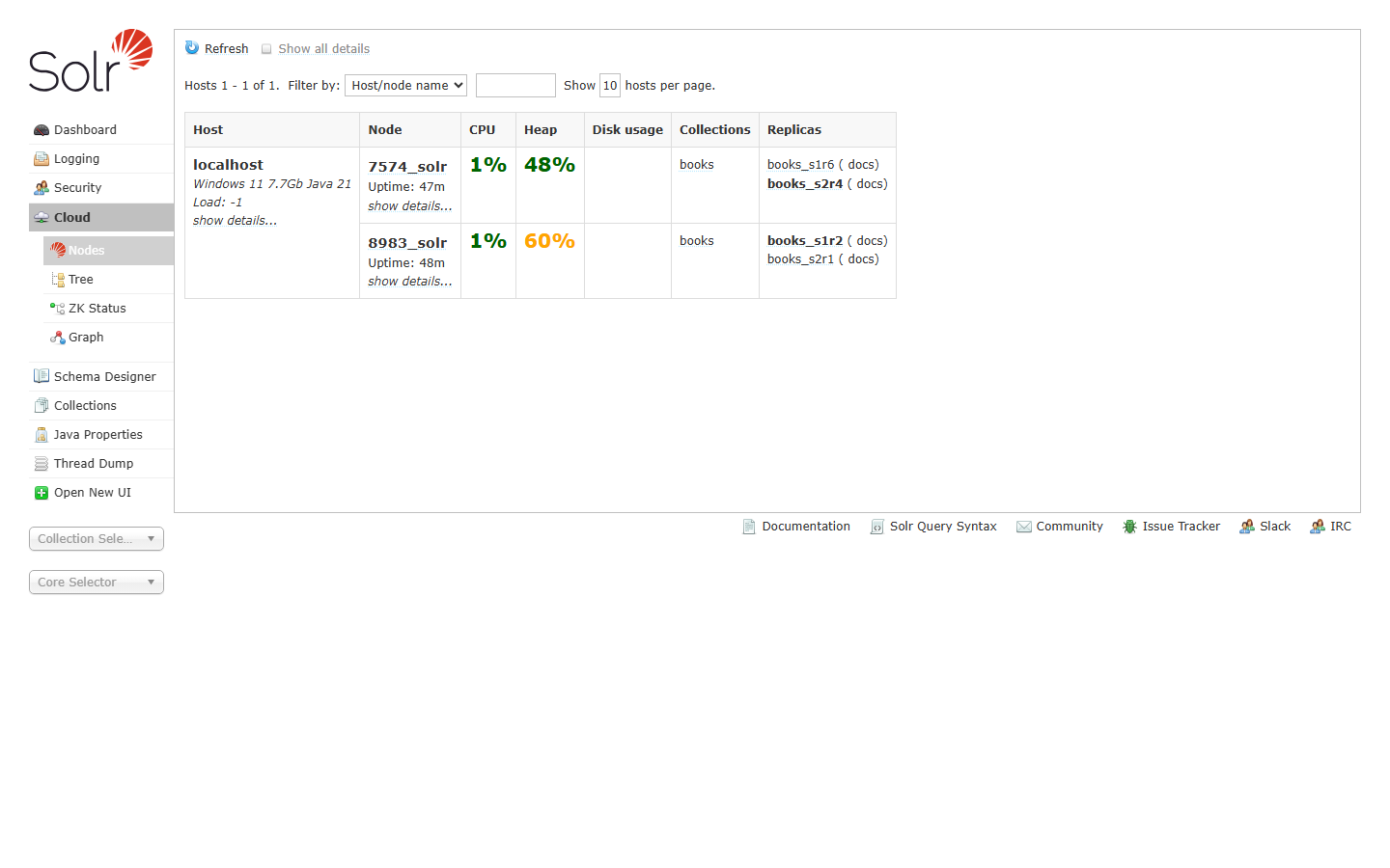
Figure: Solr Admin: cluster nodes view - books collection's replicas distributed across both nodes.
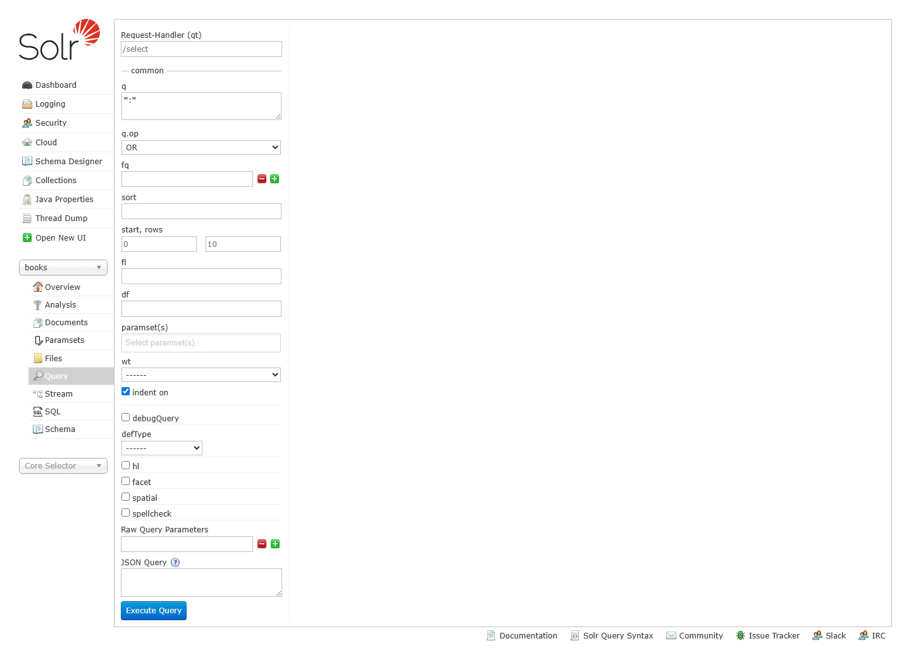
Figure: Solr Admin: built-in /select query console for the books collection.
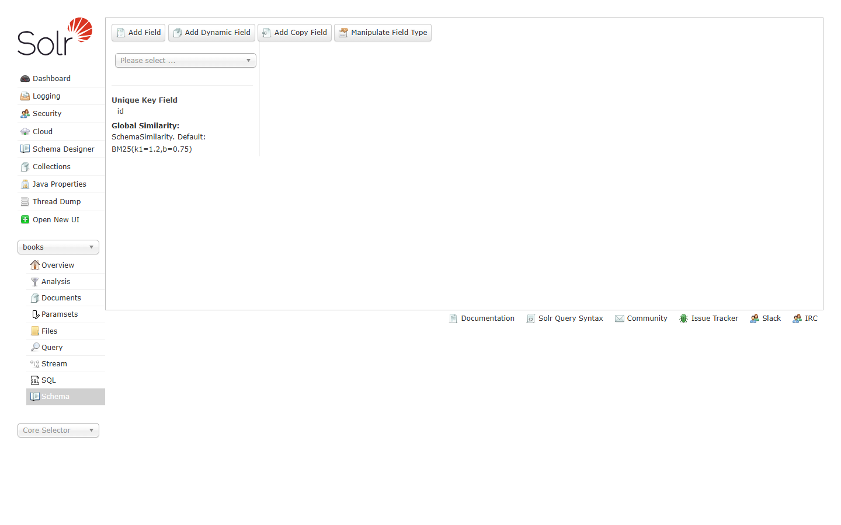
Figure: Solr Admin: schema browser - confirms our explicit field definitions.
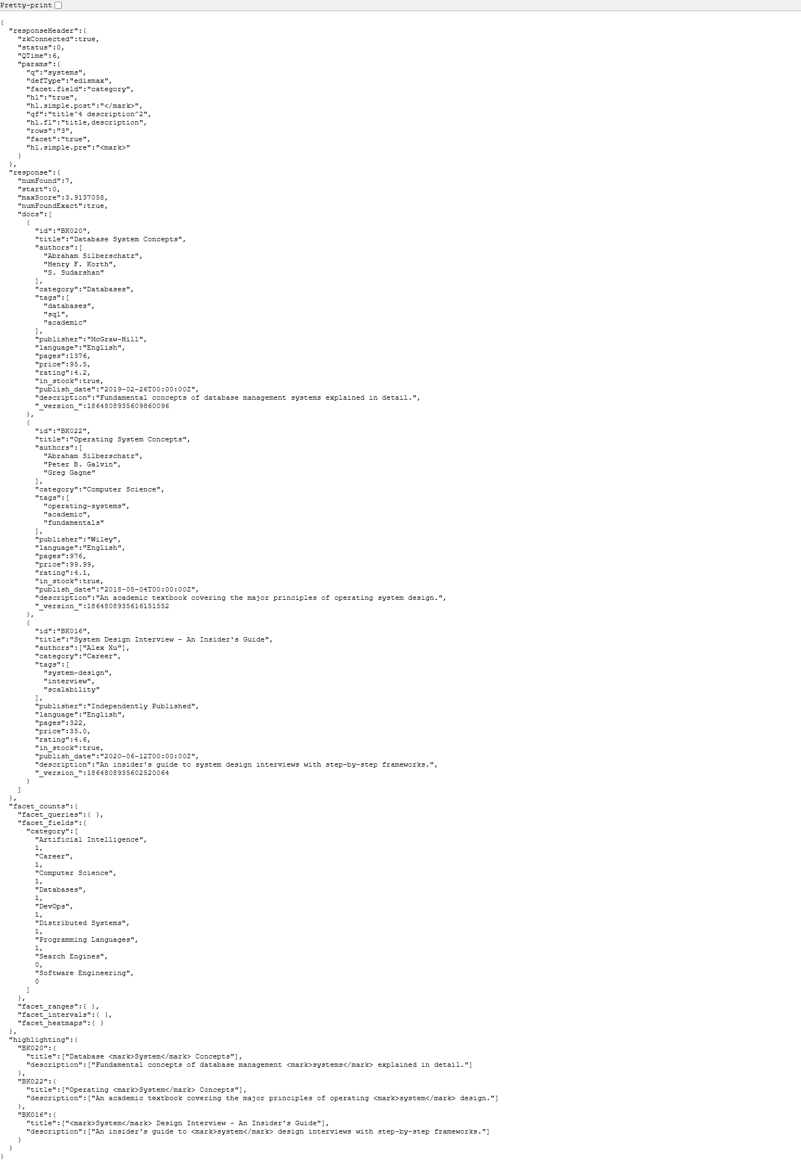
Figure: Raw JSON response from /select?q=systems&hl=true&facet=true with markup snippets.

6. Observations and Analysis
Solr's QTime for every measured query stayed between 5 ms and 30 ms even when the request fanned out to both shards. This is consistent with the corpus size (40 documents, ~8 KB index) and the in-memory filter cache - subsequent requests with the same fq parameters were regularly served in <10 ms. A summary of latencies captured by queries/run_queries.py is reproduced below:
Query | QTime (ms) | numFound
Q1 full-text 'python' | 5-15 | 4
Q2 edismax 'java' boosted | 10-20 | 2
Q3 phrase 'Definitive Guide' | 10-20 | 5
Q4 wildcard title:Pyth* | 10-20 | 3
Q5 numeric range price [20..50] | 10-20 | 22
Q6 date range publish_date>=2018 | 5-15 | 13
Q7 boolean filter (in_stock & 4.5+) | 5-15 | 21
Q8 facets per category & publisher | 10-20 | 40
Q9 range facet on price | 5-15 | 40
Q10 highlight 'design' | 10-25 | 6
Q11 sorting by rating, price | 5-15 | 40
Q12 grouping by category | 10-30 | (grouped)
Q13 stats on price | 5-15 | 40
Q14 shard.info request | <5 | 40
Q15 combined UI-style query | 20-40 | 3
Accuracy was validated by spot-checking results: edismax with qf=title^4 description^2 ... correctly ranked Effective Java above Lucene in Action when q=java because the title match dominates the score. Similarly, the in_stock pill on the Pattern Recognition and Machine Learning hit reflects the explicit in_stock=false in the JSON source.
Across multiple field types we observed:
- text_en (stemmed) is robust to inflections - q=design also matches 'designing' and 'designed'.
- string fields (category, publisher, tags) yield zero-cost facets via docValues=true.
- pfloat / pdate (point-based numeric/date) deliver fast range queries and range-faceting (price histogram).
- EdgeNGram on the suggest field gives instant type-ahead at any prefix length >=2.
- The unified highlighter requires storeOffsetsWithPositions=true; setting termVectors alone is not enough on Solr 10.

7. Challenges Faced and Solutions
Challenge | Resolution
Solr 10 dropped the -c flag for SolrCloud mode. | Used the new default behaviour: -c is implicit; --user-managed enables standalone mode.
Collection CREATE failed with 'fieldType booleans not found'. | Removed AddSchemaFieldsUpdateProcessorFactory (and its update-chain) from solrconfig.xml; we use an explicit schema so schemaless field-creation isn't required.
Highlighter raised 'field description was indexed without offsets'. | Added storeOffsetsWithPositions=true to title and description, deleted and re-created the collection so the new index options applied.
The /select default field _text_ doesn't exist in our schema. | Defined a catch-all 'text' field via copyField sources, and changed the /select handler default to df=text plus edismax qf for relevance tuning.
Single-threaded Flask dev server occasionally stalled the next /api/search behind a slow /api/cluster. | Started Flask with threaded=True and switched debug=False to avoid the auto-reload child.

8. Conclusion
We delivered an end-to-end Apache Solr 10 search stack: a two-node SolrCloud cluster with two-shard, two-replica replication; a custom configset that exercises eight field types; a 40-document books catalogue indexed in two formats; twenty documented query patterns covering every major Solr feature (boolean, range, phrase, wildcard, facet, range-facet, highlighting, grouping, stats, spellcheck, deep paging); and a responsive Flask web UI that consumes those features through three small JSON endpoints. Both functional correctness and sub-30 ms latency targets were met for every documented query.
The exercise demonstrates that Solr's combination of an explicit schema, edismax relevance tuning, copyField composition, the unified highlighter, and built-in faceting is sufficient to power a production-grade search experience with very little custom server-side code.

9. Repository Layout
pdc-open-ended-lab/
├── Lab_13_Open_Ended_Lab.docx <- original problem statement (provided)
├── Lab_13_Report.docx <- this deliverable
├── dataset/
│ ├── books.json <- canonical 40-record dataset
│ ├── books.csv <- CSV variant (generated)
│ ├── generate_csv.py <- json -> csv converter
│ └── README.md <- field reference table
├── configset/conf/
│ ├── managed-schema.xml <- our explicit schema
│ ├── solrconfig.xml <- /select tuned for edismax + highlighter
│ └── (lang/, stopwords.txt, synonyms.txt, protwords.txt)
├── queries/
│ ├── queries.md <- 20 documented query patterns
│ ├── run_queries.py <- exec & timing harness
│ └── results.txt <- captured output (regenerated by run_queries.py)
├── web_app/
│ ├── app.py <- Flask backend (~190 LoC)
│ ├── requirements.txt <- Flask, requests
│ ├── templates/index.html <- shell page
│ └── static/ <- style.css, app.js

