GET /api/books | List all | 200 OK

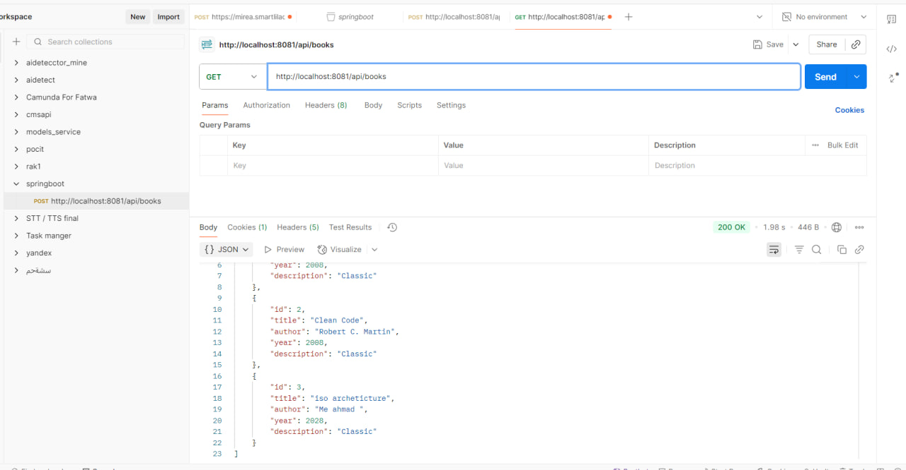

GET /api/books/{id} | Get one| 200 OK

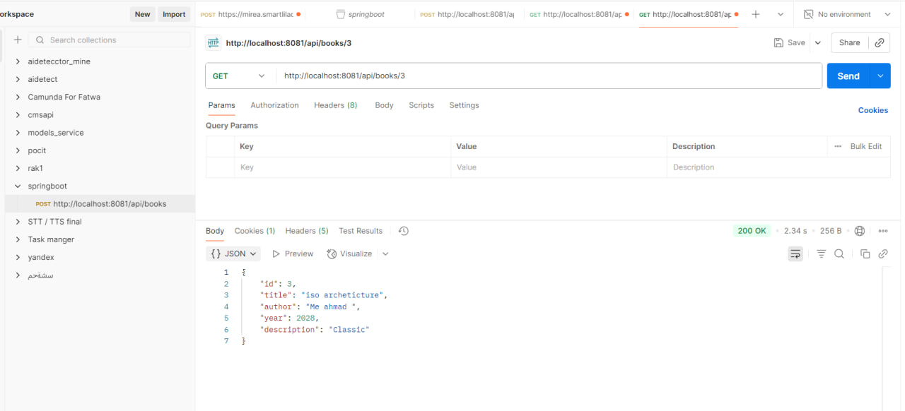

GET /api/books/{id} | Get one| 404 Not Found

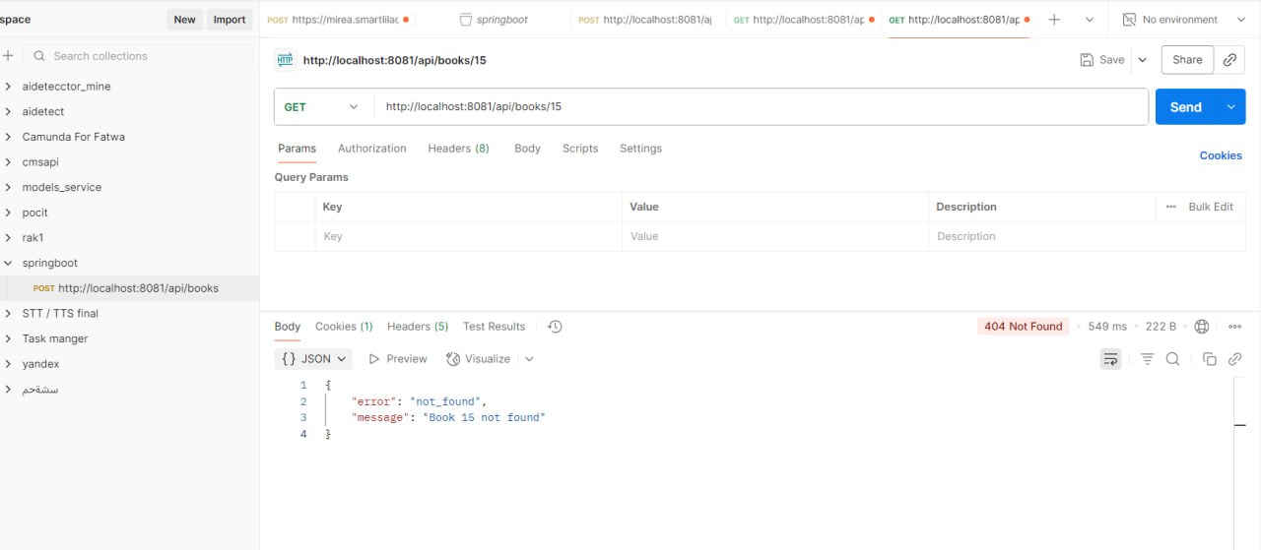

POST /api/books| Create | 201 Created

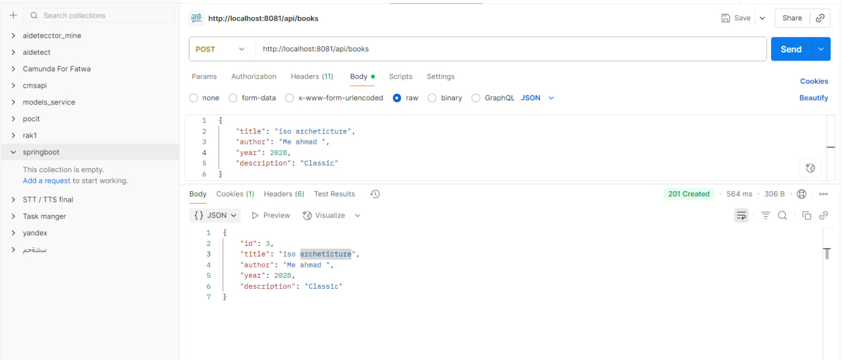

POST /api/books| Create | 400 Bad Request

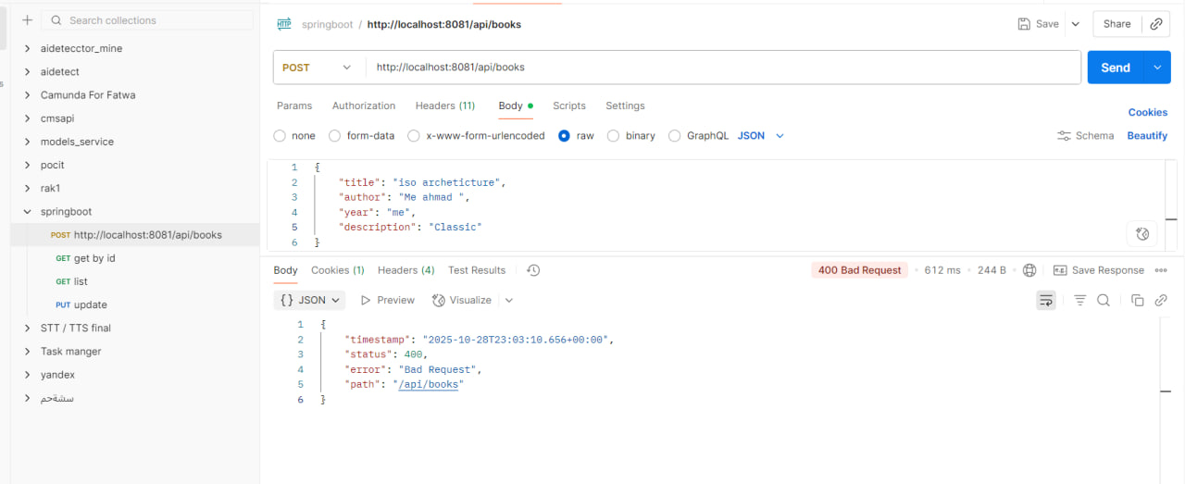

PUT /api/books/{id} | Update | 200 OK

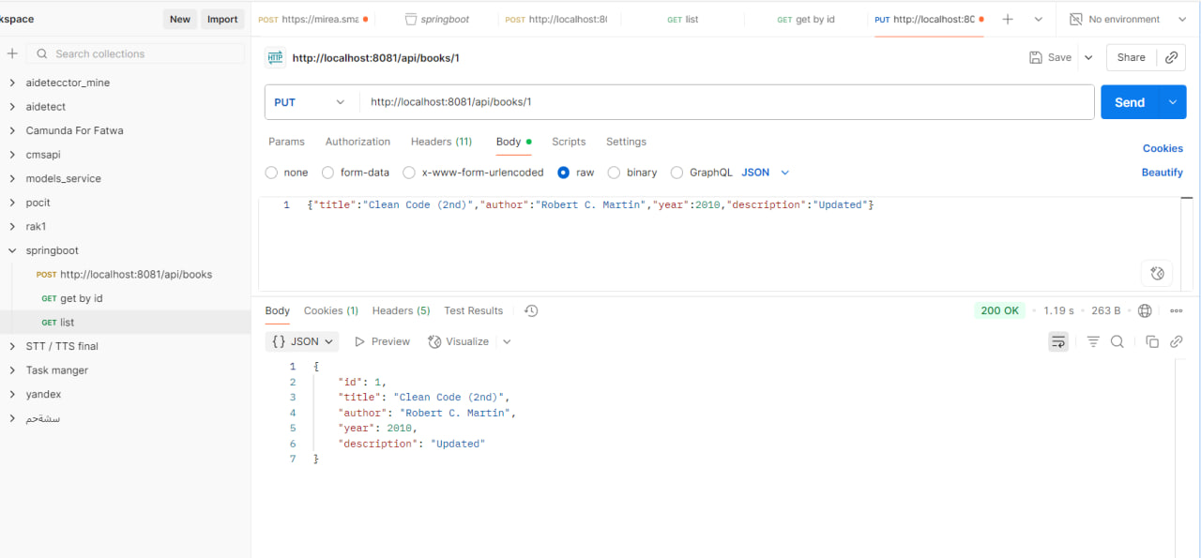

DELETE /api/books/{id} | Delete| 204 No Content

