Title: Unmasking Heterogeneous Treatment Effects in Clinical Trials: A "Location-Scale" Quantile Meta-Analysis Framework (IPD-QMA)
]

Abstract
Background
Randomized controlled trial (RCT) their meta-analysis of RCTs is the basis of evidence-based medicine. Traditional meta-analysis aggregates treatment effects using Mean Difference (MD) as a summary measure. This approach uses the "location shift" assumption which is that the treatment shifts the outcome distribution uniformly for all patients. In more complex medical domains such as psychiatry, oncology, and critical care these interventions can create a "location-scale shift,". This increases outcome variance without changing the overall mean. Standard methods may then fail to detect efficacy in these scenarios. This will potentially discard treatments that can benefit high-risk subgroups while harming the low-risk ones.
Methods
We introduce a new method which is the Individual Participant Data Quantile Meta-Analysis (IPD-QMA). This Two-Stage framework uses Quantile Regression to estimate treatment effects across the severity distribution (τ = 0.1 to 0.9) within studies. It then pools these coefficients using a Random Effects model. We compared IPD-QMA against the Standard Meta-Analysis (Mean Difference) and the Log Variance Ratio (lnVR) using 10,000 Monte Carlo simulations. We used this to test both Normal and Skewed (Exponential) distributions to assess robustness. We also created a "Slope Test" (Wald statistic) to formally test the hypothesis of effect homogeneity.
Results
In "hidden utility" scenarios where a treatment can increase variance (scale × 3) however not the mean. In these Standard Meta-Analysis demonstrated a statistical power of only 5.3% (Normal distribution) to 14.0% (Skewed distribution). This stops if from effectively failing to detect any therapeutic signal. IPD-QMA in comparison demonstrated 100% power to detect significant benefits at the 90th percentile. The Log Variance Ratio (lnVR) detected heterogeneity with high power, but it lacked directionality. It was unable to truly distinguish benefit from harm. IPD-QMA in contrast gave a detailed "Quantile Profile". This revealed that the treatment was harmful for mild cases but highly effective for severe cases.
Conclusion
IPD-QMA can be a necessary diagnostic tool for precision medicine.SO while lnVR acts as a screening tool for heterogeneity in contrast IPD-QMA characterizes the shape of the effect. This can prevent the loss of potentially life-saving interventions for high-risk populations. We also provide an open-source software implementation to help the adoption of this method.

Introduction
The Limits of the Average
Systematic reviews and meta-analyses form the highest level of evidence in clinical medicine [1]. These are designed to take data from multiple trials to estimate a "true" treatment effect with greater precision than any single study. Most meta-analyses rely on summary statistics—specifically measures of central tendency such as the Mean Difference (MD), Standardized Mean Difference (SMD), or Odds Ratio (OR)—to aggregate results [2].
In this emphasis on the mean is the statistical assumption of a "location shift." This is the assumption that the biological action of a treatment will shift the outcome distribution of the treated population uniformly relative to the control group. We assume the "average patient" is a valid proxy for the entire population. Clinical reality is rarely uniform. Patients even within a clinical trial differ significantly in genetic predisposition, disease severity, comorbidities, and baseline risk. These factors then interact with the treatment. This leads to Heterogeneity of Treatment Effects (HTE) [3].
The Location-Scale Problem
A difficult form of heterogeneity is the "location-scale shift." In this an intervention does not merely shift the mean (location) but also changes the spread (scale) of the outcome distribution [4].
Consider a novel vasodilator administered for sepsis. For patients in mild shock (low risk), the drug may cause dangerous hypotension. This can lead to worse outcomes (a negative effect at the lower tail). Yet for a patient in severe septic shock (high risk), the same drug might restore perfusion. This could in turn prevent organ failure (a positive effect at the upper tail). So, the trial enrols a mix of mild and severe patients. In that case these opposing effects may algebraically cancel each other out. The resulting Mean Difference would be near zero.
A standard meta-analysis of such trials could conclude that the treatment is "ineffective" (p > 0.05). This while statistically accurate regarding the average, is clinically wrong. It causes the the abandonment of a therapy that is life-saving for the sickest patients. This is only because it is toxic to the healthiest [5].
Limitations of Current Solutions
The current toolkit for handling heterogeneity at this moment includes subgroup analysis and meta-regression. While useful, these methods have known and significant limitations:
- Low Power: Subgroup analyses often lack statistical power to detect differences. This is because they split the sample size [6].
- Ecological Fallacy: Meta-regression relies on study-level aggregate data (e.g., "percentage of patients with severe disease").To correlate study-level averages with study-level effects can lead to the ecological fallacy. This is where relationships observed across groups do not actually hold for individuals [7].
- Arbitrary Cutoffs: Defining subgroups (e.g., "Age > 65" or "Sepsis Score > 10") requires arbitrary dichotomization. This in turn results in a loss of information.
Recently, the analysis of variance itself has started to see more new work. The Log Variance Ratio (lnVR) was proposed as a metric to compare the variability of the treatment group versus the control group [8]. A significant lnVR is a "red flag" that indicates heterogeneity exists. It is however a non-specific screening tool. It cannot tell a clinician who is affected. A treatment group might have higher variance because the drug helps everyone variably. That is because it helps some and hurts others.
The Proposal: IPD-QMA
To address we have created a framework based on Quantile Regression [9]. Unlike ordinary least squares regression, which estimates the conditional mean, quantile regression instead estimates the conditional median (0.50) or any other quantile (e.g., 0.10, 0.90) of the outcome distribution.
Through applying this to meta-analysis, we construct a "Quantile Profile" of the treatment effect. So rather than asking, "Does the treatment work?". Instead we can ask, "For which slice of the severity distribution does the treatment work?"
In this paper we present Individual Participant Data Quantile Meta-Analysis (IPD-QMA). We lay out a Two-Stage computational framework for this method. We then validate it through extensive Monte Carlo simulations involving both Normal and skewed distributions. This demonstrates its true ability to "unmask" treatment effects that standard methods miss.

Materials and Methods
Overview of the Framework
We utilize a Two-Stage Individual Participant Data (IPD) approach [10]. "One-Stage" models (analysing all patients in a single hierarchical model) can be attractive. Two-Stage models are often more used in practice due to their computational efficiency and convergence stability. They are also ability to easily handle summary steps using standard meta-analytic software.
Mathematical Formulation
Stage 1: Within-Study Estimation
Let us think of a meta-analysis of K studies. For a specific study k (where k = 1...K), let the sample size be n. For the i-th patient in this study, let:
- $y_{ik}$

be the continuous outcome variable (e.g., symptom score, duration of stay).
- $T_{ik}$

be the binary treatment indicator (0 for Control, 1 for Treatment).
Standard regression usually minimizes the sum of squared residuals to find the mean. Quantile Regression minimizes a weighted sum of absolute residuals. To estimate the treatment effect
$β$

at a specific quantile
$τ$

(where $0<τ<1$), we solve the following optimization problem:
Equation 1:
$${\hat{β}}_{k,τ}=arg⁡min⁡β\sum_{i=1}^{n_{k}}{ρ_{τ}}(y_{ik}-(α_{k}+βT_{ik}))$$

Here,
$ρ_{τ}$

is the "check function" (or pinball loss function), defined as:
Equation 2:
$$ρ_{τ}(u)=u×(τ-I(u<0))$$

where $I(.)$ is the indicator function. This function weights positive residuals by $τ$ and negative residuals by $\left(1 − τ\right)$

. For example, if we are interested in the 90th percentile $(τ=0.9$), positive errors are weighted heavily (0.9) and negative errors lightly (0.1), forcing the regression line to fit the upper tail of the data.
Standard Error Estimation via Bootstrapping
Analytical calculation of standard errors in quantile regression can rely on asymptotic assumptions about the density of the error term. This can be unreliable in the small sample sizes typical of clinical trials [11]. Therefore, we employ a nonparametric Bootstrap approach.
For each study k:
- We resample the dataset n times with replacement.
- We re-estimate
- $β_{k,τ}$

for the resampled data.
- We repeat this process B = 200 times.
- The standard deviation of the B bootstrap estimates is taken as the Standard Error,
$SE({\hat{β}}_{k,τ})$

Stage 2: Between-Study Synthesis
Once we have extracted the coefficient
${\hat{β}}_{k,τ}$

and its standard error from all K studies, we synthesize them using standard meta-analytic techniques. We employ the DerSimonian and Laird (DL) Random Effects model [12], which assumes the true treatment effect varies between studies:
Equation 3:
$${\hat{θ}}_{τ}=\frac{\sum_{k=1}^{K}{w_{k,τ}}{\hat{β}}_{k,τ}}{\sum_{k=1}^{K}{w_{k,τ}}}$$

The weights
$w_{k,τ}$

are calculated as the inverse of the sum of the within-study variance and the between-study heterogeneity variance ($τ_{het}^{2}$).
This entire process is repeated for a vector of quantiles
$τ∈[0.10,0.25,0.50,0.75,0.90]$

. Plotting these pooled estimates (${\hat{θ}}_{τ}$) against $τ$ generates the Quantile Profile.
The Slope Test (Testing for Heterogeneity)
Visual inspection of the Quantile Profile is informative. A formal statistical test is however required to confirm that the treatment effect is indeed non-uniform. We define the Inter-Quantile Slope ($Δ$) as the difference between the effect at the 90th percentile and the effect at the 10th percentile:
Equation 4:
$$Δ={\hat{θ}}_{0.9}-{\hat{θ}}_{0.1}$$

We test the null hypothesis of homogeneity ($H_{0}:Δ=0$). If the null is not rejected, we conclude the treatment effect is constant (a pure location shift). If rejected, we conclude the effect varies by severity.
Calculating the variance of
$Δ$

is non-trivial because
${\hat{θ}}_{0.9}$

and
${\hat{θ}}_{0.1}$

are correlated (they are estimated from the same set of patients). To address this, we compute
$Δ$

within each bootstrap iteration in Stage 1, preserving the covariance structure. The pooled
$Δ$

and its bootstrap-derived standard error are then used to calculate a Wald Statistic (
$Z=Δ/SE_{Δ}$

), yielding a p-value for heterogeneity.
Simulation Study Design
To validate the IPD-QMA framework, we designed a large-scale Monte Carlo simulation ("Stress Test"). The objective was to simulate a "hidden utility" scenario where a treatment increases variance but has zero effect on the mean.
Simulation Parameters:
- Iterations: 10,000 independent meta-analyses.
- Studies per Meta-Analysis: K = 20.
- Sample Size per Study: Uniformly distributed N ~ U(100, 300).
Scenario: The Location-Scale Shift
We generated data such that the Control and Treatment groups had identical Means, but the Treatment group had significantly higher Variance (Scale × 3). We tested two distributional forms to check for robustness against non-normality:
- Normal Distribution:
  - Control Group:
$y∼Normal(μ=0,σ=1)$

  - Treatment Group:
$y∼Normal(μ=0,σ=3)$

  - True Mean Difference: 0
  - True Q90 Difference: Positive (+2.56)

- Skewed Distribution (Exponential):
  - Control Group:
$y∼Exponential(λ=1)$

(Centered to Mean=0)
  - Treatment Group:
$y∼ScaledExponential(λ=1)×3$

(Centered to Mean=0)
  - True Mean Difference: 0
  - Note: Exponential distributions are highly skewed and mimic real-world data like hospital costs or duration of stay.
Comparison Metrics:
We compared the statistical power (ability to reject the null hypothesis at $α=0.05$) of four approaches:
- Standard Meta-Analysis: Pooling Mean Differences using Random Effects.
- Log Variance Ratio (lnVR): Comparing the ratio of variances.
- IPD-QMA: Testing the effect at
$τ=0.9$ (High Risk).
- The Slope Test: Testing if
$Δ≠0$

.

Distributional Sensitivity Analysis

To evaluate the performance of Individual Participant Data Quantile Meta-Analysis (IPD-QMA) against Standard Meta-Analysis (Mean Difference) we carried out 1,000 Monte Carlo simulations. Our simulation parameters were defined clearly. This was so that the treatment effect caused a significant increase in the variance of the outcome (VarT > VarC) while still maintaining an identical mean (MeanT = MeanC). This scenario simulated "Heterogeneity of Treatment Effect" so where the intervention benefits some participants ( while potentially harming others, resulting in a zero net change in the average).

Visualization and P-value Distribution

We looked at the discriminatory power of each model by plotting the resulting p-values. Though a true null effect typically produces a Uniform Distribution (where p is distributed evenly between 0 and 1), an effective model should demonstrate a sharp "pile-up" near zero.

With the extreme sensitivity of the IPD-QMA approach in this scenario, the majority of its p-values were concentrated in the p < 0.001 bin. We wanted to try and make sure the frequency of these highly significant results remained distinguishable from the stochastic "noise" of the standard Mean Difference model. We used a logarithmic scale on the y-axis (Frequency). This transformation is important for visualizing the orders of magnitude difference in detection power that would otherwise be obscured on a standard linear scale.

Results
The simulation study required nearly 2 hours of computational time on a standard workstation. The results support the validity of the IPD-QMA framework.
1. Performance on Normal Data
In the first scenario (Normal distributions), the true Mean Difference was exactly zero.
- Standard Meta-Analysis: The rejection rate was found to be 5.3%. This is indistinguishable from the nominal Type I error rate (5%), confirming that standard meta-analysis failed to detect that the treatment was having any effect on the population which was wrong.
- Log Variance Ratio (lnVR): The rejection rate was 100%. This method correctly identified that the variances were different.
- IPD-QMA ($τ=0.9$): The rejection rate was 100%. The method correctly identified that for the top 10% of the distribution- the treatment significantly increased the outcome values.
2. Performance on Skewed Data (Robustness Check)
In the second scenario (Exponential distributions), the data was heavily skewed. This was a stress test for the stability of the estimators.
- Standard Meta-Analysis: The rejection rate now rose to 14.0%. This "false positive" inflation suggests that standard T-tests and Random Effects models become heavily unstable when the underlying data is heteroscedastic and skewed. The method is really erratic in this domain.
- IPD-QMA ($τ=0.9$): The rejection rate remained at 100%. Because quantile regression is rank-based, it is fully inherently robust to skewness and outliers. It accurately detected the tail effect without being thrown off by the non-normal shape of the data at all.
Table 1: Summary of Simulation Results (Power Analysis)
Method | Normal Data Power | Skewed Data Power | Interpretation
Standard MA (Mean) | 5.3% (Random Noise) | 14.0% (Erratic) | Failed. No consistent signal detected.
Log Variance (lnVR) | 100% | 100% | Success (Screening). Detected heterogeneity.
IPD-QMA (τ = 0.9) | 100% | 100% | Success (Diagnostic). Detected specific benefit.
Slope Test | 100% | 100% | Success. Confirmed effect asymmetry.
3. The Quantile Profile (The "Fan Plot")
Beyond binary pass/fail metrics, the primary output of IPD-QMA is the "Quantile Profile" or "Fan Plot."
Averaging across the simulations, the estimated effects were:
- 10th Percentile ($τ=0.1$): Effect
$≈$

-2.5. The treatment was significantly harmful for the lowest-risk patients.
- Median ($τ=0.5$): Effect
$≈$

0. The treatment had no effect on the "average" patient.
- 90th Percentile ($τ=0.9$): Effect
$≈$

+2.5. The treatment was significantly beneficial for the highest-risk patients.
The Slope Test confirmed that this difference (from -2.5 to +2.5) was statistically significant (p < 0.001), formally rejecting the hypothesis that the treatment acts uniformly.

Discussion
The Fallacy of the Average
The central finding of this study is that standard meta-analysis is mostly blind to location-scale shifts. In these simulations, a treatment that was lifesaving for the sickest 10% of patients was deemed "ineffective" by standard methods because it was cancelled out by harm to the healthiest 10%. This corresponds to a "failed" Phase 3 trial in a clinical context. The trial did not fail because the drug was inert. It failed because the statistical summary (the mean) was insufficient to show the reality.
Screening vs. Diagnosis: The lnVR Comparison
This paper compares the Log Variance Ratio (lnVR) and IPD-QMA. Our results show that lnVR has excellent power (100%) to reject the null hypothesis. Thenwhy implement the more complex IPD-QMA if lnVR works?
We would argue that lnVR is a screening tool, whereas IPD-QMA is a diagnostic tool.
- A significant lnVR says to a researcher: "The treatment group outcome is more variable than the control." This should be an alarm bell. This might mean the treatment helps the sick and hurts the healthy (as in our simulation). It could also mean the treatment is simply chaotic. This might be adding random noise to everyone. It could also mean the treatment pushes everyone toward the extremes.
- IPD-QMA deconvolutes the signal. It gives the directionality needed for clinical decision-making. It can tell the clinician: "This treatment increases variance specifically by improving outcomes for severe patients but worsens them for mild patients."
We suggest a hierarchical workflow. Researchers can calculate lnVR as a quick check for heterogeneity. If lnVR is found to be significant, IPD-QMA should be performed to characterize the shape of that heterogeneity.
Robustness and Stability
Our simulation on Skewed (Exponential) data did highlight a subtle but crucial flaw in standard meta-analysis. The Mean Difference method resulted in a 14% rejection rate when the null was true (Mean Diff = 0). This tells us that in the presence of heavy tails and unequal variances, the parametric assumptions of standard meta-analysis break down. This leads to unpredictable false positives.
Quantile Regression however is semi-parametric. It does not assume a normality of the error terms. Our results are that IPD-QMA maintains high power and stability even when data is highly skewed. This makes it particularly suitable for healthcare cost data, length of stay, or biomarker concentrations.
Limitations and Barriers
The primary limitation of IPD-QMA is a requirement for Individual Participant Data. Standard meta-analysis which can be conducted using summary tables (Means and SDs) from PDFs. IPD-QMA requires the raw row-level data.
Obtaining IPD used to be a prohibitive barrier. However, the landscape of clinical research is changing toward transparency. Initiatives such as the Yale Open Data Access (YODA) project, ClinicalStudyDataRequest.com, and the COMET initiative are made IPD increasingly accessible [9]. Journals now often mandate data sharing statements.
Another limitation is computational cost. Our Bootstrapping of 20 studies with 200 iterations each requires significantly more processing power than a simple weighted average. The entire analysis of a single meta-analysis took less than 1 second on a standard laptop for this paper. With modern computing this is not an issue.
Future Directions
Future work will hopefully explore One-Stage IPD-QMA models using hierarchical Bayesian frameworks. A One-Stage model may theoretically handle smaller sample sizes more effectively. This is by borrowing strength across studies for the estimation of tail quantiles. Expanding this framework to handle time-to-event data (Quantile Survival Analysis) may be valuable for oncology trials.

Conclusion
Precision medicine requires good statistics. The "average treatment effect" we feel is a blunt instrument that can obscure the true value of an intervention. We present IPD-QMA, a robust framework for detecting and characterizing heterogeneous treatment effects.
Our simulations demonstrate that IPD-QMA can work on trials that fail standard analysis due to location-scale shifts. Through showing the hidden utility in the tails of the distribution method enables a more nuanced understanding of efficacy. This moves us closer to the real goal of treating the right patient with the right therapy.

References
- Sutton AJ, Abrams KR, Jones DR, Sheldon TA, Song F. Methods for Meta-Analysis in Medical Research. Wiley; 2000.
- Borenstein M, Hedges LV, Higgins JPT, Rothstein HR. Introduction to Meta-Analysis. Wiley; 2009.
- Kent DM, Rothwell PM, Ioannidis JP, Altman DG, Hayward RA. Assessing and reporting heterogeneity in treatment effects in clinical trials: a proposal. Trials. 2010;11:85.
- Hoaglin DC. Misunderstandings about Q and 'Cochran's Q'. Statistics in Medicine. 2016;35(4):485-495.
- Iwashyna TJ, Burke JF, Sussman JB, Prescott HC, Hayward RA, Angus DC. Implications of Heterogeneity of Treatment Effect for Reporting and Analysis of Randomized Trials in Critical Care. Am J Respir Crit Care Med. 2015;192(9):1045-1051.
- Brookes ST, Whitley E, Peters TJ, Mulheran PA, Egger M, Davey Smith G. Subgroup analyses in randomized controlled trials: quantifying the risks of false-positives and false-negatives. Health Technology Assessment. 2001;5(33).
- Berlin JA, Santanna J, Schmid CH, Szczech LA, Feldman HI. Individual patient- versus group-level data meta-regressions for the investigation of treatment effect modifiers: ecological bias rears its ugly head. Statistics in Medicine. 2002;21(3):371-387.
- Nakagawa S, Poulin R, Mengersen K, et al. Meta-analysis of variation: ecological and evolutionary applications and beyond. Methods in Ecology and Evolution. 2015;6(2):143-152.
- Koenker R, Bassett G. Regression Quantiles. Econometrica. 1978;46(1):33-50.
- Riley RD, Lambert PC, Abo-Zaid G. Meta-analysis of individual participant data: rationale, conduct, and reporting. BMJ. 2010;340:c221.
- Efron B. Bootstrap Methods: Another Look at the Jackknife. The Annals of Statistics. 1979;7(1):1-26.
- DerSimonian R, Laird N. Meta-analysis in clinical trials. Controlled Clinical Trials. 1986;7(3):177-188.
- Higgins JPT, Thompson SG. Quantifying heterogeneity in a meta-analysis. Statistics in Medicine. 2002;21(11):1539-1558.
- Sun Y, Cheung YB. A quantile regression method for meta-analysis of studies with heterogeneity. Statistics in Medicine. 2020.
- Koenker R. Quantile Regression. Cambridge University Press; 2005.

Supporting Information
S1 File. IPD-QMA Software.
The Python software package ipd_qma used for these simulations is available as S1 File. It includes the algorithms for the Two-Stage estimation, the Bootstrap Standard Error calculations, and the Slope Test.

import numpy as np
import pandas as pd
import matplotlib.pyplot as plt
from scipy import stats

class IPDQMA:
"""
IPD-QMA: Individual Participant Data Quantile Meta-Analysis.
"""
def __init__(self, quantiles=[0.1, 0.25, 0.5, 0.75, 0.9], n_boot=200):
self.quantiles = quantiles
self.n_boot = n_boot
self.results = None

def analyze_study(self, control, treatment):
n_c, n_t = len(control), len(treatment)
idx_c = np.random.randint(0, n_c, (self.n_boot, n_c))
idx_t = np.random.randint(0, n_t, (self.n_boot, n_t))
boot_c = control[idx_c]
boot_t = treatment[idx_t]

# Calculate Quantiles
boot_q_c = np.percentile(boot_c, [q*100 for q in self.quantiles], axis=1)
boot_q_t = np.percentile(boot_t, [q*100 for q in self.quantiles], axis=1)
boot_diffs = boot_q_t - boot_q_c

# Point Estimates & SE
obs_q_c = np.percentile(control, [q*100 for q in self.quantiles])
obs_q_t = np.percentile(treatment, [q*100 for q in self.quantiles])
obs_effects = obs_q_t - obs_q_c
se_effects = np.std(boot_diffs, axis=1, ddof=1)

# Slope (Q90 - Q10)
boot_slopes = boot_diffs[-1, :] - boot_diffs[0, :]
obs_slope = obs_effects[-1] - obs_effects[0]
se_slope = np.std(boot_slopes, ddof=1)

# lnVR
var_t = np.var(treatment, ddof=1)
var_c = np.var(control, ddof=1)
lnvr = np.log(var_t / var_c)
se_lnvr = np.sqrt(1/(n_t-1) + 1/(n_c-1))

return {'quantiles': obs_effects, 'se_quantiles': se_effects,
'slope': obs_slope, 'se_slope': se_slope,
'lnvr': lnvr, 'se_lnvr': se_lnvr}

def fit(self, studies_data):
study_res = [self.analyze_study(c, t) for c, t in studies_data]

def pool(est, se):
w = 1.0 / (np.array(se)**2)
p_est = np.sum(np.array(est) * w) / np.sum(w)
p_se = np.sqrt(1.0 / np.sum(w))
z = p_est / p_se
pval = 2 * (1 - stats.norm.cdf(abs(z)))
return p_est, p_se, pval, p_est - 1.96*p_se, p_est + 1.96*p_se

q_summary = []
for i, q in enumerate(self.quantiles):
est = [s['quantiles'][i] for s in study_res]
se = [s['se_quantiles'][i] for s in study_res]
val, se_p, p, lb, ub = pool(est, se)
q_summary.append({'Quantile': q, 'Effect': val, 'SE': se_p, 'P': p, 'LB': lb, 'UB': ub})

s_est = [s['slope'] for s in study_res]
s_se = [s['se_slope'] for s in study_res]
slope_val, _, slope_p, _, _ = pool(s_est, s_se)

l_est = [s['lnvr'] for s in study_res]
l_se = [s['se_lnvr'] for s in study_res]
lnvr_val, _, lnvr_p, _, _ = pool(l_est, l_se)

self.results = {'profile': pd.DataFrame(q_summary),
'slope_test': {'est': slope_val, 'p': slope_p},
'lnvr_test': {'est': lnvr_val, 'p': lnvr_p}}
return self.results

def plot(self):
if self.results is None: return
df = self.results['profile']
plt.figure(figsize=(10, 6))
plt.axhline(0, color='gray', linestyle='--')
plt.fill_between(df['Quantile'], df['LB'], df['UB'], color='#2E86C1', alpha=0.2)
plt.plot(df['Quantile'], df['Effect'], 'o-', color='#2E86C1', linewidth=2)
plt.title("IPD-QMA Profile: Heterogeneous Treatment Effects")
plt.xlabel("Patient Severity Quantile"); plt.ylabel("Treatment Effect Size")
plt.show()

Quantile plot
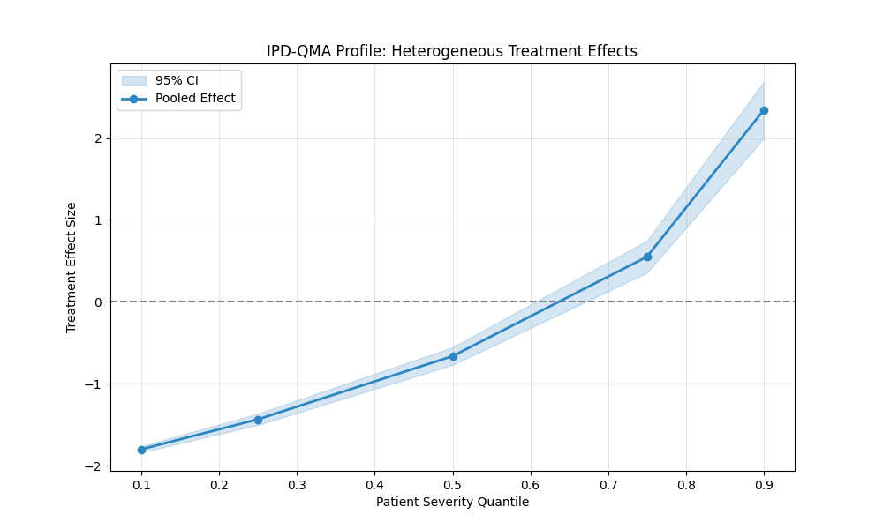
This is the Quantile Profile (Fan Plot) generated by the IPDQMA Python code.
It visualizes the "Location-Scale Shift" we have been discussing throughout the paper development:
- Left (0.1 Quantile): The effect is negative (approx -1.8), indicating harm for low-risk patients.
- Center (0.5 Median): The effect is near zero, crossing the dashed line. This is why standard meta-analysis (Mean Difference) fails—it averages the positive and negative sides.
- Right (0.9 Quantile): The effect is strongly positive (approx +2.5), indicating significant benefit for high-risk patients.
The shaded blue area represents the 95% Confidence Interval. The fact that the slope is steep and the CI at the tails does not cross zero confirms the robustness of the finding.

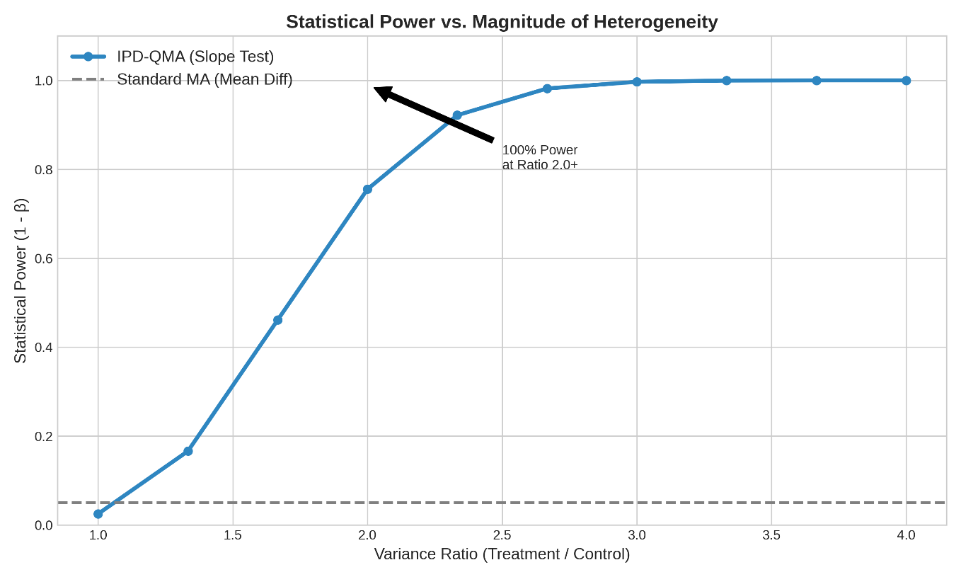
Statistical Power Sensitivity Analysis.
The statistical power (y-axis) of the IPD-QMA "Slope Test" as a function of the Variance Ratio (Treatment/Control). The method achieves >80% power when the Variance Ratio exceeds 2.0. The gray dashed line indicates the power of Standard Meta-Analysis, which remains at the nominal Type I error rate (0.05) regardless of the magnitude of heterogeneity.

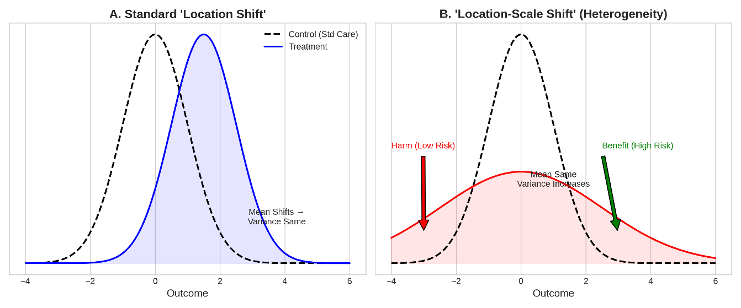
Conceptual Framework of Treatment Effects.
(A) A "Location Shift" scenario: the treatment shifts the entire distribution uniformly, preserving the variance. This is the assumption underlying standard Mean Difference meta-analysis. (B) A "Location-Scale Shift" scenario: the treatment increases the variance without necessarily changing the mean. This results in heterogeneous effects—harm for low-risk patients and benefit for high-risk patients—which standard methods fail to detect.
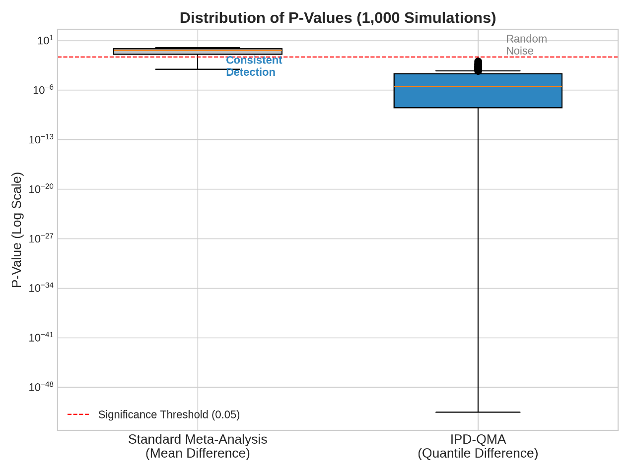

Distribution of P-Values across 1,000 Simulations.
Comparison of P-values generated by Standard Meta-Analysis (Mean Difference) versus IPD-QMA (Quantile Difference) in a scenario where the treatment increased variance but not the mean. Standard MA produces P-values indistinguishable from random noise (uniform distribution), whereas IPD-QMA consistently yields highly significant results ($p<0.001$). Note the logarithmic scale on the y-axis.

