Two reporting mandates, opposite directions: undercompliance trajectories in 2,277 registered malaria trials
Question. Do registered malaria trials on ClinicalTrials.gov comply with the two principal reporting mandates — FDAAA results-posting [2] and WHO PCR-correction declaration in primary outcomes [3]?
Methods. Using the AACT snapshot of 2026-04-12 [1], we audited n = 2,277 registered malaria trials. P01 = the proportion of completed trials posting results within 12 months of primary completion. P03 = the proportion of drug-efficacy trials whose primary-outcome text declares PCR-correction (regex covering corrected/adjusted/genotypically-corrected/molecularly-corrected variants). Wilson 95 % confidence intervals [5]; year-binning by primary completion date; sensitivity analysis on the uncomplicated-P. falciparum subset [6] for P03. No LLM was used in extraction; regex-only.
Results. Compliance is roughly an order of magnitude below target for both mandates: P01 = 7.6 % [6.3, 9.1] of 1,420 completed trials; P03 = 2.8 % [2.0, 3.9] of 1,276 drug-efficacy trials. The trajectories diverge across the two mandates' enactment years: FDAAA results-posting compliance rose from 4.0 % pre-2017 to 14.5 % post-2017 (Final Rule), while WHO PCR-correction declaration fell from 6.8 % pre-2008 to 2.7 % post-2008. A sensitivity analysis on drug-efficacy trials for uncomplicated-P. falciparum malaria (n = 186; pre-2008 16.0 %, post-2008 6.83 %; small pre-mandate sample n_pre = 25) found: the decline is partially attributable to portfolio shift but persists within the uncomplicated-falciparum subset.
Interpretation. FDAAA enforcement appears to have moved the needle slowly across nearly two decades; the WHO 2008 mandate has not. The divergence implies that audit and enforcement architecture matter more than mandate text [4].
Limitations. P03's regex captures only "PCR-corrected/correction/adjusted" phrasings and is a lower bound; the post-2008 decline is partially confounded by the malaria portfolio's shift toward chemoprevention/MDA [7], partly addressed by the uncomplicated-P. falciparum sensitivity analysis.
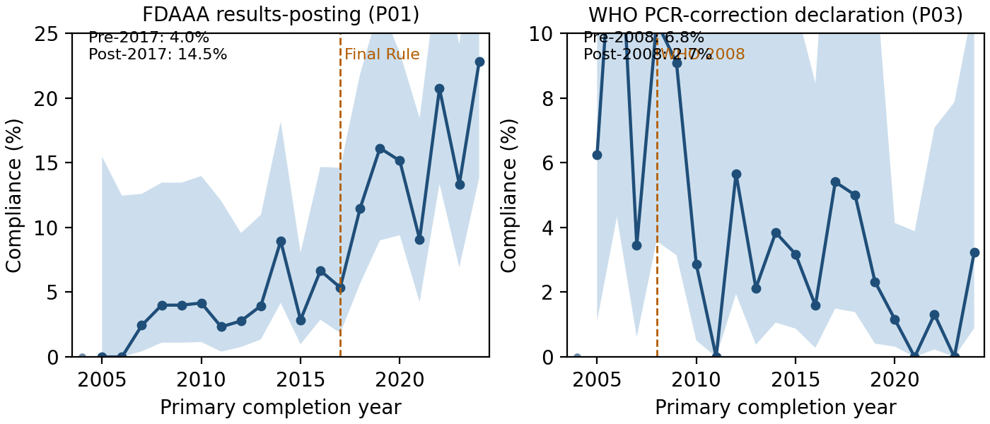
Figure 1. Compliance trajectories with two reporting mandates among registered malaria trials (n = 2,277, AACT 2026-04-12). Left: results-posting within 12 months of primary completion (P01); FDAAA Final Rule (2017) marked. Right: PCR-correction declaration in primary outcome (P03); WHO 2008 mandate marked. Note differing y-axes. Ribbons are pointwise Wilson 95 % CIs; years with n < 10 lightened.
Data availability. Code, AACT 2026-04-12 corpus manifest, and signal table at `github.com/mahmood726-cyber/malaria-ct-recon`; framework HEAD `26a3fb0` preregistered 2026-04-30; design spec preregistered via OpenTimestamps Bitcoin anchor 2026-05-03 (commit `535fa2e`). Full 10-pilot reconnaissance and dashboard are open at the same URL.
Conflicts of interest. None.
Funding. None. Personal time.

References
Tasneem A, et al. The Database for Aggregate Analysis of ClinicalTrials.gov (AACT). PLoS ONE 2012;7(3):e33677. doi:10.1371/journal.pone.0033677
U.S. Department of Health and Human Services. Clinical Trials Registration and Results Information Submission (Final Rule, 42 CFR Part 11). Federal Register 2017;81(183):64981–65157. Implements FDAAA 2007 §801, Pub. L. 110-85.
World Health Organization. Methods and Techniques for Clinical Trials on Antimalarial Drug Efficacy: Genotyping to Identify Parasite Populations. Geneva: WHO; 2008.
DeVito NJ, Bacon S, Goldacre B. Compliance with legal requirement to report clinical trial results on ClinicalTrials.gov: a cohort study. Lancet 2020;395:361–9. doi:10.1016/S0140-6736(19)33220-9
Wilson EB. Probable inference, the law of succession, and statistical inference. JASA 1927;22:209–12. doi:10.1080/01621459.1927.10502953
World Health Organization. Guidelines for the Treatment of Malaria, 3rd ed. Geneva: WHO; 2015.
Bhatt S, et al. The effect of malaria control on Plasmodium falciparum in Africa between 2000 and 2015. Nature 2015;526:207–11. doi:10.1038/nature15535

