Title: The potential cardiometabolic benefits of omega-3 polyunsaturated fatty acids focusing on recent updates and controversies
First Author: Jae Hyun Bae, Hyunjung Lim
Online Supplementary material

Supplemental Figure 1 Protective role of omega-3 fatty acids in the development of atherosclerosis. IL-6, interleukin-6; MCP-1, matrix metalloprotein-1; PDGF, platelet-derived growth factor; TNF-α, tumor necrosis factor-α.
Supplemental Figure 2 The major role of specialized pro-resolving mediators produced from enzymatic oxygenation of omega-3 fatty acids and their potential benefits in the cardiovascular system.
Supplemental Figure 3 Meta-analysis of the effects of long-chain omega-3 polyunsaturated fatty acid supplementation on three-point major adverse cardiovascular events by types, comparators, and prevention groups.
Supplemental Figure 4 Dose-response association of EPA with three-point major adverse cardiovascular events.
Supplemental Figure 5 Meta-analysis of the effects of long-chain omega-3 polyunsaturated fatty acid supplementation on all-cause mortality.
Supplemental Figure 6 Meta-analysis of the effects of long-chain omega-3 polyunsaturated fatty acid supplementation on hospitalization for heart failure.
Supplemental Figure 7 Meta-analysis of the effects of long-chain omega-3 polyunsaturated fatty acid supplementation on new-onset atrial fibrillation
Supplemental Figure 8 Dose-response association of EPA with new-onset atrial fibrillation.

Supplemental Figure 1 Protective role of omega-3 fatty acids in the development of atherosclerosis. IL-6, interleukin-6; MCP-1, matrix metalloprotein-1; PDGF, platelet-derived growth factor; TNF-α, tumor necrosis factor-α.
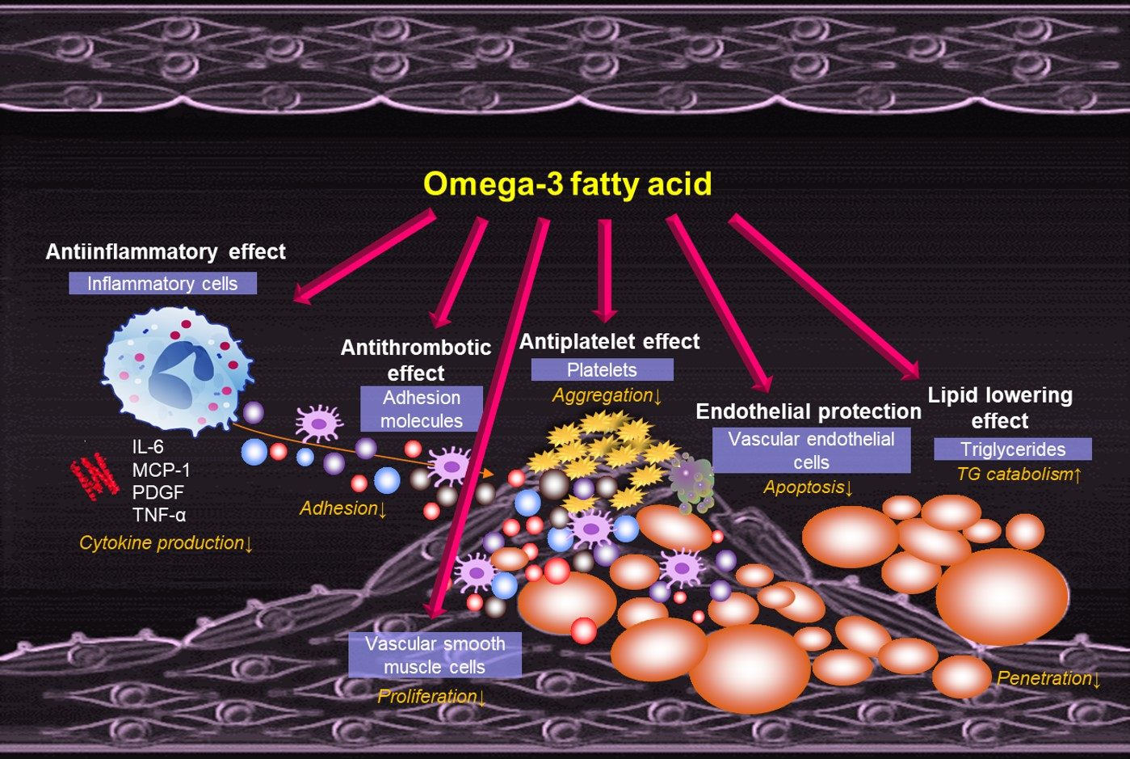
Supplemental Figure 2 The major role of specialized pro-resolving mediators produced from enzymatic oxygenation of omega-3 fatty acids and their potential benefits in the cardiovascular system.
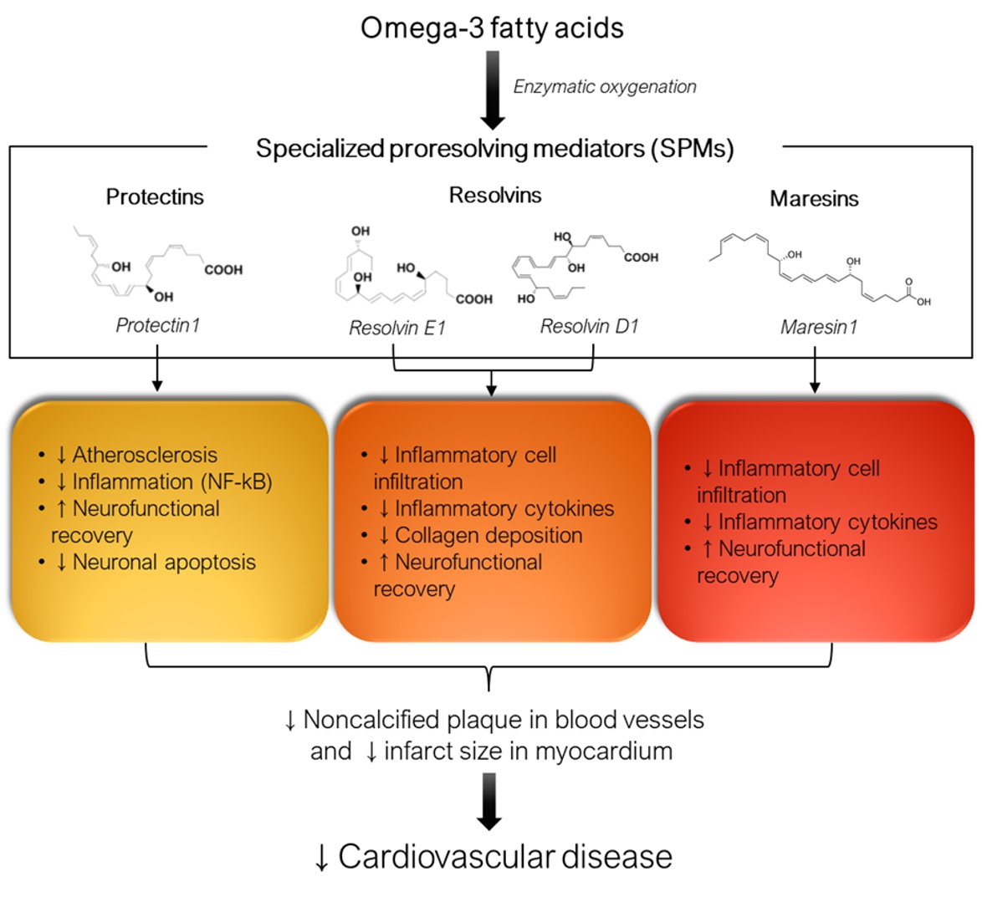

Supplemental Figure 3 Meta-analysis of the effects of long-chain omega-3 polyunsaturated fatty acid supplementation on three-point major adverse cardiovascular events by types, comparators, and prevention groups.
(A) Types of long-chain omega-3 polyunsaturated fatty acids
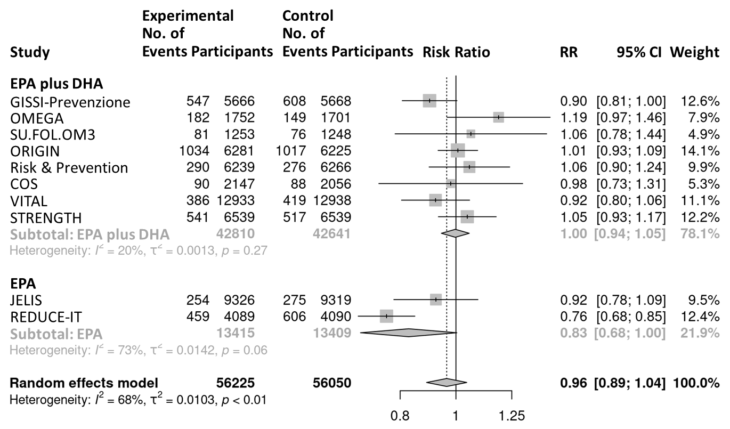

ASCEND, A Study of Cardiovascular Events iN Diabetes; CI, confidence interval; COS, CV Outcome Study; DM, diabetes mellitus; GISSI-Prevenzione, Gruppo Italiano per lo Studio della Sopravvivenza nell’Infarto miocardico-Prevenzione; JELIS, Japan EPA Lipid Intervention Study; MI, myocardial infarction; ORIGIN, Outcome Reduction with an Initial Glargine Intervention; REDUCE-IT, Reduction of Cardiovascular Events with Icosapent Ethyl-Intervention Trial; STRENGTH, Long-Term Outcome Study to Assess STatin Residual Risk Reduction with EpaNova in HiGh Cardiovascular risk PatienTs with Hypertriglyceridemia; SU.FOL.OM3, SUpplémentation en FOLates et OMega-3; VF, ventricular fibrillation; VITAL, VITamin D and OmegA-3 TriaL.

(B) Comparators
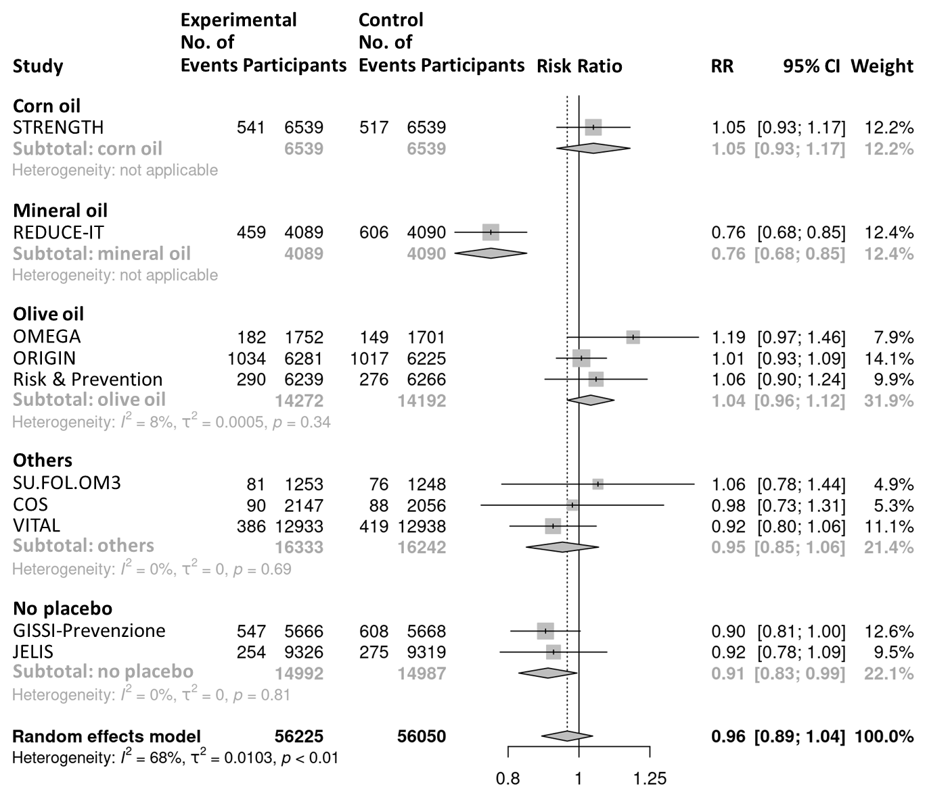

(C) Prevention groups
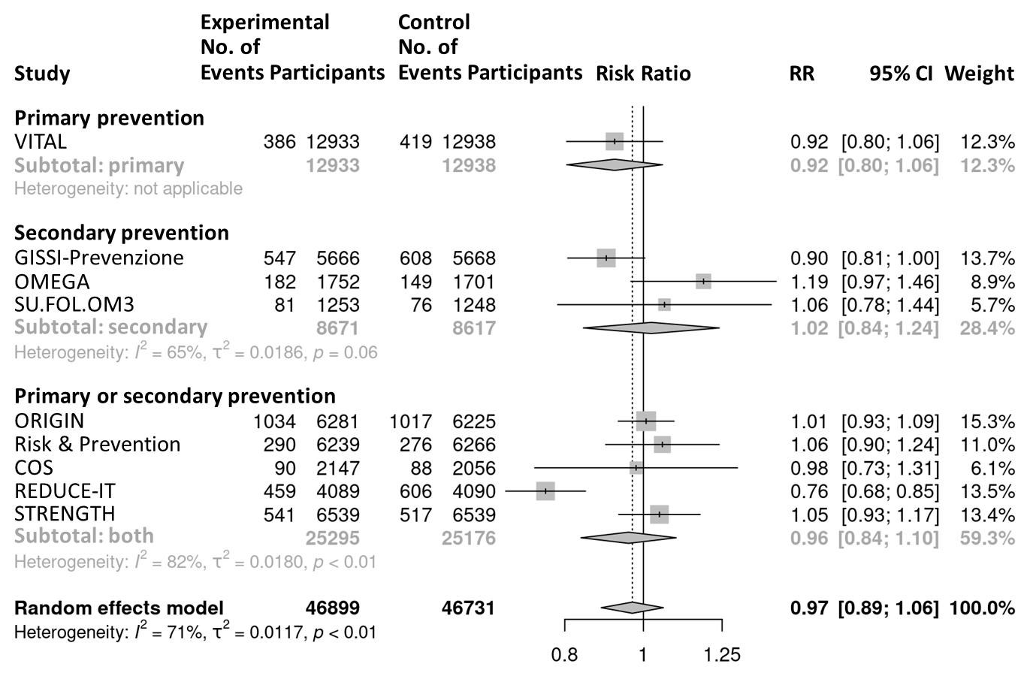

Supplemental Figure 4 Dose-response association of EPA with three-point major adverse cardiovascular events.
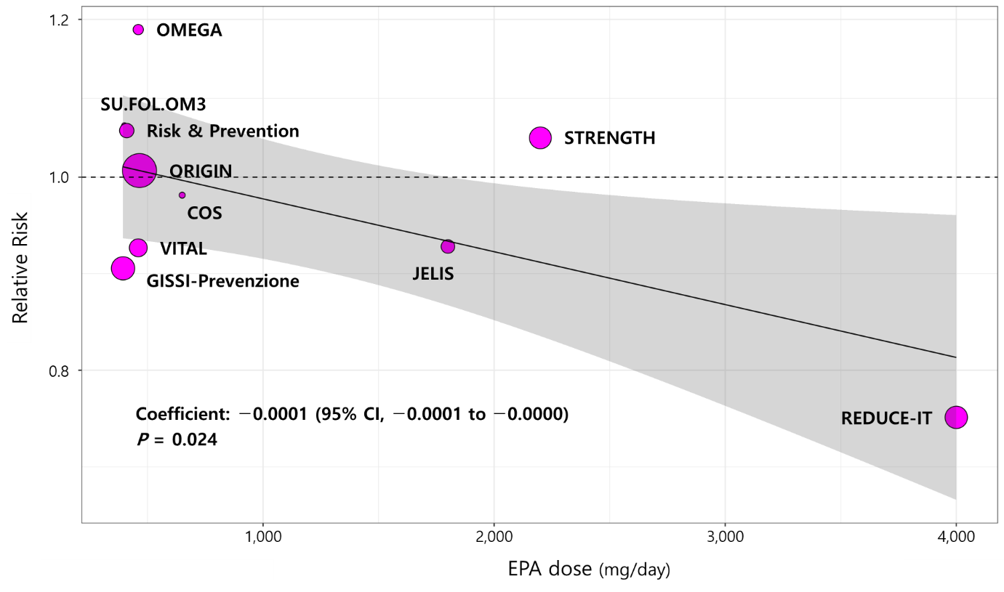

CI, confidence interval; COS, CV Outcome Study; EPA, eicosapentaenoic acid; GISSI-Prevenzione, Gruppo Italiano per lo Studio della Sopravvivenza nell’Infarto miocardico-Prevenzione; JELIS, Japan EPA Lipid Intervention Study; ORIGIN, Outcome Reduction with an Initial Glargine Intervention; REDUCE-IT, Reduction of Cardiovascular Events with Icosapent Ethyl-Intervention Trial; STRENGTH, Long-Term Outcome Study to Assess STatin Residual Risk Reduction with EpaNova in HiGh Cardiovascular risk PatienTs with Hypertriglyceridemia; SU.FOL.OM3, SUpplémentation en FOLates et OMega-3; VITAL, VITamin D and OmegA-3 TriaL.

Supplemental Figure 5 Meta-analysis of the effects of long-chain omega-3 polyunsaturated fatty acid supplementation on all-cause mortality.
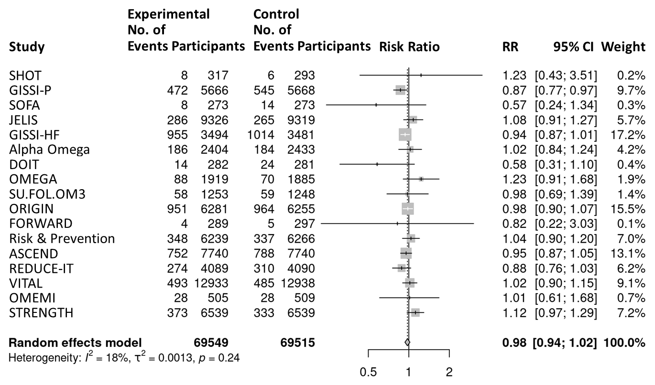

ASCEND, A Study of Cardiovascular Events iN Diabetes; DOIT, Diet and Omega-3 Intervention Trial; FORWARD, Fish Oil Research with ω-3 for Atrial Fibrillation Recurrence Delaying; GISSI-HF, Gruppo Italiano per lo Studio della Sopravvivenza nell’Infarto miocardico-Heart Failure; GISSI-Prevenzione, Gruppo Italiano per lo Studio della Sopravvivenza nell’Infarto miocardico-Prevenzione; JELIS, Japan EPA Lipid Intervention Study; OMEMI, OMega-3 fatty acids in Elderly patients with Myocardial Infarction; ORIGIN, Outcome Reduction with an Initial Glargine Intervention; REDUCE-IT, Reduction of Cardiovascular Events with Icosapent Ethyl-Intervention Trial; SHOT, SHunt Occlusion Trial; SOFA, Study on Omega-3 Fatty acids and ventricular Arrhythmia; STRENGTH, Long-Term Outcome Study to Assess STatin Residual Risk Reduction with EpaNova in HiGh Cardiovascular risk PatienTs with Hypertriglyceridemia; SU.FOL.OM3, SUpplémentation en FOLates et OMega-3; VITAL, VITamin D and OmegA-3 TriaL.

Supplemental Figure 6 Meta-analysis of the effects of long-chain omega-3 polyunsaturated fatty acid supplementation on hospitalization for heart failure.
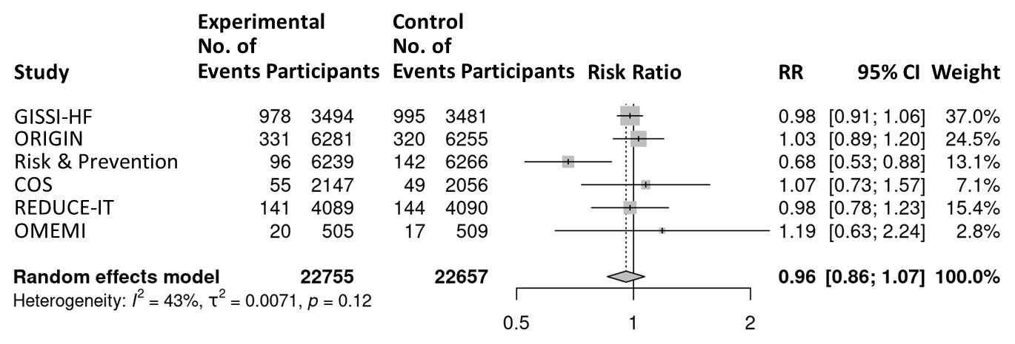

Supplemental Figure 7 Meta-analysis of the effects of long-chain omega-3 polyunsaturated fatty acid supplementation on new-onset atrial fibrillation.
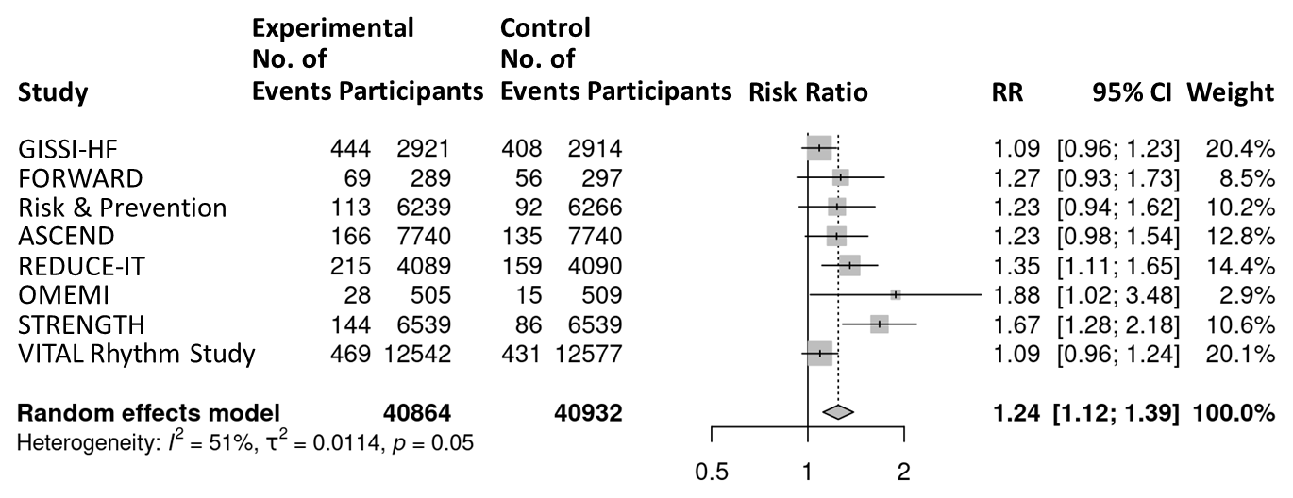

ASCEND, A Study of Cardiovascular Events iN Diabetes; COS, CV Outcome Study; DM, diabetes mellitus; DOIT, Diet and Omega-3 Intervention Trial; FORWARD, Fish Oil Research with ω-3 for Atrial Fibrillation Recurrence Delaying; GISSI-HF, Gruppo Italiano per lo Studio della Sopravvivenza nell’Infarto miocardico-Heart Failure; OMEMI, OMega-3 fatty acids in Elderly patients with Myocardial Infarction; ORIGIN, Outcome Reduction with an Initial Glargine Intervention; REDUCE-IT, Reduction of Cardiovascular Events with Icosapent Ethyl-Intervention Trial; STRENGTH, Long-Term Outcome Study to Assess STatin Residual Risk Reduction with EpaNova in HiGh Cardiovascular risk PatienTs with Hypertriglyceridemia; VITAL Rhythm Study, VITamin D and OmegA-3 TriaL Rhythm Study.
Supplemental Figure 8 Dose-response association of EPA with new-onset atrial fibrillation.
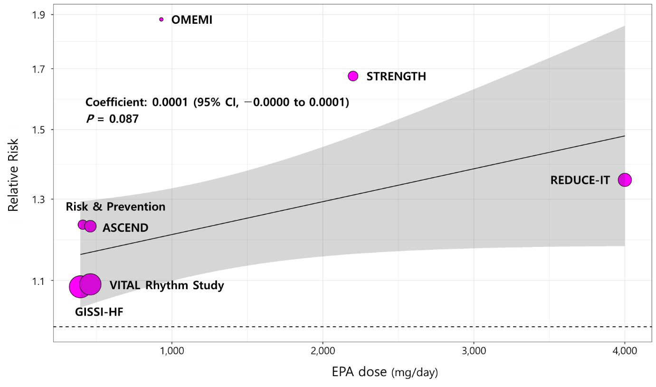

ASCEND, A Study of Cardiovascular Events iN Diabetes;CI, confidence interval; GISSI-HF, Gruppo Italiano per lo Studio della Sopravvivenza nell’Infarto miocardico-Heart Failure; OMEMI, OMega-3 fatty acids in Elderly patients with Myocardial Infarction; REDUCE-IT, Reduction of Cardiovascular Events with Icosapent Ethyl-Intervention Trial; STRENGTH, Long-Term Outcome Study to Assess STatin Residual Risk Reduction with EpaNova in HiGh Cardiovascular risk PatienTs with Hypertriglyceridemia; VITAL Rhythm Study, VITamin D and OmegA-3 TriaL Rhythm Study.

