SUPPLEMENTAL MATERIAL
APPENDIX A
Search strategy

PUBMED (MEDLINE)
Search terms: Melatonin AND random*
Limits: none
OVID databases
PsycInfo, Medline, Embase+Embase Classic
Search terms: Melatonin AND random*
Limits: none
WEB OF KNOWLEDGE
(Web of science (science citation index expanded), Biological abstracts, Biosis, Food science and technology abstracts)
Search terms: Melatonin AND random*
Limits: none

APPENDIX B
List of mental disorders
This appendix consists of the list of mental disorders that were used as an inclusion criterion during screening. Any disorder found in the screening that was not on this list was excluded.
LIST OF MENTAL DISORDERS for ADULTS
- Neurodevelopmental Disorders
- Intellectual Disabilities (Intellectual Disability (Intellectual Developmental Disorder), Global Developmental Delay)
- Autism Spectrum Disorder (Autism Spectrum Disorder)
- Attention-Deficit/Hyperactivity Disorder (Attention-Deficit/Hyperactivity Disorder)
- Schizophrenia Spectrum and Other Psychotic Disorders
(Schizotypal (Personality) Disorder, "Delusional Disorder", Brief Psychotic Disorder, Schizophrenia, Schizoaffective Disorder)
- Bipolar and Related Disorders (Bipolar I Disorder, Bipolar II Disorder, Cyclothymic Disorder)
- Depressive Disorders (Disruptive Mood Dysregulation Disorder, Major Depressive Disorder, Single and Recurrent Episodes, Persistent Depressive Disorder (Dysthymia))
- Anxiety Disorders (Social Anxiety Disorder (Social Phobia), Panic Disorder, Panic Attack (Specifier), Agoraphobia, Generalized Anxiety Disorder)
- Obsessive-Compulsive and Related Disorders (Obsessive-Compulsive Disorder, Body Dysmorphic Disorder, Hoarding Disorder, Trichotillomania (Hair-Pulling Disorder), Excoriation (Skin-Picking) Disorder)
- Trauma- and Stressor-Related Disorders (Posttraumatic Stress Disorder, Acute Stress Disorder)
- Dissociative Disorders (Dissociative Identity Disorder)
- Somatic Symptom and Related Disorders (Somatic Symptom Disorder, Illness Anxiety Disorder, Conversion Disorder (Functional Neurological Symptom Disorder))
- Feeding and Eating Disorders (Anorexia Nervosa, Bulimia Nervosa, Binge-Eating Disorder)
- Elimination Disorders
- Sleep-Wake Disorders (Insomnia Disorder, RLS)
- Gender Dysphoria (Antisocial Personality Disorder)
- Substance-Related and Addictive Disorders
- Personality Disorders (General Personality Disorder)
- Cluster A Personality Disorders (Paranoid Personality Disorder, Schizoid Personality Disorder, Schizotypal Personality Disorder)
- Cluster B Personality Disorders (Antisocial Personality Disorder, Borderline Personality Disorder, Histrionic Personality Disorder, Narcissistic Personality Disorder)
- Cluster C Personality Disorders (Avoidant Personality Disorder, Dependent Personality Disorder, Obsessive-Compulsive Personality Disorder)
19 Paraphilic Disorders (Voyeuristic Disorder, Exhibitionistic Disorder, Frotteuristic Disorder, Sexual Masochism Disorder, Sexual Sadism Disorder, Pedophilic Disorder, Fetishistic Disorder, Transvestic Disorder)

LIST OF MENTAL DISORDERS for CHILDREN and ADOLESCENTS
- Neurodevelopmental disorders
  - Intellectual disabilities (intellectual developmental disorder, global developmental delay)
  - Autism spectrum disorder (with an emphasis on Asperger´s disorder)
  - Attention-Deficit/Hyperactivity Disorder (ADHD) or Hyperkinetic Syndrome or Hyperkinetic Disorder
  - Communication Disorders (with emphasis in Language Disorder, Speech Sound Disorder, Childhood-Onset Fluency Disorder (Stuttering), Social (Pragmatic) Communication Disorder)
  - Specific learning disorders (with an emphasis in dyslexia)
  - Motor skills disorder (with an emphasis in Developmental coordination disorder)
  - Tic disorders (with an emphasis in Tourette´s disorder)
- Schizophrenia spectrum and other psychotic disorders (Schizophrenia, psychosis, delusional disorder, brief psychotic disorder, schizoaffective)
- Bipolar and related disorders (bipolar, cyclothymic disorder)
- Depressive disorders (this and the previous are part of mood disorders, with emphasis in Disruptive Mood Dysregulation Disorder)
- Anxiety disorders (with emphasis in Separation anxiety disorder, selective mutism, Phobia, Social anxiety disorder, panic disorder, agoraphobia)
- Obsessive-compulsive and related disorders [obsessive-compulsive, Body Dysmorphic Disorder, Trichotillomania (Hair-Pulling Disorder), Excoriation (Skin-Picking) Disorder]
- Trauma- and stressor-related disorders (with emphasis in Reactive Attachment Disorder; Disinhibited Social Engagement Disorder)
- Dissociative disorders (dissociative identity disorder)
- Eating disorders (with an emphasis in anorexia, bulimia, binge eating, pica, Rumination Disorder, Avoidant/Restrictive Food Intake Disorder)
- Elimination disorders (with an emphasis in Enuresis and Encopresis)
- Sleep-Wake disorders [with an emphasis in insomnia, parasomnias (with emphasis in sleepwalking, nightmare disorder, sleep terrors)
- Gender dysphoria
- Impulse-control disorders (with an emphasis in Oppositional defiant disorder, Intermittent Explosive Disorder and Conduct disorder)
- Substance-related and addictive disorder

Appendix C
Hierarchy of exclusion for methods section screening
Reason for exclusion | Number of studies excluded
- Systematic Review/Review/Meta-analysis | 149
- Age not in the right range | 79
- Does not measure melatonin effect on sleep | 33
- Duplicate | 13
- Not a listed disorder from Appendix B | 17
Table C: Hierarchy of exclusion

Appendix D
Information on the melatonin supplements used within each child and adolescent RCT
 | Melatonin
Author(s) Name, Year | Duration | Dosage | Release of Melatonin | Administration time
Attention Deficit/Hyperactivity Disorder
Mohammadi et al, 2012 | 8 weeks | 3-6 mg | Immediate Release (IR) | Not mentioned
Attention Deficit/Hyperactivity Disorder with Insomnia
Van de Heijden et al, 2007 | 4 weeks | 3 or 6 mg | IR | Not mentioned
Weiss et al, 2006 | 30 days | 5mg | IR | 20 minutes before bed
Autistic Spectrum Disorder
Garstang and Wallis, 2006 | 4 weeks | 5mg | IR | Not stated
McArthur and Budden, 1998 | 4 weeks | 2.5-7.5mg | IR | 1 hour before set bedtime
Wirojanan et al, 2009 | 4 weeks | 3mg | IR | 30 minutes prior to sleep
Wright et al, 2011 | 3 months | 2-10mg | IR | 30-40 minutes prior to sleep
Autistic Spectrum Disorder & Insomnia
Cortesi et al, 2012 | 12 weeks | 1mg or 2 mg | 1mg IR, 2mg controlled | 9pm
Gringras et al, 2017 | 13 weeks | 2-10mg | Prolonged | Not stated
Melatonin
Author(s) Name, Year Duration Dosage Release of Melatonin Administration time
Delayed Sleep Phase Disorder
Saxvig et al, 2014 | 2 weeks | 3mg | IR | Any time after 8pm
Wasdell et al, 2008 | 10 days | 5mg | Prolonged | 20-30 mins prior to bed
Insomnia
Eckerberg et al, 2012 | 2 weeks | 1mg | Not reported | Afternoon
van Geijlswijk et al, 2010b | 2 weeks | 0.05 - 0.15mg | Not reported | 7pm
Smits et al, 2000 | 4 weeks | 5mg | IR | 6pm
Smits et al, 2003 | 4 weeks | 5mg | IR | 7pm
van Maanen et al, 2017 | 3-4 weeks | 3mg | IR | 7pm
Intellectual Disability
Coppola et al, 2004 | 4 weeks | 3-12mg | IR | At their nocturnal bedtime
Intellectual Disability & Insomnia
Braam et al, 2008a | 4 weeks | 5mg | IR | 7pm
Braam et al, 2008b | 4 weeks | 2.5-5mg | IR | 6-7pm
Neurodevelopmental Disorder
Appleton et al, 2012 | 12 weeks | 0.5-12mg | Prolonged | 45 mins before bed
Dodge and Wilson, 2001 | 6 weeks | 5mg | iR | 8pm

Table D: Information on the melatonin supplements used within each child and adolescent RCT

Appendix E
Information on the melatonin supplements used within each adult RCT
 | Melatonin
Author(s) Name, Year | Duration | Dosage | Release of Melatonin | Administration time
Delayed Sleep Phase Disorder
Dahlitz et al, 1991 | 4 weeks | 5mg | Not reported | 22:00
Kayumov et al, 2001 | 4 weeks | 5mg | Not reported | 19:00 - 21:00
Mundey et al, 2005 | 4 weeks | 0.3 - 3mg | Not reported | Early evening/in between measurements
Rahman et al, 2009 | 4 weeks | 5mg | Not reported | 19:00 – 21:00
Sletten et al, 2018 | 4 weeks | 0.5mg | IR | 1 hour before bed
Insomnia
Dawson et al, 1998 | 4 days | 0.5mg | No release stated | 19:00
Ellis et al, 1996 | 7 days | 5mg | Prolonged release | 20:00
James et al, 1990 | 3 weeks | 1-5mg | No release stated | 22:45
Montes et al, 2003 | 7 days | 0.3-1 mg | Prolonged release | Not stated
REM Sleep Disorder
Jun et al, 2019 | 4 weeks | 6mg | Not reported | 30 mins before bedtime
Kunz and Mahlberg, 2010 | 4 weeks | 3mg | Not reported | 22 - 30 mins before bed
Melatonin
Author(s) Name, Year Duration Dosage Release of Melatonin Administration time
Schizophrenia
Kumar et al, 2007 | 15 days | 3 -15mg | Controlled release | At night with food
Seasonal Affective Disorder
Danilenko and Putilov, 2005 | 6 days | 0.5mg | Not reported | 17:00
Table E: Information on the melatonin supplements used within each adult RCT

Appendix F
Information regarding the tolerability of melatonin across RCTs in children and adolescents
 | Melatonin Group |  |  | Control Group
Author(s) Name, Year | Mild side effects | Dropout to adverse events | Most Frequent Side Effect | Mild side effects | Dropout to adverse events | Most Frequent Side Effect
Attention Deficit/Hyperactivity Disorder
Mohammadi et al, 2012 | 90 | 0 | Irritability | 68 | 0 | Loss of appetite
Attention Deficit/Hyperactivity Disorder with Insomnia
van de Heijden et al, 2007 | 16 | 0 | Headaches | 0 | 0 | None
Weiss et al, 2006 | Quantity not recorded | 0 | Severe migraines | Quantity not recorded | 0 | Severe migraines
Autistic Spectrum Disorder
Garstang and Wallis, 2006 | 0 | 0 | None | 0 | 0 | None
McArthur and Budden, 1998 | 0 | 0 | None | 0 | 0 | None
Wirojanan et al, 2009 | 4 | 0 | Seizure | 0 | 0 | None
Wright et al, 2011 | 0 | 0 | None | 2 | 0 | Tearfulness
Autistic Spectrum Disorder & Insomnia
Cortesi et al, 2012 | 0 | 0 | None | 0 | 0 | None
Gringras et al, 2017 | 202 | 0 | Agitation | 159 | 0 | Agitation
 | Melatonin Group |  |  | Control Group
Author(s) Name, Year | Mild side effects | Dropout to adverse events | Most Frequent Side Effect | Mild side effects | Dropout to adverse events | Most Frequent Side Effect
Delayed Sleep Phase Disorder
Saxvig et al, 2014 | 2 | 0 | Headache | 3 | 0 | Headache
Wasdell et al, 2008 | 35.28 | 0 | Seizures* | 39.2 | 0 | Seizures
Insomnia
Eckerberg et al, 2012 | 0 | 0 | None | 0 | 0 | None
van Geijlswijk et al, 2010b | 27 | 0 | Red eyes | 3 | 0 | Headache
Smits et al, 2000 | 3 | 0 | Headache | 1 | 1 | Allergic reaction
Smits et al, 2003 | 7 | 0 | Dizziness | 3 | 0 | Headache
van Maanen et al, 2017 | 1 | 1 | Headaches | 0 | 0 | None
Intellectual Disability
Coppola et al, 2004 | 0 | 0 | None | 0 | 0 | None
Intellectual Disability & Insomnia
Braam et al, 2008a | 1 | 0 | Night wakes | 1 | 0 | Night wakes
Braam et al, 2008b | Quantity not recorded | 0 | None | Quantity not recorded | 0 | None
Neurodevelopmental Disorder
Appleton et al, 2012 | 289 | 0 | Coughing | 310 | 1 | Coughing
Dodge and Wilson, 2001 | 2 | 0 | Hyper and moody | 2 | 0 | Hyper and moody
Table F: Information regarding the tolerability of melatonin across RCTs in children and adolescents

Appendix G
Information regarding the tolerability of melatonin across RCTs in children and adolescents
 | Melatonin Group |  |  |  | Control Group
Author(s) Name, Year | Mild side effects | Dropout to adverse events | Most frequent side effect |  | Mild side effects | Dropout to adverse effects | Most frequent side effect
Delayed Sleep Phase Disorder
Dahlitz et al, 1991 | 1 | 0 | Headache |  | 0 | 0
Kayumov et al, 2001 | 0 | 0 |  |  | 0 | 0
Mundey et al, 2005 | 0 | 0 |  |  | 0 | 0
Rahman et al, 2009 | 0 | 0 |  |  | 0 | 0
Sletten et al, 2018 | 8 | 0 | Light-headedness |  | 7 | 0 | Vivid dreams/nightmares
Insomnia
Dawson et al, 1998 | Not stated | 0 |  |  | Not stated | 0
Ellis et al, 1996 | 4 | 0 | Headache |  | 1 | 0 | Extreme tiredness
James et al, 1990 | 0 | 0 |  |  | 0 | 0
Montes et al, 2003 | Quantity not recorded | 0 |  |  | Quantity not recorded | 0
Wade et al, 2011 | Not stated | 3 |  |  | Not stated | 2
REM Sleep Disorder
Jun et al, 2019 | 2 | 0 |  |  | Not stated | 0
Kunz and Mahlberg, 2010 | Not stated | 0 |  |  | Not stated | 0
Schizophrenia
Kumar et al, 2007 | Not stated | 0 |  |  | Not stated | 0
Seasonal Affective Disorder
Danilenko and Putilov, 2005 | Not stated | 0 |  |  | Not stated | 0
Table G: Information regarding the tolerability of melatonin across RCTs in adults
Appendix H
Overall risk of bias 2.0 judgement for each RCT included in the meta-analysis

Author(s), year | Low |  | Some concerns |  | High
Children & Adolescent RCTs
Van der Heijden et al, 2007
Weiss etl al, 2006
Cortesi et al, 2012
Garstand and Wallis, 2006
Gringras et al, 2017
McArthur and Budden, 1998
Wirojanan et al, 2009
Wright et al, 2010
Saxvig et al, 2013
Wasdell et al, 2007
Eckerberg et al, 2012
van Geijlswijk et al, 2010b
Smits et al, 2000
Smits et al, 2003
van Maanen et al, 2017
Braam et al, 2008a
Braam et al, 2008b
Coppola et al, 2004
Appleton et al, 2012
Dodge and Wilson, 2001
Adult RCTs
Dahlitz et al, 1991
Kayumov et al, 2001
Mundey et al, 2005
Rahman et al, 2010
Sletten et al, 2018
Dawson et al, 1998
Ellis et al, 1996
James et al, 1990
Montes et al, 2003
Wade et al, 2010
Kunz and Mahlberg 2010
Kumar et al, 2007
Danilenko and Putilov, 2005
Table H: Overall risk of bias 2.0 judgement for each RCT included in the meta-analysis
Appendix I
Individual RCT ratings for the Risk of Bias 2.0 per domain
Domain 1: Risk of bias arising from the randomization process. Domain 2: Risk of bias due to deviations from the intended interventions. Domain 3: Missing outcome data. Domain 4: Risk of bias in measurement of the outcome. Domain 5: Risk of bias in selection of the reported result.
Author(s), year | Domain 1 |  | Domain 2 |  | Domain 3 |  | Domain 4 |  | Domain 5 |  | Overall
Children & Adolescent RCTs
Van der Heijden et al, 2007
Weiss et al, 2006
Cortesi et al, 2012
Garstang and Wallis, 2006
Gringras et al, 2017
McArthur and Budden, 1998
Wirojanan et al, 2009
Wright et al, 2010
Saxvig et al, 2013
Wasdell et al, 2007
Eckerberg et al, 2012
van Geijlswijk et al, 2010b
Smits et al, 2000
Smits et al, 2003
van Maanen et al, 2017
Braam et al, 2008a
Braam et al, 2008b
Coppola et al, 2004
Appleton et al, 2012
Dodge and Wilson, 2001
Adult RCTs
Dahlitz et al, 1991
Kayumov et al, 2001
Mundey et al, 2005
Rahman et al, 2010
Sletten et al, 2018
Dawson et al, 1998
Ellis et al, 1996
James et al, 1990
Montes et al, 2003
Wade et al, 2010
Kunz and Mahlberg, 2010
Kumar et al, 2007
Danilenko and Putilov, 2005
Table I: Individual RCT ratings for the Risk of Bias 2.0 per doma

Appendix J
Forest Plot for the outcome variable SOL actigraphy for children and adolescents in the Attention Deficit/Hyperactivity Disorder group & Comorbid Insomnia
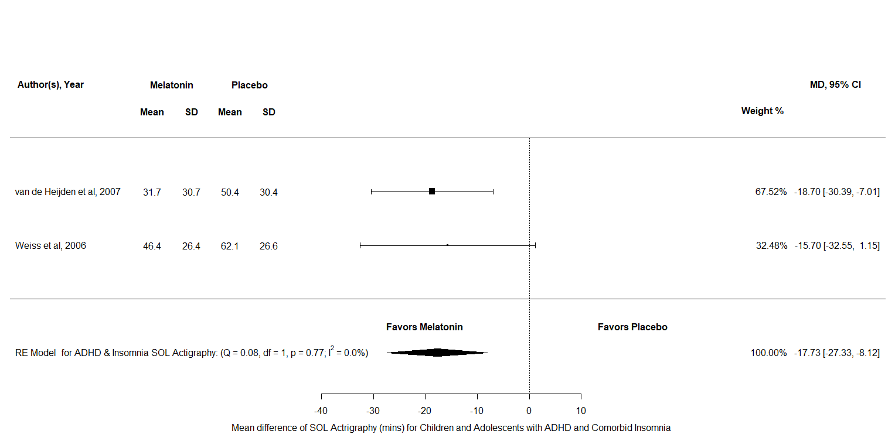
Figure J1: A forest plot to show the mean difference of SOL diary scores for melatonin against placebo in the Attention Deficit/Hyperactivity Disorder group & Comorbid Insomnia

Appendix K
A detailed description and forest Plots for all the outcome variables analysed in children and adolescents with Autistic Spectrum Disorder
SOL
For SOL diary there were k = 2 and N = 28, the results indicated a significant difference in favour of melatonin over placebo MD = -51.04, 95% CI [-59.57, -42.5], z = -11.72, p <.001. Furthermore, the test for heterogeneity showed Q(df = 1) = 0.001, p = 0.97, τ = 0, I² = 0% which meant that this analysis produced an output which can account for variability of effect sizes. For SOL actigraphy there were k = 2 and N = 21, the results indicated a significant difference in favour of melatonin over placebo MD = -13.41, 95% CI [-19.9, -6.92], z = -4.05, p <.001. Furthermore, the test for heterogeneity showed Q(df = 1) = 0.68, p = 0.41, τ = 0, I² = 0% which meant that this analysis did produced an output which can account for variability of effect sizes. Overall, both measurements of SOL appear to reduce after a treatment of melatonin in children and adolescents with ASD which would suggest that melatonin is more effective than placebo here.
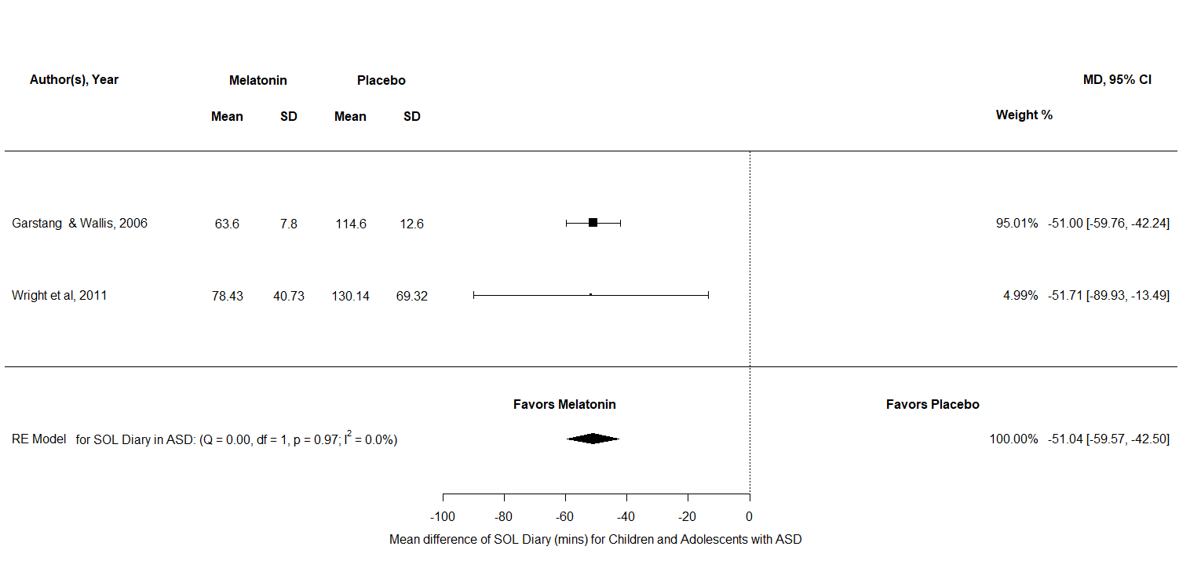

Figure K1: A forest plot to show the mean difference of SOL diary scores for melatonin against placebo in the ASD group
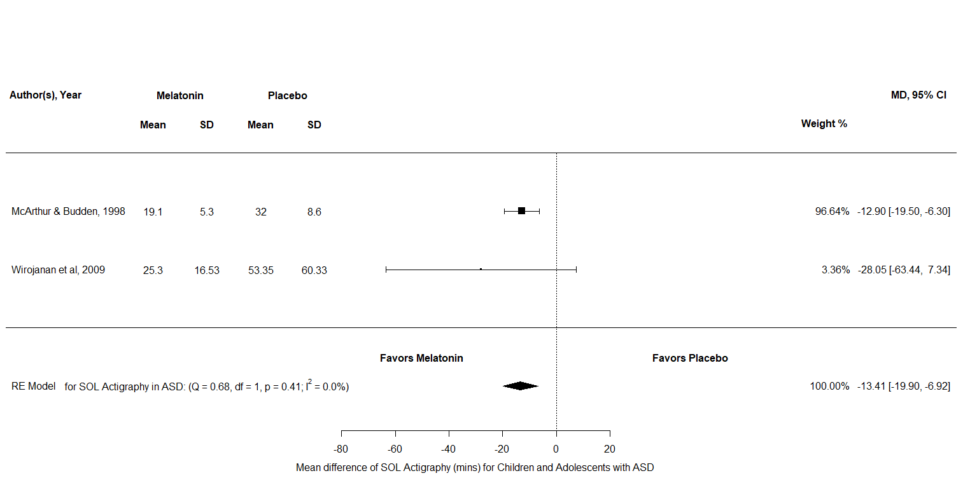
Figure K2: A forest plot to show the mean difference of SOL actigraphy scores for melatonin against placebo in the ASD group

TST
TST diary data were analysed in the ASD group. For TST diary there were k = 2 and N = 28, the results indicated a significant difference in favour of melatonin over placebo MD = 63.33, 95% CI [7.53, 78.58], z = 8.48, p <.001. Furthermore, the test for heterogeneity showed Q(df = 1) = 0.55, p = 0.46, τ = 0, I² = 0% which means that the total variability among effect sizes may be caused by “true” heterogeneity between studies and not by sampling error. Overall, TST diary appears to reduce after a treatment of melatonin in children and adolescents with ASD which would suggest that melatonin is more effective than placebo here.
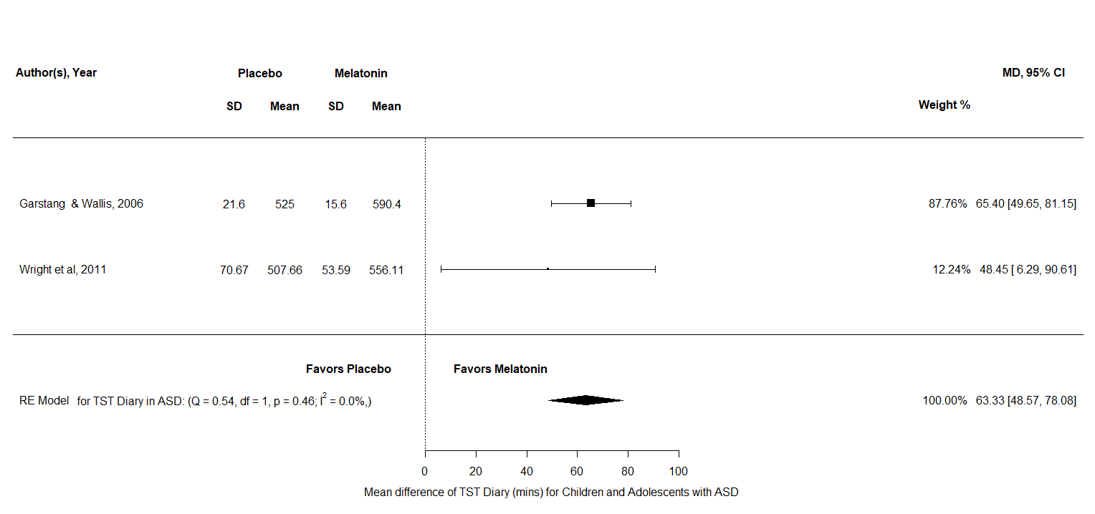

Figure K3: A forest plot to show the mean difference of TST diary scores for melatonin against placebo in the ASD group

NA
NA analysis consisted of k = 3 and N = 40, the results indicated no significant difference between melatonin and placebo SMD = -0.63, 95% CI [-1.65, 0.38], z = -1.22, p = 0.22. Therefore, this analysis indicates that the number of NAs may not reduce in children and adolescents with ASD after a period of melatonin treatment.
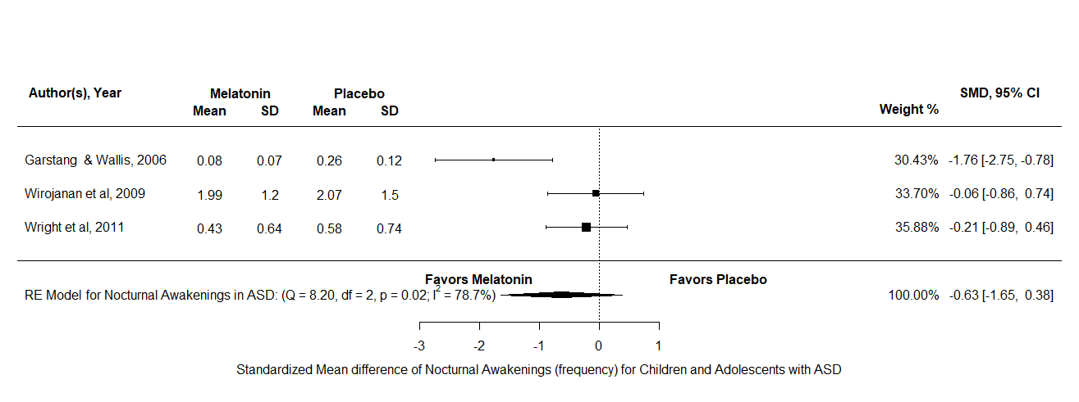

Figure K4: A forest plot to show the standardized means difference of NA scores for melatonin against placebo in the ASD group

Appendix L
A detailed description and forest Plots for all the outcome variables analysed for children and adolescents in the Autistic Spectrum Disorder with Insomnia group
SOL
For SOL diary there were k = 3 and N = 128, the results indicated a significant difference in favour of melatonin over placebo MD = -44.56, 95% CI [-59.5, -29.61], z = -5.84, p <.001. Furthermore, the test for heterogeneity showed Q(df = 2) = 3.61, p = 0.16, τ = 9.22 I² = 47.91% which meant that this analysis produced an output which can account for variability of effect sizes. For SOL actigraphy there were k = 3 and N = 87, the results indicated a significant difference in favour of melatonin over placebo MD = -23.3, 95% CI [-23.19, -39.58], z = -7.02, p = 0.01. Furthermore, the test for heterogeneity showed Q(df = 2) = 8.21, p = 0.02, τ = 11.61, I² = 72.45% which meant that this analysis did not produce an output which can account for variability of effect sizes. Overall, both measurements of SOL appear to reduce after treatment of melatonin in children and adolescents with ASD and ASD with insomnia which would suggest that melatonin is more effective than placebo here. However, the actigraphy results should be interpreted with caution as there is a lot of uncounted variability.

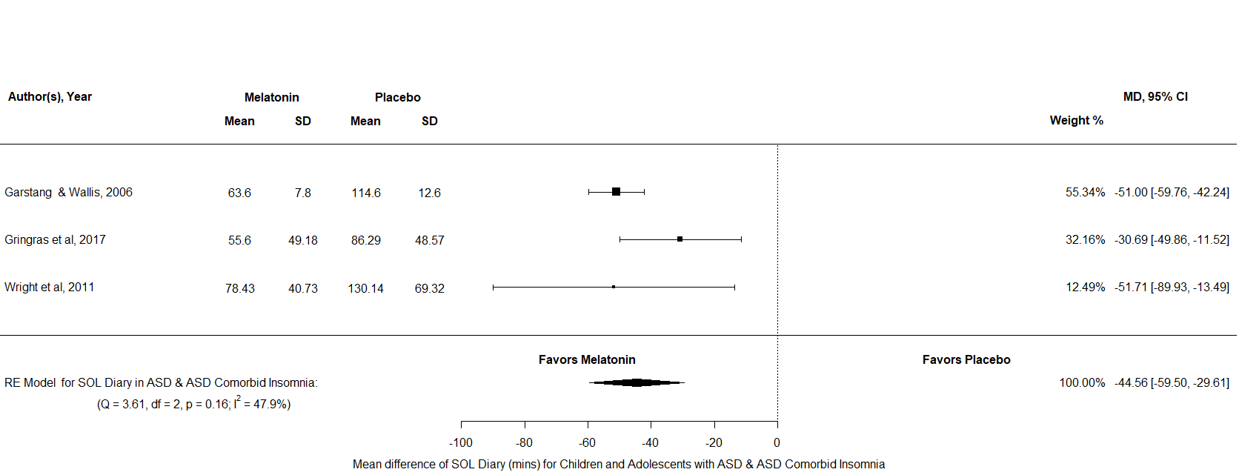

Figure L1: A forest plot to show the mean difference of SOL diary scores for melatonin against placebo in the ASD & ASD Comorbid Insomnia group
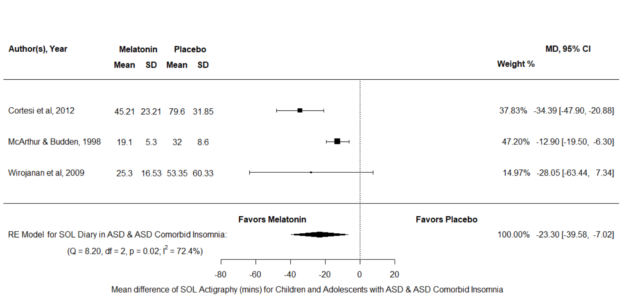
Figure L2: A forest plot to show the mean difference of SOL actigraphy scores for melatonin against placebo in the ASD & ASD Comorbid Insomnia group

TST
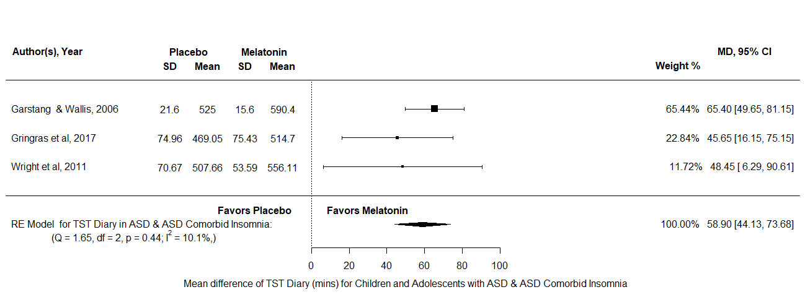
Both TST diary and TST actigraphy data were analysed in the ASD & ASD Insomnia group. For TST diary there were k = 3 and N = 128, the results indicated a significant difference in favour of melatonin over placebo MD = 58.9, 95% CI [44.13, 73.68], z = 7.8, p <.001. Furthermore, the test for heterogeneity showed Q(df = 2) = 1.65, p = 0.44, τ = 4.72, I² = 51.44% which meant that this analysis produced an output which can account for variability of effect sizes. For TST actigraphy there were k = 2 and N = 78, the results indicated a significant difference in favour of melatonin over placebo MD = 51.5, 95% CI [11.91, 91.1], z = 2.55, p = 0.01. Furthermore, the test for heterogeneity showed Q(df = 1) = 2.1, p = 0.15, τ = 22.25, I² = 51.44% which meant that this analysis did produce an output which can account for the variability of effect sizes. Overall, both measurements of TST appear to increase after a treatment of melatonin in children and adolescents with ASD and ASD with insomnia.

Figure L3: A forest plot to show the mean difference of TST diary scores for melatonin against placebo in the ASD & ASD Comorbid Insomnia group

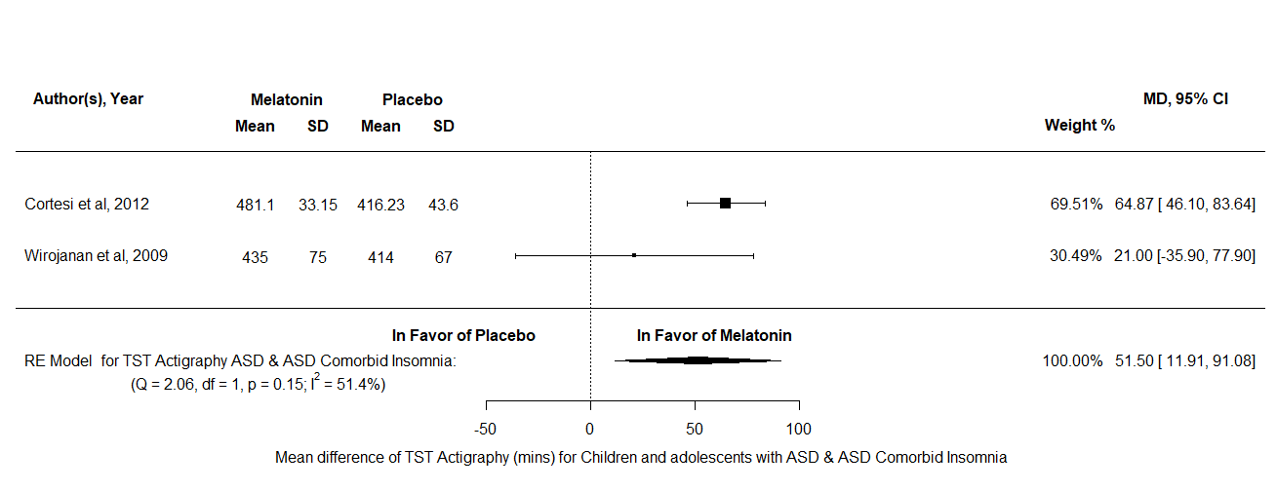

Figure L4: A forest plot to show the mean difference of TST actigraphy scores for melatonin against placebo in the ASD & ASD Comorbid Insomnia group

NA
NA analysis consisted of k = 4 and N = 106, the results indicated no significant difference between melatonin and placebo SMD = -1.22, 95% CI [-2.56, 0.11], z = -1.8, p = 0.07. Therefore, this analysis indicates that the number of NAs may not reduce in children and adolescents with ASD and ASD with insomnia after a period of melatonin treatment.
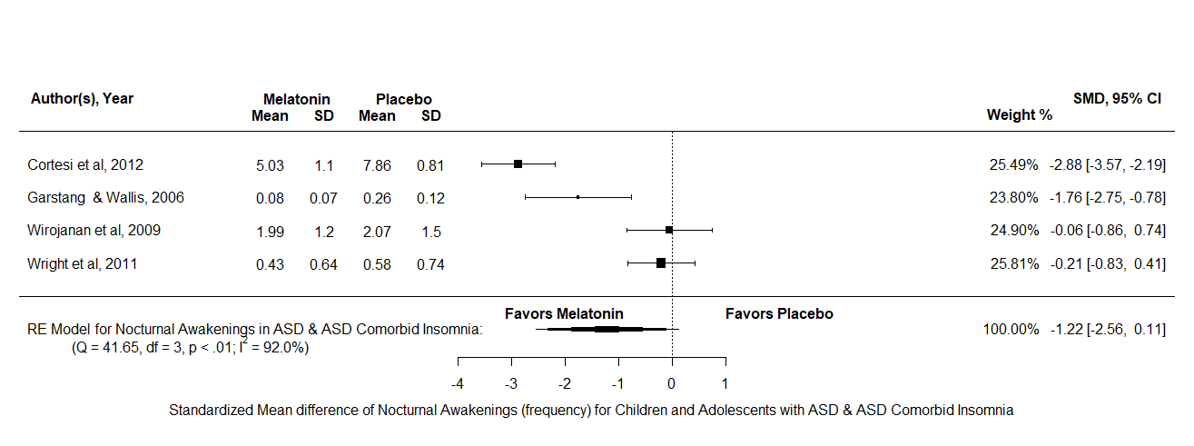
Figure L5: A forest plot to show the standardized mean difference of NA scores for melatonin against placebo in the ASD & ASD Comorbid Insomnia group

Appendix M
A detailed description and forest Plots for all the outcome variables analysed for children and adolescents in the Delayed Sleep Phase Disorder group
SOL
For SOL diary there were k = 2 and N = 70, the results indicated a significant difference in favour of melatonin over placebo MD = -26.09, 95% CI [-43.61, -8.57], z = -2.92, p =0.004. Furthermore, the test for heterogeneity showed Q(df = 1) = 1.72, p = 0.19, τ = 8.56, I² = 41.87% which meant that this analysis produced an output which can account for variability of effect sizes. For SOL actigraphy there were k = 3 and N = 87, the results indicated no significant difference between melatonin and placebo MD = -13.75, 95% CI [-34.58, -7.08], z = -1.29, p = 0.2. Overall, SOL diary appears to reduce after a treatment of melatonin whilst SOL actigraphy does not reduce in children and adolescents with DSPD.

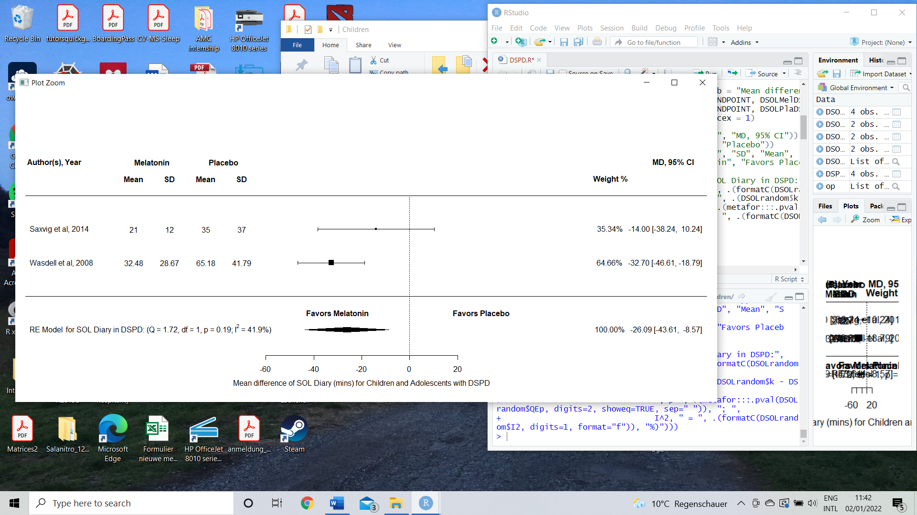

Figure M1: A forest plot to show the mean difference of SOL diary scores for melatonin against placebo in the DSPD group
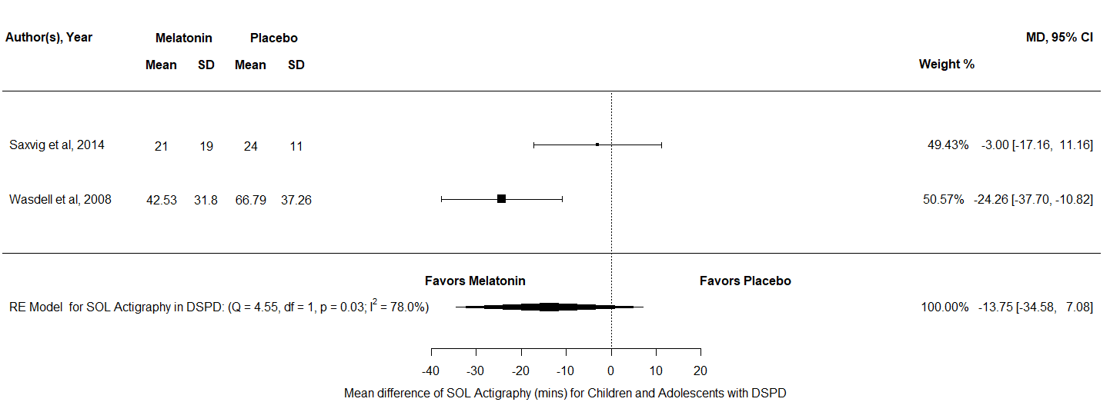
Figure M2: A forest plot to show the mean difference of SOL actigraphy scores for melatonin against placebo in the DSPD group

TST
Both TST diary and TST actigraphy data were analysed in the DSPD group. For TST diary, there were k = 2 and N = 70, the results indicated no significant difference between melatonin and placebo MD = 31.7, 95% CI [3.29, 60.12], z = 2.19, p = 0.29. Similarly, for TST actigraphy there were k = 2 and N = 70, the results indicated no significant difference between melatonin and placebo MD = 20.58, 95% CI [-6.79, 47.95], z = 1.47, p = 0.14. Overall, this means that both outcome variables of TST appear not to differ after a treatment of melatonin in comparison to placebo, for children and adolescents with DSPD.
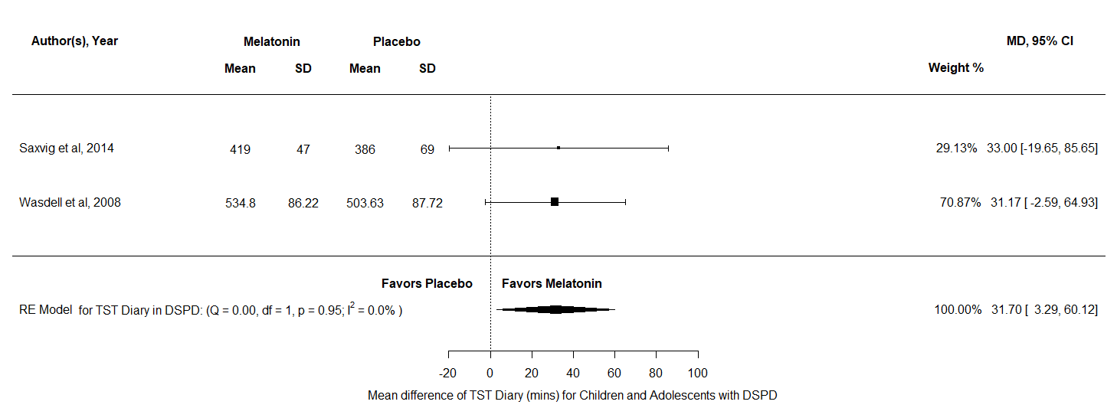
Figure M3: A forest plot to show the mean difference of TST diary scores for melatonin against placebo in the DSPD group
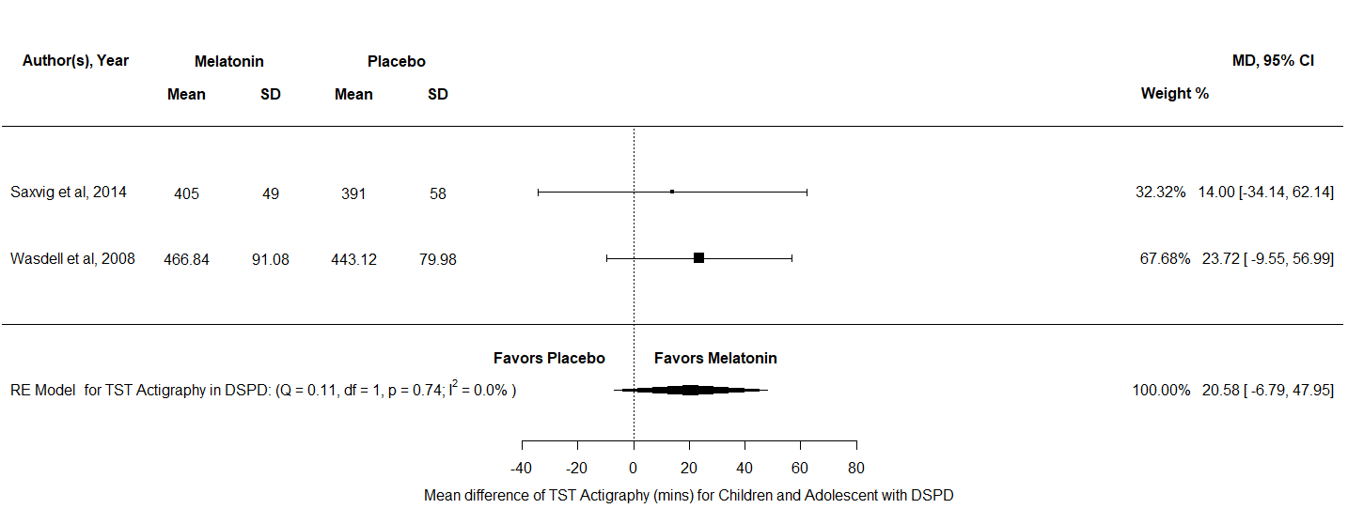
Figure M4: A forest plot to show the mean difference of TST actigraphy scores for melatonin against placebo in the DSPD group

Appendix N
A detailed description and forest Plots for all the outcome variables analysed for children and adolescents in the Insomnia group
SOL
For SOL diary there were k = 4 and N = 221, the results indicated a significant difference in favour of melatonin over placebo MD = -22.9, 95% CI [-34.63, -11.16], z = -3.82, p <.001. Furthermore, the test for heterogeneity showed Q(df = 3) = 6.37, p = 0.1, τ = 8.69, I² = 53.69% which meant that this analysis produced an output which can account for variability of effect sizes. Overall, this result indicates that melatonin may reduce SOL diary scores by on average 22.9 minutes in children and adolescents with Insomnia in comparison to using placebo supplements.
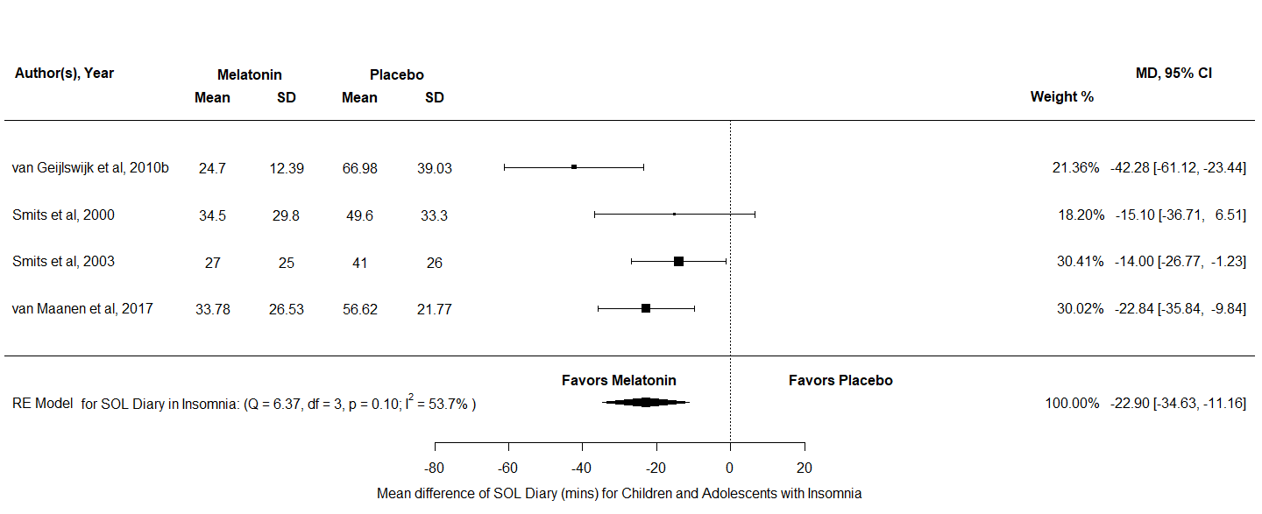
Figure N1: A forest plot to show the mean difference of SOL diary scores for melatonin against placebo in the Insomnia group

TST
TST diary was analysed in the insomnia group, there were k = 4 and N = 168 and the results indicated a significant difference in favour melatonin over placebo MD = 31.54, 95% CI [22.45, 40.62], z = 6.8, p <.001. Furthermore, the test for heterogeneity showed Q(df = 3) = 5.19, p = 0.16, τ = 5.43, I² = 31.54% which meant that this analysis produced an output which can account for variability of effect sizes. Overall, this result indicates that melatonin may increase TST diary scores by on average 31.54 minutes in children and adolescents with Insomnia in comparison to using placebo.
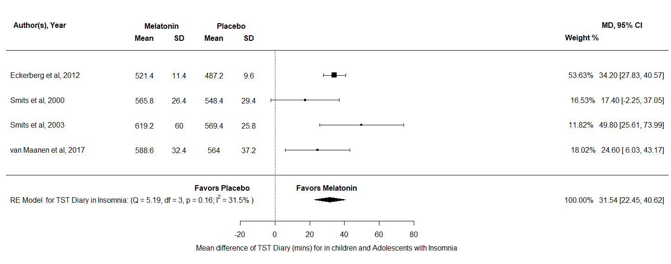
Figure N2: A forest plot to show the mean difference of TST diary scores for melatonin against placebo in the Insomnia group

DLMO
Finally, DLMO was analysed in the insomnia group, there were k = 4 and N = 226, the results indicated no significant difference between melatonin and placebo MD = -0.32, 95% CI [-0.81, 0.15], z = -1.32, p = 0.19. This meant that DLMO scores did not differ between melatonin and placebo after a period of treatment for children and adolescents with insomnia.
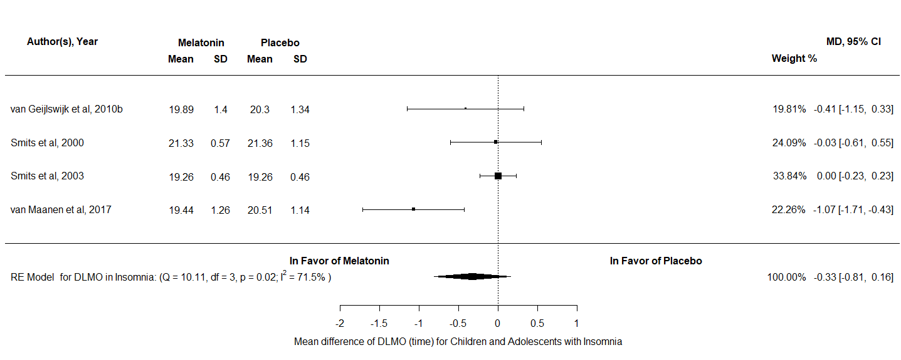
Figure N3: A forest plot to show the mean difference of DLMO scores for melatonin against placebo in the Insomnia group

Appendix O
A detailed description and forest Plots for all the outcome variables analysed for children and adolescents in the Neurodevelopmental Disorders with Comorbid Insomnia group
SOL
For SOL diary there were k = 3 and N = 158, the results indicated a significant difference in favour of melatonin over placebo MD = -30.12, 95% CI [-42.22, -18.04], z = -4.88, p <.001. Furthermore, the test for heterogeneity showed Q(df = 2) = 1.4, p = 0.5, τ = 0 I² = 0% which meant that this analysis did not produce an output which can account for variability of effect sizes. For SOL actigraphy there were k = 3 and N = 190, the results indicated a significant difference in favour of melatonin over placebo MD = -23.26, 95% CI [-34.51, -12], z = -4.05, p <.001. Furthermore, the test for heterogeneity showed Q(df = 2) = 3.96, p = 0.14, τ = 7, I² = 49.54% which meant that this analysis produced an output which can account for variability of effect sizes. Overall, both measurements of SOL appear to reduce after a treatment of melatonin in children and adolescents with ASD and ASD with insomnia which would suggest that melatonin is more effective than placebo here.
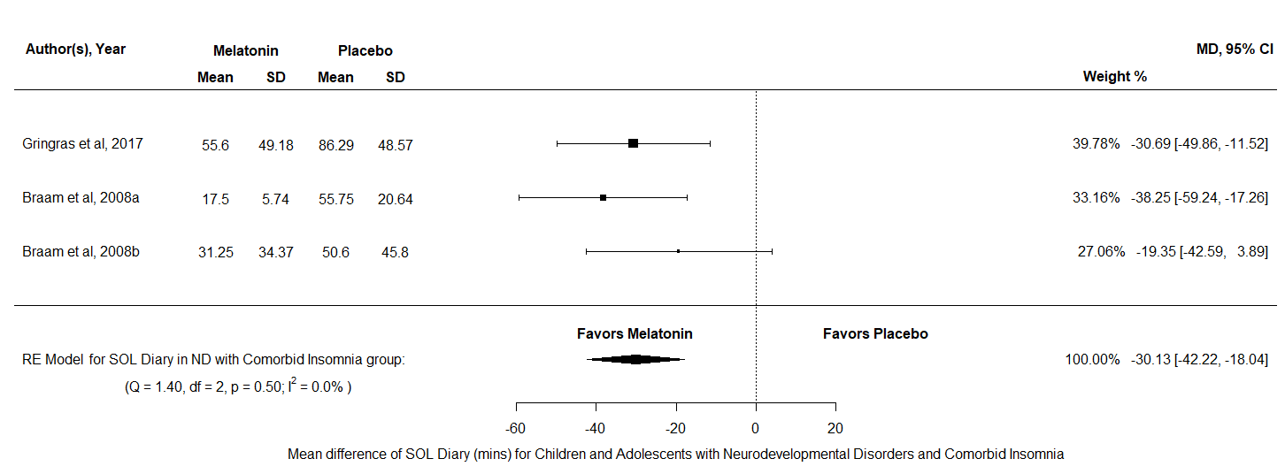
Figure O1: A forest plot to show the mean difference of SOL diary scores for melatonin against placebo in the Neurodevelopmental Disorders with Comorbid Insomnia group

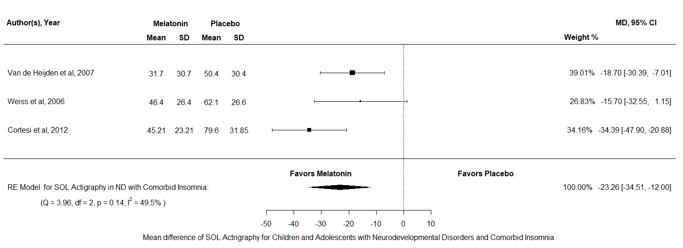
Figure O2: A forest plot to show the mean difference of SOL actigraphy scores for melatonin against placebo in the Neurodevelopmental Disorders with Comorbid Insomnia group

TST
Both TST diary and TST actigraphy data were analysed in the Neurodevelopmental Disorders with Comorbid Insomnia group. For TST diary there were k = 3 and N = 149, the results indicated no significant difference between melatonin and placebo MD = 62.22, 95% CI [2.95, 127.38], z = 1.87, p = 0.06. For TST actigraphy there were k = 2 and N = 171, The results indicated no significant difference between melatonin and placebo MD = 41.83, 95% CI [-3.51, 87.18], z = 1.81, p = 0.07. Overall, this means that both outcome variables of TST appear not to differ after a treatment of melatonin in comparison to placebo, for children and adolescents with neurodevelopmental disorders and comorbid insomnia. 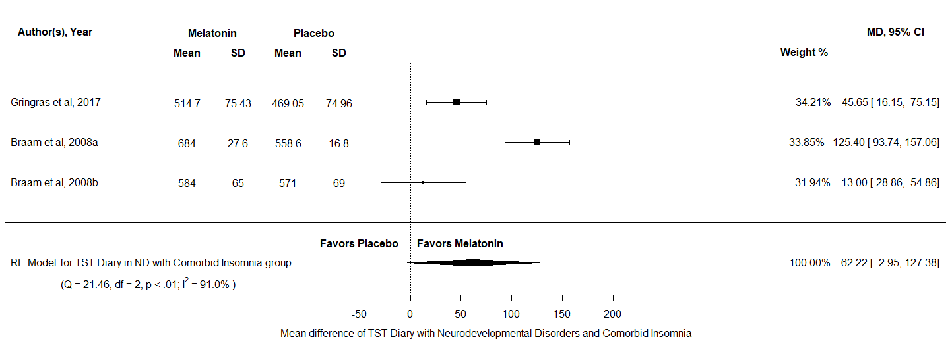
Figure Ü3: A forest plot to show the mean difference of TST diary scores for melatonin against placebo in the Neurodevelopmental Disorders with Comorbid Insomnia group

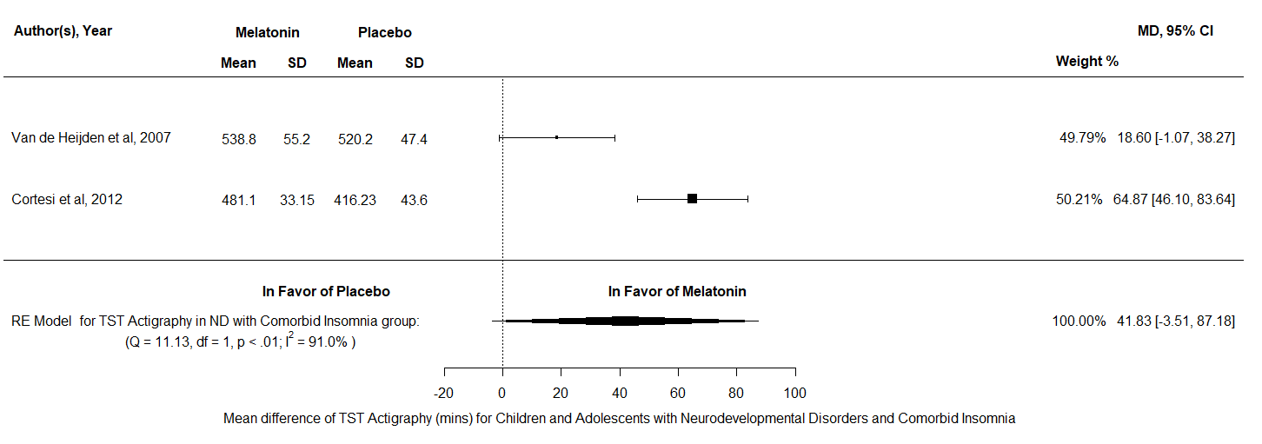
Figure O4: A forest plot to show the mean difference of TST actigraphy scores for melatonin against placebo in the Neurodevelopmental Disorders with Comorbid Insomnia group

NA
NA analysis consisted of k = 3 and N = 132, the results indicated no significant difference between melatonin and placebo SMD = -1.41, 95% CI [-3.05, 0.24], z = -1.67, p = 0.1. Therefore, this analysis indicates that the number of NAs may not reduce in children and adolescents with neurodevelopmental disorders and comorbid insomnia after a period of melatonin treatment.
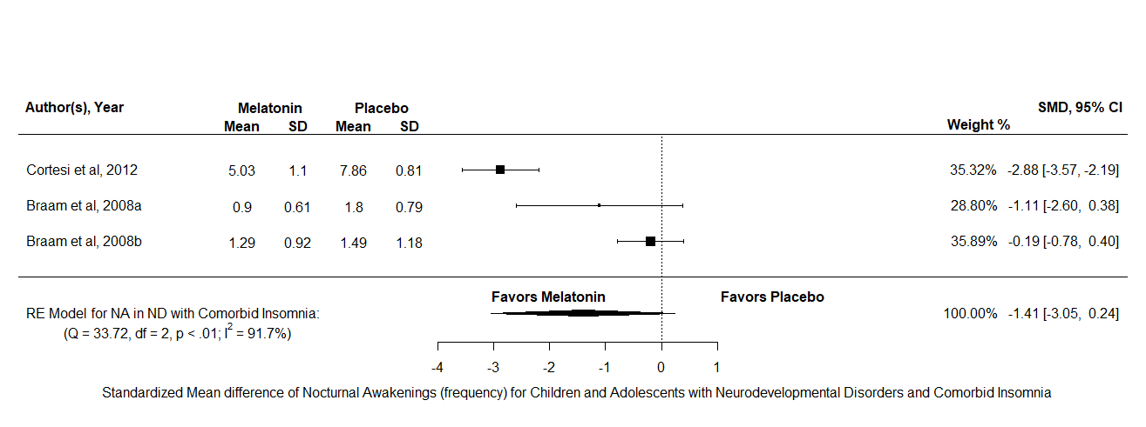
Figure O5: A forest plot to show the standardized mean difference of NA scores for melatonin against placebo in the Neurodevelopmental Disorders with Comorbid Insomnia group

Appendix P
A detailed description and forest Plots for all the outcome variables analysed for children and adolescents in the Intellectual Disability with Insomnia group
SOL
For SOL diary there were k = 2 and N = 58, the results indicated a significant difference in favour of melatonin over placebo MD = -29.49, 95% CI [-47.96, -11.01], z = -4.27, p = 0.002. Furthermore, the test for heterogeneity showed Q(df = 1) = 1.4, p = 0.24, τ = 0, I² = 0% which meant that this analysis produced an output which can account for variability of effect sizes. Overall, this result indicated that melatonin may reduce SOL by on average 30.05 minutes in children and adolescents with ID and insomnia in comparison to using placebo supplements.
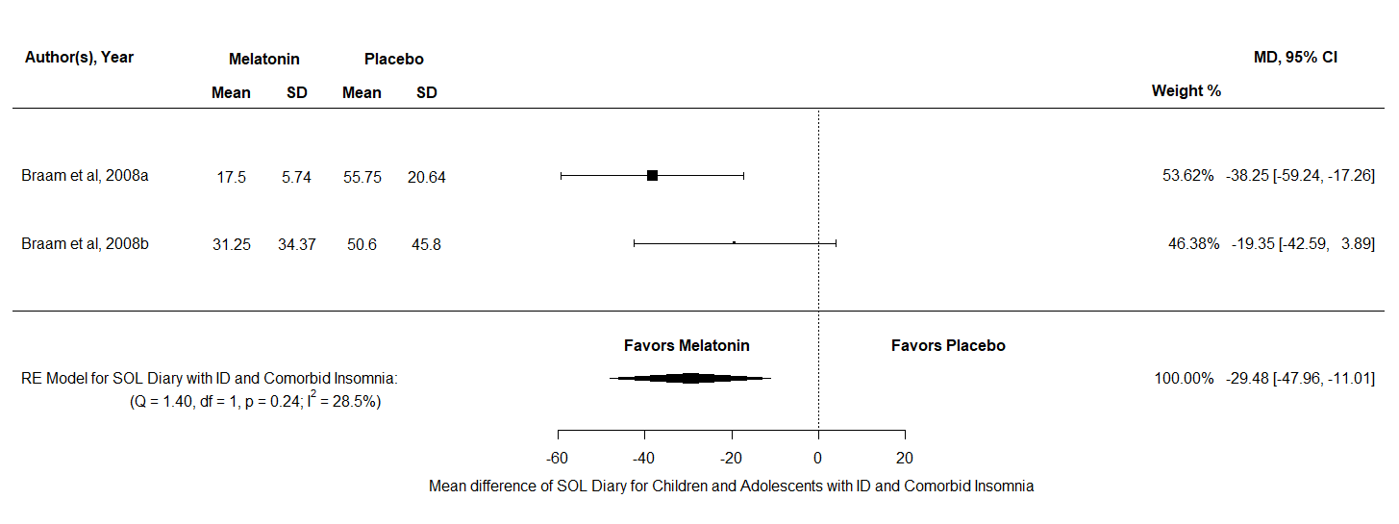
Figure P1: A forest plot to show the mean difference of SOL diary scores for melatonin against placebo in the ID with Comorbid Insomnia group
TST
TST diary was analysed in the ID group, there were k = 2 and N = 49 and the results indicated no significant difference between melatonin and placebo MD = 70.07, 95% CI [-440.07, 180.21], z = 1.25, p =0.21. Overall, this result indicates that melatonin does not increase TST in children and adolescents with ID and insomnia in comparison to using placebo.
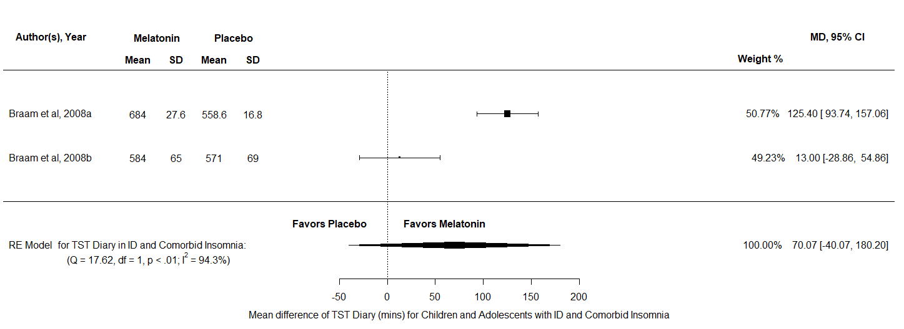
Figure P2: A forest plot to show the mean difference of TST diary scores for melatonin against placebo in the ID with Comorbid Insomnia group

NA
The NA analysis consisted of k = 2 and N = 52, the results indicated no significant difference between melatonin and placebo SMD = -0.39, 95% CI [-1.12, 0.35], z = -1.03, p =0.3. Therefore, this analysis indicates that the number of NAs is similar in children and adolescents with ID and insomnia regardless of the condition.
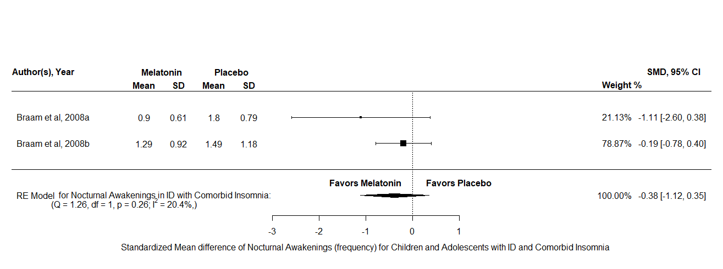
Figure P3: A forest plot to show the mean difference of NA scores for melatonin against placebo in the ID with Comorbid Insomnia group
Appendix Q
A detailed description and forest Plots for all the outcome variables analysed for children and adolescents in the Intellectual Disability & Intellectual Disability with Comorbid Insomnia group
SOL
For SOL diary there were k = 3 and N = 83, the results indicated a significant difference in favour of melatonin over placebo MD = -28.65, 95% CI [-42.66, -14.65], z = -4.01, p <.001. Furthermore, the test for heterogeneity showed Q(df = 2) = 1.5, p = 0.47, , τ = 0, I² = 0% which meant that this analysis produced an output which can account for variability of effect sizes. Overall, this result indicated that melatonin may reduce SOL by on average 27.4 minutes in children and adolescents with ID and ID with Comorbid Insomnia in comparison to using placebo supplements.
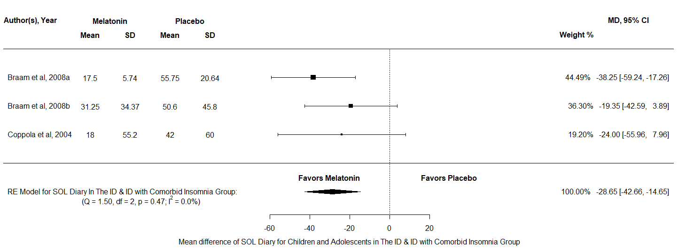
Figure Q1: A forest plot to show the mean difference of SOL diary scores for melatonin against placebo in the ID & ID with Comorbid Insomnia group
TST
TST diary was analysed in the ID & ID with Comorbid Insomnia group, there were k = 3 and N = 74 and the results indicated no significant difference between melatonin and placebo MD = 65.81, 95% CI [-2.29, 133.91], z = 1.89, p =0.06. Overall, this result indicates that melatonin does not increase TST in children and adolescents with ID and ID with comorbid insomnia in comparison to using placebo.
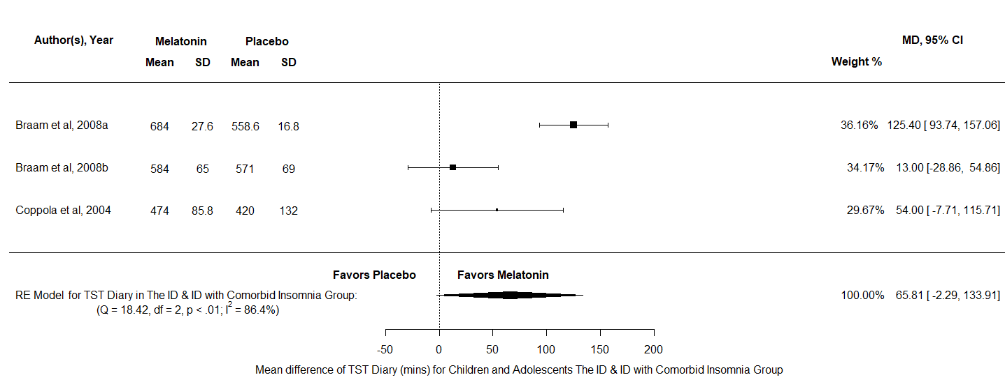
Figure Q2: A forest plot to show the mean difference of TST diary scores for melatonin against placebo in the ID & ID with Comorbid Insomnia group
NA
The NA analysis consisted of k = 3 and N = 77, the results indicated a significant difference in favour of melatonin over placebo SMD = -0.34, 95% CI [-0.73, -0.06], z = -1.69, p = 0.09 τ = 0, I² = 0%. Therefore, this analysis indicates that there is no difference between melatonin and placebo on the reduction of NAs in children and adolescents with ID and ID with Comorbid Insomnia.

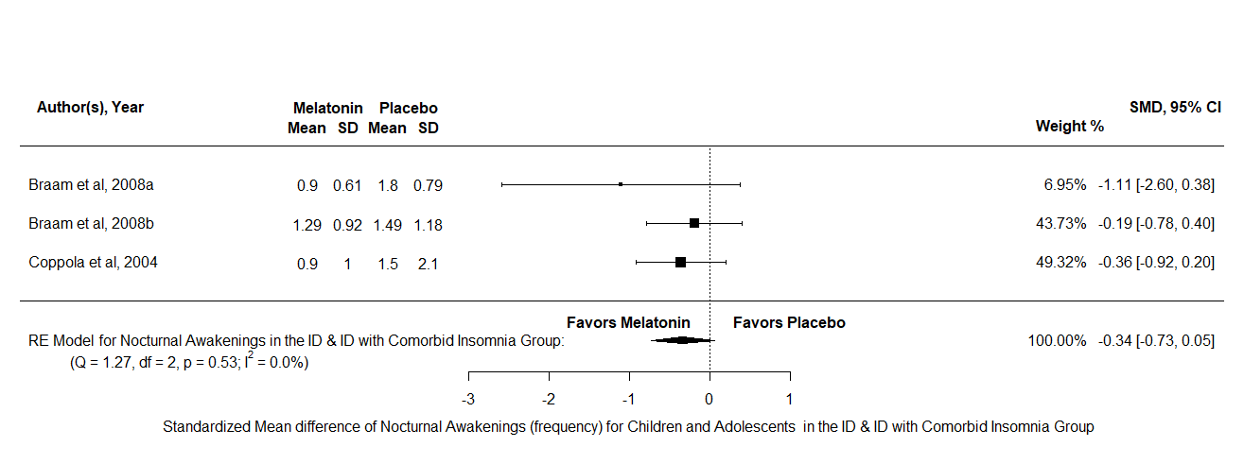
Figure Q3: A forest plot to show the mean difference of NA scores for melatonin against placebo in the ID & ID with Comorbid Insomnia group

Appendix R
A detailed description and forest Plots for all the outcome variables analysed for children and adolescents in the Neurodevelopmental Disorder group (not better specified)
SOL
For SOL diary there were k = 2 and N = 130, the results indicated a significant difference in favour of melatonin over placebo MD = - 36.84, 95% CI [-55.85, -17.84], z = -3.8, p <.001. Furthermore, the test for heterogeneity showed Q(df = 1) = 0.02, p = 0.88, τ = 0, I² = 0%. which meant that this analysis produced an output which can account for variability of effect sizes. Overall, this result indicates that melatonin may reduce SOL diary scores by on average 36.77 minutes in children and adolescents with ND in comparison to using placebo supplements.
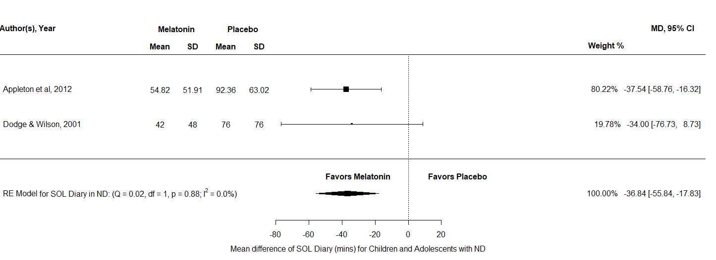
Figure R1: A forest plot to show the mean difference of SOL diary scores for melatonin against placebo in the Neurodevelopmental Disorders group
TST
TST diary was analysed in the ND group, there were k = 2 and N = 100, the results indicated no significant difference between melatonin and placebo MD = 14.54, 95% CI [-15.67, 44.74], z = 0.94, p = 0.35. This means that the outcome variable TST diary appears not to differ after a treatment of melatonin in comparison to placebo, for children and adolescents with ND.
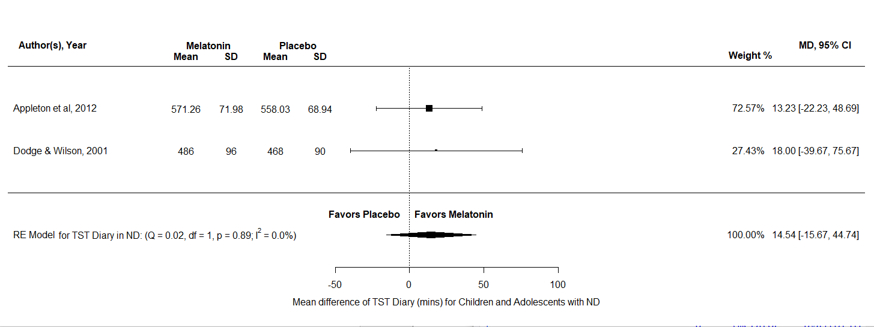
Figure R2: A forest plot to show the mean difference of TST diary scores for melatonin against placebo in the Neurodevelopmental Disorders group

Appendix S
A detailed description and forest Plots for all the outcome variables analysed in the All Neurodevelopmental Disorder group
SOL
For SOL diary there were k = 8 and N = 341, the results indicated a significant difference in favour of melatonin over placebo MD = -37.77, 95% CI [-47.66, -27.88], z = -7.49, p <.001. Furthermore, the test for heterogeneity showed Q(df = 7) = 10.92, p = 0.14, τ = 8.46, I² = 49.16% which meant that this analysis produced an output which can account for variability of effect sizes. For SOL actigraphy there were k = 6 and N = 296, the results indicated a significant difference in favour of melatonin over placebo MD = -21.19, 95% CI [-29.83, -12.55], z = -4.81, p <.001. Furthermore, the test for heterogeneity showed Q(df = 5) = 9.73, p = 0.08, τ = 7.21 I² = 51.01% which meant that this analysis produced an output which can account for variability of effect sizes. Overall, both measurements of SOL appear to reduce after a treatment of melatonin in children and adolescents in the All Neurodevelopmental Disorder group.
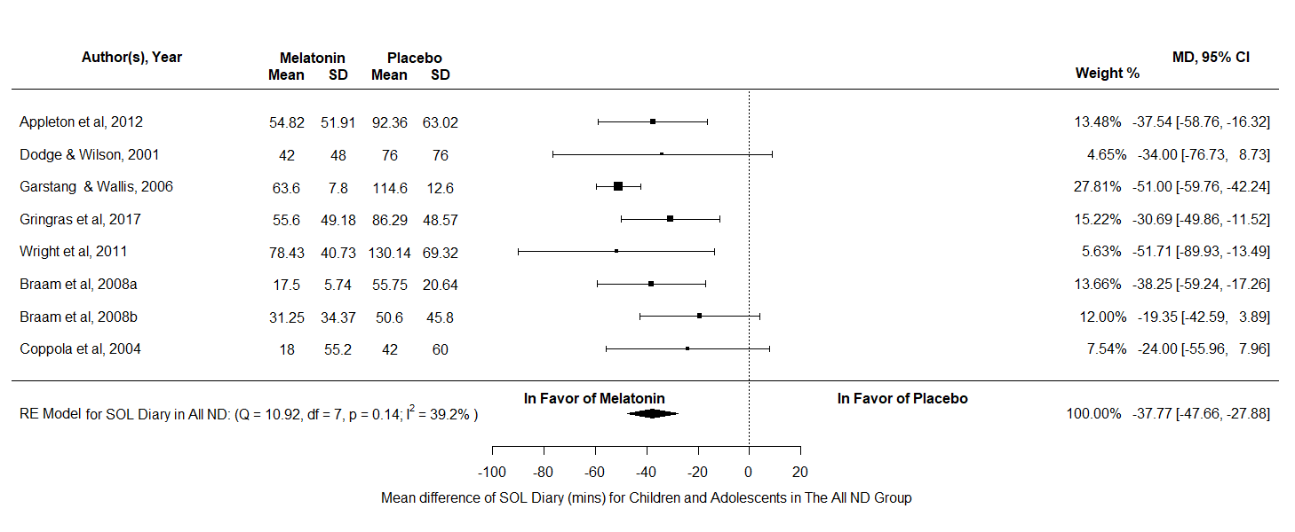
Figure S1: A forest plot to show the mean difference of SOL diary scores for melatonin against placebo in the All Neurodevelopmental Disorders group
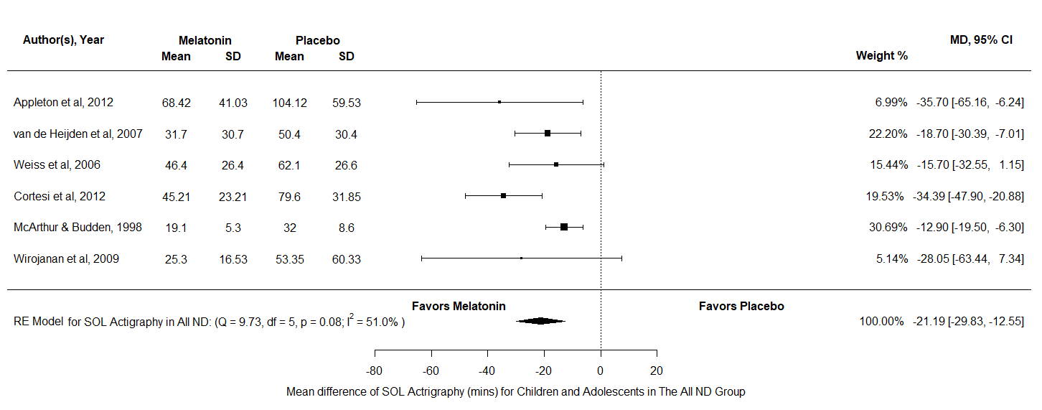
Figure S2: A forest plot to show the mean difference of SOL actigraphy scores for melatonin against placebo in the All Neurodevelopmental Disorders group
TST
Both TST diary and TST actigraphy data were analysed in the AND group. For TST diary there were k = 8 and N = 332, the results indicated a significant difference in favour of melatonin over placebo MD = 49.48, 95% CI [22.24, 76.72], z = 3.56, p <.001. Furthermore, the test for heterogeneity showed Q(df = 7) = 36.17, p <.001, τ = 34.08, I² = 81.7% which meant that this analysis did not produce an output which can account for variability of effect sizes. For TST actigraphy there were k = 4 and N = 242, the results indicated a significant difference in favour of melatonin over placebo MD = 36.44, 95% CI [10.29, 62.6], z = 2.73, p = 0.01. Furthermore, the test for heterogeneity showed Q(df = 3) = 11.99, p = 0.01, τ = 21.14, I² = 69.36% which meant that this analysis did not produce an output which can account for the variability of effect sizes. Overall, both measurements of TST appear to increase after a treatment of melatonin in children and adolescents with AND. However, these results should be interpreted with caution as there is a lot of uncounted variability in both measurements.
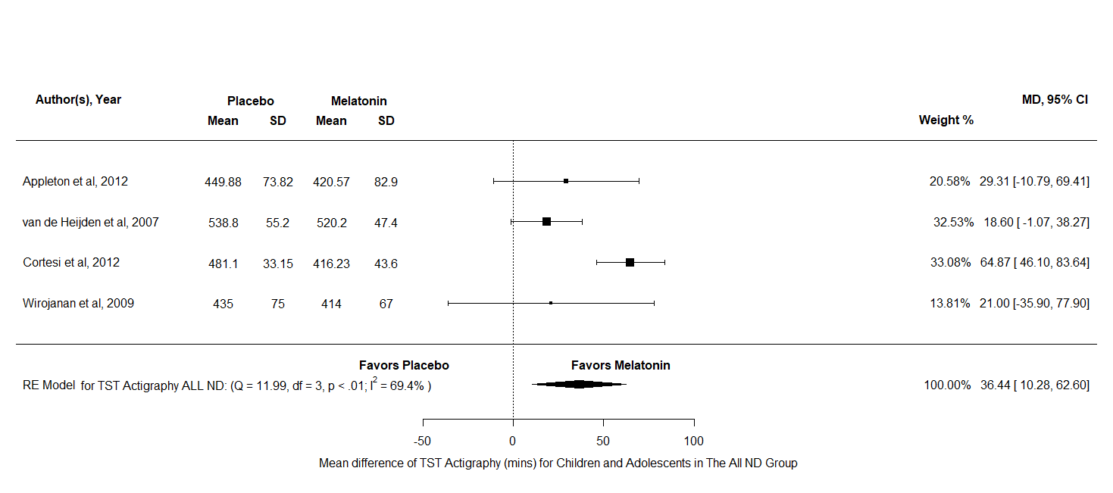
Figure S3: A forest plot to show the mean difference of TST diary scores for melatonin against placebo in the All Neurodevelopmental Disorders group
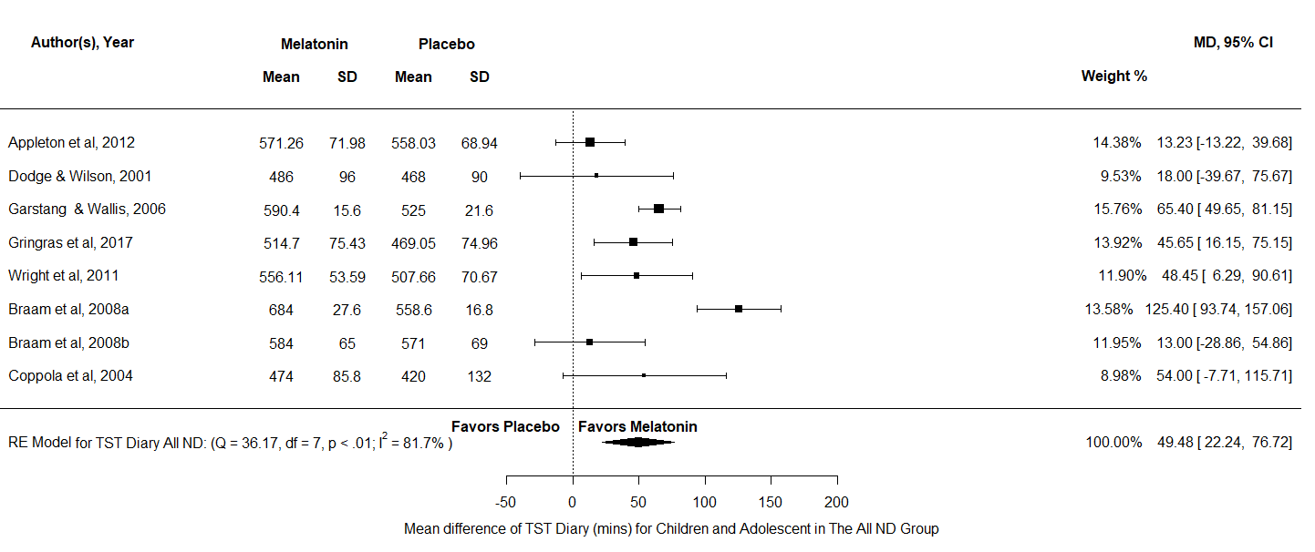
Figure S4: A forest plot to show the mean difference of TST actigraphy scores for melatonin against placebo in the All Neurodevelopmental Disorders group
NA
NA analysis consisted of k = 8 and N = 200, the results indicated a significant difference in favour of melatonin over placebo SMD = -0.76, 95% CI [-1.52, -0.004], z = -1.95, p = 0.05. Furthermore, the test for heterogeneity showed Q(df = 7) = 60.73, p <.001, τ = 1.04, I² = 88.46% which meant that this analysis did not produce an output which can account for variability of effect sizes. Therefore, this analysis indicates that the number of NAs reduce in children and adolescents with AND after a period of melatonin treatment. However, these results should be interpreted with caution as there is a lot of uncounted variability.
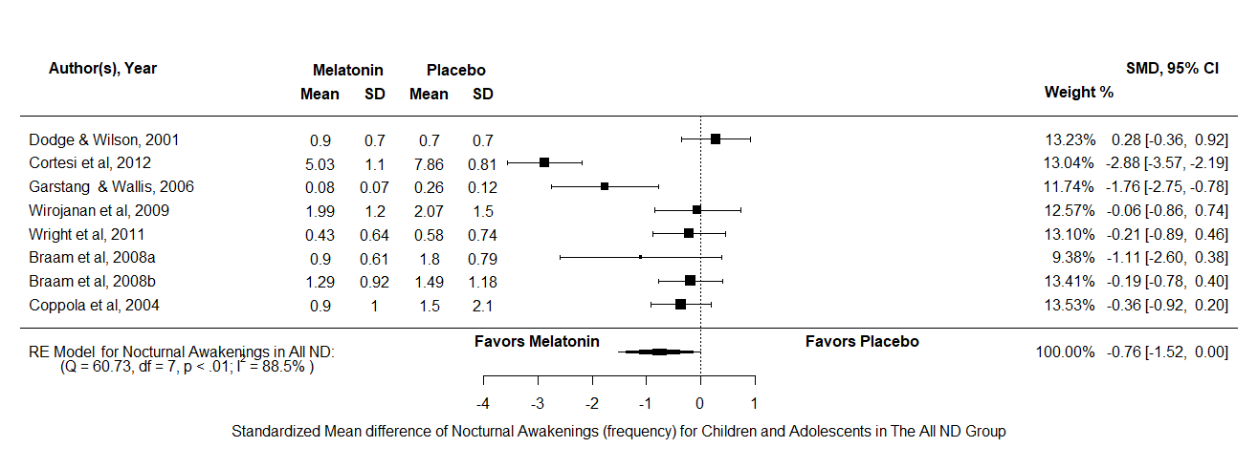
Figure S5: A forest plot to show the standardized mean difference of nocturnal awakenings scores for melatonin against placebo in the All Neurodevelopmental Disorders group
DLMO
DLMO was analysed in the AND, there were k = 2 and N = 143, the results indicated no significant difference between melatonin and placebo MD = -0.75, 95% CI [-2.07, 0.57], z = -1.12, p = 0.26. Therefore, this analysis indicates that DLMO does not appear to be different in the night in children and adolescents with AND after a period of melatonin treatment compared to placebo.
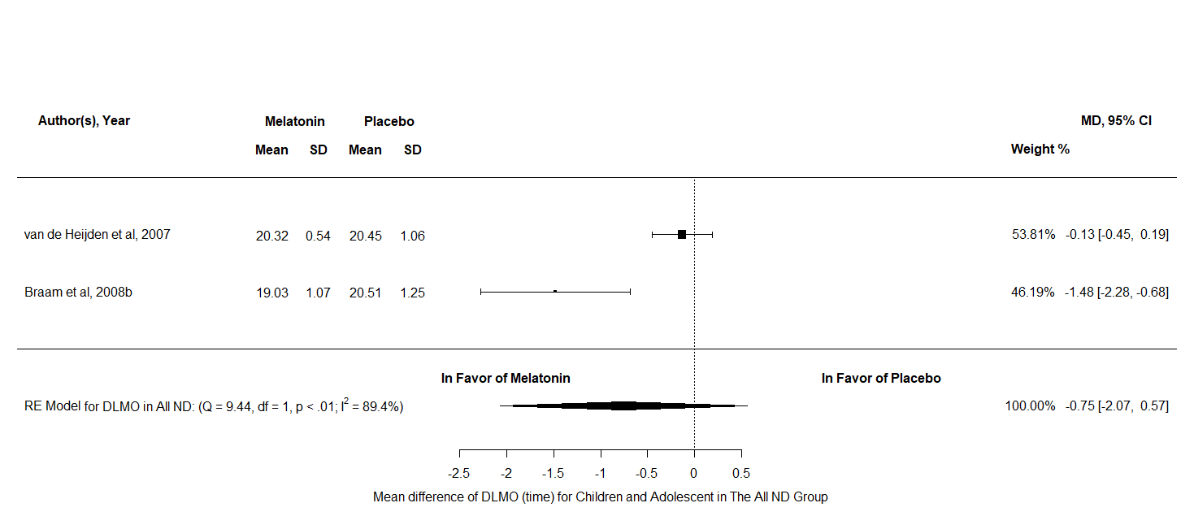
Figure S6: A forest plot to show the mean difference of DLMO scores for melatonin against placebo in the All Neurodevelopmental Disorders group

Appendix T
A detailed description and forest Plots for all the outcome variables analysed for children and adolescents in the All Sleep Disorders group
SOL
For SOL diary there were k = 6 and N = 291, the results indicated a significant difference in favour of melatonin over placebo MD = -23.87, 95% CI [-32.78, -14.95], z = -5.25, p <.001. Furthermore, the test for heterogeneity showed Q(df = 5) = 8.8, p = 0.12, τ = 7.2, I² = 43.2% which meant that this analysis produced an output which can account for variability of effect sizes. For SOL actigraphy there were k = 3 and N = 124, the results indicated a significant difference in favour of melatonin over placebo MD = -18.53, 95% CI [-33.12, -3.95], z = -2.49, p 0.01. Furthermore, the test for heterogeneity showed Q(df = 2) = 7.48, p = 0.02, τ = 11.09, I² = 74.2% which meant that this analysis did not produce an output which can account for variability of effect sizes. Overall, both measurements of SOL appear to reduce after a treatment of melatonin for children and adolescents in the All Sleep Disorders group. However, more research using actigraphy data or moderator analyses is needed to uncover the large amount of unaccounted variability in SOL actigraphy.
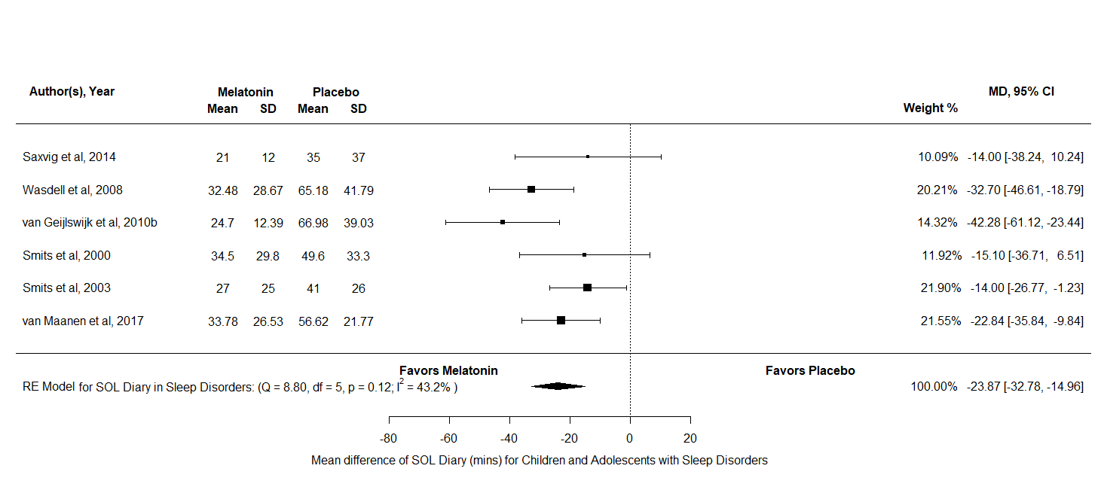
Figure T1: A forest plot to show the mean difference of SOL diary scores for melatonin against placebo in the All Sleep Disorders group
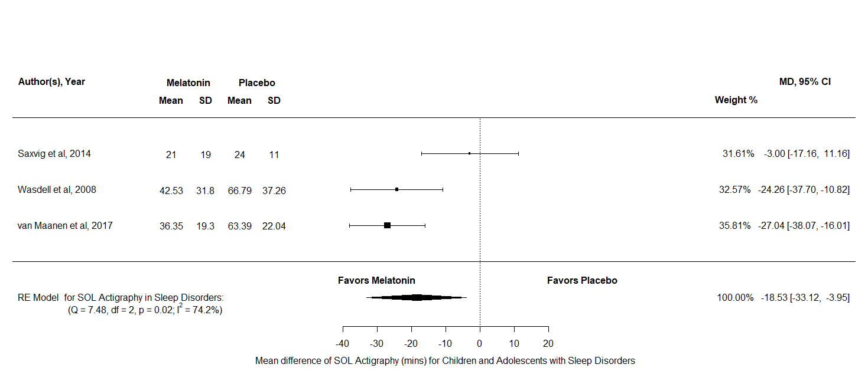
Figure T2: A forest plot to show the mean difference of SOL actigraphy scores for melatonin against placebo in the All Sleep Disorders group
TST
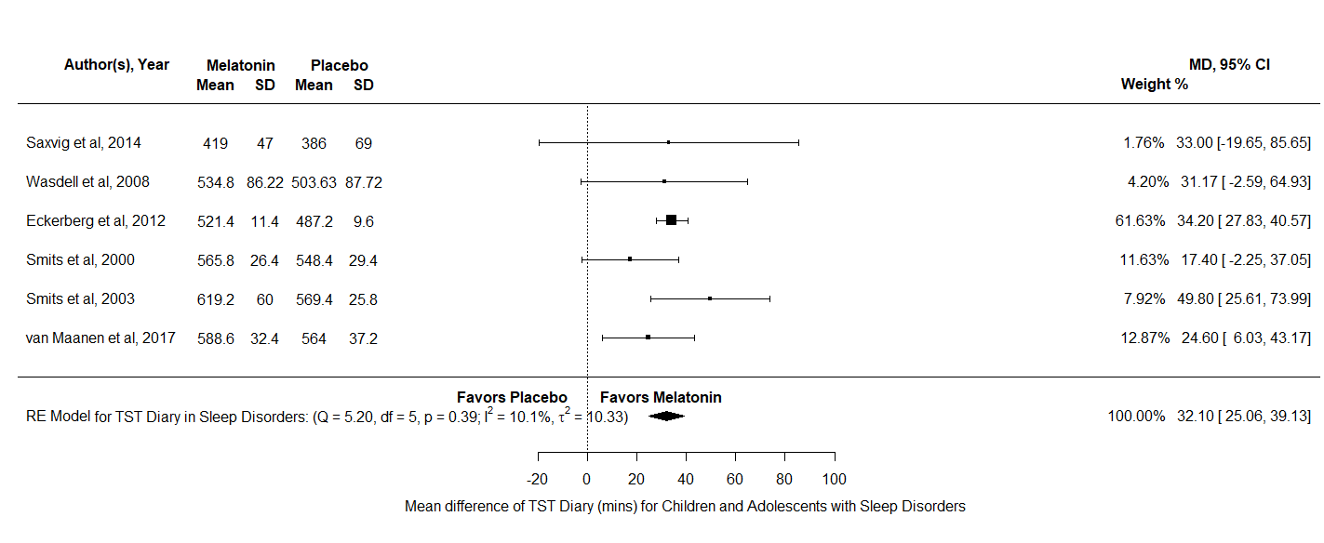
Both TST diary and TST actigraphy data were analysed for the All Sleep Disorders group. For TST diary there were k = 6 and N = 238, the results indicated a significant difference in favor of melatonin over placebo MD = 32.1, 95% CI [25.6, 39.13], z = 8.94, p <.001. Furthermore, the test for heterogeneity showed Q(df = 5) = 5.2, p = 0.39, τ = 3.21 I² = 10.09% which means that this analysis produced an output which can account for variability of effect sizes. For TST actigraphy there was k = 3 and N = 121, the results indicated no significant difference between melatonin and placebo MD = 7.04, 95% CI [-6.85, 20.93], z = 0.99, p = 0.32. Overall, only TST diary appears to increase after treatment of melatonin in children and adolescents in all sleep disorders combined. Whilst TST actigraphy suggests the opposite.
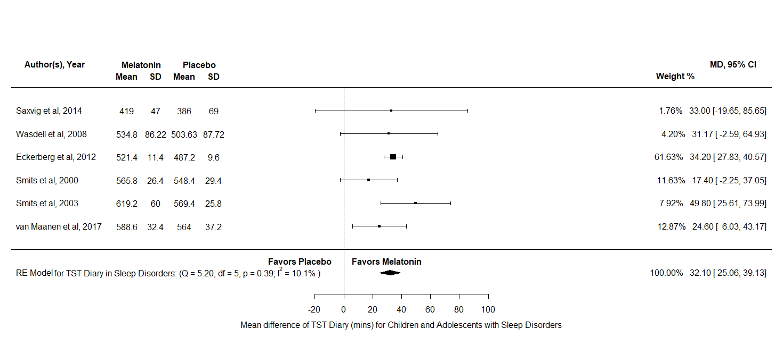
Figure T3: A forest plot to show the mean difference of TST diary scores for melatonin against placebo in the All Sleep Disorders group
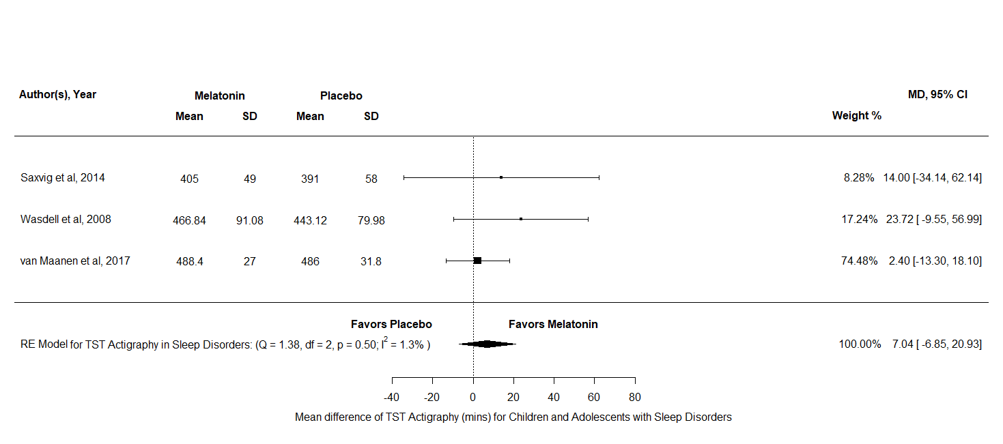
Figure T4: A forest plot to show the mean difference of TST actigraphy scores for melatonin against placebo in the All Sleep Disorders group

Appendix U
A detailed description and forest Plots for all the outcome variables analysed for children and adolescents in the All Sleep Disorders group & Neurodevelopmental Disorders with Insomnia group
SOL
For SOL diary there were k = 9 and N = 449, the results indicated a significant difference in favour of melatonin over placebo MD = -25.44, 95% CI [-32.43, -18.44], z = -7.13, p <.001. Furthermore, the test for heterogeneity showed Q(df = 8) = 11.06, p = 0.2, τ = 5.72, I² = 29.35% which meant that this analysis produced an output which can account for variability of effect sizes. For SOL actigraphy there were k = 6 and N = 124, the results indicated a significant difference in favour of melatonin over placebo MD = -20.93, 95% CI [-29.35, -12.51], z = -4.3, p 0.01. Furthermore, the test for heterogeneity showed Q(df = 5) = 11.86, p = 0.04, τ = 8.02, I² = 58.75% which meant that this analysis did not produce an output which can account for variability of effect sizes. Overall, both measurements of SOL appear to reduce after a treatment of melatonin for children and adolescents in the All Sleep Disorders & Neurodevelopmental Disorders with Insomnia group. However, more research using actigraphy data or moderator analyses is needed to uncover the large amount of unaccounted variability in SOL actigraphy.
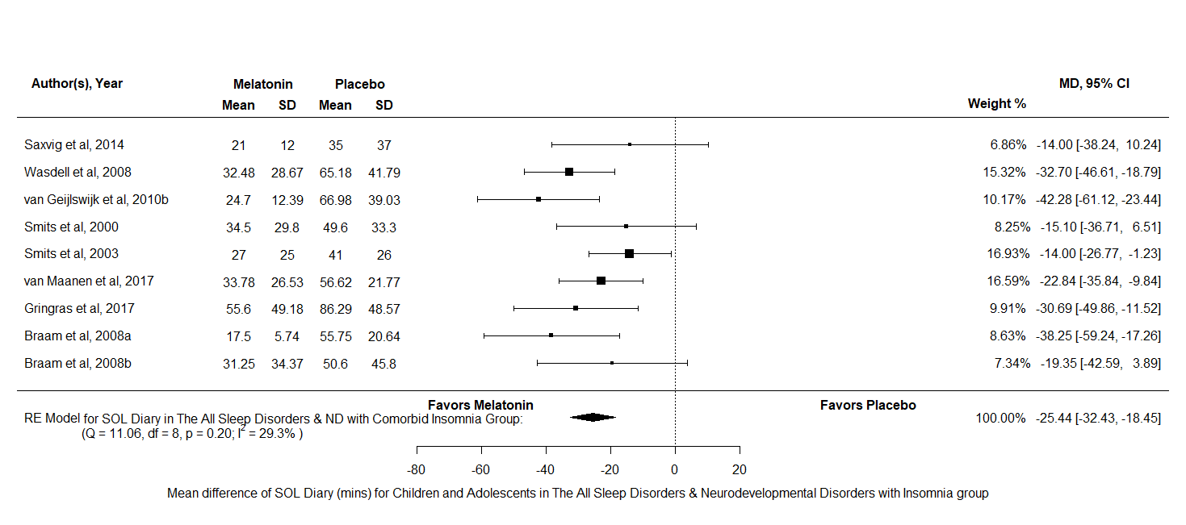
Figure U1: A forest plot to show the mean difference of SOL diary scores for melatonin against placebo in the All Sleep Disorders & Neurodevelopmental Disorders with Comorbid Insomnia group

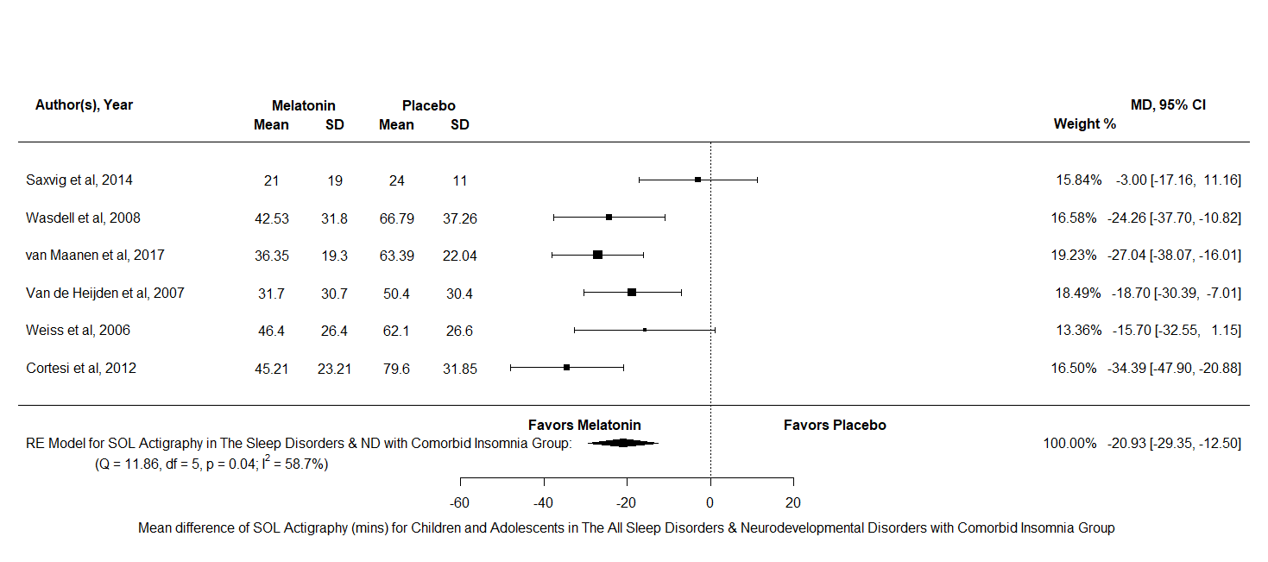
Figure U2: A forest plot to show the mean difference of SOL actigraphy scores for melatonin against placebo in the All Sleep Disorders & Neurodevelopmental Disorders with Comorbid Insomnia group
TST
Both TST diary and TST actigraphy data were analysed for the All Sleep Disorders & Neurodevelopmental Disorders with Insomnia group. For TST diary there were k = 9 and N = 387, the results indicated a significant difference in favour of melatonin over placebo MD = 41.45, 95% CI [20.06, 62.84], z = 3.8, p <.001. Furthermore, the test for heterogeneity showed Q(df = 8) = 38.69, p <.001, τ = 29.12 I² = 88.13% which means that this analysis does not produce an output which can account for variability of effect sizes. For TST actigraphy there was k = 5 and N = 295, the results indicated a significant difference in favour of melatonin over placebo MD = 25.65, 95% CI [-1.81, 49.5], z = 2.11, p = 0.04. Furthermore, the test for heterogeneity showed Q(df = 4) = 25.9, p <.001, τ = 23.51 I² = 80.63% which means that this analysis does not produce an output which can account for variability of effect sizes. Overall, both measures of TST appears to increase after treatment of melatonin in children and adolescents in the All Sleep Disorders and Neurodevelopmental Disorders with Insomnia group. However, more research using actigraphy data or moderator analyses is needed to uncover the large amount of unaccounted variability in both measures.
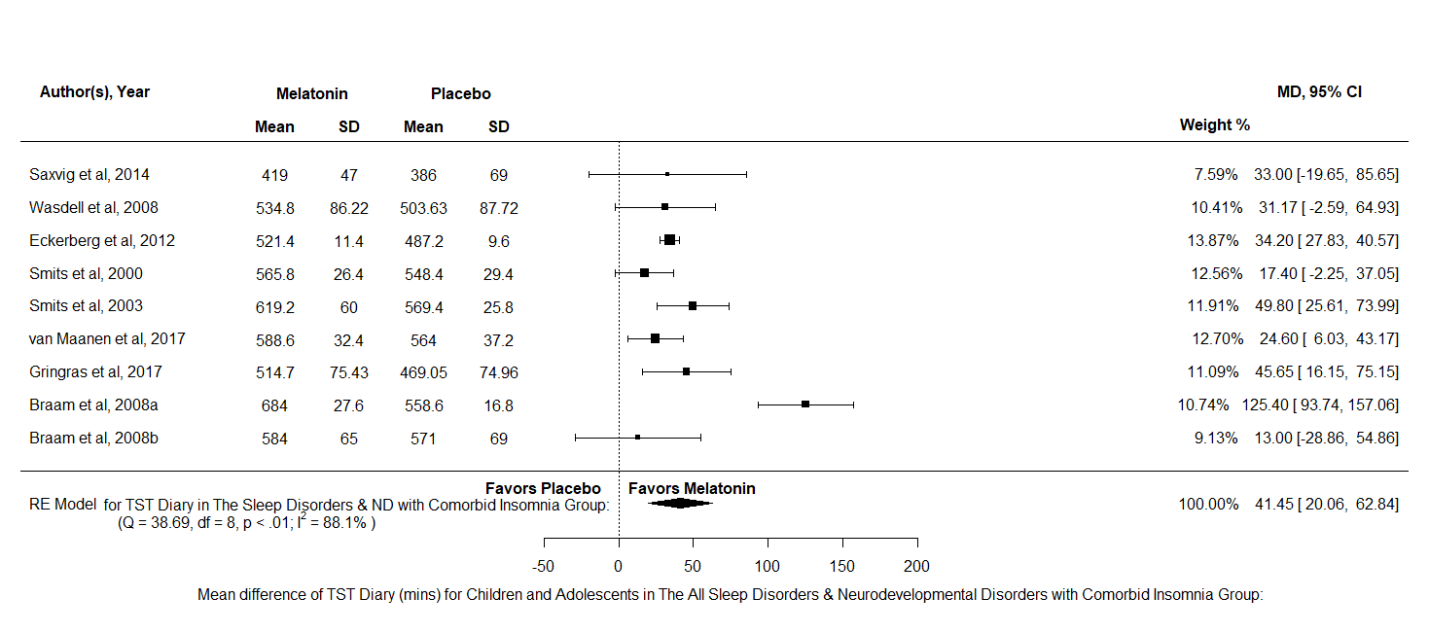
Figure U3: A forest plot to show the mean difference of TST diary scores for melatonin against placebo in the All Sleep Disorders & Neurodevelopmental Disorders with Comorbid Insomnia group

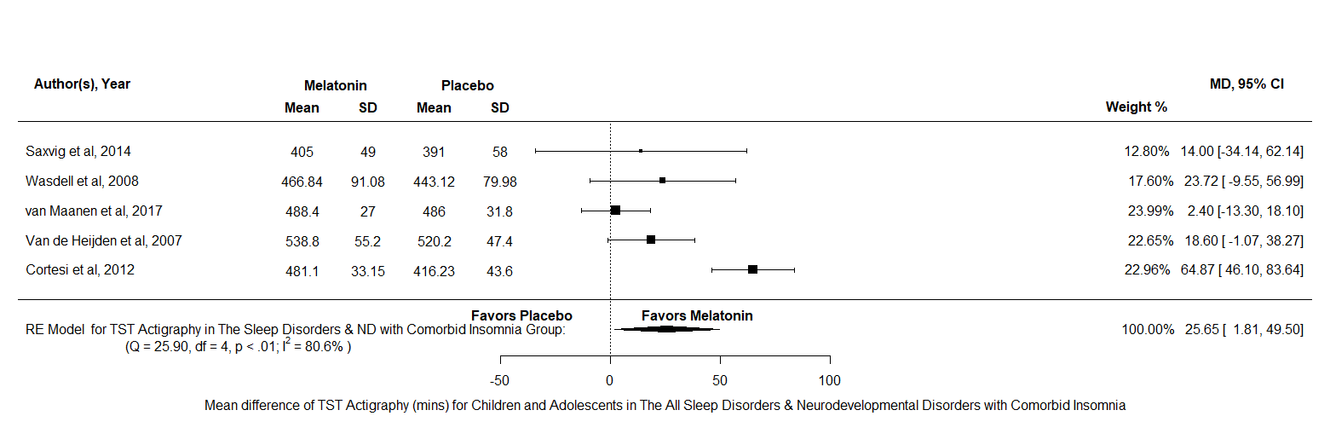
Figure U4: A forest plot to show the mean difference of TST actigraphy scores for melatonin against placebo in the All Sleep Disorders & Neurodevelopmental Disorders with Comorbid Insomnia group

NA
The NA analysis consisted of k = 4 and N = 183, the results indicated no significant difference between melatonin and placebo SMD = -1.03, 95% CI [-2.38, -0.31], z = -1.51, p = 0.13. Therefore, this analysis indicates that the number of NAs is similar in children and adolescents with sleep disorders or neurodevelopmental disorders with insomnia.
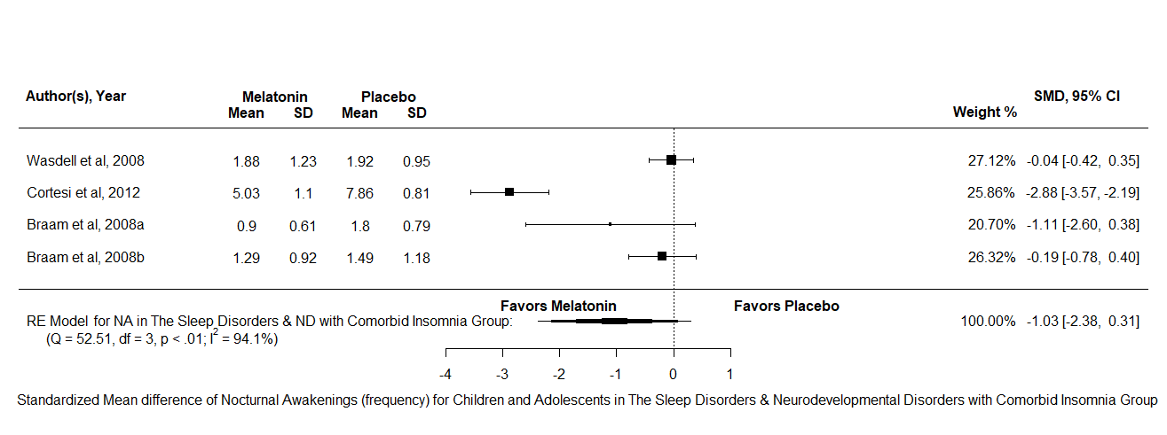
Figure U5: A forest plot to show the standardized mean difference of nocturnal awakenings scores for melatonin against placebo in the All Sleep Disorders & Neurodevelopmental Disorders with Comorbid Insomnia group
DLMO
DLMO was analysed across all disorders, there were k = 6 and N = 410, the results indicated no significant difference between melatonin and placebo MD = -0.45, 95% CI [-0.91, 0.01], z = -1.92, p = 0.06. This means that DLMO scores did not differ between melatonin and placebo after a period of treatment for children and adolescents with sleep disorders or neurodevelopmental disorders with insomnia.
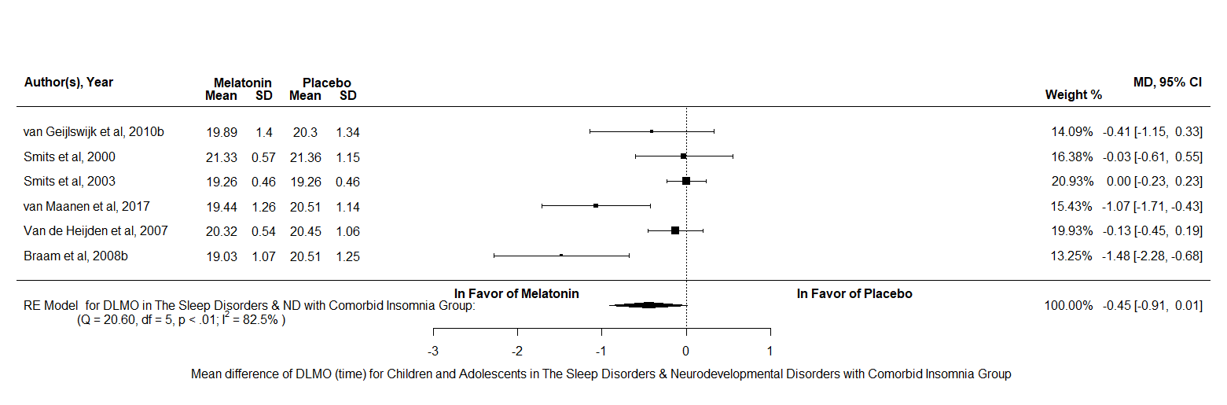
Figure U6: A forest plot to show the mean difference of DLMO scores for melatonin against placebo in the All Sleep Disorders & Neurodevelopmental Disorders with Comorbid Insomnia group
Appendix V
A detailed description and forest Plots for all the outcome variables analysed for children and adolescents in the All Disorders Combined group
SOL
For SOL diary there were k = 14 and N = 632, the results indicated a significant difference in favour of melatonin over placebo MD = -30.46, 95% CI [-38.12, -22.79], z = -7.79, p <.001. Furthermore, the test for heterogeneity showed Q(df = 13) = 36.03, p <.001, τ = 10.31, I² = 56.78% which meant that this analysis did not produce an output which can account for variability of effect sizes and interpretation of this result should be taken with caution. For SOL actigraphy there were k = 9 and N = 414, the results indicated a significant difference in favour of melatonin over placebo MD = -20.37, 95% CI [-27.28, -13.47], z = -5.78, p <.001. Furthermore, the test for heterogeneity showed Q(df = 8) = 17.47, p = 0.03, τ = 7.43 I² = 55.76% which also meant that this analysis does not produce an output which can account for variability of effect sizes. Overall, both SOL scores appear to reduce after a treatment of melatonin in children and adolescents across all disorder.
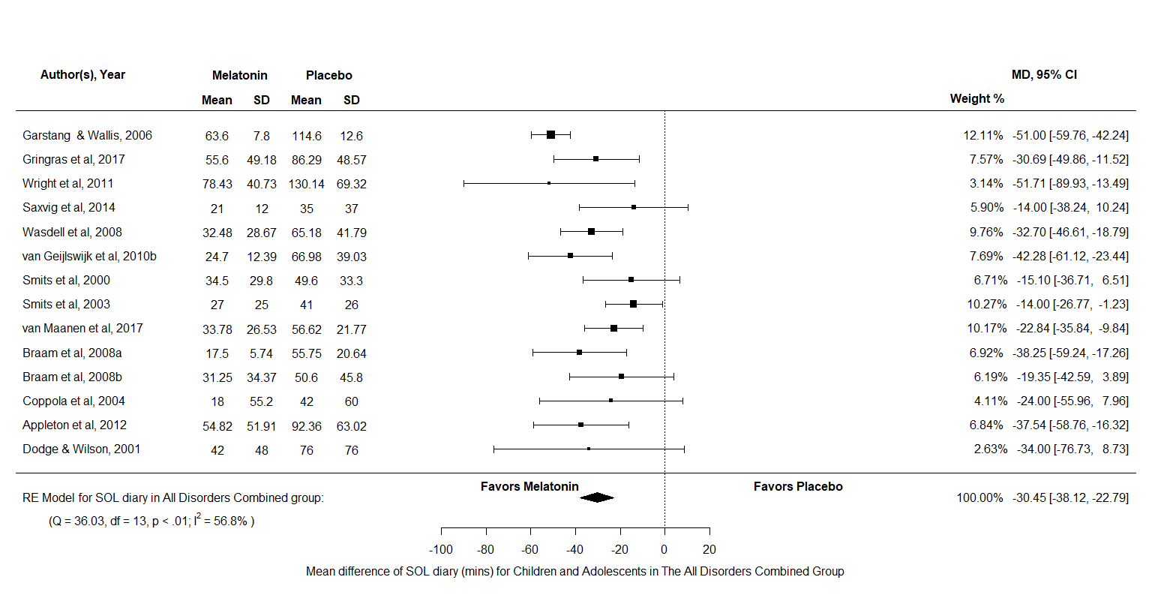
Figure V1: A forest plot to show the mean difference of SOL diary scores for melatonin against placebo in the All Disorders Combined group
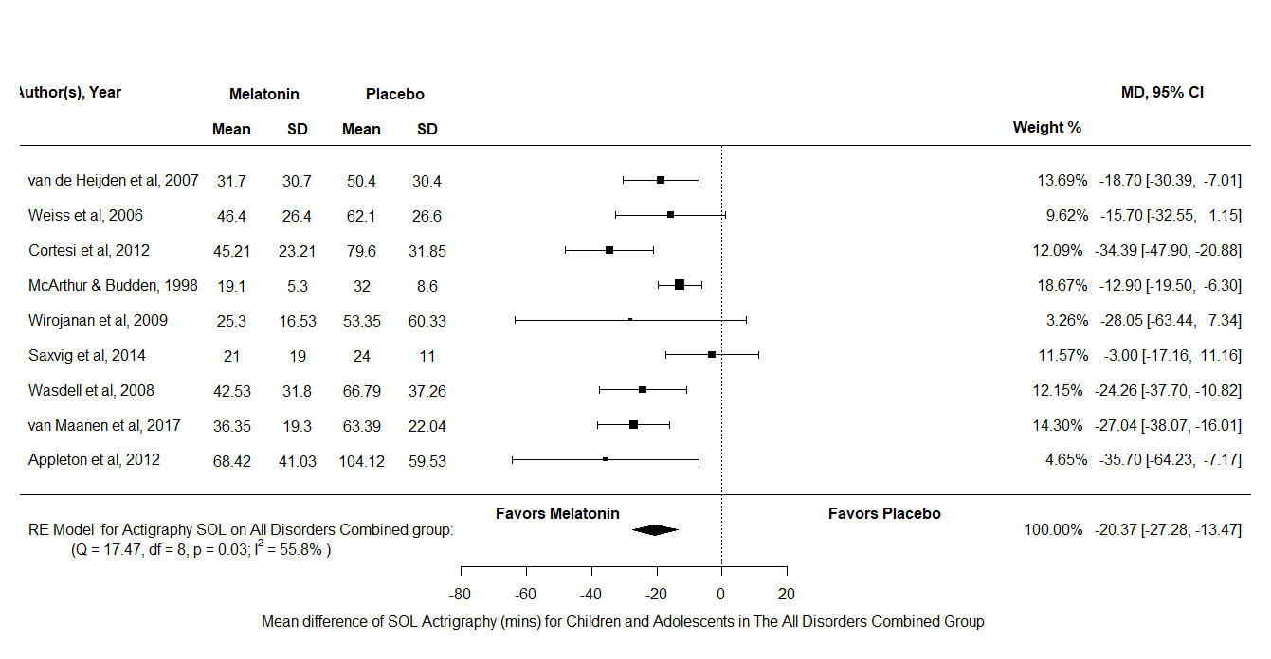
Figure V2: A forest plot to show the mean difference of SOL actigraphy scores for melatonin against placebo in the All Disorders Combined group
TST
Both TST diary and TST actigraphy data were analysed across all disorders. For TST diary there were k = 14 and N = 570, the results indicated a significant difference in favour of melatonin over placebo MD = 41.24, 95% CI [25.47, 57.02], z = 5.13, p <.001. Furthermore, the test for heterogeneity showed Q(df = 13) = 55.53, p <.001, τ = 25.16, I² = 83.5% which meant that this analysis did not produce an output which can account for variability of effect sizes. For TST actigraphy there were k = 7 and N = 366, the results indicated a significant difference in favor of melatonin over placebo MD = 25.82, 95% CI [6.64, 49.99], z = 2.64, p = 0.01. Furthermore, the test for heterogeneity showed Q(df = 6) = 25.97, p <.001, τ = 20.3, I² = 70.29% which meant that this analysis did not produce an output which can account for the variability of effect sizes. Overall, both measurements of TST appear to increase after a treatment of melatonin in children and adolescents across all disorders. However, these results should be interpreted with caution as there is a lot of uncounted variability in both measurements.

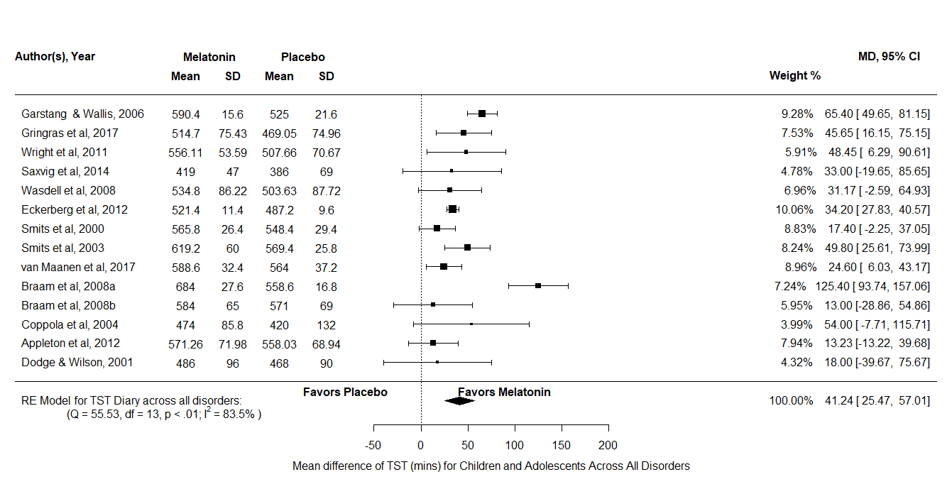 Figure V3: A forest plot to show the mean difference of TST diary scores for melatonin against placebo in the All Disorders Combined group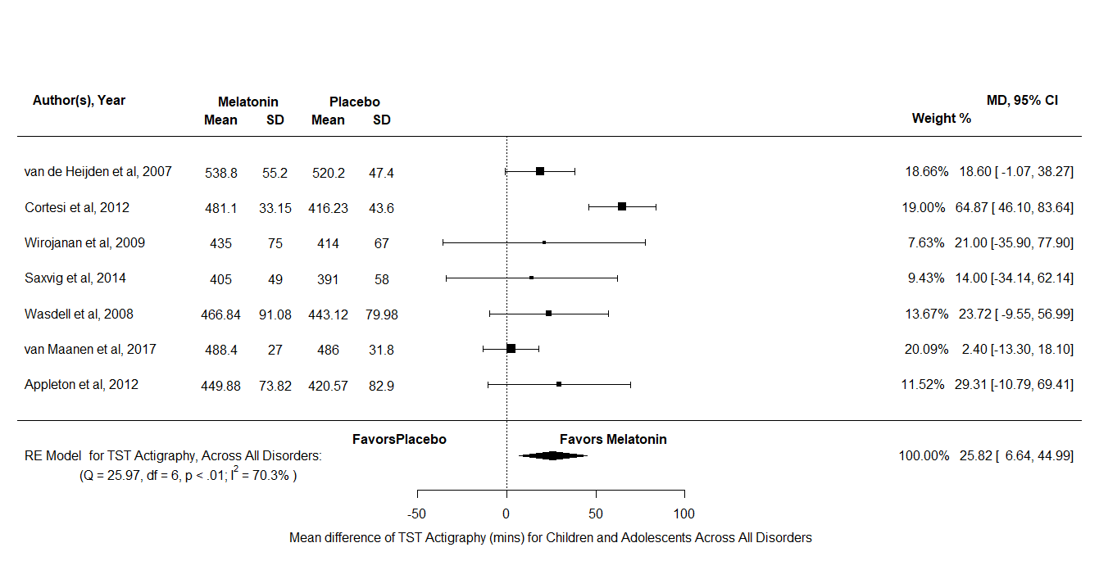
Figure V4: A forest plot to show the mean difference of TST actigraphy scores for melatonin against placebo in the All Disorders Combined group
NA
The NA analysis consisted of k = 9 and N = 256, the results indicated no significant difference between melatonin and placebo SMD = -0.67, 95% CI [-1.35, -0.02], z = -1.91, p = 0.06. Therefore, this analysis indicates that the number of NAs is similar in children and adolescents with sleep disorders or neurodevelopmental disorders with insomnia.
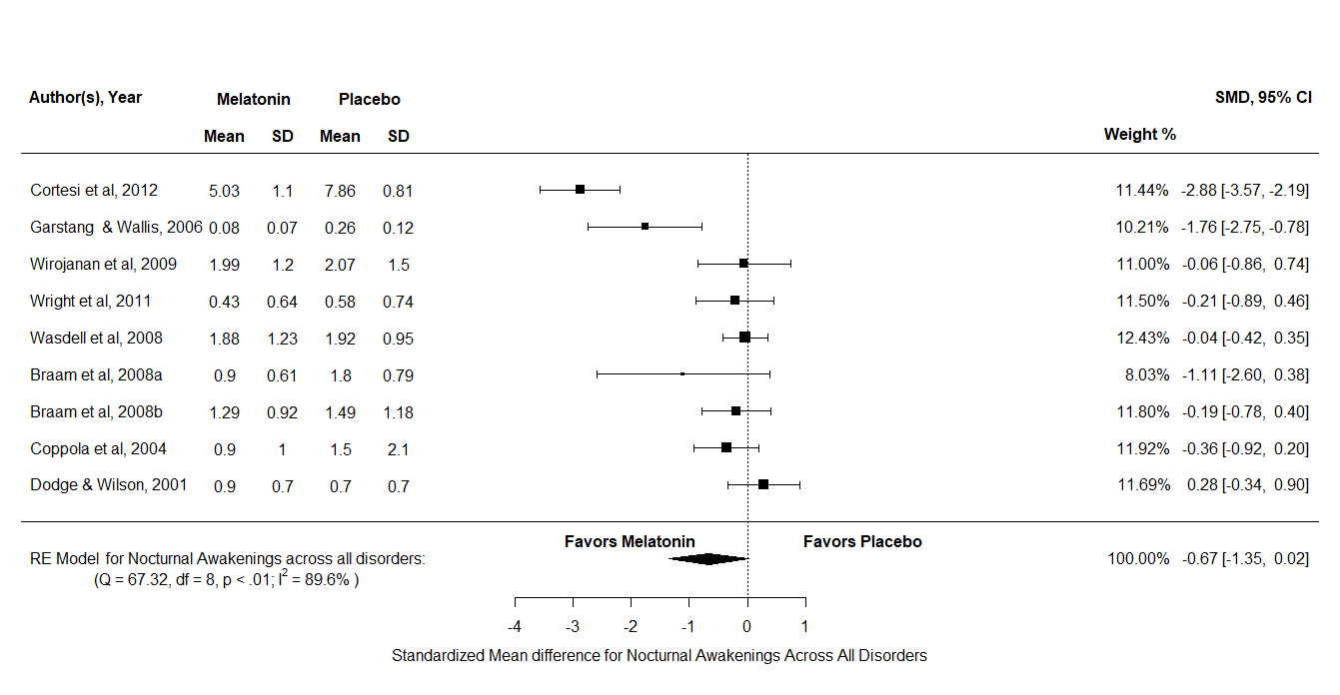
Figure V5: A forest plot to show the standardized mean difference of nocturnal awakenings scores for melatonin against placebo in the All Disorders Combined group

Appendix W
A detailed description and forest Plots for all the outcome variables analysed in the adult Delayed Sleep Phase Disorder group
SOL
For SOL actigraphy there were k = 2 and N = 114, the results indicated no significant difference between melatonin and placebo MD = -6.89, 95% CI [-14.52, -0.56], z = -1.82, p =0.07. For SOL polysomnography there were k = 2 and N = 40, the results indicated no significant difference between melatonin and placebo MD = -3.35, 95% CI [-7.01, -0.31], z = -1.8, p = 0.07. Overall, SOL scores do not appear to reduce after a treatment of melatonin in comparison to placebo for adults with DSPD.
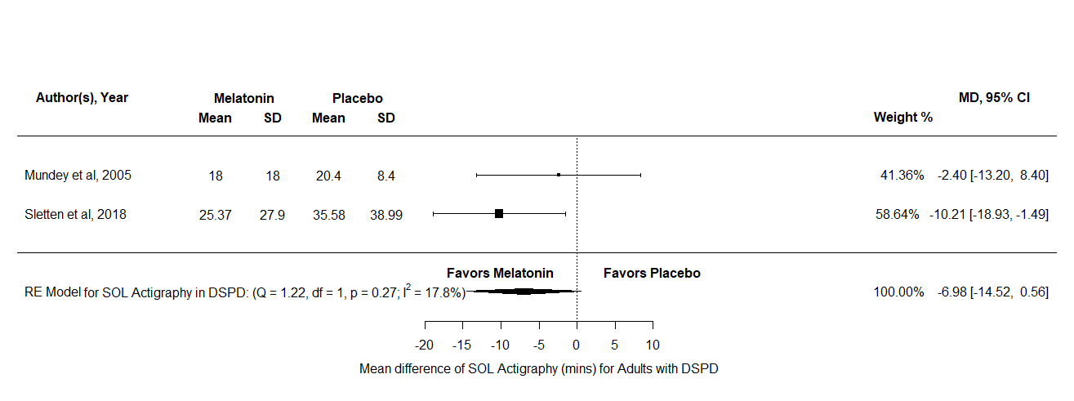
Figure W1: A forest plot to show the mean difference of SOL diary scores for melatonin against placebo for adults with DSPD
TST
TST diary, actigraphy, and polysomnography data were analysed in the DSPD group. For TST diary, there were k = 2 and N = 111, the results indicated no significant difference between melatonin and placebo MD = 21.58, 95% CI [52.79, 9.63], z = -1.36, p = 0.19. Similarly, for TST actigraphy there were k = 2 and N = 106, the results indicated no significant difference between melatonin and placebo MD = 12.05, 95% CI [-9.77, 33.87], z = 1.08, p = 0.28. On the other hand, TST polysomnography there were k = 2 and N = 40, the results indicated a significant difference in favour of melatonin against placebo MD = 43.26, 95% CI [-12.91, 73.61], z = 2.79, p = 0.01. Furthermore, the test for heterogeneity showed Q(df = 1) = 2.88, p =0.09, τ = 18.51, I² = 65.29% which meant that this analysis produced an output which can account for variability of effect sizes. Therefore, this analysis indicates that TST polysomnography scores reduce in adults with DSPD. However, the actigraphy and diary scores do not improve compared to placebo in adults with DSPD.
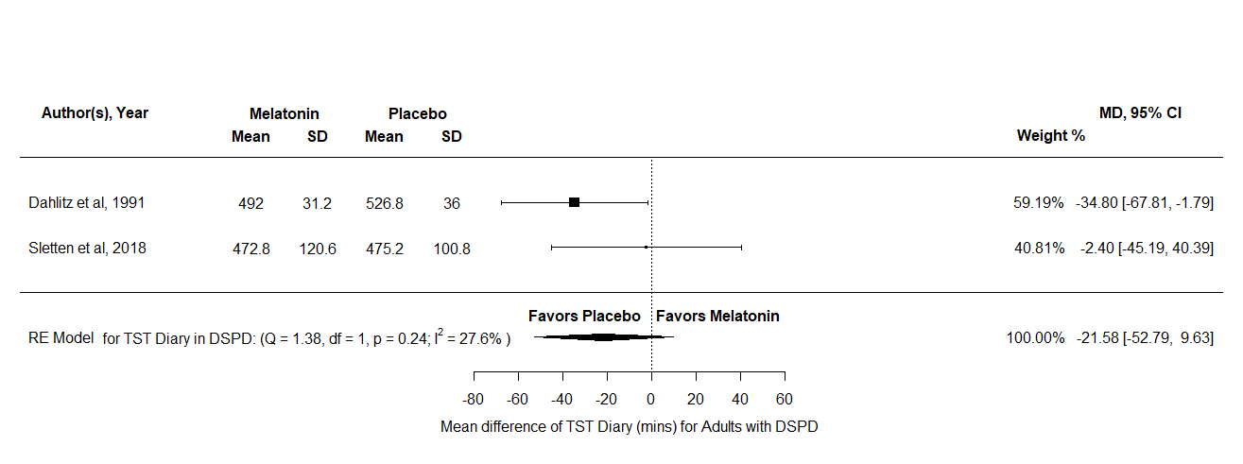
Figure W2: A forest plot to show the mean difference of TST diary scores for melatonin against placebo for adults with DSPD
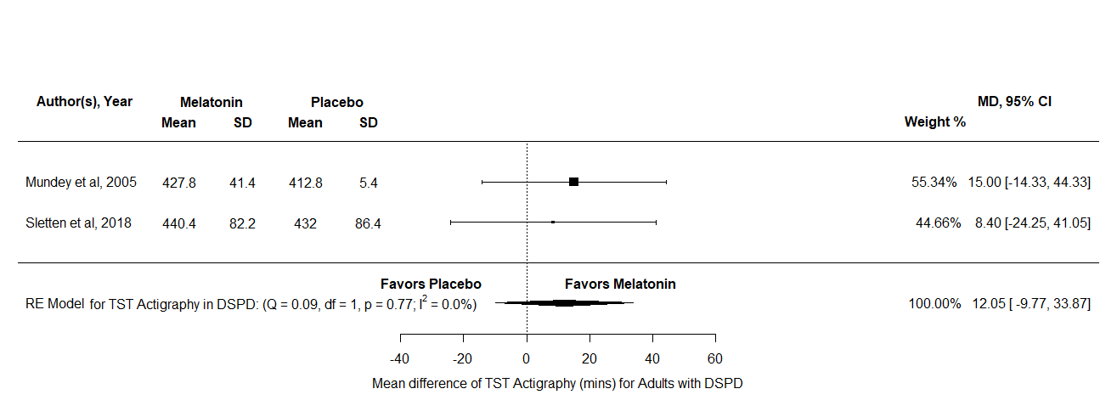
Figure W3: A forest plot to show the mean difference of TST actigraphy scores for melatonin against placebo for adults with DSPD

Appendix X
A detailed description and forest Plots for all the outcome variables analysed in the adult Insomnia group
SOL
For SOL diary there were k = 2 and N = 732, the results indicated no significant difference between melatonin and placebo SMD = -0.14, 95% CI [-0.28, 0.01], z = -1.85, p = 0.06. Similarly, SOL Polysomnography had k = 2 and N = 22, the results indicated no significant difference between melatonin and placebo MD = -3.72, 95% CI [-8.45, 1.01], z = -1.54, p = 0.12. Overall, this result indicates that there is no difference in the effects of melatonin compared to placebo for SOL Diary and Polysomnography scores in adults with insomnia.
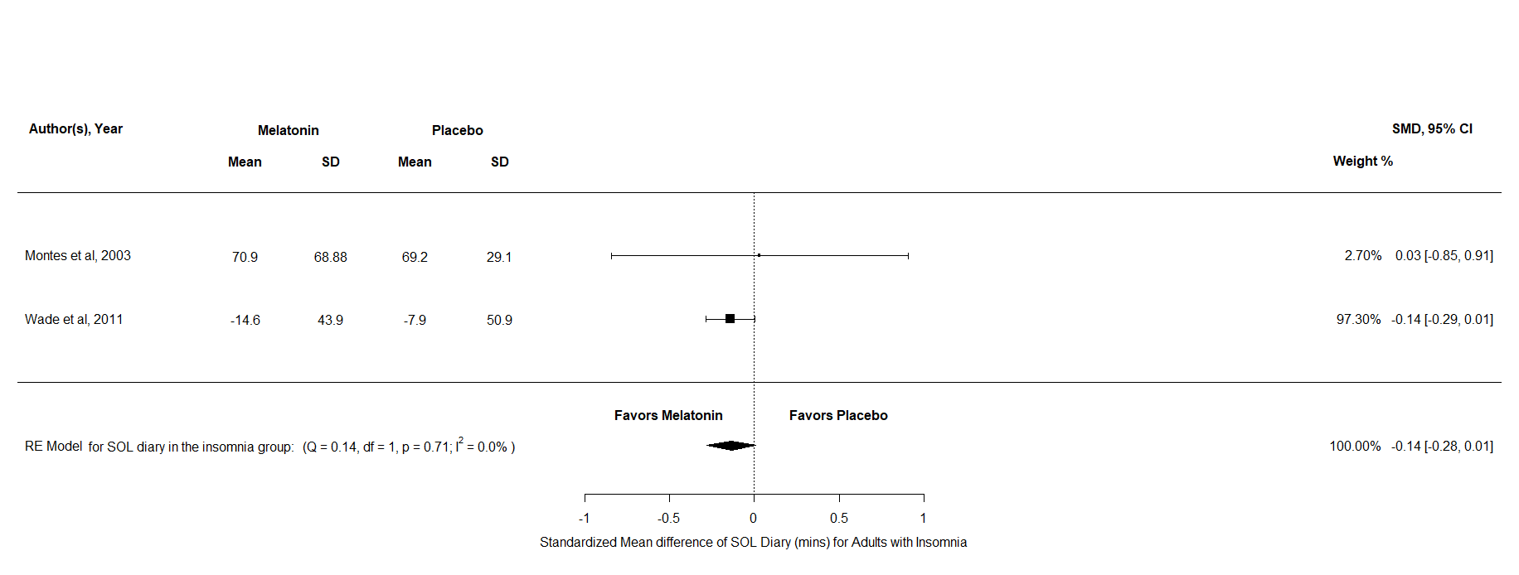
Figure X1: A forest plot to show the standardized mean difference of SOL diary scores for melatonin against placebo for adults with insomnia
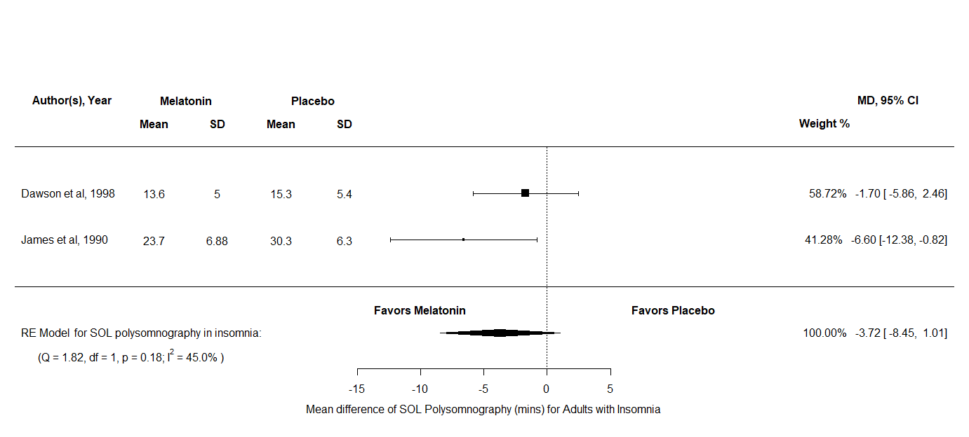
Figure X2: A forest plot to show the mean difference of SOL polysomnography scores for melatonin against placebo for adults with insomnia
TST
TST diary was analysed in the insomnia group, there were k = 2 and N = 737 and the results indicated no significant difference between melatonin and placebo SMD = 3.87, 95% CI [-4.3, 12.03], z = 0.93, p = 0.35. Overall, this result indicates that that there is no difference in the effects of melatonin compared to placebo for TST Diary scores in adults with insomnia
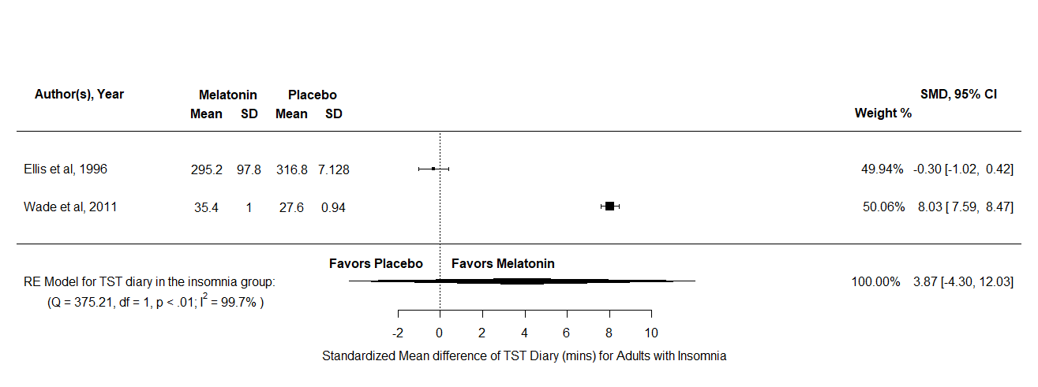
Figure X3: A forest plot to show the standardized mean difference of TST diary scores for melatonin against placebo for adults with insomnia
Appendix Y
A detailed description and forest Plots for all the outcome variables analysed in the adult All Sleep Disorder group
SOL
For SOL diary there were k = 3 and N = 835, the results indicated a significant difference in favour of melatonin against placebo SMD = -0.16, 95% CI [-0.29, -0.02], z = -2.28, p = 0.02. Therefore, this result indicates that that there is no difference in the effects of melatonin compared to placebo for SOL Diary scores in adults across sleep disorders.
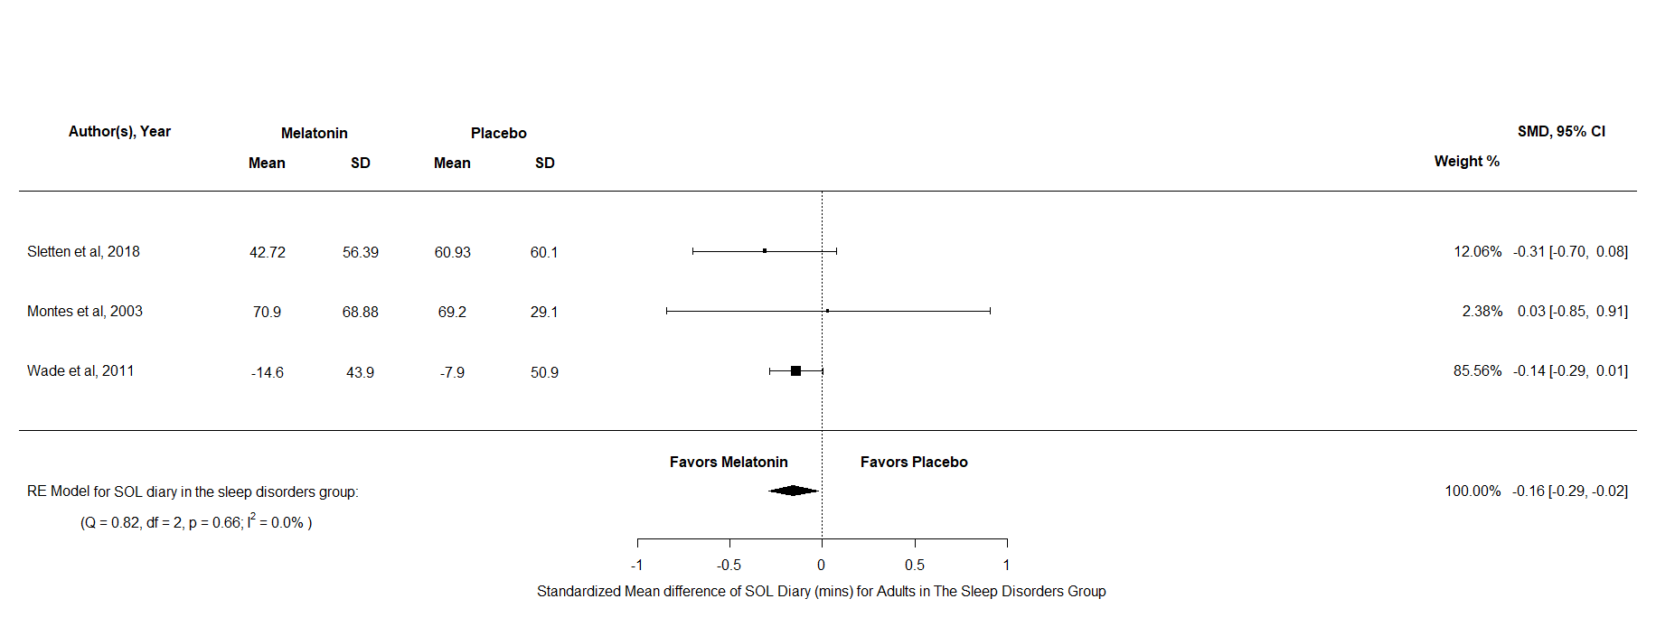
Figure Y1: A forest plot to show the standardized mean difference of SOL diary scores for melatonin against placebo for adults with sleep disorders
TST
TST diary was analysed in the All Sleep Disorders group, there were k = 4 and N = 848 and the results indicated no significant difference between melatonin and placebo SMD = 1.69, 95% CI [-2.48, 5.87], z = 0.8, p = 0.43. Overall, this result indicates that that there is no difference in the effects of melatonin compared to placebo for TST Diary scores in adults across sleep disorders.

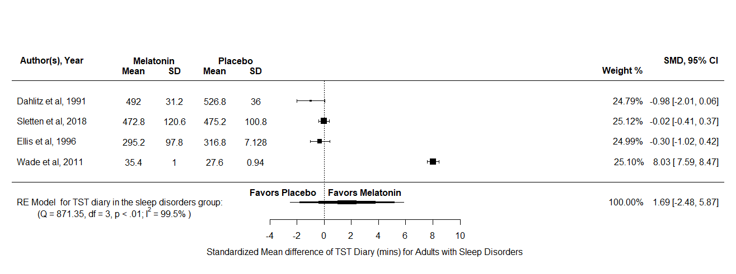
Figure Y2: A forest plot to show the standardized mean difference of TST diary scores for melatonin against placebo for adults with sleep disorders

Appendix Z
A detailed description and forest Plots for all the outcome variables analysed in adult the All Disorders Combined group
SOL
For SOL diary there were k = 4 and N = 875, the results indicated a significant difference in favour of melatonin over placebo SMD = -0.23, 95% CI [-0.44, -0.02], z = -2.13, p = 0.03. Furthermore, the test for heterogeneity showed Q(df = 3) = 4.13, p = 0.25, τ = 0.11, I² = 22.58% which means that this analysis produces an output which can account for variability of effect sizes. For SOL polysomnography there were k = 5 and N = 70, the results indicated a significant difference in favour of melatonin over placebo MD = -17.78, 95% CI [-35.28, -0.28], z = -1.99, p = 0.05. Furthermore, the test for heterogeneity showed Q(df = 4) = 176.29, p <.001, τ = 19.39, I² = 97.29% which meant that this analysis does not produce an output which can account for variability of effect sizes and the interpretation should be taken with caution. Overall, both SOL scores appear to reduce after a treatment of melatonin in adults across all disorder.
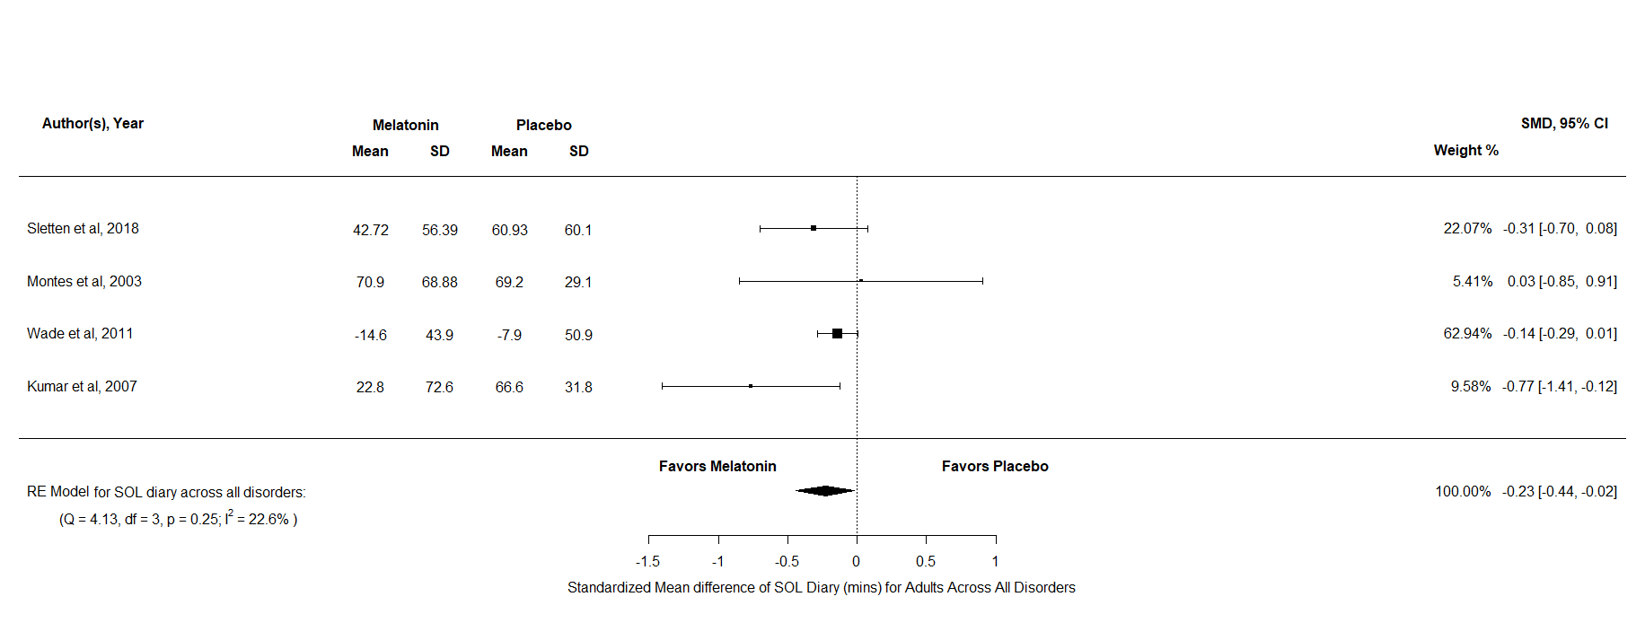
Figure Z1: A forest plot to show the standardized mean difference of SOL diary scores for melatonin against placebo for adults across all disorders
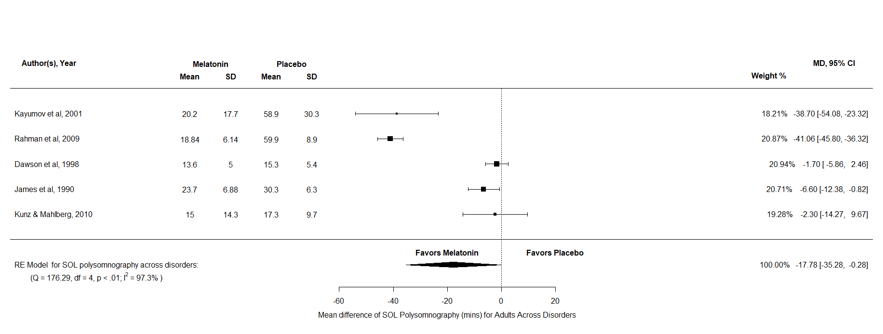
Figure Z2: A forest plot to show the mean difference of SOL polysomnography scores for melatonin against placebo for adults across all disorders
TST
For TST diary there were k = 6 and N =904, the results indicated no significant difference between melatonin and placebo SMD =1.14, 95% CI [-1.6, 3.88], z = 0.82, p = 0.42. For TST polysomnography there were k = 4 and N = 60, the results indicated a significant difference in favour of melatonin over placebo MD = 55.34, 95% CI [25.04, 85.63], z = 3.58, p <.001. Furthermore, the test for heterogeneity showed Q(df = 3) = 10.53, p = 0.02, τ = 25.52, I² = 77.68% which meant that this analysis did not produce an output which can account for the variability of effect sizes. Overall, only TST polysomnography appears to increase after treatment of melatonin in adults across all disorders. However, this result should be interpreted with caution as there is a lot of uncounted variability.
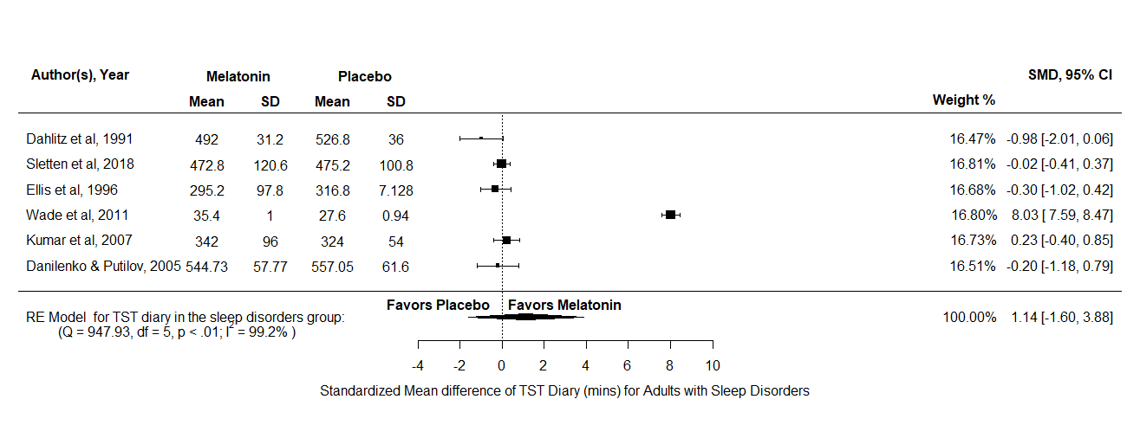
Figure Z3: A forest plot to show the standardized mean difference of TST diary scores for melatonin against placebo for adults across all disorders
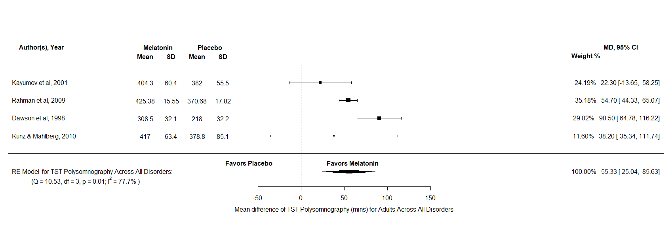
Figure Z4: A forest plot to show the mean difference of TST polysomnography scores for melatonin against placebo for adults across all disorders

NA
The NA analysis consisted of k = 2 and N = 50, the results indicated no significant difference between melatonin and placebo SMD = -0.58, 95% CI [-1.9, 0.73], z = -0.87, p = 0.39. Therefore, this analysis indicates that the effects melatonin has no difference compared to place in reducing the number of NAs adults across all disorders.
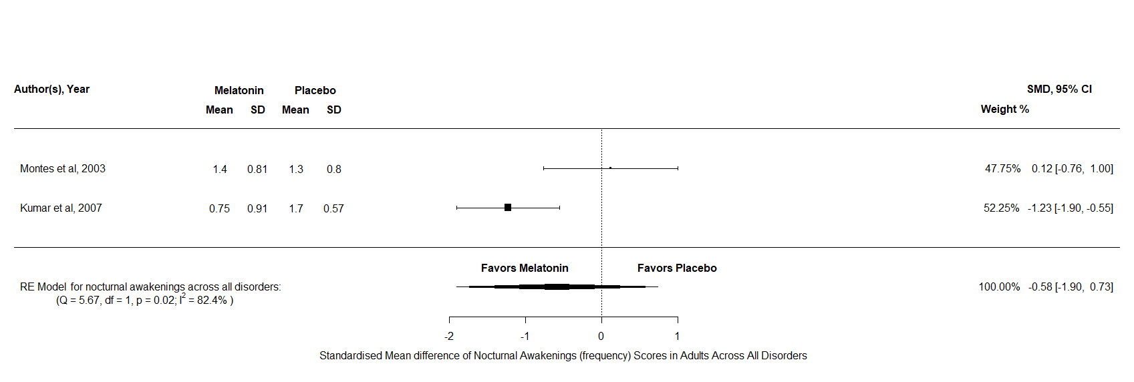
Figure Z5: A forest plot to show the standardized mean difference of nocturnal awakening scores for melatonin against placebo for adults across all disorders

Appendix AA
Results of the sensitivity analyses in adult RCTs
 |  |  |  |  |  |  | Test of null
 |  |  |  | Effect size and 95% CI |  |  | (two-tailed) |  | Heterogeneity
Outcome variable | Effect Size | N | K | Point estimate | LL | UL | z | p | Q | df(Q) | p | I2 | t
All Sleep Disorders
SOL Diary | SMD | 113 | 2 | -0.26 | -0.61 | 0.1 | -1.4 | 0.16 | 0.49 | 1 | 0.49 | 0 | 0
TST Diary | SMD | 126 | 3 | -0.25 | -0.69 | 0.2 | -1.09 | 0.28 | 3.02 | 2 | 0.22 | 30.1 | 0.23
All Disorders Combined
SOL Diary | SMD | 153 | 3 | -0.38 | -0.69 | -0.06 | -2.36 | 0.02 | 2.35 | 2 | 0.31 | 0.01 | 0.002
TST Diary | SMD | 182 | 5 | -0.1 | -0.37 | 0.18 | -0.68 | 0.5 | 4.31 | 4 | 0.37 | 0 | 0.002
Note. SOL – sleep onset latency, TST – total sleep time, SMD -standardized mean difference.
Table 8
A table that reports the main meta-analysis of each outcome variable within and across disorders for adults.
Table AA: Appendix AA Results of the sensitivity analyses in adult RCTs

Appendix AB
A detailed description and forest Plots for all the outcome variables analysed in the sensitivity analyses for adult the All Sleep Disorder and All Disorder Combined groups
SOL All Sleep Disorder
For SOL diary there were k = 2 and N = 113, the results indicated no significant difference between melatonin and placebo SMD = -0.26, 95% CI [-0.61, 0.1], z = -1.4, p = 0.16. Therefore, this result indicates that that there is no difference in the effects of melatonin compared to placebo for SOL Diary scores in adults across sleep disorders.
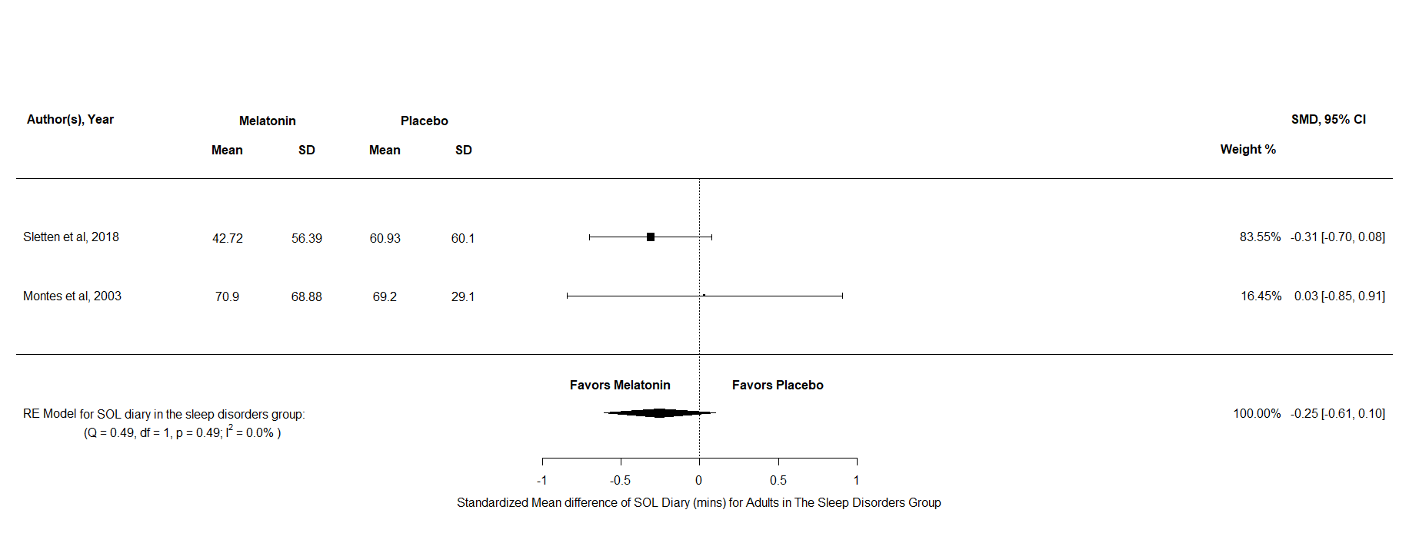
Figure AB1: A forest plot to show the sensitivity analysis of SOL diary scores for melatonin against placebo for adults with sleep disorders

TST All Sleep Disorder
For TST diary there were k = 3 and N = 126 and the results indicated no significant difference between melatonin and placebo SMD = -0.25, 95% CI [-0.69, 0.2], z = -1.09, p = 0.28. Overall, this result indicates that that there is no difference in the effects of melatonin compared to placebo for TST Diary scores in adults across sleep disorders.
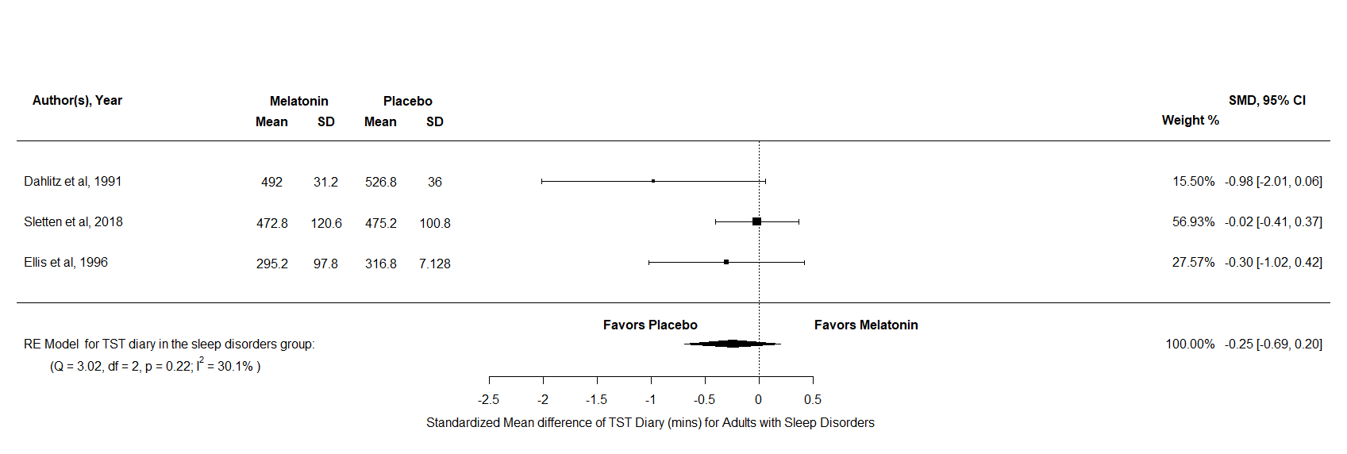
Figure AB2: A forest plot to show the sensitivity analysis of TST diary scores for melatonin against placebo for adults with sleep disorders

SOL All Disorder Combined
For SOL diary there were k = 3 and N = 153, the results indicated a significant difference in favour of melatonin over placebo SMD = -0.38, 95% CI [-0.69, -0.06], z = -2.36, p = 0.02. Furthermore, the test for heterogeneity showed Q(df = 2) = 2.35, p = 0.31, τ = 0.002, I² = 0.01% which means that this analysis produces an output which can account for variability of effect sizes. Overall, SOL diary scores appear to reduce after a treatment of melatonin compared to placebo in adults across all disorder.

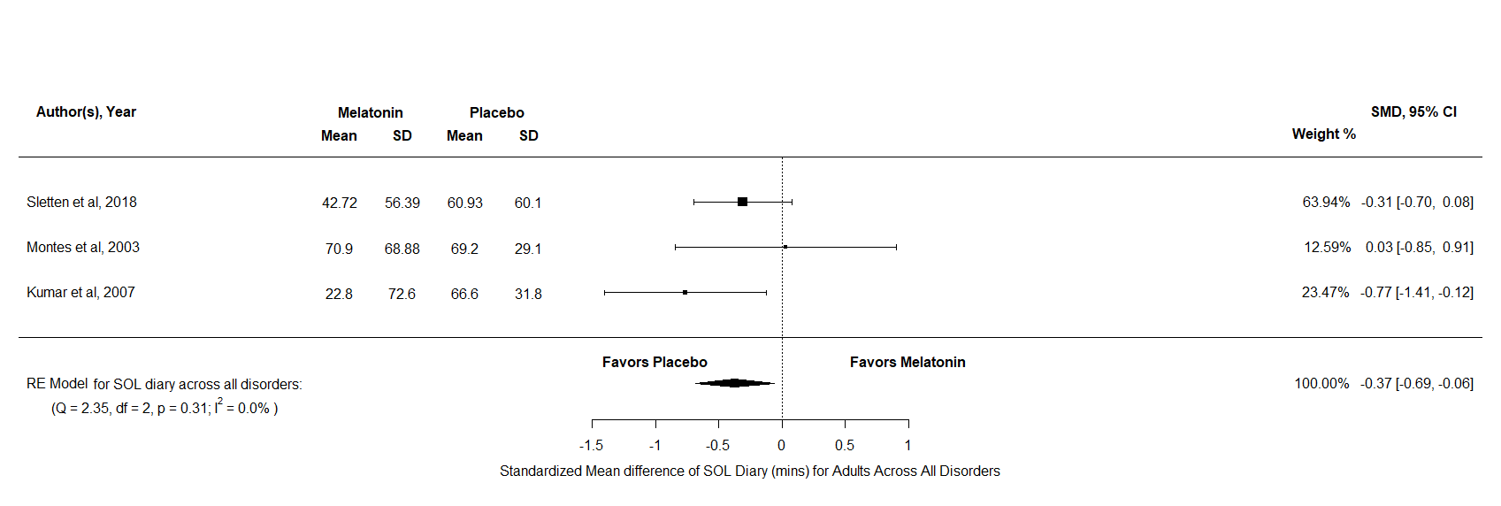
Figure AB3: A forest plot to show the sensitivity analysis of SOL diary scores for melatonin against placebo for adults across all disorders

TST All Disorder Combined
For TST diary there were k = 5 and N = 182, the results indicated no significant difference between melatonin and placebo SMD = -0.1, 95% CI [-0.37, 0.18], z = -0.68, p = 0.5. Overall, this result indicates that that there is no difference in the effects of melatonin compared to placebo for TST Diary scores in adults across all disorders.
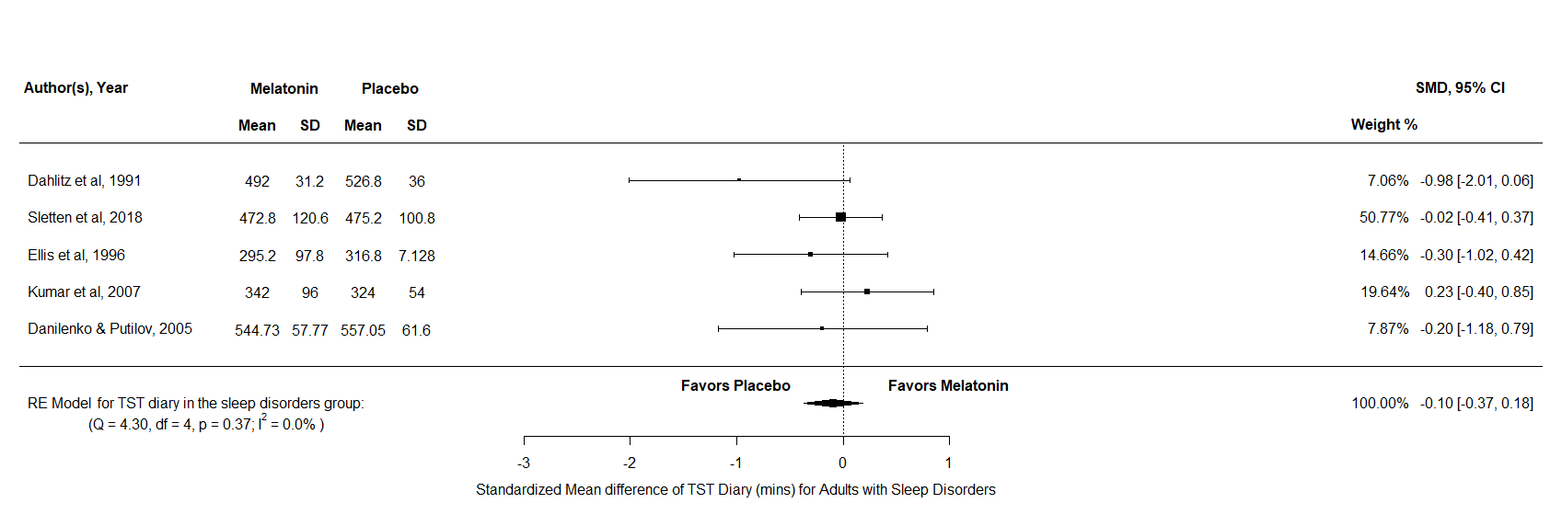
Figure AB4: A forest plot to show the sensitivity analysis of TST diary scores for melatonin against placebo for adults across all disorders

Appendix AC
A detailed description and forest Plots for all the outcome variables analysed in the Delayed Sleep Phase Disorder group, across all ages
SOL
For SOL actigraphy there were k = 3 and N = 173, the results indicated a significant in favour of melatonin against placebo MD = -23.54, 95% CI [-35.23, -11.86], z = -3.95, p <.001. Furthermore, the test for heterogeneity showed Q(df = 2) = 2.73, p =0.26, τ = 5.29, I² = 30.95% which meant that this analysis produced an output which can account for variability of effect sizes. For SOL actigraphy there were k = 4 and N = 184, the results indicated a significant difference in favour of melatonin over placebo MD = -9.72, 95% CI [-18.72, -0.63], z = -2.1, p = 0.04. Furthermore, the test for heterogeneity showed Q(df = 3) = 7.13, p =0.07, τ = 7.12, I² = 59.78% which meant that this analysis produced an output which can account for variability of effect sizes. Overall, both SOL scores appear to reduce after a treatment of melatonin in comparison to placebo for all ages with DSPD.
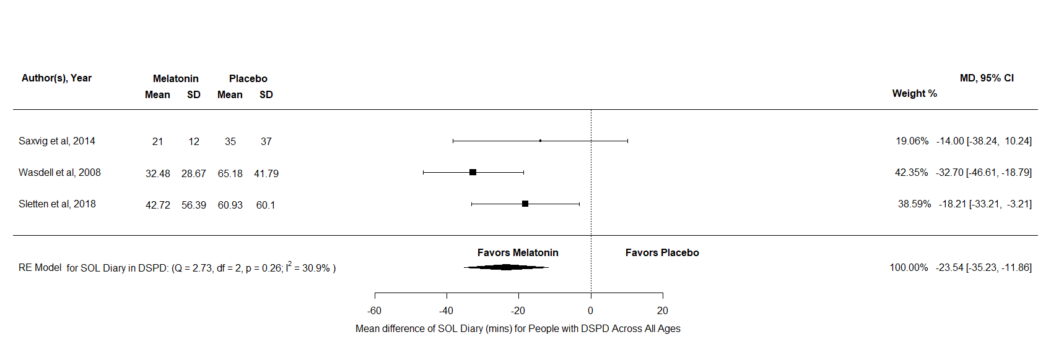
Figure AC1: A forest plot to show the mean difference of SOL diary scores for melatonin against placebo for DSPD across all ages
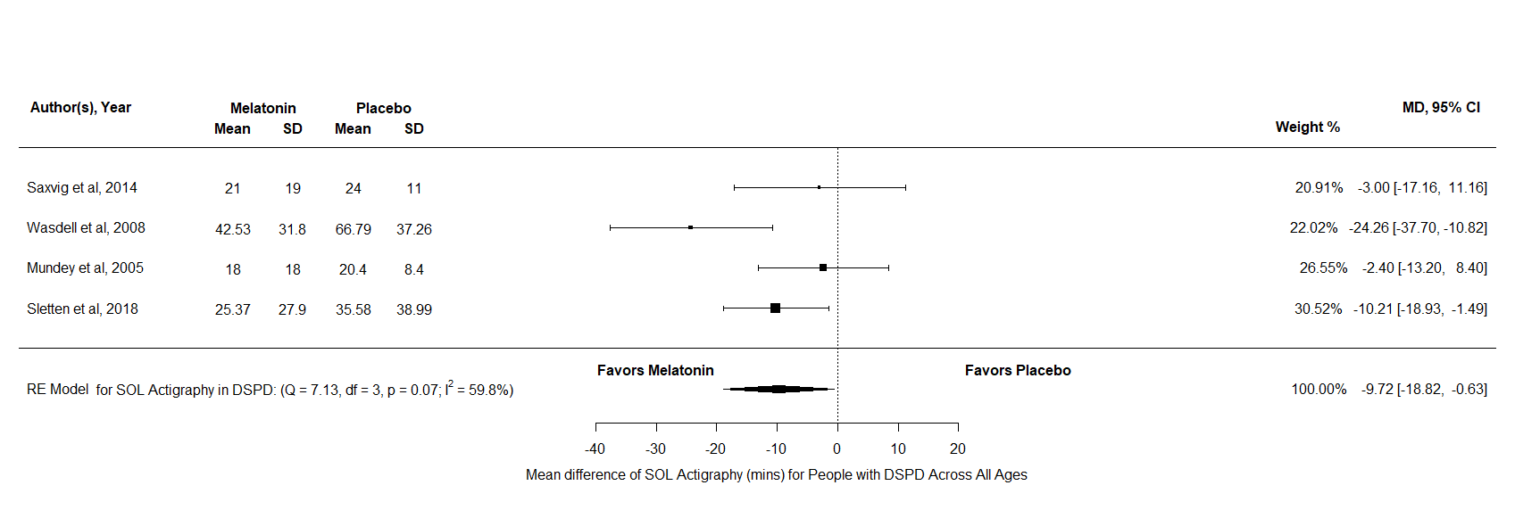
Figure AC2: A forest plot to show the mean difference of SOL actigraphy scores for melatonin against placebo for DSPD across all ages

TST
For TST diary there were k = 4 and N = 181, the results indicated no significant difference between melatonin and placebo MD = 4.23, 95% CI [-27.04, 35.57], z = 0.27, p = 0.79. For TST actigraphy there were k = 4 and N = 184, the results indicated a significant difference in favour of melatonin over placebo MD = 13.78, 95% CI [0.18, 27.39], z = 1.99, p = 0.05. Furthermore, the test for heterogeneity showed Q(df = 3) = 0.59, p =0.9, τ = 0, I² = 0% which meant that this analysis produced an output which can account for variability of effect sizes. Therefore, these analyses indicate that both TST scores increase after a period of melatonin treatment in patients with DSPD, across all ages.

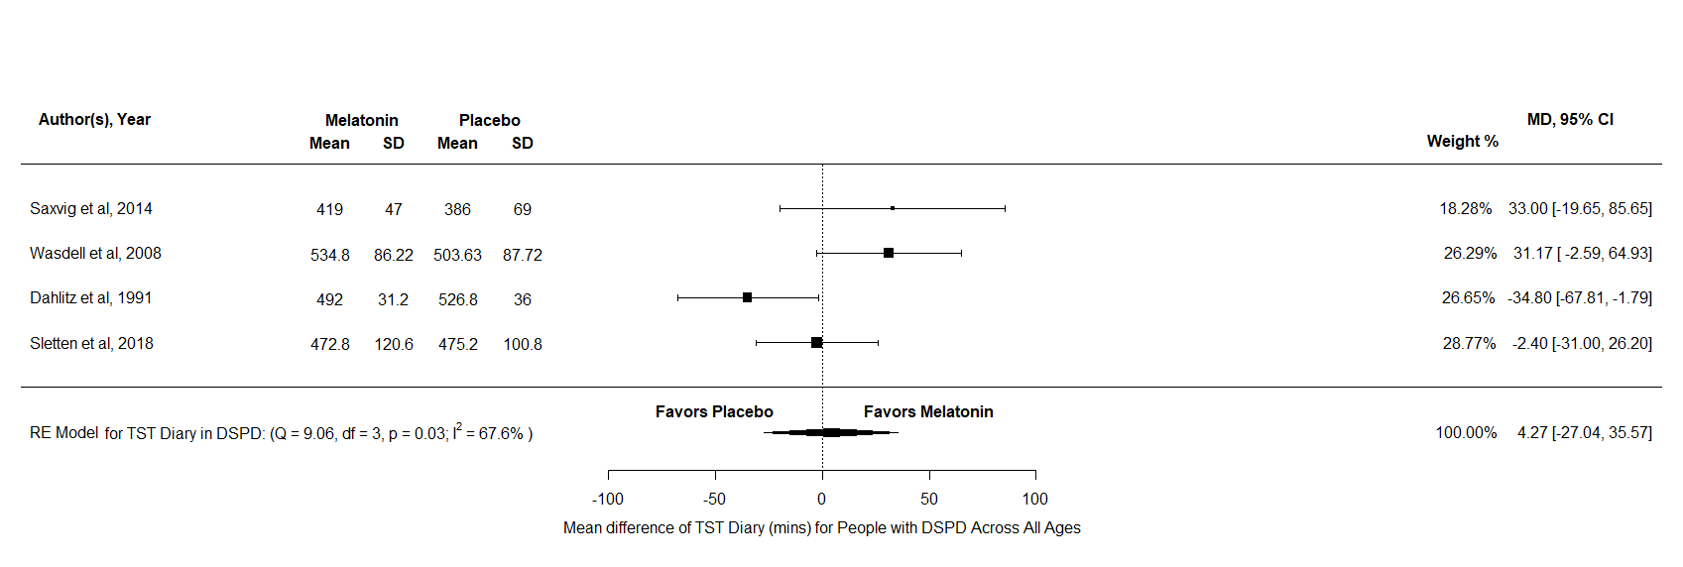
Figure AC3: A forest plot to show the mean difference of TST diary scores for melatonin against placebo for DSPD across all ages
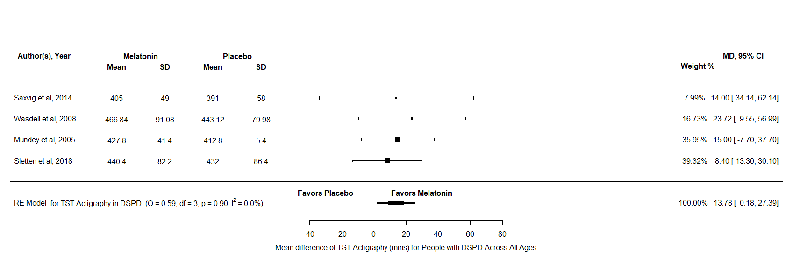
Figure AC4: A forest plot to show the mean difference of TST actigraphy scores for melatonin against placebo for DSPD across all ages

Appendix AD
A detailed description and forest Plots for all the outcome variables analysed in the Insomnia group, across all ages
SOL
For SOL diary there were k = 6 and N = 953, the results indicated a significant difference in favour of melatonin over placebo SMD = -0.66, 95% CI [-1.22, 0.11], z = -2.35, p = 0.02. Furthermore, the test for heterogeneity showed Q(df = 5) = 37, p <.001, τ = 0.62, I² = 86.97% which meant that this analysis did not produce an output which can account for variability of effect sizes. Overall, SOL diary scores appear to reduce after a treatment of melatonin in comparison to placebo for any aged person with insomnia. However, this result must be interpreted with caution due there being significant heterogeneity.
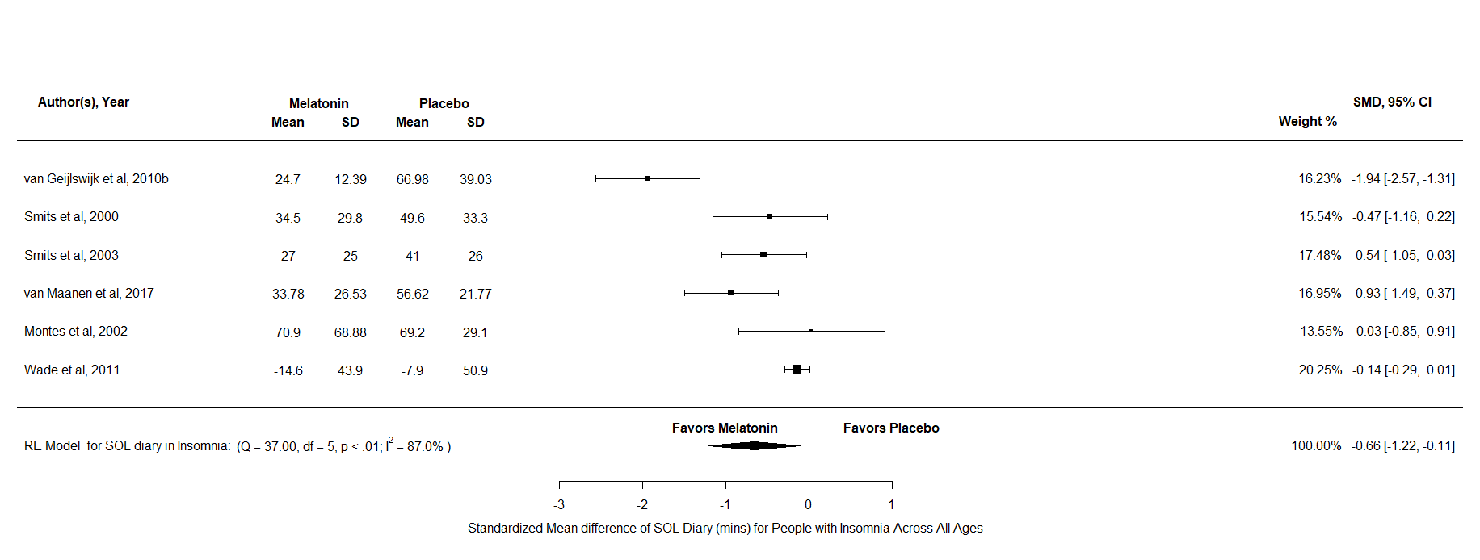
Figure AD1: A forest plot to show the standardized mean difference of SOL diary scores for melatonin against placebo for Insomnia across all ages
TST
TST diary was analysed in the insomnia group, there were k = 6 and N = 905 and the results indicated no significant difference between melatonin and placebo SMD = 2.2, 95% CI [-0.24, 4.7], z = 1.77, p = 0.08. Overall, this result indicates that that there is no difference in the effects of melatonin compared to placebo for TST Diary scores in adults with insomnia.

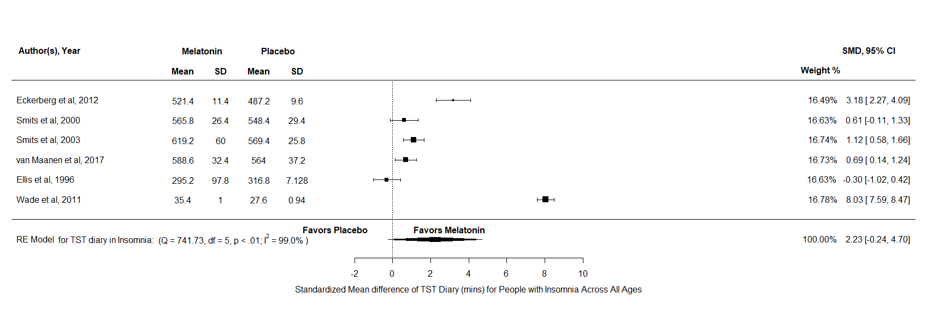
Figure AD2: A forest plot to show the standardized mean difference of TST diary scores for melatonin against placebo for Insomnia across all ages

Appendix AE
A detailed description and forest Plots for all the outcome variables analysed in the All Sleep Disorders group, across all ages
SOL
For SOL diary there were k = 9 and N = 1126, the results indicated a significant difference in favour of melatonin over placebo SMD = -0.63, 95% CI [-1, 0.26], z = -3.33, p <.001. Furthermore, the test for heterogeneity showed Q(df = 8) = 45.03, p <.001, τ =0.49 I² = 82.76% which meant that this analysis did not produce an output which can account for variability of effect sizes. For SOL actigraphy there were k = 4 and N = 382, the results indicated a significant difference in favour of melatonin over placebo MD = -13.35, 95% CI [-23.39, -3.31], z = -2.61, p <.001. Furthermore, the test for heterogeneity showed Q(df = 3) = 14.93, p <.001, τ <.001, I² = 14.93% which meant that this analysis did not produce an output which can account for variability of effect sizes. Overall, both measurements of SOL appear to reduce after a treatment of melatonin in all aged participants with sleep disorders. However, both must be interpreted with caution due to both not being able to explain the heterogeneity.
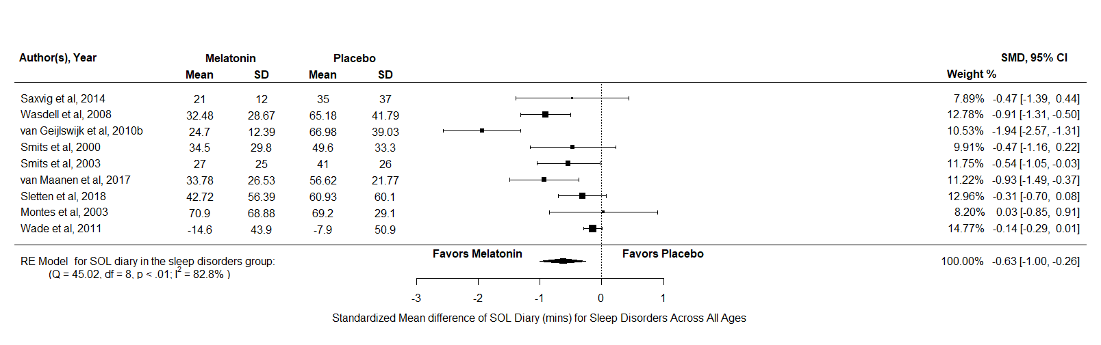
Figure AE1: A forest plot to show the standardized mean difference of SOL diary scores for melatonin against placebo for all sleep disorders across all ages
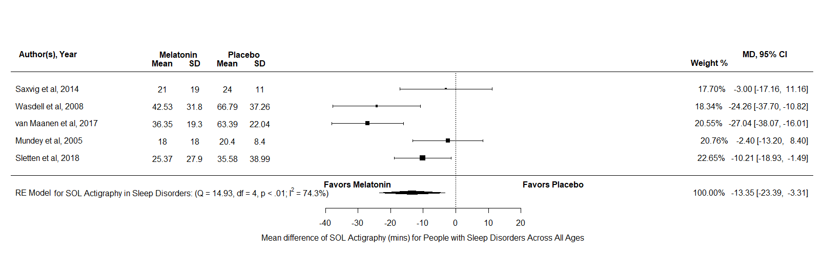
Figure AE2: A forest plot to show the mean difference of SOL actigraphy scores for melatonin against placebo for all sleep disorders across all ages
TST
For TST diary there were k = 10 and N = 1086, the results indicated a significant difference in favour of melatonin over placebo SMD = 1.33, 95% CI [-0.29, 2.95], z = 1.61, p <.001. Furthermore, the test for heterogeneity showed Q(df = 9) = 1018, p <.001, τ = 2.59, I² = 98.76% which meant that this analysis produced an output which cannot account for variability of effect sizes. For TST actigraphy there were k = 5 and N = 245, the results indicated no significant difference between melatonin and placebo MD = -8.9, 95% CI [-1.38, 19.18], z = 1.7, p = 0.09. Overall, TST diary appears to increase after a treatment of melatonin in all aged participants with sleep disorders. However, these results should be interpreted with caution. On the other hand, there is no difference between melatonin and placebo in TST actigraphy scores.
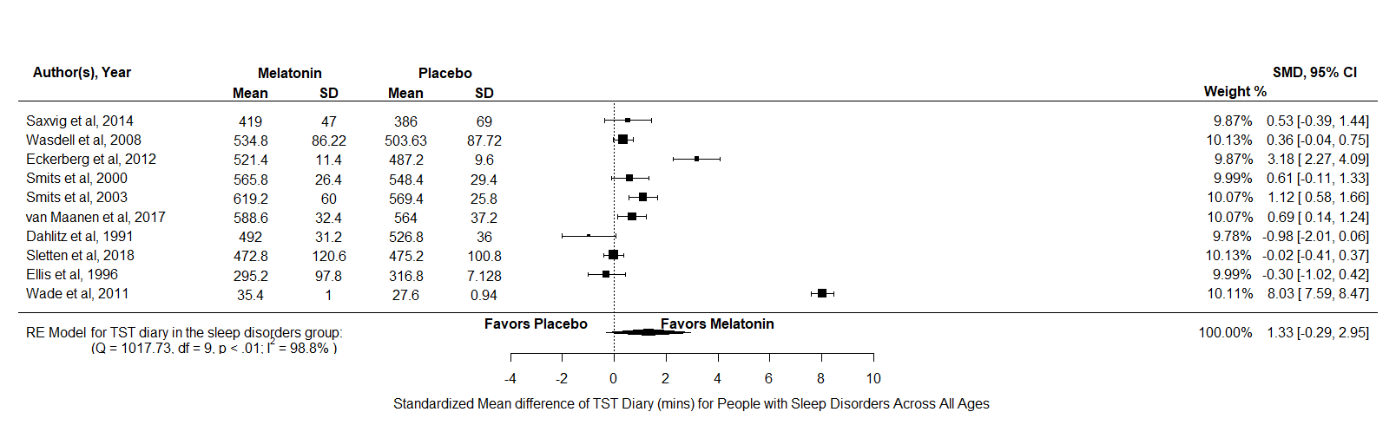
Figure AE3: A forest plot to show the standardized mean difference of TST diary scores for melatonin against placebo for all sleep disorders across all ages

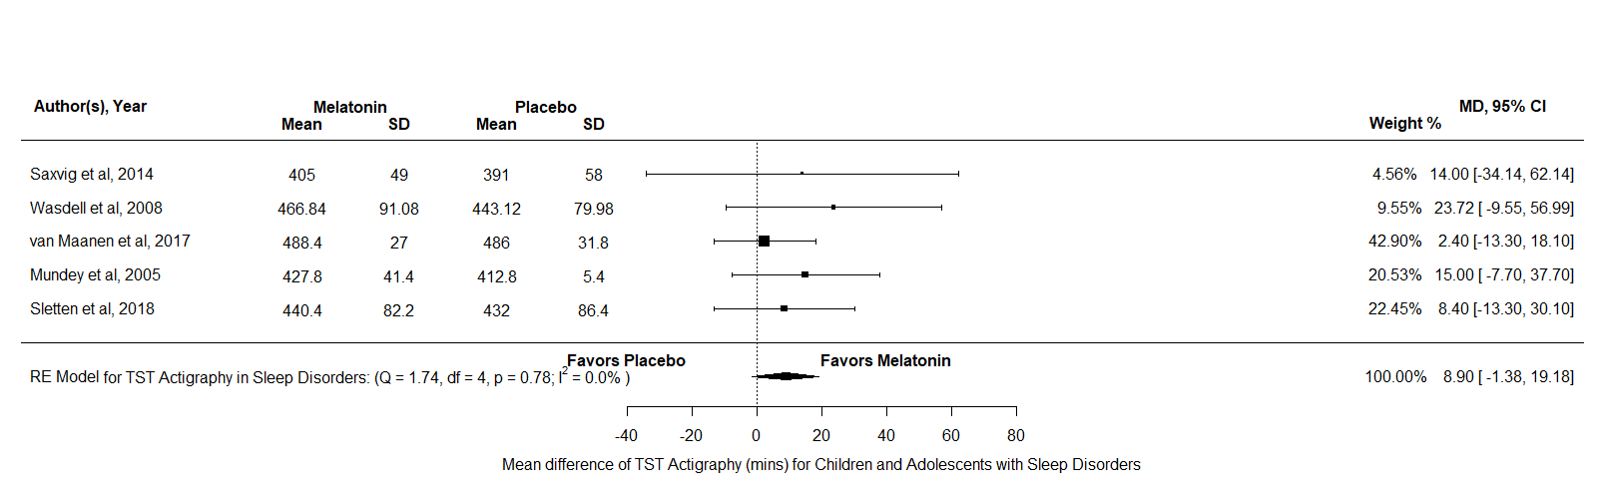
Figure AE4: A forest plot to show the mean difference of TST actigraphy scores for melatonin against placebo for all sleep disorders across all ages
NA
The NA analysis consisted of k = 3 and N = 77, the results indicated no significant difference between melatonin and placebo SMD = -0.06, 95% CI [-0.4, 0.28], z = -0.32, p = 0.75. Therefore, this analysis indicates that the effects melatonin has no difference compared to placebo in reducing the number of NAs in all aged participants with sleep disorders.
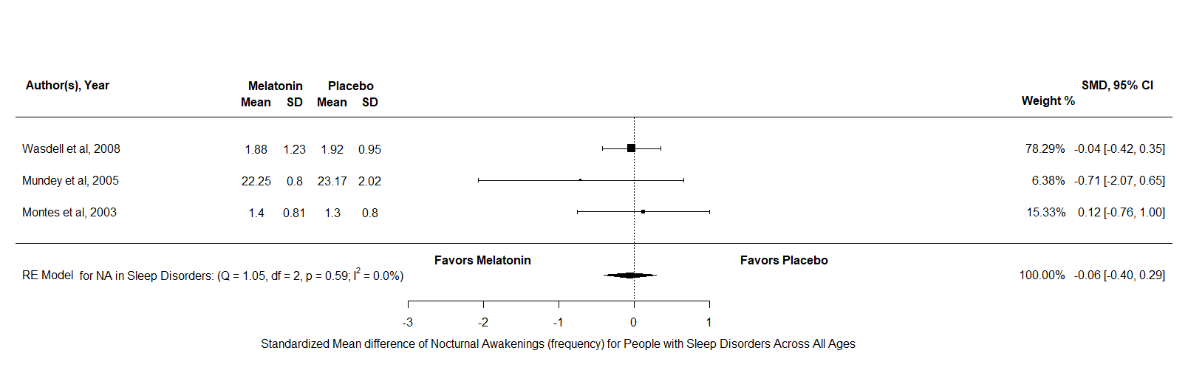
Figure AE5: A forest plot to show the standardized mean difference of nocturnal awakenings scores for melatonin against placebo for all sleep disorders across all ages

DLMO
The DLMO analysis consisted of k = 4 and N = 226, the results indicated no significant difference between melatonin and placebo MD = -0.33, 95% CI [-0.81, 0.16], z = -1.32, p = 0.19. Therefore, this analysis indicates that the effects melatonin has no difference compared to placebo in reducing DLMO in all aged participants with sleep disorders.
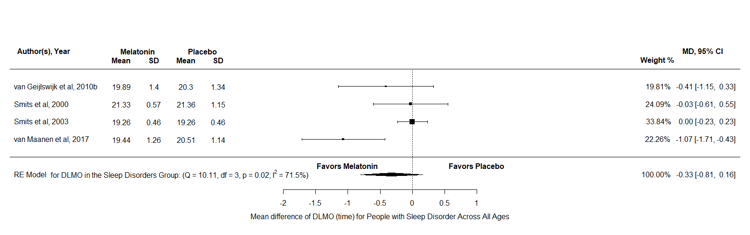
Figure AE6: A forest plot to show the mean difference of DLMO scores for melatonin against placebo for all sleep disorders across all ages

Appendix AF
A detailed description and forest Plots for all the outcome variables analysed in the All Sleep Disorders & Neurodevelopmental Disorders with Insomnia group, across all ages
SOL
For SOL diary there were k = 12 and N = 1284, the results indicated a significant difference in favour of melatonin over placebo SMD = -0.65, 95% CI [-0.95, -0.35], z = -4.27, p <.001. Furthermore, the test for heterogeneity showed Q(df = 11) = 50.97, p <.001, τ =0.43 I² = 77.73% which meant that this analysis did not produce an output which can account for variability of effect sizes. For SOL actigraphy there were k = 8 and N = 428, the results indicated a significant difference in favour of melatonin over placebo MD = -16.77, 95% CI [-24.72, -8.8], z = -4.14, p <.001. Furthermore, the test for heterogeneity showed Q(df = 7) = 23.64, p <.001, τ = 9.55, I² = 70.84% which meant that this analysis did not produce an output which can account for variability of effect sizes. Overall, both measurements of SOL appear to reduce after a treatment of melatonin in all aged participants with sleep disorders and or comorbid neurodevelopmental disorders. However, both must be interpreted with caution due to both not being able to explain the heterogeneity.

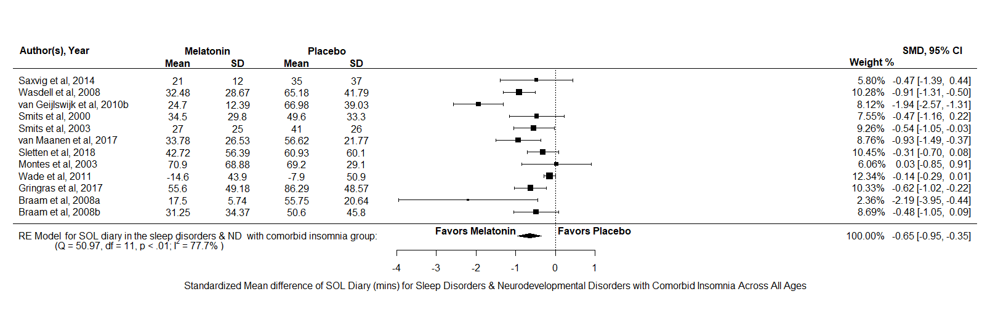
Figure AF1: A forest plot to show the standardized mean difference of SOL diary scores for melatonin against placebo for all sleep disorders & neurodevelopmental disorders with comorbid insomnia across all ages
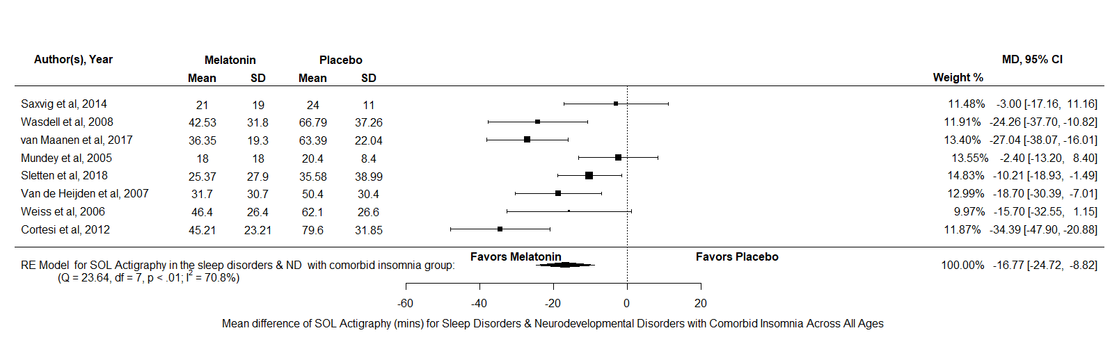
Figure AF2: A forest plot to show the mean difference of SOL actigraphy scores for melatonin against placebo for all sleep disorders & neurodevelopmental disorders with comorbid insomnia across all ages

TST
For TST diary there were k = 13 and N = 1235, the results indicated a significant difference in favour of melatonin over placebo SMD = 1.39, 95% CI [-0.05, 2.73], z = 2.04, p = 0.04. Furthermore, the test for heterogeneity showed Q(df = 12) = 1062.42, p <.001, τ = 2.42, I² = 98.56% which meant that this analysis produced an output which cannot account for variability of effect sizes. For TST actigraphy there were k = 7 and N = 419, the results indicated a significant difference in favour of melatonin over placebo MD = -21.49, 95% CI [4.05, 38.92], z = 2.42, p = 0.02. Furthermore, the test for heterogeneity showed Q(df = 6) = 28.1, p <.001, τ = 19.77, I² = 75.26% which meant that this analysis produced an output which cannot account for variability of effect sizes. Overall, both TST scores appear to increase after a treatment of melatonin in all aged participants with sleep disorders and or comorbid neurodevelopmental disorders. However, these results should be interpreted with caution.
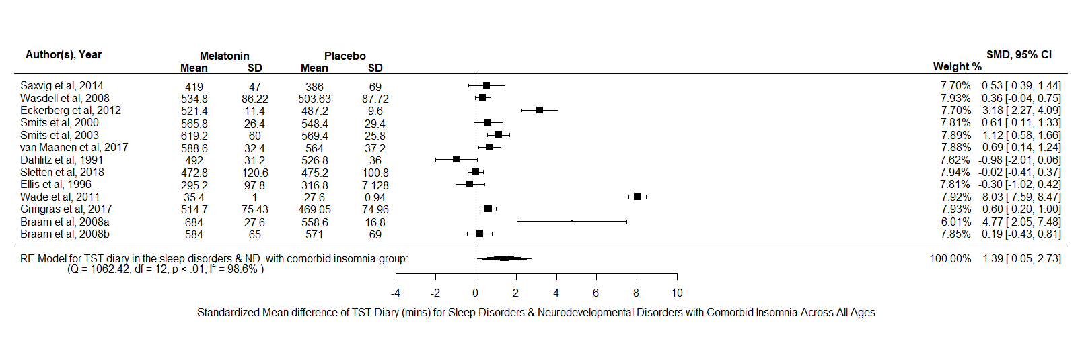
Figure AF3: A forest plot to show the standardized mean difference of TST diary scores for melatonin against placebo for all sleep disorders & neurodevelopmental disorders with comorbid insomnia across all ages
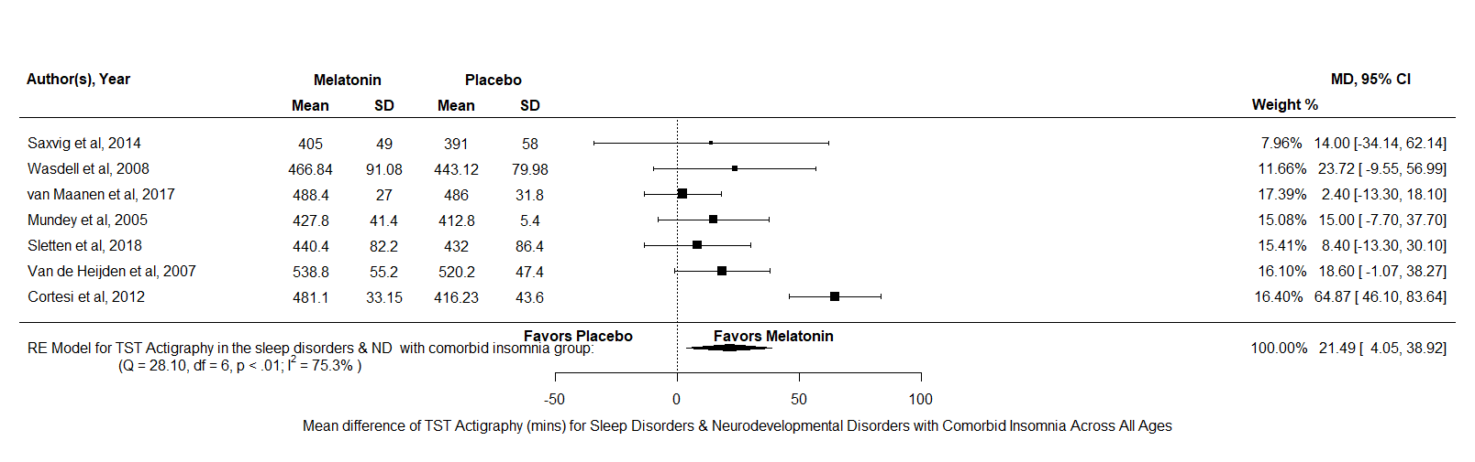
Figure AF4: A forest plot to show the mean difference of TST actigraphy scores for melatonin against placebo for all sleep disorders & neurodevelopmental disorders with comorbid insomnia across all ages
NA
The NA analysis consisted of k = 5 and N = 193, the results indicated no significant difference between melatonin and placebo SMD = -0.8, 95% CI [-1.94, 0.33], z = -1.39, p = 0.17. Therefore, this analysis indicates that the effects melatonin has no difference compared to placebo in reducing the number of NAs in all aged participants with sleep disorders and or comorbid neurodevelopmental disorders.
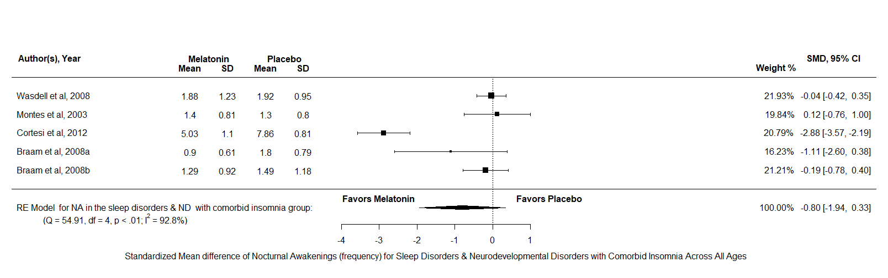
Figure AF5: A forest plot to show the standardized mean difference of nocturnal awakenings scores for melatonin against placebo for all sleep disorders & neurodevelopmental disorders with comorbid insomnia across all ages

DLMO
The DLMO analysis consisted of k = 7 and N = 380, the results indicated a significant difference in favour of melatonin over placebo MD = -0.46, 95% CI [-0.91, -0.02], z = -2.04, p = 0.04. Furthermore, the test for heterogeneity showed Q(df = 6) = 20.97, p <.001, τ = 0.49, I² = 79.13% which meant that this analysis produced an output which cannot account for variability of effect sizes. Therefore, this analysis indicates that melatonin may reduce DLMO in all aged participants with sleep disorders and or comorbid neurodevelopmental disorders after a period of treatment.
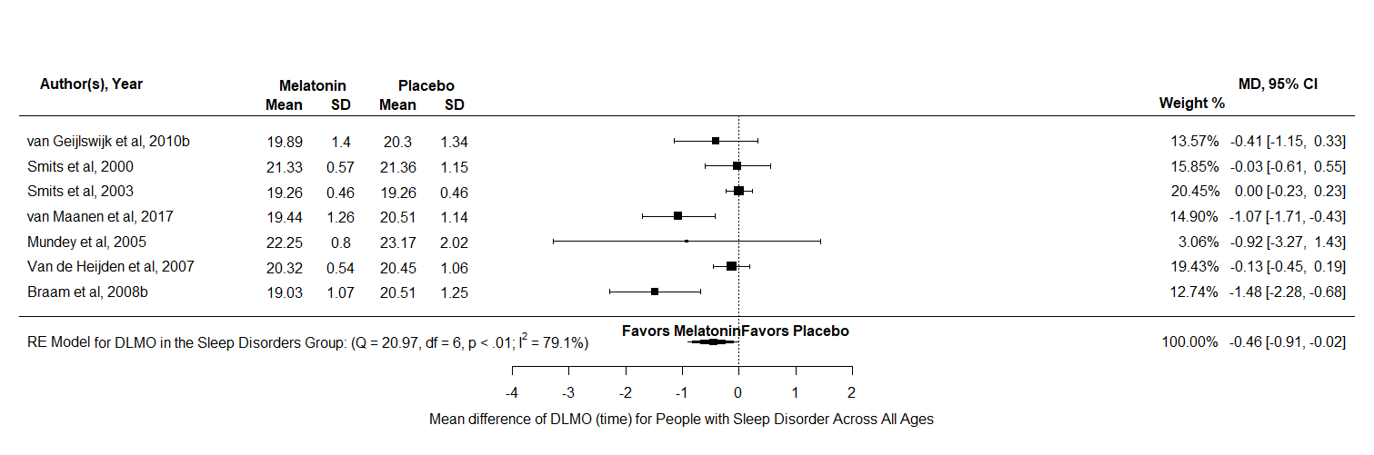
Figure AF6: A forest plot to show the mean difference of DLMO scores for melatonin against placebo for all sleep disorders & neurodevelopmental disorders with comorbid insomnia across all ages

Appendix AG
A detailed description and forest Plots for all the outcome variables analysed in the All Disorders Combined group, across all ages
SOL
For SOL diary there were k = 18 and N = 1504, the results indicated a significant difference in favour of melatonin over placebo SMD = -0.74, 95% CI [-1.01, -0.47], z = -5.29, p <.001. Furthermore, the test for heterogeneity showed Q(df = 17) = 82.32, p <.001, τ =0.49 I² = 80.51% which meant that this analysis did not produce an output which can account for variability of effect sizes. For SOL actigraphy there were k = 11 and N = 498, the results indicated a significant difference in favour of melatonin over placebo MD = -17.86, 95% CI [-24.29, -11.43], z = -5.44, p <.001. Furthermore, the test for heterogeneity showed Q(df = 10) = 22.37, p <.001, τ = 7.85, I² = 58.01% which meant that this analysis did not produce an output which can account for variability of effect sizes. Overall, both measurements of SOL appear to reduce after a treatment of melatonin in all aged participants across all disorders. However, both must be interpreted with caution due to both not being able to explain the heterogeneity.
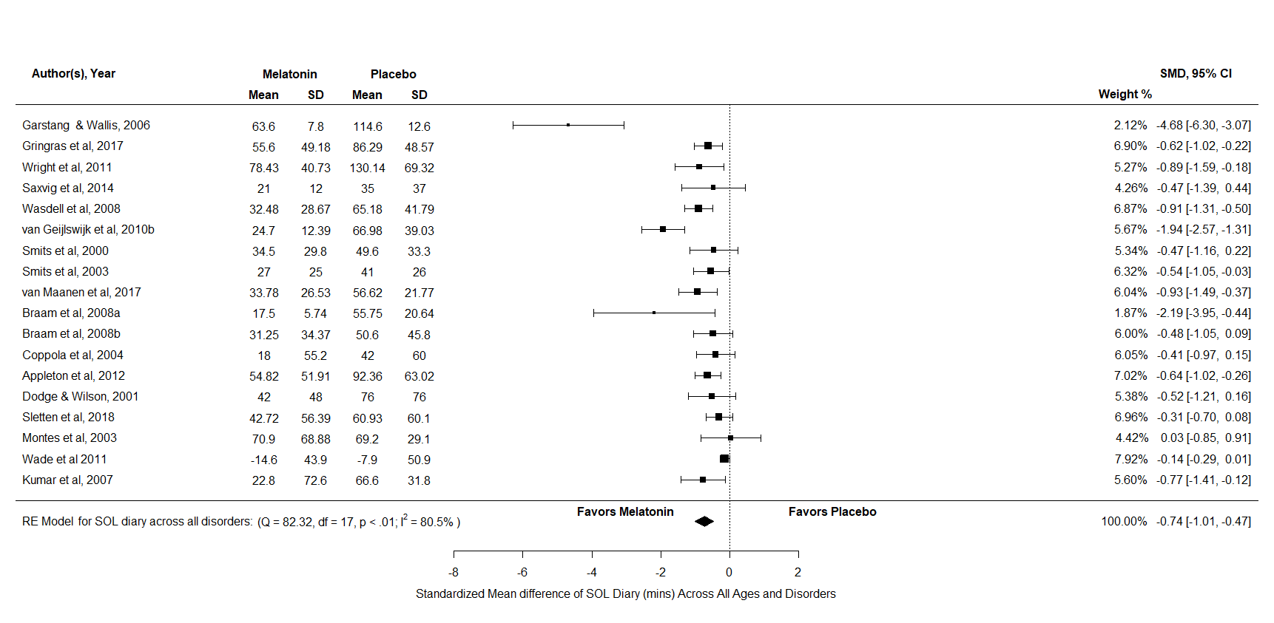
Figure AG1: A forest plot to show the standardized mean difference of SOL diary scores for melatonin against placebo for all disorders across all ages

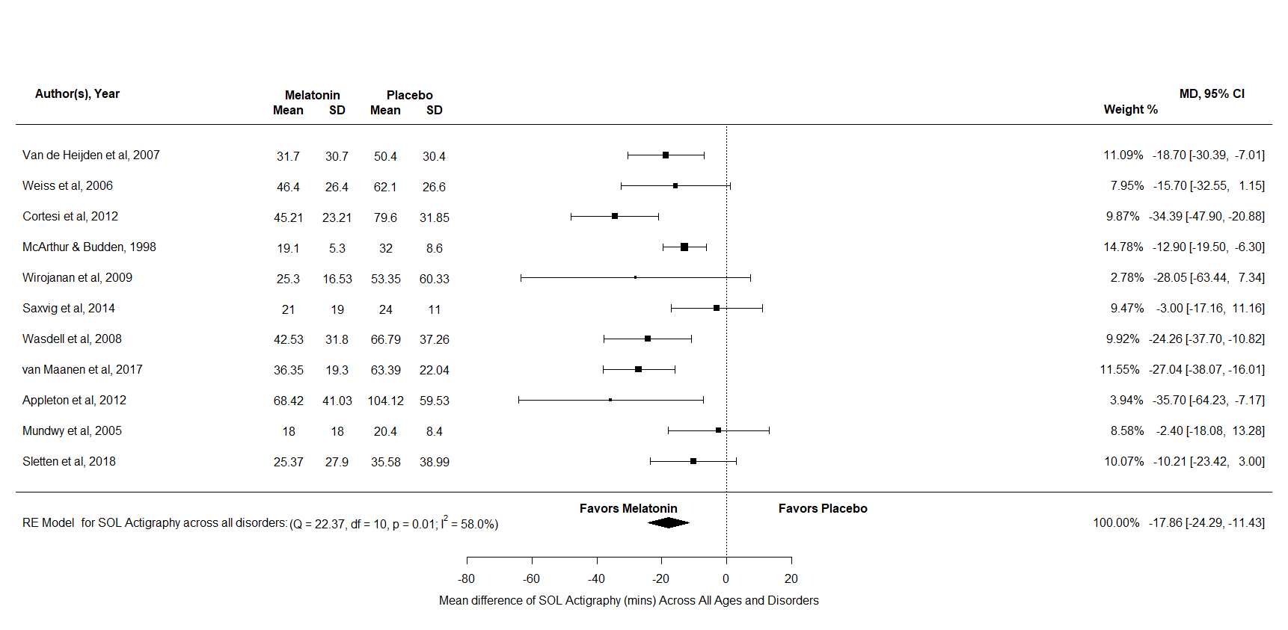
Figure AG1: A forest plot to show the mean difference of SOL actigraphy scores for melatonin against placebo for all disorders across all ages

TST
For TST diary there were k = 20 and N = 1474, the results indicated a significant difference in favour of melatonin over placebo SMD = 1.13, 95% CI [0.22, 2.04], z = 2.44, p = 0.02. Furthermore, the test for heterogeneity showed Q(df = 19) = 1142, p <.001, τ = 2.03, I² = 97.89% which meant that this analysis produced an output which cannot account for variability of effect sizes. For TST actigraphy there were k = 9 and N = 480, the results indicated a significant difference in favour of melatonin over placebo MD = -22.78, 95% CI [7.07, 38.49], z = 2.84, p <.001. Furthermore, the test for heterogeneity showed Q(df = 8) = 27.21, p <.001, τ = 18.17, I² = 64.23% which meant that this analysis produced an output which cannot account for variability of effect sizes. Overall, both TST scores appear to increase after a treatment of melatonin in all aged participants across all disorders. However, these results should be interpreted with caution.
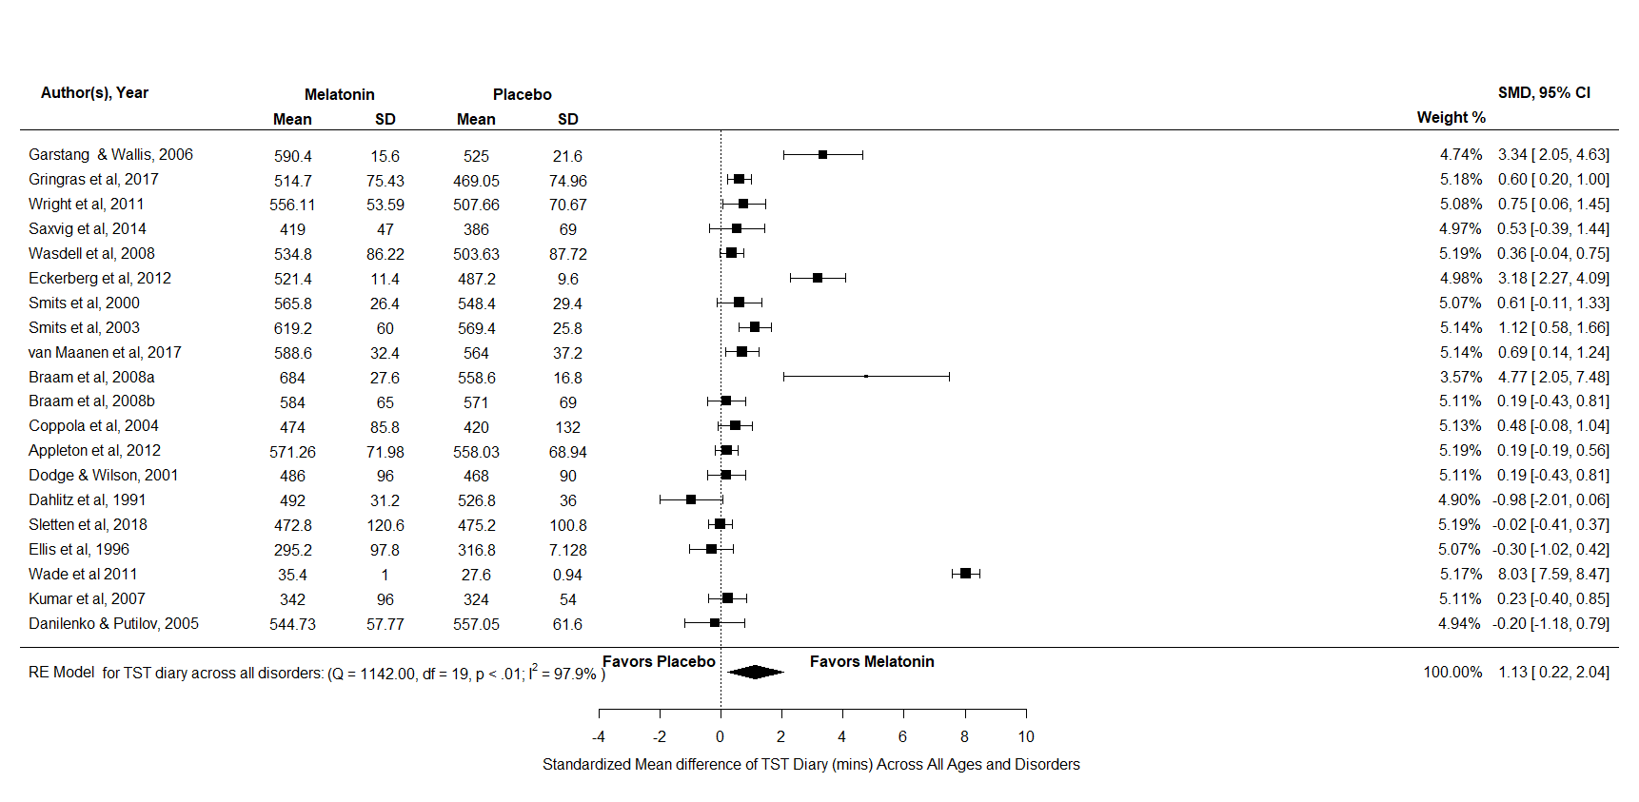
Figure AG3: A forest plot to show the standardized mean difference of TST diary scores for melatonin against placebo for all disorders across all ages

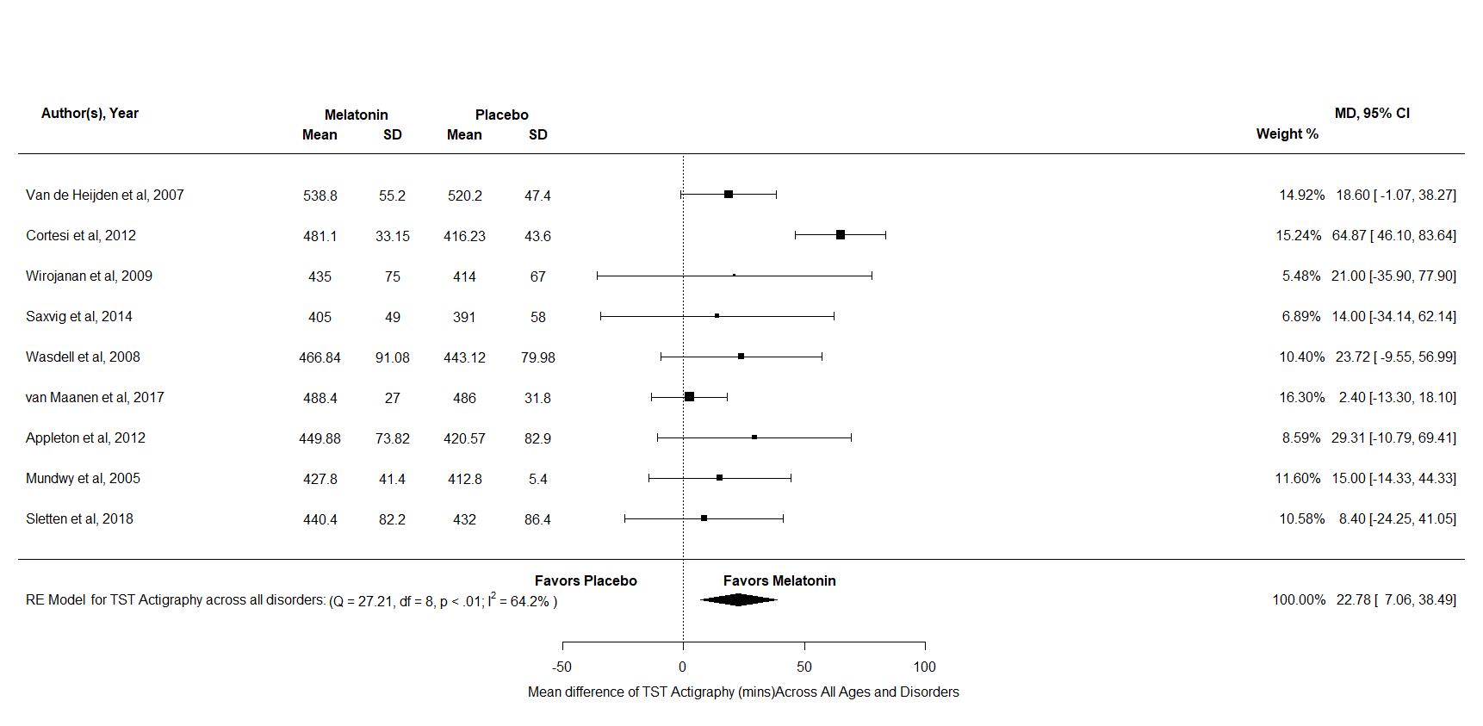
Figure AG4: A forest plot to show the mean difference of TST actigraphy scores for melatonin against placebo for all disorders across all ages
NA
The NA analysis consisted of k = 11 and N = 306, the results indicated a significant difference in favour of melatonin over placebo SMD = -0.65, 95% CI [-1.23, -0.07], z = -2.18, p = 0.03. Furthermore, the test for heterogeneity showed Q(df = 10) = 73.88, p <.001, τ = 0.9, I² = 87.66% which meant that this analysis produced an output which cannot account for variability of effect sizes. Therefore, this analysis indicates that melatonin has a reducing effect in comparison to placebo for the number of NAs experienced in all aged participants across all disorders.
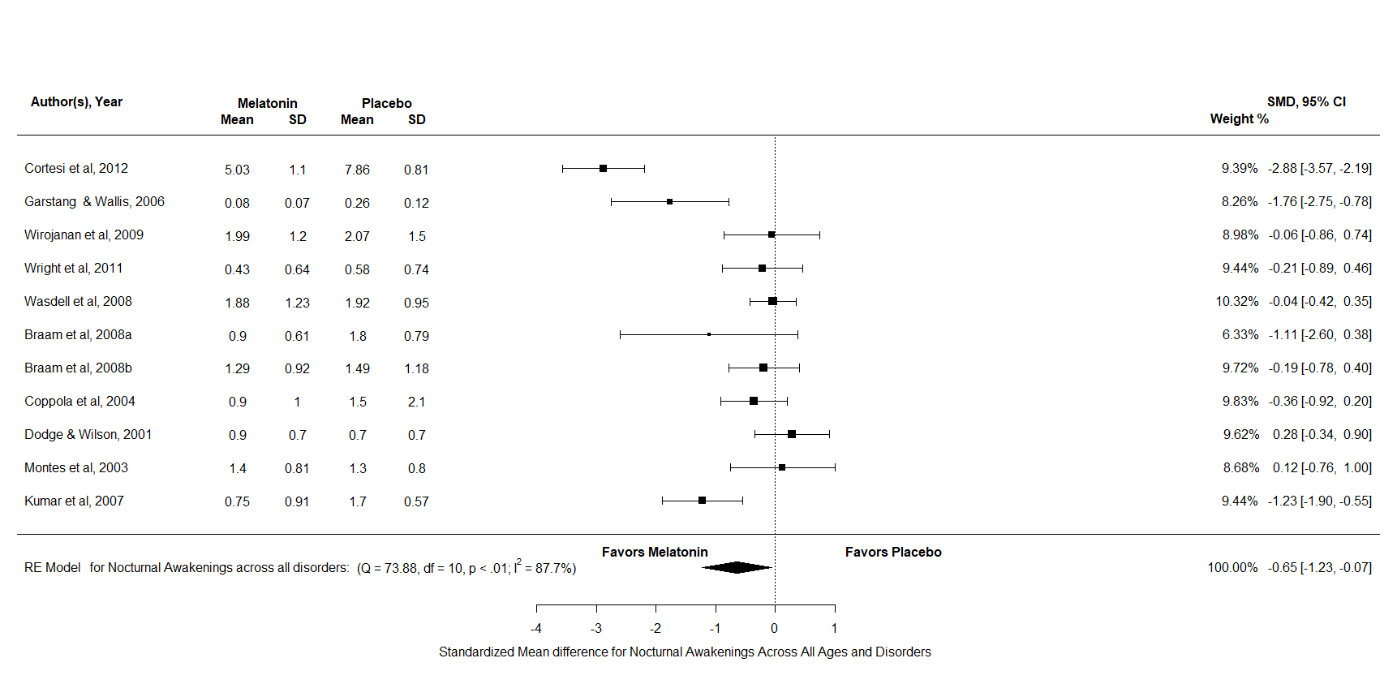
Figure AG5: A forest plot to show the standardized mean difference of nocturnal awakening scores for melatonin against placebo for all disorders across all ages

Appendix AH
Results of the sensitivity analyses in children/adolescents+ adult disorders
 |  |  |  |  |  |  | Test of null
 |  |  |  | Effect size and 95% CI |  |  | (two-tailed) |  | Heterogeneity
Outcome variable | Effect size | N | K | Point estimate | LL | UL | z | p | Q | df(Q) | p | I2 | t
Insomnia
SOL Diary | SMD | 231 | 5 | -0.8 | -1.42 | -0.17 | -2.49 | 0.01 | 17.99 | 4 | 0.001 | 79.41 | 0.63
TST Diary | SMD | 183 | 5 | 1.04 | -0.06 | 2.13 | 1.86 | 0.06 | 36.7 | 4 | <.001 | 92.6 | 1.2
Insomnia & Comorbid Insomnia
SOL Diary | SMD | 399 | 8 | -0.79 | -1.22 | -0.37 | -3.65 | <.001 | 22.23 | 7 | 0.002 | 71.96 | 0.5
TST Diary | SMD | 353 | 8 | 1.09 | 0.2 | 2 | 2.4 | 0.02 | 49.65 | 7 | <.001 | 93.09 | 1.2
All Sleep Disorders
SOL Diary | SMD | 404 | 8 | -0.72 | -1.11 | -0.32 | -3.56 | <.001 | 24.01 | 7 | 0.01 | 73.24 | 0.47
TST Diary | SMD | 364 | 9 | 0.57 | -0.14 | 1.28 | 1.59 | 0.11 | 58.86 | 8 | <.001 | 91.91 | 1.02
All Sleep Disorders & Neurodevelopmental Disorders with Insomnia
SOL Diary | SMD | 562 | 11 | -0.72 | -1.02 | -0.42 | -4.65 | <.001 | 27.49 | 10 | 0.002 | 65.82 | 0.4
TST Diary | SMD | 513 | 12 | 0.69 | 0.06 | 1.31 | 2.14 | 0.03 | 69.66 | 11 | <.001 | 92.03 | 1.03
All Disorders Combined
SOL Diary | SMD | 782 | 17 | -0.78 | -1.06 | -0.51 | -5.6 | <.001 | 52.52 | 16 | <.001 | 71.73 | 0.46
TST Diary | SMD | 752 | 19 | 0.65 | 0.2 | 1.11 | 2.81 | 0.005 | 94.43 | 18 | <.001 | 90.25 | 0.92
Note. SOL – sleep onset latency, TST – total sleep time, SMD -standardized mean difference.
Table AH: Results of the sensitivity analyses in children/adolescents+ adult disorders
Appendix AI
A detailed description and forest Plots for the outcome variables analysed in the sensitivity analyses when all ages were combined
SOL Insomnia
For SOL diary there were k = 5 and N = 231, the results indicated a significant difference in favour of melatonin against placebo SMD = -0.8, 95% CI [-1.42, -0.17], z = -2.49, p = 0.01. Furthermore, the test for heterogeneity showed Q(df = 4) = 17.99, p = 0.001, τ = 0.63, I² = 79.41% which meant that this analysis produced an output which cannot account for variability of effect sizes. Therefore, this analysis indicates that melatonin has a reducing effect in comparison to placebo for SOL diary scores in people of all ages with insomnia.
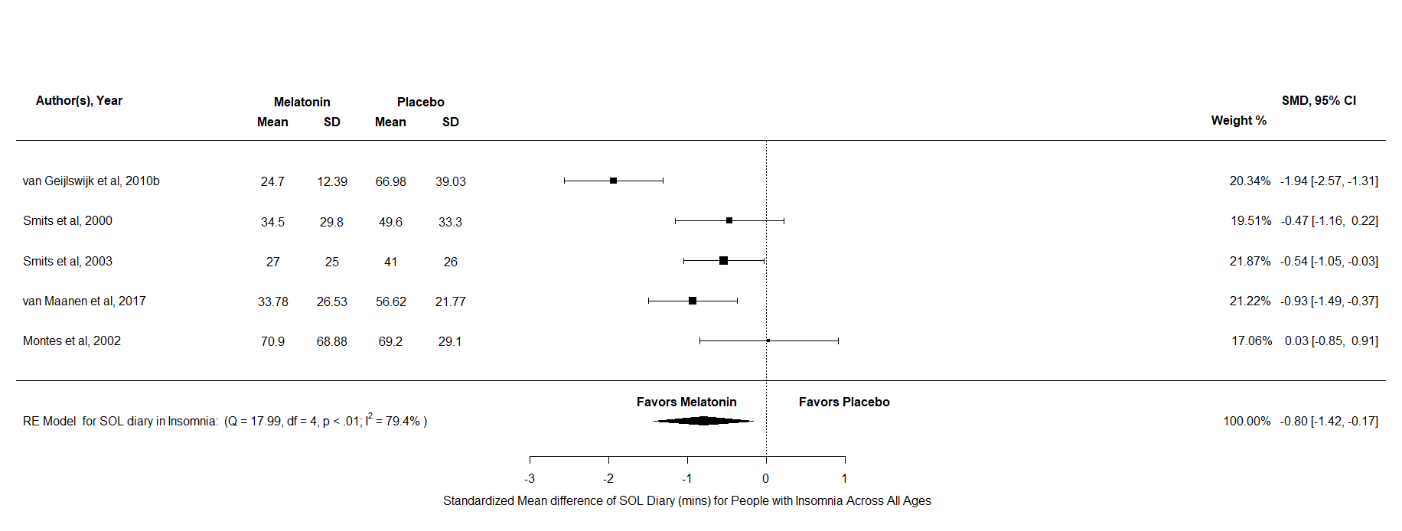
Figure AI1: A forest plot to show the sensitivity analysis of SOL diary scores for melatonin against placebo for insomnia across all ages
TST Insomnia
For TST diary there were k = 5 and N = 183 and the results indicated no significant difference between melatonin and placebo SMD = 1.04, 95% CI [-0.06, 2.13], z = 1.86, p = 0.06. Overall, this result indicates that that there is no difference in the effects of melatonin compared to placebo for TST Diary scores in people of all ages with insomnia.
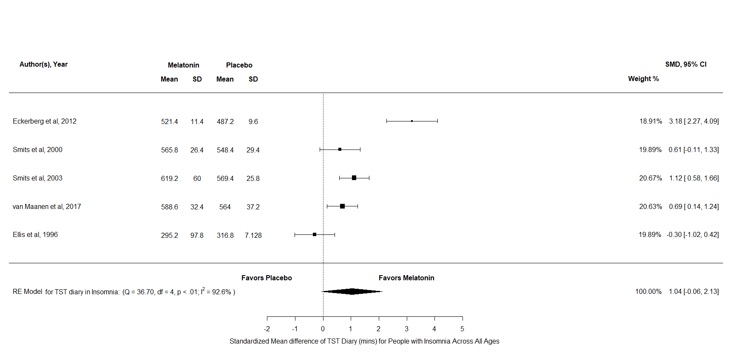
Figure AI2: A forest plot to show the sensitivity analysis of TST diary scores for melatonin against placebo for insomnia across all ages
SOL Insomnia & Comorbid Insomnia
For SOL diary there were k = 8 and N = 399, the results indicated a significant difference in favour of melatonin against placebo SMD = -0.79, 95% CI [-1.22, -0.37], z = -3.65, p < .001. Furthermore, the test for heterogeneity showed Q(df = 7) = 22.23, p = 0.002, τ = 0.5, I² = 71.96% which meant that this analysis produced an output which cannot account for variability of effect sizes. Therefore, this analysis indicates that melatonin has a reducing effect in comparison to placebo for SOL diary scores in people of all ages with insomnia and neurodevelopmental disorders with comorbid insomnia.
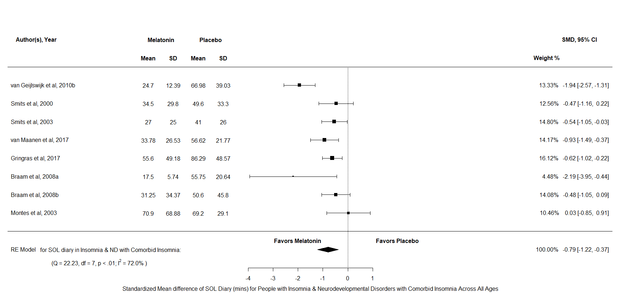
Figure AI3:A forest plot to show the sensitivity analysis of SOL diary scores for melatonin against placebo for insomnia and neurodevelopmental disorders with comorbid insomnia across all ages
TST Insomnia & Comorbid Insomnia
For TST diary there were k = 8 and N = 353, the results indicated a significant difference in favour of melatonin against placebo SMD = 1.09, 95% CI [0.2, 2], z = 2.4, p = 0.02. Furthermore, the test for heterogeneity showed Q(df = 7) = 49.65, p <.001, τ = 1.2, I² = 93.09% which meant that this analysis produced an output which cannot account for variability of effect sizes. Therefore, this analysis indicates that melatonin has a reducing effect in comparison to placebo for TST diary scores in people of all ages with insomnia and neurodevelopmental disorders with comorbid insomnia.
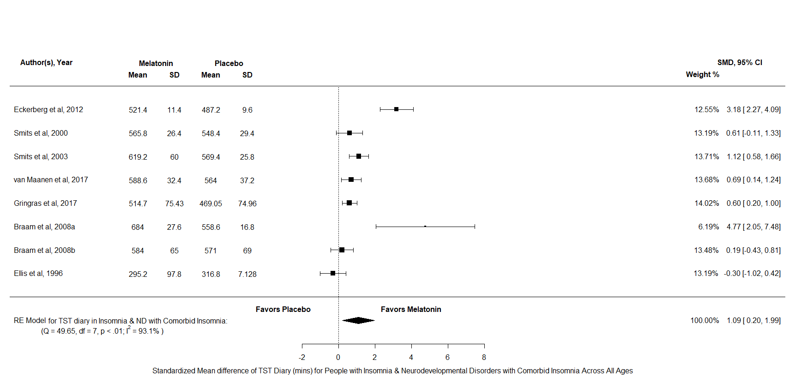
Figure AI4:A forest plot to show the sensitivity analysis of TST diary scores for melatonin against placebo for insomnia and neurodevelopmental disorders with comorbid insomnia across all ages

SOL All Sleep Disorder
For SOL diary there were k = 8 and N = 404, the results indicated a significant difference in favour of melatonin against placebo SMD = -0.72, 95% CI [-1.11, -0.32], z = -3.56, p <.001. Furthermore, the test for heterogeneity showed Q(df = 7) = 24.01, p = 0.01, τ = 0.47, I² = 73.24% which meant that this analysis produced an output which cannot account for variability of effect sizes. Therefore, this analysis indicates that melatonin has a reducing effect in comparison to placebo for SOL diary scores in people of all ages with sleep disorders.
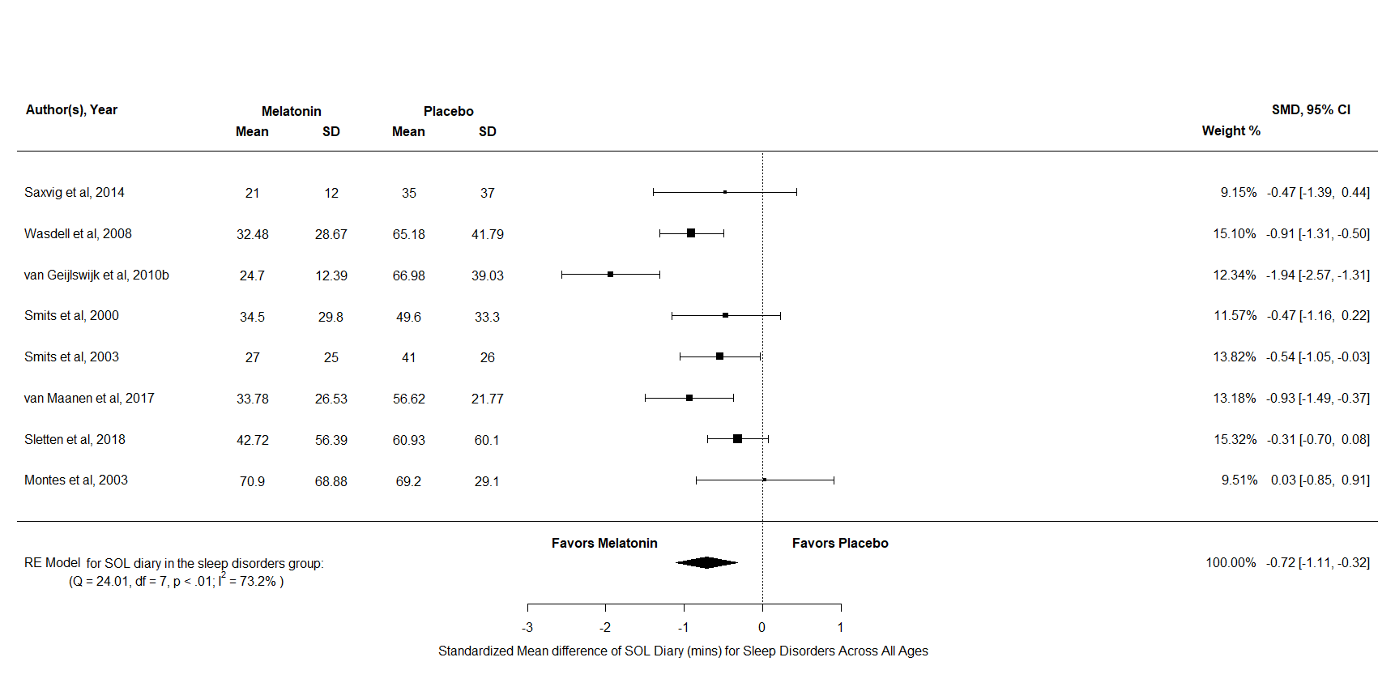
Figure AI5: A forest plot to show the sensitivity analysis of SOL diary scores for melatonin against placebo for sleep disorders across all ages

TST All Sleep Disorder
For TST diary there were k = 9 and N = 364 and the results indicated no significant difference between melatonin and placebo SMD = 0.57, 95% CI [-0.14, 1.28], z = 1.59, p = 0.11. Overall, this result indicates that that there is no difference in the effects of melatonin compared to placebo for TST Diary scores in people of all ages with sleep disorders.
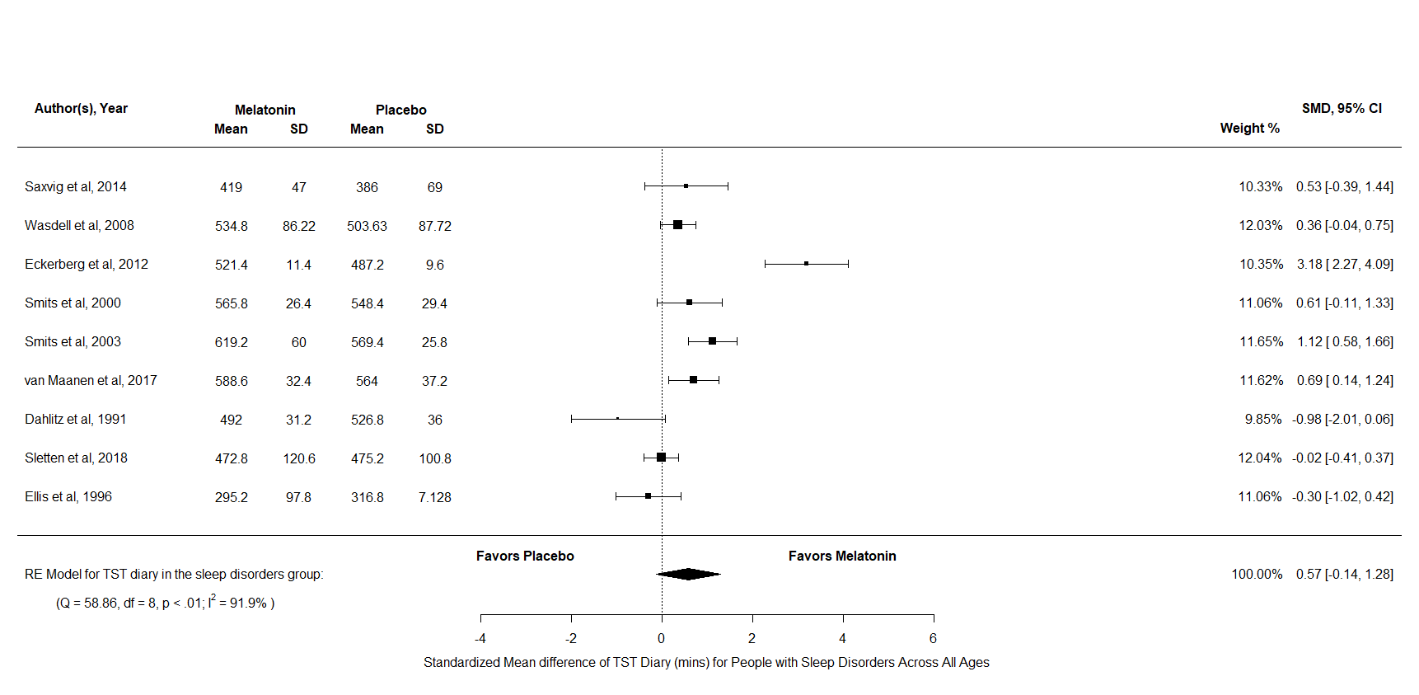
Figure AI6: A forest plot to show the sensitivity analysis of TST diary scores for melatonin against placebo for sleep disorders across all ages

SOL All Sleep Disorders & Neurodevelopmental Disorders with Insomnia
For SOL diary there were k = 11 and N = 562, the results indicated a significant difference in favour of melatonin against placebo SMD = -0.72, 95% CI [-1.02, -0.42], z = -4.65, p <.001. Furthermore, the test for heterogeneity showed Q(df = 10) = 27.49, p = 0.002, τ = 0.4, I² = 65.82% which meant that this analysis produced an output which cannot account for variability of effect sizes. Therefore, this analysis indicates that melatonin has a reducing effect in comparison to placebo for SOL diary scores in people of all ages with sleep disorders and neurodevelopmental disorders with comorbid insomnia.

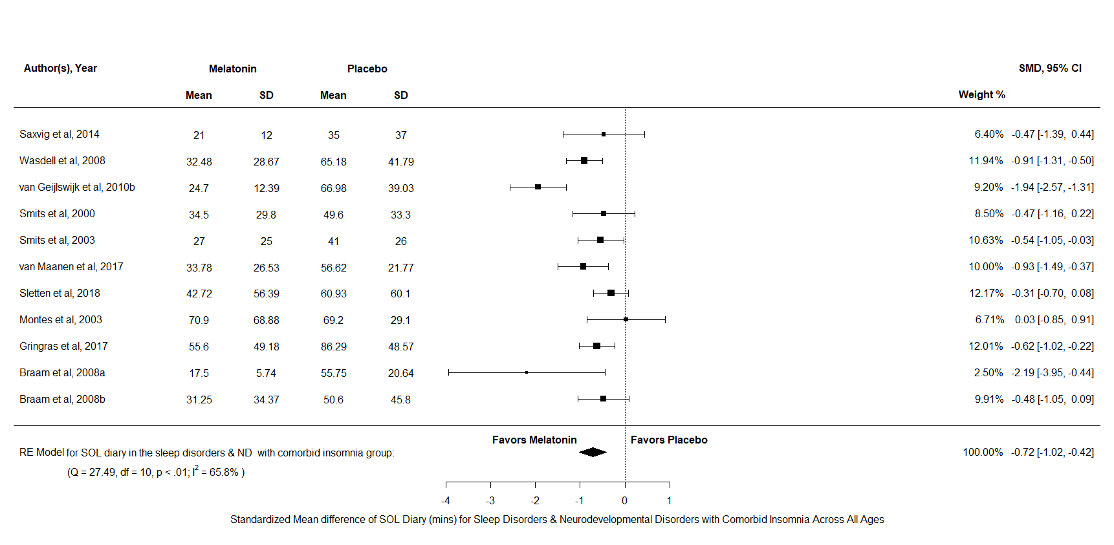
Figure AI7: A forest plot to show the sensitivity analysis of SOL diary scores for melatonin against placebo for people with sleep disorders and neurodevelopmental disorders with comorbid insomnia across all ages

TST All Sleep Disorders & Neurodevelopmental Disorders with Insomnia
For TST diary there were k = 12 and N = 513, the results indicated a significant difference in favour of melatonin against placebo SMD = 0.69, 95% CI [0.06, 1.31], z = 2.14, p = 0.03. Furthermore, the test for heterogeneity showed Q(df = 11) = 69.66, p <.001, τ = 1.03, I² = 92.03% which meant that this analysis produced an output which cannot account for variability of effect sizes. Therefore, this analysis indicates that melatonin has a reducing effect in comparison to placebo for TST diary scores in people of all ages with sleep disorders and neurodevelopmental disorders with comorbid insomnia.
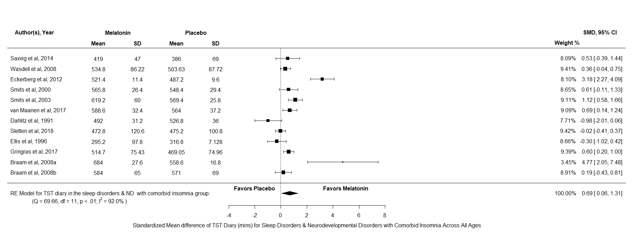
Figure AI8: A forest plot to show the sensitivity analysis of TST diary scores for melatonin against placebo for people with sleep disorders and neurodevelopmental disorders with comorbid insomnia across all ages
SOL All Disorder Combined
For SOL diary there were k = 17 and N = 782, the results indicated a significant difference in favour of melatonin over placebo SMD = -0.78, 95% CI [-1.06, -0.51], z = -5.6, p <.001. Furthermore, the test for heterogeneity showed Q(df = 16) = 52.52, p <.001, τ = 0.46, I² = 71.73% which means that this analysis did not produce an output which can account for variability of effect sizes. Overall, SOL diary scores appear to reduce after a treatment of melatonin compared to placebo in people of all ages, across all disorders.
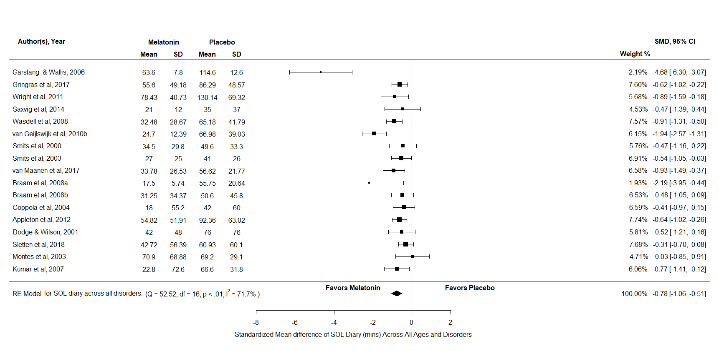
Figure AI9: A forest plot to show the sensitivity analysis of SOL diary scores for melatonin against placebo for all disorders across all ages

TST All Disorder Combined
For TST diary there were k = 19 and N = 752, the results indicated a significant difference in favour of melatonin against placebo SMD = 0.65, 95% CI [0.2, 1.11], z = 2.81, p = 0.005. Furthermore, the test for heterogeneity showed Q(df = 18) = 94.43, p <.001, τ = 0.92, I² = 90.25% which meant that this analysis produced an output which cannot account for variability of effect sizes. Therefore, this analysis indicates that melatonin has a reducing effect in comparison to placebo for TST diary scores in people of all ages, across all disorders.
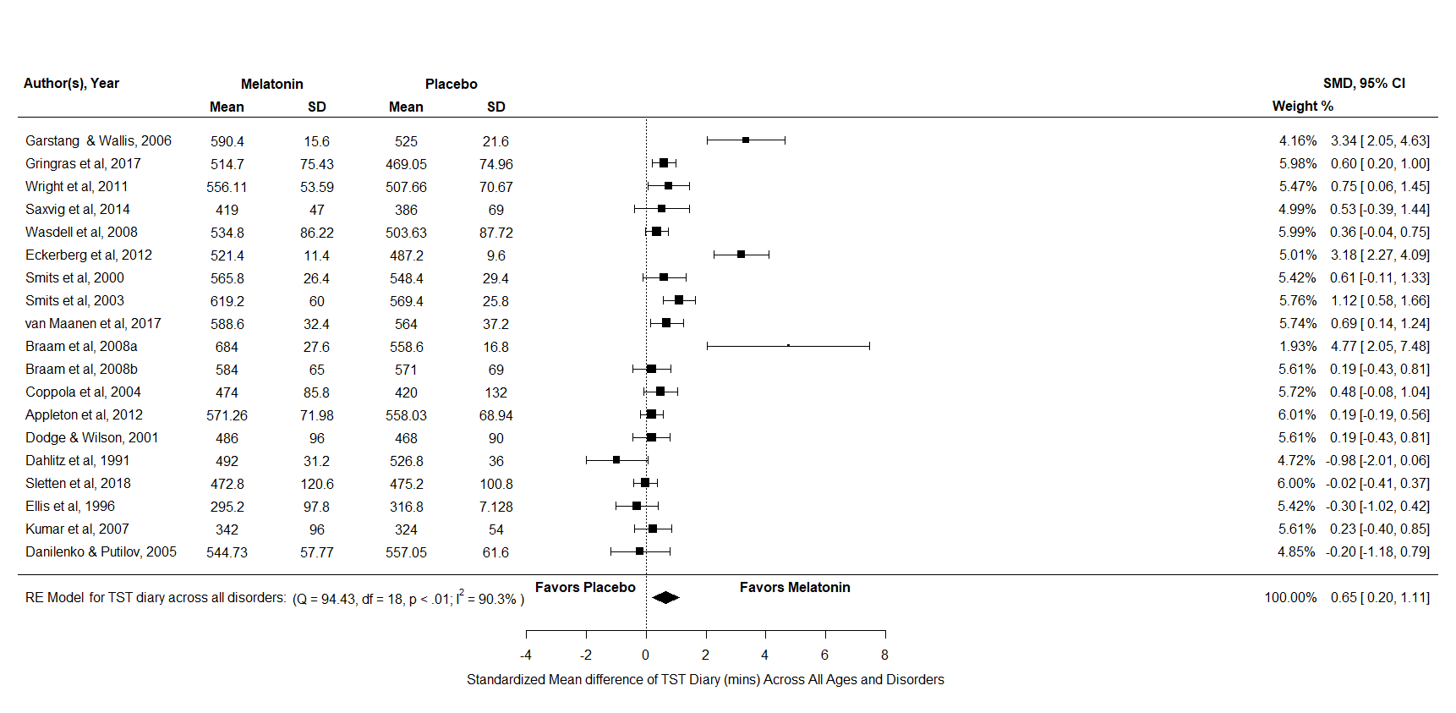
Figure AI10: A forest plot to show the sensitivity analysis of TST diary scores for melatonin against placebo for all disorders across all ages

Appendix AJ
Funnel plot for the outcome variable SOL diary, across all disorders
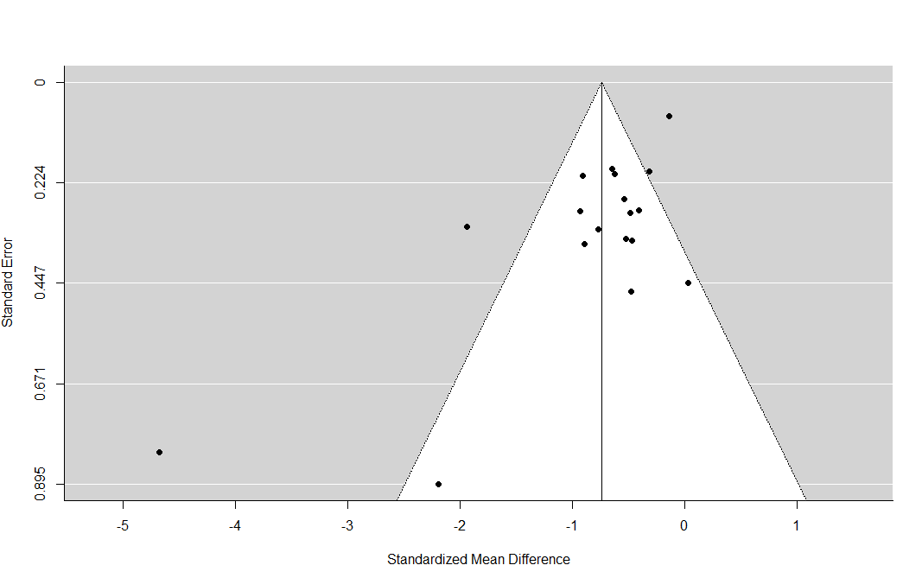
Figure AJ: Funnel plot for the outcome variable SOL diary, across all disorders

Appendix AK
Funnel plot for the outcome variable SOL actigraphy, across all disorders
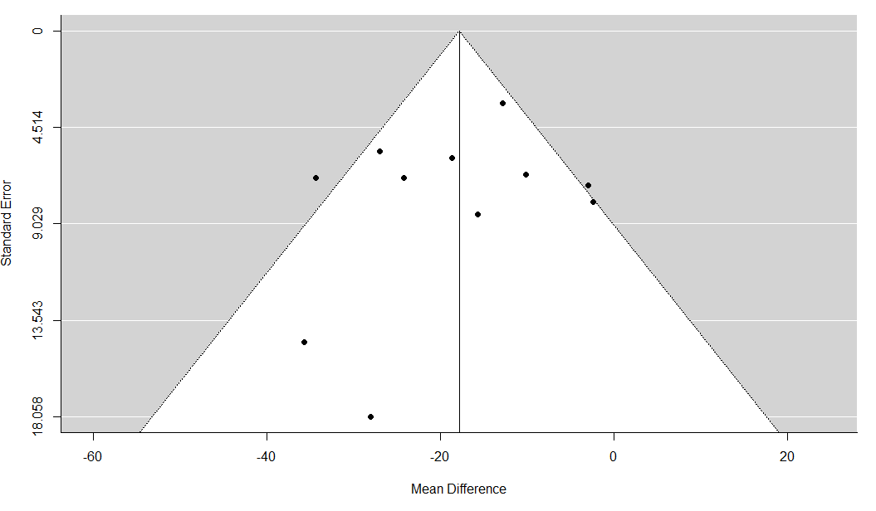
Figure AK: Funnel plot for the outcome variable SOL actigraphy, across all disorders

Appendix AL
Funnel plot for the outcome variable TST diary, across all disorders
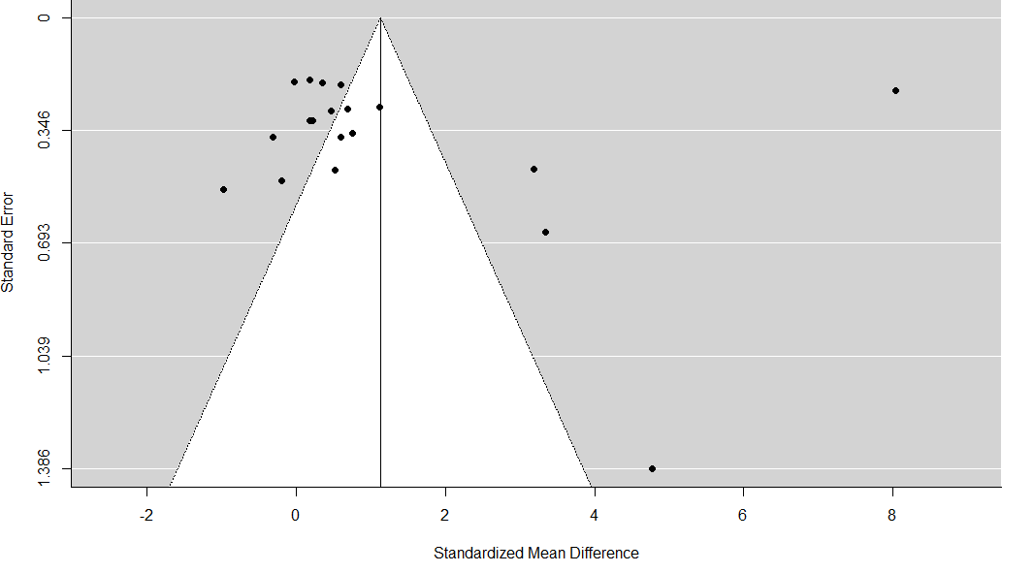
Figure AL: Funnel plot for the outcome variable TST diary, across all disorders

Appendix AM
Funnel plot for the outcome variable NA, across all disorders
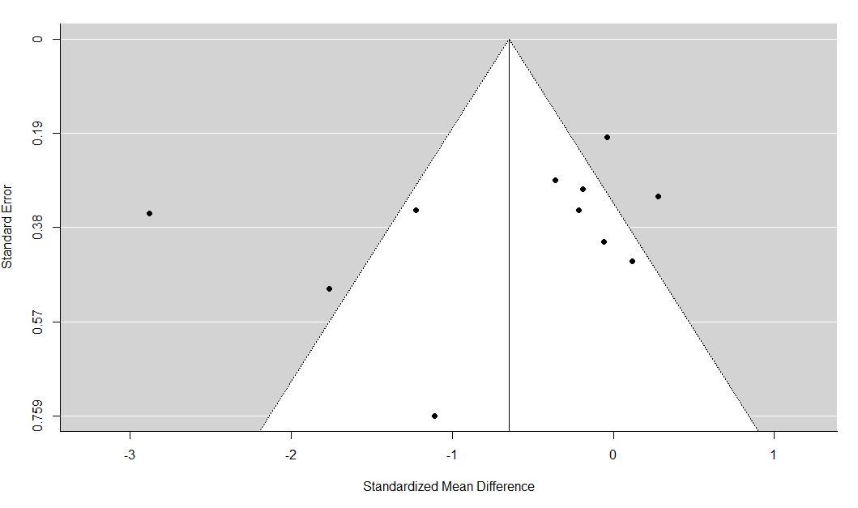
Figure AM: Funnel plot for the outcome variable NA, across all disorders

Appendix AN
Forest plot for the meta-analysis on the tolerability of melatonin against placebo across all disorder and ages.
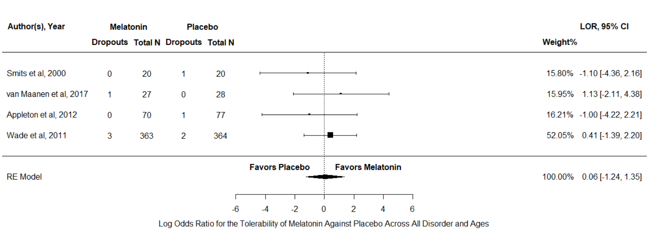
Figure AN: Forest plot for the meta-analysis on the tolerability of melatonin against placebo across all disorder and ages.

