OpenPalp
Your Personal Heart Rhythm Programme

Patient name:
______________________________________________
Date started:
______________________________________________

My personal commitment
Before you read another word — take a moment. You came here because something has been worrying you. That took courage. This is your programme. These are your thirty days.

Complete these three lines. Come back and read them on day 30.

In 30 days I want to feel ______________________________________
Palpitations stop me from ______________________________________
I commit to ______________________________________

If you feel unwell at any point — call 999 or go to A&E.
Symptoms that need urgent help: fainting, chest pain, severe breathlessness, palpitations lasting more than 20 minutes. This booklet is not for emergencies.

Start here — read pages 1 to 3 first, then come back each day to fill in your diary.

What is in this booklet

Part 1 | Understanding your heart | Pages 3–4

Part 2 | Using your devices | Pages 5–8

Part 3 | Your diary — 48 hours + 30 days | Pages 9–17

Part 4 | Your progress tracker | Page 18

Part 5 | The evidence + letter to yourself | Pages 19–20

Part 6 | Safety, consent, devices | Pages 21–22

Clinician | Suitability checklist — retain | Page 23

Emergency: call 999 or go to A&E if you faint, have chest pain, severe breathlessness, or palpitations lasting more than 20 minutes.

Part one — understanding your heart

You are not alone
If you are reading this, you have probably spent time worrying about your heart — perhaps lying awake, perhaps checking your pulse repeatedly, perhaps avoiding things you used to enjoy. You are not imagining your symptoms. And you are not alone.

Millions of people experience palpitations. Most of the time, they are not a sign of a serious heart problem — but that does not make them any less real, or any less frightening, when they happen to you.

What your heart is doing
Your heart beats about 100,000 times every day. You are not normally aware of it. Palpitations happen when something makes those beats noticeable — an extra beat, a brief change in rhythm, or a heightened sensitivity to normal variation.

The attention loop — and why it matters
Here is something important to understand:
The more you monitor your heartbeat, the more you notice it — and the more noticeable it becomes. This is not your imagination. It is how the nervous system works. It has learned to watch for a signal, and so it finds it, again and again.
Part of this programme is gently helping your nervous system to become less reactive — so that your heart can beat without you needing to listen.

Common triggers
- Caffeine — coffee, tea, cola, energy drinks
- Poor sleep — even one disturbed night increases sensitivity
- Stress and anxiety — activates the nervous system directly
- Alcohol — particularly the morning after drinking
- Dehydration — reduces blood volume and raises heart rate
- Hormonal changes — menstrual cycle, thyroid, perimenopause

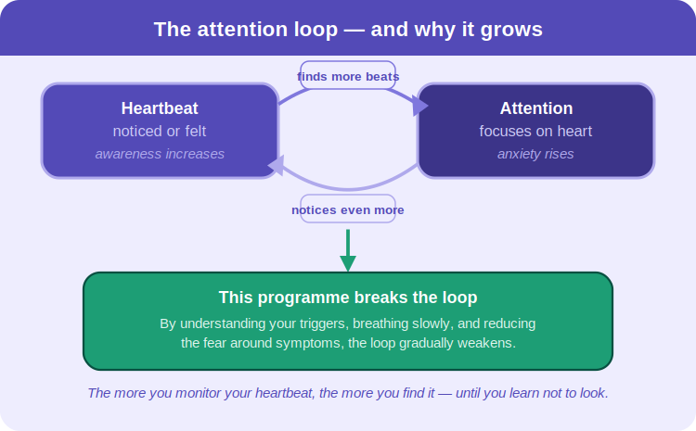
You will find your personal triggers through this programme. Most people are surprised by what they discover.

Your map — 30 days of monitoring, 6 weeks of change
Two things happen at once, starting on day 1:
Your monitoring runs for 30 days. The Wellue patch records for 48 hours. The Kardia records symptoms for 30 days, then is returned.
Your lifestyle programme runs for 6 weeks. After day 30 the devices come back — but weeks 5 and 6 of your programme continue. Your diary, your breathing, your movement, your progress: all continue to week 6.

This is your path. Not a prescription — a journey. Each week has one focus. Build on the one before.

Week 1  Listen | Wear your Wellue patch for 48 hours. Start your Kardia. Begin your diary. Simply observe. Every entry is a clue. Monitoring runs this week and for 30 days total.

Week 2  Breathe | Five minutes of slow breathing, twice a day. 4 seconds in, 6 seconds out. In a meta-analysis of 31 studies, this changed heart rhythm within the same session — not after weeks. Within minutes.

Week 3  Discover | Look back at your diary. Find your two personal triggers. In studies of people with palpitations, 71% found stress, 62% caffeine, 58% sleep disruption. You are part of a very human pattern.

Week 4  Change | Act on your top trigger. One change. Seven days. The same heart responds differently to a different life. This is the week you test that.

Week 5  Move | Monitoring has ended. Devices returned. Your programme continues. Set your step baseline and add 500 per day. Researchers tracking 22,516 adults over 14 years found every unit of excess weight added 4% more arrhythmia risk. Movement is medicine.

Week 6  Understand | Final week. No more devices. Just you and your diary and six weeks of evidence about your own heart. Fill in your progress tracker. Write your letter. See how far you have come.

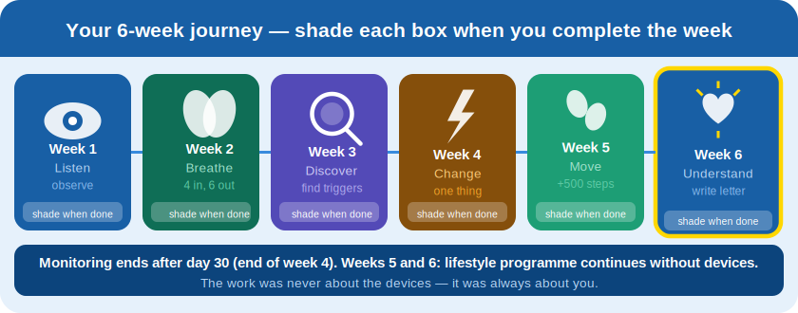

Where you are starting from
Fill this in today. You will revisit it at week 6.

How I feel right now | Day 1 | Day 30
Palpitations per week (approx)
Sleep quality (1 = poor, 10 = great)
Anxiety about my heart (1–10)
Energy levels (1–10)
Confidence managing symptoms (1–10)

Part two — your tools

Your Wellue patch — 48 hours
This small device will record every heartbeat for 48 hours — day and night, while you sleep, while you live your life. It does not judge. It simply listens. And your diary will tell us what was happening at the exact moment your heart changed.

Placing the patch — this is the most important step
Correct placement gives a clear trace. Incorrect placement is the most common cause of poor recordings.
Position: one palm-width below your left collarbone, angled 45 degrees toward your left side. The 'R' marker faces right.
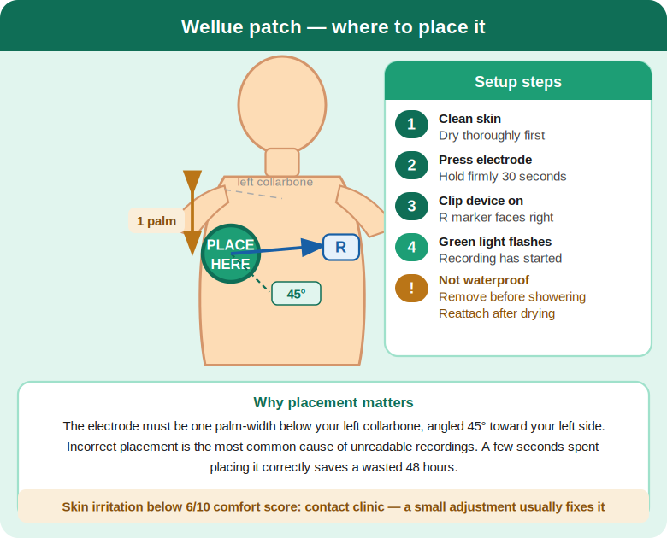

Setting up — step by step
- Clean and dry your skin thoroughly before applying the pad
- Peel the electrode and press firmly for 30 seconds — good adhesion matters
- Clip the Wellue device onto the electrode
- A green light confirms recording has started
- Begin your 48-hour diary immediately

Showering and comfort
The Wellue is not waterproof. Remove it before showering — reattach after drying. If your skin feels irritated (comfort below 6 in your diary), note it and contact the clinic — a small adjustment often resolves it.

Returning the Wellue after 48 hours
Remove the device. Place in the prepaid return envelope. Post the same day — or bring to clinic.
Write your name on the envelope. Include the completed 48-hour diary pages. Continue using the Kardia for the remaining 28 days.

Your Kardia device — 30 days
The Kardia is yours to use whenever you feel something. Think of it as your heart's voice recorder — activated by you, at the moment that matters.

Setting up in three steps
- Download the free Kardia app — search 'Kardia' on the App Store or Google Play
- Open the app, tap 'Add a device', follow the pairing steps
- You do not need a paid subscription. The free tier records and stores all your ECGs.

How to record
- Left thumb on the bottom electrode. Right index finger and thumb on the top two.
- For a fuller picture: rest the back of the device lightly on your left knee.
- Hold still, breathe gently, stay for 30 seconds.
- The app saves and analyses your recording automatically.

Record whenever you feel symptoms — as quickly as you can.
Also take one morning resting recording each day, before getting up. This builds a baseline picture of your rhythm at rest.
Note the time of each recording in your diary. At your results appointment, open the app and show your full recording history.
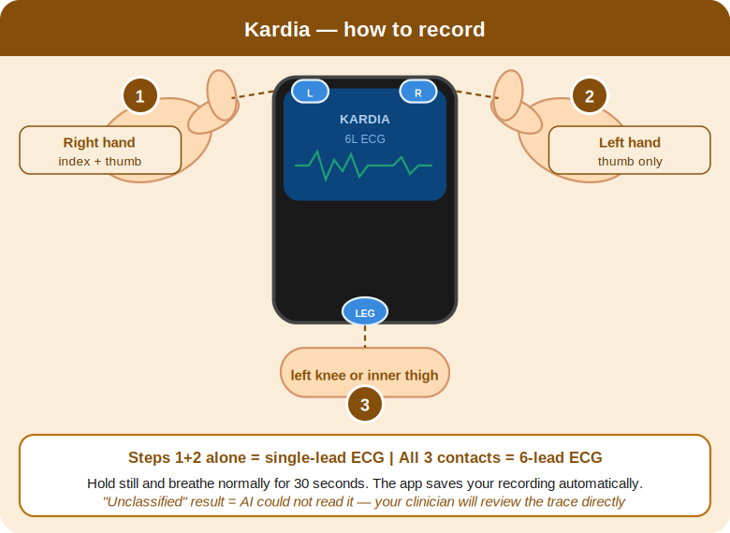

When you feel palpitations
Most episodes pass within a few minutes. Here is what to do — in order.

1 | Stay calm  Anxiety amplifies palpitations. Take one slow breath and remind yourself: most palpitations are not dangerous. You are not in danger.

2 | Sit or lie down  Reduce demand on your heart. Do not continue strenuous activity until the episode has fully passed.

3 | Breathe slowly  4 seconds in. 6 seconds out. Repeat five times. This activates your vagus nerve and can slow or settle the heart.

4 | Try a vagal technique  If you feel safe to do so: bear down gently as if straining (Valsalva), or splash cold water on your face. Only if you feel well enough. If in doubt — skip this and breathe instead.

5 | Record on Kardia  As quickly as possible. Even if symptoms are settling — record anyway. A trace during or just after an episode is highly informative.

6 | Write in your diary  Time, duration, severity, what you were doing, what helped. The pattern across 30 days is where the answers live.

Important note on vagal techniques:
Not suitable if you have known eye disease or significant heart valve problems. If you feel very unwell, do not attempt them. Always sit or lie down first.

Your daily practice
Small consistent actions change the nervous system more than anything else. You do not need to be perfect. You need to be regular.

Every morning  1. Check your HRV if your watch tracks it — note the number in your diary.  2. Take one resting Kardia recording — before getting up.  3. Five minutes of 4-6 breathing. In for 4, out for 6.  4. Fill in your diary for yesterday. | Every evening  1. Five minutes of 4-6 breathing.  2. Note one thing that helped your heart today.  3. Rate your heart anxiety today (1–10) in your diary.  4. Note your steps for the day.

Understanding HRV — your nervous system score
Heart rate variability (HRV) is the variation between heartbeats. A higher number means your nervous system is calm and adaptable. A lower number means it is under strain.

You do not need to analyse it. Just watch the trend. Most people see their HRV rise over six weeks as their nervous system settles. That number rising is your body telling you the programme is working.

Your two lifestyle experiments — do these in weeks 3 and 4

Experiment 1 — The caffeine test (week 3)
Replace your first coffee with hot water and lemon for 7 days. Note your palpitations in the diary each day. Week 4: reintroduce caffeine. Compare. If palpitations increase, caffeine is your trigger.
Experiment 2 — The sleep anchor (week 4)
Set one fixed wake time. Keep it for 7 days — even weekends. Stop caffeine after 2pm. Note sleep quality in your diary each morning. This single change often reduces palpitations within days.

My caffeine experiment result: □ Caffeine is a trigger □ No clear difference
My sleep anchor wake time: _______ Sleep quality before: ___/10 After: ___/10

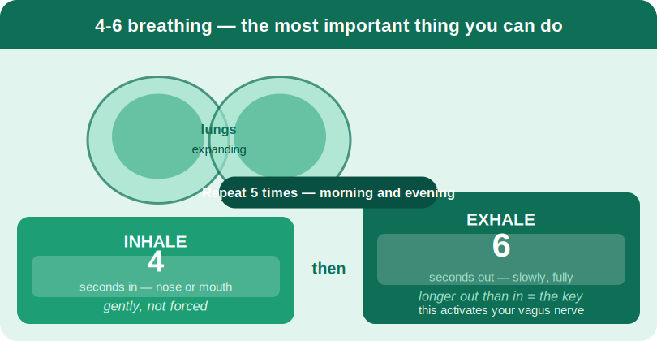

Your step goals — set these now and add 500 per week

Graded movement is one of the most powerful things you can do for your heart. Set your starting point today — not where you think you should be, but where you actually are.

Week | My target steps/day | Actual average
Week 1 — my baseline today (fill in now) | _____ steps
Week 2 — baseline + 500
Week 3 — week 2 + 500
Week 4 — week 3 + 500
Week 5 — week 4 + 500
Week 6 — my new normal

Researchers tracking 22,516 adults over 14 years found that every unit increase in BMI (closely linked to low activity) added 4% more risk of ectopic beats. Movement is not optional — it is medicine.

Part three — your diary

Start simple. In week 1, just fill in the first three columns — time, symptoms, and heart anxiety score. Add more columns as the weeks go on. The diary is for you, not against you.

48-hour diary — day 1
This diary runs alongside your Wellue trace. When we review your recording, we will match each entry to your heart rhythm — so the more detail you give, the richer the picture.

Date: _____________________ Wellue patch fitted at: ___________

Day 1 — hour by hour
Time of day | Symptoms (Y+severity) | Kardia taken | Stress 1-10 | Triggers noticed | Heart anxiety 1-10 | What helped | Notes
Morning 6am–12pm
Afternoon 12–5pm
Evening 5–9pm
Night 9pm–morning

Today's heart anxiety score (1–10): _____ One word to describe today: _______________

48-hour diary — day 2
Date: _____________________

Day 2 — hour by hour
Time of day | Symptoms (Y+severity) | Kardia taken | Stress 1-10 | Triggers noticed | Heart anxiety 1-10 | What helped | Notes
Morning 6am–12pm
Afternoon 12–5pm
Evening 5–9pm
Night 9pm–morning

Today's heart anxiety score (1–10): _____ One word to describe today: _______________

When your Wellue is fitted — turn to page 9 to begin your 48-hour diary.

Returning your Wellue — today
1. Remove the Wellue device from the electrode pad.
2. Place it in the prepaid return envelope with your name written on it.
3. Post it today — or drop it to the clinic.
4. Continue your Kardia and diary for the remaining 28 days. You are doing well.

Wellue returned — turn to the next page to begin your week 1 diary.

W1 | W2 | W3 | W4 | W5 | W6

This week, simply notice. Scientists call this interoceptive awareness — the ability to sense your own body. Most people with palpitations have too much of it. You are beginning to understand it instead.
This week: This week, simply notice. Do not try to change anything yet. Just observe your heart, your triggers, and your patterns. Every entry in your diary is a clue.

Week 1 — Listen and observe

Date | Sleep 1-10 | Caffeine cups | Stress 1-10 | Steps approx | Palpitations episodes+severity | Kardia taken | Heart anxiety 1-10 | What I did for my heart | One thing I noticed

Week 1 reflection
Notice what your heart did this week. Every observation is data.
Compared to last week, my palpitations are: □ Better □ Same □ Worse
My heart anxiety average this week: ___/10 Last week: ___/10
One thing I am proud of this week: _______________________________________________

W1 | W2 | W3 | W4 | W5 | W6

Five minutes of slow breathing changes your heart rhythm within the same session. Not next week. Now. A 2024 analysis of 31 studies confirmed this. Your nervous system is already responding.
This week: Begin your daily breathing practice this week. Five minutes, morning and evening. 4 seconds in, 6 seconds out. Notice whether your heart anxiety score starts to shift.

Week 2 — Breathe

Date | Sleep 1-10 | Caffeine cups | Stress 1-10 | Steps approx | Palpitations episodes+severity | Kardia taken | Heart anxiety 1-10 | What I did for my heart | One thing I noticed

Week 2 reflection
Five minutes of slow breathing measurably changed heart rhythm in every study that tested it. Did you feel it?
Compared to last week, my palpitations are: □ Better □ Same □ Worse
My heart anxiety average this week: ___/10 Last week: ___/10
One thing I am proud of this week: _______________________________________________

W1 | W2 | W3 | W4 | W5 | W6

You are not unusual. In studies of palpitation patients, the three most common triggers were stress (71%), caffeine (62%), and poor sleep (58%). Finding yours is not failure — it is precision.
This week: Look back at weeks 1–2. What pattern do you see? Complete the trigger finder below. Then begin the caffeine experiment if caffeine appears in your diary.

Week 3 — Discover your triggers

Date | Sleep 1-10 | Caffeine cups | Stress 1-10 | Steps approx | Palpitations episodes+severity | Kardia taken | Heart anxiety 1-10 | What I did for my heart | One thing I noticed

My trigger finder — week 3
In studies of people with palpitations, the most commonly identified triggers were: stress (71%), caffeine (62%), and poor sleep (58%). You are not unusual. You are part of a very large and very human pattern.

Looking at my diary so far, my palpitations are most common when:
□ I have had more caffeine than usual
□ I have slept poorly
□ I am stressed or anxious
□ I have drunk alcohol recently
□ I have done less movement than usual
□ No clear pattern yet

My top two triggers are: _____________________ and _____________________
Week 3 reflection
You have named your triggers. That knowledge belongs to you now. Nobody can take it back.
Compared to last week, my palpitations are: □ Better □ Same □ Worse
My heart anxiety average this week: ___/10 Last week: ___/10
One thing I am proud of this week: _______________________________________________

W1 | W2 | W3 | W4 | W5 | W6

One change. Seven days. The same heart, a different life. The sleep study showing 33% fewer PVCs after a single protected night was not testing a drug. It was testing exactly this — one small change.
This week: Act on your top trigger this week. One change only. Try the sleep anchor — a fixed wake time, caffeine cut-off at 2pm. Or go caffeine-free for 7 days. Note the result.

Week 4 — Change one thing

Date | Sleep 1-10 | Caffeine cups | Stress 1-10 | Steps approx | Palpitations episodes+severity | Kardia taken | Heart anxiety 1-10 | What I did for my heart | One thing I noticed

Week 4 reflection
One change, seven days. The same heart responds differently to a different life.
Compared to last week, my palpitations are: □ Better □ Same □ Worse
My heart anxiety average this week: ___/10 Last week: ___/10
One thing I am proud of this week: _______________________________________________

W1 | W2 | W3 | W4 | W5 | W6

Monitoring has ended. Devices returned. The programme continues — and so do you. Researchers following 22,516 adults for 14 years found that even modest increases in daily movement reduced arrhythmia risk measurably.
This week: Devices have been returned. Your programme continues. Check your step target from page 5. This week, hit it. Movement improves your autonomic nervous system and builds lasting resilience.

Week 5 — Move more (monitoring ended — lifestyle continues)

Date | Sleep 1-10 | Caffeine cups | Stress 1-10 | Steps approx | Palpitations episodes+severity | Kardia taken | Heart anxiety 1-10 | What I did for my heart | One thing I noticed

Week 5 reflection
Devices returned. Programme continues. The work was never about the devices.
Compared to last week, my palpitations are: □ Better □ Same □ Worse
My heart anxiety average this week: ___/10 Last week: ___/10
One thing I am proud of this week: _______________________________________________

W1 | W2 | W3 | W4 | W5 | W6

This is your final week. You have done something most people with palpitations never do — you have studied your own heart with care and patience. The answers were always in you.
This week: Your final week. No more devices. Review your full diary. Complete the progress tracker. Fill in your day-30 scores on page 3. Then write your letter to yourself.

Week 6 — Understand and consolidate (final week)

Date | Sleep 1-10 | Caffeine cups | Stress 1-10 | Steps approx | Palpitations episodes+severity | Kardia taken | Heart anxiety 1-10 | What I did for my heart | One thing I noticed

Week 6 reflection
This is your final reflection. Read back through every week. You did this.
Compared to last week, my palpitations are: □ Better □ Same □ Worse
My heart anxiety average this week: ___/10 Last week: ___/10
One thing I am proud of this week: _______________________________________________

Week 6 complete — turn to page 18 to fill in your progress tracker, then page 19 for the evidence behind what you have done.

Part four — how far you have come

Your progress tracker
Fill this in at the end of weeks 2, 4, and 6. Then compare. The numbers will tell a story.

Measure | Week 2 | Week 4 | Week 6
Palpitations per week
Sleep quality (1–10)
Heart anxiety (1–10)
Energy levels (1–10)
Average daily steps
HRV (if tracked)
Confidence managing symptoms (1–10)

Look at your heart anxiety score. Has it fallen?
This number falling is not a small thing. It means you are living differently. It means you understand your heart better than you did thirty days ago. It means the programme has worked — not because we fixed something, but because you did.

The interventions that worked for me
□ Slow breathing
□ Reducing caffeine
□ Fixed wake time and better sleep
□ Increased daily movement
□ Recording on Kardia — feeling in control
□ Understanding the attention-symptom loop
□ The Valsalva or cold water technique
□ Simply understanding my triggers
Progress tracker complete — turn to page 17 for your self-assessment, then page 19 for the science behind everything you have done.

Looking back — your self-assessment
Complete this before your results appointment. Bring this booklet with you.

Go back to page 3 and fill in your day-30 scores now.

Overall, compared to when I started:
□ Significantly better — palpitations much less frequent or severe
□ Somewhat better — I have improved
□ About the same — but I understand them better now
□ Worse — I need further help

My understanding of my palpitations:
□ I now understand what drives them — I feel in control
□ I understand them better — but still some uncertainty
□ I still feel uncertain — I need more support

My main trigger was ______________________________________
The most helpful intervention was ______________________________________
The biggest thing I have learned about my heart is ______________________________________

This page is for you and for your clinician. Your answers shape the conversation at your results appointment. There are no right or wrong answers — only honest ones.

The evidence behind the programme
These are not theories. They are findings from real studies involving real people — people whose hearts changed when they changed how they lived.

The breathing story
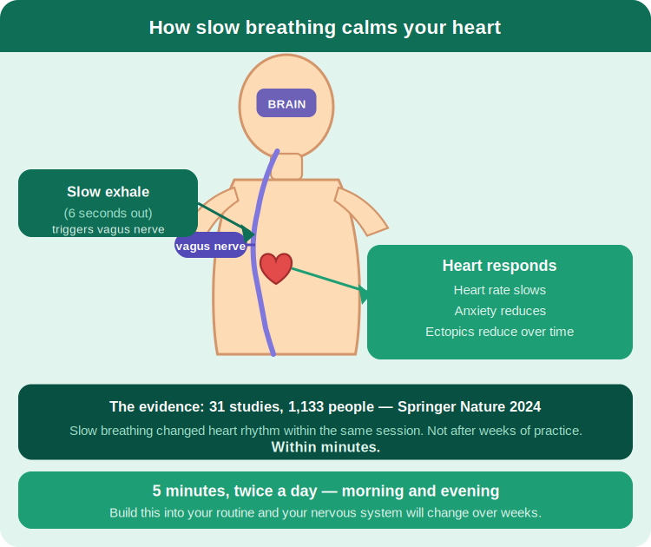
Researchers gathered 31 studies involving 1,133 people. Some were anxious. Some had high blood pressure. Some had palpitations. All of them were asked to do one thing: slow their breathing to fewer than 10 breaths per minute for five minutes.
In every group, the heart rhythm changed. Not after weeks of practice. Within the same session. Within minutes. The vagus nerve — the body's main brake on the heart — responded to the exhale. Longer out than in. The heart slowed. The anxiety eased. The nervous system, given a single slow breath, began to settle.
(Springer Nature, 2024 — meta-analysis of 31 studies, n=1,133)

The sleep story
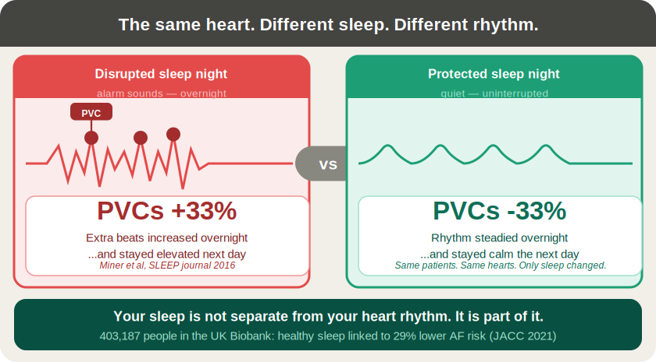
In a hospital in Canada, researchers noticed something. On nights when the hospital's overhead alarm system triggered repeatedly, patients on cardiac monitoring had more extra heartbeats. Not just during the night — the following day too.
On nights when the alarms were quiet and patients slept, premature ventricular beats fell by 33% overnight — and stayed low the next day.
The same hearts. The same patients. The only thing that changed was their sleep. (Miner et al., SLEEP journal, 2016)

In a study of 403,187 people across the UK, those with consistently healthy sleep patterns had a 29% lower risk of developing atrial fibrillation — independent of every other risk factor measured. Your sleep is not separate from your heart rhythm. It is part of it. (JACC, 2021)

The movement story
Over 14 years, researchers followed 22,516 apparently healthy men and women attending health screenings. They measured weight, activity, and heart rhythm.
Obese patients were 33% more likely to have ectopic ventricular beats. Every additional unit of BMI added 4% more risk. Not because of a disease — because of how they were living. The heart that moves less, fires irregularly more.
(PubMed, 2015 — 22,516 adults, 14-year follow-up)

The most important story in modern cardiology
In 1989, doctors ran a trial. They had a drug that successfully suppressed extra heartbeats after heart attack. The logic seemed obvious: fewer extra beats, less risk of sudden death.
The trial was stopped early. Patients taking the drug were dying at three times the rate of those who took nothing.
The lesson was profound and it changed cardiology permanently: extra heartbeats are a signal, not always the problem. Silencing them without understanding them can be worse than leaving them alone. Understanding them — as you are doing — is more powerful than any drug designed to suppress them. (CAST Trial, 1989)

A letter to yourself
This is the most important page in this booklet. Write it at the end of week 6. Write it to the person who sat down on day 1 and filled in their commitment on the cover — the person who was worried, who was not sure this would work, who perhaps did not believe their heart would feel better.

Begin with this line: "I want you to know that you made it." Then write whatever comes.

What do you know now that you wish you had known then?
What has changed?
What would you tell them?

Now go back to the cover. Re-read what you wrote on day 1. You came here with a worry. Look at what you have built instead.

Part five — we will keep you safe

When to seek urgent help
Call 999 or go to A&E immediately if you experience:
Fainting or loss of consciousness
Chest pain, pressure, or tightness
Severe breathlessness
Palpitations that do not stop after 20–30 minutes
Collapse, or feeling you are about to collapse

Do not use this booklet or attempt self-monitoring in an emergency.

Contact the clinic if:
- Your skin is significantly irritated by the Wellue electrode
- The device stops recording or the app stops connecting
- Your symptoms feel significantly different from your usual palpitations
- You have any concern during the monitoring period

If something significant is found
This pathway is designed for low-risk palpitations. If monitoring reveals atrial fibrillation, SVT, significant pauses, or a high ectopy burden, you will be referred promptly to NHS or private cardiology. You will not be left without a plan.

Clinic contact: _____________________________ Tel: ____________________________

Our agreement
Please read each section carefully, tick each box, and sign at the bottom.

Device loan
Device | Serial number | Return by
Wellue ER1-LW |  | 48 hours
KardiaMobile 6L |  | 30 days

If either device is lost or damaged beyond reasonable wear: Wellue replacement cost £90 / Kardia £70.

Consent
□ I understand this service is for low-risk palpitations only and does not replace emergency care or NHS cardiology services.
□ I understand that significant findings may require onward referral to NHS or private cardiology.
□ I consent to my ECG recordings being reviewed by the supervising clinician and cardiac physiologist within this pathway.
□ I consent to a summary results letter being sent to my GP. (If you do not wish your GP to be informed, please discuss with the clinician before signing.)
□ I understand my data will be stored securely in accordance with UK GDPR and will not be shared beyond the clinical team without my further consent.
□ I have received, read, and understood the information in this booklet.

Patient signature: ________________________________
Printed name: ________________________________
Date: ________________________________
Clinician signature: ________________________________

Quick reference card — keep this page handy

When palpitations start:
1 Stay calm. Palpitations feel frightening. Most are not dangerous.
2 Sit or lie down.
3 Breathe: in for 4 seconds, out for 6 seconds. Repeat 5 times.
4 Record on Kardia as quickly as possible.
5 Write in your diary: time, severity, what helped.

Call 999 or go to A&E immediately if you have:
Fainting or loss of consciousness
Chest pain or pressure
Severe breathlessness
Palpitations not stopping after 20 minutes

Clinic: _______________________ Tel: _______________________

Cut here and keep by your bed or on your fridge.

CLINICIAN COPY — Retain for audit. Do not give to patient.

Pathway suitability checklist
Complete at point of booking. File in patient record. This is your audit trail that exclusion criteria were checked.

Patient name: ________________________ DOB: ___________ Date: ___________

Inclusion — patient has all of:
□ Intermittent palpitations — awareness of heartbeat
□ Episodes brief — seconds to minutes
□ Generally well between episodes
□ No known significant structural heart disease

Exclusion — confirm NONE present:
□ Syncope or near-syncope
□ Chest pain of possible cardiac origin
□ Severe or unexplained breathlessness
□ Sustained palpitations >20–30 minutes
□ Known structural heart disease or heart failure
□ Known significant arrhythmia requiring management
□ Abnormal baseline ECG requiring investigation
□ Strong family history of sudden cardiac death
□ Symptoms clearly triggered by exertion
□ Pacemaker or ICD in situ

Clinical notes ______________________________________
_______________________________________________________________________________

Decision: □ Suitable — proceed with pathway □ Not suitable — refer or redirect

Clinician signature: ________________________________
Date: ________________________________

OpenPalp Pathway v1.0 | Retain this page. Do not give to patient.

