Sacubitril/valsartan against enalapril in heart failure with reduced ejection fraction: the three randomised trials that report cardiovascular death or heart failure hospitalization as a time-to-first hazard ratio
In adults with heart failure and reduced ejection fraction, what is the hazard of a first cardiovascular death or heart failure hospitalization with sacubitril/valsartan compared with enalapril?
Submission readiness: NOT YET DETERMINED. This manuscript is projected from a canonical data object; the sections marked as awaiting the author are not written here.

Contents

Abstract
Objective. In adults with heart failure and reduced ejection fraction, what is the hazard of a first cardiovascular death or heart failure hospitalization with sacubitril/valsartan compared with enalapril?
Data sources and eligibility. The search ran across PubMed and ClinicalTrials.gov for randomised comparisons of sacubitril/valsartan with enalapril in heart failure, and was then extended by the reconciliation step: the included-study list of every retrievable published synthesis of the same comparison was read and diffed against this one in both directions. That second pass is what found PARALLEL-HF, which the brief this object was built from did not name. A randomised trial of sacubitril/valsartan against enalapril, in adults with heart failure and reduced ejection fraction, reporting cardiovascular death or heart failure hospitalization as a time-to-first-event hazard ratio. All four conditions, and the last is a condition on the QUANTITY reported, not on the trial's quality: several excluded trials are large, well conducted and directly on topic, and report something that is not this.
Synthesis. random model, estimator REML, k = 3.
Results. Pooled HR 0.8392 (0.7429 to 0.948, 95% interval); I-squared 14.9469%, tau-squared 0.0035.
Certainty. GRADE certainty low. start high; risk_of_bias serious (-1), imprecision serious (-1); total -2 -> low
Limitations. The one apparent gap this search had is now closed, and closing it removed a trial rather than adding one: the patient total of the paywalled Chagas reviews exceeded the trials found here by a post hoc PARADIGM-HF subgroup, which is not a separate randomisation and is not recovered. The reconciliation block sets out the arithmetic and the deduplication reason. What is still unread is how those reviews themselves treated that subgroup, which their abstracts do not say.

Introduction
This section is not written here. The canonical object carries no background or rationale field, and an introduction generated without one would be argument that no source in this review supports. It is left for the author, and its absence is stated rather than filled.

Methods

Protocol and registration
Registered as a timestamped public commit in https://github.com/mahmood726-cyber/rapidmeta-finerenone at path ssot/arni-hfref/arni-hfref.json. Commit 961400264a06, committed 2026-08-10T05:13:40Z. The ordering test asks whether a protocol commit precedes the search, the screening decisions and the analysis. It cannot pass here: this object's EARLIEST commit is also its only one, and it already contains the finished analysis -- its own subject line says 'certified build'. The object's `built` date is 2026-08-09, which is BEFORE that commit, so the analysis demonstrably existed before the first registration evidence rather than after it. Nothing is being hidden by saying so: the commit is real and public, it just registers a completed review rather than a plan. A future review that commits its protocol first will pass this test, and the test is what makes the claim worth anything.

Eligibility criteria
A randomised trial of sacubitril/valsartan against enalapril, in adults with heart failure and reduced ejection fraction, reporting cardiovascular death or heart failure hospitalization as a time-to-first-event hazard ratio. All four conditions, and the last is a condition on the QUANTITY reported, not on the trial's quality: several excluded trials are large, well conducted and directly on topic, and report something that is not this.

Information sources and search
The search ran across PubMed and ClinicalTrials.gov for randomised comparisons of sacubitril/valsartan with enalapril in heart failure, and was then extended by the reconciliation step: the included-study list of every retrievable published synthesis of the same comparison was read and diffed against this one in both directions. That second pass is what found PARALLEL-HF, which the brief this object was built from did not name.
No executed query string is recorded in the canonical object for any database. The search is therefore described but not reproducible from this document, and that is a stated limitation rather than an omission.

Synthesis methods
random model with the REML estimator.

Results

Included studies
Table 1. Characteristics of the included trials
Trial | Registry ID | Year | Design | Population | Analysed (T/C)
PARADIGM-HF | NCT01035255 | 2014 | phase 3, double-blind, randomised one to one against an acti | adults with NYHA class II to IV heart failure and | 4187 / 4212
PARACHUTE-HF | NCT04023227 | 2026 | phase 4, multicentre, randomised one to one against an activ | adults with NYHA class II to IV heart failure, an | 462 / 460
PARALLEL-HF | NCT02468232 | 2021 | phase 3, randomised one to one against an active comparator, | Japanese adults with NYHA class II to IV chronic h | 111 / 112

Per-arm event counts
Table 2. Per-arm events and denominators for the pooled composite
Trial | Intervention events / n | Comparator events / n | Source tier
PARADIGM-HF | 914 / 4187 | 1117 / 4212 | T1+T2
PARACHUTE-HF | 155 / 462 | 169 / 460 | T1
PARALLEL-HF | 30 / 111 | 28 / 112 | T1+T2

Pooled result
Pooled HR 0.8392 (0.7429 to 0.948), k = 3. I-squared 14.9469%, tau-squared 0.0035, Q 2.3515 on 2 degrees of freedom.
Table 3. The same 2x2 on three scales (sensitivity to the primary hazard-ratio pool)
Measure | Pooled (95% interval) | I-squared (%)
Risk ratio | 0.856332 (0.775055 to 0.946131) | 21.026426
Odds ratio | 0.791379 (0.721055 to 0.868561) | 0.059244
Risk difference | -0.044191 (-0.061519 to -0.026863) | 0

Table 4. Leave-one-out sensitivity analysis
Trial omitted | Pooled estimate (95% interval) | I-squared (%)
paradigm-hf | 0.935412 (0.765004 to 1.143778) | 0
parachute-hf | 0.837976 (0.67489 to 1.040471) | 25.799481
parallel-hf | 0.81941 (0.742717 to 0.904023) | 13.077904

Table 5. Between-study-variance estimator comparison
Estimator | Interval method | Point | Lower | Upper | tau-squared
DL | Wald | 0.8333 | 0.7473 | 0.9292 | 0.002149
PM | Wald | 0.8315 | 0.7485 | 0.9237 | 0.001796
REML | Wald | 0.8392 | 0.7429 | 0.948 | 0.003498
REML | HKSJ | 0.8392 | 0.6421 | 1.0968 | 0.003498

Figures
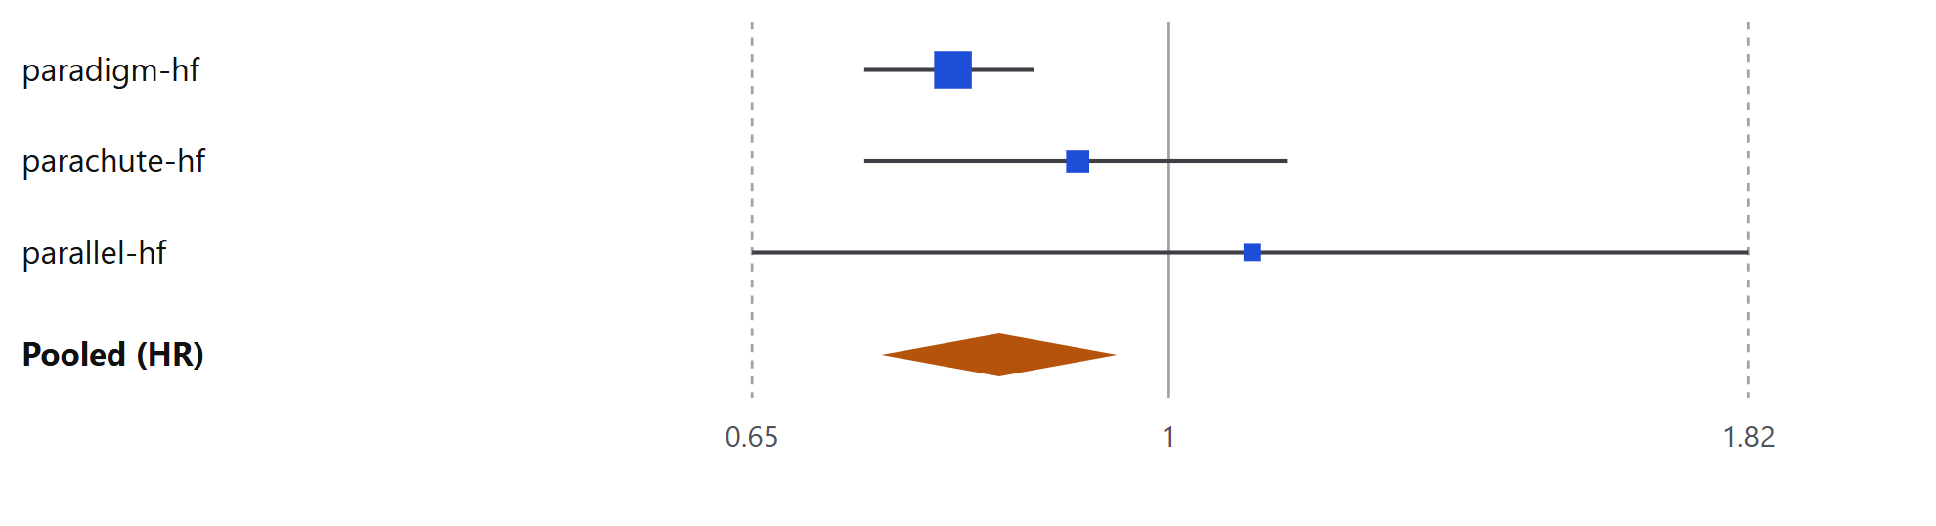
Figure 1. Forest plot
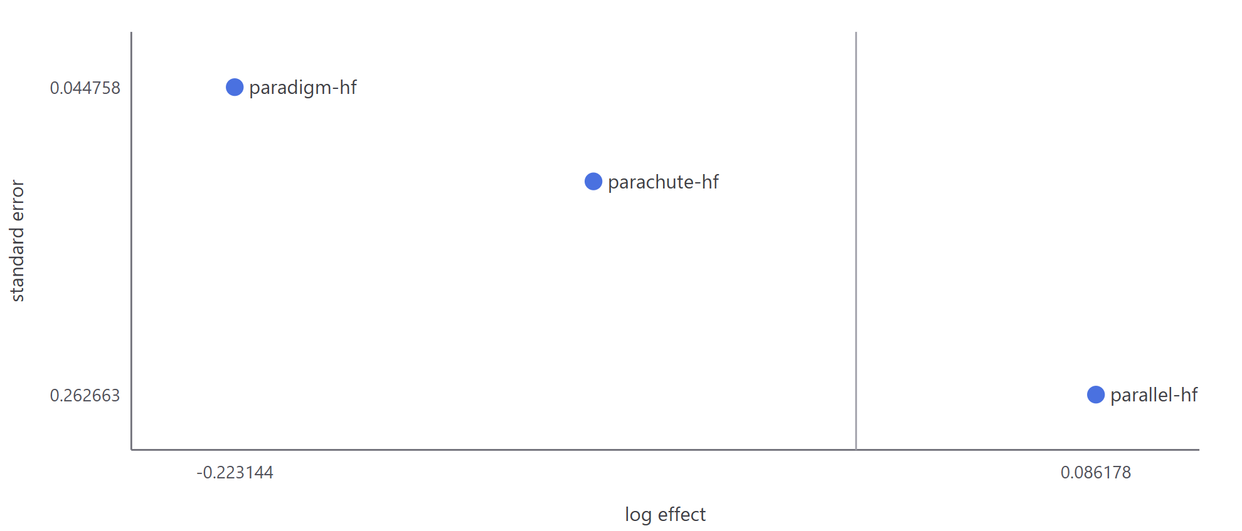
Figure 2. Funnel plot
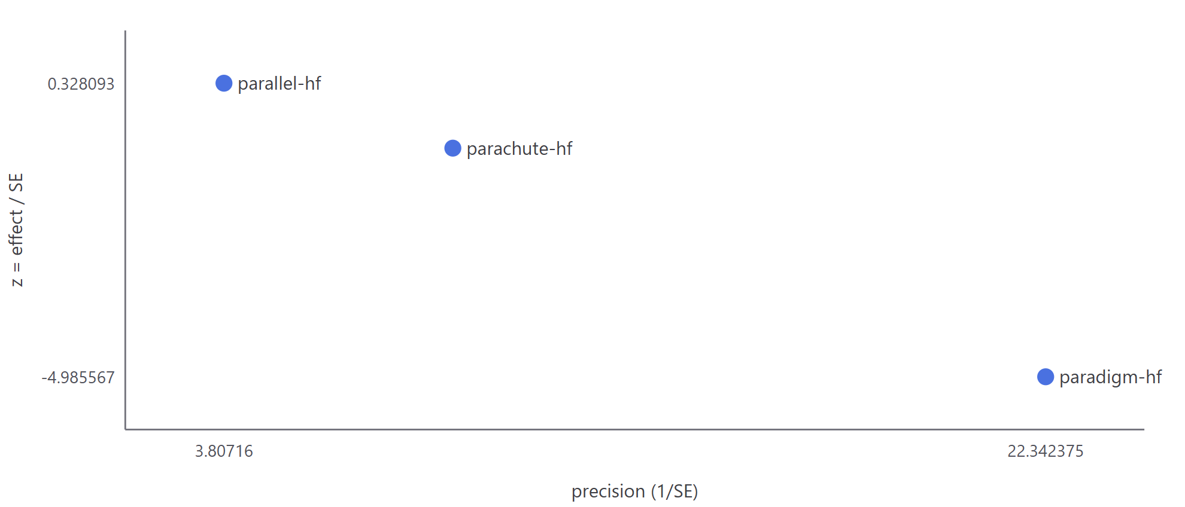
Figure 3. Galbraith (radial) plot
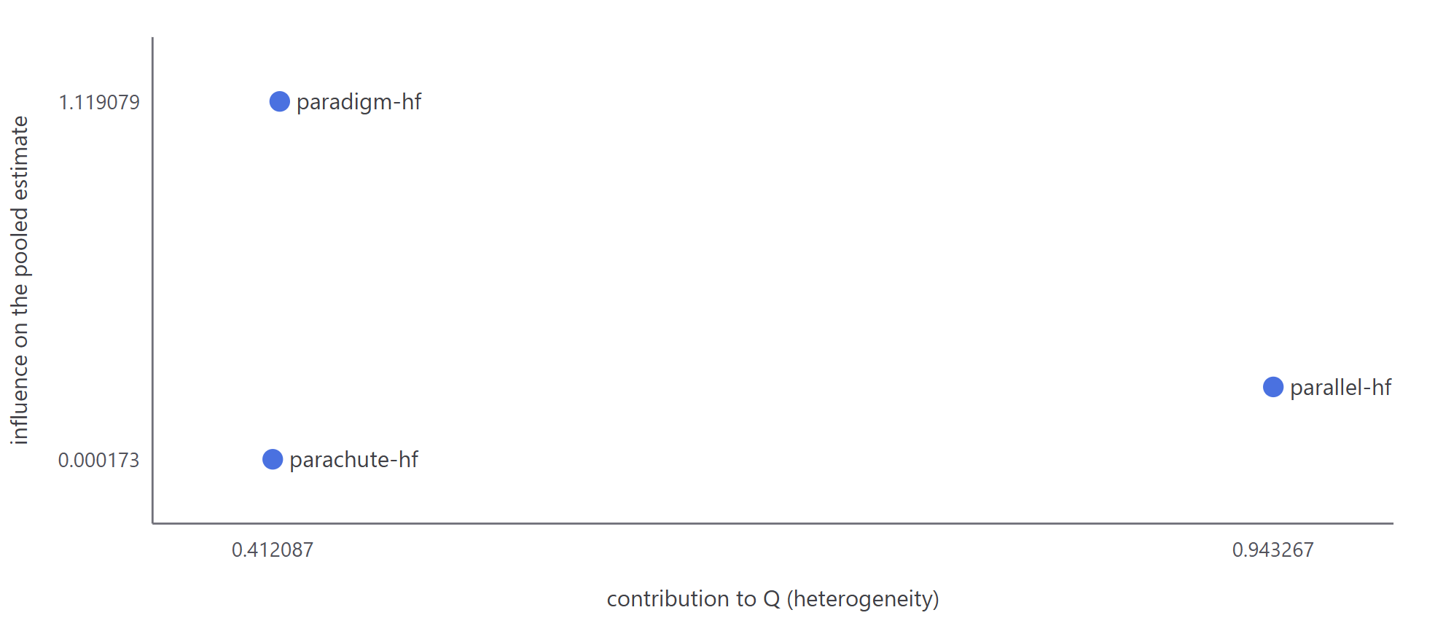
Figure 4. Baujat plot
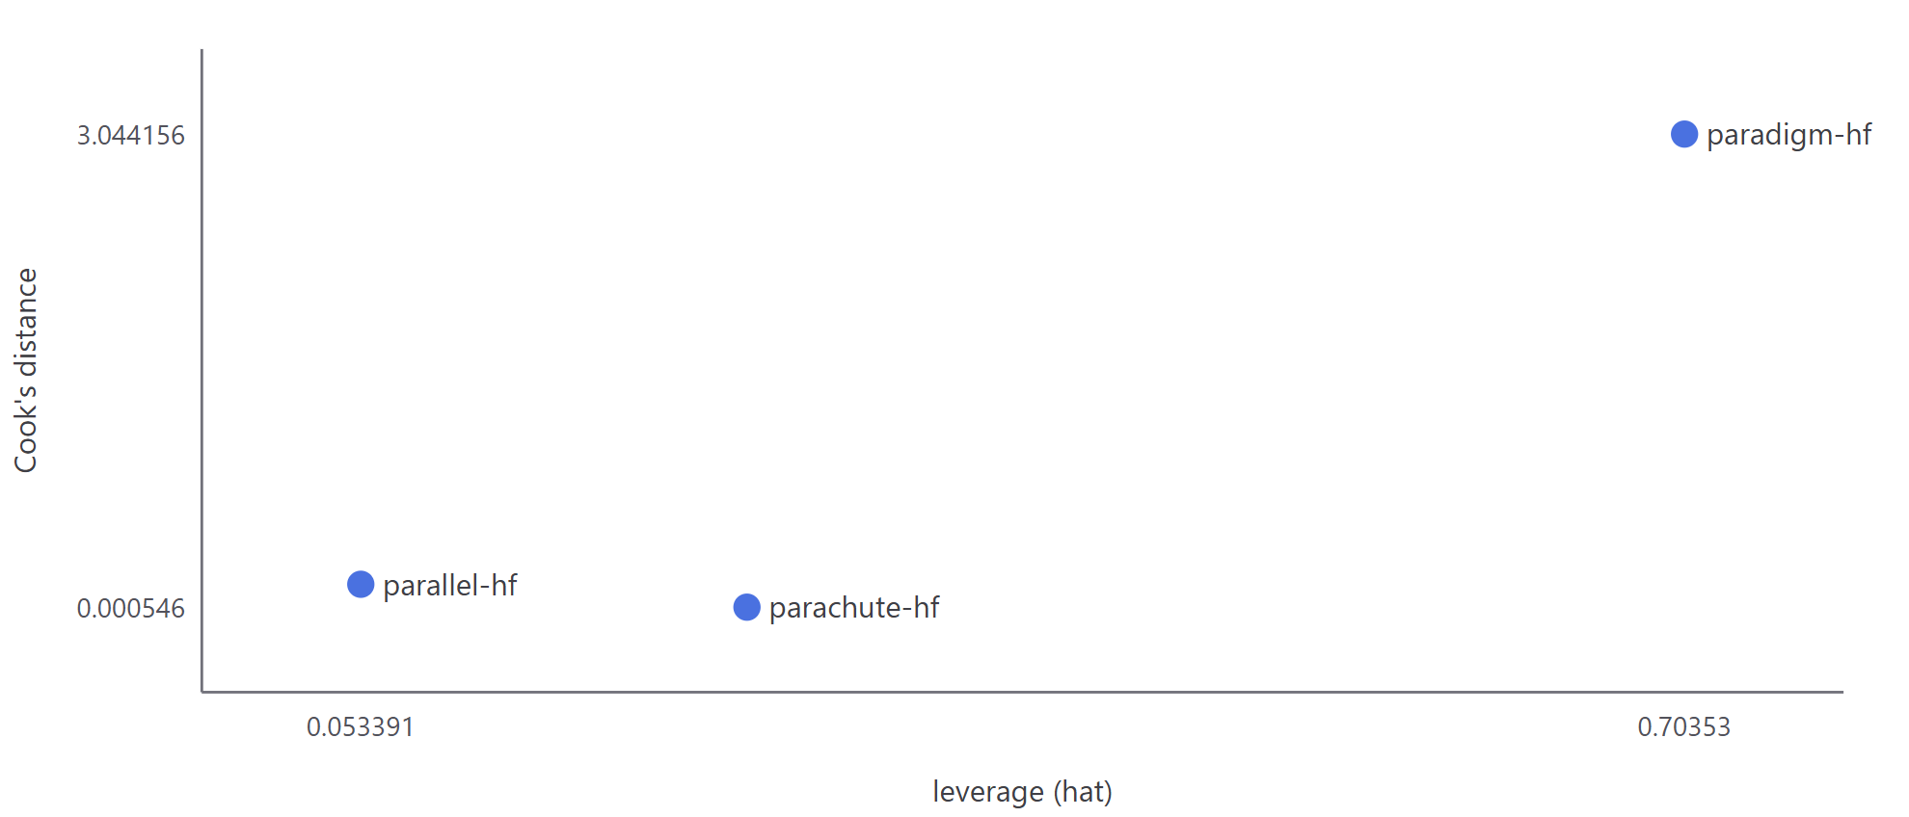
Figure 5. Influence diagnostics
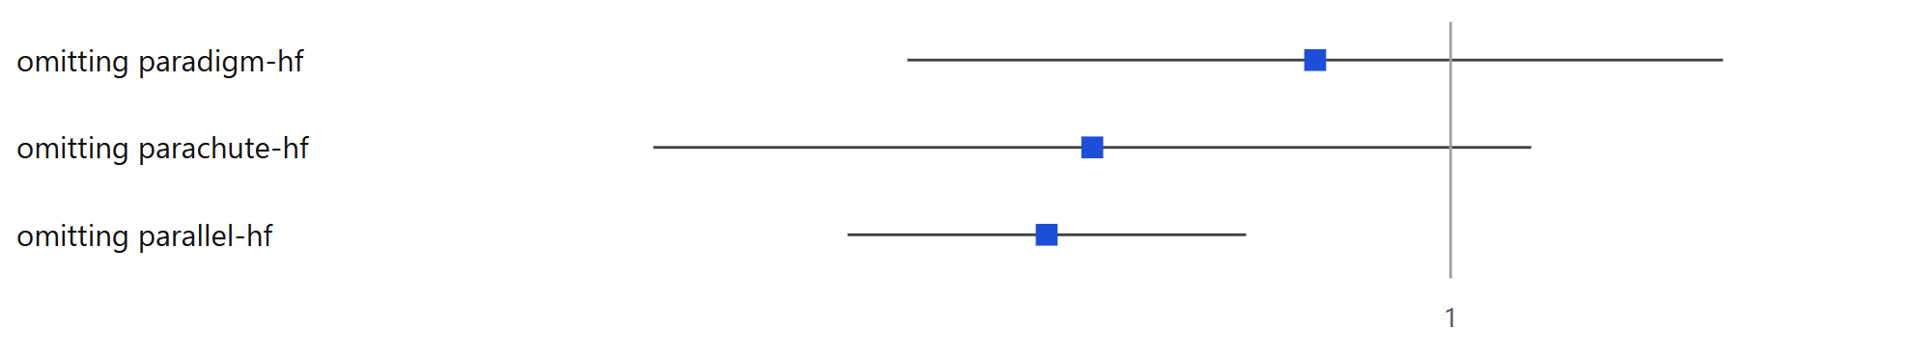
Figure 6. Leave-one-out
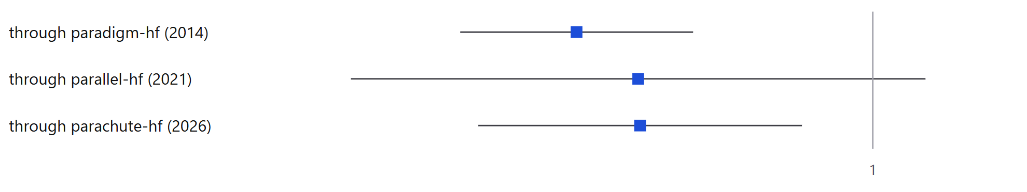
Figure 7. Cumulative meta-analysis
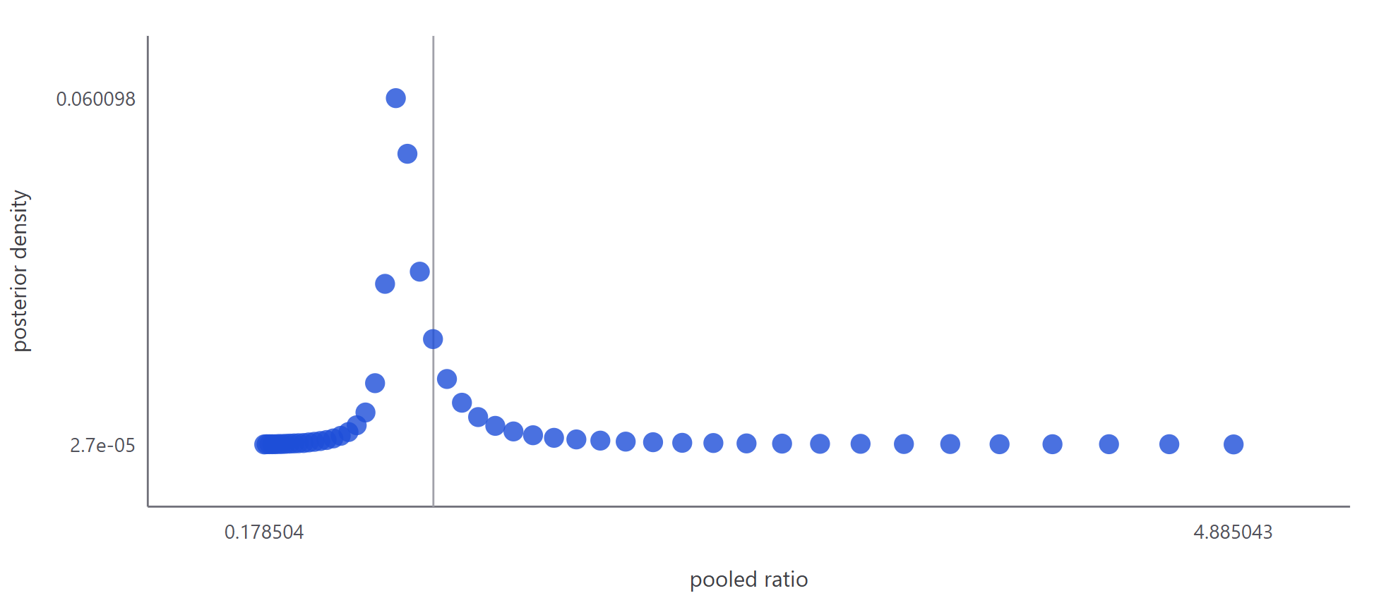
Figure 8. Bayesian posterior density
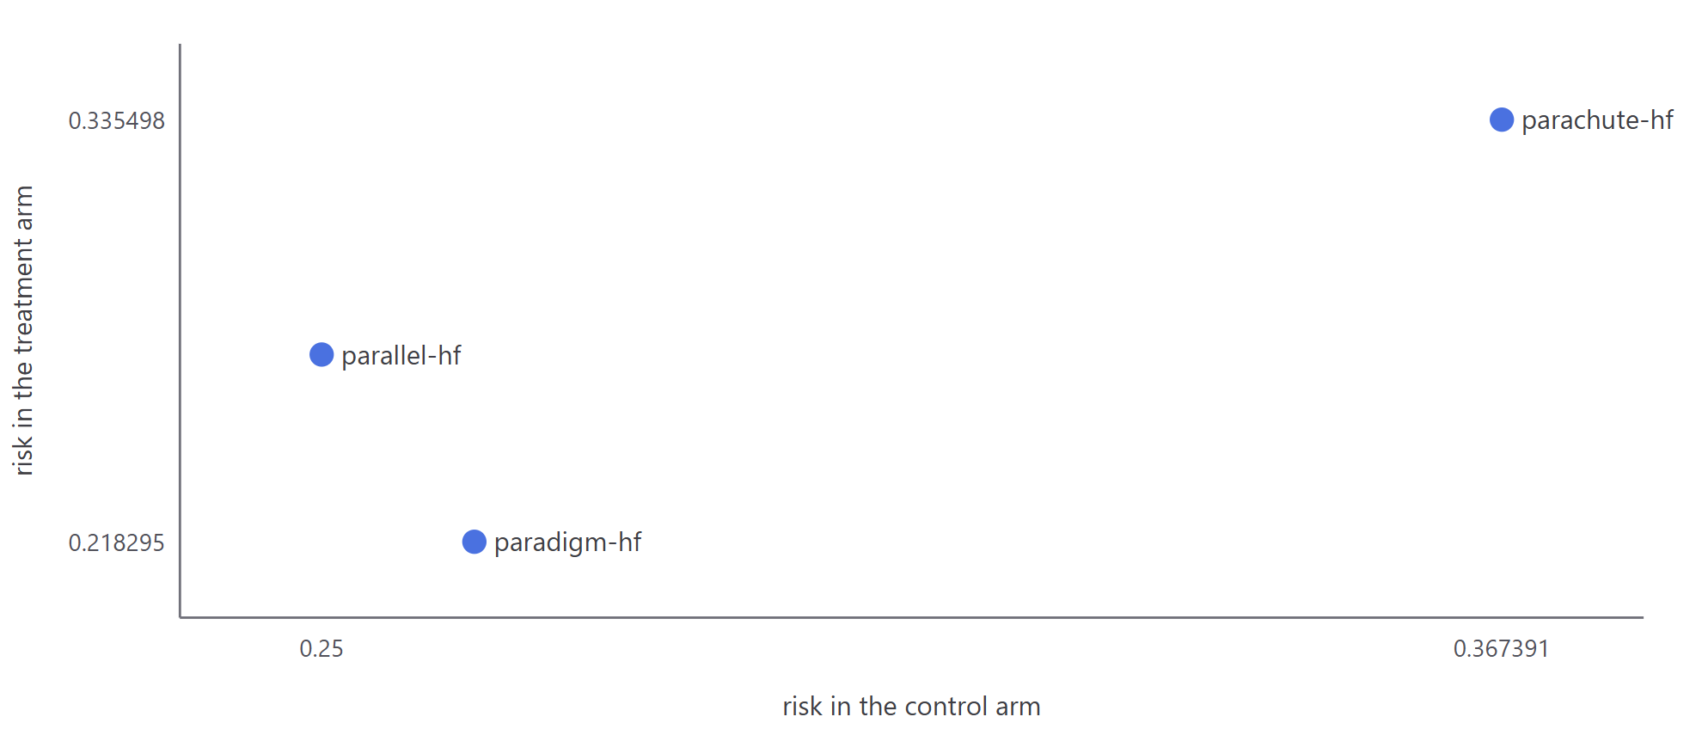
Figure 9. L'Abbe plot
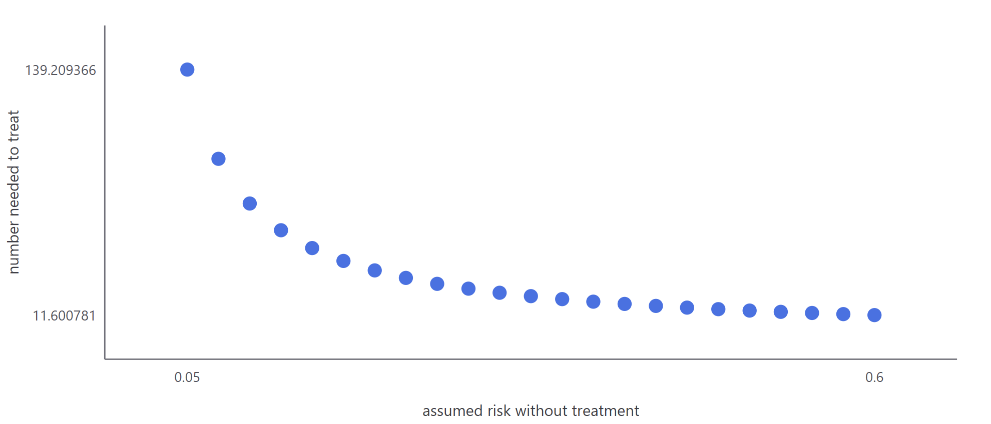
Figure 10. Number needed to treat, across baseline risk

Screening and exclusions
Table 6. Screening log: every record adjudicated, with its decision and the reason for it
Record | Registry / PMID | Decision | Reason
PARAGON-HF | NCT01920711 PMID 31475794 | excluded | Fails the frozen question on all three axes, and any one of them is sufficient. POPULATION: it enrolled an ejection fraction of 45% or higher, which is preserved rather than reduced. COMPARATOR: it randomised against VALSARTAN, not enalapril. MEASURE: its primary is the cumulative number of cardiovascular deaths and TOTAL, first and recurrent, heart failure hospitalizations, analysed as a RATE RAT
PARADISE-MI | NCT02924727 | excluded | POPULATION: acute myocardial infarction with left-ventricular dysfunction or pulmonary congestion, not chronic heart failure with reduced ejection fraction. COMPARATOR: RAMIPRIL, not enalapril. OUTCOME: its composite counts INCIDENT heart failure -- a first presentation in people who did not have heart failure at randomisation -- which is not hospitalization for heart failure in an established hea
PARAGLIDE-HF | NCT03988634 PMID 37212758 | excluded | POPULATION: ejection fraction above 40% after a worsening heart failure event. COMPARATOR: VALSARTAN. MEASURE: the primary is the time-averaged proportional change in NT-proBNP, a biomarker ratio-of-change, and its hierarchical secondary is a win ratio. Neither is a hazard ratio for a clinical event.
ANSWER-HF | NCT04853758 PMID 41396086 | excluded | This is the hardest exclusion in the table and the only one that passes the population and the comparator: 190 patients with heart failure with reduced ejection fraction due to Chagas cardiomyopathy, randomised double-blind against ENALAPRIL. It fails on the MEASURE. Its primary endpoint is the change in left-ventricular ejection fraction at six months, and its only composite analysis of cardiovas
PIONEER-HF | NCT02554890 | screened, not eligible | Right population and right comparator -- acute decompensated heart failure with reduced ejection fraction, randomised against enalapril -- and the wrong quantity over the wrong horizon. The brief noted a conflict between a rule excluding follow-up under twelve weeks and a rule keyed to the trial's own endpoint, and left both standing. It is resolved here against the frozen question and only one ru
EVALUATE-HF | NCT02874794 | screened, not eligible | Randomised against enalapril in heart failure with reduced ejection fraction, and its endpoint is a vascular-mechanics measurement. It reports no hazard ratio for the composite.
OUTSTEP-HF | NCT02900378 | screened, not eligible | Randomised against enalapril in heart failure with reduced ejection fraction. Its endpoint is an activity measure, not a clinical event, and it reports no hazard ratio for the composite.
PARALLAX | NCT03066804 | screened, not eligible | Fails the population as well as the measure: it enrolled an ejection fraction above 40%, and its comparator is individualised medical therapy rather than enalapril alone.
HFN-LIFE | NCT02816736 | screened, not eligible | Advanced, NYHA class IV heart failure, randomised against VALSARTAN rather than enalapril, with a biomarker endpoint. Recorded because the brief listed a trial called LIFE and this is the trial that name resolves to.
Pathadka 2020 | PMID 33553256 | screened, not eligible | This is the only excluded record in this object that reports THE QUANTITY THIS REVIEW POOLS, for THE COMPOSITE THIS REVIEW POOLS, and it is excluded anyway. It is not a randomised trial: it is a population-based new-user cohort drawn from the Hong Kong-wide electronic health record, 1056 people dispensed sacubitril/valsartan against 2181 dispensed enalapril, with treatment assigned by prescribers
Bano 2021 | PMID 34395116 | screened, not eligible | Right population and right comparator: a randomised comparison of sacubitril/valsartan with enalapril, in equal allocation, in heart failure at a tertiary hospital in Pakistan, 181 against 183, followed for twelve months or to an event. It fails on the measure. Its full text contains no hazard ratio, no Cox model and no time-to-event analysis of any kind; it reports proportions and relative risk r
Zhao 2022 | PMID 35874853 | screened, not eligible | A randomised comparison of sacubitril/valsartan with enalapril, 52 against 45, in pulmonary hypertension due to heart failure with reduced ejection fraction, followed for six months. Population and comparator hold; the measure does not. Its declared primary endpoint is echocardiographic right-ventricular function, and it reports no hazard ratio for any clinical event -- it states only that readmis
Li 2019 |  | screened, eligibility could not be established | Eligibility is undetermined, not decided. Neither inclusion nor exclusion is asserted here, and the trial is NOT pooled -- so this row records a limit of the search rather than a judgement about the trial. Its likely weight is small and is stated rather than used as a reason to stop looking: 126 randomised participants against the 8399 of the largest trial already pooled. If this trial does report

This log covers the records the review adjudicated. The object does not hold the full set retrieved by the search, nor the stage at which each decision was taken, so a title/abstract versus full-text split cannot be shown. That gap is stated here rather than implied by a shorter table.

Certainty of the evidence
Table 7. GRADE summary of findings
Domain | Rating | Basis
Risk of bias | serious | Three separate features, each read from a staged source rather than assumed. PARACHUTE-HF describes itself as an 'open-label, multicenter randomized clinical trial' with blinded endpoint adjudication; blinded adjudication protects how an event is classified but not the unblinded management decisions that produce a heart failure hospitalization, which is one of the two components. In the same trial
Inconsistency | not serious
Indirectness | not serious | All three trials enrol the population the question names, randomise the intervention the question names against the comparator the question names, and report the outcome the question names. The Chagas aetiology of one trial makes its population narrower than the others, not indirect: it is heart failure with reduced ejection fraction, entered on an ejection fraction of 40% or less and NYHA class I
Imprecision | serious
Publication bias | not assessable

Overall certainty: low. start high; risk_of_bias serious (-1), imprecision serious (-1); total -2 -> low

Discussion
This section is not written here, for the same reason as the introduction: interpretation is argument, and the object holds none. What the object does hold, and what a discussion would have to account for, is stated in the limitations below.

Limitations
- The pooled benefit rests on PARADIGM-HF, and the table is blunter than that summary sounds. Every leave-one-out fit still points below the null, so the DIRECTION is stable. The INTERVAL is not: only the fit that drops PARALLEL-HF keeps the null outside it. Dropping PARADIGM-HF or dropping PARACHUTE-HF both leave an interval that includes the null, so two of the three fits do. That is the single most important qualification on the headline, it is what the imprecision domain of the GRADE assessment is counting, and it is stated here rather than left for a reader to derive from the table.
- The one apparent gap this search had is now closed, and closing it removed a trial rather than adding one: the patient total of the paywalled Chagas reviews exceeded the trials found here by a post hoc PARADIGM-HF subgroup, which is not a separate randomisation and is not recovered. The reconciliation block sets out the arithmetic and the deduplication reason. What is still unread is how those reviews themselves treated that subgroup, which their abstracts do not say.
- The ordering test asks whether a protocol commit precedes the search, the screening decisions and the analysis. It cannot pass here: this object's EARLIEST commit is also its only one, and it already contains the finished analysis -- its own subject line says 'certified build'. The object's `built` date is 2026-08-09, which is BEFORE that commit, so the analysis demonstrably existed before the first registration evidence rather than after it. Nothing is being hidden by saying so: the commit is real and public, it just registers a completed review rather than a plan. A future review that commits its protocol first will pass this test, and the test is what makes the claim worth anything.
- Computed at BUILD time by metafor 5.0.1 under R 4.6.0 from the per-arm 2x2 counts stored on each trial, which were themselves READ from the sources named on each cell. No composite was reconstructed by addition and no count was derived from a percentage. These are SEPARATE ESTIMANDS from this review's primary pooled hazard ratio, which is unchanged at 0.8392 and is what the headline reports; a risk ratio, an odds ratio and a risk difference computed from first-event counts answer related but different questions and are shown as sensitivity, never as the primary result.

Conclusions
Awaiting the author. See Discussion.

Funding and conflicts of interest
The canonical object records neither a funding statement nor a conflict-of-interest declaration for this review.

References
1. FDA statistical review, NDA 207620 (Entresto), 2015.. https://www.accessdata.fda.gov/drugsatfda_docs/nda/2015/207620Orig1s000StatR.pdf
2. Entresto EPAR public assessment report, European Medicines Agency.. https://www.ema.europa.eu/en/documents/assessment-report/entresto-epar-public-assessment-report_en.pdf
3. Two 2026 systematic reviews of sacubitril/valsartan against enalapril in heart failure with reduced ejection fraction due to Chagas cardiomyopathy, both in Cardiology in Review: Daniyal SM et al (PMID 41923142) and AlSejari NY et al (PMID 41941460).. https://pubmed.ncbi.nlm.nih.gov/41923142/
4. Reyaz I et al. Comparison of outcomes between sacubitril/valsartan and enalapril in patients with heart failure: a systematic review and meta-analysis. Cureus 2023;15(11):e48623.. https://www.ncbi.nlm.nih.gov/pmc/articles/PMC10710849/
5. McMurray JJV et al. Angiotensin-neprilysin inhibition versus enalapril in heart failure. N Engl J Med 2014.. https://pubmed.ncbi.nlm.nih.gov/25176015/
6. Lopes RD et al. Sacubitril/valsartan vs enalapril in heart failure due to Chagas disease: an open-label, multicenter randomized clinical trial. JAMA 2026;335(1):49-59.. https://pubmed.ncbi.nlm.nih.gov/41335448/
7. Tsutsui H et al. Efficacy and safety of sacubitril/valsartan in Japanese patients with chronic heart failure and reduced ejection fraction -- results from the PARALLEL-HF study. Circ J 2021;85(5):584-594.. https://pubmed.ncbi.nlm.nih.gov/33731544/
8. Madrini V et al. Sacubitril-valsartan vs enalapril in heart failure due to Chagas disease: primary results of the ANSWER-HF randomized trial. J Am Coll Cardiol 2025;87(10):1220-1232.. https://pubmed.ncbi.nlm.nih.gov/41396086/
9. Pathadka S, Yan VKC, Li X, et al. Hospitalization and mortality in patients with heart failure treated with sacubitril/valsartan vs. enalapril: a real-world, population-based study. Front Cardiovasc Med 2020;7:602363.. https://pubmed.ncbi.nlm.nih.gov/33553256/
10. Bano S, Bai P, Kumar S, et al. Comparison of sacubitril/valsartan versus enalapril in the management of heart failure. Cureus 2021;13(7):e16332.. https://pubmed.ncbi.nlm.nih.gov/34395116/
11. Zhao Y, Tian LG, Zhang LX, et al. The comparative effects of sacubitril/valsartan versus enalapril on pulmonary hypertension due to heart failure with a reduced ejection fraction. Pulm Circ 2022;12(3).. https://pubmed.ncbi.nlm.nih.gov/35874853/
12. ClinicalTrials.gov records for every trial this object names: posted results for the three contributing trials, and the full record for each excluded and each screened trial, staged one file per registration.. https://clinicaltrials.gov/study/NCT01035255

