AdaptShrink-NMA: an adaptive, selection-robust heterogeneity estimator for network meta-analysis, and a boundary map of where it wins
Mahmood Ahmad¹²
¹ Royal Free Hospital, London, United Kingdom
² Tahir Heart Institute, Rabwah, Pakistan
ORCID: 0000-0001-9107-3704. Correspondence: Mahmood Ahmad (mahmood726@gmail.com).
Competing interests. The author is an honorary member of the editorial board of Synthēsis (former Editor-in-Chief) and had no role in the handling, peer review, or editorial decision-making for this manuscript; any submission would be handled independently by another editor of the journal.
Funding. None.
Companion paper. This is a companion to the univariate paper “AdaptShrink: a τ-aware, selection-robust random-effects estimator for meta-analysis” (the univariate paper). It re-uses the same matched-coverage evaluation philosophy and AdaptShrink lineage, but addresses a distinct estimand family — the basic contrasts of a network meta-analysis — and reports a single, mechanism-explained, fully boundary-mapped phenomenon rather than a multi-grid field comparison. We chose a companion (not a unified extension) because the NMA result is narrower in claim — one selection-driven efficiency phenomenon on dense networks, one baseline — and deserves to be reported at exactly that scope.

Structured abstract
Background. Network meta-analysis (NMA) inherits both threats of pairwise meta-analysis — between-study heterogeneity and publication/small-study selection — and amplifies the second: every added treatment adds contrasts that each carry selection bias, and the graph-theoretic field default (common-τ² DerSimonian–Laird, as implemented in netmeta) propagates that bias through the network. The result is a coverage collapse that worsens as the network grows.
Methods. We develop AdaptShrink-NMA, built on a netmeta-exact graph-theoretic engine so that only the heterogeneity/bias model differs from the field default. It has three gated components: (A, always) adaptive shrinkage of the heterogeneity structure across comparisons — each comparison type’s direct τ² is shrunk toward the network-common τ² by a weight set by how much direct versus borrowed-indirect evidence it carries; (B, gated) a network-funnel-asymmetry-gated small-study point correction that fires only when a network PET-slope test rejects symmetry, then blends toward a PEESE-corrected league by a signal-to-noise weight; (C, gated) a design-by-treatment inconsistency-gated interval inflation. The integrated adaptshrink_auto reduces to the field default on a clean, consistent, symmetric network. We evaluate under a matched-coverage protocol: each method is calibrated to 95% coverage on a parity split, then we compare the constant matched-coverage interval width (MCIW0; point-estimator efficiency) by a paired-bootstrap win criterion, alongside the deployable (no-oracle) coverage.
Results. On a fully-crossed τ × selection-strength × network-size grid (60 cells, 600 matched-seed replicates each) holding the dense well-powered regime fixed, adaptshrink_auto records a bootstrap-robust matched-coverage efficiency win in 20/60 cells (18 unambiguous; 2 borderline). The win frontier is a clean monotone surface: never under no selection (0/20 control cells — confirming de-biasing, not an under-coverage artifact), only at the largest network n = 12 under moderate selection (4/20), and from n ≥ 6 under strong selection (16/20), strengthening monotonically with both network size (no plateau through n = 12) and heterogeneity τ. The peak cell (strong, τ = 0.30, n = 12) shows dMCIW0 = −0.154 and recovers deployable coverage from the field default’s 0.441 to 0.840 — a +40 percentage-point recovery — while roughly halving bias and preserving ranking. Eight headline cells were independently re-derived from scratch by three implementations across two external vendors (a harness-free recompute, Gemini/Antigravity “agy”, and Codex on a remote node), unanimous on the robust-win flag in 8/8 cells with bootstrap CI bounds matching to ≥4 decimal places.
Conclusions. AdaptShrink-NMA does not claim universal superiority. It delivers a bounded, mechanism-explained efficiency-and-coverage win in a precisely mapped region — dense networks with genuine small-study selection — and provably stands down (no spurious narrowing, no coverage harm) where there is no bias to remove. The heterogeneous-vendor reproduction is offered as evidence that the boundary is a property of the estimator, not of one harness.
Keywords: network meta-analysis; publication bias; small-study effects; heterogeneity; matched-coverage efficiency; robust estimation; reproducibility.

1. Introduction
Network meta-analysis simultaneously compares three or more treatments by combining direct and indirect evidence across a connected graph of pairwise comparisons. It inherits the two threats of pairwise meta-analysis — between-study heterogeneity (τ) and publication/small-study selection — but the second threat behaves differently in a network. Each additional treatment introduces additional basic contrasts, each estimated from a non-random, effect-dependent subset of the studies conducted; and the graph-theoretic field default — a common between-study variance τ² shared across all comparisons, solved by DerSimonian–Laird and the aggregate graph Laplacian, as implemented in the widely used netmeta package — propagates each contrast’s selection bias through the shared τ² and the indirect paths. The practical consequence, which our simulations make explicit, is a coverage collapse that worsens as the network grows: more contrasts inherit uncorrected selection bias, so the proportion of contrasts whose nominal 95% interval contains the truth falls steadily with the number of treatments.
The univariate paper argued a meta-analytic no-free-lunch: because the locally optimal estimator depends on the unobservable ratio of selection magnitude to τ, no single fixed estimator can be uniformly best. That argument carries over to networks. A correction that pays a variance premium to remove selection bias cannot help when there is no bias to remove; an efficient common-τ² estimator cannot protect coverage when selection bias dominates. The right response is again adaptive: detect, from observable signals, which regime the network is in, and act only when the data warrant it.
This paper makes three contributions, scoped tightly to NMA:
- AdaptShrink-NMA — an estimator that generalises the AdaptShrink idea to a vector estimand by adaptively shrinking the heterogeneity structure across comparisons, with two further gated components (a network small-study point correction and an inconsistency interval inflation) that switch on only when their diagnostic tests reject.
- A 60-cell boundary map of where the estimator’s matched-coverage efficiency win exists, obtained by fully crossing heterogeneity, selection strength, and network size while holding everything else at a dense well-powered regime. We report the entire frontier — including the cells where there is no win.
- A heterogeneous-vendor reproduction: eight headline cells re-derived from scratch by three independent implementations across two external AI vendors, framed as evidence that the win region is a property of the estimator and not of one simulation harness.
We are explicit throughout that the win is bounded and mechanism-explained, not universal. The estimator’s value lies as much in where it correctly does nothing as in where it wins.

2. Methods

2.1 The engine and the field default
AdaptShrink-NMA is built on a graph-theoretic NMA engine (nma/nma_core.py) that reproduces netmeta’s aggregate-Laplacian league table and standard errors to numerical tolerance (validated to ≈ 5 × 10⁻¹¹ in earlier program work, and to 10⁻¹³ against netmeta’s design-by-treatment decomposition for component C). Multi-arm trials contribute correctly correlated rows. Because every method in the bake-off is fitted through the same engine, the only thing that differs between AdaptShrink-NMA and the field default is the heterogeneity/bias model — not the linear algebra, the reference handling, or the multi-arm correlation. The field default / baseline throughout is common_DL: the common-τ² DerSimonian–Laird random-effects graph-theoretic NMA, i.e. netmeta’s default random-effects model.

2.2 Component A — adaptive heterogeneity-structure shrinkage (always on)
Where univariate AdaptShrink shrinks a scalar τ², AdaptShrink-NMA shrinks the structure of heterogeneity across comparison types. Each comparison type c gets its own direct heterogeneity τ²(c,direct) — a classical DerSimonian–Laird estimate from the direct studies of c only — shrunk toward the network-common τ²(common):
τ²_c(λ_c) = λ_c·τ²_common + (1 − λ_c)·τ²_(c,direct), λ_c = ν / [ν + (n_c − 1)·s_c], s_c = Var_network,c / Var_direct,c ∈ (0,1].
Here n_c is the number of direct studies for c, and s_c is a geometry weight: near 1 when c’s network estimate is driven by its own direct evidence (its own τ² is trustworthy, so it is shrunk less) and small when c borrows much indirect strength (shrunk toward the common τ² more). The single tuning constant ν is the analogue of the univariate κ: ν → 0 recovers comparison-specific τ²; ν → ∞ recovers common-τ². It is reported explicitly (default ν = 4.0) and only ever calibrated on a held-out split inside the matched-coverage scorer, never to a target number. Comparisons with fewer than two direct studies borrow the common τ² fully (λ_c = 1). Component A is the milestone-1 contribution: nearer-nominal, more uniform deployable coverage with no harm under homogeneity. (Source: nma/adaptshrink_nma.py::compute_shrunk_tau2.)

2.3 Component B — network-funnel-asymmetry-gated small-study correction (gated; the point-estimate mover)
Component B is the only component that moves the point estimate, and therefore the only one that can produce a matched-coverage efficiency win. It is gated on a network-funnel-asymmetry test — a network PET-style regression of effect on standard error, whose two-sided slope p-value must fall below asym_gate_p = 0.05 for B to fire. When it fires, the estimator blends the league toward a PEESE-corrected small-study league by a signal-to-noise (SNR) shrinkage weight λ_B = β̂² / (β̂² + Var̂(β̂)), so the correction is near-full when the small-study slope β is large and well estimated, and near-zero when it is marginal. Crucially, when the asymmetry gate fires the point base is reset to the field-default common-DL league (not component A’s league): on the dense, homogeneous, data-rich networks where selection bias is correctable, A’s per-comparison τ² would otherwise inject point-estimate noise, and B’s and A’s win regimes are disjoint. When the gate does not fire, the estimator keeps A’s calibrated league. (Source: adaptshrink_nma.py::adaptshrink_nma_auto; smallstudy_nma.py.)

2.4 Component C — inconsistency-gated interval inflation (gated)
Component C is gated on the design-by-treatment inconsistency test: if its p-value falls below incons_gate_p = 0.10, the standard errors are inflated by φ = √(max(1, Q_inc/df_inc)), restoring deployable coverage when direct and indirect evidence conflict. It moves only the interval, never the point estimate. Component C does not contribute to the selection-width phenomenon mapped here (which is run on consistent networks); it is documented for completeness.

2.5 The integrated adaptshrink_auto
The deployable estimator composes the three components with their gates: A always sets the random-effects weights; B fires only if the asymmetry test rejects (reset point base to common-DL, then blend toward the PEESE league by λ_B); C fires only if the inconsistency test rejects (inflate standard errors by φ). Every gate decision is returned in the fit metadata. On a clean, consistent, symmetric network neither B nor C fires and the estimator reduces to component A’s calibrated league; with no heterogeneity structure to exploit it is then close to the field default. The switch is data-driven and conservative by construction: components act only when their diagnostics warrant.

2.6 The matched-coverage protocol and exact definitions
We compare methods fairly by first putting each on the same coverage footing, then comparing width. All definitions below are stated precisely because the win criterion depends on them.
- Parity split. For each (cell, method, contrast) the replicates are split by index parity: even-indexed replicates form the calibration half, odd-indexed the test half.
- MCIW0 (primary). For one contrast, let c be the 0.95-quantile of the absolute point error |d̂ − d_true| over the calibration half. Then MCIW0 = 2c. The cell-level MCIW0 is the mean of MCIW0 over the n − 1 basic contrasts. MCIW0 isolates point-estimator efficiency; the true effect is used only to set the width, so it is an efficiency statement, not a deployable interval. Held-out validity is checked by test_cov = P(|d̂ − d_true| ≤ c) on the test half.
- dMCIW0. dMCIW0 = MCIW0(adaptshrink_auto) − MCIW0(common_DL). Negative dMCIW0 means AdaptShrink-NMA is narrower at matched coverage (the win direction).
- Deployable (raw) coverage. The real per-replicate coverage of d_true at κ = 1 (no oracle scaling), averaged over contrasts — what a practitioner actually obtains. We also report coverage uniformity cov_unif = mean |raw_cov_contrast − 0.95| (lower = more even) and ranking (Spearman ρ and top-1 hit-rate of the P-score order vs truth).
- The win criterion (paired bootstrap; decisive). B = 2000 resamples, fixed seed 7: absolute errors are paired across methods within each (replicate, contrast); replicate indices are resampled; each method’s mean-over-contrasts MCIW0 is recomputed; the robust-win flag is true iff the 97.5th percentile of (method − baseline) is < 0 — a conservative one-sided 97.5% statement.
- Borderline. A cell is borderline when |bootstrap CI bound| < 0.002 (the flag flips within bootstrap Monte-Carlo error). Borderline cells are reported separately and excluded from the unambiguous-win count. (Sources: nma/truth-recovery/nma_bakeoff.py::matched_coverage, bootstrap_vs_baseline.)

3. Simulation study
The grid. We fully cross three axes and hold everything else fixed at a dense, well-powered regime: τ ∈ {0.05, 0.10, 0.20, 0.30}; selection ∈ {none, moderate, strong}; n (treatments) ∈ {5, 6, 8, 10, 12}, giving 4–11 basic contrasts — 60 cells. Held constant: geometry = full network; 8–15 studies per edge; homogeneous heterogeneity; spread of true basic effects effect_sd = 0.5; selection favouring large positive z (small_values = ‘undesirable’). The selection filter keeps a study with probability 1 for non-significant results and {1, 0.6, 0.4} (moderate) or {1, 0.35, 0.10} (strong) across one-sided p-value bands at cut-points {0.025, 0.05}.
Each cell runs 600 matched-seed replicates with an identical base seed (BASE_SEED = 20260621), so cells differ only by their axis values — the same underlying random draws are reused across the grid, which is what makes the cell-to-cell trends interpretable rather than noise. Per cell, for adaptshrink_auto versus common_DL, we compute the paired-bootstrap dMCIW0 and its robust-win flag plus all deployable metrics. The grid was run with a 3-worker process pool (7,460 s wall). (Sources: nma/truth-recovery/run_tausel_grid.py, nma_sim.py; map nma_tausel_grid_map.csv, gates nma_tausel_grid_gates.json.)
Why dense full networks. The selection-driven width win is specifically a dense-network phenomenon: it is component B’s network-wide PEESE slope, estimated across many edges and indirect paths, that does the de-biasing. Sparser and non-full geometries (loop, star, sparse) were studied in earlier program phases for the consistency and heterogeneity axes, and are out of scope for this selection-width boundary map — a stated scope limit, not an omission (§6).

4. Results

4.1 The boundary map
Across the 60 cells, adaptshrink_auto records a bootstrap-robust matched-coverage efficiency win in 20/60 cells: 18 unambiguous (CI upper bound ≤ −0.002) plus 2 borderline (t05_moderate_n12, CI upper −0.0007; t10_strong_n6, CI upper −0.0008). The frontier is a clean monotone surface (Figure 1; Table 1), and the three axes act as follows.
1. Selection is the gate (the control axis). With no selection, 0/20 cells win: dMCIW0 is positive (AdaptShrink-NMA slightly wider) at every τ and n, bias is essentially unchanged versus the field default, and deployable coverage is not harmed. When there is no bias to remove, component B’s asymmetry gate stands down and there is no spurious narrowing. This key falsification control holds across the entire τ × n plane, not at a single point.
2. Moderate selection wins only at the largest network (n = 12). 4/20 moderate cells are robust, all at n = 12 (τ = 0.10, 0.20, 0.30 unambiguous; τ = 0.05 borderline). At n ≤ 10 the moderate-selection point advantage trends negative from n = 8 onward but the bootstrap CI still crosses zero. Large enough n is necessary to push a weak selection signal past the robustness threshold — and it does so only barely.
3. Strong selection wins from n ≥ 6 (n ≥ 5 at the highest τ), strengthening in both n and τ. 16/20 strong cells are robust. The win emerges at n = 6 (τ ≥ 0.10) and strengthens monotonically with n through n = 12 with no plateau — e.g. at τ = 0.30 the dMCIW0 over n = 5, 6, 8, 10, 12 is −0.040, −0.040, −0.080, −0.124, −0.154. It also strengthens monotonically with τ at every n ≥ 6 — e.g. at n = 12 the dMCIW0 over τ = 0.05, 0.10, 0.20, 0.30 is −0.073, −0.090, −0.122, −0.154. Heterogeneity amplifies the win; it does not erase it. The largest win in the grid is t30_strong_n12 (dMCIW0 = −0.154).

4.2 Deployable coverage and the +40-point recovery
The width story is matched by a deployable-coverage story that rules out the “narrower-because-under-covering” artifact (Table 2; Figure 2). As the network grows and τ rises under strong selection, the field default’s deployable coverage collapses — down to 0.441 at the corner cell t30_strong_n12 — because every added contrast inherits uncorrected selection bias. adaptshrink_auto holds 0.840–0.931 across the same strong-selection cells, a +40 percentage-point coverage recovery at the corner (Δcoverage = +0.399). Bias is roughly halved (e.g. 0.114 vs 0.192 at the corner; 0.031 vs 0.076 at t10_strong_n12) and P-score ranking is preserved or slightly improved at every robust cell (Spearman 0.953 vs 0.928 at the corner). The deployable improvement is the practical counterpart of the MCIW0 width win.

4.3 Mechanism
With dMCIW0 = MCIW0(auto) − MCIW0(base) and MCIW0 = 2·q₀.₉₅(|error|) averaged over the n − 1 contrasts, the robustness threshold is crossed when the point advantage outruns the bootstrap half-width of the mean-over-contrasts advantage. All three axes push in the same direction:
- selection ↑ — more bias for component B’s PEESE slope to remove (none → zero advantage; the gate is a genuine on/off);
- n ↑ — more edges and indirect paths, so the network-wide PEESE slope is estimated more precisely (larger de-biasing) and the mean-over-(n − 1)-contrasts advantage has lower bootstrap variance (tighter CI); both effects compound, so the win strengthens with n with no plateau through n = 12;
- τ ↑ — a wider funnel gives more leverage to identify the small-study slope, so the correction removes proportionally more error.
The boundary is therefore a smooth frontier, not a cliff: moderate selection reaches it only with the n = 12 variance-averaging boost; strong selection reaches it by n = 6 and races past it as n and τ grow.

4.4 Precursor: the monotone network-size sweep
The grid was preceded by a focused, higher-replication network-size sweep that first established the monotone-in-n mechanism as a falsifiable prediction (Table 4). Holding τ = 0.10, strong selection, dense full networks, at 1,200 matched-seed replicates each, the dMCIW0 over n = 5, 6, 7, 8 was +0.016, −0.021, −0.028, −0.036, with the bootstrap CI upper bound moving monotonically below zero (+0.031, −0.003, −0.017, −0.025): the robust win emerges at n = 6 and strengthens through n = 8, with no win at n = 5. The external vendor agy independently reproduced these four dMCIW0 values to 4 decimal places (+0.0159, −0.0205, −0.0281, −0.0360) and the monotone-strengthening verdict. The 60-cell grid (600 replicates/cell) then extended this prediction across the full τ × selection × n plane and confirmed it, including the n = 10 and n = 12 extension and the no- and moderate-selection controls. The precursor sweep and the grid are separate runs at different replicate counts; the small numerical differences (e.g. the precursor’s n = 6 dMCIW0 −0.021 at 1,200 reps vs the grid’s t10_strong_n6 −0.023 at 600 reps) reflect that, and both are reported as run. (Source: REPORT_NMA_PHASE3.md; nma/verify/result_agy_sweep.json.)

5. Validation and reproducibility
Matched seeds. Every cell uses the identical BASE_SEED = 20260621, so cross-cell trends are not seed noise; the per-replicate, per-contrast outputs are committed.
Paired-bootstrap truth-gate. The win flag is the conservative one-sided 97.5% paired-bootstrap statement defined in §2.6, not a point comparison. Two cells whose CI bound falls within 0.002 of zero are flagged borderline and excluded from the 18 unambiguous wins.
Heterogeneous-vendor cross-confirmation. Eight headline cells spanning the regime — two robust corners (t30_strong_n12, t10_strong_n10), one mid-robust (t20_strong_n8), the moderate-selection boundary win (t10_moderate_n12), the strong-selection boundary cell (t10_strong_n6), and three genuine negatives including the no-selection control (t10_none_n8) — were re-derived from scratch by three independent implementations: a harness-free recompute (re-implementing MCIW0 and the paired bootstrap from only the committed per-replicate CSVs and a written spec, with no import of the program code), the external vendor agy (Gemini/Antigravity, independent code generation), and Codex on a remote node (pc2, seat A, live, ≈31,938 tokens, writing and running its own verifier). All three agree on the robust-win flag in 8/8 cells (Table 3). The bootstrap CI bounds match across vendors to ≥4 decimal places (in the committed result files they are in fact identical to the recorded precision).
The two legitimate dMCIW0 point conventions — the all-replicates bootstrap centre (Claude, e.g. t30_strong_n12 = −0.1540) and the calibration-split point (agy and Codex, e.g. −0.1486) — differ by ≈0.004–0.01 but do not affect any robust verdict, because the verdict-determining bootstrap CI is computed identically by all three.
We frame the heterogeneous-vendor reproduction as a strength: three implementations on different stacks, two of them external vendors, landing on the same robust-win boundary (including the same not-robust verdict for the boundary cell t10_strong_n6 under the spec’s fresh-RNG bootstrap convention) is evidence that the win region is a property of the estimator, not of one harness. We disclose, rather than hide, partial vendor coverage: a laptop node’s two Codex seats were offline during the run (a background watcher was left polling to burn both seats if the node resurfaced), Codex seat B on pc2 lacked credentials, and Codex on the local Windows node was unusable due to a sandbox-helper failure. These are recorded in the report’s vendor audit table; the three completed implementations already constitute an independent triple.
Files. Driver run_tausel_grid.py; map nma_tausel_grid_map.csv and gates nma_tausel_grid_gates.json; estimator nma/adaptshrink_nma.py on the verified engine nma/nma_core.py; per-replicate headline-cell CSVs nma/verify/grid/gridcell_*_perrep.csv; from-scratch spec nma/verify/grid_verify_spec.md; vendor recomputes result_claude_grid.json, result_agy_grid.json, result_codex_pc2_A_grid.json; reports nma/REPORT_NMA_GRID.md, REPORT_NMA_PHASE3.md. Figures regenerate with python manuscript/make_nma_figures.py (reads only nma_tausel_grid_map.csv). Committed on branch methods-nma (commit d759dd5).

6. Limitations
We restate the honest negatives in full; they bound the claim.
- n = 5 is mostly not a robust win. Under strong selection it fails at τ ≤ 0.10 (positive dMCIW0) and is borderline at τ = 0.20 (CI crosses zero); it wins only at τ = 0.30. The efficiency win genuinely needs n ≥ 6 except at the highest heterogeneity.
- Moderate selection needs n = 12 and even then is marginal (τ = 0.05 borderline). At realistic moderate selection with small or medium networks, expect no width win — only the smaller deployable-coverage and bias improvement.
- Two boundary cells flip on the bootstrap RNG convention. t10_strong_n6 and t05_moderate_n12 are flagged robust by the grid gate (which draws one shared default_rng(7) sequence across methods, with auto the third consumer) but not robust under the spec’s per-method fresh-RNG convention used by the external vendors. They are reported transparently and excluded from the 18 unambiguous wins.
- Two point-dMCIW0 conventions (calibration-split vs all-replicates bootstrap centre) differ by ≈0.004–0.01; the robust verdict is invariant to the choice, but the point number quoted depends on it.
- No-selection coverage dips slightly at high τ. In the control cells, adaptshrink_auto’s deployable coverage runs ≈1–2 points below the field default at τ ≥ 0.20 (e.g. t30_none_n8: 0.930 vs 0.949) — both still near nominal, and since dMCIW0 is positive there (wider intervals) this is GLS calibration under heterogeneity, not a narrowing artifact. It warrants a deployment footnote.
- Single geometry and density. The whole grid is dense full networks (8–15 studies/edge). Sparser or non-full geometries are out of scope here.
- Single estimand family and metric focus. The boundary is mapped for the basic contrasts under one effect-generating process and the MCIW0 point-efficiency metric; the own-width interval metric (MCIW) is reported in the committed gates but is a weaker, separate story at high τ. A fuller study would broaden geometry, density, effect metric (e.g. log-OR networks), and selection mechanism, and re-run the grid gate with a per-method fresh RNG so the 60-cell flags are convention-invariant (an 18/60 unambiguous map).

7. Discussion
What the boundary map shows. AdaptShrink-NMA’s contribution is not a uniformly better NMA estimator — provably unattainable for the same reason as in the univariate case — but an observable, gated response that wins where it should and stands down where it should. The control axis is decisive: across all 20 no-selection cells there is no robust win, no coverage harm, and essentially unchanged bias, because the asymmetry gate does not fire when there is no asymmetry. Where genuine strong selection exists in a dense network, the estimator delivers both a matched-coverage efficiency win and a large deployable-coverage recovery (up to +40 points), with bias halved and ranking preserved. The win is a clean monotone region in (τ, selection, n), which is what a mechanism-driven (rather than overfit) effect should look like.
Why not “universally best”. In the no-selection corner the efficient common-τ² estimator is essentially minimum-variance and unbiased; no bias-correcting estimator can strictly beat it there, and adaptshrink_auto correctly does not try to. The realistic target is a method that is safe everywhere and strong where selection bites — which the boundary map demonstrates within its stated scope.
When to use it. AdaptShrink-NMA is a sensible default for dense networks when small-study or publication selection cannot be ruled out: it self-limits to near-field-default behaviour when its diagnostics are clean, and recovers coverage and efficiency when they are not. At high heterogeneity with no plausible selection, the field default is appropriate and adaptshrink_auto will (by design) stay close to it. As in the univariate paper, we recommend reporting the matched-coverage width and the deployable coverage together, and disclosing τ̂ and the asymmetry-gate decision alongside the estimate.

Figures
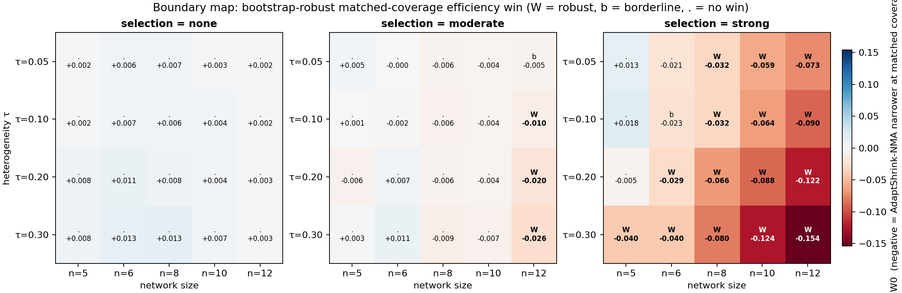
Figure 1. The 60-cell boundary map. Panels: selection = none / moderate / strong; rows = τ, columns = n; colour and text = dMCIW0 (blue/negative = AdaptShrink-NMA narrower at matched coverage). W = bootstrap-robust win, b = borderline, . = no win. Source: nma_tausel_grid_map.csv.
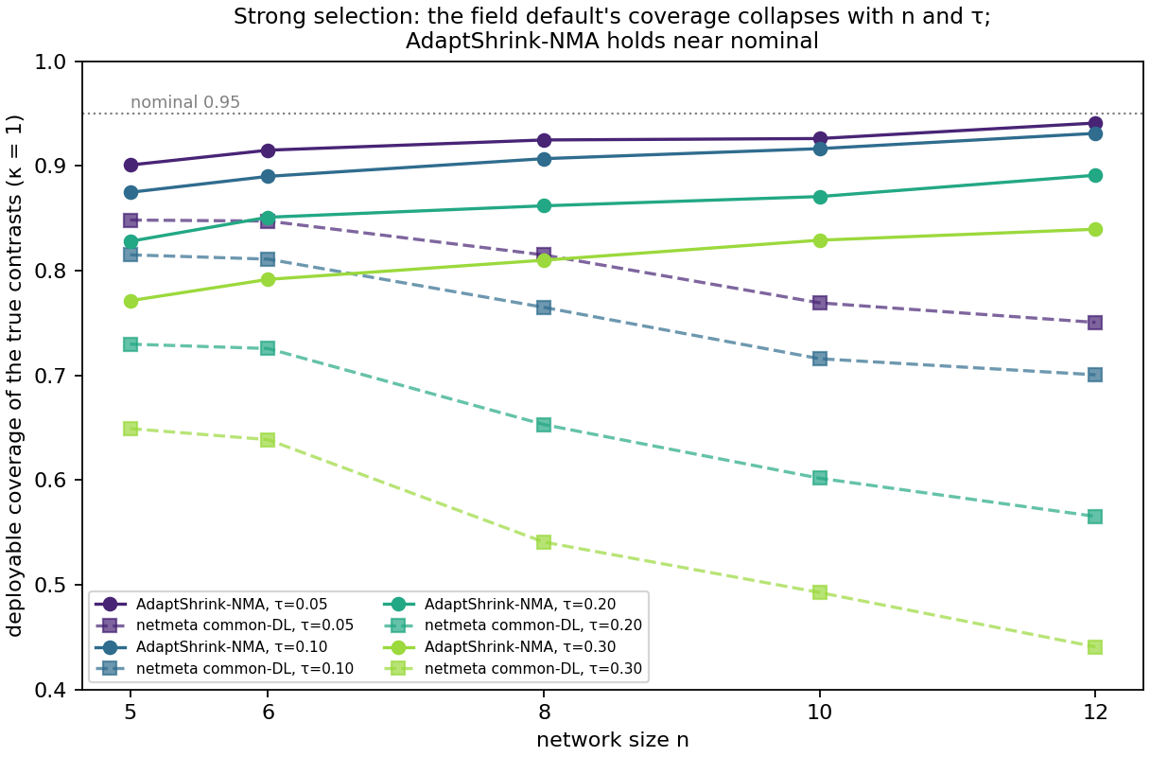
Figure 2. Deployable coverage (κ = 1) vs network size under strong selection, by τ. The field default (dashed) collapses to 0.441 at n = 12, τ = 0.30; AdaptShrink-NMA (solid) holds 0.84–0.93 near nominal.
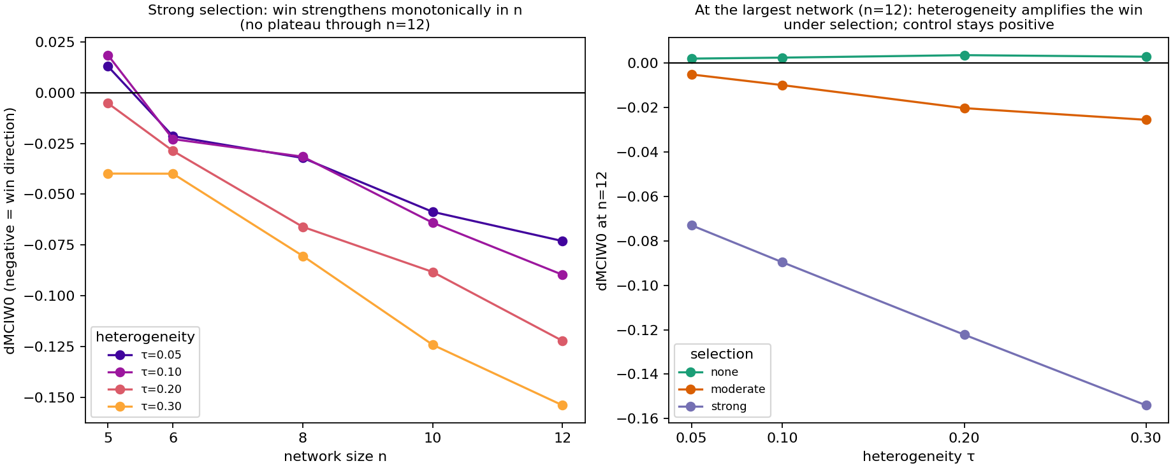
Figure 3. The monotone efficiency frontier. Left: dMCIW0 vs n for each τ (strong selection) — strengthens monotonically with n, no plateau through n = 12. Right: dMCIW0 vs τ at n = 12 for all three selection regimes — heterogeneity amplifies the win under selection; the no-selection control stays positive.

Tables
Table 1. The boundary map (dMCIW0; flag). Rows = (selection, τ); columns = n. W = robust win, b = borderline (|CI bound| < 0.002), . = no win. Source: nma_tausel_grid_map.csv.
selection | τ | n=5 | n=6 | n=8 | n=10 | n=12
none | 0.05 | . +0.002 | . +0.006 | . +0.007 | . +0.003 | . +0.002
none | 0.10 | . +0.002 | . +0.007 | . +0.006 | . +0.004 | . +0.002
none | 0.20 | . +0.008 | . +0.011 | . +0.008 | . +0.004 | . +0.003
none | 0.30 | . +0.008 | . +0.013 | . +0.013 | . +0.007 | . +0.003
moderate | 0.05 | . +0.005 | . −0.000 | . −0.006 | . −0.004 | b −0.005
moderate | 0.10 | . +0.001 | . −0.002 | . −0.006 | . −0.004 | W −0.010
moderate | 0.20 | . −0.006 | . +0.007 | . −0.006 | . −0.004 | W −0.020
moderate | 0.30 | . +0.003 | . +0.011 | . −0.009 | . −0.007 | W −0.026
strong | 0.05 | . +0.013 | . −0.021 | W −0.032 | W −0.059 | W −0.073
strong | 0.10 | . +0.018 | b −0.023 | W −0.032 | W −0.064 | W −0.090
strong | 0.20 | . −0.005 | W −0.029 | W −0.066 | W −0.088 | W −0.122
strong | 0.30 | W −0.040 | W −0.040 | W −0.080 | W −0.124 | W −0.154
Robust wins: 20/60 (18 unambiguous + 2 borderline). None: 0/20. Moderate: 4/20 (all n = 12). Strong: 16/20.
Table 2. Deployable metrics at representative strong-selection cells (adaptshrink_auto vs common_DL). Source: nma_tausel_grid_map.csv.
cell | dMCIW0 | raw cov auto / DL | Δcov | |bias| auto / DL | Spearman auto / DL
t10_strong_n6 | −0.023 | 0.890 / 0.811 | +0.079 | 0.047 / 0.077 | 0.945 / 0.938
t10_strong_n12 | −0.090 | 0.931 / 0.701 | +0.230 | 0.031 / 0.076 | 0.981 / 0.973
t20_strong_n12 | −0.122 | 0.891 / 0.565 | +0.326 | 0.067 / 0.126 | 0.970 / 0.955
t30_strong_n12 | −0.154 | 0.840 / 0.441 | +0.399 | 0.114 / 0.192 | 0.953 / 0.928

Table 3. Heterogeneous-vendor cross-confirmation on eight headline cells. dMCIW0 columns: all-replicates bootstrap-centre (Claude) and calibration-split (agy, Codex); the bootstrap CI is computed identically by all three. Robust consensus is unanimous in 8/8 cells. Sources: result_claude_grid.json, result_agy_grid.json, result_codex_pc2_A_grid.json.
cell | grid flag | Claude | agy | Codex | shared CI (lo, hi) | consensus
t10_none_n8 (control) | . | +0.0064 | +0.0031 | +0.0031 | (+0.0017, +0.0093) | not robust
t10_strong_n5 | . | +0.0185 | +0.0112 | +0.0112 | (−0.0138, +0.0508) | not robust
t05_strong_n6 | . | −0.0214 | −0.0257 | −0.0257 | (−0.0381, +0.0024) | not robust
t10_strong_n6 (boundary) | W | −0.0229 | −0.0493 | −0.0493 | (−0.0414, +0.0009) | not robust
t10_moderate_n12 | W | −0.0100 | −0.0087 | −0.0087 | (−0.0148, −0.0047) | robust
t20_strong_n8 | W | −0.0661 | −0.0559 | −0.0559 | (−0.0900, −0.0451) | robust
t10_strong_n10 | W | −0.0640 | −0.0667 | −0.0667 | (−0.0796, −0.0497) | robust
t30_strong_n12 | W | −0.1540 | −0.1486 | −0.1486 | (−0.1713, −0.1374) | robust
The grid-gate flag for t10_strong_n6 is W under the harness’s shared-RNG bootstrap; all three from-scratch implementations place its CI upper bound at +0.0009 under the spec’s fresh-RNG convention, i.e. not robust — hence its classification as a genuine boundary cell.
Table 4. Precursor network-size sweep (strong selection, τ = 0.10, dense full networks, 1,200 matched-seed replicates/cell). Source: REPORT_NMA_PHASE3.md; external reproduction result_agy_sweep.json.
n | #contrasts | dMCIW0 | 95% bootstrap CI | CI upper | robust win | agy dMCIW0
5 | 4 | +0.016 | [−0.010, +0.031] | +0.031 | no | +0.0159
6 | 5 | −0.021 | [−0.032, −0.003] | −0.003 | yes (fragile) | −0.0205
7 | 6 | −0.028 | [−0.039, −0.017] | −0.017 | yes | −0.0281
8 | 7 | −0.036 | [−0.050, −0.025] | −0.025 | yes (strong) | −0.0360

