TRAVEL ASSISTANCE SERVICE (TAS)
TR6 09/25
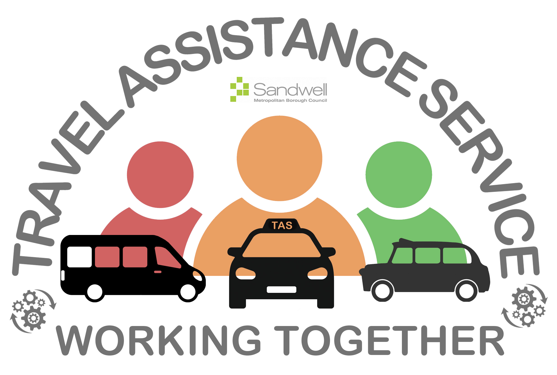

ACCIDENT AND MEDICAL EMERGENCY PROCEDURE

In the event of an accident or medical emergency the driver should STOP, NOT move the vehicle unless it is unsafe to leave it where it is and should evacuate the passengers ONLY if there
is a risk of fire or further accident. The Driver or Passenger Assistant MUST then:

- CALL 999 EMERGENCY SERVICES. Inform them that your passengers have special educational needs and/or disabilities and you need them to be checked by a medical professional.

- CALL your Operator to inform them of the situation.

- Your operator will need to call TAS, providing your location, the names of the passengers on the vehicle and brief details of the incident (0121 569 4888).

- TAS will then contact parents/carers and school.

If particulars cannot be exchanged at the time, then you should report the incident to the police either as soon as possible or within 24 hours.

Sandwell’s Private Hire and Hackney Carriage Licensing Policy Handbook states:

2.30 ACCIDENTS
If at any time the vehicle is involved in an accident, however minor, the driver must inform the Licensing Office of this fact as soon as possible and in any event within 1 working day (by telephone or email). An accident report form (available from the Licensing Office) must then be completed and submitted to the Licensing Office within 72 hours of the accident occurring (except in exceptional circumstances when the report must be made as soon as possible after the 72 hours deadline – an example of an exceptional circumstance would be that the driver is incapacitated due to the accident and physically unable to make the notification).
If you are Licensed with another Local Authority, please refer to their Licensing policy. You MUST inform your Licensing Authority that you were transporting SEND/CLA passengers as part of a contract on behalf of the Council.

*VEHICLE ACCIDENT INFORMATION EXCHANGE

OTHER DRIVER’S DETAILS
Other Driver’s Name: | {{other_driver_name}}
Is this person the registered owner? {{is_registered_owner}}
If NO, Name of vehicle owner: | {{vehicle_owner_name}}
INSURANCE DETAILS
Insurance company: | {{insurance_company}}
Policy number (if available) | {{insurance_policy_number}}
VEHICLE DETAILS
Vehicle make: | {{other_vehicle_make}}
Colour: | {{other_vehicle_colour}}
Registration number: | {{other_vehicle_registration}}
Damage to other vehicle and/or property:
{{damage_description}}

ACCIDENT DETAILS
Where did the accident occur?
{{accident_location}}

Date and time: {{accident_datetime}}

WITNESS DETAILS
Witness name(s): | {{witness_names}}
Address: | {{witness_address}}
Comments made by the other driver:

{{other_driver_comments}}

Make a rough sketch on the back page

