DoS Project Part1

Dr.Samer Arandi

Asa’d Sukhon 11819144

Mahmood Jabri 11822913

We made out project using Spring boot , Each server has a controller , service and repository except the front server , it has only controller and service because there are no database connected with it.

Firstly, I will run the three servers, the front server I’m running it on my host OS (windows) , the catalog server I’m running it on vw instance (linux), the order server I’m running it on other vw instance (linux) , as shown below.

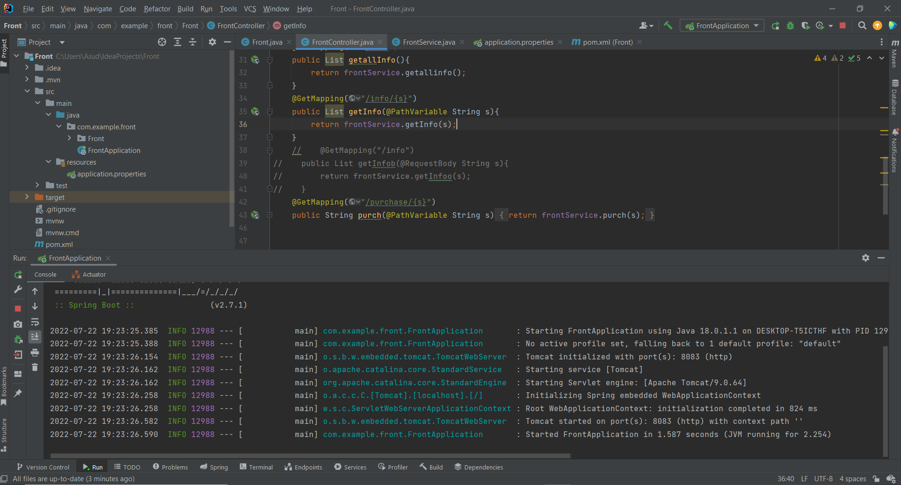

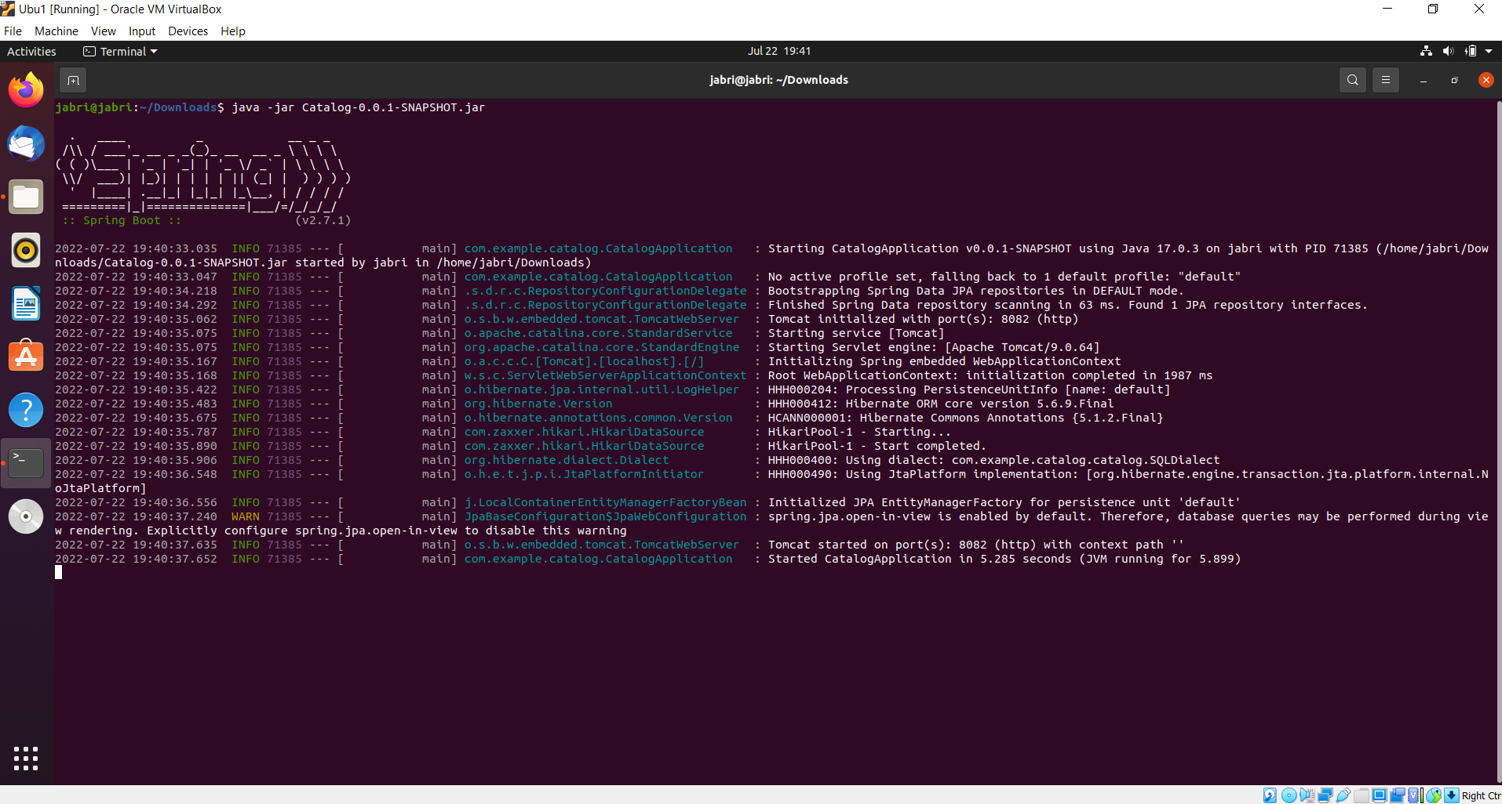

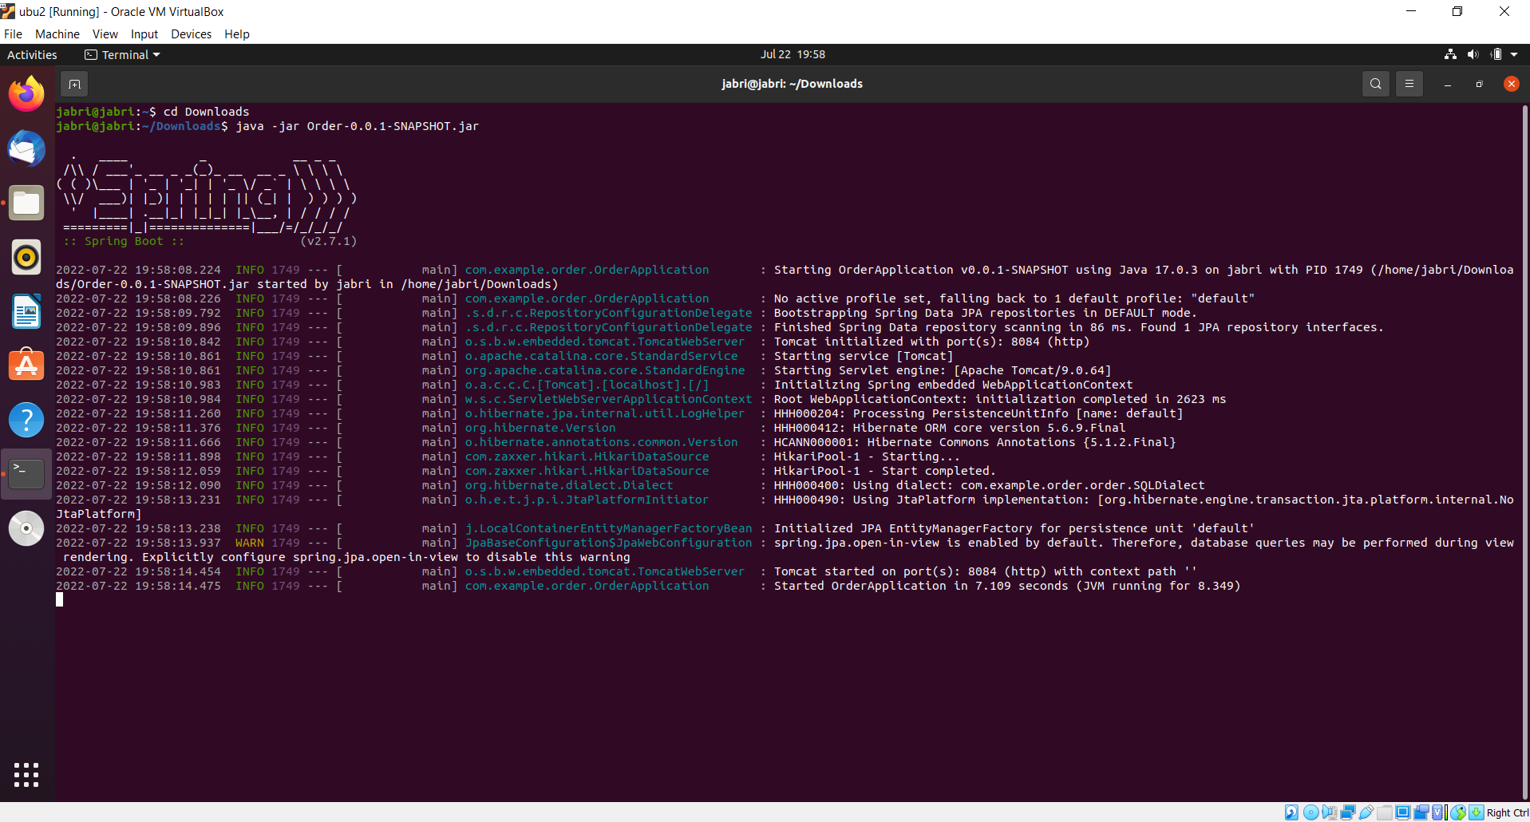

For the catalog and order servers , I only executed for the code as a jar file then I copied it to my vm instances , and downloaded the jdk and run the jar file.

How the project works

I used the postman to send requests for the front server.

For the search operation I did the following: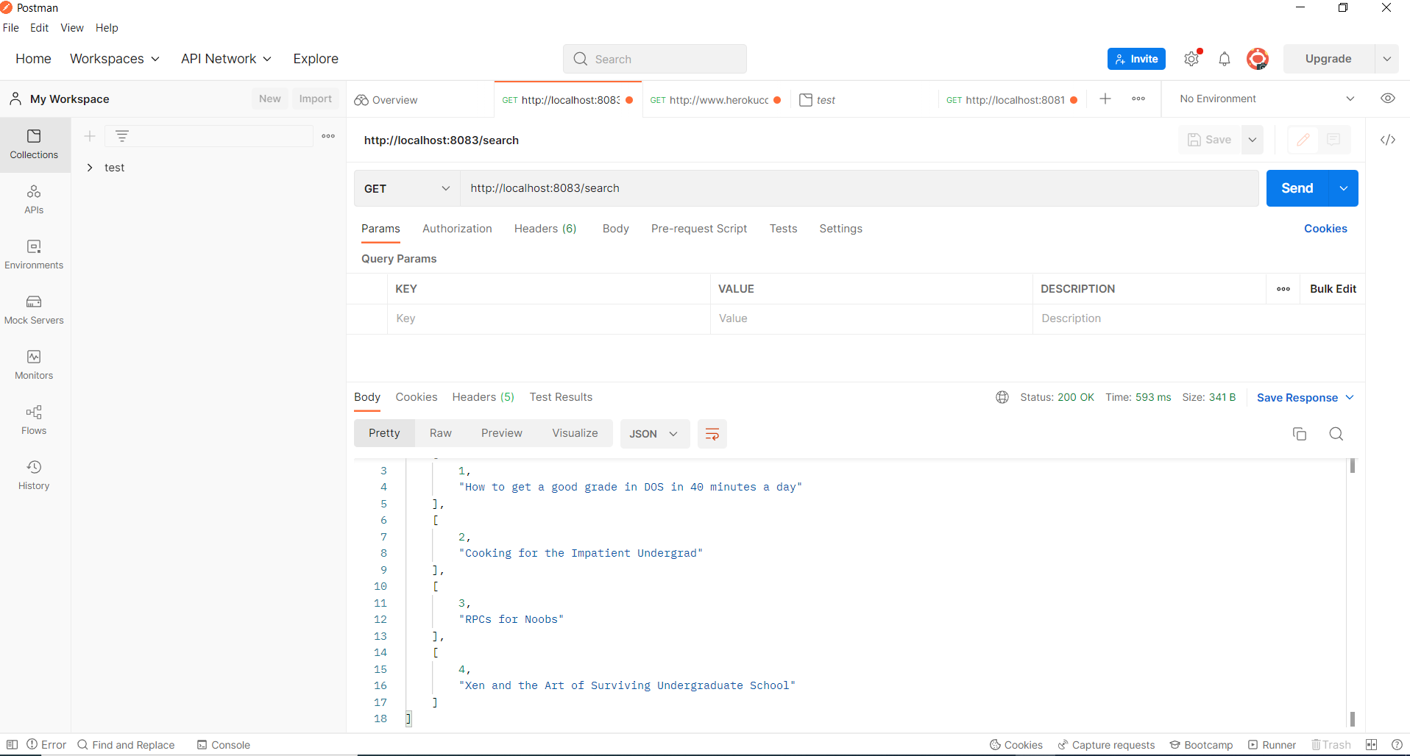

When I send request for the http://localhost:8083/search url , the front server forward the request to the catalog server , then i get Json object with all the books stored in the catalog database and it’s id’s.

I can also search for a specific book with it’s subject (topic) as following :

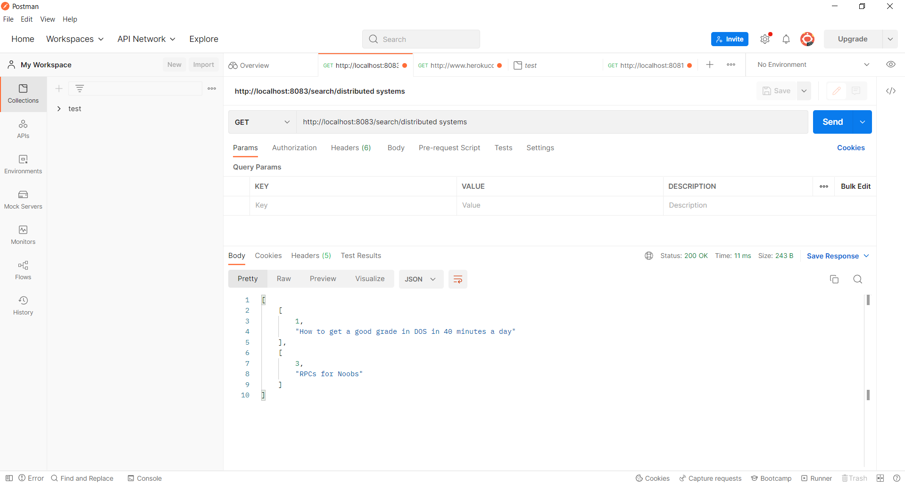

For the info operation I did the following :

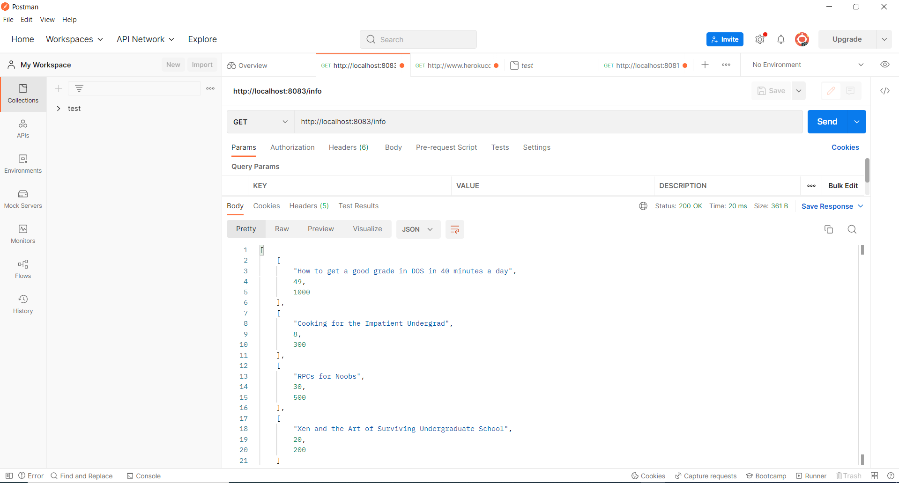

When I send request to <http://localhost:8083/info> to the front server , the front server forward the request to the catalog server which return json object with all the books stored in the database with it’s price and it’s quantity.

I can also get info about a specific book using it’s id as following:

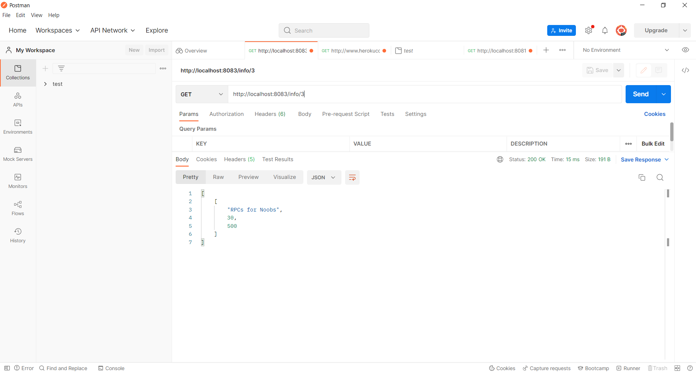

For the order server : there is purchase operation. When you send request for a purchase operation , you only need to specify an id for a book and the front server will forward it to the catalog server to check if the book exists , if it’s exists , then it checks if there are enough quantity of it. If all the conditions are right , the order server sends a request to the catalog server tells it to decrement the book quantity at the database as following:

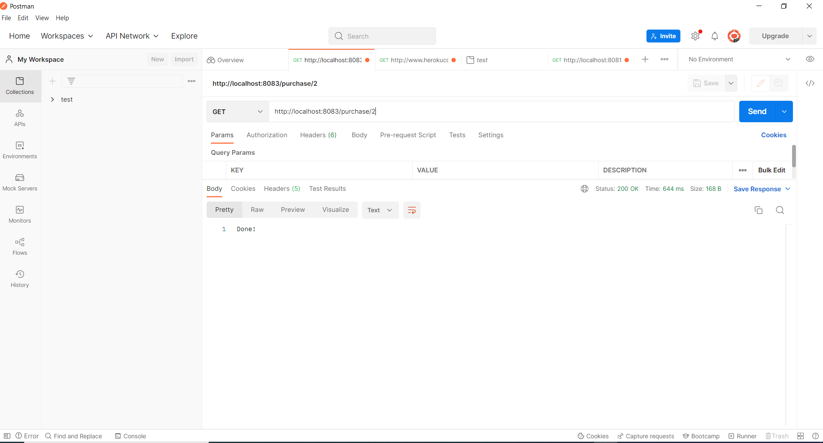

But if there is an error in any condition it will do the following:

