Observation:

**Daily Reports:**

**Delete **

**Message required for Save**

**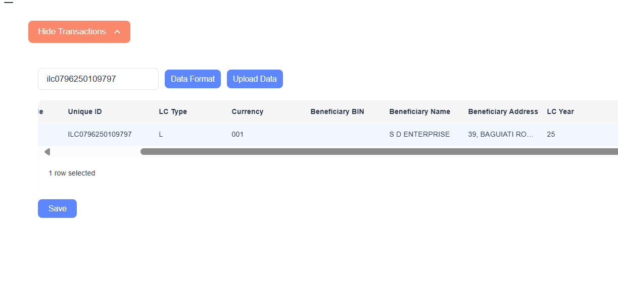  
  
  
validate tab not working properly**

**SSRS report footer-FinSoft Technology**



**Edit not working**

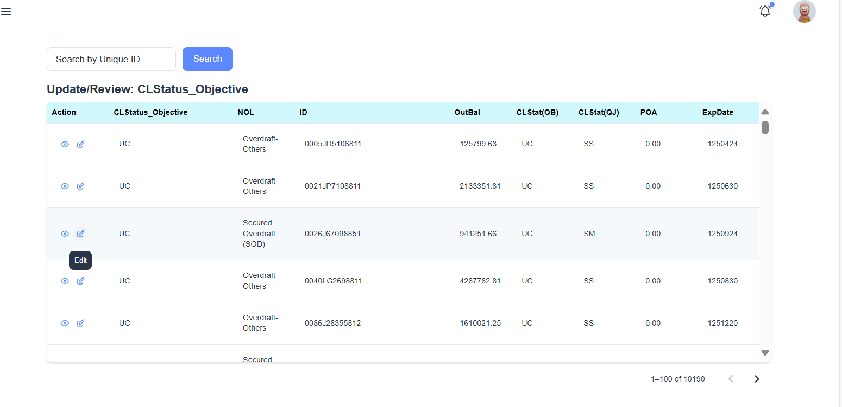

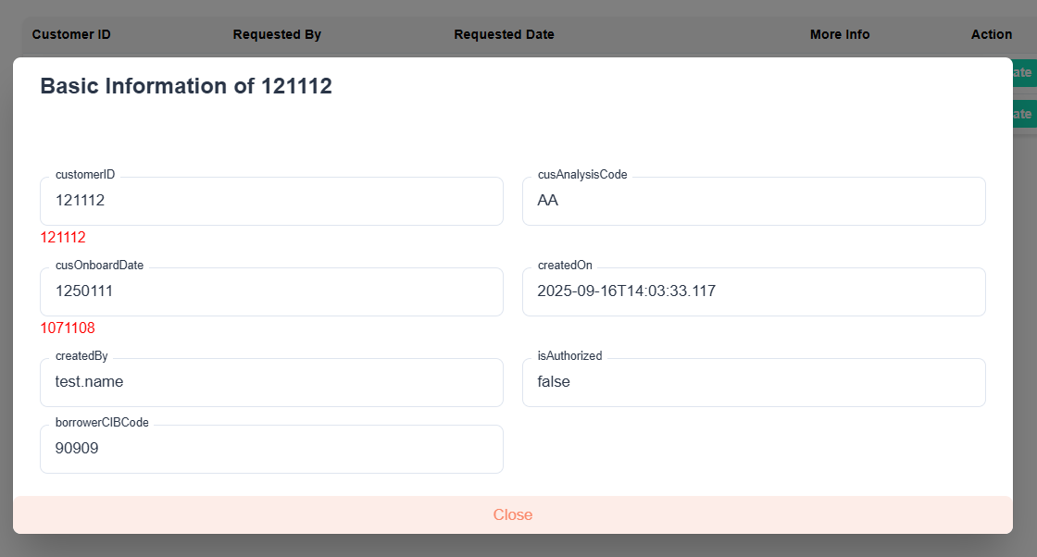

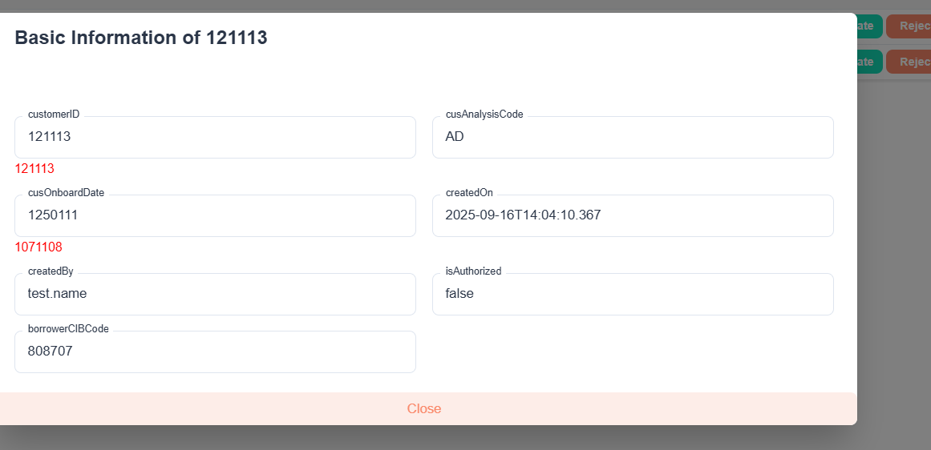

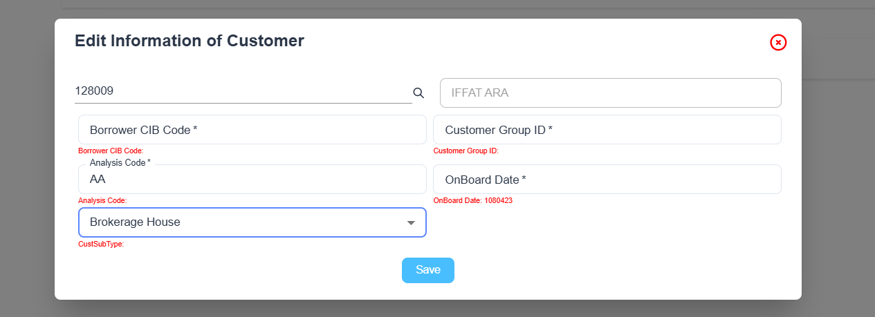

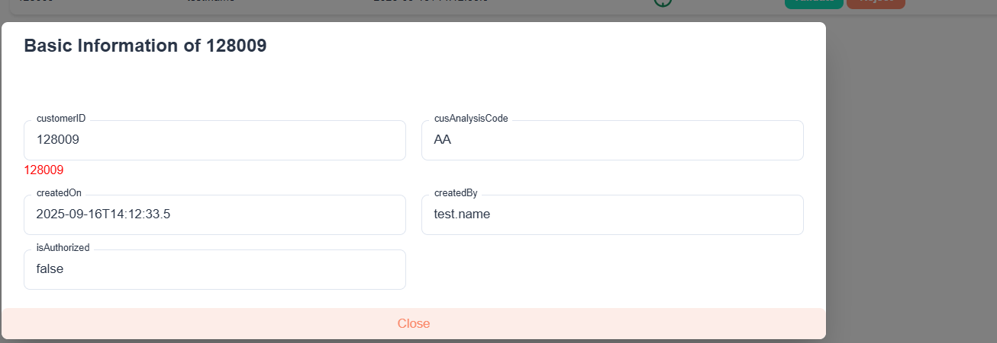

**Remove this tag**

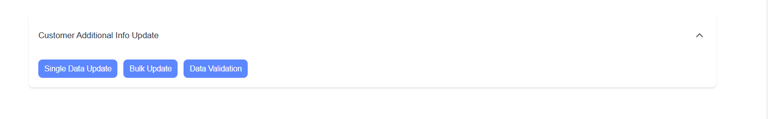

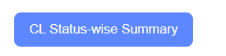**not working**