SYSTEM DESIGN DOCUMENT (SDD)

Smart Field Attendance & Workforce Verification System

With Integrated Shift Reporting & Fleet Accountability
Graduation Project | Academic Year 2026–2027
Document field | Value
Document version | 1.0 — architecture baseline proposal
Status | Proposed / pending design and stakeholder approval
Date | 7 October 2026
Prepared by | Graduation Project Team of 7 — [TBD: names and roles]
Reviewed by | [TBD: supervisor, industry partner, security reviewer]
Primary reference | Software Requirements Specification v1.0 (7 October 2026)
Secondary reference | Graduation Project Proposal (2026–2027), 13 pages
Source priority | SRS first; proposal second; unresolved rules are never presented as approved
Source-status clarification. Although the accompanying instruction calls the SRS “approved,” the supplied SRS cover marks v1.0 “Draft for Requirements Review.” This SDD treats its requirements as the controlling design input while preserving the outstanding approval gate. References of the form FR-WFV-016, NFR-SEC-003, BR-014, UC-009 and OI-020 refer to the provided SRS.
Reading key. [REQ] = explicitly required by SRS; [DESIGN] = implementation proposal; [PENDING] = unresolved stakeholder choice; [DERIVED] = implementation necessity grounded in a cited requirement. All values marked [TBD] must be finalized before production acceptance. Unless otherwise noted, technical selections below are recommendations, not signed-off commitments.

Executive Architecture at a Glance
The platform uses an offline-first cross-platform mobile client, an authenticated React web dashboard, and a REST API implemented as a modular monolith backed by PostgreSQL and protected object storage. Camera/GPS capture, liveness, face embeddings, and geofence validation run locally; submissions are durably queued with immutable event identifiers and synchronized later. Authoritative backend transactions validate claims, enforce RBAC and uniqueness, store operational events, and publish dashboard state with explicit data-freshness labels. Vehicle claims made by disconnected devices cannot be globally exclusive without coordination; offline fleet locking remains a blocking decision (OI-020 / OI-015 / OI-021). Device GPS and face models provide evidence, not infallible proof of physical presence.

1. Introduction
1.1 Purpose. This document specifies technical structures, data contracts, state transitions, APIs, trust boundaries, operations, and implementation guidance needed to realize the supplied SRS. It does not introduce new business modules.
1.2 Scope. Mobile attendance/enrollment; site/geofence management; 12-hour shift reporting; QR vehicle custody, inspections and tracking; backend/API; administrative review; synchronization; media; security/privacy; deployment; testability.
1.3 Intended readers. Mobile and web engineers, backend and database developers, AI/ML engineers, system architects, security/privacy reviewers, DevOps engineers, QA/testing engineers, project supervisors, and partner-company stakeholders.
1.4 References. SRS v1.0, §§1–18 and Appendix A/B; Graduation Project Proposal, §§1–11. In any difference of scope or language, SRS wording controls pending review.
1.5 Vocabulary. AttendanceEvent means one verified or flagged check-in/check-out attempt; AttendancePair is a calculated association of two accepted events, not a separately authoritative time record; VehicleSession is the custody window starting at QR claim and ending at release; Trip denotes drive activity within that custody window; ShiftReport is a site/shift-specific operational report; CaptureEvent is immutable client-generated event data; SyncReceipt records server acceptance/rejection; FaceEmbedding is a sensitive numerical biometric template; RBAC is role-based access control; HSE is health/safety/environment; OI is a pending SRS open issue; ADR is a proposed architecture decision record; GPS is device-reported location and quality metadata, not an independent identity assertion.

2. Design Goals and Principles
Goal | Architectural implementation | Evidence
Offline availability | Local transactional storage, signed configuration snapshots, outbox retries; no network check in the verification path | FR-SYNC-001..010; NFR-REL-001
Verifiable attendance | Four independent checks in one local attempt; outcomes stored with site/worker/time and validated again on sync | FR-WFV-005..018; BR-001
Chain of custody | One authoritative vehicle lock, QR identity, inspection gates, GPS-scoped session | FR-FLEET-003..031; BR-014
Auditability | Append-only audit stream for site change and security-critical transitions, attributable event IDs | FR-SITE-008; SRS §11
Privacy and security | Embedding-only enrollment, scoped tracking, least privilege, TLS/encryption, media ACLs | NFR-PRIV-001..006; NFR-SEC-001..010
Field usability | Camera/QR-guided steps, actionable failure reasons, clear pending-sync indicator | NFR-USA-001..004
Maintainability | One deployable modular backend with explicit interfaces and test seams | NFR-MAINT-001..002
Honest freshness | Dashboard states last synchronization and never implies disconnected units are live | FR-FLEET-034; OI-018

3. Design Constraints
ID | Constraint | Source | Design impact
CON-001 | Weak/absent cellular connectivity | SRS §2.6; FR-SYNC-* | Durable offline queue; resumable media uploads
CON-002 | Four checks in same attendance attempt | FR-WFV-016 | Atomic verification context with no mixed captures
CON-003 | Discard enrollment face images | FR-WFV-004 | Volatile capture buffers; only embedding persisted
CON-004 | Restricted/audited site changes | FR-SITE-008..009 | RBAC + append-only audit transaction
CON-005 | 12-hour shift reporting | FR-REPORT-001 | Site/timezone-specific shift scheduler
CON-006 | Pre-trip evidence required | FR-FLEET-007..017 | State-machine gate, backend rule check
CON-007 | Location only during open custody | FR-FLEET-018..020 | Trip tracking lifecycle bound to VehicleSession
CON-008 | Fleet GPS hardware not selected | FR-FLEET-033; OI-017 | Location-source adapter interface
CON-009 | Cross-platform mobile + web dashboard | SRS §2.6 | Framework selection pending for mobile; React dashboard from proposal
CON-010 | Supported devices/SLAs/retention not specified | OI-023..025 | No fabricated throughput/availability thresholds

4. High-Level System Architecture
[DESIGN: proposed] Modular monolith + offline-capable clients. A single containerized backend deployable contains isolated modules (Auth/RBAC, Workers/Enrollment, Sites/Shifts, Attendance, Reports, Fleet/Trips, Media, Sync, Notifications, Audit/Alerts). PostgreSQL transactions provide vehicle locks, idempotency and relational history without distributed transaction complexity. Binary evidence is stored outside the database using opaque object keys. A stateless API tier can be horizontally replicated; scheduled tasks may run as a separately assigned worker process using the same codebase. Mobile stores an encrypted local SQLite database and media outbox; the web dashboard consumes authenticated API reads and subscription/poll updates. Framework choice for mobile (Flutter versus React Native) is [PENDING]; the proposal requires cross-platform and on-device ML integration but does not name a framework.
Benefits: low deployment overhead for a seven-person academic team; transactionally consistent vehicle claims; clear functional boundaries; testable local/offline core. Trade-offs: one deployment unit; central datastore; worker tasks require careful ownership; a monolith must not become one unstructured module. Split-out services are a future option only if measured capacity/team boundaries justify it.
Data-authority contract: a locally captured event is evidence with status PENDING; backend acceptance turns it into the authoritative record. A local face/geofence pass does not supersede server RBAC, inactive sites, duplicate constraints, or global fleet custody state. Where a field must work during disconnection but cannot be globally authenticated/locked, show a provisional result and preserve discrepancy for explicit review (OI-020).

5. System Context Diagram
D-01 — System context.
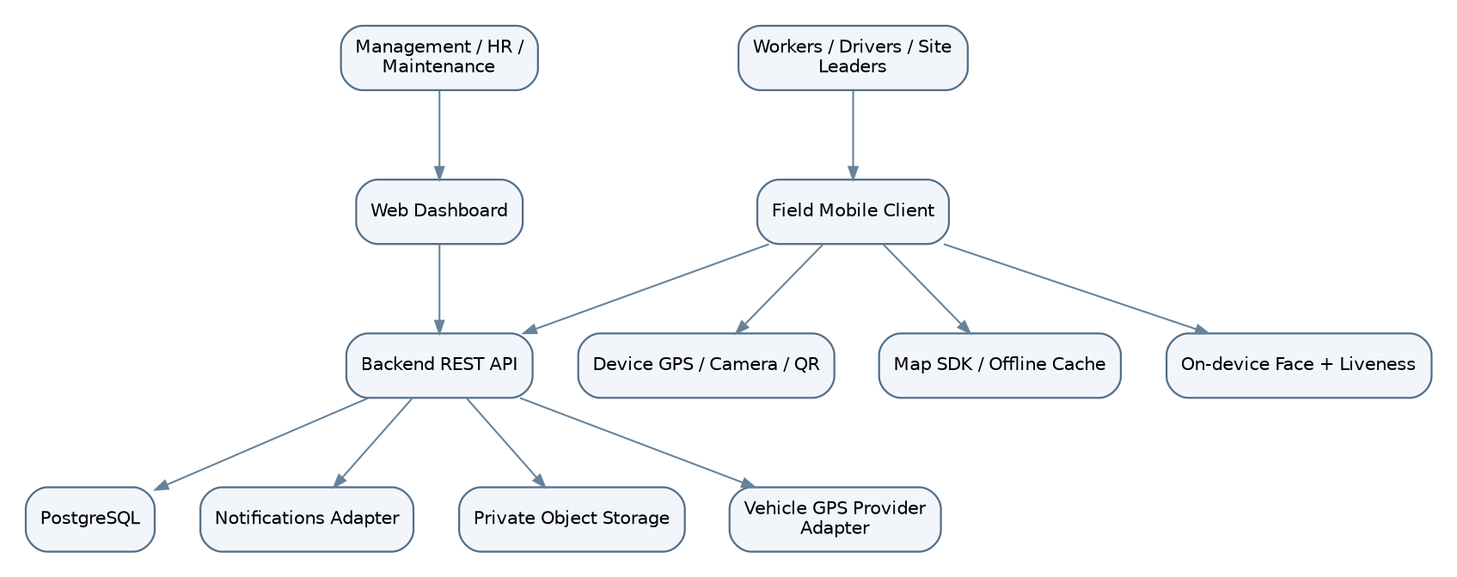
D-01: System context
On-device verification is the network-independent trust boundary; the backend is the authoritative consistency boundary. The optional tracker adapter is not an approved dependency (OI-017).

6. Container and Component Architecture
D-02 — Container layout.
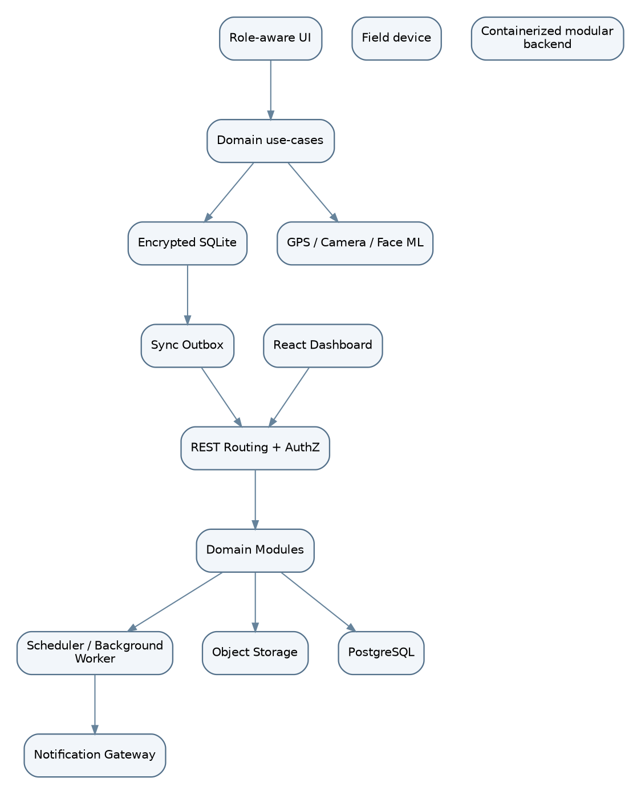
D-02: Container layout
The local queue is durable; the server handles decisions requiring shared state. Domain modules communicate via interfaces and PostgreSQL transactions, not ad hoc table writes.
Component | Responsibility | Inputs | Outputs | Dependencies | SRS requirements
Mobile UI + domain | Guided role flows; locally validated capture | Camera/GPS/forms | Captured events | Device APIs, local DB | FR-WFV-, FR-SITE-, FR-FLEET-*
Face/liveness engine | Embedding, active challenge, threshold | Live frames, enrolled template | Result/quality metadata | On-device ML runtime | FR-WFV-001..016
Geofence engine | Circular radius calculation; accuracy handling | Site cache + GNSS fix | Inside/outside/uncertain | Device location | FR-WFV-005..009; FR-SITE-001..007
Sync engine | Durable idempotent outbox; exponential backoff | Local events/media | Receipts, retries | SQLite, REST, object storage | FR-SYNC-001..010
Authentication + RBAC | Access lifecycle, resource authorization | Credentials/tokens/role grants | Principal/denials | Users/roles | FR-AUTH-001..009
Workers + Attendance | Enrollment ownership, verify server evidence, pair events | Biometric metadata / attendance | Accepted events, hours | Workers, sites, shifts | FR-WFV-001..029
Site + Shift | Sites, geofences, workers, shift periods | Site/assignment requests | Active sites, shifts | Audit, RBAC | FR-SITE-001..011
Shift Reports | 12-hour forms, manpower, incidents | Report + media | Report history, anomalies | Attendance, media | FR-REPORT-001..021
Fleet + Inspections | Atomic vehicle claim, inspections, release | QR ID, evidence, issues | VehicleSession, condition | Vehicles, media, locks | FR-FLEET-001..034
Trip tracking adapter | Track only during custody, GPS/OBD2 substitution | Location batches | Trip/route summaries | VehicleSession, location source | FR-FLEET-018..024, 033..034
Admin + Alerts | Filtered live snapshots, case review | Sync records, anomalies | Dashboards, maintenance view | Read models, notification | FR-ADMIN-001..010
Media service | Private upload/auth, integrity and references | Image/audio payload | Opaque object references | Object storage | FR-REPORT-012..013; FR-FLEET-015
Audit service | Append-only actor/action/change trail | Domain critical actions | AuditEvent | PostgreSQL restricted writes | FR-SITE-008; NFR-SEC-005
Scheduler/Notifications | Shift opening/missed windows; fault alerts | Shift cycles, incidents | Notifications + flags | Job execution, gateway | FR-NOTIF-001..005

7. Application Architecture
7.1 Mobile. UI screens/controllers → domain use-cases → interfaces/repositories → encrypted local SQLite + device integrations + REST adapter. A background sync worker is the only owner of outbox sends. Mobile framework remains [PENDING: Flutter/React Native]. Platform-native plugins must expose (a) precise GNSS fix with accuracy, elapsed-time/source; (b) camera and QR; (c) secure key store and encryption; (d) lifecycle-safe location tracking; (e) TFLite/ONNX face models. Presentation handles permissions and error states, never decides attendance acceptance independently of the domain verifier. A verified event is transactionally persisted with the outbox entry before success is shown.
7.2 Backend. Request controller → principal/RBAC → schema validator → domain command handler → repository/transaction → PostgreSQL + object storage. Workers execute idempotent scheduled escalation/notification and queued media finalization. Modules expose explicit ports; for example, VehicleClaimService.claim(vehicleId, driverId, eventId) owns the exclusive lock. Every request carries trace/correlation IDs; exception translation produces standardized errors. Row-level checks enforce that the authenticated user may act on each referenced worker, site, report or session.
7.3 Web. React SPA with role-aware routes and server-enforced action permissions; dashboards are projections of synchronized server state, with last_seen_at/data_freshness indicators. It must never present stale coordinates as a current live position.
7.4 Interfaces. Shared versioned contracts for enums, event envelopes, timestamps in UTC, coordinates in WGS84, and storage references; consumers should generate DTO validation types from OpenAPI where feasible. Models should not depend on UI framework classes.

8. Module Design

8.1 Authentication and User Management
Purpose/responsibility: Authenticate and bind users to one or more role grants. Input: Credentials, account role grants. Output: Principal/session state; denied attempts. Business invariants: Account-active and resource-scoped RBAC. Tables: users, roles, user_roles. API: POST /auth/login; POST /auth/logout; GET /me. Security: Credential theft, revocation, offline freshness. Failure path: Auth unavailable => deny untrusted first login; offline session validation [PENDING OI-001]. Trace: FR-AUTH-001..009.

8.2 Workforce Verification
Purpose/responsibility: Enroll several images into an embedding; discard raw frames; check live face + liveness. Input: Worker identity, captures, device ML model. Output: Enrolled template and result metadata. Business invariants: No stored enrollment photographs. Tables: workers, biometric_templates. API: POST /workers/{id}/enrollment. Security: Consent/biometric template exposure; thresholds [PENDING OI-004]. Failure path: Low face quality/camera failure => no enrollment. Trace: FR-WFV-001..004,010..016.

8.3 Attendance
Purpose/responsibility: Use signed current site snapshot; four checks; bind to shift and compute verified hours. Input: GPS accuracy/lat-lon, site, live embedding, liveness. Output: Locally queued AttendanceEvent, later accepted result. Business invariants: All four checks same attempt, no unverified backdate. Tables: attendance_events, shifts, sites. API: POST /attendance/check-in; POST /attendance/check-out; POST /sync/events. Security: Mock-location and stale assignment; server revalidation. Failure path: Invalid GPS/time/similarity => reject; duplicate check-in rule TBD. Trace: FR-WFV-005..029.

8.4 Site Management
Purpose/responsibility: Create circle from current position/map pin, assign workers, audit updates. Input: Center, radius, name, assignments. Output: Active site, change audit. Business invariants: Site Leader creates; Management deactivates. Tables: sites, site_assignments, audit_events. API: POST /sites; PATCH /sites/{id}; POST /sites/{id}/deactivate. Security: Fraudulent geofence; edits while clients offline. Failure path: Reject unauthorized changes; stale cached sites require flagged conflict. Trace: FR-SITE-001..011.

8.5 Shift Reporting
Purpose/responsibility: Schedule 12-hour reports; gather operation, progress, manpower, media, HSE. Input: Site shift, reports + optional images/voice. Output: ShiftReport + alert flags. Business invariants: Incident/failed equipment flagged; missed window escalated. Tables: shifts, shift_reports, media_objects. API: POST /shift-reports; GET /shift-reports. Security: Report amendment policy OI-012; inaccurate offline manpower. Failure path: Validate fields; local pending submission on network loss. Trace: FR-REPORT-001..021.

8.6 Fleet Management
Purpose/responsibility: Register vehicle and QR; assign authoritative custody. Input: Vehicle QR and driver. Output: VehicleSession status. Business invariants: At most one server-accepted active session/vehicle. Tables: vehicles, vehicle_sessions. API: POST /vehicle-sessions/claim. Security: Cloned QR, offline double claim. Failure path: Collision => 409; disconnected claim provisional/blocked per OI-020. Trace: FR-FLEET-001..006,032.

8.7 Vehicle Assignment
Purpose/responsibility: Single active claim, custody start/end timestamps. Input: Vehicle ID, driver ID, client event ID. Output: Vehicle locked until valid release. Business invariants: Claim only available vehicle; no concurrent claims. Tables: vehicle_sessions, vehicles. API: POST /vehicle-sessions/claim; POST /vehicle-sessions/{id}/release. Security: Replay or concurrent claims. Failure path: DB unique partial index; retries return same outcome. Trace: FR-FLEET-003..006,028..032.

8.8 Vehicle Inspection
Purpose/responsibility: Require four exterior + dashboard image before start; end odometer/issues. Input: Photos, answers, description, odometer. Output: Pre/post inspection and evidence references. Business invariants: Cannot start until valid pre; post required for release. Tables: vehicle_inspections, media_objects, evidence_links. API: POST /vehicle-sessions/{id}/inspections. Security: Image substitution, invalid media. Failure path: Incomplete => 422, release exception OI-016. Trace: FR-FLEET-007..017,023..027,031.

8.9 Trip Tracking
Purpose/responsibility: Sample route while session open; produce trip origin/route/destination. Input: Location timestamp, accuracy, odometer. Output: Trip points and summary. Business invariants: Tracking at claim; off at release. Tables: trips, trip_locations. API: POST /vehicle-sessions/{id}/locations/batch. Security: Tracking leakage, stale location, GPS spoofing. Failure path: Tracking provider unavailable => degraded status + alert [PENDING]. Trace: FR-FLEET-018..024,033..034.

8.10 Notifications
Purpose/responsibility: Open-window prompt, missed-report escalation, maintenance issue. Input: Shift timer and flagged operational events. Output: User/admin notifications. Business invariants: Re-delivery cannot multiply case records. Tables: notifications, flagged_events. API: GET /notifications; POST /notifications/{id}/ack. Security: Unbounded retries; recipients TBD. Failure path: Provider down => retry queue; channel policy OI-011. Trace: FR-NOTIF-001..005.

8.11 Reporting and Historical Records
Purpose/responsibility: Filter attendance/shift/vehicle histories by site/time. Input: Authorized filters, pagination. Output: Time-ordered archives and calculated summaries. Business invariants: Read authoritative accepted events only. Tables: attendance_events, shift_reports, trips. API: GET /attendance/events; GET /shift-reports; GET /vehicles/{id}/history. Security: Excessive data exposure. Failure path: Database degraded => read-only error, do not fabricate live state. Trace: FR-ADMIN-001..010.

8.12 Administration
Purpose/responsibility: Review anomalies, see data freshness, deactivate sites. Input: Authorized actors, filters and decisions. Output: Admin views/audit records. Business invariants: Server authorizes each action. Tables: flagged_events, audit_events. API: GET /admin/flags; POST /sites/{id}/deactivate. Security: IDOR and privilege escalation. Failure path: Missing role => 403; missing sync => stale badge. Trace: FR-ADMIN-001..010.

8.13 Audit Logging
Purpose/responsibility: Write append-only site change and significant security transition. Input: Actor, action, old/new metadata, correlation. Output: Immutable audit event. Business invariants: No app-level UPDATE/DELETE permissions. Tables: audit_events. API: GET /admin/audit-events. Security: Audit deletion/tampering. Failure path: Audit persistence failure => abort critical site changes. Trace: FR-SITE-008; NFR-SEC-005.

9. Data Flow Design
D-03 — Logical data flow.
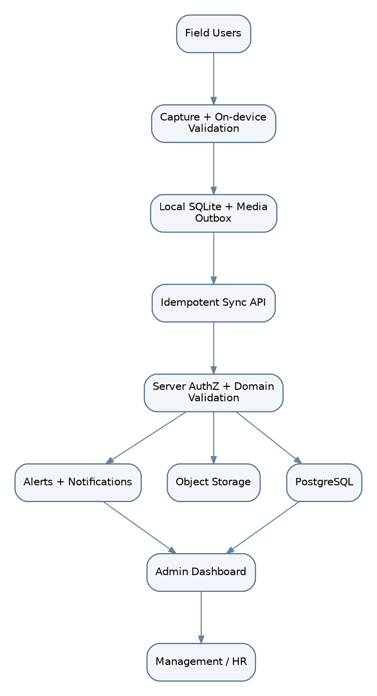
D-03: Logical data flow
Authenticity checks on the phone produce evidence; central validation resolves authorization, claims and duplicate rules. Sync receipt ties server outcome to client event; attachments are uploaded independently but cannot lose their owner association.
Flow | Local validation | Central validation | Persistence
Login | Cached session policy [PENDING] | Credentials, status, RBAC | Users + audit as applicable
Enrollment | Consent state, sample quality, embedding | Enrollment authority, worker linkage | biometric_templates (no raw faces)
Check-in/out | Geofence, mock state, liveness, match | User/site/time evidence, duplicate rules | attendance_events, SyncReceipt
Site creation | Form/geofence geometry | Role, ranges, revision/audit | sites, site_assignments, audit_events
12-hour report | Fields, incident/notes, shift ID | Submitter/site/shift, media metadata | shift_reports, evidence_links
QR claim / inspection | QR decode, gated evidence capture | Unique active claim, session ownership | vehicle_sessions, vehicle_inspections
Route points/release | Sensor capture scoped to open session | Accepted session/timing, distance constraints | trips, trip_locations
Media upload | Local file hash, size and owner | MIME/size/owner, integrity, malware screening [DESIGN] | media_objects in DB, bytes in object storage

10. Database Design and Technology
[REQ + DESIGN] PostgreSQL is named in proposal §8 and compatible with SRS §7–8. It is the authoritative database. Use UUID primary keys (client-generated UUIDv7/UUIDv4 for offline events), timestamptz UTC, numeric(10,7) for latitude and numeric(11,7) for longitude, numeric(12,2) for measurements where precision matters, jsonb for bounded evidence-result metadata (not as replacement for key relations). Enforce referential integrity and uniqueness in PostgreSQL, not only application code. Actual media binary goes into private object storage; database stores IDs, hashes, MIME, state and owner linkage. Sensitive embeddings should be encrypted and preferably isolated from normal report-read accounts. Client SQLite mirrors only the subset needed for authenticated offline duties plus outbox/events, never the entire partner database.
Transaction strategy. A claim uses INSERT ... ON CONFLICT / row lock plus partial unique constraint on active sessions; server returns a stable result for duplicate event ID. Site mutation and immutable audit insert execute in one transaction. Sync receipts deduplicate at ingress. Shift report revisions are append/supersede only if OI-012 approves edits. Referential deletion defaults to RESTRICT on evidence-critical history; erasure/retention policy remains [PENDING OI-023]. Database schema below is a proposed implementation, not a newly approved business requirement.

11. Entity Relationship Diagram (ERD)
D-04 — Core relational ERD.
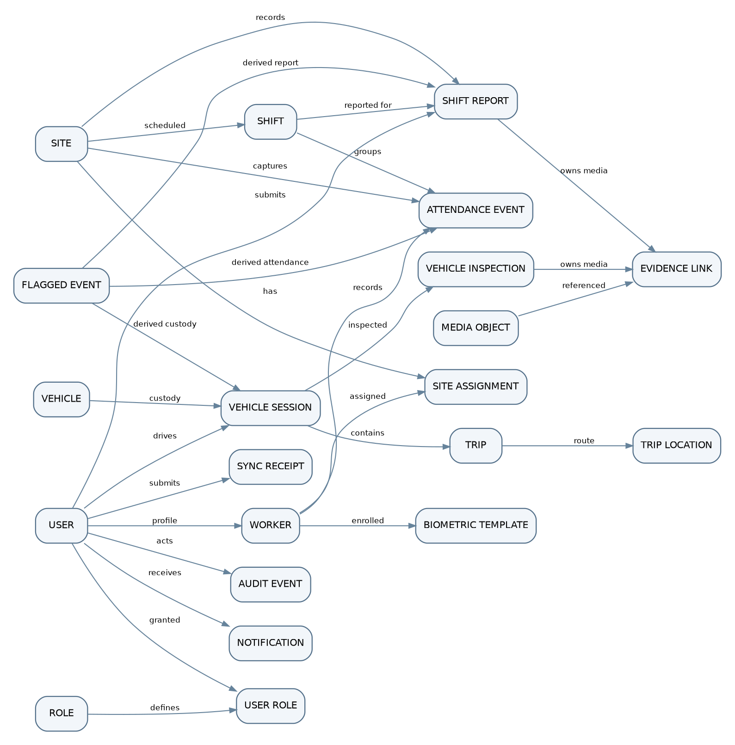
D-04: Core relational ERD
Optional relationships are modeled with nullable foreign keys; FLAGGED_EVENT references only one applicable source using a discriminator plus guarded typed references. EVIDENCE_LINK likewise must reference exactly one parent. The ERD is schematic; the data dictionary and constraints are the authoritative column-level design.

12. Database Schema and Data Dictionary
The following schema is the proposed PostgreSQL logical schema, not a physical migration. generated denotes server UUID defaults except where offline clients mint durable event IDs. — indicates absent default. Foreign keys are RESTRICT unless the approved data lifecycle specifies otherwise. Nullability of optional consent/clock/route fields may change after the listed OIs. The one parent only evidence-link rule is enforced with a CHECK summing non-null parent references.

users
Column | PostgreSQL type | PK/FK | Nullable | Default | Constraints | Description
id | UUID | PK | No | generated | immutable | Account ID
employee_code | VARCHAR(64) | UQ | Yes | — | unique when set | Partner workforce identifier
full_name | VARCHAR(160) | — | No | — | nonblank | Display identity
login_identifier | VARCHAR(190) | UQ | No | — | unique, normalized | Login principal; scheme TBD
credential_hash | TEXT | — | Yes | NULL | only for local-password option | Password hash; omit for external IdP
account_status | VARCHAR(16) | — | No | active | CHECK(active,inactive) | Authorization status
created_at | TIMESTAMPTZ | — | No | now() | UTC | Creation timestamp
updated_at | TIMESTAMPTZ | — | No | now() | UTC | Last account update

roles
Column | PostgreSQL type | PK/FK | Nullable | Default | Constraints | Description
id | UUID | PK | No | generated | immutable | Role ID
code | VARCHAR(48) | UQ | No | — | unique | WORKER/SITE_LEADER/DRIVER/MANAGEMENT_HR/MAINTENANCE/ENROLLMENT_STAFF
name | VARCHAR(100) | — | No | — | nonblank | Display name

user_roles
Column | PostgreSQL type | PK/FK | Nullable | Default | Constraints | Description
user_id | UUID | PK,FK users | No | — | ON DELETE RESTRICT | User grant target
role_id | UUID | PK,FK roles | No | — | ON DELETE RESTRICT | Granted role
grant_status | VARCHAR(16) | — | No | active | CHECK(active,revoked) | Revocation state
granted_at | TIMESTAMPTZ | — | No | now() | UTC | Assignment time
granted_by | UUID | FK users | Yes | NULL | record original actor | Grant source

workers
Column | PostgreSQL type | PK/FK | Nullable | Default | Constraints | Description
id | UUID | PK | No | generated | immutable | Worker ID
user_id | UUID | UQ,FK users | No | — | unique | Linked user
consent_status | VARCHAR(20) | — | No | pending | policy TBD | Consent workflow status
enrollment_status | VARCHAR(20) | — | No | not_enrolled | CHECK(not_enrolled,enrolled,suspended) | Biometric availability
created_at | TIMESTAMPTZ | — | No | now() | UTC | Profile creation

biometric_templates
Column | PostgreSQL type | PK/FK | Nullable | Default | Constraints | Description
id | UUID | PK | No | generated | immutable | Template version ID
worker_id | UUID | FK workers | No | — | ON DELETE RESTRICT | Template owner
model_version | VARCHAR(80) | — | No | — | nonblank | Embedding model revision
embedding_ciphertext | BYTEA | — | No | — | AEAD encrypted | Sensitive embedding vector
enrolled_at | TIMESTAMPTZ | — | No | now() | UTC | Enrollment time
active | BOOLEAN | — | No | true | at most one active per worker | Selection state
consent_reference | VARCHAR(128) | — | Yes | NULL | policy TBD | Consent proof reference

sites
Column | PostgreSQL type | PK/FK | Nullable | Default | Constraints | Description
id | UUID | PK | No | generated | immutable | Site ID
name | VARCHAR(160) | — | No | — | nonblank | Field site name
center_lat | NUMERIC(10,7) | — | No | — | CHECK between -90 and 90 | Geofence center latitude
center_lon | NUMERIC(11,7) | — | No | — | CHECK between -180 and 180 | Geofence center longitude
radius_m | NUMERIC(9,2) | — | No | — | CHECK > 0; bounds TBD | Circular geofence radius
status | VARCHAR(16) | — | No | active | CHECK(active,inactive) | Current activation state
revision | BIGINT | — | No | 1 | CHECK > 0 | Optimistic config version
created_by | UUID | FK users | No | — | ON DELETE RESTRICT | Authorized site leader
created_at | TIMESTAMPTZ | — | No | now() | UTC | Audit timestamp

site_assignments
Column | PostgreSQL type | PK/FK | Nullable | Default | Constraints | Description
id | UUID | PK | No | generated | immutable | Assignment ID
site_id | UUID | FK sites | No | — | ON DELETE RESTRICT | Site
worker_id | UUID | FK workers | No | — | ON DELETE RESTRICT | Worker
effective_from | TIMESTAMPTZ | — | Yes | NULL | OI-008 | Validity start
effective_until | TIMESTAMPTZ | — | Yes | NULL | greater than start if set | Validity end
status | VARCHAR(16) | — | No | active | CHECK(active,inactive) | Active site assignment
assigned_by | UUID | FK users | No | — | role check | Assigning actor

shifts
Column | PostgreSQL type | PK/FK | Nullable | Default | Constraints | Description
id | UUID | PK | No | generated | immutable | Shift occurrence ID
site_id | UUID | FK sites | No | — | ON DELETE RESTRICT | Site
cycle | VARCHAR(12) | — | No | — | CHECK(day,night) or approved config | Reporting cycle
starts_at | TIMESTAMPTZ | — | No | — | UTC | Shift start
ends_at | TIMESTAMPTZ | — | No | — | CHECK end > start | Shift end; standard 12-hour reporting cycle
standard_minutes | INTEGER | — | Yes | NULL | OI-010 | Worked-hours comparison target
report_window_opens_at | TIMESTAMPTZ | — | Yes | NULL | OI-011 | Start reminder window
report_window_closes_at | TIMESTAMPTZ | — | Yes | NULL | OI-011 | Missed-report threshold

attendance_events
Column | PostgreSQL type | PK/FK | Nullable | Default | Constraints | Description
id | UUID | PK | No | client-generated | idempotent | Stable event ID
event_type | VARCHAR(16) | — | No | — | CHECK(check_in,check_out) | Verification action
worker_id | UUID | FK workers | No | — | ON DELETE RESTRICT | Verified worker
site_id | UUID | FK sites | No | — | ON DELETE RESTRICT | Assigned site
shift_id | UUID | FK shifts | Yes | NULL | shift pairing TBD | Shift context
paired_checkin_id | UUID | FK attendance_events | Yes | NULL | only for check_out | Check-in association
captured_at | TIMESTAMPTZ | — | No | — | client signed/wall clock trust OI-022 | Event capture time
received_at | TIMESTAMPTZ | — | No | now() | server set | Sync arrival time
latitude | NUMERIC(10,7) | — | No | — | valid range | Reported GPS latitude
longitude | NUMERIC(11,7) | — | No | — | valid range | Reported GPS longitude
accuracy_m | NUMERIC(9,2) | — | Yes | NULL | threshold OI-006 | Reported location accuracy
geofence_revision | BIGINT | — | No | — | > 0 | Used site rules version
mock_location_detected | BOOLEAN | — | No | false | no acceptance when true | OS signal
liveness_pass | BOOLEAN | — | No | false | no acceptance when false | Liveness result
face_match_pass | BOOLEAN | — | No | false | no acceptance when false | Threshold-comparison result
verification_model_version | VARCHAR(80) | — | No | — | model traceability | ML model version
acceptance_status | VARCHAR(24) | — | No | pending | CHECK(pending,accepted,rejected,flagged) | Server decision
rejection_code | VARCHAR(80) | — | Yes | NULL | no sensitive scores | Non-secret reason

shift_reports
Column | PostgreSQL type | PK/FK | Nullable | Default | Constraints | Description
id | UUID | PK | No | client-generated | immutable event identity | Report ID
shift_id | UUID | FK shifts | No | — | may be unique subject to OI-012 | Report’s shift
site_id | UUID | FK sites | No | — | must match shift site | Site
submitted_by | UUID | FK users | No | — | site-leader RBAC | Submitting leader
submitted_at | TIMESTAMPTZ | — | No | — | UTC/source | Submission time
work_completed | TEXT | — | No | — | nonblank | Structured narrative
progress_metric | NUMERIC(14,3) | — | No | — | domain range TBD | Measured depth/progress
manpower_count | INTEGER | — | Yes | NULL | system computed | Verified attendance count
equipment_status | VARCHAR(24) | — | No | — | CHECK(operational,degraded,down) | Equipment state
equipment_notes | TEXT | — | Yes | NULL | — | Equipment explanation
hse_incident | BOOLEAN | — | No | false | — | HSE flag
hse_details | TEXT | — | Yes | NULL | required if incident | Incident detail
delay_reason | VARCHAR(48) | — | Yes | NULL | domain categories | Weather/equipment/supply/personnel
delay_notes | TEXT | — | Yes | NULL | — | Delay explanation
supersedes_report_id | UUID | FK shift_reports | Yes | NULL | only after OI-012 | Optional correction link

vehicles
Column | PostgreSQL type | PK/FK | Nullable | Default | Constraints | Description
id | UUID | PK | No | generated | immutable | Vehicle ID
fleet_label | VARCHAR(80) | UQ | No | — | unique | Partner fleet identifier
qr_identifier_hash | VARCHAR(128) | UQ | No | — | unique, QR scheme TBD | QR payload binding
status | VARCHAR(16) | — | No | available | CHECK(available,in_use) | Projected availability
created_at | TIMESTAMPTZ | — | No | now() | UTC | Vehicle master record

vehicle_sessions
Column | PostgreSQL type | PK/FK | Nullable | Default | Constraints | Description
id | UUID | PK | No | client-generated | immutable idempotency key | Custody session ID
vehicle_id | UUID | FK vehicles | No | — | one active per vehicle | Vehicle
driver_id | UUID | FK users | No | — | DRIVER permission | Current driver
status | VARCHAR(28) | — | No | claimed | CHECK(claimed,pre_inspected,trip_started,post_inspected,released,conflicted) | Custody lifecycle
claimed_at | TIMESTAMPTZ | — | No | — | UTC/source | Custody start
released_at | TIMESTAMPTZ | — | Yes | NULL | >= claimed time | Custody end
server_accepted_at | TIMESTAMPTZ | — | Yes | NULL | server-authorized | Lock decision moment
provisional | BOOLEAN | — | No | false | OI-020 governs offline | Awaiting conflict resolution
revision | BIGINT | — | No | 1 | positive | Optimistic transition version

vehicle_inspections
Column | PostgreSQL type | PK/FK | Nullable | Default | Constraints | Description
id | UUID | PK | No | client-generated | immutable | Inspection ID
vehicle_session_id | UUID | FK vehicle_sessions | No | — | ON DELETE RESTRICT | Custody context
inspection_type | VARCHAR(8) | — | No | — | CHECK(pre,post) | Inspection stage
captured_at | TIMESTAMPTZ | — | No | — | UTC/source | Inspection time
odometer_value_km | NUMERIC(12,1) | — | Yes | NULL | entered/verified policy TBD | Displayed reading
fuel_level_note | VARCHAR(80) | — | Yes | NULL | pre inspection | Fuel evidence text
warning_or_damage | BOOLEAN | — | Yes | NULL | required for pre | Visible damage/warnings
trip_issue | BOOLEAN | — | Yes | NULL | required for post | Mechanical/accident response
issue_description | TEXT | — | Yes | NULL | required when issue true | Text or voice reference
completion_status | VARCHAR(20) | — | No | incomplete | CHECK(incomplete,complete,exception) | Evidence validation state

trips
Column | PostgreSQL type | PK/FK | Nullable | Default | Constraints | Description
id | UUID | PK | No | client-generated | immutable | Trip ID
vehicle_session_id | UUID | UQ,FK vehicle_sessions | No | — | unique session trip assumption | Custody association
started_at | TIMESTAMPTZ | — | Yes | NULL | >= claim | Trip start action
ended_at | TIMESTAMPTZ | — | Yes | NULL | >= started | Trip end action
status | VARCHAR(16) | — | No | pending | CHECK(pending,in_progress,completed) | Trip lifecycle
odometer_distance_km | NUMERIC(12,1) | — | Yes | NULL | >= 0 | Derived from photos/readings
route_distance_km | NUMERIC(12,3) | — | Yes | NULL | >= 0 | Accumulated GPS trajectory
origin_lat | NUMERIC(10,7) | — | Yes | NULL | valid latitude | First known origin
origin_lon | NUMERIC(11,7) | — | Yes | NULL | valid longitude | First known origin
destination_lat | NUMERIC(10,7) | — | Yes | NULL | valid latitude | Last known destination
destination_lon | NUMERIC(11,7) | — | Yes | NULL | valid longitude | Last known destination

trip_locations
Column | PostgreSQL type | PK/FK | Nullable | Default | Constraints | Description
id | UUID | PK | No | client-generated | deduplicated | Location sample ID
trip_id | UUID | FK trips | No | — | ON DELETE RESTRICT | Trip
captured_at | TIMESTAMPTZ | — | No | — | monotonic sequence checked | Point time
latitude | NUMERIC(10,7) | — | No | — | valid latitude | Sample position
longitude | NUMERIC(11,7) | — | No | — | valid longitude | Sample position
accuracy_m | NUMERIC(9,2) | — | Yes | NULL | >= 0 | Reported quality
source | VARCHAR(20) | — | No | phone | CHECK(phone,obd2,provider) | Location adapter ID
received_at | TIMESTAMPTZ | — | No | now() | server set | Last available timestamp

media_objects
Column | PostgreSQL type | PK/FK | Nullable | Default | Constraints | Description
id | UUID | PK | No | client-generated | immutable | Blob identifier
created_by | UUID | FK users | No | — | owner | Uploader
object_key | TEXT | UQ | No | — | private opaque key | Private object storage path
mime_type | VARCHAR(100) | — | No | — | allowlist TBD | Declared validated type
byte_size | BIGINT | — | No | — | CHECK >= 0, cap TBD | Object size
sha256_hex | CHAR(64) | — | No | — | integrity check | SHA-256 content hash
captured_at | TIMESTAMPTZ | — | Yes | NULL | optional source metadata | Local capture time
status | VARCHAR(20) | — | No | pending | CHECK(pending,uploaded,verified,failed) | Upload lifecycle

evidence_links
Column | PostgreSQL type | PK/FK | Nullable | Default | Constraints | Description
id | UUID | PK | No | generated | immutable | Evidence link ID
media_id | UUID | FK media_objects | No | — | ON DELETE RESTRICT | Referenced media
shift_report_id | UUID | FK shift_reports | Yes | NULL | one parent only | Report reference
inspection_id | UUID | FK vehicle_inspections | Yes | NULL | one parent only | Inspection reference
kind | VARCHAR(32) | — | No | — | enumerated by parent | front/rear/left/right/dashboard/odometer/voice/progress
captured_lat | NUMERIC(10,7) | — | Yes | NULL | location provenance | Image capture latitude
captured_lon | NUMERIC(11,7) | — | Yes | NULL | location provenance | Image capture longitude
captured_at | TIMESTAMPTZ | — | Yes | NULL | required for inspection image | Capture timestamp

flagged_events
Column | PostgreSQL type | PK/FK | Nullable | Default | Constraints | Description
id | UUID | PK | No | generated | immutable | Alert/case ID
category | VARCHAR(48) | — | No | — | allowlist | Mock, liveness, HSE, fault, missed report, sync conflict
attendance_event_id | UUID | FK attendance_events | Yes | NULL | at most one source | Attendance source
shift_report_id | UUID | FK shift_reports | Yes | NULL | at most one source | Report source
vehicle_session_id | UUID | FK vehicle_sessions | Yes | NULL | at most one source | Custody source
site_id | UUID | FK sites | Yes | NULL | optional context | Site context
status | VARCHAR(24) | — | No | open | review workflow TBD | Open/reviewed/closed candidate
created_at | TIMESTAMPTZ | — | No | now() | UTC | Event timestamp
assigned_to | UUID | FK users | Yes | NULL | permissions TBD | Review owner

notifications
Column | PostgreSQL type | PK/FK | Nullable | Default | Constraints | Description
id | UUID | PK | No | generated | immutable | Notification ID
recipient_id | UUID | FK users | No | — | RBAC | Target user
kind | VARCHAR(48) | — | No | — | report_open/missed/fleet_fault | Notification type
related_flag_id | UUID | FK flagged_events | Yes | NULL | source reference | Alert linkage
scheduled_for | TIMESTAMPTZ | — | No | — | UTC | Dispatch time
sent_at | TIMESTAMPTZ | — | Yes | NULL | UTC | Gateway success time
status | VARCHAR(20) | — | No | queued | CHECK(queued,sent,failed,acknowledged) | Delivery state
attempts | INTEGER | — | No | 0 | CHECK >= 0 | Retry counter

audit_events
Column | PostgreSQL type | PK/FK | Nullable | Default | Constraints | Description
id | UUID | PK | No | generated | append only | Immutable audit ID
actor_id | UUID | FK users | Yes | NULL | service actor allowed | User or system actor
action | VARCHAR(64) | — | No | — | nonblank | CREATE_SITE, MODIFY_SITE etc
entity_type | VARCHAR(64) | — | No | — | allowlist | Audited domain type
entity_id | UUID | — | No | — | indexed | Target record ID
occurred_at | TIMESTAMPTZ | — | No | now() | server time | Audit time
request_id | UUID | — | Yes | NULL | correlation | API request linkage
result | VARCHAR(20) | — | No | success | success/denied/conflict | Outcome
safe_metadata | JSONB | — | No | ‘{}’ | redacted/no credentials | Change context/hash; privacy-reviewed
previous_hash | CHAR(64) | — | Yes | NULL | tamper evidence [DESIGN] | Prior log digest
entry_hash | CHAR(64) | — | Yes | NULL | tamper evidence [DESIGN] | Current digest

sync_receipts
Column | PostgreSQL type | PK/FK | Nullable | Default | Constraints | Description
event_id | UUID | PK | No | client-generated | deduplication key | Accepted/rejected envelope ID
submitted_by | UUID | FK users | No | — | actor | Uploader
entity_type | VARCHAR(48) | — | No | — | allowlist | Event routing type
entity_id | UUID | — | No | — | correlation | Resulting domain ID
status | VARCHAR(24) | — | No | — | CHECK(accepted,rejected,conflicted) | Processing result
received_at | TIMESTAMPTZ | — | No | now() | server time | Arrival time
reason_code | VARCHAR(80) | — | Yes | NULL | no sensitive material | Failure reason
payload_hash | CHAR(64) | — | No | — | SHA-256 | Detect inconsistent replay
Device-only SQLite entities (not central tables). local_event_outbox(event_id PK, entity_type, encrypted_payload, captured_at, status, attempt_count, next_attempt_at, payload_hash), local_media_outbox(media_id PK, parent_event_id, encrypted_local_path, sha256, status, bytes_sent), and local_config_cache(resource_id, version, expires_at, signed_snapshot) implement disconnected capture. These are versioned caches, not independent system-of-record entities. Schema encryption/keying and purge are bound to an approved device/retention policy (OI-021/023/024).

13. Database Relationships
A user can hold multiple roles (user_roles join table); a worker is an optional one-to-one extension of users. Many workers attend many sites through site_assignments with effective dates [PENDING OI-008]. A site has many shift occurrences and attendance events; each verified event references one worker and one site and optionally one shift. Attendance pairs are a deterministic association through paired_checkin_id; no inferred check-out becomes a verified event. A shift can have zero or more historical report versions; policy for correction remains OI-012. A vehicle has many historical sessions but at most one active accepted session. One session has a pre and post inspection and, in this baseline, at most one Trip [PENDING OI-015]. A trip has many sampled points. Evidence media has private object ownership and one typed domain parent. Flagged items reference one originating record; audit events reference actor/entity without cascading deletion.
Open modeling decisions: if the partner requires multiple trips within a custody period, remove trips.vehicle_session_id UNIQUE and revise state/diagram semantics; if a shift report must exist exactly once, add partial unique (shift_id, current_revision) after OI-012; shift overlap/exceptions depend on OI-010 and OI-009.

14. Database Integrity Constraints
Required/proposed DDL invariants (adapt syntax during migration):
CREATE UNIQUE INDEX uq_vehicle_active_claim
ON vehicle_sessions(vehicle_id)
WHERE status IN ('claimed','pre_inspected','trip_started','post_inspected')
AND provisional = false;
CREATE UNIQUE INDEX uq_worker_active_embedding
ON biometric_templates(worker_id) WHERE active = true;
CREATE UNIQUE INDEX uq_session_inspection_stage
ON vehicle_inspections(vehicle_session_id, inspection_type)
WHERE completion_status <> 'exception';
CREATE INDEX idx_attendance_site_time ON attendance_events(site_id, captured_at DESC);
CREATE INDEX idx_attendance_worker_time ON attendance_events(worker_id, captured_at DESC);
CREATE INDEX idx_location_trip_time ON trip_locations(trip_id, captured_at);
CREATE INDEX idx_reports_site_shift ON shift_reports(site_id, shift_id);
CREATE INDEX idx_flagged_status_time ON flagged_events(status, created_at DESC);
ALTER TABLE evidence_links ADD CONSTRAINT one_evidence_owner
CHECK ((shift_report_id IS NOT NULL)::int + (inspection_id IS NOT NULL)::int = 1);
Add CHECK latitude BETWEEN -90 AND 90, longitude BETWEEN -180 AND 180, radius_m > 0, nonnegative distances, and ends_at > starts_at across relevant tables. Enforce site/shift linkage and stage gating inside a transaction/domain handler, not only UI. Reject client-controlled claims to server received_at. The active-session index guarantees uniqueness among accepted sessions only; provisional offline sessions remain unresolved pending OI-020. No cascade delete on audit/attendance/inspection/trip records; retention policy and permitted anonymization are OI-023. Use revision compare-and-swap for mutable sites and custody transitions.

15. Indexing Strategy
Index / columns | Query supported | Write/read trade-off
attendance_events(worker_id,captured_at DESC) | Worker history, pairing and payroll | Additional index write per check
attendance_events(site_id,captured_at DESC) | Site attendance monitoring | Supports date/site filters
site_assignments(worker_id,site_id,status) | Assigned active geofences for mobile sync | Fast worker lookup
shift_reports(site_id,shift_id) | Chronological site reporting | Small write overhead
vehicle_sessions(vehicle_id) active partial UNIQUE | Authoritative exclusive custody | Mandatory consistency, transaction retries
vehicle_sessions(driver_id,claimed_at DESC) | Driver custody history | Moderate index write
trip_locations(trip_id,captured_at) | Ordered route replay | High-volume ingest: partition only when measured
flagged_events(status,created_at DESC) | Administrator review queue | New alert creation cost
audit_events(entity_type,entity_id,occurred_at) | Auditing object changes | Potential large history
sync_receipts(event_id) PK | Idempotency lookup | Mandatory for every sync event

16. Historical Data and Audit Design
Attendance captures, completed inspections, route samples and custody transitions are historical evidence; avoid in-place edits to recorded values. Corrections, if permitted, should be separate correction events referencing original IDs and retain original hashes [DESIGN; approval OI-009/012/023]. PostgreSQL permissions prohibit ordinary actors from modifying audit_events; service inserts are atomic with site creation/update/deactivation. A central append-only stream may additionally use digest chaining and restricted export/backup to make undetected tampering harder; this is tamper-evidence, not a proof of absolute immutability. Ensure actor_id, server and device timestamps (distinguished), action, entity ID, prior/new allowed values, correlation ID, and decision reason. Deactivation must not erase historical attendance or site references. Media retention/erasure/legal hold unresolved (OI-023).

17. API Architecture
Base: /api/v1 over HTTPS; JSON (application/json) for commands/queries; multipart/form-data or authorized direct-to-object upload for media. Every protected request uses an approved principal/session; Authorization: Bearer <token> is a proposed implementation, not a decision on the ultimate credential scheme (OI-001). Mutating offline-sensitive requests include Idempotency-Key: <event_uuid> and X-Correlation-ID. Timestamps: RFC 3339 UTC with offset; coordinates WGS84 decimal degrees; distances named with units (*_m, *_km). Sensitive face vectors are never echoed in standard API responses.
Pagination: limit plus opaque cursor; maximum page size [TBD]. Filters: server allowlist (siteId, from, to, status, vehicleId, workerId) with resource-scoped authorization. Sorting: explicit allowlist (typically latest first); no arbitrary SQL sort. Rate limits: endpoint/role/device-specific [TBD] with 429 Retry-After; low-connectivity queue should obey backoff. Versioning: major-breaking contracts get /api/v2; additive fields permitted with optional defaults and model version logging. Authority: online domain endpoints and /sync/events use the same domain handlers, event IDs and transactional dedupe; otherwise different routes could create contradictory records.
Implementation contracts: OpenAPI 3.x (generated from actual handlers), strict schema validation, content-type limits, authenticated media grants and per-file SHA-256; server-issued receivedAt; request IDs returned in all errors. Client-event time is stored separately; server rejects impossible/replayed evidence based on approved clock-drift policy [PENDING OI-022].

18. API Endpoint Catalogue

Auth
Method | Endpoint (prefixed /api/v1) | Purpose | Actor / permission | Auth | Related SRS
POST | /auth/login | Authenticate | All | Yes | FR-AUTH-001
POST | /auth/logout | Invalidate session | All | Yes | FR-AUTH-001; OI-001
POST | /auth/refresh | Refresh proposed token session | All | Yes | OI-001

Users
Method | Endpoint (prefixed /api/v1) | Purpose | Actor / permission | Auth | Related SRS
GET | /me | Own roles and policy snapshot | All | Yes | FR-AUTH-002..003
POST | /users | Provision staff [DERIVED] | Admin/Enrollment staff TBD | Yes | FR-AUTH-006
PATCH | /users/{id}/status | Deactivate account | Admin TBD | Yes | FR-AUTH-007..008

Enrollment
Method | Endpoint (prefixed /api/v1) | Purpose | Actor / permission | Auth | Related SRS
POST | /workers/{id}/enrollment | Submit encrypted worker embedding metadata | Worker/Enrollment staff TBD | Yes | FR-WFV-001..004

Sites
Method | Endpoint (prefixed /api/v1) | Purpose | Actor / permission | Auth | Related SRS
GET | /sites/assigned | Assigned sites + signed revisions | Worker/Site Leader | Yes | FR-WFV-006; FR-SITE-006
POST | /sites | Create site | Site Leader | Yes | FR-SITE-001..008
PATCH | /sites/{id} | Revise site geometry/name/assignments | Site Leader authorized | Yes | FR-SITE-008,011
POST | /sites/{id}/deactivate | Deactivate active site | Management/HR | Yes | FR-SITE-009..010
PUT | /sites/{id}/assignments | Replace authorized roster | Site Leader per OI-008 | Yes | FR-SITE-006

Shifts
Method | Endpoint (prefixed /api/v1) | Purpose | Actor / permission | Auth | Related SRS
GET | /shifts?siteId={id} | Return shift schedule/report windows | Site Leader/Worker | Yes | FR-WFV-022; FR-REPORT-005

Attendance
Method | Endpoint (prefixed /api/v1) | Purpose | Actor / permission | Auth | Related SRS
POST | /attendance/check-in | Synchronous event submission | Worker | Yes | FR-WFV-005..018
POST | /attendance/check-out | Synchronous event submission | Worker | Yes | FR-WFV-019..023
GET | /attendance/events | Filtered attendance history | Management/HR | Yes | FR-ADMIN-001

Reports
Method | Endpoint (prefixed /api/v1) | Purpose | Actor / permission | Auth | Related SRS
POST | /shift-reports | Submit structured report | Site Leader | Yes | FR-REPORT-001..016
GET | /shift-reports | Read report history | Management/HR | Yes | FR-REPORT-017
GET | /shift-reports/{id} | Read one report/media refs | Management/HR | Yes | FR-ADMIN-002

Fleet
Method | Endpoint (prefixed /api/v1) | Purpose | Actor / permission | Auth | Related SRS
GET | /vehicles | Read permitted available vehicles | Driver/Fleet Admin TBD | Yes | FR-FLEET-001..003
POST | /vehicle-sessions/claim | Atomic custody claim | Driver | Yes | FR-FLEET-003..006,032
POST | /vehicle-sessions/{id}/inspections | Store pre/post inspection | Session driver | Yes | FR-FLEET-007..016,023..027
POST | /vehicle-sessions/{id}/trips/start | Trip start gate | Session driver | Yes | FR-FLEET-017
POST | /vehicle-sessions/{id}/locations/batch | Upload route samples | Session driver/provider | Yes | FR-FLEET-018..022
POST | /vehicle-sessions/{id}/trips/complete | Mark trip end; prepare post-trip | Session driver | Yes | FR-FLEET-021..027
POST | /vehicle-sessions/{id}/release | Release after required evidence | Session driver | Yes | FR-FLEET-020,028..031
GET | /vehicles/{id}/history | Custody, inspection, trip history | Management/HR/Maintenance | Yes | FR-FLEET-030

Media
Method | Endpoint (prefixed /api/v1) | Purpose | Actor / permission | Auth | Related SRS
POST | /media/uploads/init | Authorize private media object | Uploader | Yes | FR-REPORT-012..013; FR-FLEET-015
POST | /media/{id}/complete | Verify uploaded checksum/metadata | Uploader | Yes | NFR-REL-005
GET | /media/{id}/access | Temporary evidence download grant | Authorized reviewer | Yes | NFR-PRIV-003

Sync
Method | Endpoint (prefixed /api/v1) | Purpose | Actor / permission | Auth | Related SRS
POST | /sync/events | Idempotent offline event batch | Authorized mobile actor | Yes | FR-SYNC-001..010
GET | /sync/receipts?cursor={c} | Reconcile queue outcomes | Event owner | Yes | FR-SYNC-008..010

Admin
Method | Endpoint (prefixed /api/v1) | Purpose | Actor / permission | Auth | Related SRS
GET | /admin/flags | Flagged event review queue | Management/HR/Maintenance scoped | Yes | FR-ADMIN-004..010
GET | /admin/audit-events | Restricted immutable audit review | Management/HR authorized | Yes | FR-ADMIN-009
GET | /admin/vehicle-positions | Freshness-aware open session positions | Management/HR | Yes | FR-FLEET-022,034

Notifications
Method | Endpoint (prefixed /api/v1) | Purpose | Actor / permission | Auth | Related SRS
GET | /notifications | Recipient notification inbox | Authenticated recipient | Yes | FR-NOTIF-001..005
POST | /notifications/{id}/ack | Optional acknowledgement [PENDING] | Recipient | Yes | OI-011; FR-NOTIF-005

19. Detailed API Specifications
Every JSON example uses illustrative identifiers and timestamps. Required headers for protected mutating requests: Authorization, Content-Type: application/json, X-Correlation-ID, and Idempotency-Key when an offline event can be replayed. All responses follow §20. The examples do not expose biometric embeddings or raw media; enrollment’s encrypted template payload is sent only to the appropriately protected enrollment endpoint if centralized template distribution is approved [PENDING OI-002/026].

POST /auth/login
Purpose/actor: Any authorized actor; exact credential scheme OI-001. Authentication: required (except pre-auth login); token/session per ADR-004. Headers: JSON, correlation ID and idempotency key where appropriate. Path/query: use path <built-in function id> only where specified; filter lists with approved query keys. Request: { "identifier":"worker-123", "credential":"<opaque>" }. Validation: Nonblank credential; active account; rate limit and identity check. Success response: { "success":true,"data":{"accessToken":"<opaque>","roles":["WORKER"],"expiresAt":"<time>"},"error":null }. Errors: 401 AUTH_INVALID_CREDENTIALS; 423 ACCOUNT_INACTIVE; 429 RATE_LIMITED. Requirement trace: FR-AUTH-001..003; OI-001.

POST /workers/{id}/enrollment
Purpose/actor: Authorized enrollment staff or approved self-enrollment [PENDING OI-002]. Authentication: required (except pre-auth login); token/session per ADR-004. Headers: JSON, correlation ID and idempotency key where appropriate. Path/query: use path <built-in function id> only where specified; filter lists with approved query keys. Request: { "workerId":"<uuid>","consentRef":"<ref>","modelVersion":"<version>","encryptedEmbedding":"<base64-ciphertext>" }. Validation: Worker ID matches path, authorized enrollment, consent, supported model/encoding; raw photos prohibited. Success response: { "success":true,"data":{"templateId":"<uuid>","enrollmentStatus":"enrolled"},"error":null }. Errors: 403 FORBIDDEN; 422 ENROLLMENT_CONSENT_REQUIRED / ENROLLMENT_INVALID_TEMPLATE. Requirement trace: FR-WFV-001..004; NFR-PRIV-001/004.

POST /sites
Purpose/actor: SITE_LEADER. Authentication: required (except pre-auth login); token/session per ADR-004. Headers: JSON, correlation ID and idempotency key where appropriate. Path/query: use path <built-in function id> only where specified; filter lists with approved query keys. Request: { "name":"Drill Site A", "center":{"lat":29.9,"lon":30.2},"radiusM":250,"workerIds":["<uuid>"] }. Validation: Role, valid WGS84 coordinate, positive radius and bounded range OI-007, eligible worker IDs. Success response: { "success":true,"data":{"siteId":"<uuid>","status":"active","revision":1},"error":null }. Errors: 403 FORBIDDEN; 422 INVALID_GEOFENCE; 409 SITE_CONFLICT. Requirement trace: FR-SITE-001..008.

PATCH /sites/{id}
Purpose/actor: Authorized SITE_LEADER (scope per OI-003/008). Authentication: required (except pre-auth login); token/session per ADR-004. Headers: JSON, correlation ID and idempotency key where appropriate. Path/query: use path <built-in function id> only where specified; filter lists with approved query keys. Request: { "revision":3, "name":"Site A", "radiusM":240 }. Validation: Optimistic revision; change to audit log transaction; update rights TBD. Success response: { "success":true,"data":{"siteId":"<uuid>","revision":4},"error":null }. Errors: 403 FORBIDDEN; 409 REVISION_CONFLICT. Requirement trace: FR-SITE-008,011.

POST /attendance/check-in
Purpose/actor: Authenticated WORKER; same domain handler as sync. Authentication: required (except pre-auth login); token/session per ADR-004. Headers: JSON, correlation ID and idempotency key where appropriate. Path/query: use path <built-in function id> only where specified; filter lists with approved query keys. Request: { "eventId":"<uuid>","siteId":"<uuid>","capturedAt":"2026-10-07T04:00:00Z","location":{"lat":29.9,"lon":30.2,"accuracyM":9},"siteRevision":4,"verification":{"mockDetected":false,"livenessPassed":true,"faceMatched":true,"modelVersion":"v1"} }. Validation: Required four checks same attempt, authorized site assignment, client time policy; face metadata integrity security limitations stated. Success response: { "success":true,"data":{"eventId":"<uuid>","status":"accepted","receivedAt":"<time>"},"error":null }. Errors: 422 ATTENDANCE_OUTSIDE_SITE / FACE_NOT_MATCHED; 409 ATTENDANCE_DUPLICATE; 202 PENDING_REVIEW where policy allows. Requirement trace: FR-WFV-005..018,023..029.

POST /attendance/check-out
Purpose/actor: Authenticated WORKER. Authentication: required (except pre-auth login); token/session per ADR-004. Headers: JSON, correlation ID and idempotency key where appropriate. Path/query: use path <built-in function id> only where specified; filter lists with approved query keys. Request: { "eventId":"<uuid>","siteId":"<uuid>","pairedCheckinId":"<uuid>","capturedAt":"<time>","location":{...},"verification":{...} }. Validation: Same 4 checks, applicable check-in under OI-009, valid interval. Success response: { "success":true,"data":{"eventId":"<uuid>","status":"accepted","workedMinutes":720,"overtimeMinutes":0},"error":null }. Errors: 409 MISSING_CHECKIN / ATTENDANCE_DUPLICATE; 422 VERIFICATION_FAILED. Requirement trace: FR-WFV-019..029; OI-009/010.

POST /shift-reports
Purpose/actor: SITE_LEADER for selected site/shift. Authentication: required (except pre-auth login); token/session per ADR-004. Headers: JSON, correlation ID and idempotency key where appropriate. Path/query: use path <built-in function id> only where specified; filter lists with approved query keys. Request: { "reportId":"<uuid>","shiftId":"<uuid>","workCompleted":"Drilling progressed", "progressMetric":12.5,"equipmentStatus":"operational","hseIncident":false,"delayReason":null,"mediaIds":["<uuid>"] }. Validation: Required fields; verified attendance count server-side or marked provisional while offline; issues require details. Success response: { "success":true,"data":{"reportId":"<uuid>","status":"accepted","manpowerCount":8},"error":null }. Errors: 422 REPORT_INCOMPLETE; 409 REPORT_EXISTS or REVISION_CONFLICT [TBD]. Requirement trace: FR-REPORT-001..021.

POST /vehicle-sessions/claim
Purpose/actor: Authenticated DRIVER. Authentication: required (except pre-auth login); token/session per ADR-004. Headers: JSON, correlation ID and idempotency key where appropriate. Path/query: use path <built-in function id> only where specified; filter lists with approved query keys. Request: { "eventId":"<uuid>", "vehicleId":"<uuid>","qrProof":"<encoded-validated-claim>" }. Validation: Valid QR scheme OI-014; no accepted active session; transactionally insert session and lock. Success response: { "success":true,"data":{"sessionId":"<uuid>","status":"claimed","vehicleStatus":"in_use"},"error":null }. Errors: 409 VEHICLE_ALREADY_CLAIMED; 422 INVALID_VEHICLE_QR; offline provisional policy OI-020. Requirement trace: FR-FLEET-001..006,032.

POST /vehicle-sessions/{id}/inspections
Purpose/actor: Authenticated owner DRIVER. Authentication: required (except pre-auth login); token/session per ADR-004. Headers: JSON, correlation ID and idempotency key where appropriate. Path/query: use path <built-in function id> only where specified; filter lists with approved query keys. Request: { "inspectionId":"<uuid>","type":"pre","media":{"frontId":"<uuid>","rearId":"<uuid>","leftId":"<uuid>","rightId":"<uuid>","dashboardId":"<uuid>"},"warningOrDamage":false,"odometerKm":10920.0 }. Validation: All five pre-trip photos, GPS+time capture metadata; required descriptions if issues; post type requires final odometer and tripIssue. Success response: { "success":true,"data":{"inspectionId":"<uuid>","completionStatus":"complete"},"error":null }. Errors: 422 INSPECTION_REQUIRED / EVIDENCE_INVALID; 403 SESSION_NOT_OWNED. Requirement trace: FR-FLEET-007..016,023..027.

POST /vehicle-sessions/{id}/trips/start
Purpose/actor: Owner DRIVER. Authentication: required (except pre-auth login); token/session per ADR-004. Headers: JSON, correlation ID and idempotency key where appropriate. Path/query: use path <built-in function id> only where specified; filter lists with approved query keys. Request: { "eventId":"<uuid>","startedAt":"<time>" }. Validation: Session server-accepted; pre-inspection complete; state transition permitted. Success response: { "success":true,"data":{"tripId":"<uuid>","status":"in_progress"},"error":null }. Errors: 409 INSPECTION_REQUIRED / INVALID_SESSION_STATE. Requirement trace: FR-FLEET-007,017.

POST /vehicle-sessions/{id}/locations/batch
Purpose/actor: Owner DRIVER or approved provider. Authentication: required (except pre-auth login); token/session per ADR-004. Headers: JSON, correlation ID and idempotency key where appropriate. Path/query: use path <built-in function id> only where specified; filter lists with approved query keys. Request: { "points":[{"pointId":"<uuid>","time":"<time>","lat":29.9,"lon":30.2,"accuracyM":9,"source":"phone"}] }. Validation: Sample belongs to open custody window; dedupe by point ID; reject external time/vehicle mismatch. Success response: { "success":true,"data":{"accepted":1,"duplicates":0},"error":null }. Errors: 422 LOCATION_INVALID; 409 SESSION_CLOSED; 413 MEDIA_TOO_LARGE if payload limits. Requirement trace: FR-FLEET-018..022.

POST /vehicle-sessions/{id}/trips/complete
Purpose/actor: Owner DRIVER. Authentication: required (except pre-auth login); token/session per ADR-004. Headers: JSON, correlation ID and idempotency key where appropriate. Path/query: use path <built-in function id> only where specified; filter lists with approved query keys. Request: { "eventId":"<uuid>","endedAt":"<time>" }. Validation: Trip active; end >= start; do not release vehicle here. Success response: { "success":true,"data":{"tripId":"<uuid>","status":"completed"},"error":null }. Errors: 409 INVALID_TRIP_STATE. Requirement trace: FR-FLEET-021..027.

POST /vehicle-sessions/{id}/release
Purpose/actor: Owner DRIVER. Authentication: required (except pre-auth login); token/session per ADR-004. Headers: JSON, correlation ID and idempotency key where appropriate. Path/query: use path <built-in function id> only where specified; filter lists with approved query keys. Request: { "eventId":"<uuid>","releasedAt":"<time>" }. Validation: Post-trip evidence complete or documented approved exception OI-016; stops tracking; atomic status updates. Success response: { "success":true,"data":{"sessionId":"<uuid>","status":"released","vehicleStatus":"available"},"error":null }. Errors: 409 POST_INSPECTION_REQUIRED / SESSION_CONFLICT. Requirement trace: FR-FLEET-020,028..031.

POST /media/uploads/init
Purpose/actor: Authenticated authorized evidence owner. Authentication: required (except pre-auth login); token/session per ADR-004. Headers: JSON, correlation ID and idempotency key where appropriate. Path/query: use path <built-in function id> only where specified; filter lists with approved query keys. Request: { "mediaId":"<uuid>","mimeType":"image/jpeg","byteSize":380000,"sha256":"<hex>","parentKind":"inspection" }. Validation: Private grants, allowlist/size OI-013, quota and role/parent scope. Success response: { "success":true,"data":{"mediaId":"<uuid>","uploadUrl":"<short-lived-url>"},"error":null }. Errors: 413 MEDIA_TOO_LARGE; 415 MEDIA_UNSUPPORTED; 403 FORBIDDEN. Requirement trace: NFR-SEC-008; NFR-REL-005.

POST /sync/events
Purpose/actor: Authenticated device user; each event authorized separately. Authentication: required (except pre-auth login); token/session per ADR-004. Headers: JSON, correlation ID and idempotency key where appropriate. Path/query: use path <built-in function id> only where specified; filter lists with approved query keys. Request: { "events":[{"eventId":"<uuid>","type":"attendance.check_in","schemaVersion":1,"capturedAt":"<time>","payload":{...},"payloadHash":"<hex>"}] }. Validation: Bounded batch, stable IDs, same domain handlers, verify payload hash; reject replays with mismatched payload. Success response: { "success":true,"data":{"receipts":[{"eventId":"<uuid>","status":"accepted","serverTime":"<time>"}]},"error":null }. Errors: 200 partial per-event statuses; 409 SYNC_CONFLICT; 422 SYNC_INVALID_EVENT; 503 SERVER_UNAVAILABLE. Requirement trace: FR-SYNC-001..010.
Read-only API shape. GET /attendance/events?siteId=...&from=...&to=..., /shift-reports?..., /vehicles/{id}/history, and /admin/flags?... return data.items, data.nextCursor, and freshness/last-synced metadata. GET /media/{id}/access gives a short-lived authorized URL only after record-level access checks. No raw embedding or credential can be requested through standard read endpoints. Exact authorization for maintenance and history is [PENDING OI-003].

20. Standard API Response Format and Error Catalogue
All routes use the same logical envelope. HTTP status carries protocol semantics; per-event status in a sync batch is independent of HTTP success.
{"success":true,"data":{"id":"<uuid>"},"message":null,"error":null,"correlationId":"<uuid>"}
{"success":false,"data":null,"message":"This action could not be completed.","error":{"code":"VEHICLE_ALREADY_CLAIMED","details":{"vehicleId":"<uuid>"}},"correlationId":"<uuid>"}
Error family | Sample codes | HTTP guidance | Action
Authentication | AUTH_INVALID_CREDENTIALS, ACCOUNT_INACTIVE | 401/403 | Sign in/recover according to OI-001
Authorization | FORBIDDEN, SESSION_NOT_OWNED | 403 | No data leakage; audit denied sensitive actions
Validation | INVALID_GEOFENCE, REPORT_INCOMPLETE, EVIDENCE_INVALID | 422 | Show actionable field errors
Geolocation | LOCATION_UNAVAILABLE, ATTENDANCE_OUTSIDE_SITE, LOCATION_ACCURACY_LOW | 422 | Retry fix; never fabricate verified event
Verification | LIVENESS_FAILED, FACE_NOT_MATCHED, MOCK_LOCATION_DETECTED | 422/403 | Non-sensitive message, optional flag
Concurrency | VEHICLE_ALREADY_CLAIMED, REVISION_CONFLICT, SESSION_CONFLICT | 409 | Refresh authoritative state
Custody gates | INSPECTION_REQUIRED, POST_INSPECTION_REQUIRED, INVALID_SESSION_STATE | 409 | Complete necessary evidence
Sync | SYNC_CONFLICT, SYNC_INVALID_EVENT, PAYLOAD_HASH_MISMATCH | 409/422 | Keep local immutable evidence for resolution
Media | MEDIA_UNSUPPORTED, MEDIA_TOO_LARGE, MEDIA_NOT_VERIFIED | 415/413/422 | Retry or correct format; limits TBD
Service/network | RATE_LIMITED, SERVER_UNAVAILABLE, INTERNAL_ERROR | 429/503/500 | Retry safe idempotent action with backoff
All internal stack traces, DB queries, secrets, face scores and sensitive templates stay in protected diagnostic channels, never user-visible responses.

21. Authentication Design
[PENDING OI-001] The SRS mandates authentication and RBAC, but not password/JWT/IdP/session policy. Proposed pilot: centrally managed accounts, TLS login, short-lived signed access token + rotating server-tracked refresh token, and account/role revocation checks for write operations. If the partner already owns an identity provider, prefer OIDC and drop local passwords. In the local-password alternative, use Argon2id with per-user salts and approved parameters; never store reversible passwords or log credentials. Password reset, MFA, session expiry and offline authorization are stakeholder decisions.
Access lifecycle: create account under approved enrollment authority; authenticate; issue narrowly scoped identity/roles; authorize action and object; revoke on logout/deactivation; do not delete historical actor references. Short session tokens alone do not instantly revoke offline clients; cached permissions must have bounded expiry [PENDING]. Biometric attendance is not a substitute for account authorization, and evidence from a lost or compromised phone is not automatically trustworthy.
D-05 — Authentication sequence.
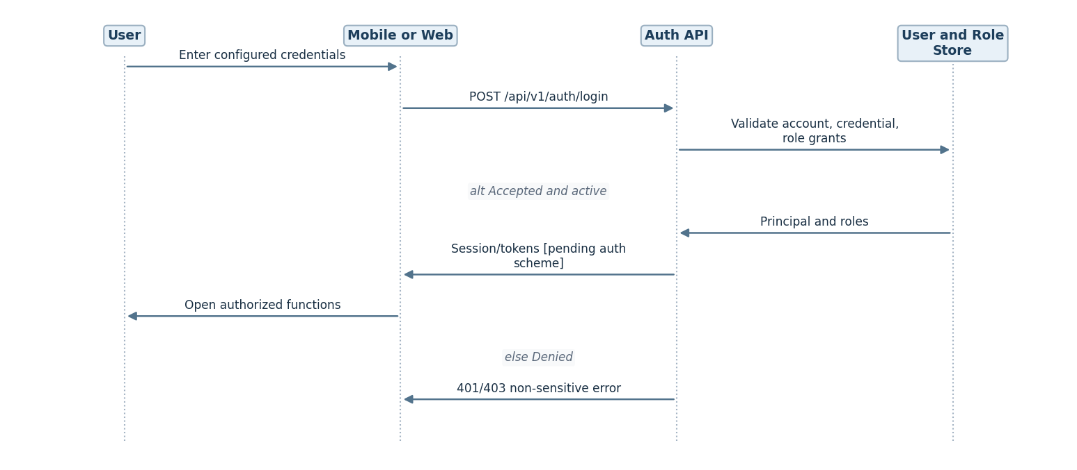
D-05: Authentication sequence
The scheme is intentionally illustrative; OAuth/OIDC versus locally managed credential storage remains OI-001.

22. Authorization and Role-Based Access Control
Resource / action | Worker | Site Leader | Driver | Management/HR | Maintenance | Enrollment Staff
Verified attendance | Own | If also worker | If also worker | — | — | —
Biometric enrollment | Participant | TBD | — | TBD | — | Authorized [derived]
Create/geofence edit | — | Authorized | — | Deactivate confirmed | — | —
Assign workers | — | Authorized / TBD | — | TBD | — | —
Submit shift report | — | Authorized | — | — | — | —
QR claim + inspections | — | — | Own session | — | — | —
Attendance/report archive | — | Own context TBD | — | Authorized | TBD | —
Fleet history/maintenance alerts | — | — | Own context TBD | Authorized | Scoped / TBD | —
Flag review + site deactivation | — | — | — | Authorized | Scoped alerts TBD | —
Audit events | — | — | — | Authorized | — | —
Policy evaluation: require authentication, then role permission, then ownership/scope for every API request; never trust UI-hidden actions as authorization. A user with multiple roles receives permission unions only within their authorized site/vehicle scopes. Create/update site decisions are evaluated again when offline actions sync. Authorization for worker assignment, maintenance and enrollment is not settled; the table intentionally preserves OI-002/003/008. API control includes IDOR prevention for all {id} resources and deny-by-default for unspecified routes.

23. Location and Geofencing Design
Specified baseline. The proposal describes and the SRS defines a circular geofence by center latitude, center longitude, and radius in meters (FR-SITE-002..004). This is not an unresolved circle-vs-polygon choice: use circles for v1. A polygon geometry would be a future scope change requiring revised site requirements, migration and approval.
Device fix: capture GNSS-reported lat/lon, horizontal accuracy (if exposed), location timestamp, monotonic acquisition time, and mock-provider/integrity signals. Reject stale, invalid or impossible coordinates; numeric accuracy and border tolerance remain OI-006/007. Calculate proximity only against cached assigned, active, and valid-at-capture site versions. Require successful liveness and face match in the same verification attempt. The server reevaluates geometry and assignment against the applicable version after sync and flags conflict instead of rewriting original evidence.
Offline: the client requires a signed/revisioned cached site+roster snapshot; without reliable cached authority, state is unverified/pending review, not a guaranteed valid attendance. Whether stale site revocations invalidate otherwise locally valid events is OI-020 and OI-022. Mock-location flags improve risk detection but cannot detect all signal-level spoofing, rooted-device tampering, relay attacks or replayed evidence. Privacy: check-in/out location only during the attendance attempt, distinct from continuous fleet tracking.
Boundary model | Fits SRS? | Advantages | Limitations | Conclusion
Circle: center + radius | Yes | Small payload; cheap on-device haversine; easy site-leader UI | Awkward irregular site borders | Adopt for v1
Polygon: list of vertices | Not specified | Follows irregular drilling-property boundary | Editing and edge tolerance complexity; new schema/rules | Future change request only

24. Geofence Verification Algorithm
For each currently assigned active site, calculate great-circle distance by Haversine:
(a = ^2(/2)+(_1)(_2)^2(/2)), (d=2R(a,)), with coordinates in radians and R ≈ 6,371,000 m. Compare d against radius_m only if location-age and reported horizontal accuracy satisfy approved limits. Exact edge policy (for example “distance + accuracy <= radius” for conservative acceptance) is a recommendation pending OI-006/007, not an approved threshold. Do not treat a location whose uncertainty circle crosses a boundary as unequivocally inside. Test anti-meridian/radian conversion, impossible latitudes, site overlap, low accuracy, frozen fixes and stale GPS. If multiple geofences match, worker/site assignment and selected site must determine intended attribution; no automatic site guessing without approved rule.
D-06 — Attendance location/identity decision.
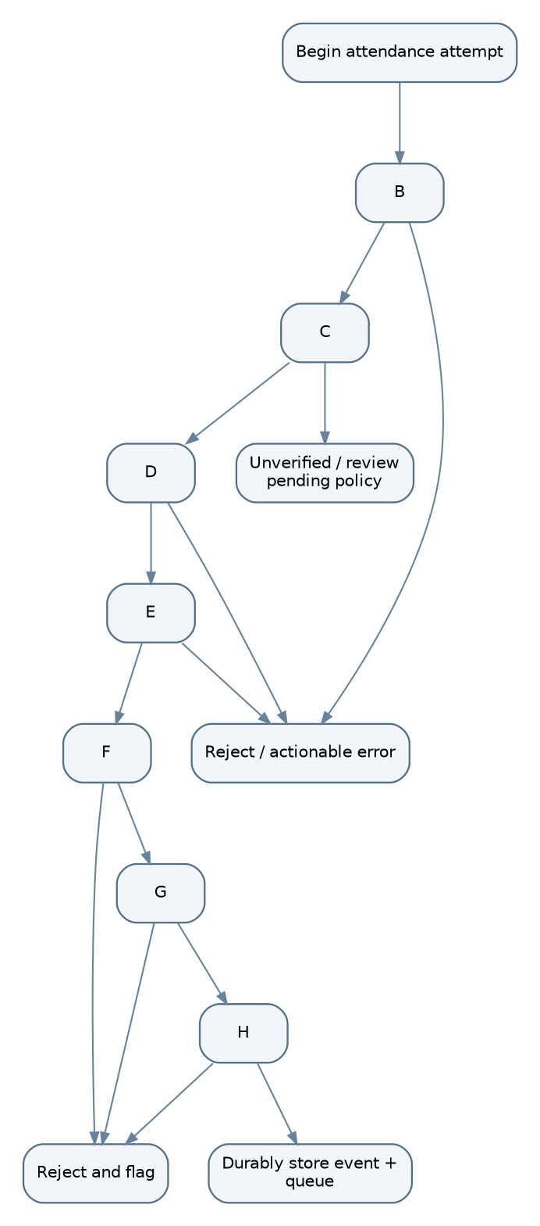
D-06: Attendance location/identity decision
Acceptance depends on all checks and a valid identity/site context at capture. Accuracy and cached-permission governance are still awaiting approval.

25. Fleet Location Architecture
Criterion | Driver phone GPS | Dedicated vehicle tracker / OBD2 | Existing tracking provider API | Hybrid
Accuracy | Phone GNSS; device-dependent | Device/installation-dependent | Vendor-dependent | Can cross-check
Reliability | Battery, permissions, app lifecycle dependent | Vehicle-powered; hardware health dependent | Provider uptime dependent | Best coverage if managed
Cost | Low up-front; battery/data impact | Hardware + install + subscription | Subscription/API fees | Highest integration cost
Tamper resistance | Lower against driver control | Higher against casual app tampering; still vulnerable | Depends on provider trust | Better cross-evidence
Integration | Mobile background APIs | Hardware vendor protocol/API | Existing API credentials/integration | Multiple adapters and reconciliation
Offline behavior | Local buffering on phone | Tracker store-forward if supported | Vendor-specific offline buffering | More failure paths
Pilot feasibility | Recommended pilot | Evaluate for production | Only if existing fleet service | Not for initial seven-person pilot
[Recommended design – pending stakeholder approval, OI-017]. Implement a VehicleLocationProvider interface with PhoneGpsProvider for the pilot and a future Obd2Provider/third-party provider. Tracking begins at claim and stops at release; TripLocation.source, captured_at, received_at, accuracy and freshness always travel with each point. A separate route distance is retained from odometer-derived custody distance; reconciliation rule is OI-019. Never label a stale last-known coordinate “live.” A hardware tracker does not automatically prove a specific individual drove the vehicle; driver–vehicle binding still comes from authenticated custody claim and inspection evidence.

26. Media and Evidence Storage
Proposed upload path: (1) capture required images/voice note into app-private encrypted local storage; (2) attach device capture time, GPS, session/vehicle or report ID, SHA-256, MIME and size; (3) persist event/media outbox transactionally; (4) request /media/uploads/init after connectivity; (5) upload compressed bytes to a short-lived private URL using chunk/resume support if provider allows; (6) confirm with /media/{id}/complete; (7) server rechecks actual content type, checksum, ownership and minimum completeness; (8) link media evidence and mark parent inspection/report synchronized. The database stores metadata and access controls; the object store holds binary bytes.
Security: private buckets; no public ACLs; server-verified parent ownership; time-limited GET grants; malware/type checks; EXIF metadata minimized or extracted only under defined evidence policy; client local encryption; object keys not derived from worker names. Retention, format allowlist, upload size, compression targets and deletion policy are [PENDING OI-013/023]. Biometric enrollment is different: raw facial enrollment captures must be discarded after embedding generation and must not flow through normal MediaObject storage. Failing upload never silently produces a complete inspection at server; locally captured evidence remains pending with visible sync status.

27. Detailed Sequence Diagrams
All sequences show the conceptual domain flow. On disconnected devices, local capture succeeds only for workflows the SRS allows offline, and the network request happens later via /api/v1/sync/events; server acceptance is a separate outcome. Captured timestamps and receiving timestamps must remain distinguishable. The source uses VehicleSession consistently for custody and Trip for movement. Authentication sequence is D-05 in §21.
D-07 — Biometric enrollment sequence.
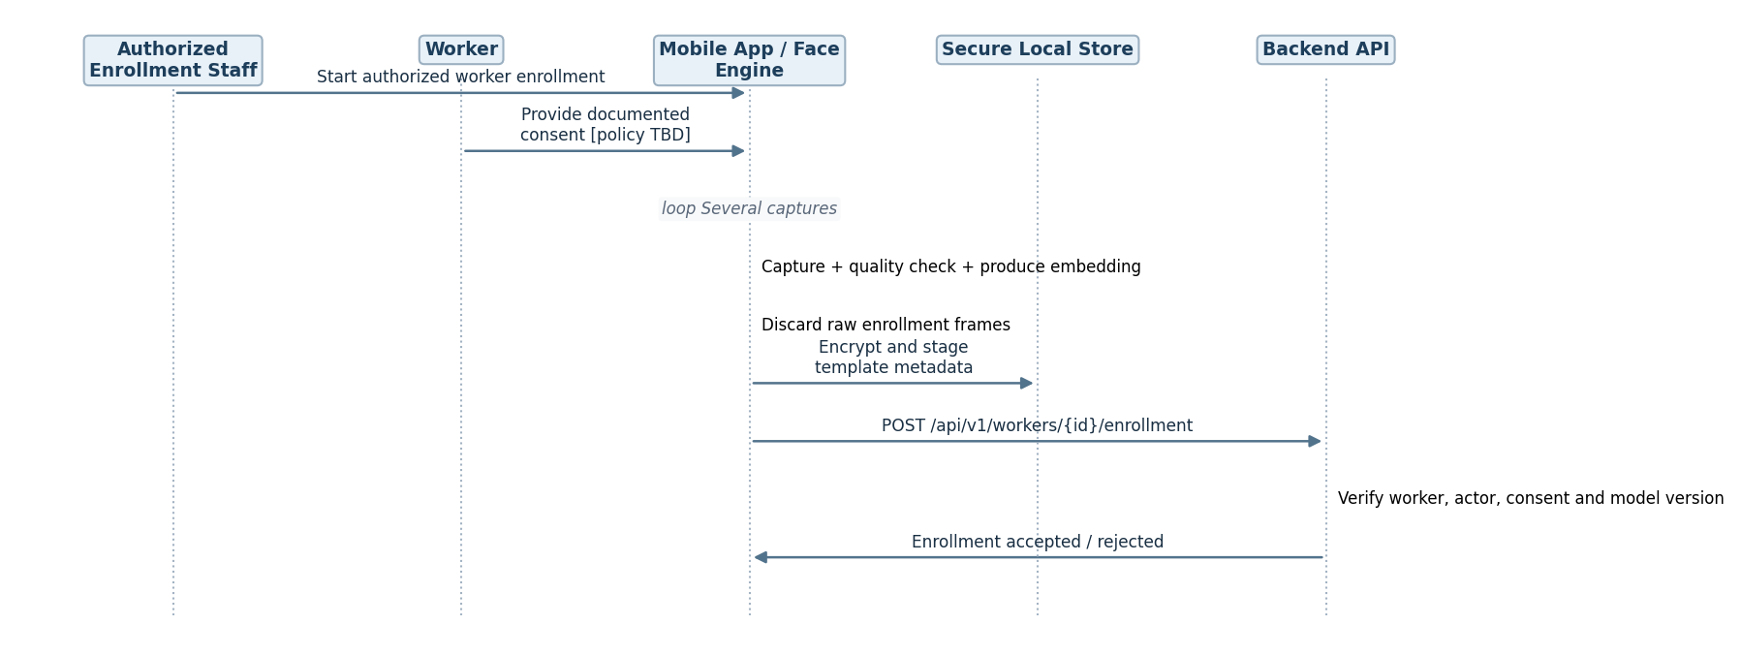
D-07: Biometric enrollment sequence
Consent wording and who may enroll remain OI-002/OI-026. No raw enrollment photo is stored or uploaded.
D-08 — Verified check-in sequence.
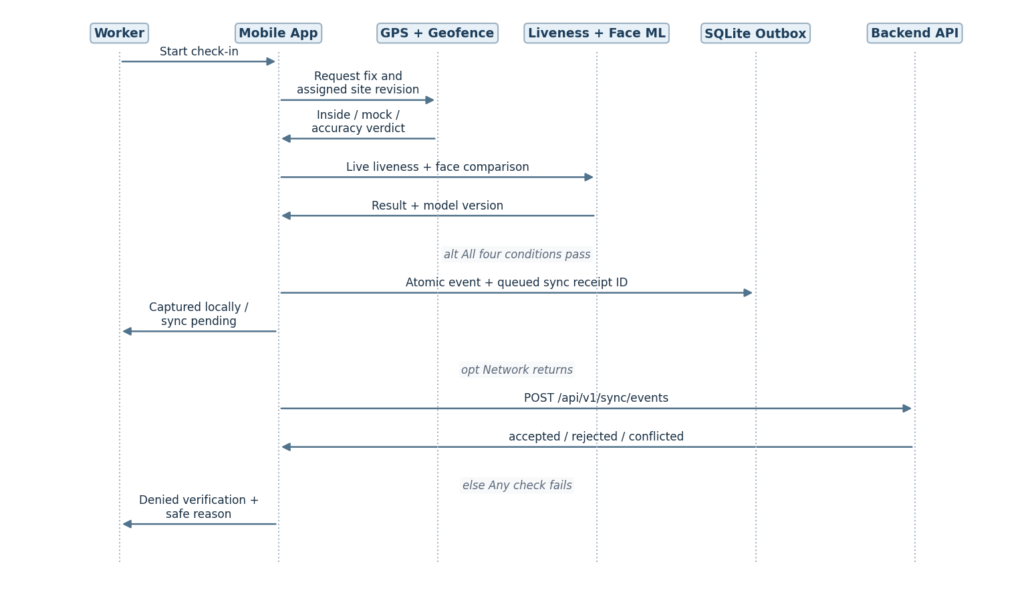
D-08: Verified check-in sequence
Online POST /attendance/check-in uses the same domain validation. Do not turn a locally successful capture into an authoritative server acceptance before sync.
D-09 — Verified check-out and worked-hours sequence.
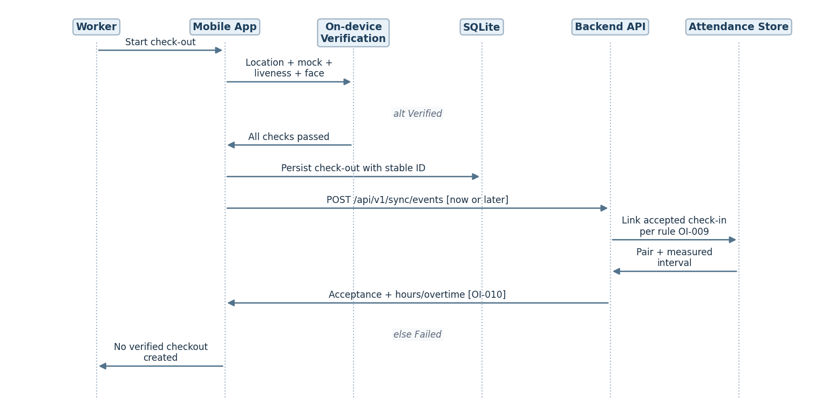
D-09: Verified check-out and worked-hours sequence
The same four checks apply to check-out. Missing pair, duplicates and payroll exception pathways remain OI-009/010.
D-10 — Site creation sequence.
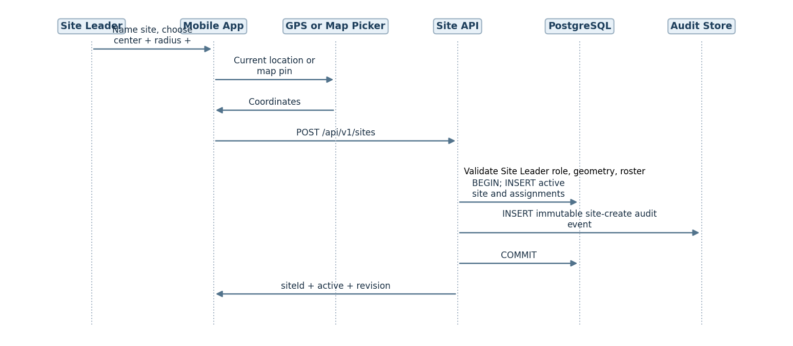
D-10: Site creation sequence
Newly created site becomes active after authorized creation; offline activation/global site policy is OI-020 and must not be assumed.
D-11 — Twelve-hour shift report sequence.
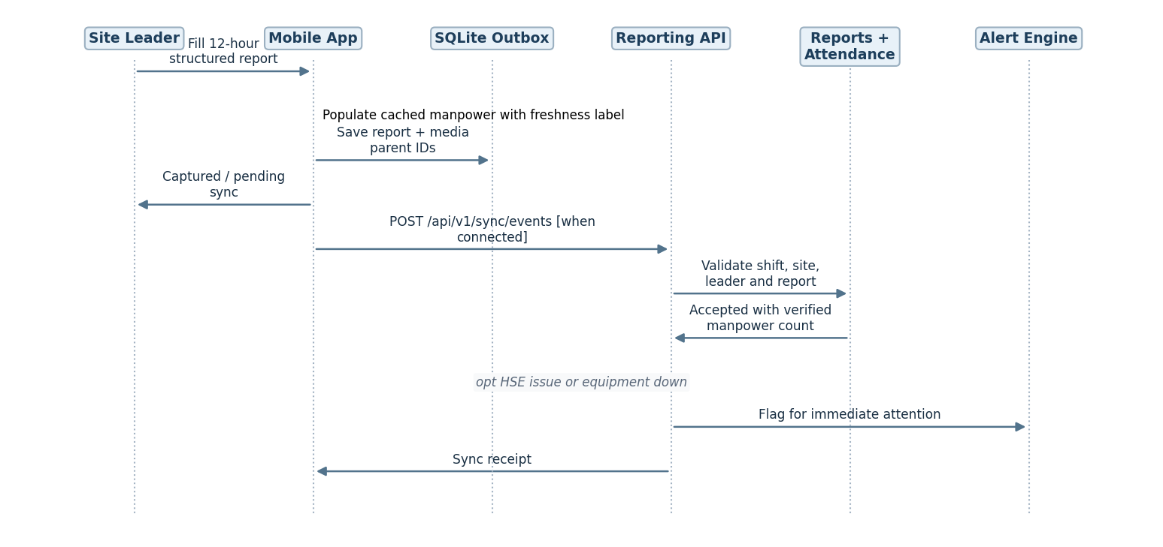
D-11: Twelve-hour shift report sequence
The back end calculates accepted verified manpower from authoritative attendance; offline display is provisional. Missed window scheduler is independent of device availability and can be reconciled later.
D-12 — QR vehicle assignment sequence.
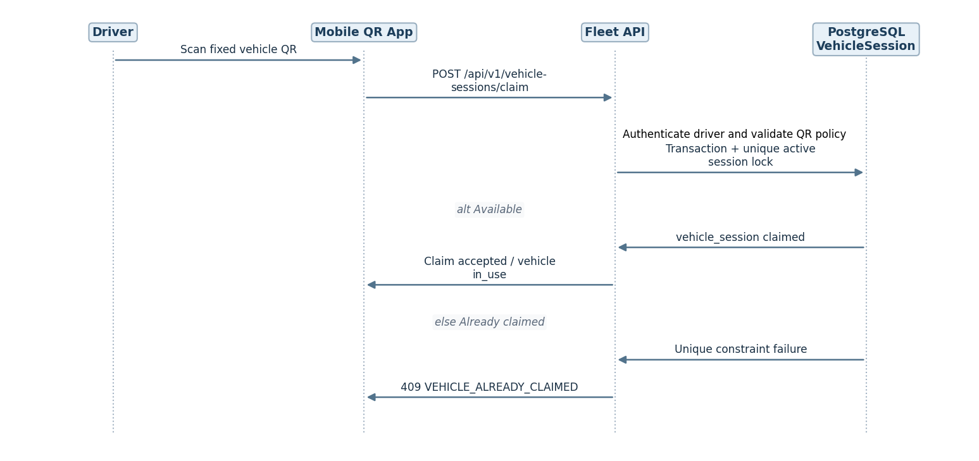
D-12: QR vehicle assignment sequence
No cloud-wide lock can be guaranteed while both claiming devices are disconnected. For offline claim, explicitly preserve OI-020 and show provisional/not-accepted behavior pending approval.
D-13 — Pre-trip inspection sequence.
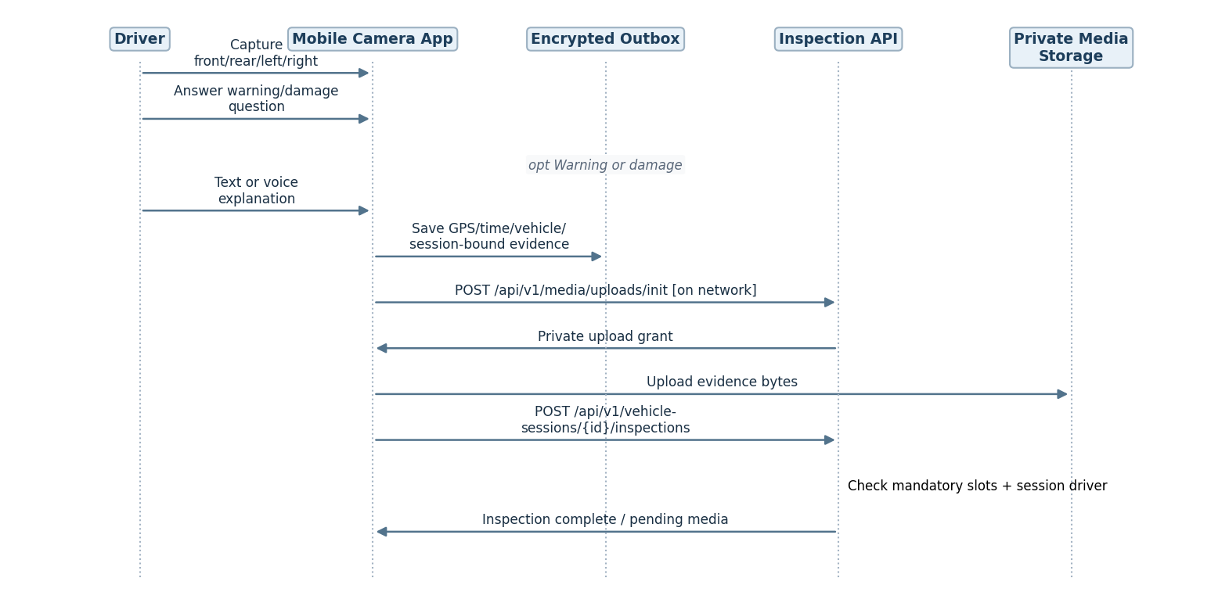
D-13: Pre-trip inspection sequence
Trip start remains gated until all mandatory pre-trip items are valid. The offline policy for “locally complete, server pending” inspection is a distinct system status.
D-14 — Trip-start sequence.
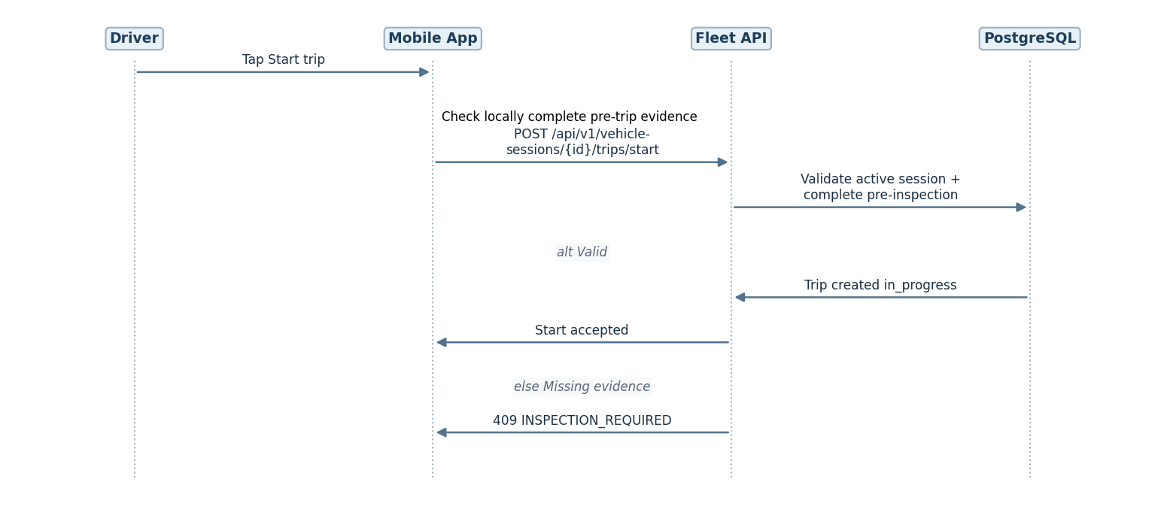
D-14: Trip-start sequence
Per proposal the tracking service starts at claim, not only after pressing “Start trip”; trip-start gate controls the operational trip state, not the start of custody-scoped sampling.
D-15 — Trip tracking sequence.
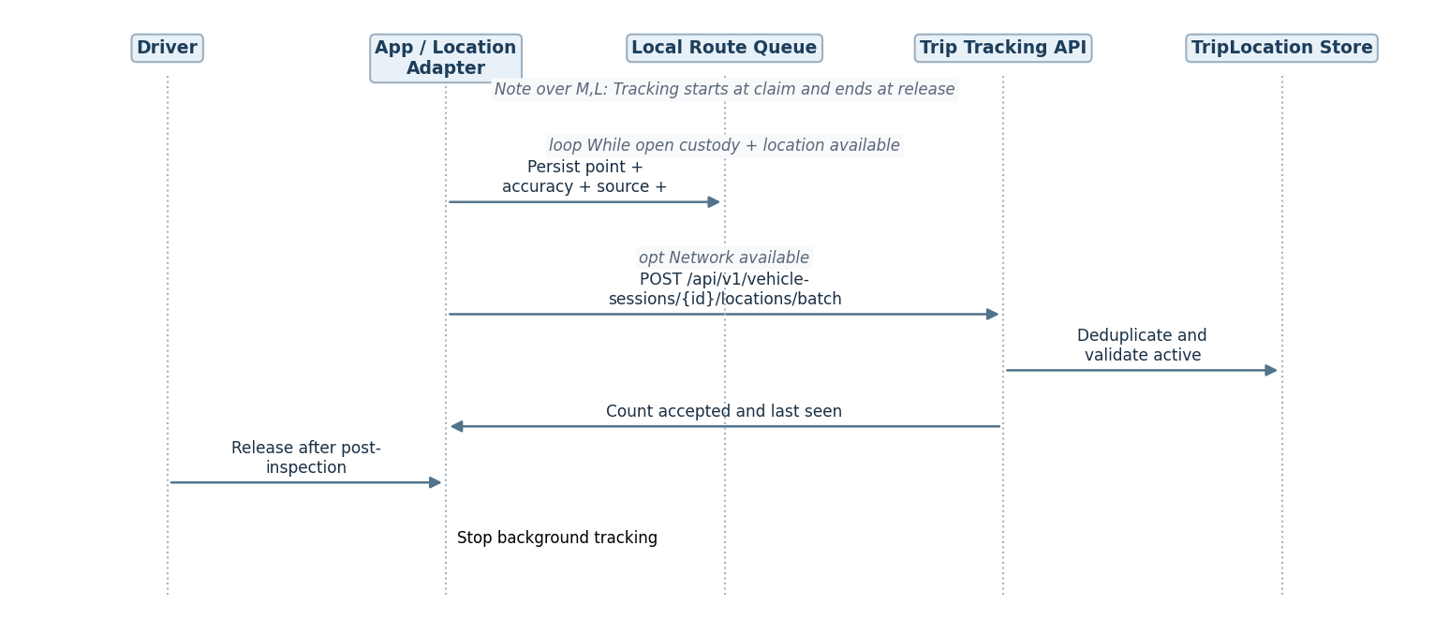
D-15: Trip tracking sequence
The “live” map displays the latest synchronized point with freshness timestamp; history may fill in later.
D-16 — Trip completion sequence.
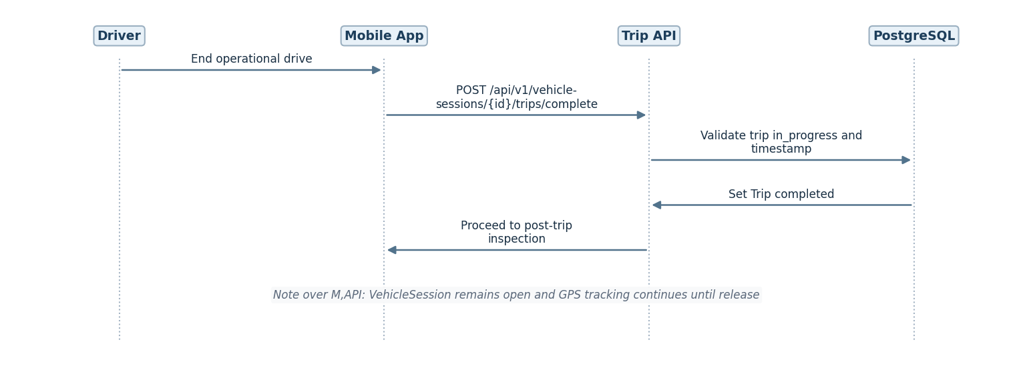
D-16: Trip completion sequence
The distinction between trip completion and custody release prevents violating the proposal’s tracking scope.
D-17 — Post-trip inspection sequence.
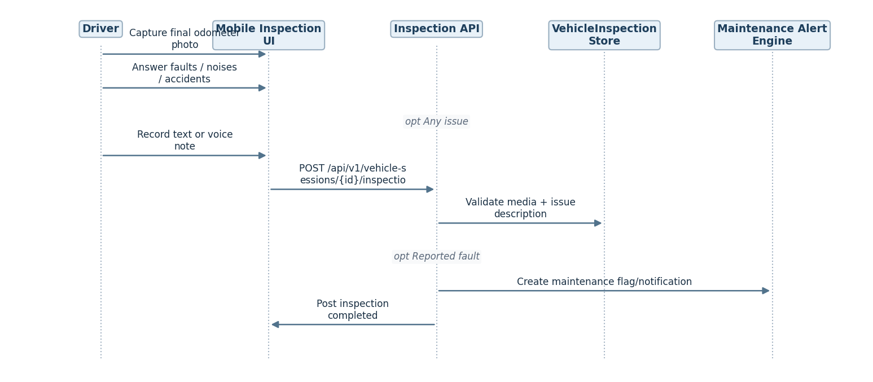
D-17: Post-trip inspection sequence
Odometer reading interpretation and reconciliation with GPS distance must be defined (OI-019).
D-18 — Custody release and sync sequence.
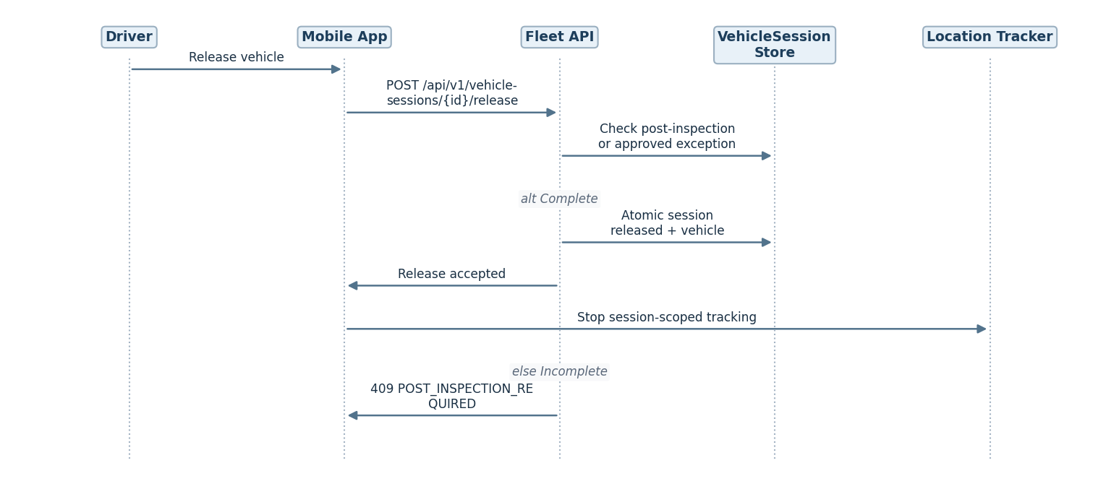
D-18: Custody release and sync sequence
A failed final server call in the desert is the core OI-020 custody conflict; phone should cease unauthorized tracking only according to approved offline release policy, while preserving captured end evidence.

28. State Diagrams and Transition Rules
D-19 — Attendance lifecycle per worker/site/shift.
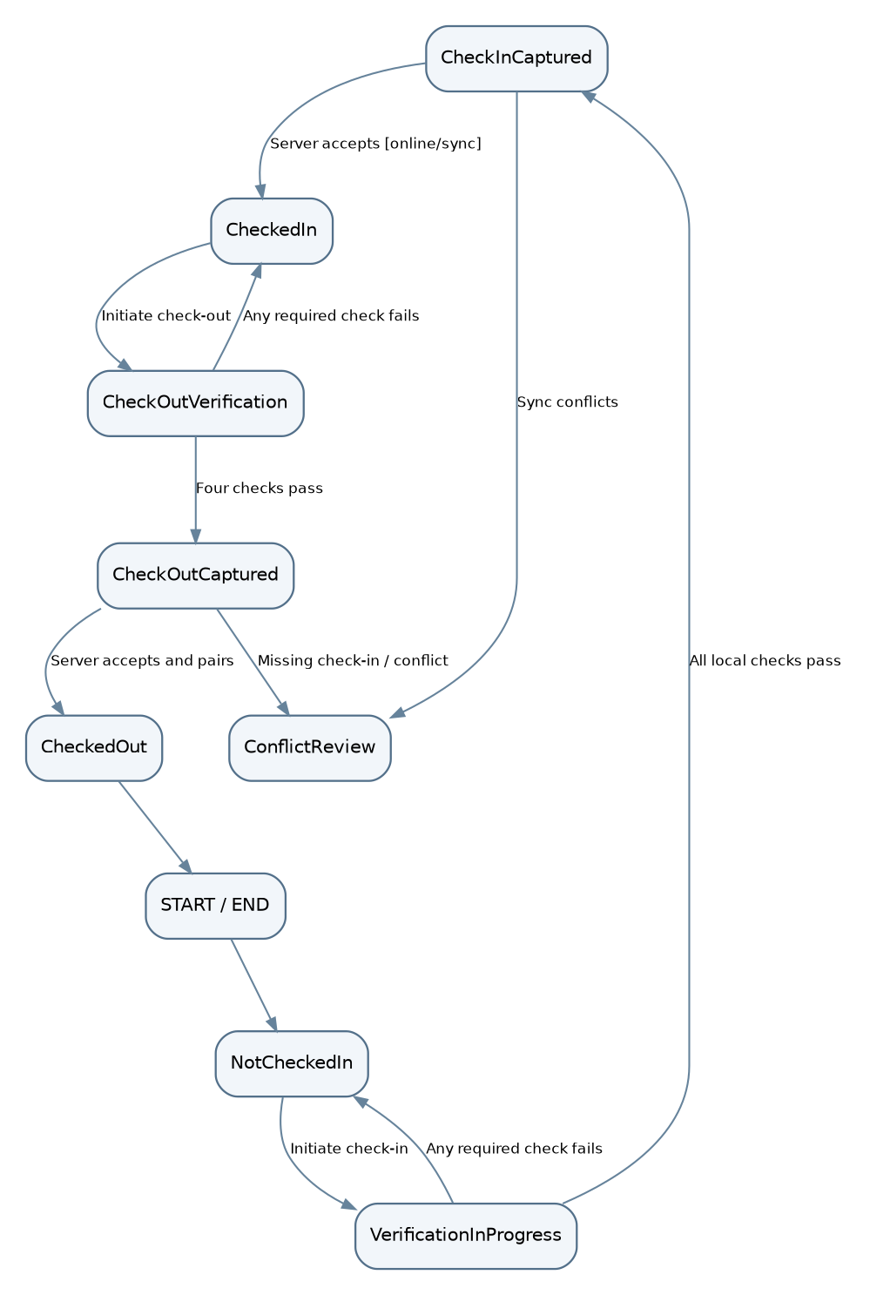
D-19: Attendance lifecycle per worker/site/shift
NotCheckedIn etc describe a projection, not the row status enum for attendance_events. Every captured event also has pending/accepted/rejected/flagged server-acceptance status. Repeated/missing event policy OI-009 may add exception transitions; invalid transitions must not fabricate verified attendance.
D-20 — Vehicle custody session lifecycle.
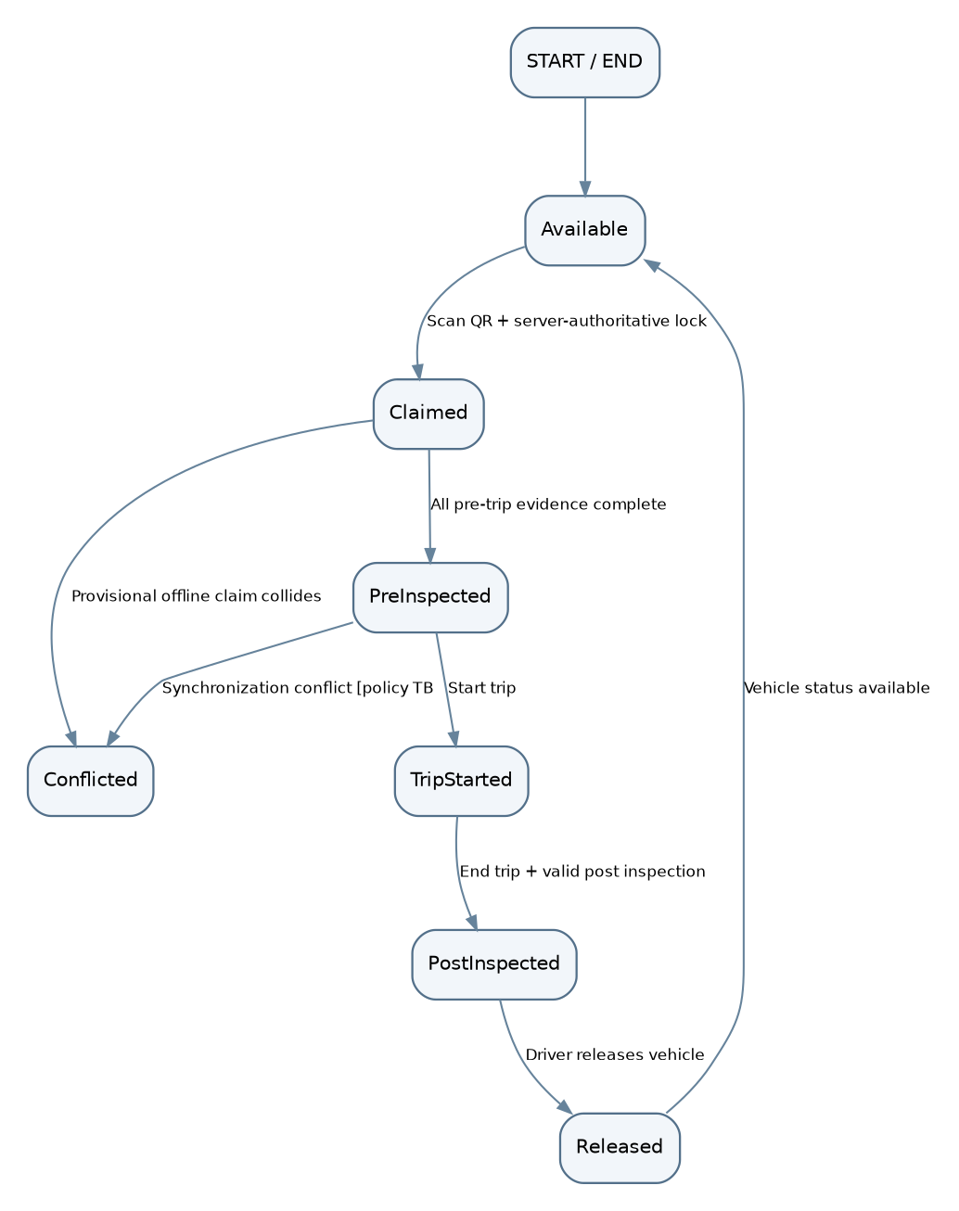
D-20: Vehicle custody session lifecycle
States map to vehicle_sessions.status (claimed, pre_inspected, trip_started, post_inspected, released, conflicted) with Available as vehicles.status=available. Claim is authoritative only with a server lock. Whether post-trip can be completed without a distinct trip-start action is OI-015. Emergency release is OI-016 and is deliberately not assumed.
D-21 — Trip lifecycle.
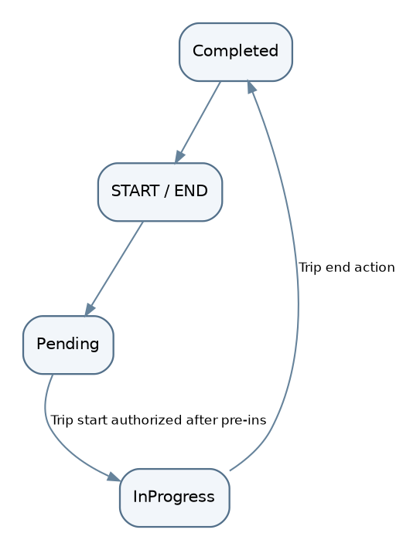
D-21: Trip lifecycle
Trip.status is pending / in_progress / completed. Vehicle custody continues from QR claim until release even after the trip is completed; no direct trip-end release. A broken device must not silently bypass post-inspection.
Transition validation checklist. The service checks actor ownership, expected prior state, idempotency ID, revision, required evidence completeness, capture-time plausibility and applicable site/vehicle status. Invalid transitions return 409 without modifying historical data. Offline-captured state is a provisional mobile projection and may diverge from authoritative server state; it cannot be converted into two accepted owners of the same vehicle.

29. High-Level Domain Class Diagram
D-22 — Domain classes and core associations.
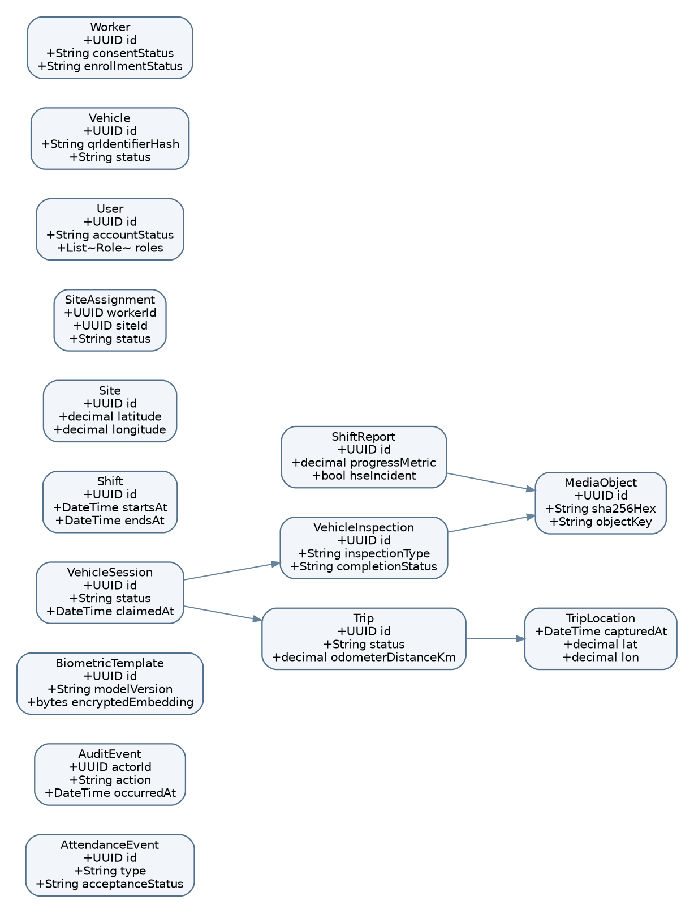
D-22: Domain classes and core associations
Associations distinguish domain parent/child from attachment references. MediaObject is not stored inside a report/inspection row; links are represented by evidence_links. No inheritance is added solely for illustration.

30. Service and Repository Class Design
Class / interface | Primary method(s) | Responsibility / invariants | Dependencies
AuthService | authenticate, revoke, principalFor | Validate account/role/session | UserRepo, RoleRepo, security provider
EnrollmentService | enrollWorker, deactivateTemplate | Enforce consent/role, encrypt template | WorkerRepo, TemplateRepo
LocationVerificationService | evaluateFix(siteSnapshot, fix) | Haversine/accuracy/mock/staleness | DeviceLocationProvider
FaceVerificationService | verifyLiveness, compareEmbedding | On-device face model policy | ML runtime, SecureTemplateStore
AttendanceService | captureLocal, acceptSyncedEvent, pairShift | All-four checks evidence, server rules | AttendanceRepo, SiteRepo, ShiftRepo
SiteService | createSite, reviseSite, deactivateSite | RBAC, revision, immutable audit | SiteRepo, AuditService
ShiftReportService | validateReport, submitReport, escalateMissed | 12-hour report/incident flow | ShiftRepo, AttendanceRepo, MediaService
VehicleSessionService | claim, startTrip, release | Single accepted active session, gated transitions | VehicleRepo, SessionRepo
InspectionService | validateEvidence, finalizeInspection | Photo/answers/issue gating | InspectionRepo, MediaService
TripService | appendLocations, completeTrip, calculateDistance | Custody-scoped route and distance | TripRepo, LocationProvider
SyncService | acceptBatch, generateReceipt, reconcile | Deduplication, durable receipts, retry policy | SyncReceiptRepo, domain handlers
NotificationService | queue, deliver, escalate | Idempotent schedule and fault notifications | NotificationRepo, AlertRepo
AuditService | appendEvent, listAuthorized | Append-only critical actions | AuditRepo
Repository interfaces | get, save, updateIfRevision | Persist with DB transactions and clear ownership | PostgreSQL + object storage
Recommended service boundaries coincide with SRS modules, but preserve one deployable process for the pilot. The mobile implementation of LocationVerificationService, FaceVerificationService, and local AttendanceService must not require a network call. Backend AttendanceService checks evidence consistency and authoritative permissions; it cannot magically re-perform liveness after sync without retaining sensitive data. This limitation must be reflected in the threat model.

31. Security Architecture
31.1 Identity and sessions. Authenticate using the OI-001-approved mechanism, enforce account status for each protected write, rotate/revoke refresh tokens if adopted, and authenticate scheduled services with short-lived machine credentials. Local biometrics verify an attendance claim and must not replace user login.
31.2 Authorization. Deny by default; check action role plus entity ownership and site scope in service and query layer. Management access does not imply unrestricted access to biometric templates. Enforce MFA for privileged roles if approved [PENDING OI-001].
31.3 Passwords. Under a local-credential option only, hash using Argon2id, unique salt and appropriately tuned parameters. No plaintext logs or reversible password storage. Password recovery and lockout remain OI-001.
31.4 API protection. HTTPS/TLS, strict JSON schemas, IDOR checks, input size limits, scoped upload grants, event idempotency, CORS allowlist for web, CSRF protection if cookie-based sessions selected, and safe error envelopes.
31.5 Data layer. Restricted service accounts, encrypted disks/backups, parametrized SQL, separate readonly analytics access, least-privilege DB migrations, uniqueness constraints, encrypted template fields, and tested restore.
31.6 Transport. TLS between clients/API and backend dependencies; do not expose the database or object store publicly. Signed uploads expire quickly and reference one authorized parent.
31.7 Media/evidence. Compute SHA-256 on device and verify after upload; bind to event/session/vehicle, capture time and location; preserve private ACLs; quarantine invalid MIME/file payloads; inspect malicious uploads with approved service if deployed.
31.8 Location controls. Capture GPS accuracy/timestamps/provider flags; Haversine local geofence; server review of cached revision/assignment; mock-location detection; conservative unknown state on poor accuracy; suspicious pattern review. These controls do not guarantee anti-spoofing.
31.9 Fleet tracking. Consent/purpose-limited custody window; stop collection at release; never silently track outside a session; staff access to routes is scoped/audited; prevent stale points looking live.
31.10 Audit protection. Atomic site-change audit inserts, write-once service permission, restricted read, rotation and backup, optional hash-chain tamper-evidence; log access to sensitive records.
31.11 Admin security. Role-filtered dashboards, explicit privileged confirmations, no trust in front-end role routing, logged site deactivations and exceptional fleet overrides [PENDING OI-016].
31.12 Device security. Secure key storage, app-private encryption, disable debug logging of templates, protect local media, attempt root/emulator/integrity signals only as defense in depth, clear local data under approved logout/revocation policies. Cannot guarantee sensor signals against fully compromised devices.

32. Threat Model
Threat | Target | Likelihood* | Impact* | Mitigation / residual risk
Proxy check-in by colleague | Attendance | Medium | High | Live face match + liveness; spoofed/compromised sensor remains
Photo/video replay | Biometrics | Medium | High | Active challenge with variation; ML bypass residual
Mock GPS / GNSS spoof | Geofence | High | High | OS flag, accuracy, timestamp, anomaly detection; hardware-level spoof persists
Malicious geofence change | Site trust | Medium | High | Site-leader RBAC, append-only audit, management deactivation
Stolen account/token | Protected API | Medium | High | Short-lived sessions, revocation, MFA recommendation; offline revocation lag
Cloned/replaced QR | Vehicle identity | Medium | High | QR binding/physical inspection, signed code design option OI-014; not foolproof
Two offline drivers claim same vehicle | Fleet custody | High | Critical | No reliable exclusive lock offline; block or provisional policy OI-020
Replay/duplicate sync event | Integrity | High | High | Stable event ID, payload hash, receipts/unique constraints
Altered photo/odometer | Inspection evidence | Medium | High | Hash, GPS/time binding, guided capture; cannot independently prove vehicle photographed
IDOR/resource guessing | History/privacy | Medium | High | Object-scoped authz for all endpoints
SQL injection/file upload abuse | Backend/media | Medium | High | Parameterized SQL, parser limits, MIME/content validation, least privilege
Biometric template leak | Privacy | Medium | Critical | Encryption, restricted access, consent/retention policy; templates remain sensitive
Audit log tampering | Governance | Low | High | Append-only DB role, chain/backup/alerts; privileged insider risk persists
Clock manipulation | Attendance/custody | Medium | High | Server time + monotonic/device drift checks; offline exact time uncertainty OI-022
*Likelihood and impact are qualitative design-team estimates, not supplied risk measurements; confirm with the partner. Threat priorities should be revisited after a penetration/privacy review. No control removes all residual risk, particularly malicious/rooted phones and signal-level GPS manipulation.

33. Location Spoofing and Anti-Fraud Design
Primary controls required by SRS: enforce assigned active site geofence, OS mock-location provider check, active liveness challenge, and enrolled face match simultaneously for each attendance attempt (BR-001 / FR-WFV-016). Any failure means “not verified.” Bind resulting event to user, worker, site revision, device-reported GPS/time, model version and outcomes. Retain flagged attempts only according to approved privacy rule OI-027.
Defense in depth [DESIGN]: GNSS quality threshold; capture-age/clock plausibility; device integrity signals; signed config snapshots; comparison against implausible jumps or impossible travel; bounded retries and random challenges; server-side geofence recomputation at sync; admin case review. Exact cutoffs and response ladders are OI-004–007/022/028. Defenders must never replace a failed liveness/match with “location good enough.”
Known limitations: phone GPS attests a device-reported location, not immutable physical presence; camera ML provides probabilistic similarity, not identity certainty. A strong adversary can tamper with GPS at signal level or with a compromised device. Do not report these controls as unbreakable in performance metrics or external audit.

34. Data Protection and Privacy
Data class | Why collected | Storage/visibility | Retention / lifecycle
Worker account and role | Authorization, accountability | Restricted users/roles | OI-023
Face embedding | Attendance identity comparison | Encrypted local/template store, restricted server access if distributed | Consent + withdrawal OI-026; no raw enrollment images
Attendance GPS + time | Site/time verification | Encrypted event data; HR/site filtered | OI-023
Trip route and custody | Vehicle accountability | Open session only; restricted fleet dashboard | Tracking stops on release; retention OI-023
Inspection photos/voice | Vehicle condition evidence | Private object store + metadata ACLs | OI-013/023
Shift HSE/incident notes | Operational/safety reporting | Restricted reports + alert view | OI-023
Audit and flagged attempts | Traceability and security review | Protected immutable audit/case view | OI-027 for failed ML attempts
Purpose boundaries: attendance GPS capture is event-based, while continuous route samples are collected only inside an open vehicle custody session (NFR-PRIV-002). Minimize precision/retention where operational value does not justify indefinite storage. Encrypted biometric embeddings can still be sensitive/re-identifying and should not be described as necessarily irreversible. Obtain explicit written decisions covering lawful basis, biometric consent, withdrawal, deletion, export and legal-hold workflows (OI-023/026) before production deployment. For a pilot, use anonymized test identities and avoid real biometric data unless appropriate consent and safeguards are in place.

35. Encryption and Key Management
In transit: require modern TLS for mobile and web HTTPS connections, internal API/database connection as deployed, and object-store signed upload/download. At rest: encrypted PostgreSQL volumes/backups, encrypted object storage, encrypted SQLite and media app-private directories using OS keystore-managed secrets. Field-level: AES-GCM or equivalent authenticated encryption for face embeddings, with distinct key access path and rotation plan. Credentials: Argon2id (only if using local password authentication), never reversible encryption. Store secrets in managed secret storage/environment injection, not source control, mobile bundles or CI logs. Rotate compromised keys; define key-escrow/recovery and deletion with partner [PENDING]. A hash of an image proves bytes unchanged relative to a recorded hash, not that its depicted vehicle/time are truthful.

36. Audit Logging Specification
Event | Actor | Minimum audit content | Failure behavior
CREATE_SITE / MODIFY_SITE / DEACTIVATE_SITE | Site Leader / Management | site ID, before/after approved fields, actor, timestamp, request ID | Abort site mutation if audit write fails
ENROLL_WORKER | Enrollment actor | worker ID, template version, consent reference; no raw face | Enforce consent and authority
ATTENDANCE_ACCEPT / FLAG | Worker / system | event ID, site/worker, result; minimal location | Retain failed attempts only after OI-027
VEHICLE_CLAIM / RELEASE | Driver | session/vehicle/driver IDs, server and capture times | Atomic state mutation + audit insert
INSPECTION_COMPLETE / ISSUE | Driver | evidence IDs and status without public media URLs | Flag missing evidence/fault
REPORT_SUBMIT / REPORT_MISSED | Site Leader / scheduler | site/shift/report IDs, event type/time | Idempotent escalation
AUTH_DENIED / RBAC_DENIED | User/system | target action and outcome, sanitized origin | Rate limit/monitor; redact credentials
SYNC_CONFLICT / REPLAY | System | event ID, payload digest, conflict code | Preserve both claims for adjudication
Central audit_events records id, actor, action, entity type/ID, server occurred_at, result, correlation, sanitized metadata and optional chained hashes. Audit records for site changes are immutable under application-level credentials; independent backup or secured log sink raises confidence. Maintenance/administrator access to history is logged. The broader audit events above are design extensions justified by the SRS accountability objective; site create/modify immutability is the explicit MUST.

37. Error Handling Architecture
Client classes: PermissionDenied, DeviceSensorUnavailable, LocationUncertain, VerificationRejected, LocalStorageFailed, PendingSync, ConflictNeedsReview, MediaUploadFailed, ServerUnavailable. Field screens show clear next actions, never cryptographic details or face scores. Offline PendingSync is a status, not an error or proof of backend acceptance.
Server classes: schema validation 422; authentication 401; authorization 403; nonexistent in scope 404; uniqueness/revision/transition conflict 409; payload/rate limits 413/429; transient 503; unexpected 500. Errors use stable codes from §20 and always include a correlation ID. Database exceptions are translated at module boundaries; clients do not receive SQL stack traces.
Policy-dependent errors: clock drift (OI-022), offline vehicle collision (OI-020), emergency device failure on post-trip (OI-016), missing check-in (OI-009), stale geofence (OI-006/007/020) must have a defined adjudication path before roll-out. Failing a mandatory camera/verification step may allow retry but never fabricate verified evidence.

38. Offline and Weak Connectivity Design
Operation | Offline allowed? | Local storage | Server sync | Conflict/qualification
View cached assigned sites | Yes if valid snapshot | Signed/revisioned site cache | Refresh on connection | Stale revocation OI-020
Verified check-in/out | Yes when four checks available | AttendanceEvent + outbox atomic | Required for authoritative acceptance | Site/shift/clock/duplicate conflicts
New biometric enrollment | Model local yes, approval policy TBD | Encrypted template only | Required | Who enrolls/consents OI-002/026
Create/activate site | Form capture possible; activation TBD | Pending site proposal | Required before globally active | Other workers cannot see un-synced site
Shift report submission | Yes | Report + optional media outbox | Required | Late/missed window + manpower freshness
QR claim vehicle | Blocking decision | Only provisional if approved | Required global lock | Concurrent disconnected claims unsolvable locally
Pre/post inspections | Yes after valid session policy | Private encrypted media + form | Required for authoritative evidence | Photo completeness, claim conflict
Trip location tracking | Yes while custody open | Buffered route points | Required | Battery/storage/freshness OI-018/021
Media upload | No network upload; capture yes | Encrypted pending files | Required after connectivity | Incomplete parent until upload verified
Admin dashboard live view | No new field data offline | Server last synchronized | Live on connectivity | Stale badge and last seen time
Outbox algorithm [DESIGN]: assign stable eventId before capture; commit event + outbox row in one SQLite transaction; preserve capture timestamp and payload hash; order same-session dependencies (claim -> pre inspection -> trip start -> trip complete -> post inspection -> release) during replay. Retry network/server transient failures using exponential backoff + jitter, and do not retry deterministic 4xx endlessly. Media uploads resume separately but are referenced by parent event and must be verified before server completion. POST /sync/events routes events to same domain handlers as online APIs; sync_receipts.event_id and domain unique constraints prevent duplicates. Local statuses: captured, pending, uploading, accepted, rejected, conflicted, retrying; after acceptance preserve original evidence, never rewrite captured_at. A conflict is retained for authorized resolution, not silently “last write wins.”
Two critical boundaries: (1) a disconnected client cannot know that the server has deactivated a site; decide whether prior signed snapshot is temporarily authoritative or requires later review. (2) two independent disconnected phones cannot prove exclusive custody. Proposed safe default is disable authoritative vehicle claim while offline, retaining claim form/inspection drafts only; the operational impact must be agreed (OI-020). The proposal also says field vehicle records are captured offline: this tension is an explicit design issue, not a decision to discard offline requirements.

39. Caching Strategy
Cached item | Expiry/invalidation | Security | Reason
Assigned active sites + geofence revisions | Signed snapshot TTL [TBD], invalidate on sync | Encrypt and bind to account | Offline check-in
Worker encrypted embedding/model | Version/consent-aware; revoke when online | OS-keystore key, no raw photo | On-device face comparison
Shift schedule + reporting windows | Periodic update; revision/version | Scope to assigned sites | 12-hour report and overtime
Vehicle QR/identity reference | Verified latest revision; QR trust OI-014 | No broad fleet roster necessary | Scan in the field
Queued attendance/reports/media | Until receipt or approved resolution | Encrypted local storage | Survive outages/reboot
Route points | Until confirmed/retention threshold OI-021 | Custody-scoped encryption | Offline trip capture
Clear protected caches at account switch/logout according to the approved retention and revocation policy. Persist integrity/version metadata with every cached item and event so later sync can identify which policies existed at event time. A cache miss is not permission to accept unverified attendance.

40. Concurrency and Data Consistency
Vehicle claim: PostgreSQL partial unique index on accepted active sessions plus a single transaction for status/claim. Retried eventId returns original receipt; conflicting different eventId returns 409, preserving audit. Release: require current driver, expected session revision and valid post-inspection; transition session and projected vehicles.status atomically. Site updates: optimistic revision compare-and-swap; audit insert in same transaction; stale offline actions flagged for adjudication. Attendance: stable event ID and separate approved duplicate check-in rule OI-009. Shift reports: unique ID and optional revision chain; exactly-one active report policy after OI-012. Trip points: point UUID + trip/timestamp ordering and sample filtering; do not treat resend as new travel. Media: deduplicate upload by media ID + SHA-256, but do not share authorization across parent records implicitly. Exactly-once physical execution is not assumed; the objective is idempotent logical acceptance.

41. Notification Architecture
Trigger | Producer | Recipient/view | Delivery semantics | Trace
Shift report window opens | Shift scheduler | Site Leader notification | Local scheduled notification may assist offline; server authority on sync | FR-REPORT-002; FR-NOTIF-001
Shift report missed window | Shift scheduler | Management escalation + flag | Idempotent (shiftId, triggerType) | FR-REPORT-003..004; FR-NOTIF-002
Report HSE/equipment issue | Report module | Admin flags | Immediate when synchronized | FR-REPORT-018; FR-NOTIF-004
Post-trip mechanical issue | Inspection module | Maintenance view/management | Immediate when synchronized; offline pending noted | FR-FLEET-027; FR-NOTIF-003
Implementation: NotificationService stores queued delivery attempts, dispatches to chosen push/in-app/email provider adapters, tracks queued/sent/failed/[acknowledged], and retries failures without multiplying flag cases. [PENDING OI-011 / OI-005] actual channels, reminder repeats, acknowledgement and escalation policy are not specified. In a disconnected site, “immediate alert” means as soon as server receives the evidence; the dashboard cannot receive unsynchronized events.

42. Deployment Architecture
D-23 — Pilot deployment architecture.
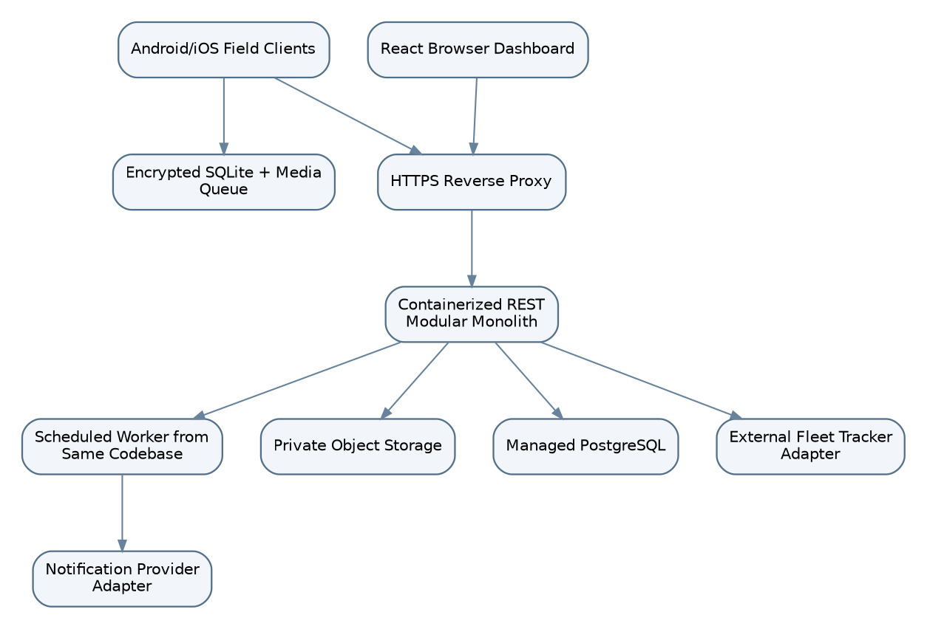
D-23: Pilot deployment architecture
Use segregated development, staging and production environments where feasible, independent credentials/buckets and test datasets. Load balancer is optional at initial pilot scale, not a mandate for microservices or Kubernetes.
Development: local containers for API/PostgreSQL and mock object storage; emulator/device location and fake biometric data. Staging: isolated private test users and synthetic route/media; representative device matrix, rate-limit, offline conflict tests. Production/pilot: HTTPS, managed Postgres with backups, private object storage, monitored API and scheduled worker, limited site rollout. Deploy backend/worker from same versioned artifact with leader election or DB advisory lock for scheduled jobs to prevent double escalations. CI checks migrations, OpenAPI compatibility, tests, secret scanning, and rollout/rollback gates. Cloud vendor and exact resource sizing [TBD].

43. Environment Configuration
Configuration keys (illustrative, never commit values): DATABASE_URL, OBJECT_STORAGE_BUCKET, OBJECT_STORAGE_ENDPOINT, AUTH_ISSUER, AUTH_AUDIENCE, TOKEN_SECRET_REFERENCE, MAPS_API_KEY_REFERENCE, MEDIA_MAX_BYTES, SYNC_BATCH_LIMIT, DEVICE_POLICY_VERSION, APP_ENV, LOG_LEVEL, NOTIFICATION_PROVIDER_REFERENCE. Store production secrets in managed secret vault/CI injection; device public map keys must be restricted at the provider. Application config may specify supported model revisions and shift schedule IDs, but thresholds are policy inputs, not guessed constants (OI-004/006/007). Separate migrations, service accounts and buckets for dev/staging/prod; mask private locations/embeddings in diagnostics.

44. Scalability Design
Expected growth: sites start around two or three concurrently (proposal §2); no precise worker/fleet counts or SLOs are supplied (OI-025). PostgreSQL normalized entities scale naturally for site/worker/vehicle management; the most write-intensive domain is trip_locations. Approximate point volume by N_vehicles × active_hours × 3600 / sampling_interval_seconds; interval and active count are [TBD OI-018/025]. Report/inspection media may dominate storage bytes, while attendance dominates timestamped structured events at high headcount.
Capacity levers [DESIGN]: paginate archive APIs; use indexes in §15; stream/limit route batches; downsample dashboard map visualization without destroying approved raw evidence; compress/upload media separately; rotate/partition trip_locations only after volume and retention are measured; scale stateless API replicas before splitting services; offload file bytes to object storage. Evaluate alert/sync worker throughput with burst tests simulating reconnect of multiple field sites. No invented requests/sec, latency SLA or fleet sampling interval is treated as a requirement.

45. Reliability and Fault Tolerance
Failure | System behavior | Persistence / recovery
Mobile loses network | Continue locally authorized capture, queue | SQLite transaction, backoff resend
Backend down | Reject new server authorization; keep local evidence | Retry safely; acknowledge only after durable commit
PostgreSQL unavailable | Fail central claim/write; no false success | Backups + controlled recovery; vehicle lock remains unresolved offline
Object storage down | Retain encrypted local media; mark pending | Resumable upload; do not finalize evidence
GPS unavailable or inaccurate | Do not accept verified attendance | Actionable error; hardware/accuracy policy OI-006
Face model fails/camera denied | No verified attendance event | Retry/fallback only after OI-005 approval
Notification provider fails | Persist queued notification with idempotent trigger | Worker retry/monitor delivery
Device lost/corrupted before sync | Potential unsynced evidence loss; cannot reconstruct verified events | Encrypted backup feasibility and recovery OI-021/023
Concurrent offline QR claims | Cannot guarantee single exclusive driver | Safe hold/provisional arbitration OI-020

46. Performance Design
Path | Design choice | Metric requiring approval
Check-in/out verification | On-device ML and circle test; no network round-trip | Verification seconds/false rate OI-004/025
SQLite capture | Atomic insert event + outbox before success | Max durable-save latency OI-025
Sync API | Bounded batch, stable IDs, transaction handlers | Reconnect drain duration, error ratio OI-025
Dashboard | Indexed site/time queries + paginated archives + freshness | Near-live refresh target OI-025
Trip points | Compact batches, indexes, optional late partitioning | Sampling/battery/storage OI-018
Media | Compression, separate resumable uploads | Max bytes/format and upload target OI-013
Database | Explain analyze representative high-volume paths | Users/sites/vehicle concurrency OI-025

47. Observability and Monitoring
Use structured backend logs keyed by correlationId, eventId, siteId or sessionId where authorized; never log face vectors, enrollment frames, access tokens, full location traces or media bodies. Metrics: API success/error/latency by route; outbox lag, sync conflict/retry rates, queued bytes, stale fleet location age, current active vehicle sessions, missed report escalations, notification delivery failures, media upload checksum errors, DB lock waits, sensor denial rates and model false accept/reject evaluation under approved test settings. Health endpoints must separate service liveness from DB/object-store readiness; do not reveal internals publicly. Security alerts on repeated auth denials, QR collision bursts, unusual geofence edits, replay attempts and audit write failures. Dashboards display source timestamps so consumers distinguish event time from sync arrival.

48. Backup and Recovery
Back up PostgreSQL with encrypted point-in-time recovery if deployment supports it, object metadata and blobs with cross-checkable hashes, service configs, and protected audit logs. Test a restoration into staging and verify referential consistency between media_objects and actual blobs; restore vehicle_sessions before reopening new claims, to avoid duplicate locks. Define RPO/RTO only after OI-025, backups/retention under OI-023, and device-outbox recovery under OI-021. Because unsynchronized local records are not in backend backup, display explicit pending state and plan data-loss treatment with stakeholders. Secure all backup credentials and deletion/restore permissions.

49. Testing and Verification Considerations
System area | Critical tests | Mapped criteria
Authentication + RBAC | Unauthenticated access, role escalation, IDOR, deactivation | AC-AUTH-001; FR-AUTH-*
On-device face/liveness | Dust/light/device variation; photo/replay; thresholds and consent | AC-WFV-001/002; NFR-ENV-003
Geofence | Haversine boundary, accuracy, stale GPS, mock provider, overlapping sites | AC-WFV-001/002; OI-006/007
Hours | Check-in/out linking, duplicate/missing case, overtime shift | AC-WFV-003; OI-009/010
Sites | Current GPS vs map pin; audit atomicity; deactivation | AC-SITE-001/002
Reports | 12h window, offline, verified manpower, HSE flag, missed escalation | AC-REPORT-001/002
Vehicle sessions | Parallel SQL claims, offline two-phone collision, QR substitution | AC-FLEET-001; OI-014/020
Inspection gate | Five required pre photos, GPS/time, issue description, final odometer | AC-FLEET-002/004
Trip tracking | Begins claim, stops release, stale map, source substitution | AC-FLEET-003/005
Sync | Retry, crash/restart, duplicate ID, changed hash replay, conflict receipt | AC-SYNC-001
Media | Lost upload, partial checksum, owner ACL, malicious MIME | NFR-REL-005; NFR-SEC-008
Security/privacy | No retained raw enrollment face, encryption, tracked-only-during-custody | AC-PRIV-001; NFR-PRIV-002
Admin | Fresh/stale position, flagged issues, role-scoped archives | AC-ADMIN-001
QA should create automated API contract tests from OpenAPI; property-based location and state-machine tests; concurrency tests with two simultaneous claims; reconnect storms with identical and mutated event IDs; migration/backup restore drills; and field usability tests. Verification acceptance cannot be signed off until quantitative performance thresholds and the 28 open questions are resolved by their owners.

50. Design Traceability Matrix
Design component | SRS requirements | Database entity / store | API(s) | Diagrams
Authentication + RBAC | FR-AUTH-001..009; NFR-SEC-001..002 | users, roles, user_roles | /auth/login, /users, /me | D-05
Biometric enrollment | FR-WFV-001..004; NFR-PRIV-001/004 | workers, biometric_templates | /workers/{id}/enrollment | D-07
Attendance verifier | FR-WFV-005..018; NFR-PERF-001 | attendance_events, sites, workers | /attendance/check-in; /sync/events | D-06, D-08
Hours and checkout | FR-WFV-019..029 | attendance_events, shifts | /attendance/check-out | D-09, D-19
Site creation + governance | FR-SITE-001..011; NFR-SEC-005 | sites, site_assignments, audit_events | /sites, /sites/{id}/deactivate | D-10
12-hour reporting | FR-REPORT-001..021 | shifts, shift_reports, evidence_links | /shift-reports | D-11
Fleet claim + release | FR-FLEET-001..006,028..032 | vehicles, vehicle_sessions | /vehicle-sessions/claim, /release | D-12, D-18, D-20
Pre/post inspection | FR-FLEET-007..017,023..027,031 | vehicle_inspections, media_objects | /inspections, /media | D-13, D-17
Trip tracking | FR-FLEET-018..024,033..034; NFR-PRIV-002 | trips, trip_locations | /locations/batch, /trips/start | D-14..16, D-21
Administrative dashboard | FR-ADMIN-001..010 | flagged_events, audit_events | /admin/flags, /admin/vehicle-positions | D-01/02/03
Offline sync | FR-SYNC-001..010; NFR-REL-001..006 | sync_receipts; client outbox | /sync/events, /sync/receipts | D-03, D-08/09
Notifications | FR-NOTIF-001..005 | notifications, flagged_events | /notifications | D-11, D-17
Confidentiality + audit | NFR-SEC-003..010; NFR-PRIV-001..006 | audit_events, media_objects, biometric_templates | /admin/audit-events; /media | D-02, D-23
Availability and environment | NFR-AVAIL-001..002; NFR-ENV-001..006 | client SQLite, server stores | /sync/events | D-02/03/23
Performance, scalability, portability | NFR-PERF-001..005; NFR-SCAL-001..002; NFR-COMP-001..003 | all tables | all routes | D-02, D-23
Usability + maintainability | NFR-USA-001..005; NFR-MAINT-001..002 | client cache and all domain stores | all routes | D-02
Complete requirements coverage inventory (generated from every formal FR/NFR row in SRS v1.0). The family link below is a trace-to-module path; precise design actions appear in the sections and diagrams cited above. The inventory deliberately keeps each SRS ID rather than claiming that unapproved TBDs have been solved.
Exact SRS ID | Design owner | Design section(s) | Figure(s)
FR-AUTH-001 | Auth/RBAC | §§21–22 | D-05
FR-AUTH-002 | Auth/RBAC | §§21–22 | D-05
FR-AUTH-003 | Auth/RBAC | §§21–22 | D-05
FR-AUTH-004 | Auth/RBAC | §§21–22 | D-05
FR-AUTH-005 | Auth/RBAC | §§21–22 | D-05
FR-AUTH-006 | Auth/RBAC | §§21–22 | D-05
FR-AUTH-007 | Auth/RBAC | §§21–22 | D-05
FR-AUTH-008 | Auth/RBAC | §§21–22 | D-05
FR-AUTH-009 | Auth/RBAC | §§21–22 | D-05
FR-WFV-001 | Workforce/Attendance | §§8.2–8.3, 23–24 | D-06–09
FR-WFV-002 | Workforce/Attendance | §§8.2–8.3, 23–24 | D-06–09
FR-WFV-003 | Workforce/Attendance | §§8.2–8.3, 23–24 | D-06–09
FR-WFV-004 | Workforce/Attendance | §§8.2–8.3, 23–24 | D-06–09
FR-WFV-005 | Workforce/Attendance | §§8.2–8.3, 23–24 | D-06–09
FR-WFV-006 | Workforce/Attendance | §§8.2–8.3, 23–24 | D-06–09
FR-WFV-007 | Workforce/Attendance | §§8.2–8.3, 23–24 | D-06–09
FR-WFV-008 | Workforce/Attendance | §§8.2–8.3, 23–24 | D-06–09
FR-WFV-009 | Workforce/Attendance | §§8.2–8.3, 23–24 | D-06–09
FR-WFV-010 | Workforce/Attendance | §§8.2–8.3, 23–24 | D-06–09
FR-WFV-011 | Workforce/Attendance | §§8.2–8.3, 23–24 | D-06–09
FR-WFV-012 | Workforce/Attendance | §§8.2–8.3, 23–24 | D-06–09
FR-WFV-013 | Workforce/Attendance | §§8.2–8.3, 23–24 | D-06–09
FR-WFV-014 | Workforce/Attendance | §§8.2–8.3, 23–24 | D-06–09
FR-WFV-015 | Workforce/Attendance | §§8.2–8.3, 23–24 | D-06–09
FR-WFV-016 | Workforce/Attendance | §§8.2–8.3, 23–24 | D-06–09
FR-WFV-017 | Workforce/Attendance | §§8.2–8.3, 23–24 | D-06–09
FR-WFV-018 | Workforce/Attendance | §§8.2–8.3, 23–24 | D-06–09
FR-WFV-019 | Workforce/Attendance | §§8.2–8.3, 23–24 | D-06–09
FR-WFV-020 | Workforce/Attendance | §§8.2–8.3, 23–24 | D-06–09
FR-WFV-021 | Workforce/Attendance | §§8.2–8.3, 23–24 | D-06–09
FR-WFV-022 | Workforce/Attendance | §§8.2–8.3, 23–24 | D-06–09
FR-WFV-023 | Workforce/Attendance | §§8.2–8.3, 23–24 | D-06–09
FR-WFV-024 | Workforce/Attendance | §§8.2–8.3, 23–24 | D-06–09
FR-WFV-025 | Workforce/Attendance | §§8.2–8.3, 23–24 | D-06–09
FR-WFV-026 | Workforce/Attendance | §§8.2–8.3, 23–24 | D-06–09
FR-WFV-027 | Workforce/Attendance | §§8.2–8.3, 23–24 | D-06–09
FR-WFV-028 | Workforce/Attendance | §§8.2–8.3, 23–24 | D-06–09
FR-WFV-029 | Workforce/Attendance | §§8.2–8.3, 23–24 | D-06–09
FR-SITE-001 | Site management | §§8.4, 23, 40 | D-10
FR-SITE-002 | Site management | §§8.4, 23, 40 | D-10
FR-SITE-003 | Site management | §§8.4, 23, 40 | D-10
FR-SITE-004 | Site management | §§8.4, 23, 40 | D-10
FR-SITE-005 | Site management | §§8.4, 23, 40 | D-10
FR-SITE-006 | Site management | §§8.4, 23, 40 | D-10
FR-SITE-007 | Site management | §§8.4, 23, 40 | D-10
FR-SITE-008 | Site management | §§8.4, 23, 40 | D-10
FR-SITE-009 | Site management | §§8.4, 23, 40 | D-10
FR-SITE-010 | Site management | §§8.4, 23, 40 | D-10
FR-SITE-011 | Site management | §§8.4, 23, 40 | D-10
FR-REPORT-001 | Shift reporting | §§8.5, 41 | D-11
FR-REPORT-002 | Shift reporting | §§8.5, 41 | D-11
FR-REPORT-003 | Shift reporting | §§8.5, 41 | D-11
FR-REPORT-004 | Shift reporting | §§8.5, 41 | D-11
FR-REPORT-005 | Shift reporting | §§8.5, 41 | D-11
FR-REPORT-006 | Shift reporting | §§8.5, 41 | D-11
FR-REPORT-007 | Shift reporting | §§8.5, 41 | D-11
FR-REPORT-008 | Shift reporting | §§8.5, 41 | D-11
FR-REPORT-009 | Shift reporting | §§8.5, 41 | D-11
FR-REPORT-010 | Shift reporting | §§8.5, 41 | D-11
FR-REPORT-011 | Shift reporting | §§8.5, 41 | D-11
FR-REPORT-012 | Shift reporting | §§8.5, 41 | D-11
FR-REPORT-013 | Shift reporting | §§8.5, 41 | D-11
FR-REPORT-014 | Shift reporting | §§8.5, 41 | D-11
FR-REPORT-015 | Shift reporting | §§8.5, 41 | D-11
FR-REPORT-016 | Shift reporting | §§8.5, 41 | D-11
FR-REPORT-017 | Shift reporting | §§8.5, 41 | D-11
FR-REPORT-018 | Shift reporting | §§8.5, 41 | D-11
FR-REPORT-019 | Shift reporting | §§8.5, 41 | D-11
FR-REPORT-020 | Shift reporting | §§8.5, 41 | D-11
FR-REPORT-021 | Shift reporting | §§8.5, 41 | D-11
FR-FLEET-001 | Fleet/Inspection/Trip | §§8.6–8.9, 25, 38 | D-12–18, D-20–21
FR-FLEET-002 | Fleet/Inspection/Trip | §§8.6–8.9, 25, 38 | D-12–18, D-20–21
FR-FLEET-003 | Fleet/Inspection/Trip | §§8.6–8.9, 25, 38 | D-12–18, D-20–21
FR-FLEET-004 | Fleet/Inspection/Trip | §§8.6–8.9, 25, 38 | D-12–18, D-20–21
FR-FLEET-005 | Fleet/Inspection/Trip | §§8.6–8.9, 25, 38 | D-12–18, D-20–21
FR-FLEET-006 | Fleet/Inspection/Trip | §§8.6–8.9, 25, 38 | D-12–18, D-20–21
FR-FLEET-007 | Fleet/Inspection/Trip | §§8.6–8.9, 25, 38 | D-12–18, D-20–21
FR-FLEET-008 | Fleet/Inspection/Trip | §§8.6–8.9, 25, 38 | D-12–18, D-20–21
FR-FLEET-009 | Fleet/Inspection/Trip | §§8.6–8.9, 25, 38 | D-12–18, D-20–21
FR-FLEET-010 | Fleet/Inspection/Trip | §§8.6–8.9, 25, 38 | D-12–18, D-20–21
FR-FLEET-011 | Fleet/Inspection/Trip | §§8.6–8.9, 25, 38 | D-12–18, D-20–21
FR-FLEET-012 | Fleet/Inspection/Trip | §§8.6–8.9, 25, 38 | D-12–18, D-20–21
FR-FLEET-013 | Fleet/Inspection/Trip | §§8.6–8.9, 25, 38 | D-12–18, D-20–21
FR-FLEET-014 | Fleet/Inspection/Trip | §§8.6–8.9, 25, 38 | D-12–18, D-20–21
FR-FLEET-015 | Fleet/Inspection/Trip | §§8.6–8.9, 25, 38 | D-12–18, D-20–21
FR-FLEET-016 | Fleet/Inspection/Trip | §§8.6–8.9, 25, 38 | D-12–18, D-20–21
FR-FLEET-017 | Fleet/Inspection/Trip | §§8.6–8.9, 25, 38 | D-12–18, D-20–21
FR-FLEET-018 | Fleet/Inspection/Trip | §§8.6–8.9, 25, 38 | D-12–18, D-20–21
FR-FLEET-019 | Fleet/Inspection/Trip | §§8.6–8.9, 25, 38 | D-12–18, D-20–21
FR-FLEET-020 | Fleet/Inspection/Trip | §§8.6–8.9, 25, 38 | D-12–18, D-20–21
FR-FLEET-021 | Fleet/Inspection/Trip | §§8.6–8.9, 25, 38 | D-12–18, D-20–21
FR-FLEET-022 | Fleet/Inspection/Trip | §§8.6–8.9, 25, 38 | D-12–18, D-20–21
FR-FLEET-023 | Fleet/Inspection/Trip | §§8.6–8.9, 25, 38 | D-12–18, D-20–21
FR-FLEET-024 | Fleet/Inspection/Trip | §§8.6–8.9, 25, 38 | D-12–18, D-20–21
FR-FLEET-025 | Fleet/Inspection/Trip | §§8.6–8.9, 25, 38 | D-12–18, D-20–21
FR-FLEET-026 | Fleet/Inspection/Trip | §§8.6–8.9, 25, 38 | D-12–18, D-20–21
FR-FLEET-027 | Fleet/Inspection/Trip | §§8.6–8.9, 25, 38 | D-12–18, D-20–21
FR-FLEET-028 | Fleet/Inspection/Trip | §§8.6–8.9, 25, 38 | D-12–18, D-20–21
FR-FLEET-029 | Fleet/Inspection/Trip | §§8.6–8.9, 25, 38 | D-12–18, D-20–21
FR-FLEET-030 | Fleet/Inspection/Trip | §§8.6–8.9, 25, 38 | D-12–18, D-20–21
FR-FLEET-031 | Fleet/Inspection/Trip | §§8.6–8.9, 25, 38 | D-12–18, D-20–21
FR-FLEET-032 | Fleet/Inspection/Trip | §§8.6–8.9, 25, 38 | D-12–18, D-20–21
FR-FLEET-033 | Fleet/Inspection/Trip | §§8.6–8.9, 25, 38 | D-12–18, D-20–21
FR-FLEET-034 | Fleet/Inspection/Trip | §§8.6–8.9, 25, 38 | D-12–18, D-20–21
FR-ADMIN-001 | Web dashboard | §§8.12, 22 | D-01–03
FR-ADMIN-002 | Web dashboard | §§8.12, 22 | D-01–03
FR-ADMIN-003 | Web dashboard | §§8.12, 22 | D-01–03
FR-ADMIN-004 | Web dashboard | §§8.12, 22 | D-01–03
FR-ADMIN-005 | Web dashboard | §§8.12, 22 | D-01–03
FR-ADMIN-006 | Web dashboard | §§8.12, 22 | D-01–03
FR-ADMIN-007 | Web dashboard | §§8.12, 22 | D-01–03
FR-ADMIN-008 | Web dashboard | §§8.12, 22 | D-01–03
FR-ADMIN-009 | Web dashboard | §§8.12, 22 | D-01–03
FR-ADMIN-010 | Web dashboard | §§8.12, 22 | D-01–03
FR-SYNC-001 | Outbox + Sync | §§8.13, 38, 40 | D-03, D-08
FR-SYNC-002 | Outbox + Sync | §§8.13, 38, 40 | D-03, D-08
FR-SYNC-003 | Outbox + Sync | §§8.13, 38, 40 | D-03, D-08
FR-SYNC-004 | Outbox + Sync | §§8.13, 38, 40 | D-03, D-08
FR-SYNC-005 | Outbox + Sync | §§8.13, 38, 40 | D-03, D-08
FR-SYNC-006 | Outbox + Sync | §§8.13, 38, 40 | D-03, D-08
FR-SYNC-007 | Outbox + Sync | §§8.13, 38, 40 | D-03, D-08
FR-SYNC-008 | Outbox + Sync | §§8.13, 38, 40 | D-03, D-08
FR-SYNC-009 | Outbox + Sync | §§8.13, 38, 40 | D-03, D-08
FR-SYNC-010 | Outbox + Sync | §§8.13, 38, 40 | D-03, D-08
FR-NOTIF-001 | Notifications | §41 | D-11, D-17
FR-NOTIF-002 | Notifications | §41 | D-11, D-17
FR-NOTIF-003 | Notifications | §41 | D-11, D-17
FR-NOTIF-004 | Notifications | §41 | D-11, D-17
FR-NOTIF-005 | Notifications | §41 | D-11, D-17
NFR-PERF-001 | Performance | §46 | D-02
NFR-PERF-002 | Performance | §46 | D-02
NFR-PERF-003 | Performance | §46 | D-02
NFR-PERF-004 | Performance | §46 | D-02
NFR-PERF-005 | Performance | §46 | D-02
NFR-SEC-001 | Security | §§31–36 | D-02/23
NFR-SEC-002 | Security | §§31–36 | D-02/23
NFR-SEC-003 | Security | §§31–36 | D-02/23
NFR-SEC-004 | Security | §§31–36 | D-02/23
NFR-SEC-005 | Security | §§31–36 | D-02/23
NFR-SEC-006 | Security | §§31–36 | D-02/23
NFR-SEC-007 | Security | §§31–36 | D-02/23
NFR-SEC-008 | Security | §§31–36 | D-02/23
NFR-SEC-009 | Security | §§31–36 | D-02/23
NFR-SEC-010 | Security | §§31–36 | D-02/23
NFR-PRIV-001 | Privacy | §§33–35 | D-06/23
NFR-PRIV-002 | Privacy | §§33–35 | D-06/23
NFR-PRIV-003 | Privacy | §§33–35 | D-06/23
NFR-PRIV-004 | Privacy | §§33–35 | D-06/23
NFR-PRIV-005 | Privacy | §§33–35 | D-06/23
NFR-PRIV-006 | Privacy | §§33–35 | D-06/23
NFR-REL-001 | Reliability | §§38,45 | D-03
NFR-REL-002 | Reliability | §§38,45 | D-03
NFR-REL-003 | Reliability | §§38,45 | D-03
NFR-REL-004 | Reliability | §§38,45 | D-03
NFR-REL-005 | Reliability | §§38,45 | D-03
NFR-REL-006 | Reliability | §§38,45 | D-03
NFR-AVAIL-001 | Availability | §§38,45 | D-02
NFR-AVAIL-002 | Availability | §§38,45 | D-02
NFR-USA-001 | Mobile UI | §§7,37 | D-02
NFR-USA-002 | Mobile UI | §§7,37 | D-02
NFR-USA-003 | Mobile UI | §§7,37 | D-02
NFR-USA-004 | Mobile UI | §§7,37 | D-02
NFR-USA-005 | Mobile UI | §§7,37 | D-02
NFR-SCAL-001 | Scalability | §44 | D-23
NFR-SCAL-002 | Scalability | §44 | D-23
NFR-MAINT-001 | Services + tests | §§7,30,49 | D-22
NFR-MAINT-002 | Services + tests | §§7,30,49 | D-22
NFR-COMP-001 | Mobile/Web adaptation | §§7,42 | D-02/23
NFR-COMP-002 | Mobile/Web adaptation | §§7,42 | D-02/23
NFR-COMP-003 | Mobile/Web adaptation | §§7,42 | D-02/23
NFR-ENV-001 | Field constraints | §§23,38,49 | D-06
NFR-ENV-002 | Field constraints | §§23,38,49 | D-06
NFR-ENV-003 | Field constraints | §§23,38,49 | D-06
NFR-ENV-004 | Field constraints | §§23,38,49 | D-06
NFR-ENV-005 | Field constraints | §§23,38,49 | D-06
NFR-ENV-006 | Field constraints | §§23,38,49 | D-06
Coverage checksum: 176 unique formal FR/NFR identifiers were found in the uploaded SRS tables and assigned design owners. IDs expressed as ranges in the condensed matrix can be reconciled against this list before acceptance.

51. Architecture Decision Records (ADRs)

ADR-001 — Backend deployment topology
Status: Proposed. Context: FR-SYNC-006, FR-FLEET-006; NFR-MAINT-001. Options considered: Modular monolith vs microservices. Proposed decision: Modular monolith REST app. Rationale: Single SQL transaction, small team, lower ops overhead. Consequences/trade-offs: Scaling later by stateless replication; risk of module coupling. Approval owner: project technical lead and named partner stakeholder (refer to §52).

ADR-002 — Primary database
Status: Proposed. Context: SRS §8; FR-FLEET-006. Options considered: PostgreSQL vs document database vs hybrid. Proposed decision: PostgreSQL authoritative + SQLite local. Rationale: Proposal §8 relational PostgreSQL; strong integrity for custody. Consequences/trade-offs: Manage schema migrations/indexes. Approval owner: project technical lead and named partner stakeholder (refer to §52).

ADR-003 — Geofence representation
Status: Derived from approved baseline; edge policy TBD. Context: FR-SITE-002..004; FR-WFV-006. Options considered: Circle versus polygon. Proposed decision: Circle center+radius per SRS. Rationale: SRS explicitly defines radius and center. Consequences/trade-offs: Irregular boundaries approximate; edge tolerance OI-007. Approval owner: project technical lead and named partner stakeholder (refer to §52).

ADR-004 — Authentication
Status: Decision required OI-001. Context: FR-AUTH-001..009; NFR-SEC-010. Options considered: Existing IdP/OIDC vs local Argon2id + access/refresh session. Proposed decision: Prefer partner SSO/OIDC if available; else local managed login. Rationale: Minimize custom authentication code and simplify revocation. Consequences/trade-offs: Offline token policy and MFA remain undefined. Approval owner: project technical lead and named partner stakeholder (refer to §52).

ADR-005 — Mobile framework
Status: Decision required OI-024. Context: NFR-COMP-001; FR-WFV-013. Options considered: Flutter versus React Native + native ML bridges. Proposed decision: Benchmark Flutter and React Native against supported devices. Rationale: Cross-platform requirement but no framework dictated. Consequences/trade-offs: OS plugin and background GPS feasibility to test. Approval owner: project technical lead and named partner stakeholder (refer to §52).

ADR-006 — Offline event serialization
Status: Proposed / pending OI-020/021. Context: FR-SYNC-001..010. Options considered: Direct online CRUD vs event outbox with server receipts. Proposed decision: SQLite transactional outbox + idempotent sync. Rationale: Satisfies offline capture and retry. Consequences/trade-offs: Conflicts and retention require governance. Approval owner: project technical lead and named partner stakeholder (refer to §52).

ADR-007 — Fleet GPS source
Status: Decision required OI-017. Context: FR-FLEET-018..022/033. Options considered: Driver phone vs OBD2 hardware vs existing provider vs hybrid. Proposed decision: Phone GPS pilot with provider interface; evaluate OBD2 for rollout. Rationale: No up-front device cost; matches proposal evaluation. Consequences/trade-offs: Battery/permission/app integrity residual. Approval owner: project technical lead and named partner stakeholder (refer to §52).

ADR-008 — Offline exclusive fleet claim
Status: Blocking OI-020. Context: FR-FLEET-006/032; FR-SYNC-009. Options considered: Deny offline claim vs provisional claim vs online reservation tokens. Proposed decision: Safe default deny global claim while disconnected; partner review. Rationale: Cannot guarantee exclusivity independently on disconnected devices. Consequences/trade-offs: Offline vehicle operational delay conflicts with full offline promise. Approval owner: project technical lead and named partner stakeholder (refer to §52).

ADR-009 — Media evidence storage
Status: Proposed. Context: FR-FLEET-015; FR-REPORT-012. Options considered: DB BLOB vs private object store + DB metadata. Proposed decision: Object storage with signed grants, SHA-256 and evidence links. Rationale: Separates bytes from relational metadata. Consequences/trade-offs: Retention/security configurations required. Approval owner: project technical lead and named partner stakeholder (refer to §52).

ADR-010 — Historical correction policy
Status: Decision required OI-009/012/023. Context: FR-REPORT-020; SRS §11. Options considered: In-place rewrite vs append/supersede with audit. Proposed decision: Append/supersede under approval. Rationale: Preserve evidence chain and traceability. Consequences/trade-offs: More query complexity; retention/legal rules TBD. Approval owner: project technical lead and named partner stakeholder (refer to §52).

ADR-011 — Trip/session model
Status: Decision required OI-015. Context: FR-FLEET-018..031. Options considered: One trip per custody vs multiple trips per custody. Proposed decision: One trip per session pilot; confirm with fleet manager. Rationale: Smallest model consistent with proposal wording. Consequences/trade-offs: Migration and state machine revision if multi-trip required. Approval owner: project technical lead and named partner stakeholder (refer to §52).

52. Open Technical Issues and Stakeholder Decisions
The following 28 questions are copied in substance from SRS §15, with design recommendations explicitly labeled nonbinding. They are the gating worklist for moving this design from proposed to accepted. Each entry must be assigned a decision owner, dated resolution, updated acceptance tests and an ADR before implementation assumptions harden.
ID | Unresolved SRS question | Recommendation — NOT approved | Affected requirements | Decision owner
OI-001 | What authentication mechanism, credential policy, recovery flow, and MFA requirements will be used? | Prefer existing OIDC identity platform if present; otherwise reviewed local auth | FR-AUTH-001, FR-AUTH-009, NFR-SEC-010 | Industry partner + Security lead
OI-002 | Who is authorized to provision users and perform biometric enrollment? | Authorize HR-enrollment staff explicitly, record consent and supervisory action | FR-AUTH-006, FR-WFV-001 | Industry partner / HR
OI-003 | What is the exact role model and permission hierarchy for site leader, supervisor, management, HR, administrator, and maintenance users? | Approve least-privilege site/HR/fleet/maintenance RBAC matrix | FR-AUTH-002..004, FR-SITE-011, FR-ADMIN-* | Industry partner / Product owner
OI-004 | What face-match similarity threshold and liveness acceptance criteria will be used, and who may change them? | Tune FAR/FRR and liveness thresholds with field data; sign off model versions | FR-WFV-011, FR-WFV-015, NFR-PERF-004 | AI lead + Industry partner
OI-005 | What liveness challenge(s), retry limit, lockout behavior, and fallback process apply after repeated failure? | Document challenge selection and bounded retry/lockout/exception policy | FR-WFV-010..011, FR-WFV-026 | AI lead + Security lead
OI-006 | What minimum GPS accuracy is required for attendance, and how should low-accuracy or unavailable GPS be handled? | Define accuracy-age tolerances with representative GNSS tests; conservative accept | FR-WFV-005..007, NFR-ENV-006 | Mobile lead + Industry partner
OI-007 | What minimum/maximum geofence radius is allowed and what boundary behavior applies at the edge? | Retain circle baseline; approve radius min/max and conservative edge test | FR-SITE-004, FR-WFV-006 | Industry partner + Mobile lead
OI-008 | Who may assign/remove workers from sites, and do assignments require an effective start/end time? | Time-bound assignments with authorized changes and revisioned site policy | FR-SITE-006, FR-WFV-006 | HR / Operations
OI-009 | What rules govern duplicate check-ins, repeated attempts, missing check-outs, and check-out without a valid check-in? | No fabricated events; missing/duplicate cases go to documented HR exception | FR-WFV-027..028 | HR / Payroll / Operations
OI-010 | How are shift definitions, day/night cycles, standard hours, and overtime rules configured? | Configure site shift timezone, hours and approved overtime formula | FR-WFV-022, FR-REPORT-005 | HR / Operations
OI-011 | What is the exact opening/closing duration of the twelve-hour report window, who receives escalations, and are reminders repeated? | Specify reporting windows, local reminders, management escalation and recipients | FR-REPORT-002..004, FR-REPORT-021, FR-NOTIF-005 | Operations management
OI-012 | Can a submitted shift report be edited, corrected, approved, rejected, or superseded? | Preserve immutable prior report and append correction if allowed | FR-REPORT-020 | Operations management
OI-013 | What attachment file types, maximum sizes, compression limits, and retention periods apply to photos and voice notes? | Set MIME allowlist, size caps, compression and private evidence retention | FR-REPORT-012..013, NFR-PRIV-005 | Product owner + Backend lead
OI-014 | What QR code format/security mechanism prevents copied or replaced vehicle QR codes from causing incorrect vehicle claims? | Use opaque authenticated QR reference; physical vehicle confirmation and tamper review | FR-FLEET-002..004 | Security lead + Fleet manager
OI-015 | What is the exact allowed order of vehicle claim, inspection, trip start, trip end, post-trip inspection, and release? | Confirm custody vs trip state order and one-vs-many trips per session | FR-FLEET-003..031 | Fleet manager
OI-016 | How should the system handle an emergency or device failure that prevents completion of mandatory post-trip steps? | Define authorized emergency exception evidence and later reconciliation | FR-FLEET-031 | Fleet manager + Product owner
OI-017 | Which production vehicle location source will be selected: driver mobile phone GPS or OBD2 hardware tracker? | Phone GPS pilot; evaluate OBD2 and existing fleet tracker before production | FR-FLEET-033 | Project supervisor + Industry partner
OI-018 | What route sampling frequency, battery budget, offline buffering limit, and location freshness indicators are required? | Specify point interval, buffer/battery budget, and last-seen freshness threshold | FR-FLEET-018..022, FR-FLEET-034 | Mobile lead + Fleet manager
OI-019 | How is distance reconciled if odometer-derived distance and GPS-route distance differ? | Store both odometer and route distance, flag material discrepancy | FR-FLEET-021, FR-FLEET-024 | Fleet manager
OI-020 | What data is considered authoritative when offline records conflict with backend state? | No globally accepted offline lock without server; approve hold/provisional adjudication | FR-SYNC-009 | Backend lead + Product owner
OI-021 | What is the maximum supported offline duration and local queue/media storage capacity? | Set maximum outage duration and protected local storage capacity | FR-SYNC-001..010, NFR-REL-002 | Industry partner + Mobile lead
OI-022 | How should the system handle device clock tampering or large clock drift for event timestamps? | Store dual device/server timestamps, detect drift, define trust/adjudication | FR-WFV-017, FR-REPORT-014, FR-FLEET-004 | Security lead
OI-023 | What retention, deletion, archival, and legal-hold rules apply to biometric embeddings, attendance, reports, trips, routes, inspections, media, and audit logs? | Approve privacy retention, deletion, backup and legal-hold matrix | NFR-PRIV-005 | Industry partner + Legal/Privacy
OI-024 | Which mobile OS versions, device models/capabilities, browsers, and camera/GPS minimums are supported? | Benchmark supported devices/background GPS/ML and browser versions | NFR-COMP-001..003, NFR-ENV-006 | Technical lead
OI-025 | What exact measurable performance, availability, concurrency, and synchronization targets are required? | Define measurable availability, latency, concurrency and reconnect sync SLOs | NFR-PERF-002..005, NFR-AVAIL-002 | Project supervisor + Industry partner
OI-026 | What worker-consent wording, withdrawal process, privacy notice, and legal basis apply to biometric enrollment and location data? | Legal/privacy-approved biometric consent/withdrawal and notices | NFR-PRIV-004 | Industry partner + Legal/Privacy
OI-027 | Should failed liveness/face-match attempts be stored, and if yes, what detail and retention are permitted? | Minimize/limit retention of failed biometric attempt metadata | FR-ADMIN-006, NFR-PRIV-005 | Security + Privacy
OI-028 | What response should the system take for specialized signal-level GPS spoofing beyond flagging anomalous patterns? | Escalation and human review for GNSS spoof signals; no auto-certainty | FR-ADMIN-004..005, NFR-SEC-007 | Security lead + Operations
Top pre-pilot blockers: OI-001 authentication; OI-004/005/006 biometric + GPS accuracy; OI-009/010 attendance/payroll rules; OI-014–020 fleet QR/custody/offline conflicts; OI-021/022 outage/clock integrity; OI-023/026 biometric/privacy legal basis; OI-024/025 field devices and measurable acceptance. Remaining items are also open and must be closed according to their risk and phase.

53. Architecture Risks and Technical Debt
Risk | Probability* | Impact* | Mitigation / contingency
Disconnected fleet double-claim | High | Critical | Stakeholder-approved offline claim policy; conflict audit, lock on reconnect
GNSS spoofing/poor desert accuracy | High | High | Accuracy checks, anti-mock, field baselines and spoof anomaly review
Low-light/dust face failures | High | High | Representative AI data/accuracy testing; retry/fallback policy approval
Excessive background battery usage | Medium | High | Location provider pilot measurement; sampling/energy budget OI-018
Accumulated media / no connectivity | High | High | Bounded queue, encrypted storage, compression, visible storage warnings
Leaked biometric templates | Medium | Critical | Encryption, restricted templates, consent/deletion rules and reviews
Missed on-device shift notification | Medium | Medium | Backend scheduled escalation plus offline reminders
Clock tampering/inaccurate hours | Medium | High | Dual timestamps, drift alerts and approved adjudication
Incomplete role boundaries | High | High | Close OI-002/003/008 and test deny-by-default
Partner device compatibility | Medium | High | Representative Android/iOS camera/GPS model and ML bridge test
Unclear media/historical retention | High | High | Close OI-023 and design purge/hold before production
*Ratings are qualitative design-team estimates, not measured incidence rates. Technical debt watch: keep a single OpenAPI schema, generated client models, one domain state-machine implementation, explicit ADR approvals and automated traceability; resist duplicated online versus sync handlers. Contract changes affecting the SRS require change control, not quiet implementation.

54. Final Architecture Summary
The field mobile application performs enrollment, face/liveness and geofence verification, QR/photo capture, shift reports and route sampling using phone hardware and on-device ML. An encrypted SQLite outbox persists each event and its media references immediately. Network-independent capture is possible for permitted workflows; server acceptance is explicitly separate. When connectivity resumes, the REST sync API validates identity, authorization, payload versions, site rules, duplicate IDs and transaction invariants. A PostgreSQL modular monolith owns users/roles, sites/shifts, authoritative attendance, reports, vehicles, inspections, trips, alerts and audit events; private object storage retains evidence media without enrollment face photographs. A React web dashboard reads synchronized attendance, per-site reporting, vehicle history, maintenance flags and last-known vehicle positions with freshness. Security uses TLS, encryption, RBAC, immutable site-change audits and minimization of biometric/route data. Container deployment with separated environments, backup, observability and test gates supports the pilot without unnecessary microservices or Kubernetes.
Non-negotiable design limitations to disclose: face recognition and device GPS do not constitute perfect proof; offline server-side revocations may be unknown; two independently disconnected devices cannot enforce exclusive custody; the location-source choice and many policy/acceptance thresholds require partner decisions. Do not label this proposed architecture implementation-ready for production until those blockers are resolved.

55. Diagram Catalogue
Figure ID | Diagram | Purpose
D-01 | System context | Context and actors
D-02 | Container layout | Container boundaries
D-03 | Logical data flow | Information movement
D-04 | Core relational ERD | Relational associations
D-05 | Authentication sequence | Login/session flow
D-06 | Attendance location/identity decision | Four-check attendance decision
D-07 | Biometric enrollment sequence | Enrollment
D-08 | Verified check-in sequence | Check-in
D-09 | Verified check-out and worked-hours sequence | Check-out and hours
D-10 | Site creation sequence | Site creation
D-11 | Twelve-hour shift report sequence | Shift report
D-12 | QR vehicle assignment sequence | Vehicle claim
D-13 | Pre-trip inspection sequence | Pre-trip evidence
D-14 | Trip-start sequence | Trip start
D-15 | Trip tracking sequence | Custody-scoped tracking
D-16 | Trip completion sequence | Trip completion
D-17 | Post-trip inspection sequence | Post-trip evidence
D-18 | Custody release and sync sequence | Release
D-19 | Attendance lifecycle per worker/site/shift | Attendance states
D-20 | Vehicle custody session lifecycle | Custody states
D-21 | Trip lifecycle | Trip states
D-22 | Domain classes and core associations | Classes
D-23 | Pilot deployment architecture | Deployment

56. Design Completeness Review
The review below checks design-to-SRS consistency, not whether the outstanding questions have already been approved.
Finding | Type | Severity | Recommendation / disposition
SRS file is marked Draft for Requirements Review although input instruction calls it approved | Ambiguity | High | Obtain reviewed/approved SRS baseline; do not upgrade status unilaterally
Exclusive fleet claim conflicts with offline disconnected multi-device operation | Architecture / Reliability | Critical | Resolve OI-020, then revise fleet flow, data model and tests
Site creation “active immediately” cannot propagate instantly to disconnected workers | Consistency | High | Define local provisional versus global active under OI-020
Vehicle tracking starts at claim, but “trip start” is separately gated by inspection | State / API | Medium | Preserved as distinct custody and trip transitions; confirm OI-015
Location source phone/OBD2 unresolved | Technical decision | High | Keep provider abstraction and obtain OI-017 selection
Multiple team/worker roles but enrollment and management permissions unclear | Security | High | Finalize OI-002/003/008 role matrix
GPS accuracy, face threshold, clock trust and failed attempt retention unresolved | Security / Privacy | High | Close OI-004..007/022/027 before field verification sign-off
Manpower in offline shift report may be incomplete until attendance sync | Data consistency | High | Mark provisional local counts; recompute authoritative count on server
Server cannot independently rerun on-device liveness from embedding result alone | Security | High | Document mobile trust limit, model attestation options, pilot adversarial tests
Odometer and GPS distance may disagree; policy missing | Domain | Medium | Preserve both, resolve OI-019
Retention, consent, supported devices, measurable SLOs still unknown | Privacy / QA | High | Close OI-023..026 and refresh acceptance matrix
Evidence link, API names, state enums and diagram names are aligned in this baseline | Architecture | Informational | Keep automated contract/schema tests during implementation
Review checklist outcomes. All four SRS functional modules and all published actors are represented; database entities cover SRS §8, API paths used by sequences are in §18, D-19–21 match proposed state enums, core site-change immutability and evidence privacy are modeled, and full FR/NFR ID coverage is listed in §50. Unresolved role boundaries and business policies are not considered satisfied merely because the design provides placeholders. The proposed one-trip-per-custody and claim-offline policy are the largest candidate changes requiring partner confirmation. Architecture approval should occur only after these high/critical items have owners, resolutions and updated QA criteria.
Mermaid source note. All 23 figures are included as editable Mermaid source in the companion Markdown edition of this SDD.
End of proposed System Design Document v1.0.

