Predicting Airbnb Prices in European Cities
Data preprocessing, leakage-aware modelling and a supplementary web-scraping experiment
Author: [Your name] Course / Date: [Course], October 2026

Summary
This project predicts nightly Airbnb prices for ten European cities (Amsterdam, Athens, Barcelona, Berlin, Budapest, Lisbon, London, Paris, Rome and Vienna) using listing-level data split into weekday and weekend files. After combining and cleaning the data, simple correlations with price were weak to moderate (the largest was 0.43), which raised the question of whether extra features should be collected. A Random Forest evaluated on a random split reached R² = 0.856, but this figure was inflated by data leakage: the weekday and weekend rows of the same listing appeared in both training and test sets. With group-aware cross-validation the realistic performance was R² ≈ 0.74.
A tuned gradient-boosting model achieved R² = 0.750, a median absolute error of €34 (16.8 %) and a mean absolute error of €56. Location (longitude, latitude, attraction index) and room type were the dominant price drivers. A small supplementary scrape of 385 listings suggested that amenity count and property type carry some additional information, but the improvement was modest and statistically uncertain (ΔR² = +0.046).

1. Introduction
Accurate price prediction helps hosts set competitive rates and helps guests judge whether a listing is fairly priced. The goal of this project was to build and honestly evaluate a model that predicts the total nightly price (realSum) of an Airbnb listing from its characteristics, and to decide whether additional features should be gathered from Airbnb itself. The project brief suggested scraping extra features (amenities, number of reviews, host type, rating, property type, location details, availability and fees) if the existing data showed a weak relationship with price.

2. Data and Preprocessing
The dataset consists of twenty CSV files: a weekday file and a weekend file for each of the ten cities. Each file was loaded, tagged with its city and a weekend indicator (is_weekend), and the files were concatenated into a single table. Index columns created by the export were dropped and exact duplicate rows were removed.
Prices are strongly right-skewed. To prevent a small number of extreme listings from dominating training, listings above the 99th percentile of price were removed, and the target was transformed with log(1 + price). Modelling on the log scale makes errors proportional to price, which is more natural for a quantity spanning from tens to hundreds of euros. After cleaning, the modelling table contained 51,189 rows, of which only 29,854 were unique locations (latitude/longitude pairs). This difference matters for evaluation and is discussed in Section 4.
For modelling, boolean columns (for example room_private, room_shared and host_is_superhost) were converted to 0/1, and the categorical variables city and room type were one-hot encoded. The numeric features used include person capacity, bedrooms, distance to the city centre and to the metro, attraction and restaurant indices (raw and normalised), cleanliness rating, overall guest satisfaction, business and multi-listing flags, latitude, longitude and the weekend indicator.

3. Exploratory Correlation Analysis
Pearson correlations between each feature and price were computed to judge whether the data supports price prediction. The relationships were weak to moderate (Table 1). The strongest was the normalised attraction index (0.43); no feature reached 0.5. Guest satisfaction (−0.03) and cleanliness (−0.01) were essentially unrelated to price.
Feature | Correlation with price | Interpretation
attr_index_norm | 0.430 | Moderate
lat | 0.324 | Moderate
person_capacity | 0.308 | Moderate
lng | −0.294 | Moderate
room_private | −0.288 | Moderate
bedrooms | 0.265 | Weak–moderate
rest_index_norm | 0.250 | Weak–moderate
host_is_superhost | −0.073 | Very weak
guest_satisfaction_overall | −0.026 | None
cleanliness_rating | −0.015 | None
Table 1. Selected Pearson correlations with price (realSum).
Weak linear correlation does not necessarily mean poor predictability. Price depends on location and room type in a non-linear way, and longitude and latitude mainly act as proxies for which city a listing is in. This is why a model can perform well even when single-feature correlations look weak, as shown below.

4. Evaluation Methodology and Data Leakage
An initial Random Forest evaluated with a standard random train/test split reached R² = 0.856. This number turned out to be misleading. Because every listing appears in both a weekday and a weekend file with identical location, capacity and bedroom values, a random split places one copy in the training set and the other in the test set. The model can then recognise the listing (largely through its coordinates) rather than learn general pricing patterns. Consistently, longitude was the top feature in that first model.
To obtain an honest estimate, all later results use group-aware cross-validation (GroupKFold, five folds) in which rows sharing the same rounded latitude/longitude are kept together in the same fold. A third check, standard cross-validation without shuffling (where folds follow the file order and mostly hold out entire cities), gave R² = 0.50, showing how much of the model's skill comes from learning city-specific price levels.
Evaluation scheme (Random Forest) | R² | Comment
Random shuffled split / shuffled 5-fold | 0.856 | Leaks duplicate listings
Group-aware 5-fold (by location) | 0.736 | Realistic
Unshuffled 5-fold (mostly unseen cities) | 0.495 | Hard generalisation test
Table 2. The same model under different evaluation schemes.

5. Modelling

5.1 Model comparison
Three model families were compared under identical group-aware folds: linear regression, a Random Forest (200 trees) and histogram-based gradient boosting. Gradient boosting performed best, although the gap to the Random Forest is small. The linear model is only about 0.07 below the best model, which indicates that after the log transform and encoding of city and room type, much of the predictable variation is approximately linear. Two engineered features (beds per person and a distance × attraction interaction) did not improve gradient boosting (0.742 with and without them), so they were not kept.
Model | Mean R² | Fold std
Linear regression | 0.673 | 0.004
Random Forest | 0.736 | 0.004
Gradient boosting (default) | 0.742 | 0.004
Gradient boosting (tuned) | 0.750 | —
Table 3. Cross-validated R² on log price (group-aware 5-fold).

5.2 Hyperparameter tuning
The gradient-boosting model was tuned with a randomised search of 20 configurations over learning rate, number of iterations, tree depth, leaf count, minimum leaf size and L2 regularisation, using the same group-aware folds. Tuning raised R² from 0.742 to 0.750. As the tuning and the final evaluation used the same folds, this figure is very slightly optimistic; a held-out set of unseen locations gave a consistent R² of 0.749.

6. Results of the Final Model

6.1 Prediction accuracy
Using out-of-fold predictions converted back to euros, the final model achieved the following accuracy:
Metric | Value
R² (log price) | 0.750
Mean absolute error | €56
Median absolute error | €34
Median percentage error | 16.8 %
Table 4. Final model accuracy (out-of-fold, listings below the 99th-percentile price).
Half of all predictions are within about 17 % of the true price. The mean error is larger than the median because a minority of expensive listings are predicted poorly.

6.2 Residual analysis
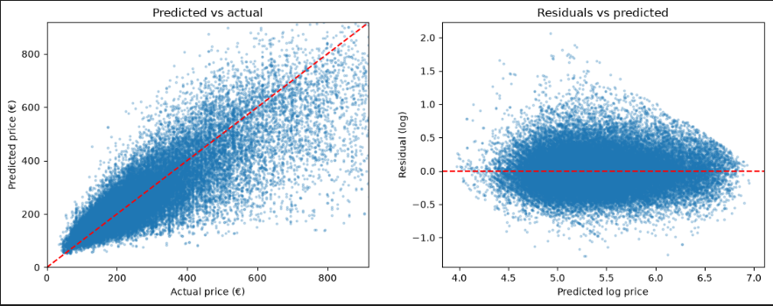
Figure 1. Predicted vs actual price (left) and residuals vs predicted log price (right).
Predictions follow the diagonal but spread out as price increases, and above roughly €400 the model tends to under-predict. Expensive listings are rare and are driven by factors the data does not contain, such as views, luxury finishes or exact building. Residuals on the log scale are centred on zero without a strong pattern, indicating that the model is not systematically biased. Accuracy was similar across cities, with a mean absolute log error between about 0.18 (Lisbon) and 0.23 (Budapest), i.e. a typical miss of roughly 20 %.

6.3 Feature importance
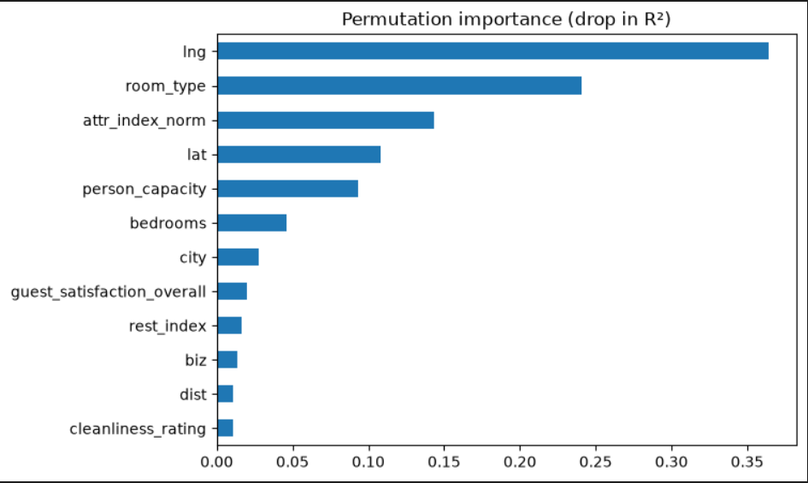
Figure 2. Permutation importance (drop in R² when a feature is shuffled), computed on held-out locations.
Permutation importance identifies longitude (about 0.36), room type (0.24), the normalised attraction index (0.14), latitude (0.11) and person capacity (0.09) as the most influential features, followed by bedrooms. City appears small only because latitude and longitude already encode it, and permutation importance divides credit among correlated features. Taken together, location is the main price driver. Longitude should not be read as having a causal effect; it stands in for the city and area of the listing. Guest satisfaction, cleanliness, distance to the centre and the business flag contribute little.

7. Supplementary Scraping Experiment
Because single-feature correlations were weak, a small sample of extra features was collected from Airbnb listing pages using Selenium, in line with the project hint. The scraper was deliberately limited and polite: about 40 listings per city, 2–4 second delays between requests, no login, and no personal data stored. Airbnb's terms restrict automated access, so the scraper was not scaled up and results are treated as an illustrative academic sample. For each listing it recorded property type, nightly price (EUR), amenity count, superhost and guest-favourite flags, rating, review count, guests, bedrooms, beds and bathrooms.
The final sample contained 385 listings (40 each for seven cities, 38 for Lisbon and London, and 29 for Berlin). The scraped listings could not be joined to the original data because the original files contain no listing identifiers, so the experiment compares two models on the scraped sample alone: a baseline using city, guests and bedrooms, and an extended model that adds property type, amenity count, superhost, guest favourite, rating, reviews, beds and bathrooms. Bedroom, bathroom and bed counts were missing for 38 %, 39 % and 26 % of listings (studios, hotel rooms and private rooms often do not state them), so missing-value indicators were added to both models. Evaluation used 5 × repeated 5-fold cross-validation with identical folds for both models.
Model (scraped sample, n = 385) | R² | Note
Baseline: city, guests, bedrooms | 0.259
Extended: + property type, amenities, host, rating, reviews | 0.305
Paired gain | +0.046 ± 0.104 | Better in 68 % of folds
Table 5. Effect of scraped features on the scraped sample.
Before missing-value indicators were added, the apparent gain was much larger (0.194 vs 0.302). Roughly 60 % of that difference came from the baseline being handicapped by missing bedroom data rather than from the new features, which is why the corrected comparison is reported. Permutation importance on the extended model ranked property type (about 0.19) and amenity count (about 0.12) above rating and review count (about 0.03 each); superhost and guest-favourite status contributed almost nothing.
The conclusion is that the scraped features give a small and uncertain improvement on this sample. This is consistent with the main analysis, in which guest-satisfaction and cleanliness ratings also had almost no predictive value, and with the fact that the original features already explain about 75 % of the variation in log price. A larger scrape matched to the original listings would be needed to confirm the value of amenities and property type.

8. Limitations
- Unexplained variance. About a quarter of the variation in log price is unexplained, and the largest errors occur for the most expensive listings.
- Capped prices. Listings above the 99th percentile were removed, so error figures apply to listings below that cap.
- Possible residual leakage. Grouping by rounded coordinates handles repeated listings, but different listings in the same building share a location and could be split across folds.
- Scraped sample. The scrape is small (385 listings), uneven across cities, taken at a different time from the original data and not linkable to individual rows, so its findings are suggestive rather than definitive.
- Correlation, not causation. Feature importances describe association with price, not what would happen if a host changed a feature.

9. Conclusion and Future Work
Single-feature correlations with price were weak, yet a gradient-boosting model reached R² = 0.75 under leakage-free evaluation, with a median error of about €34 or 17 %. The study also showed how an apparently excellent result (R² = 0.856) was inflated by duplicated listings, and how a careful evaluation design changes the conclusion. Location and room type explain most of the predictable variation, while guest-satisfaction measures add little.
The supplementary scraping experiment indicated that amenities and property type may add a modest amount of information, but the evidence is not conclusive. Future work could scrape a larger sample matched to the original listings (or use openly published listing data such as Inside Airbnb), include seasonality and availability, and test models that handle location more explicitly, for example neighbourhood embeddings or spatial features.

