**Name:** Mahmoud ali hamdi

**B.N /** 39

**Date/** (12-6-2021)

**S.N /**858

**Gethub-link: https:**

**Gethub-page (published-website):**

**Topic:** mobile computing

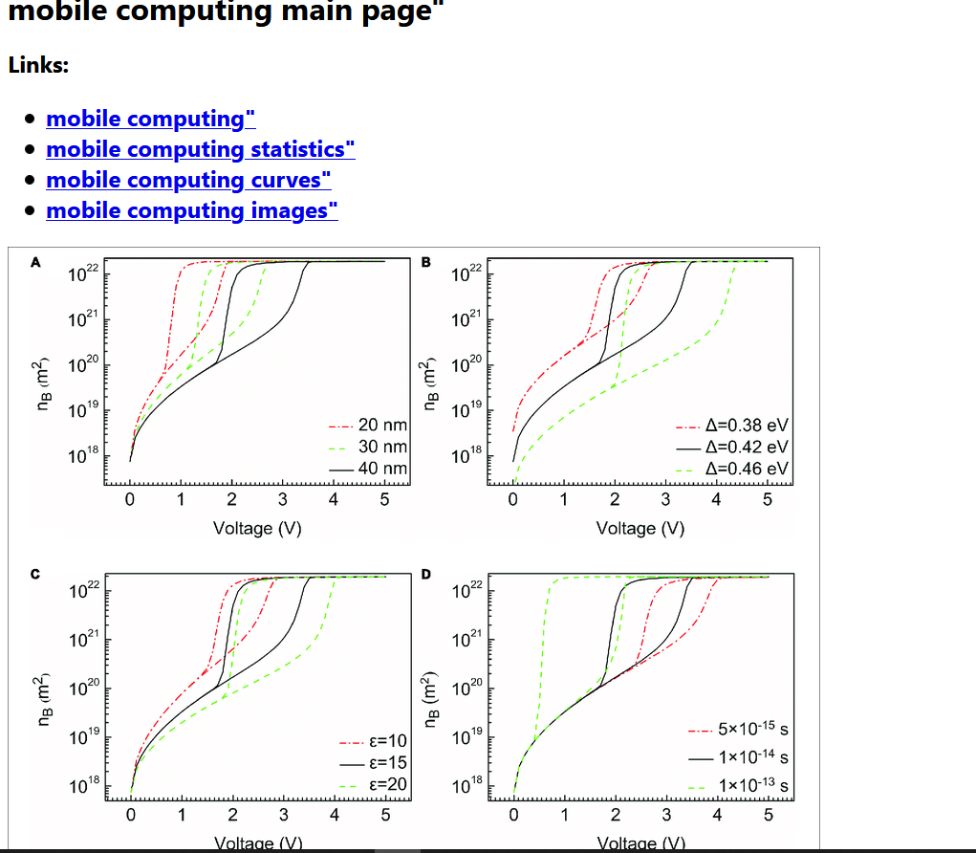**Screenshots:** 