CSE343 — Web Development
Lab 5 | Task 2: Comments App
Student Name | Mahmoud Badwy Abdelhamied
Student ID | 24P0397
Section | 3
Repository | https://github.com/mahmoud-badwy/web-development-course-at-university/tree/main/lab5task

Objective
Build a simple React comments interface where users can post comments and like existing comments.

Implementation
The app uses a React function component and useState to store comments and the current text input. Clicking Post adds a new comment to the list. Each comment shows the author label “You,” its text, and a like button with a count. Clicking the like button increases the count.

Features
- Add a comment using the text field and Post button.
- Display comments with the total count.
- Like individual comments and update their like counts.

Screenshot evidence
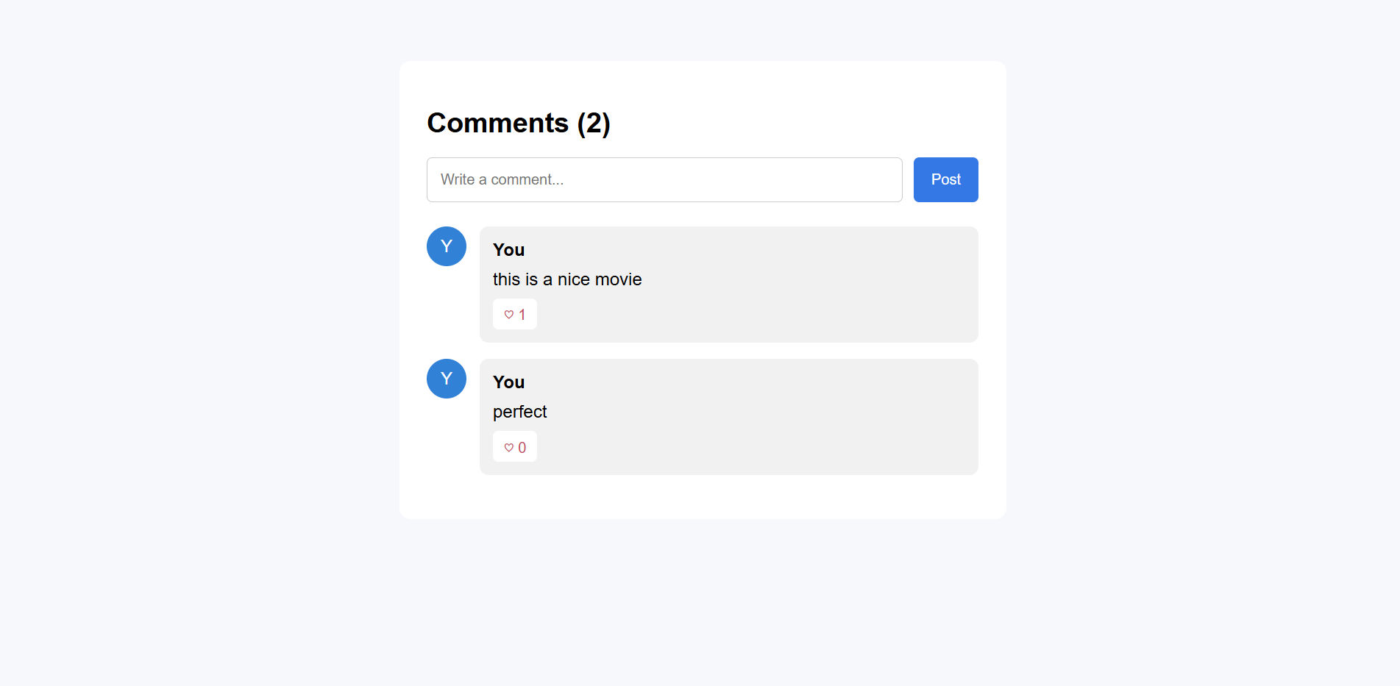

Conclusion
The Comments App demonstrates basic React state management, event handling, components, and rendering lists using map(), following the concepts covered in Lab 5.

