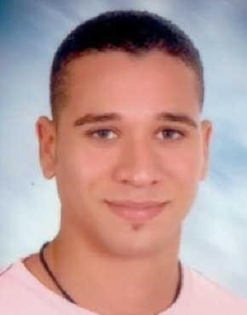

# C.V

**Name: Mahmoud Mohamed Abdalla Elsodany**

**Birth day: 24/10/1988**

**Address : 6 eldereny street Alexandria Egypt**

**Gender: male**

**Nationality: Egyptian**

**Graduation: faculty of arts/ department: sociology**

**Phone number: 01007314336**

**Email Address: mahmoud_elsodany@hotmail.com**

# Language Skills

**1-Arabic: mother language**

**2-English: Certificate of conversation 3 from Arab academy for science and technology (Excellent)**

**3- German: levels at Goethe (very Good) B2+**

# Experience

**Customer service agent at TP: account Booking.com (2023 till now) German and English**

**Customer service agent at concentrix: account Booking.com (2022) German and English**

**freelancer with Pixology company as WordPress developer (2020)**

**2 year in wordpress mechanic company as WordPress developer (2018)**

**Computer skills**

**ICDL**

**Front end developer:**

# *HTML/HTML5

# *CSS/CSS3

# *BOOTSTRAP

# *JAVASCRIPT

# *JQUERY

# *WORDPRESS

## previous work:-

1. <http://divepro-egypt.com/>
2. <https://canteenfurnitures.com/>
3. <https://kccpositivebusinesspsychology.com/>
4. <http://www.toptechnologygroup.com/>
5. <https://www.professional-guide.com/>
6. <https://beehivews.com/>
7. <https://onerequest.sa/>

my portfolio link

https://www.canva.com/design/DAGs4DKZG9A/fPedixH-U7Fix1GevfBuxA/edit?utm_content=DAGs4DKZG9A&utm_campaign=designshare&utm_medium=link2&utm_source=sharebutton

## Diving Licenses

**Padi open water scuba instructor Member ship NO: 291814 Nitrox specialty EFR instructor**

**Experience**

**Dive top safaga : 6 months**

**Company: extra divers world wide**

**MARSA ALAM :-** From 2011 to 2014

**HAMATA: with ORCA dive club wadi lahmy (2015)**

## Sea serpent fleet : 2016 - 2017

**Dives number: more than 5000**

**Military status: Exemption of a final**

### Marketing course : marketing specialist course