**Wrangle and Analyze Data – Project**

**Introduction**

Real-world data rarely comes clean. Using Python and its libraries, you will gather data from a variety of sources and in a variety of formats, assess its quality and tidiness, then clean it. This is called data wrangling. You will document your wrangling efforts in a Jupyter Notebook, plus showcase them through analyses and visualizations using Python (and its libraries).

The dataset that you will be wrangling (and analyzing and visualizing) is the tweet archive of Twitter user [**@dog\_rates**](https://twitter.com/dog_rates), also known as **[WeRateDogs](https://en.wikipedia.org/wiki/WeRateDogs" \t "_blank)**. WeRateDogs is a Twitter account that rates people's dogs with a humorous comment about the dog. These ratings almost always have a denominator of 10. The numerators, though? Almost always greater than 10. 11/10, 12/10, 13/10, etc. Why? Because "[**they're good dogs Brent**](http://knowyourmeme.com/memes/theyre-good-dogs-brent)." WeRateDogs has over 4 million followers and has received international media coverage.

WeRateDogs [**downloaded their Twitter archive**](https://support.twitter.com/articles/20170160) and sent it to Udacity via email exclusively for you to use in this project. This archive contains basic tweet data (tweet ID, timestamp, text, etc.) for all 5000+ of their tweets as they stood on August 1, 2017. More on this soon.

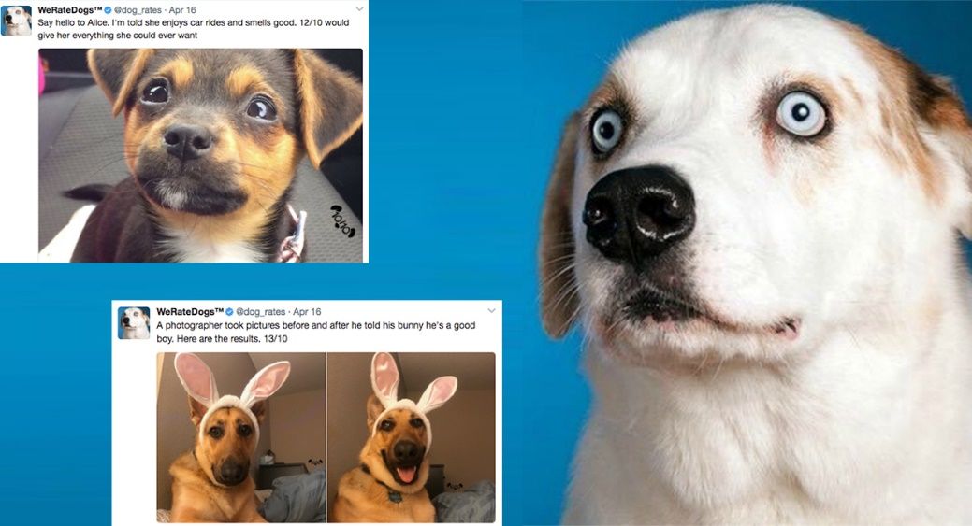

**By wrangling and visualizing this project found some exited points.**

**Golden Retriever is the most popular dog nowadays.**

****The Golden Retriever is a medium-large gun dog that was bred to retrieve shot waterfowl, such as ducks and upland game birds, during hunting and shooting parties. The name "retriever" refers to the breed's ability to retrieve shot game undamaged due to their soft mouth. Golden retrievers have an instinctive love of water and are easy to train to basic or advanced obedience standards. They are a long-coated breed, with a dense inner coat that provides them with adequate warmth in the outdoors, and an outer coat that lies flat against their bodies and repels water. Golden retrievers are well suited to residency in suburban or country environments. They shed copiously, particularly at the change of seasons, and require fairly regular grooming. The Golden Retriever was originally bred in Scotland in the mid-19th century.

**The Most Common Dog Types**

By analyzing WeRateDogs tweeter page we got that the most dogs type get rated with Retriever breed comes first

As the first one was Golden Retriever as mentioned above with more than 140 counts and the second one Labrador Retriever with almost 100 counts and below chart indicates the top five rated dogs on WeRateDogs tweeter page.

**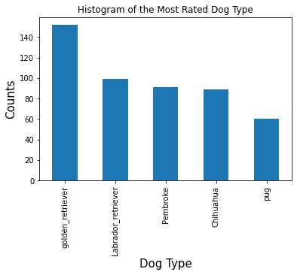**

1st Golden Retriever

2nd Labrador Retriever

3rd Pembroke

4th Chihuahua

5th Pug

**The most frequent rating**

Unless the top rating denominator expected to be 10 many users rates greater than that as by analyzing we have got that the most frequent rating is 12 by almost 400 times and there are many users rates with 13 and 14 while the top expected rating comes second and as shown below a chart indicated the frequent ratings volumes.

**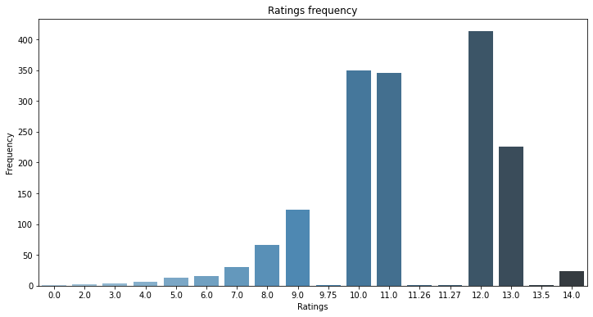**

**Favorites Count and Retweet Count**

The favorite tweets has retweeted many times, Favorite tweets and retweets is highly positive correlated as it shown below.

**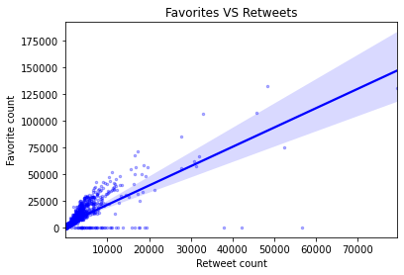**

**Pupper**

**Dog Stage**

We have got also that young dogs the most tweeted dogs as comes first with more than 160 tweets and doggo comes second with almost 60 tweets, and below charts indicates the tweet count for each dog stage.

**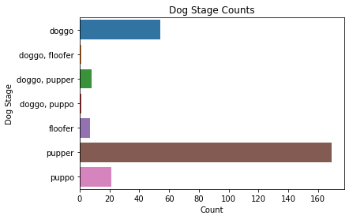**

**Tweet Source**

Twitter for iPhone is the most common used source to tweet for WeRateDogs page as below chart indicates the huge difference between Twitter for iPhone and the other sources.

**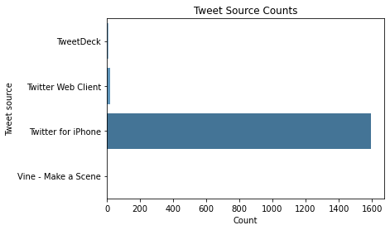**

**Dog Names**

**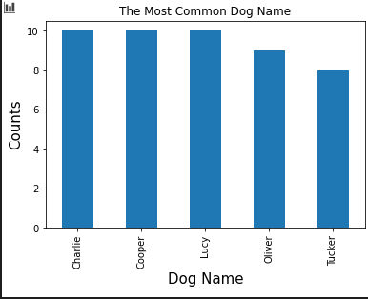**Charlie, Cooper, Lucy, Oliver, and Tucker are the most common names for dogs on WeRateDogs page there are so many names on twitter page but they are the most repeated names and here is a chart to indicate how many these name are used.

**The Most Retweeted**

“Here's a doggo realizing you can stand in a pool.”

There is the most retweet one with cute Labrador retriever realized how to stand in pool with rating 13/10 and 79,515 retweets (as our data) and posted [video](https://twitter.com/dog_rates/status/744234799360020481/video/1).

As the Labrador retriever the second common dog type and doggo is the second dog stage in our data.

Original Tweet:

["Here's a doggo realizing you can stand in a pool. 13/10 enlightened af (vid by Tina Conrad)"](https://twitter.com/dog_rates/status/744234799360020481/video/1)

Video:

<https://twitter.com/dog_rates/status/744234799360020481/video/1>

**The Most Favorite**

**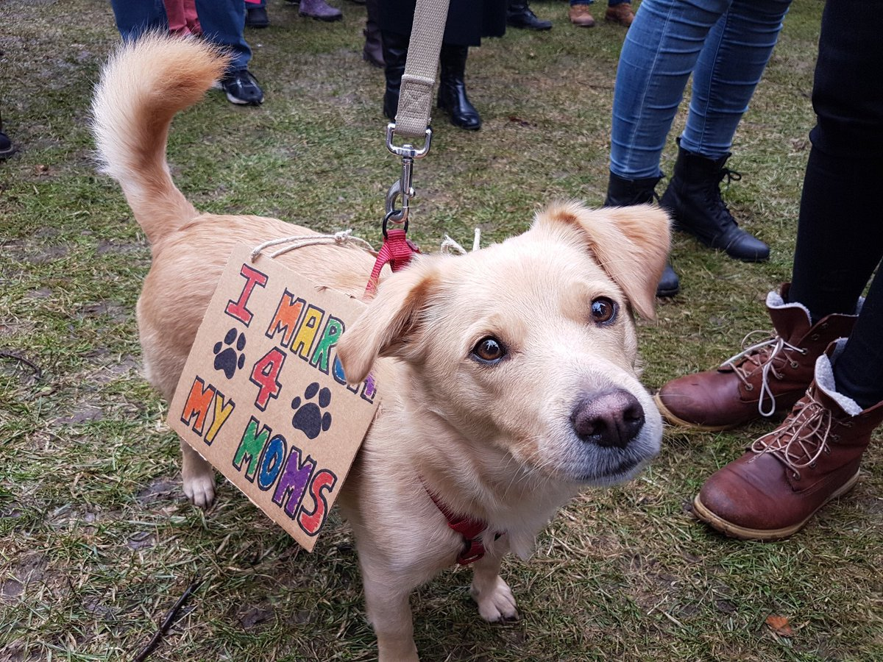**“Here's a super supportive puppo participating in the Toronto Women’s March day.”

There is the most favorite tweet for Puppo Lakeland Terrier dog breed joining in Women’s March Day really nice dog with cute face with rating 13/10 and 132,810 likes (as our data).

Original Tweet:

["Here's a super supportive puppo participating in the Toronto #WomensMarch today. 13/10"](https://t.co/nTz3FtorBc)

Dogs are domesticated mammals, not natural wild animals. They were originally bred from wolves. They have been bred by humans for a long time and were the first animals ever to be domesticated. There are different studies that suggest that this happened between 15.000 and 100.000 years before our time. The dingo is also a dog, but many dingos have become wild animals again and live independently of humans in the range where they occur (parts of Australia).

Today, some dogs are used as pets, others are used to help humans do their work. They are a popular pet because they are usually playful, friendly, loyal, and listen to humans. Thirty million dogs in the United States are registered as pets. Dogs eat both meat and vegetables, often mixed together and sold in stores as dog food. Dogs often have jobs, including as police dogs, army dogs, assistance dogs, fire dogs, messenger dogs, hunting dogs, herding dogs, or rescue dogs.

They are sometimes called "canines" from the Latin word for dog - canis. Sometimes people also use "dog" to describe other canids, such as wolves. A baby dog is called a pup or puppy. A dog is called a puppy until it is about one year old.

Dogs are sometimes referred to as "man's best friend" because they are kept as domestic pets and are usually loyal and like being around humans. Dogs like to be petted, but only when they can first see the petter's hand before petting; one should never pet a dog from behind.

August 26 is National Dog Day. While March 26 is National Puppy Day

Source: Wikipedia

At the end thank you very much for allowing me the opportunity to know more about dogs while practicing data wrangling

By:

**Mahmoud Hassan Khalil El-Tobgy**