Cairo University  
Faculty of Computers and Information



**CS251**

**Software Engineering I**

Project Name

Software Design

Team Names

Month & Year

Contents

Instructions [To be removed] 3

Team 3

Document Purpose and Audience 3

System Models 3

I. Class diagrams 3

Important Algorithm 5

II. Sequence diagrams 5

Class - Sequence Usage Table 7

Ownership Report 8

Policy Regarding Plagiarism: 8

References 8

Authors 8

# Team

|  |  |  |  |
| --- | --- | --- | --- |
| **ID** | **Name** | **Email** | **Mobile** |
| 20140267 | Mostafa Taher AbdELAziz | [Mostafa1201@hotmail.com](mailto:Mostafa1201@hotmail.com) | 01008804728 |
| 20140256 | Mahmoud Mosaad AbdElWahed | [mahmoudmosaad50@gmail.com](mailto:mahmoudmosaad50@gmail.com) | 01017747328 |
| 20140285 | Mina Magdy Mounier | mina123334@gmail.com | 01204422525 |
| 20140275 | Mostafa Mohamed Mahmoud | mos.tafa93@yahoo.com | 01064119322 |

# Document Purpose and Audience

In This Document we show the scenarios that happen in the website and construct the class diagram based on this scenarios.  
There will be mapping to the website by the class diagram.  
Our Audience are students that have interest in learning in simple ways.

# 

# System Models

## I. Class diagrams

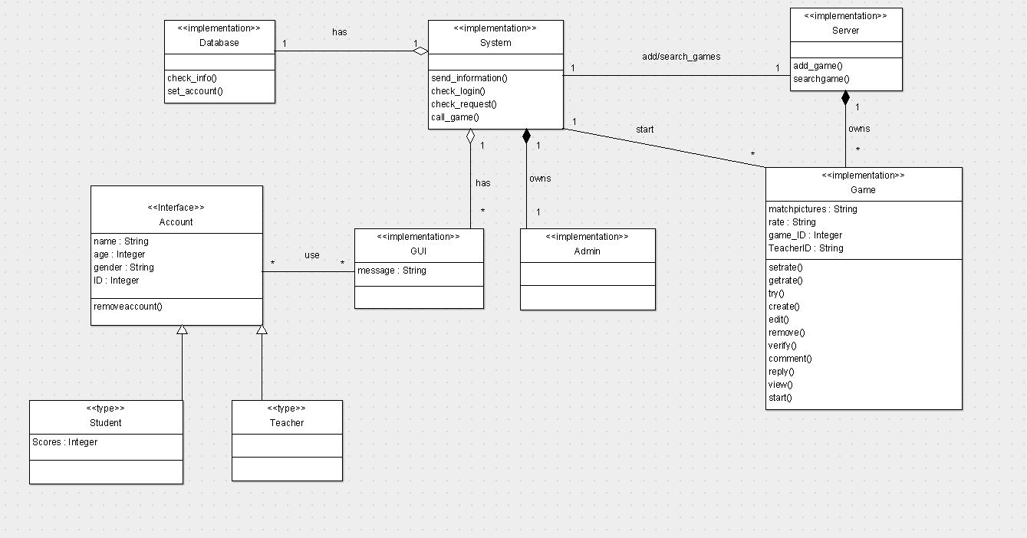

| **Class ID** | **Class Name** | **Description & Responsibility** |
| --- | --- | --- |
| 1 | System | Control the website |
| 2 | Database | Hold all the account |
| 3 | Server | Hold all games in it |
| 4 | Account | Has the information of each account |
| 5 | Student | Has ArrayList of scores that belongs to the student and can play games and comment |
| 6 | Teacher | Can add , edit or remove games and reply to the students comments |
| 7 | GUI | Display Forms into the website page and Display messages to the students or teacher. |
| 8 | Admin | It is a subsystem that verify games if they meet the terms and conditions of the website. |
| 9 | Game | Holds the game data and the ID of the teacher that made that game. |

## II. Sequence diagrams

1. Registeration sequence diagram

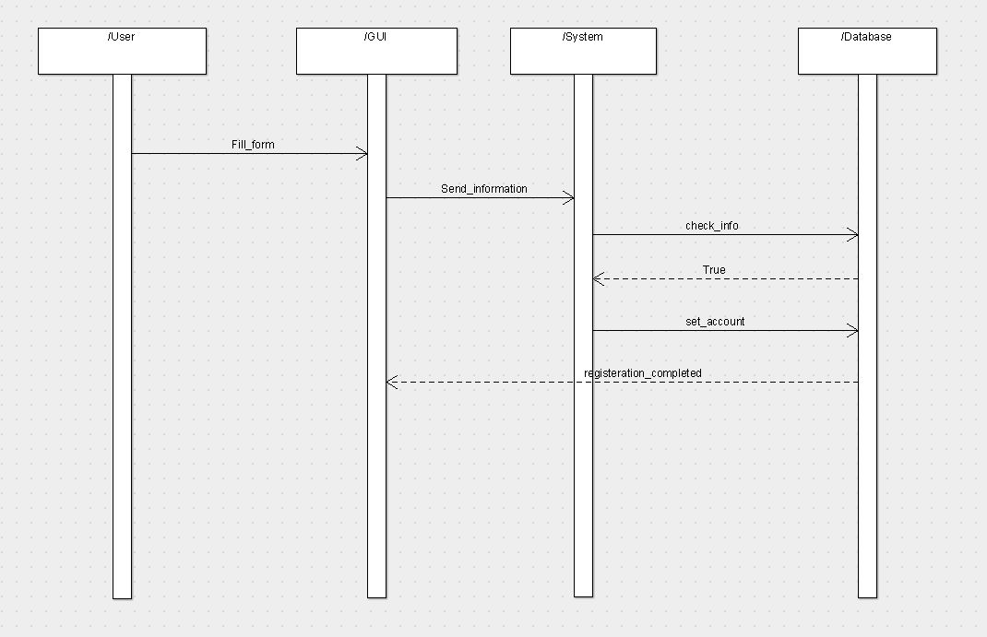

1. Play game sequence diagram  
   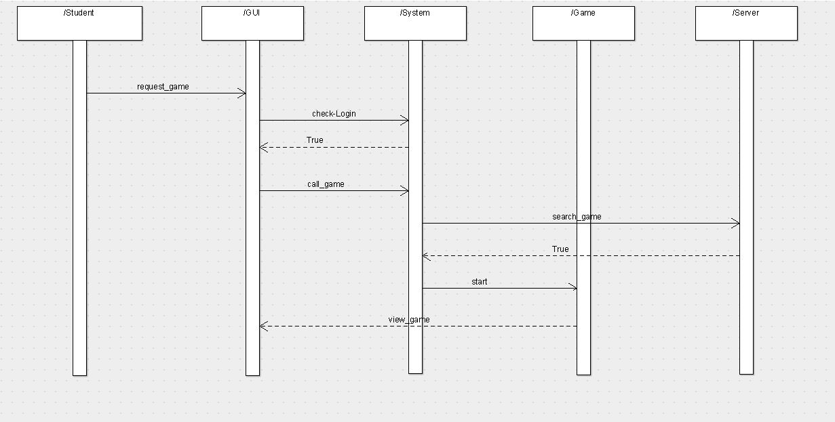
2. Add game sequence diagram  
   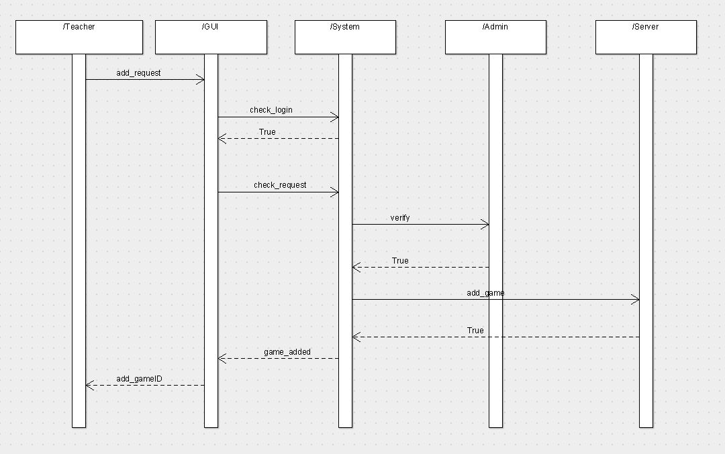

### Class - Sequence Usage Table

| **Class Name** | **Sequence Diagrams** | **Overall used methods** |
| --- | --- | --- |
| Student | 1, 2 ,3 | Fill_form, GetData |
| Teacher | 3 | Add_request |
| User(Teacher or Student) | 3 | Fill_form |
| System | 1,2,3 | Check_login,check_request,call_game |
| GUI | 1,2,3 | Print message |
| Admin | 3 | Verify |
| Server | 2,3 | Add_game |
| Game | 2 | start |

# References

* http://www.mhhe.com/engcs/compsci/pressman/graphics/Pressman5sepa/common/cs1/design.pdf

# Authors

* Mostafa Saad and Mohammad El-Ramly (Edited by Mohamed Samir)

# Github repository Link:

https://github.com/mahmoud-mosaad/stepbystep