NFA

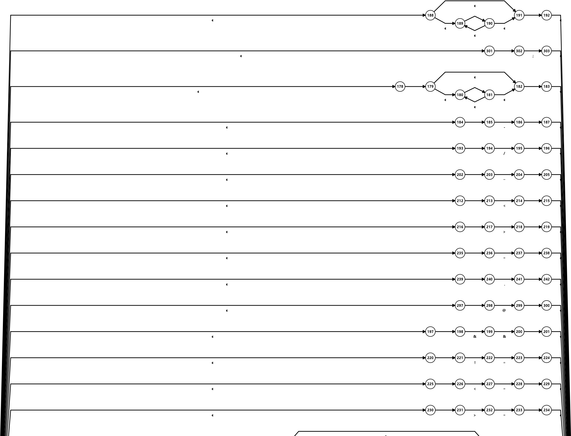

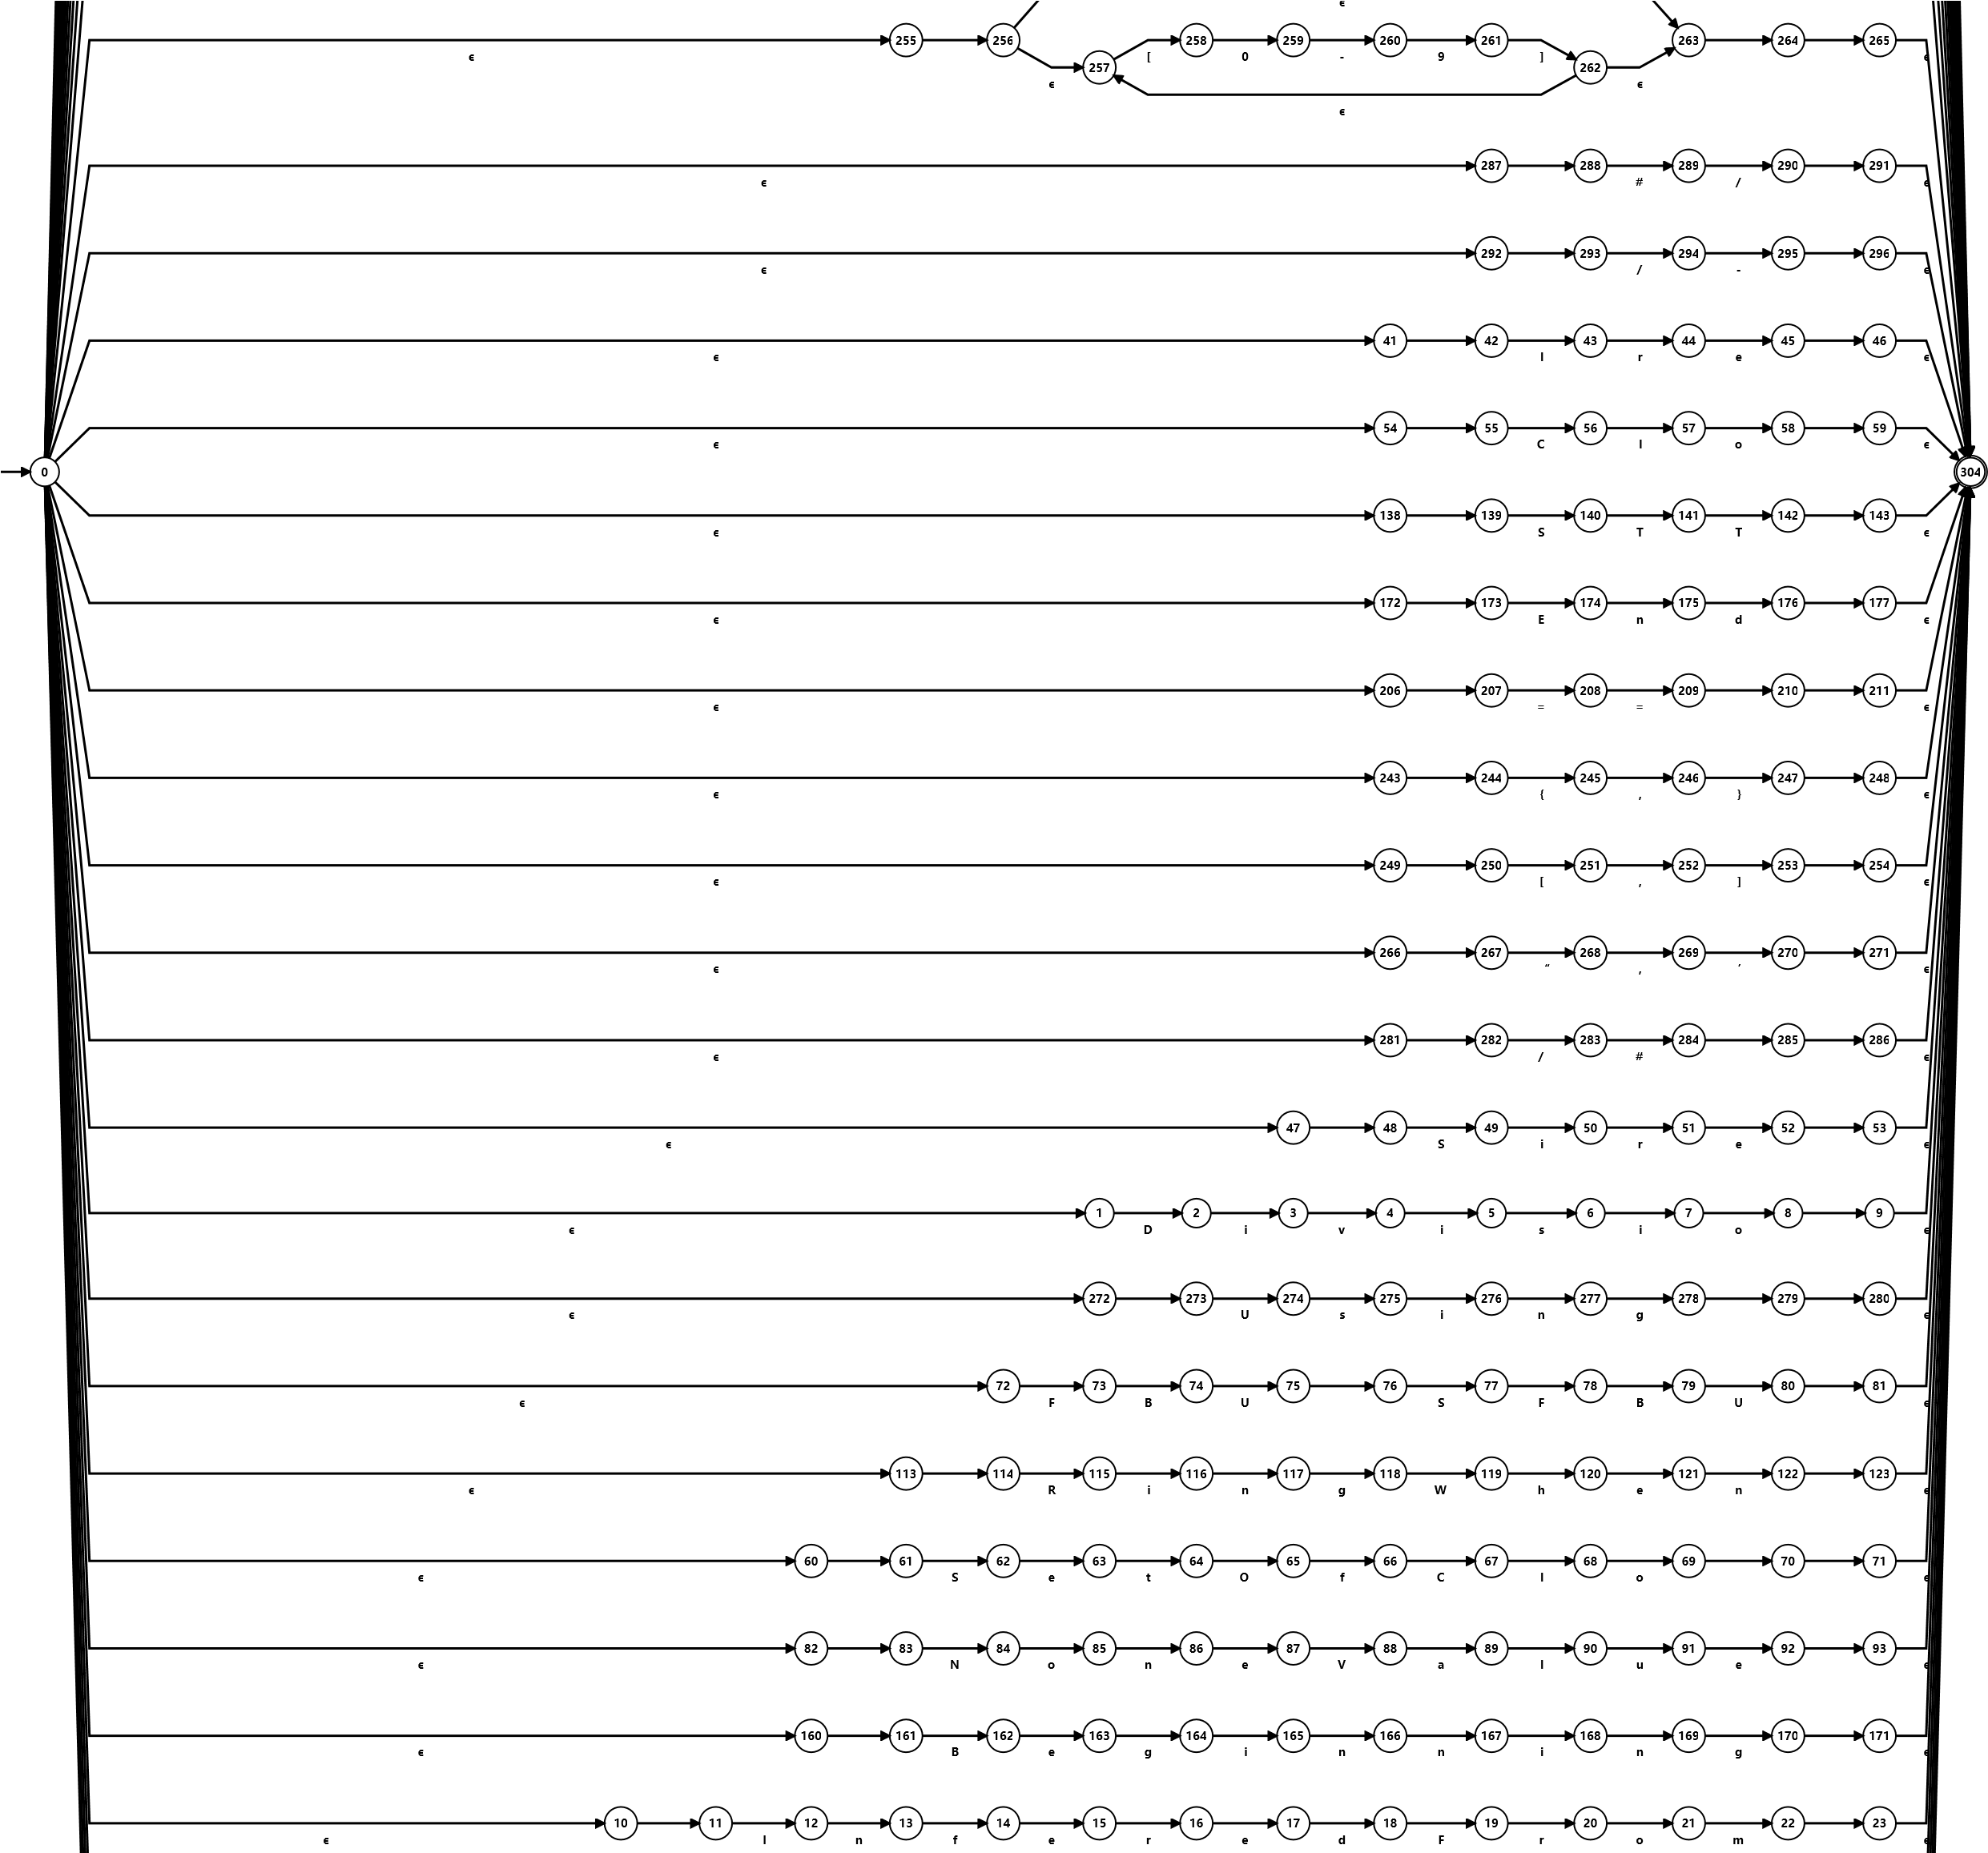

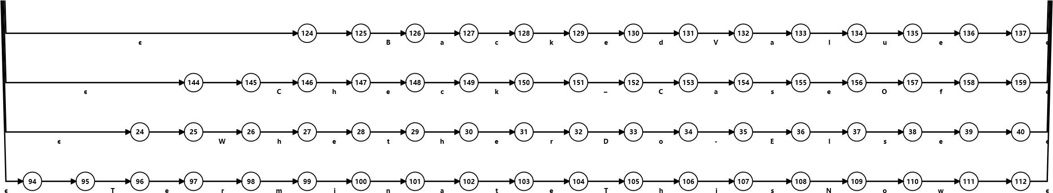

DFA

**!**

**#**

**&**

**=**

**/**

**&**

**E**

**F**

**G**

**H**

**I**

**AG**

**AH**

**AI**

**AJ**

**AK**

**BS**

**BT**

**BU**

**BV**

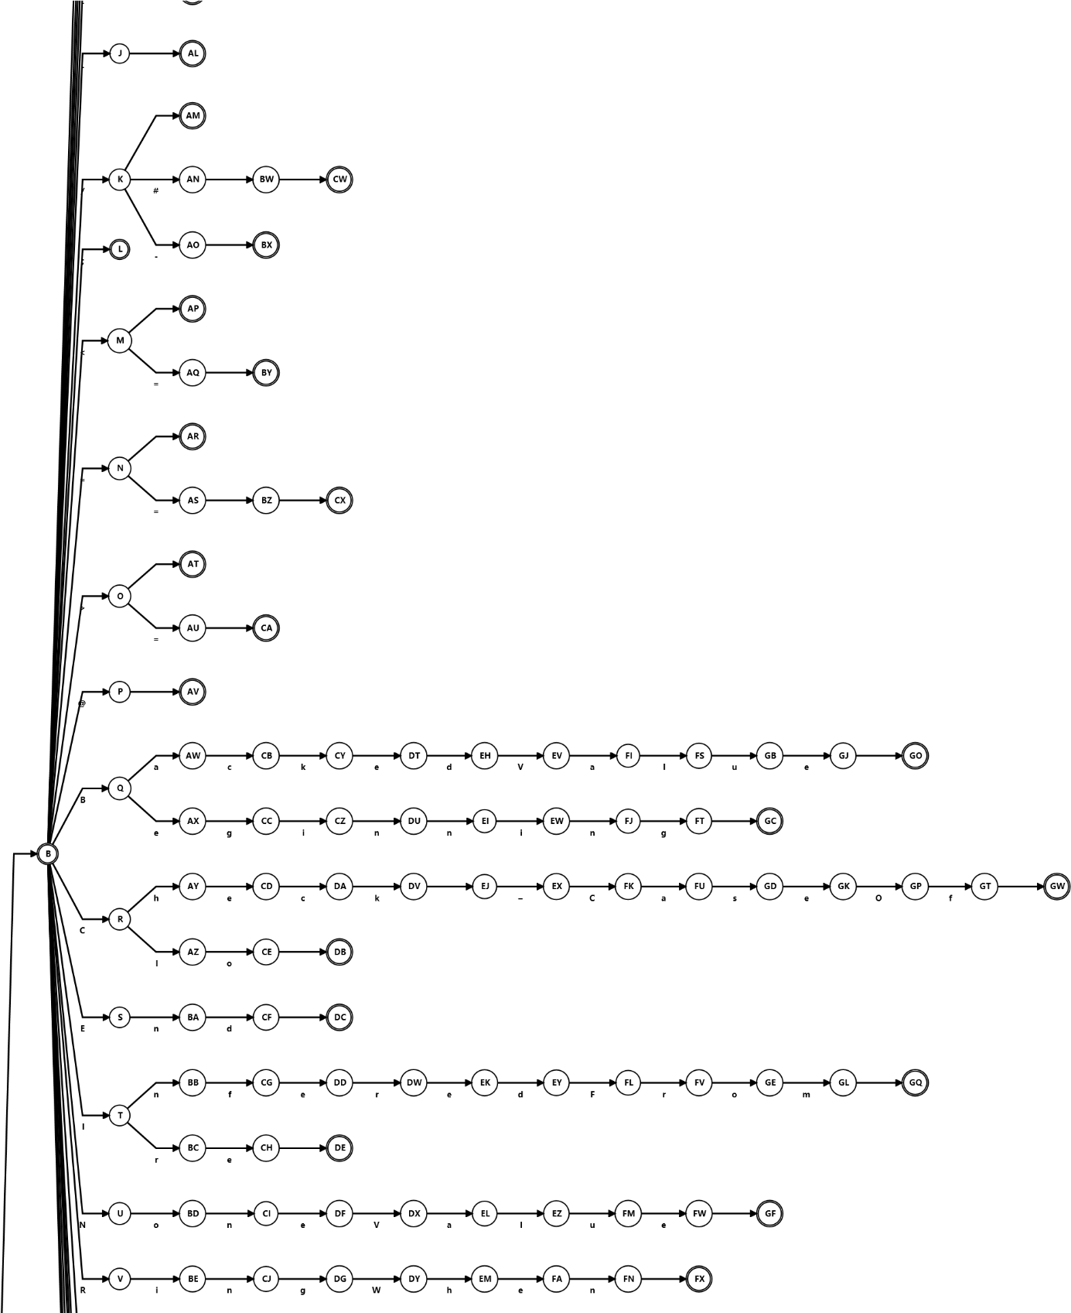

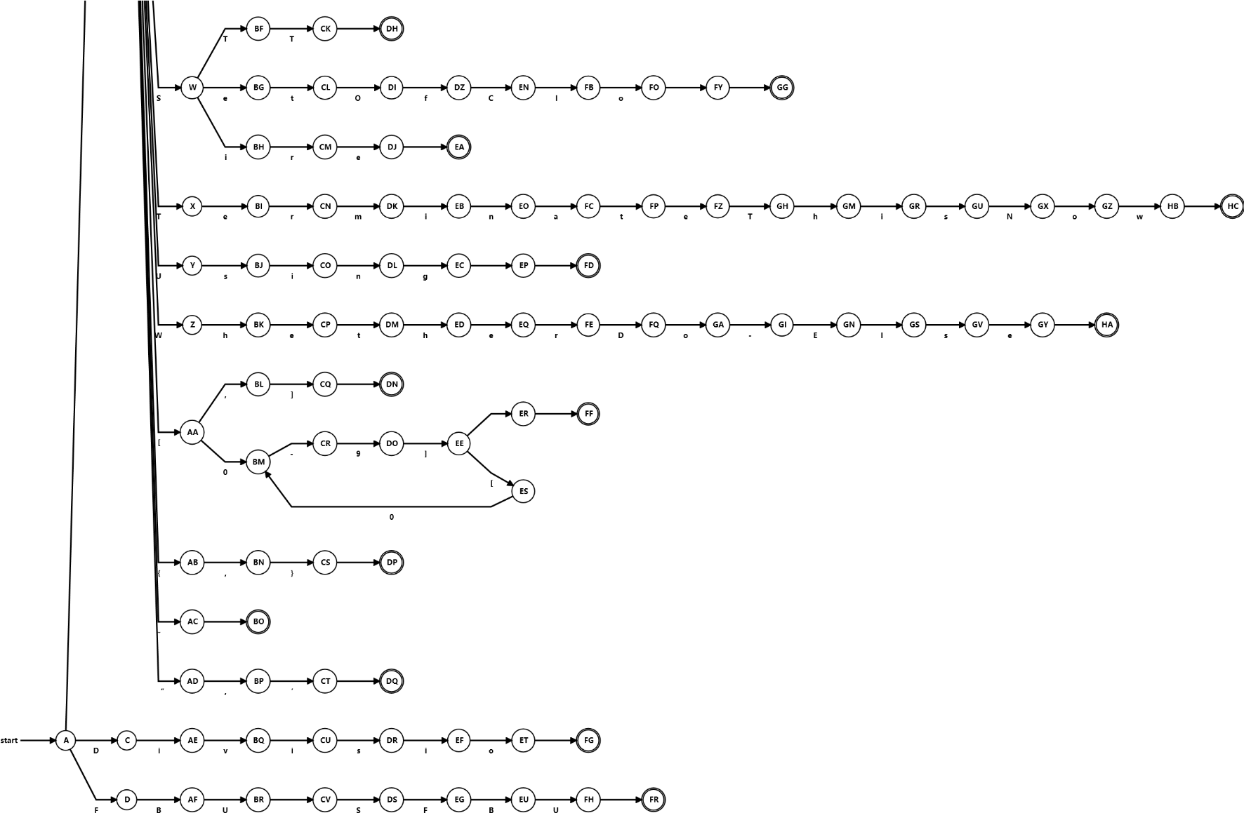

Regular Expression

(Divisio|FBU SFBU|@|==|B(eginning|ackedValue)|Using| /(#|-)|“,’|;|<=| ([0-9])* | WhetherDo-Else|C(heck-CaseOf|lo)|End|S(TT|etofc|ire|o)|NoneValue | + | - | * | / | && | || | ~ | < | > | != | <= | >= | = | . | {,} | [,] |#/| TerminateThisNow |RingWhen|I(nferedFrom | re))