

Faculty of Engineering and Technology

Electrical and Computer Engineering Department

Wireless And Mobile Networks - ENCS5323

Online Calculator for Wireless and Mobile Networks

**Project Report**

-------------------------------------------------------------------------------

Prepared by:

Mahmoud Atia ID: 1192519

NoorAdin Tirhi ID: 1190081

Instructor: Dr. Mohammad Jubran

Section: 2

Date: 12-6-2024

BIRZEIT

June – 2024

Table of Contents

Calculator 1: 4

Scenario 1: 4

Scenario 2: 5

Scenario 3: 6

Calculator 2: 7

Scenario 1 7

Scenario 2 8

Scenario 3 9

Calculator 3: 10

Scenario 1: 10

Scenario 2: 11

Scenario 3: 12

Calculator 4: 13

Scenario 1: 13

Scenario 2: 14

Scenario 3: 15

Table of Figures

Figure 1 - Calculator 1 scenario 1 4

Figure 2 - Calculator 1 scenario 2 5

Figure 3 - Calculator 1 scenario 3 6

Figure 4 - Calculator 2 scenario 1 7

Figure 5 - Calculator 2 scenario 2 8

Figure 6 - Calculator 2 scenario 3 9

Figure 7 - Calculator 3 scenario 1 10

Figure 8 - Calculator 3 scenario 2 11

Figure 9 - Calculator 3 scenario 3 12

Figure 10 - Calculator 4 scenario 1 13

Figure 11 - Calculator 4 scenario 2 14

Figure 12 - Calculator 4 scenario 3 15

# Calculator 1:

## Scenario 1:

An analog signal with a bandwidth of 4 KHz undergoes sampling at the Nyquist rate, followed by processing through an 8-bit quantizer, a source encoder with a compression rate of 0.25, a channel encoder with a rate of 0.5, and a 1024-bit interleaver.

1. **Calculate the sampling frequency.**
2. **Find the number of quantization levels.**
3. **Determine the bit rate at the output of the source encoder.**
4. **Calculate the bit rate at the output of the channel encoder.**
5. **Calculate the bit rate at the output of the interleaver.**

Inputs:

* **Bandwidth**: 4000 Hz
* **Quantizer Bits**: 8 bits
* **Compression Rate**: 0.25
* **Channel Encoder Rate**: 0.5
* **Interleaver Bits**: 1024 bits

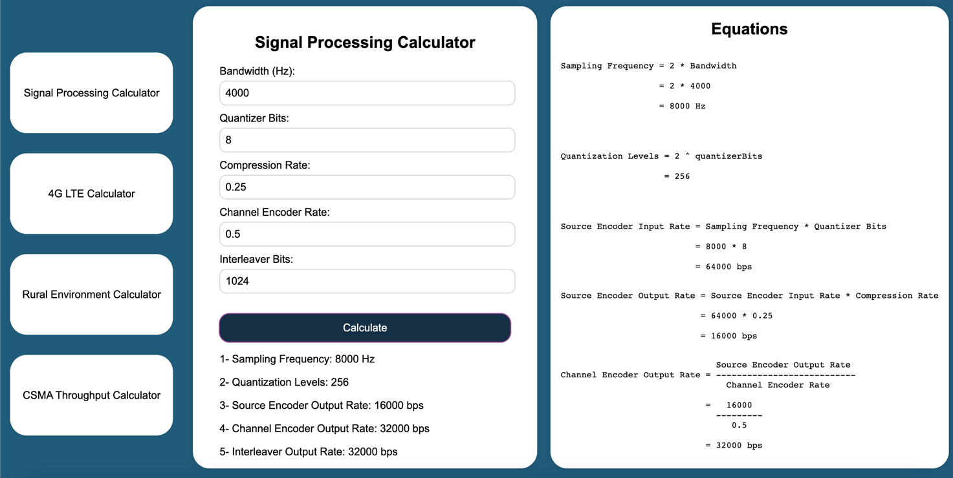

Figure 1 - Calculator 1 scenario 1

## Scenario 2:

An analog signal with a bandwidth of 10 KHz undergoes sampling at the Nyquist rate, followed by processing through a 10-bit quantizer, a source encoder with a compression rate of 0.75, a channel encoder with a rate of 0.8, and a 512-bit interleaver.

1. **Calculate the sampling frequency.**
2. **Find the number of quantization levels.**
3. **Determine the bit rate at the output of the source encoder.**
4. **Calculate the bit rate at the output of the channel encoder.**
5. **Calculate the bit rate at the output of the interleaver.**

Inputs**:**

* **Bandwidth**: 10000 Hz
* **Quantizer Bits**: 10 bits
* **Compression Rate**: 0.75
* **Channel Encoder Rate**: 0.8
* **Interleaver Bits**: 512 bits

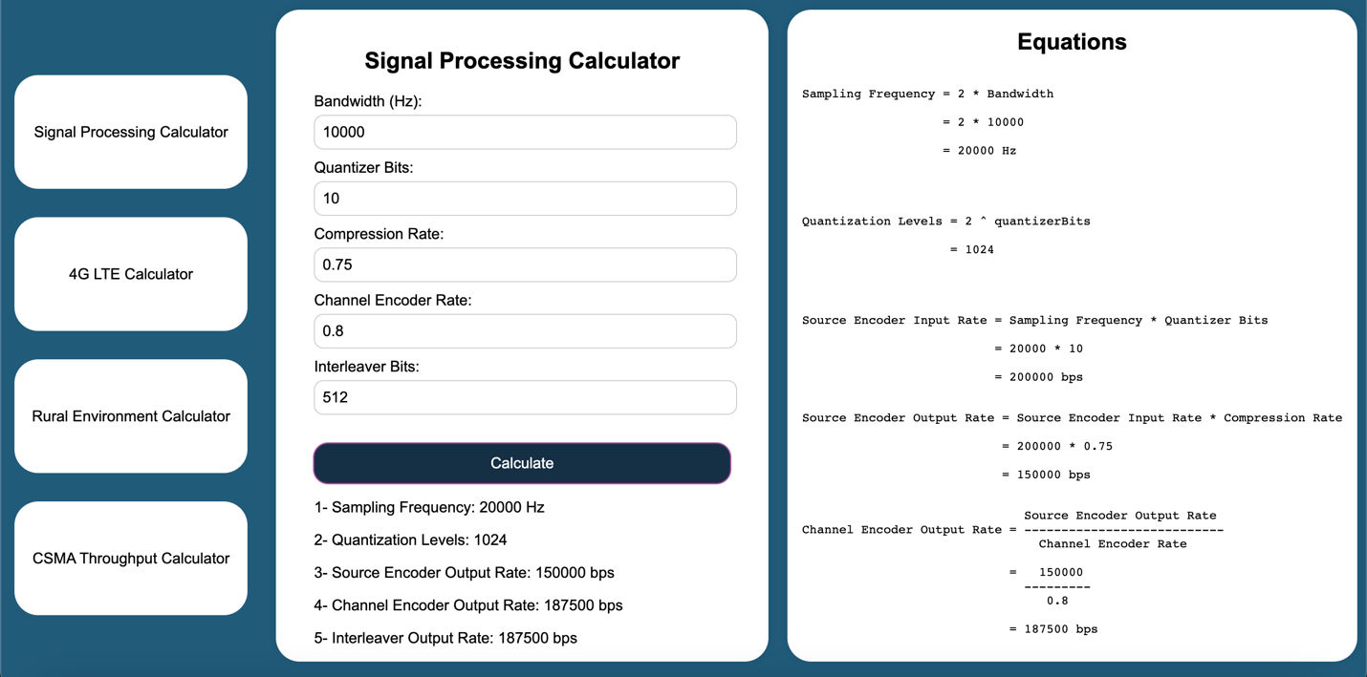

Figure 2 - Calculator 1 scenario 2

## Scenario 3:

An analog signal with a bandwidth of 20 KHz undergoes sampling at the Nyquist rate, followed by processing through a 12-bit quantizer, a source encoder with a compression rate of 0.5, a channel encoder with a rate of 0.6, and a 256-bit interleaver.

1. **Calculate the sampling frequency.**
2. **Find the number of quantization levels.**
3. **Determine the bit rate at the output of the source encoder.**
4. **Calculate the bit rate at the output of the channel encoder.**
5. **Calculate the bit rate at the output of the interleaver.**

Inputs**:**

* **Bandwidth**: 20000 Hz
* **Quantizer Bits**: 12 bits
* **Compression Rate**: 0.5
* **Channel Encoder Rate**: 0.6
* **Interleaver Bits**: 256 bits

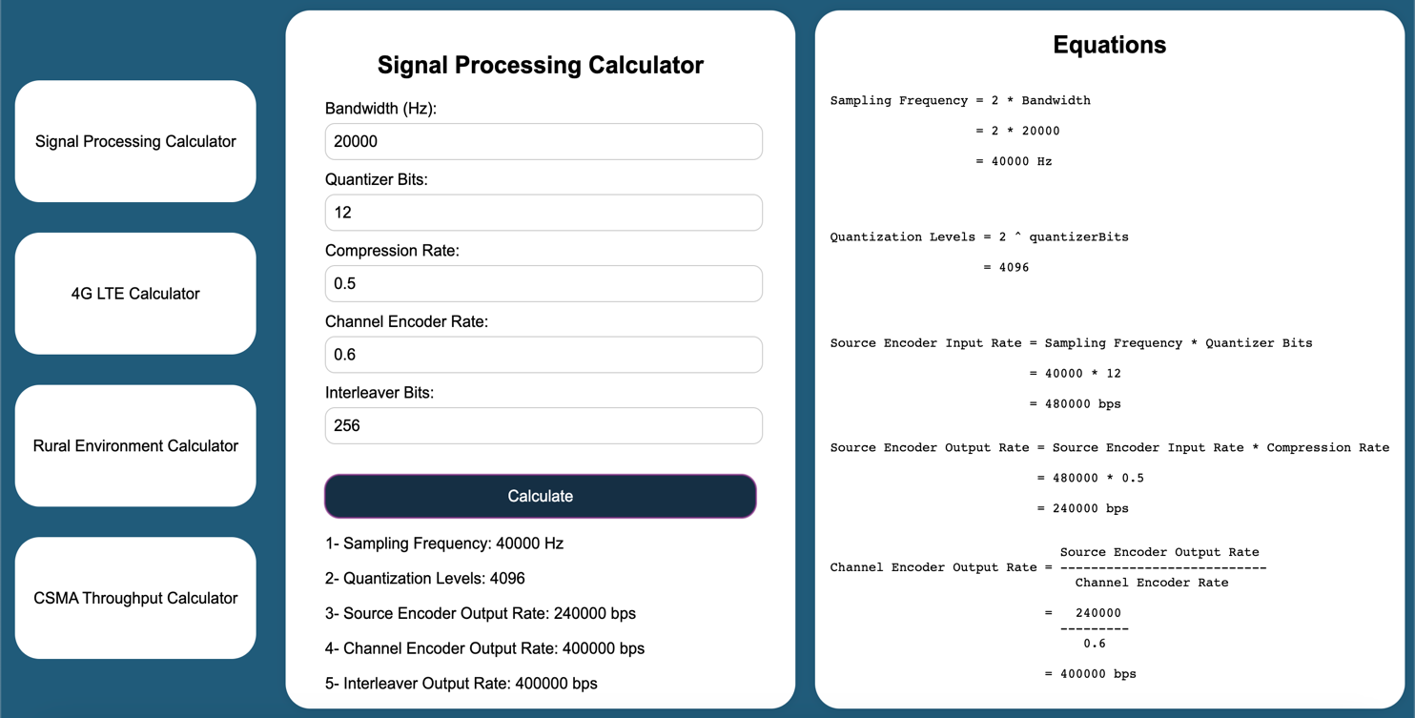

Figure 3 - Calculator 1 scenario 3

# Calculator 2:

## Scenario 1

In 4G LTE systems, each resource block has a bandwidth of 180 kHz. The subcarrier spacing is 15 kHz, and there are 7 OFDM symbols per resource block. Assuming each resource block has a duration of 0.5 milliseconds and bits are modulated using 1024-QAM, calculate the following:

1. **Determine the number of bits per resource element.**
2. **Determine the number of bits per OFDM symbol.**
3. **Determine the number of bits per OFDM resource block.**
4. **If a user is assigned 4 parallel resource blocks continuously, calculate the maximum transmission rate for this user.**

#### Inputs:

* **Resource Block Bandwidth**: 180 kHz
* **Subcarrier Spacing**: 15 kHz
* **Number of OFDM Symbols per Resource Block**: 7
* **Duration of Resource Block**: 0.5 milliseconds
* **Modulation Scheme**: 1024-QAM

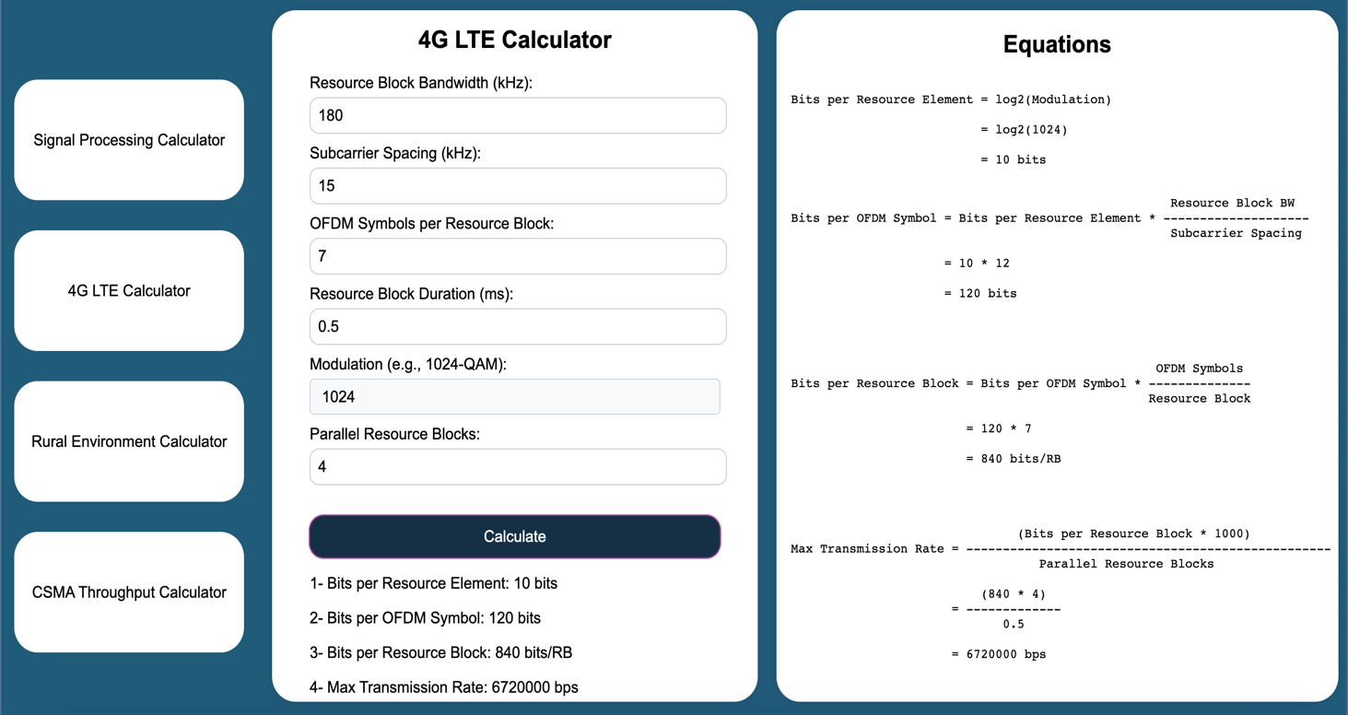

Figure 4 - Calculator 2 scenario 1

## Scenario 2

In 4G LTE systems, each resource block has a bandwidth of 180 kHz. The subcarrier spacing is 15 kHz, and there are 7 OFDM symbols per resource block. Assuming each resource block has a duration of 0.5 milliseconds and bits are modulated using 256-QAM, calculate the following:

1. **Determine the number of bits per resource element.**
2. **Determine the number of bits per OFDM symbol.**
3. **Determine the number of bits per OFDM resource block.**
4. **If a user is assigned 6 parallel resource blocks continuously, calculate the maximum transmission rate for this user.**

#### Inputs:

* **Resource Block Bandwidth**: 180 kHz
* **Subcarrier Spacing**: 15 kHz
* **Number of OFDM Symbols per Resource Block**: 7
* **Duration of Resource Block**: 0.5 milliseconds
* **Modulation Scheme**: 256-QAM

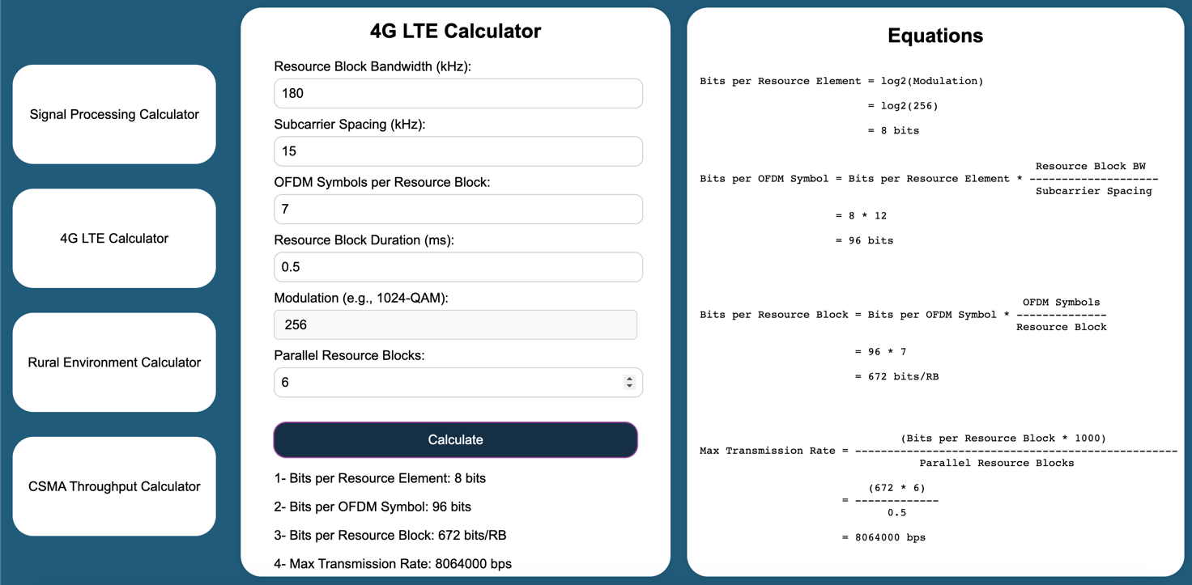

Figure 5 - Calculator 2 scenario 2

## Scenario 3

In 4G LTE systems, each resource block has a bandwidth of 180 kHz. The subcarrier spacing is 15 kHz, and there are 7 OFDM symbols per resource block. Assuming each resource block has a duration of 0.5 milliseconds and bits are modulated using 64-QAM, calculate the following:

1. **Determine the number of bits per resource element.**
2. **Determine the number of bits per OFDM symbol.**
3. **Determine the number of bits per OFDM resource block.**
4. **If a user is assigned 8 parallel resource blocks continuously, calculate the maximum transmission rate for this user.**

#### Inputs:

* **Resource Block Bandwidth**: 180 kHz
* **Subcarrier Spacing**: 15 kHz
* **Number of OFDM Symbols per Resource Block**: 7
* **Duration of Resource Block**: 0.5 milliseconds
* **Modulation Scheme**: 64-QAM

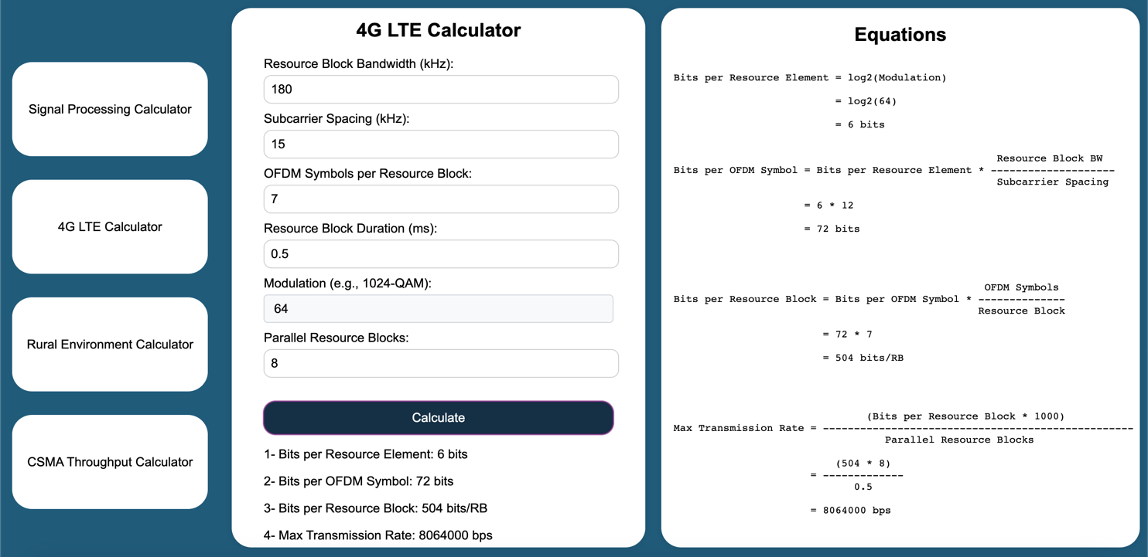

Figure 6 - Calculator 2 scenario 3

# Calculator 3:

## Scenario 1:

Given a flat rural environment with a path loss of 140 dB, a frequency of 900 MHz, an 8 dB transmit antenna gain, a 0 dB receive antenna gain, a data rate of 9.6 kbps, 12 dB in antenna feed line loss, 20 dB in other losses, a fade margin of 8 dB, a receiver amplifier gain of 24 dB, a noise figure total of 6 dB, a noise temperature of 290 K, and a link margin of 8 dB. Find the total transmit power required for an 8-PSK modulated signal with a maximum bit error rate of 10^−4.

Input:

* Path Loss: 140 dB
* Frequency: 900 MHz
* Transmit Antenna Gain: 8 dB
* Receive Antenna Gain: 0 dB
* Data Rate: 9.6 kbps
* Antenna Feed Line Loss: 12 dB
* Other Losses: 20 dB
* Fade Margin: 8 dB
* Receiver Amplifier Gain: 24 dB
* Noise Figure: 6 dB
* Noise Temperature: 290 K
* Link Margin: 8 dB

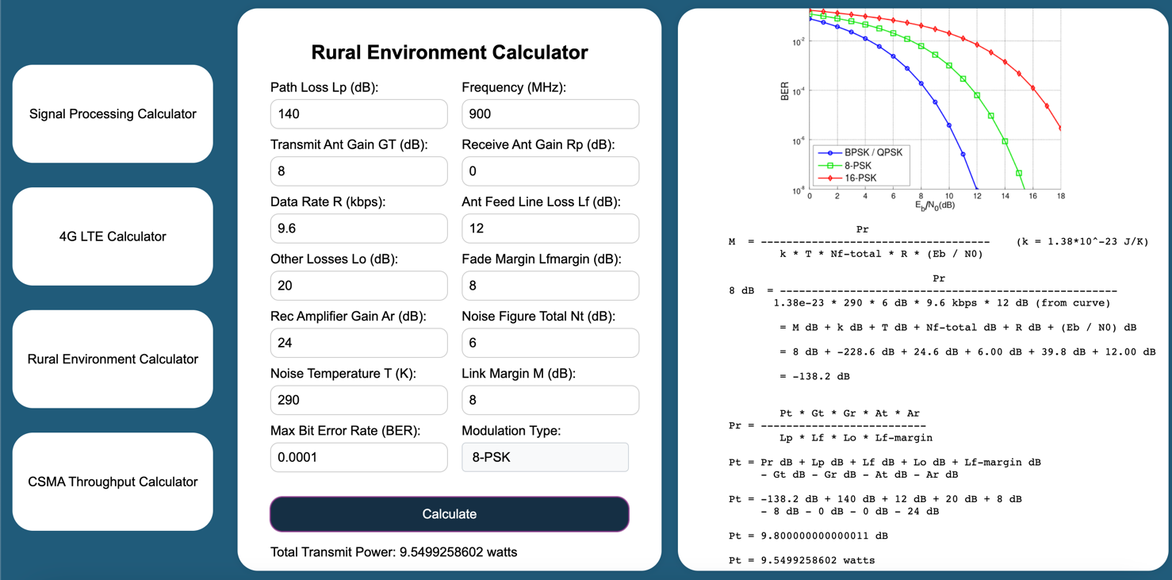

Figure 7 - Calculator 3 scenario 1

## Scenario 2:

Given a flat rural environment with a path loss of 130 dB, a frequency of 800 MHz, a 10 dB transmit antenna gain, a 2 dB receive antenna gain, a data rate of 14.4 kbps, 10 dB in antenna feed line loss, 15 dB in other losses, a fade margin of 5 dB, a receiver amplifier gain of 20 dB, a noise figure total of 5 dB, a noise temperature of 290 K, and a link margin of 10 dB. Find the total transmit power required for an 16-PSK modulated signal with a maximum bit error rate of 10^−4.

Input:

* Path Loss: 130 dB
* Frequency: 800 MHz
* Transmit Antenna Gain: 10 dB
* Receive Antenna Gain: 2 dB
* Data Rate: 14.4 kbps
* Antenna Feed Line Loss: 10 dB
* Other Losses: 15 dB
* Fade Margin: 5 dB
* Receiver Amplifier Gain: 20 dB
* Noise Figure: 5 dB
* Noise Temperature: 290 K
* Link Margin: 10 dB

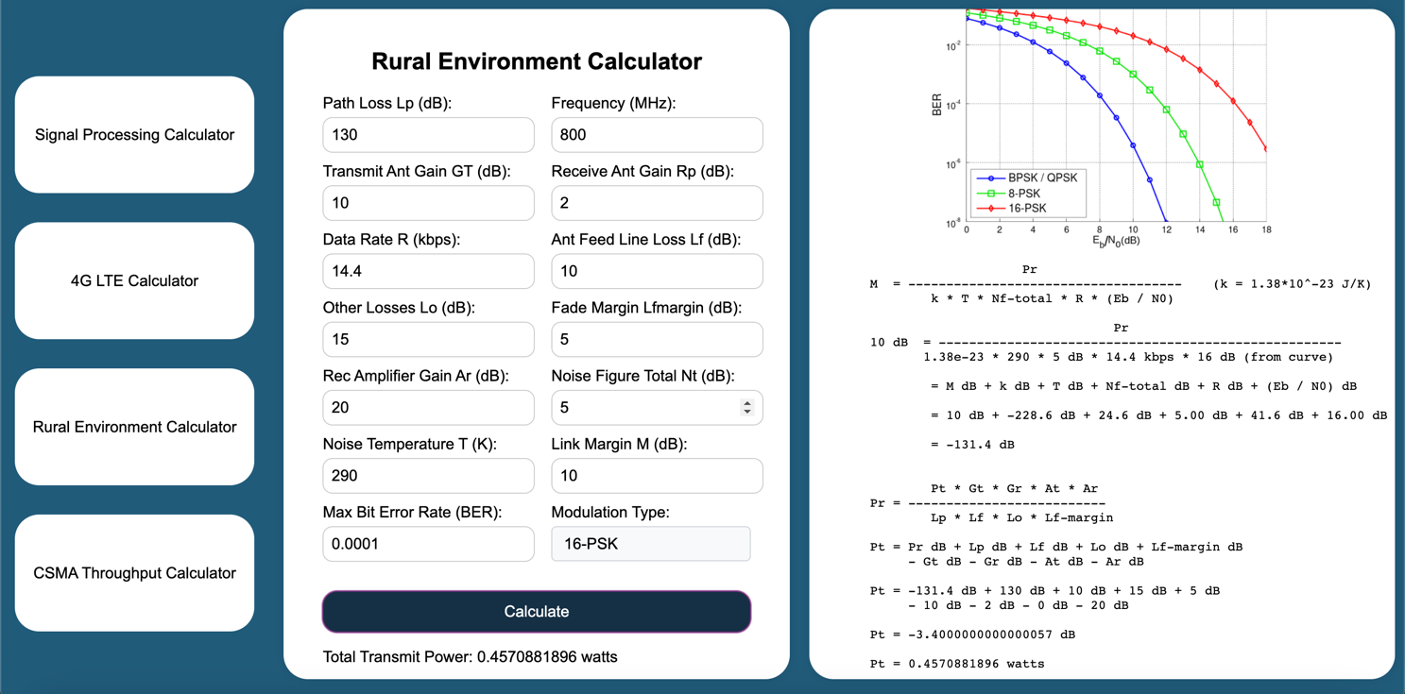

Figure 8 - Calculator 3 scenario 2

## Scenario 3:

Given a flat rural environment with a path loss of 150 dB, a frequency of 1800 MHz, a 6 dB transmit antenna gain, a 0 dB receive antenna gain, a data rate of 19.2 kbps, 8 dB in antenna feed line loss, 25 dB in other losses, a fade margin of 10 dB, a receiver amplifier gain of 30 dB, a noise figure total of 7 dB, a noise temperature of 290 K, and a link margin of 12 dB. Find the total transmit power required for an BPSK/QPSK modulated signal with a maximum bit error rate of 10^−4.

Input:

* Path Loss: 150 dB
* Frequency: 1800 MHz
* Transmit Antenna Gain: 6 dB
* Receive Antenna Gain: 0 dB
* Data Rate: 19.2 kbps
* Antenna Feed Line Loss: 8 dB
* Other Losses: 25 dB
* Fade Margin: 10 dB
* Receiver Amplifier Gain: 30 dB
* Noise Figure: 7 dB
* Noise Temperature: 290 K
* Link Margin: 12 dB

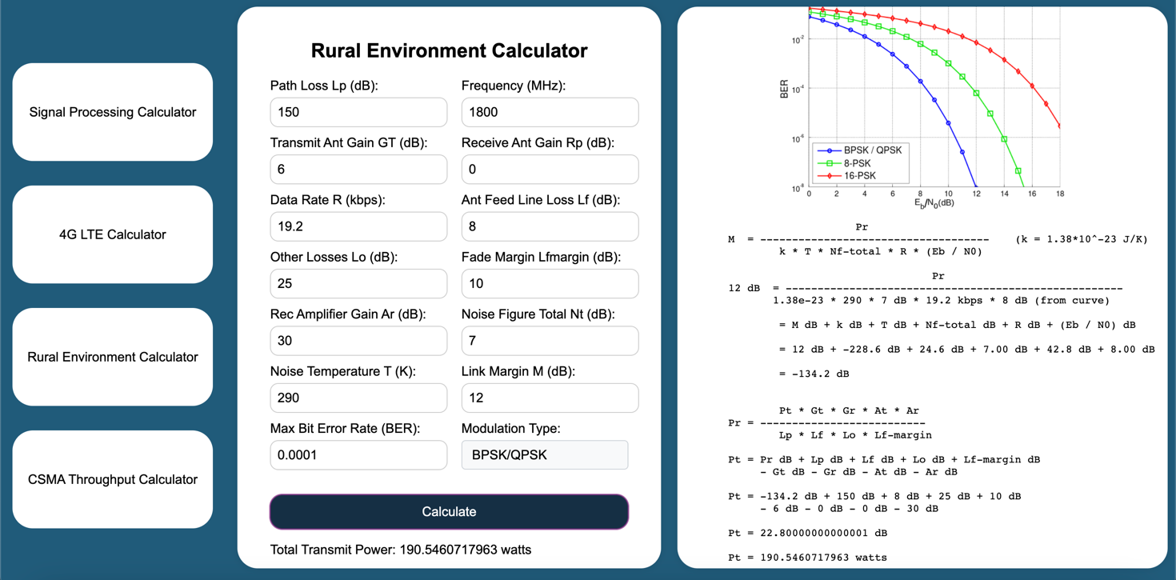

Figure 9 - Calculator 3 scenario 3

# Calculator 4:

## Scenario 1:

A network has a data transmission bandwidth of 20 Mbps. It uses unslotted nonpersistent CSMA in the MAC layer. The maximum signal propagation time from one node to another is 40 µs. Determine the throughput in percent assuming 10 Kbit frame size and a frame rate of 5 Kfps.

Input:

* Data Transmission Bandwidth: 20 Mbps
* Maximum Signal Propagation Time: 40 µs
* Frame Size: 10 Kbit
* Frame Rate: 5 Kfps

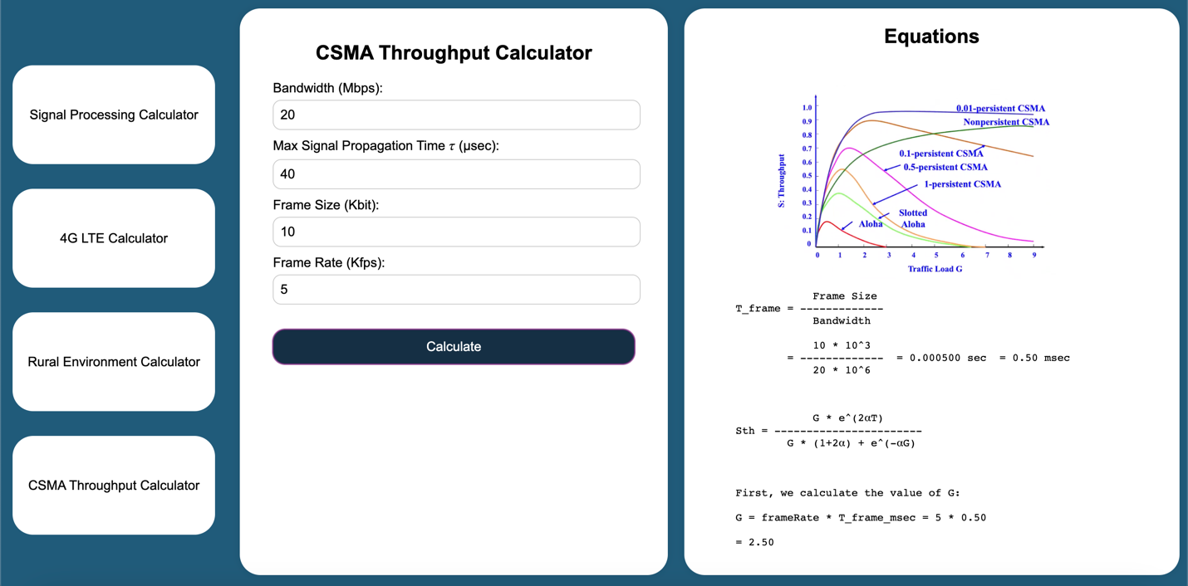

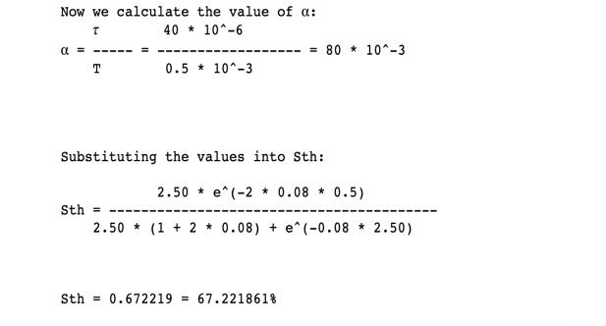

Figure 10 - Calculator 4 scenario 1

## Scenario 2:

A network has a data transmission bandwidth of 15 Mbps. It uses unslotted nonpersistent CSMA in the MAC layer. The maximum signal propagation time from one node to another is 30 µs. Determine the throughput in percent assuming 8 Kbit frame size and a frame rate of 4 Kfps.

Input:

* Data Transmission Bandwidth: 15 Mbps
* Maximum Signal Propagation Time: 30 µs
* Frame Size: 8 Kbit
* Frame Rate: 4 Kfps

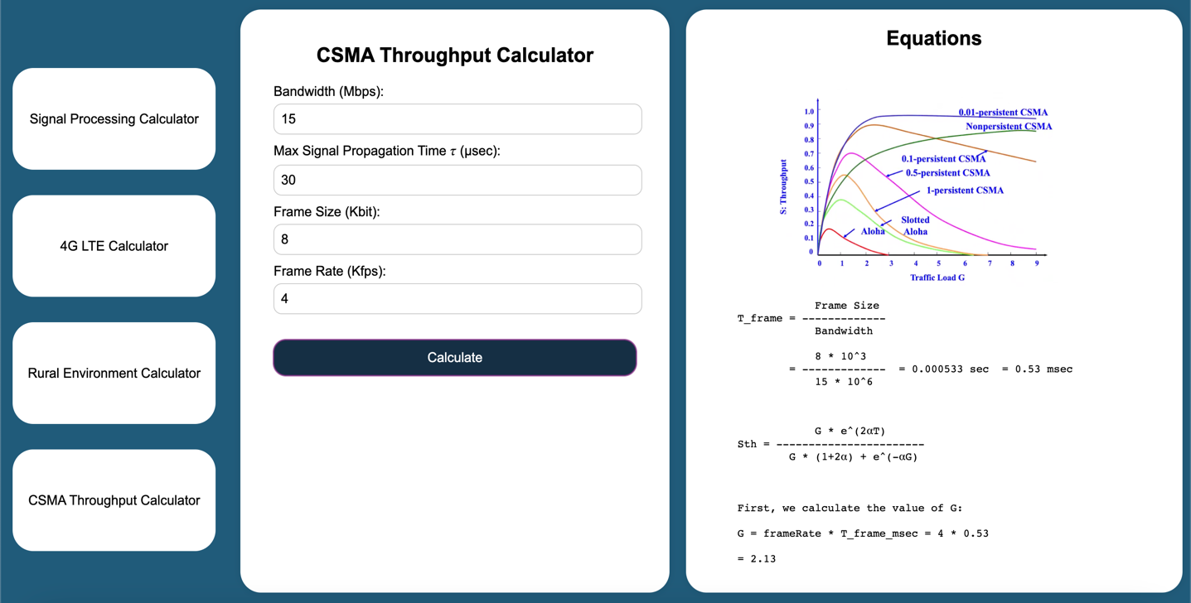

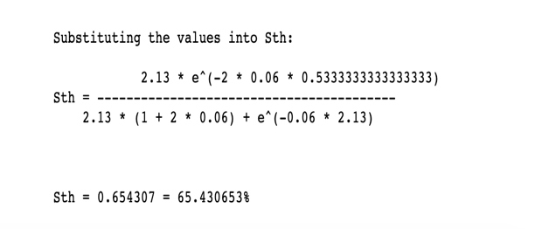

Figure 11 - Calculator 4 scenario 2

## Scenario 3:

A network has a data transmission bandwidth of 25 Mbps. It uses unslotted nonpersistent CSMA in the MAC layer. The maximum signal propagation time from one node to another is 50 µs. Determine the throughput in percent assuming 12 Kbit frame size and a frame rate of 6 Kfps.

Input:

* Data Transmission Bandwidth: 25 Mbps
* Maximum Signal Propagation Time: 50 µs
* Frame Size: 12 Kbit
* Frame Rate: 6 Kfps

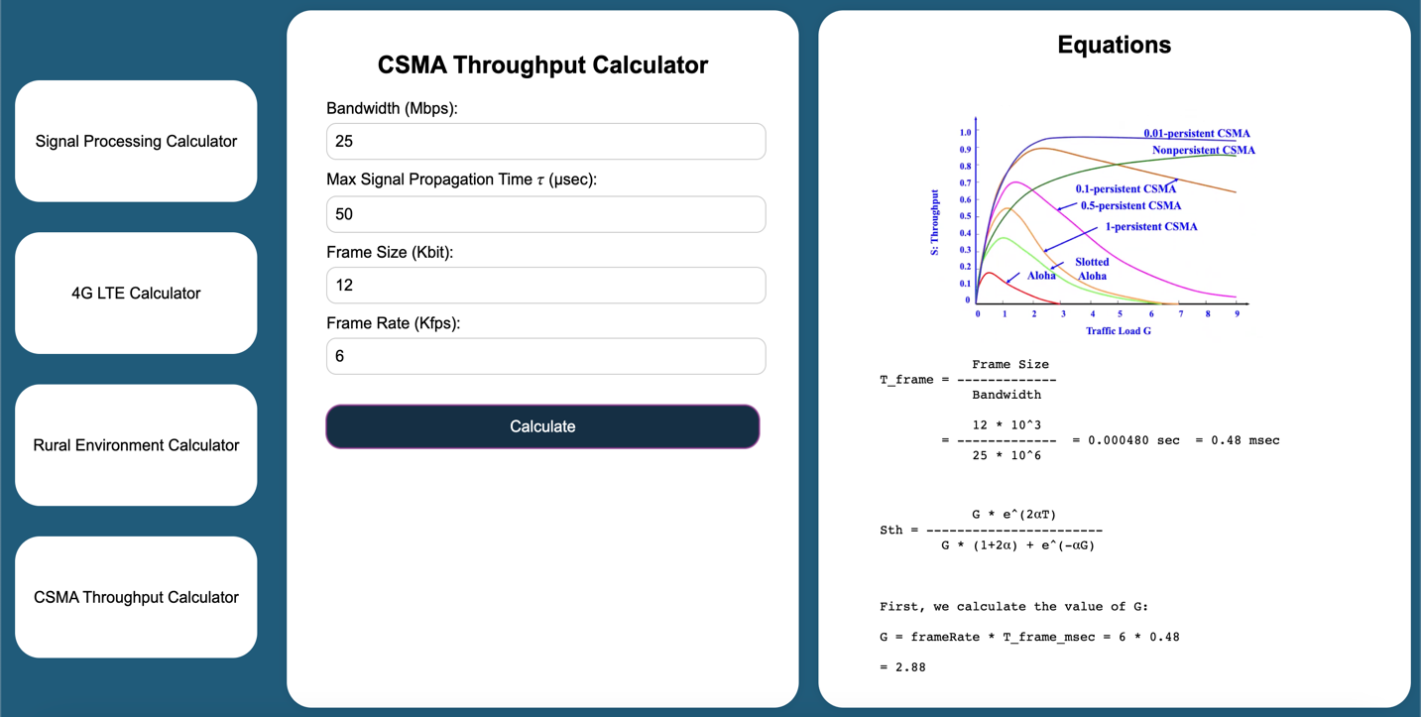

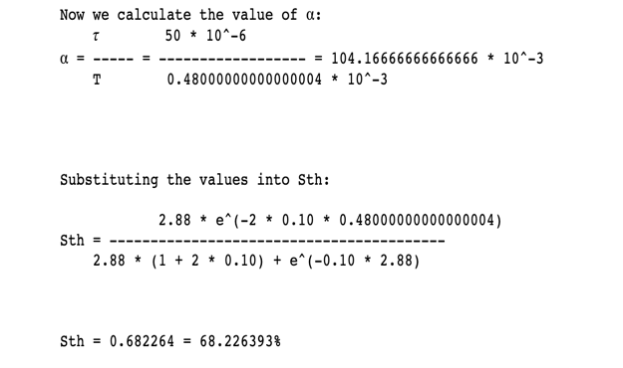

Figure 12 - Calculator 4 scenario 3

# Calculator 5:

## Scenario 1:

A new mobile network provider acquired the license to provide full-rate duplex voice communication using GSM900 technology in a certain city (8 timeslots per carrier). The area of the city is equal to 4 km² (4,000,000 m²). The mobile network provider is interested in providing service to 80 thousand subscribers. Subscribers in this city make an average of 8 calls per day, and the average call duration is 3 minutes. The service provider is interested in providing the subscribers with a quality of service that guarantees a call drop probability equal to 0.02. The minimum SIR needed to correctly provide the service is equal to 13 dB. Assuming -22.0 dB power is measured at a reference distance of 10 meters from base stations, the path loss exponent equals 3 (cellular urban area), and the receiver sensitivity is 7×10^-6 watts.

Outputs:

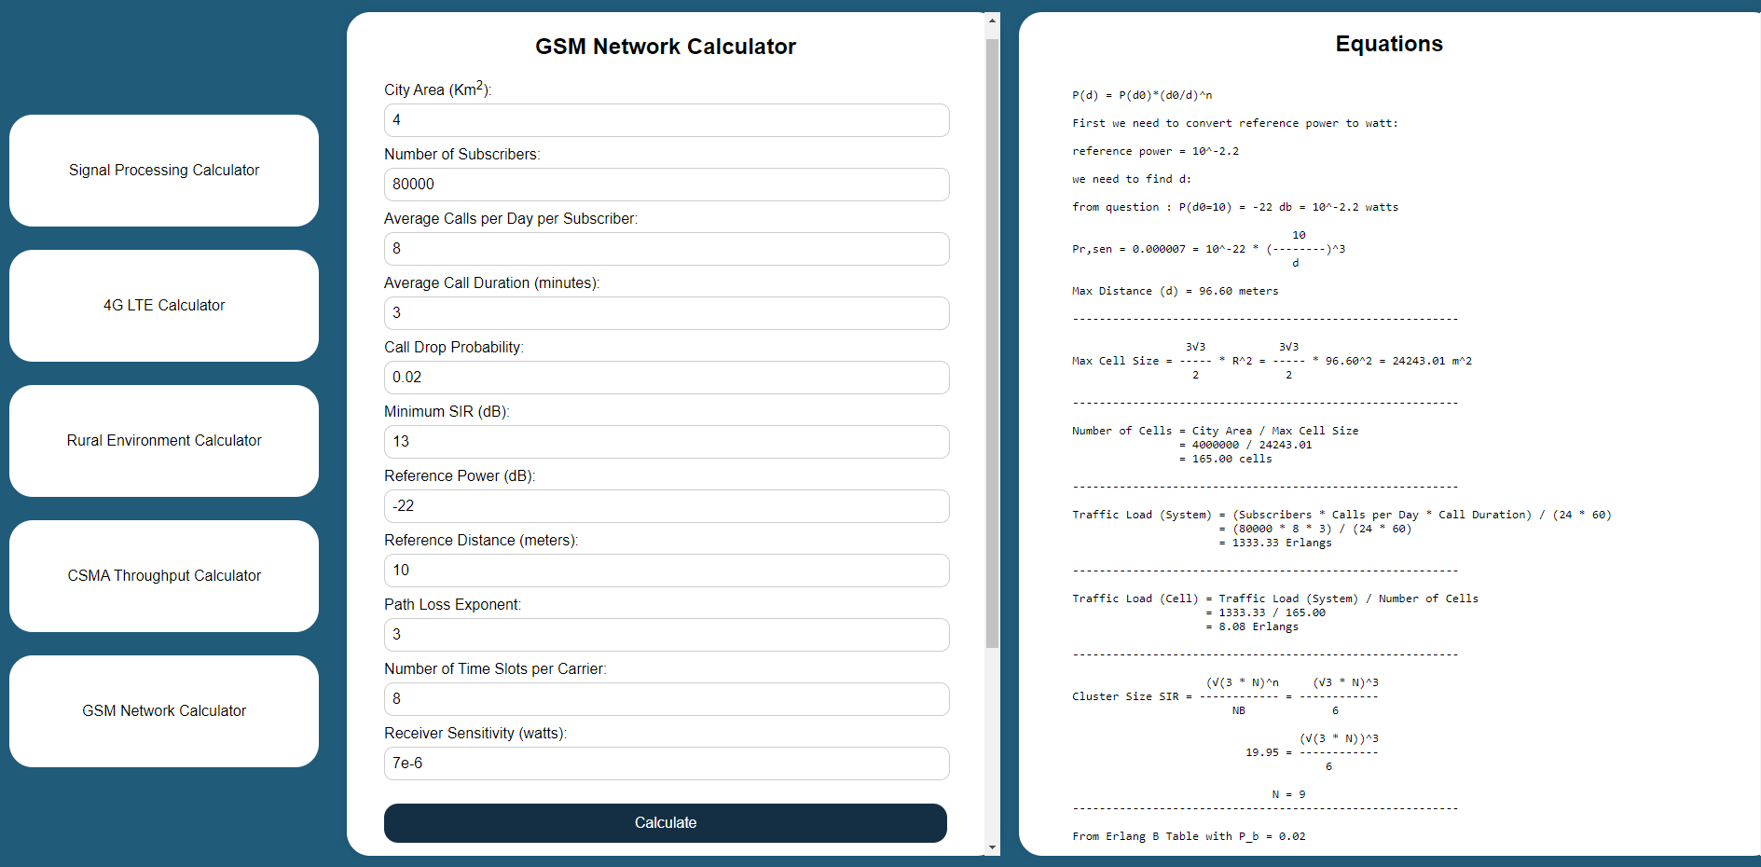

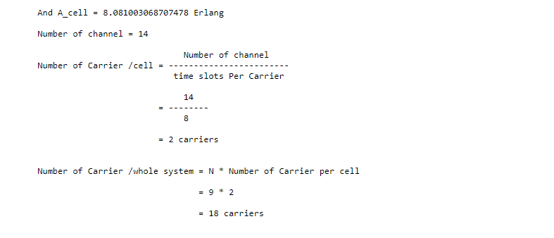

## Scenario 2:

A new mobile network provider acquired the license to provide full-rate duplex voice communication using GSM900 technology in a certain city (8 timeslots per carrier). The area of the city is equal to 4 km² (4,000,000 m²). The mobile network provider is interested in providing service to 120 thousand subscribers. Subscribers in this city make an average of 8 calls per day, and the average call duration is 3 minutes. The service provider is interested in providing the subscribers with a quality of service that guarantees a call drop probability equal to 0.02. The minimum SIR needed to correctly provide the service is equal to 13 dB. Assuming -22.0 dB power is measured at a reference distance of 10 meters from base stations, the path loss exponent equals 3 (cellular urban area), and the receiver sensitivity is 7*10^-6 watts.

Outputs:

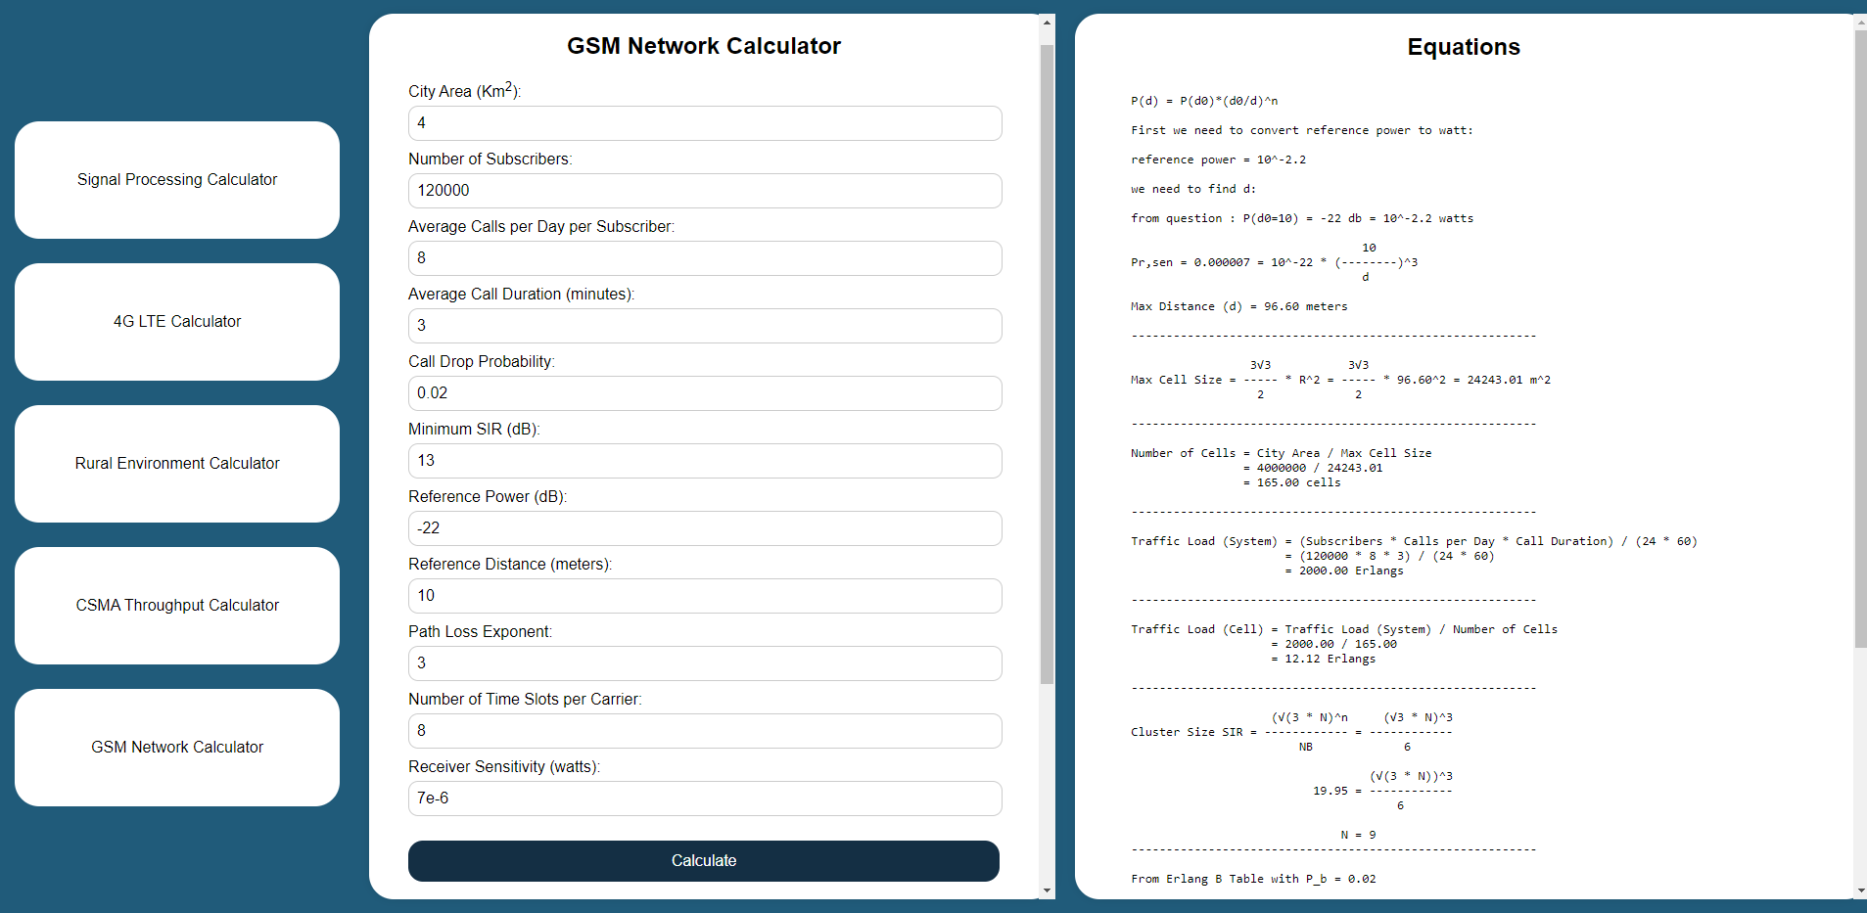

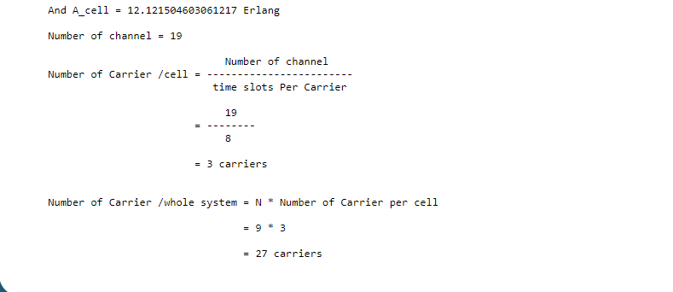

## Scenario 3:

A new mobile network provider acquired the license to provide full-rate duplex voice communication using GSM900 technology in a certain city (8 timeslots per carrier). The area of the city is equal to 4 km² (4,000,000 m²). The mobile network provider is interested in providing service to 80 thousand subscribers. Subscribers in this city make an average of 12 calls per day, and the average call duration is 5 minutes. The service provider is interested in providing the subscribers with a quality of service that guarantees a call drop probability equal to 0.02. The minimum SIR needed to correctly provide the service is equal to 13 dB. Assuming -22.0 dB power is measured at a reference distance of 10 meters from base stations, the path loss exponent equals 3 (cellular urban area), and the receiver sensitivity is 7×10^-6 watts.

Output:

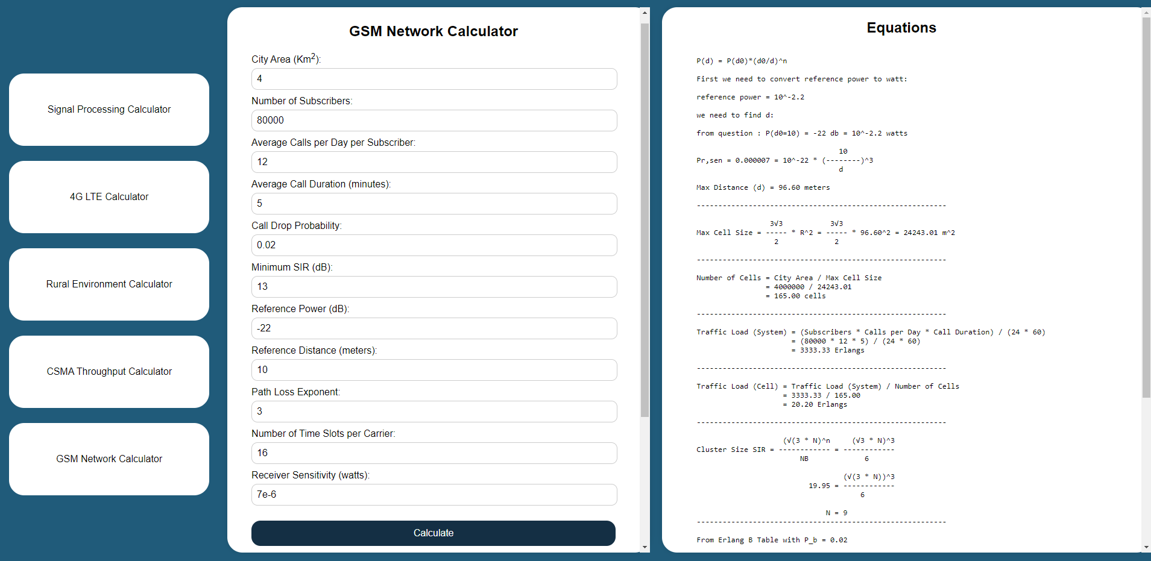

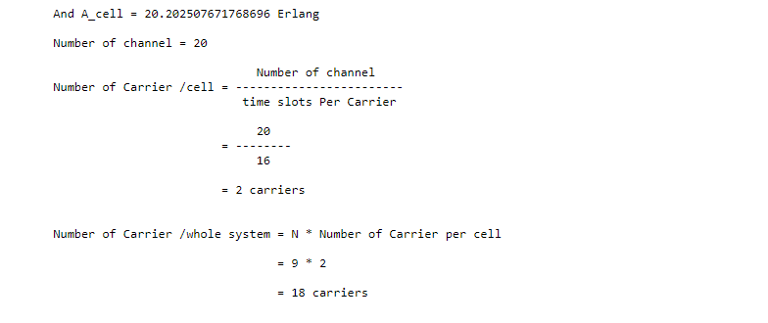

## Scenario 3:

A new mobile network provider acquired the license to provide full-rate duplex voice communication using GSM900 technology in a certain city (8 timeslots per carrier). The area of the city is equal to 4 km² (4,000,000 m²). The mobile network provider is interested in providing service to 80 thousand subscribers. Subscribers in this city make an average of 8 calls per day, and the average call duration is 3 minutes. The service provider is interested in providing the subscribers with a quality of service that guarantees a call drop probability equal to 0.02. The minimum SIR needed to correctly provide the service is equal to 13 db. Assuming -22.0 dB power is measured at a reference distance of 10 meters from base stations, the path loss exponent equals 3 (cellular urban area), and the receiver sensitivity is 7×10^-6 watts. When Minimum number of carriers needed (in the whole system) to achieve the required Quality of Service if QoS has changed to 0.05.

Output:

