Smart Task Delegation System

Systems Analysis and Design Second Semester
2026/2027

University of Jordan

Systems Analysis and Design Supervised by: Dr.Hamad Alsawalqah Second Semester 2026-4-10

Student Name | ID
Othman Mohammad | 0227350
Mahmoud Kamal | 0221522
Moaiad

Version Control

Version | Description
Version 1.0 | Initial version of the software documentation. Added Chapter 1 (Project  Initiation) and Chapter 2 (Project Management Plan).
Version 2.0 | Updated version of the software documentation. Added Chapter 3 (Software  Requirements Specifications).
Version 3.0 | Updated version of the software documentation. Added Chapter 4 (System Analysis and Design), Chapter 5 (User Manual), and Chapter 6 (References),  excluding implementation details.
Excutive Summary

Contents
- Project initiation 1
  - Project Overview 1
  - Problem Definition 1
    - Issues 1
    - Objectives 1
    - Requirements 1
    - Constraints 2
    - Vision Document 2
      - Problem Description 2
      - System Capabilities 2
      - Business Benefits 3
  - Feasbility Studies 3
    - Techinical Feasibility 3
    - Operational Feasibility 4
    - Economic Feasibility 5
    - Schedule Feasibility 6
    - Legal Feasibility 6
  - Recommended Solution and Expected Project Deliverables 7
  - Local and Global Impact of the Proposed Solution 8
- Project Management plan 9
  - Project Organization 9
  - Roles and Responsibilities 9
  - Software Process Model 11
    - Main Phases 11
  - Project Environment 13
    - Procedures 13
    - Tools 13
    - Hardware (HW) Resources: 13
    - Software (SW) Resources: 14
  - Project tasks 15
  - Project Schedule 25
    - Activity Network 25
    - Gantt Chart 26
  - Assigning Team Members to Tasks 27
  - Monitoring and Controlling Mechanisms 28
  - Risk Analysis 31
    - Effects and Causes 31
  - Communication Plan 31
- Software Requirements Specifications 31
  - System Stakeholders and Requirement Sources 31
    - System Stakeholders 31
    - Information Gathering 32
      - Interviews 33
      - Questionnaires 35
      - Document Analysis 45
      - Observation 46
      - Prototype 46
  - User Requirements 53
  - Context Diagram 56
  - Use Case Model 57
    - Use Case diagram 57
    - Use Case descriptions 59
  - Functional Requirements Specification 60
  - Data Requirements 72
  - Non-Functional Requirements 77
  - Requirements Validation and Review Summary 77
    - How We Verified the Requirements 77
      - Team Review 77
      - Stakeholder Review 78
    - How We Confirmed the Requirements Are Correct, Clear, and Complete . 78
      - Method 1: Mockups 78
      - Method 2: Walkthroughs 78
- System Analysis and Design 79
  - Structured Analysis and Design 79
    - Level 0 DFD 79
    - Level 1 DFDs 79
    - Data Dictionary 81
      - Data flow 81
      - Data Structures 97
      - Data Stores 100
      - Data Elements 101
  - Process Specifications 105
    - Fragment 1: User Management Processes 105
    - Fragment 2: Maintenance Request Management Processes 117
    - Fragment 3: Assignment & Task Management Processes 140
    - Fragment 4: Analytics & Reporting Processes 157
    - Fragment 5: Notification Management Processes 177
    - Summary of All Process Specifications 190
  - Object-Oriented Analysis 192
    - Activity Diagrams 192
  - System Architecture Design 194
    - Architectural Style 194
      - Primary Architecture Pattern: Three-Tier Client-Server
Architecture 194
      - Architectural Characteristics 194
    - Technology Stack 194
      - Frontend Technologies 194
        - Web Application 194
        - Mobile Application 194
      - Backend Technologies 195
        - API Server 195
        - Database Layer 195
      - Infrastructure & DevOps 195
      - Development & Testing Tools 195
    - Component/Module-Level View 196
      - System Components Diagram 196
      - Core Modules and Components 196
        - MODULE 1: Authentication & Authorization
Module 196
        - MODULE 2: User Management Module 197
        - MODULE 3: Maintenance Request Management
Module 197
        - MODULE 4: Task Assignment & Scheduling Module . 198
        - MODULE 5: Technician Workflow Module 198
        - MODULE 6: Notification & Communication Module .198
        - MODULE 7: Analytics & Reporting Module 199
        - MODULE 8: Location & Equipment Management Module 199
        - MODULE 9: Data Access Layer (DAL) 200
    - Module Responsibilities Summary Table 201
    - Architectural Design Decisions 201
      - Why Three-Tier Architecture? 201
      - Why RESTful API? 201
      - Why Node.js + Java Hybrid Backend? 202
      - Why MySQL? 202
      - Why Redis for Sessions? 202
    - Security Architecture 202
      - Security Measures 202
      - Data Privacy 202
    - Performance Optimization Strategies 202
    - Deployment Architecture 203
      - Production Environment 203
      - Continuous Integration/Deployment 203
    - Monitoring & Observability 204
    - Scalability Considerations 204
    - Alignment with Non-Functional Requirements 204
    - Future Enhancements 204
  - Object-Oriented Design 205
    - Class Diagram 205
    - Sequence Diagrams 206
    - Classes and Components Design 220
  - ERD analysis and Database Design 230
    - Database Design (ERD) 230
    - Object to ER Mapping 231
- User Manual 237
- References 259
Tables

Figures

Project initiation

Project Overview
This project aims to develop a web based Artificial intelligence task delegation system to help managers, allocate tasks more efficiently and ensures optimal use of resources with data-driven, automated routing, based on the employees workload, skillset, and availability, it also tracks progress and generates reports for the managers empowering their decision making.

Problem Definition
The current manual methods of assigning tasks within teams rely heavily on a manager's subjective judgment and limited visibility into the team's day-to-day capacity. This approach fails to account for the dynamic nature of employee workloads and the nuanced skill sets required for specific deliverables.
Also current methods for managing and delegating tasks in professional or educational environments are often inefficient and lack transparency. This leads to delays, user frustration, and a lack of data for performance improvement.

    - Issues

Issue | weight
- Manual assignment relies heavily on a manager's subjective judgment and limited visibility into day-to-day capacity. | 10
- Current approaches fail to account for the dynamic nature of employee workloads and nuanced skill sets. | 9
- Task management processes are inefficient and lack transparency, leading to user frustration. | 8
4.Inefficient task delegation leads to significant project delays | 7
5.severe lack of data available for performance improvement. | 6

    - Objectives
- Replace subjective manual assignment with an AI-driven, automated task routing system to provide managers with real-time visibility into day-to-day capacity.
- Develop a database of employee skill sets and competencies that allows the system to suggest or match specific tasks to the most qualified available team member.
- Build a user-facing dashboard where requesters can monitor the live status of their tasks, reducing communication gaps and increasing user confidence in the process.
- Reduce project delays and improve delivery speed by utilizing intelligent routing to eliminate bottlenecks in task delegation.
- Generate comprehensive analytics and progress reports to provide managers with actionable data for continuous performance improvement.
    - Requirements
- The system must ensure data security and protect the privacy of all users.
- The system must be intuitive and user-friendly, allowing non-technical users to navigate and interact with it easily.
- The analytics dashboard must be restricted to administrators only.
    - Constraints
    - Vision Document
      - Problem Description
The current process of manually allocating tasks and managing employee workloads is increasingly inefficient. As operations expand and projects grow in complexity, managers struggle to constantly balance workloads, accurately match tasks to the most qualified employees, and track real-time availability. This manual approach often leads to workflow bottlenecks, unequal distribution of work, employee burnout, and underutilized skill sets. Furthermore, managers spend excessive administrative time trying to optimize scheduling rather than focusing on strategic goals. An AI-driven solution is needed to automate and optimize these delegation processes, ensuring that resources are used efficiently and tasks are assigned to the right people at the right time.

      - System Capabilities
- Provide intelligent task assignment.
  - Allocate tasks automatically based on employee workload and real-time availability.
  - Match tasks to specific employee skill sets and competencies.

- Include AI-driven delegation support.
  - Generate smart suggestions for managers to assist with complex task delegation.
  - Learn from past project outcomes to improve future task-matching recommendations.

- Provide progress tracking and reporting capabilities.
  - Allow managers to track task progress and project milestones in real-time.
  - Generate comprehensive reports on resource utilization, efficiency, and team performance.
- Support employee feedback and workload management.
  - Allow employees to provide direct feedback on assigned tasks and project scope.
  - Enable employees to flag their capacity limits to proactively manage workload and prevent burnout.
      - Business Benefits
- Increasing overall operational productivity and project throughput
- Optimizing resource allocation by matching the right skills to the right tasks
- Improving employee satisfaction by preventing burnout and balancing workloads equally
- Reducing the administrative time managers spend on scheduling and delegation
- Improving project timelines by eliminating bottlenecks caused by overloaded staff
- Providing data-driven insights to managers for better future capacity planning
- Fostering better team communication through integrated employee feedback loops

Feasbility Studies
    - Techinical Feasibility
The technical feasibility assesses the technological components necessary to develop and operate theplatform. This includes evaluating the required hardware, software tools, and the technical skills essential for building and maintaining the system.

Technology: The Smart task delegation system is built using basic and easy-to-use Web tools like HTML, CSS, JavaScript, Bootstrap, and jQuery. These Tools help create a clean and responsive design that works well on Different devices. We also use Canva to design simple and clear images and graphics, making the website easy for Seniors users to understand and use .

Cloud Hosting: We are using GitHub to store and manage the project online. It helps us work together, keep track of changes, and easily share the project with others.

All the required resources including hardware, software tools, and hosting services are already available and accessible, ensuring smooth development and operation of the Smart task delegation system plat-form.

Since all these technologies are part of what we have learned at university and practiced in various projects, we are fully capable of developing and maintaining the Smart task delegation system platform using them. Our academic background and hands-on experience give us the technical foundation and confidence to build this system successfully.
    - Operational Feasibility
The proposed AI-driven task assignment system is operationally feasible. It is designed to intelligently allocate tasks within the organization, enabling managers to assign work based on employee workload, skill sets, and real-time availability, while also tracking progress and gathering feedback. Since it will be integrated as a centralized web and desktop application, managers and employees can access their dashboards from anywhere. We expect that our system will gain wide acceptance from managers, project leads, and general employees because it addresses an essential need: balancing workloads equitably, preventing burnout, and saving significant administrative effort. It will have clear data privacy guidelines and mechanisms to ensure that sensitive employee performance and workload data is secured, fully complying with the organization’s internal policies and data protection laws. Additionally, the system is well-suited to a modern corporate culture that values efficiency and employee well-being. The end users are capable of using it smoothly and effectively without requiring extensive training, due to its intuitive dashboards and user-friendly design.
    - Economic Feasibility Development Costs:

Table 1: Devlopment Costs

Expense Category | Amount
Salaries /wages | 25,000 JD
Equipment/installations | 10,000 JD
Training | 2,500 JD
Facilities | 3,000 JD
Utilities | 1,500 JD
Travel\Miscellaneous | 2,000 JD
Total | 44,000 JD

Operational Costs:

Table 2: Operational Costs

Service | Annual Cost(Per year)
Connectivity/hosting | 2,000 JD
programming | 5,000 JD
Total | 7,000 JD

Table 3: Intangible Benefits

Intangible Benefits
Enhanced Institutional Trust and reputation
Increasing users satisfaction
Saving time and effort for both users and Institutions

Benefit and Payback Analysis:

Table 4: Benefit and Payback Analysis

Category | Year 0 | Year 1 | Year 2 | Year 3 | Year 4 | Year 5
Value of  benefits | 0 | 18,000 | 19,000 JD | 20,000 JD | 21,000 JD | 22,000 JD
Development  costs | 44.000 JD | 0 | 0 | 0 | 0 | 0
Annual  expenses | 0 | −7,000 JD | −7,000 JD | −7,000 JD | −7,000 JD | −7,000 JD
Net Benefit /  Costs | −44,000 JD | 11,000 JD | 12,000 JD | 13,000 JD | 14,000 JD | 15,000 JD
Discount Rate  (7%) | 1 | 0.934 | 0.873 | 0.813 | 0.763 | 0.713
Net Present  Value (NPV) | −44,000 JD | 10,274 JD | 10,476 JD | 10,569 JD | 10,682 JD | 10,695 JD
Cumulative  NPV | −44,000 JD | -33,726 JD | -23,250 JD | -12,681 JD | -1,999 JD | 8,696 JD
Payback  Period | 4 years+ | 1,999/10,695 = 0.18 4.18 years

Lifetime ROI= (100,000-79,000)/79,000 = 0.2658 or 26.58%

Annual ROI = 26.58% / 5 = 5.32%
    - Schedule Feasibility
Table 5: Project Development Schedule

Phase | Task | Estimated Time
Planning | Define Project Scope & Objectives | 1 week
Analysis | Requirements Gathering, Process Analysis,  and Document Delivery | 2 weeks
Design | System Architecture and Interface Design | 2 weeks
Implementation | Development of Core Features | 4 weeks
Testing | System Testing and Quality Assurance | 2 weeks
Deployment | System Deployment | 1 week

    - Legal Feasibility
The Smart Task Delegation System is evaluated to be legally feasible, as it complies with Jordanian regulations and standard software engineering ethics. The system will adhere to the following legal pillars:
Data Privacy & Personal Data Protection: The system will be designed to comply with Jordanian Personal Data Protection Law No. 24 of 2023. It will ensure that employee data (performance metrics, attendance, and task history) is processed only for professional purposes. Data encryption and explicit user consent during the first login will be implemented to protect "sensitive" personal data.

Labor Law Compliance: The system’s delegation logic will respect the Jordanian Labor Law regarding working hours, overtime, and mandatory rest periods. The system will be configured to prevent the assignment of non-emergency tasks outside of official working hours, ensuring that the technology does not facilitate labor violations.

Auditability & Accountability: To provide "Legal Visibility," the system will maintain an immutable audit log. This ensures that every task assigned, accepted, or rejected is recorded with a timestamp. This log can serve as legal evidence in the event of workplace disputes, safety investigations, or performance-related legal inquiries.

Intellectual Property (IP) Rights: The development team commits to using only open-source libraries with compatible licenses (e.g., MIT, Apache) or properly licensed commercial software. All documentation and code produced will respect the intellectual property policies of the University of Jordan.

Software Engineering Ethics: The system will follow the ACM/IEEE Code of Ethics, ensuring Confidentiality (only authorized managers see performance data) and Transparency (users are aware of how their task completion rates are being calculated).

These documents will comply with both university IT regulations and national legal require-ments.

Recommended Solution and Expected Project Deliverables
To address the inefficiencies in manual task assignment and the lack of transparency in workload management, the proposed solution is a Smart Task Delegation System. This web-based platform will allow users to report tasks or issues directly to a centralized system, streamlining the process of submission, delegation, and execution. By utilizing this system, the organization will eliminate the subjective judgment of manual assignments and ensure that tasks are distributed based on real-time data, employee availability, and specific skill sets. Requesters will be able to provide comprehensive details, including descriptions, urgency levels, and location, ensuring the team has all necessary information from the start.
The system will feature a centralized dashboard where managers can review, prioritize, and delegate tasks to the most suitable staff members. To ensure continuous communication, the system will provide real-time status updates and automated notifications, keeping all stakeholders informed from the moment a task is submitted until its successful completion.
Expected Deliverables:The project team (consisting of 3 members) is committed to providing a full suite of deliverables that satisfy both the analytical and practical requirements of the course:
- Task Submission & Reporting:
The system will provide a structured interface for users to submit tasks. Each submission will act as a "Task Ticket" containing a title, detailed description, priority level, and location, ensuring that no critical information is missed before the delegation process begins.

- Centralized Review & Delegation Dashboard:

An administrative dashboard will serve as the core analysis tool for managers. It will allow for the evaluation of each task to prevent redundancy and ensure validity. The system will provide visibility into the current workload of each team member, enabling the manager to delegate tasks effectively to the person with the right expertise and availability.

- Automated Status Tracking & Transparency:

To resolve user frustration and improve service quality, the system will include a real-time communication engine. Requesters will receive automated notifications when their task is "Received," "Assigned," "In-Progress," or "Completed," building a transparent relationship between the management and the users.

- Database Design & Historical Documentation:

A robust database (PostgreSQL) will be implemented to store all task records. This documentation will provide a clear audit trail of who reported the issue, who resolved it, and how long it took. This historical data will serve as a vital resource for future resource planning and organizational decision-making.

- Performance & Workload Analytics:

The system will track key performance indicators (KPIs), such as average resolution time and team member utilization rates. By identifying bottlenecks in the delegation process, the organization can ensure that the maintenance or service teams remain responsive and continue to improve their overall operational reputation.

- Project Documentation & Prototype:

As part of the final delivery, a comprehensive technical report will be provided, alongside a high-fidelity UI/UX prototype. This documentation will cover the complete analysis and design phases, including DFDs, OOAD models (Class and Sequence diagrams), and ERDs to demonstrate the system's structural and behavioral logic.

Local and Global Impact of the Proposed Solution
Locally: The Smart Task Delegation System will ensure accuracy and fairness in workload distribution, enabling management to plan and schedule tasks more efficiently through automatically generated assignments based on real-time availability and employee expertise. Implementing these best practices will significantly improve internal service quality; automation leads to a better experience for everyone involved. It will reduce delays in handling requests, eliminate manual paperwork, and ensure that every task is managed from submission to completion through automated tracking tools. This results in optimized resource management, higher operational efficiency, and increased satisfaction for both the staff performing the tasks and the users requesting them, as they stay updated without any delay in feedback.
Globally: This project contributes directly to global digital transformation and corporate sustainability efforts. It is becoming essential for organizations of all sizes to rely on intelligent systems to allocate resources efficiently and maximize the performance of their human and technical assets. A well-designed task delegation system demonstrates how technology enables organizations to make data-driven decisions to achieve superior operational efficiency. By centralizing all delegation and tracking processes into a single digital platform, it reduces time wastage and human effort lost in unorganized manual operations, setting a standard for modern, agile management.

Project Management plan

Project Organization
The project organization shows how the team is structured and who is responsible for each part of the project. It helps make sure everyone knows their role and who to report to, keeping the work organized and efficient. The structure for our team also supports good communication between team members during development, as shown in Figure 1.




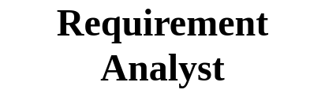
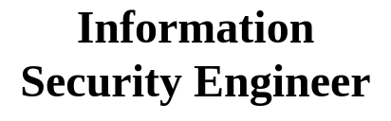







Figure 1: Project Organizational Structure Table 6: Team Roles Assignments and Responsibilities

Assigned Member | Roles
othman | Project Manager, System Analyst, Requirement Analyst
moaiad | Technical Clerk, Technician
mahmood | System Administrator, Hardware Engineer,Database Engineer
mahmood,othman | Software Engineer, Web Designer,
External | Information Security Engineer, Software QA Engineer

Roles and Responsibilities
In this section, we will explain each role with its responsibilities in perspective. see Table 7.

Table 7: Roles and Responsibilities

Role | Responsibility
Project Manager | Responsible for planning, organizing, and overseeing pro-jects to ensure they are completed on time, within budget, and meet quality standards. They coordinate team efforts, man-age resources, and communicate with stakeholders through-  out the project lifecycle.

System Analyst | Systematically assesses how businesses function by examin-ing the inputting and processing of data and the outputting of information with the intent of improving organizational  processes.
Requirement Analyst | Gathers and documents user requirements, ensuring align-  ment between business needs and system design.
Technical Clerk | Assists in maintaining documentation, schedules, and te-  chinical records. Supports techinical team with admin tasks.
Software QA Engineer | Ensuring that software products meet the highest standards  of quality and functionality.
Information Security Engineer | Rresponsible for designing, implementing, and maintaining security systems to protect an organization’s data and networks from cyber threats. They also monitor security measures, respond to incidents, and ensure compliance with  security policies and regulations.
Web Designer | Responsible for creating the visual layout and user experi-ence of websites, ensuring they are both attractive and functional. Their tasks include designing page layouts, cod-ing navigation, and collaborating with clients to meet their  needs.
System Administrator | Responsible for managing and maintaining an organization’s computer systems and networks, ensuring they operate efficiently and securely. This role often involves troubleshooting issues, installing software, and managing  user accounts.
Hardware Engineer | Responsible for analyzing blueprints and technical drawings, reviewing system tests and performing updates as needed, implementing the latest systems and processes and ensuring everyone follows them, monitoring the manufacturing and assembly of hardware equipment, acting as the technical  leader in product development
Software Engineer | Responsible for designing, developing, testing, and maintain-ing software applications and systems to meet user needs. Their responsibilities include analyzing user requirements, writing and testing code, and collaborating with other team  members to ensure software functionality and performance.
Database Engineer | Responsible for designing, implementing, and maintaining database systems to ensure efficient data storage and re-

trieval. Their key responsibilities include database design, data security, performance optimization, backup and recov-
ery, and data migration.

Software Process Model
We are going to use the Waterfall Software Process Model. This model is suitable because our project goals and requirements are clearly defined from the beginning, and we have a strict timeline to follow. Since this model is based on a highly structured approach, it will help us maintain organization and ensure that all deliverables are completed on time. See Figure 2.







Figure 2: Waterfall Software Process Model
    - Main Phases :
- Requirements Analysis and Specification:
  - Requirements Analysis: Gathering and understanding all the requirements of the client, then documenting and analyzing them.
  - Requirement Specification: Documenting the analyzed requirements in a software require-ment specification document that serves as a reference for the next phases.
- System Design:
  - Translating the requirements from the requirement specification document into a detailed system design as well as creating the overall architecture.
- Development:
  - Developing the web and mobile applications according to the designs created earlier, using a suitable programming languages and frameworks.
- Testing and Deployment:
  - Testing the whole software and verifying that all components work correctly and satisfy user expectations. After testing, the software is ready and available for use.
- Maintenance:
  - The final, ongoing phase. It ensures that the software remains functional, secure, and up-to-date throughout its operational life.

Project Environment
    - Procedures
- Initiation:
  - Establish the project team, define the requirements goals, and potential risks.
- Planning:
  - Create a detailed project plan using the Waterfall methodology, this includes outlining all necessary steps, allocating resources, and developing cost, schedule, and communication plans to achieve our outcomes.
- Execution and Testing:
  - Implement the planned activities and test them carefully to ensure quality and functionality.
- Monitoring:
  - Track progress and compare it with planned goals to ensure timely delivery and quality control.
- Documentation:
  - All design diagrams, reports, and testing results are documented using google docs and stored in a shared repository to ensure collaboration among team members.
    - Tools
Table 8: Tools

Tool | Purpose
Development Tools | Visual Studio Code for developing the web application, and Flutter for building a responsive mobile application using one shared code-  base.
Documentation | google docs for creating our PDF documentation.
Version Control | GitHub for sharing and tracking project progress and managing  team collaboration.
Design & Prototyping | Figma for creqting UI/UX design, and Draw.io for diagrams.
Database Management | MySQL, chosen for its reliability, speed, and support for relational  data.
Testing | JUnit, an open-source testing framework, to verify our code’s cor-  rectness and performance.
Communication Tools | Google Meet, WhatsApp, and GitHub for coordination.

    - Hardware (HW) Resources:
Table 9: Hardware (HW) Resources

Category | Description
Developer Devices | Personal laptops and PCs for developing both the web and mobile appli-  cations.
Database Server | A server for hosting MySQL database, optimized for security and data  backup.
Testing Devices | PCs for testing the website, and Android smartphones for mobile testing

    - Software (SW) Resources:
Table 10: Software (SW) Resources

Category | Description
Frontend Technologies | HTML, Tailwind CSS, and JavaScript for dynamic and respon-  sive designs.
Mobile Development | Flutter for building the mobile app.
Frameworks and Libraries | React for web development, and Flutter for mobile.
Backend Technologies | Java and Node.js for handling server-side operations and build-  ing a secure and scalable backend.
Database | MySQL for storing and managing maintenance request data  efficiently.
Operating System | Windows

Project tasks
Table 11: Project Tasks

Phase | Task | Detailed task | EstimatedTime
- Resource & Schedule Planning (T1)  - Requirements Gathering (T2) | - Develop Work Breakdown Structure for web and mobile app development  - Create risk register and define quality standards for the application | - Define project phases and deliverables  - Assign WBS elements to team members  - Identify risks and quality objectives  - Define acceptance criteria and mitigation  strategies | 1 weeks
 | Resources Needed | Dependencies and  Constraints | Deliverables &  Milestones
 | - N/A | - Dependencies  - Approved project charter  - Availability of key stakeholders for interviews such as the requesters and the facility managers  - Constraints  - Budget constraints | - Deliverables  - Work breakdown structure diagram  - Table with risk, impact, probability, priority, and mitigation  - Quality standards document (acceptance criteria checklist)  - Milestones  - M1.1: Charter Approved and communicated to the team.  - M1.2: Work Breakdown Structure completed and reviewed by all members.

- M1.3: Resource plan and schedule baseline approved.
- M1.4: Risk register and quality standards
finalized.
Phase | Task | Detailed task | EstimatedTime
Analysis | - Requirements Elicitation (T3)  - Requirements Modeling & Documentation (T4)  - Requirements Validation (T5) | - Conduct stakeholder interviews  - Distribute surveys to end-users  - Observe existing maintenance request processes  - Write Software Requirements Specification (SRS)  - Create use-case diagrams for maintenance workflows  - Develop entity-relationship diagrams (ERDs) for database  - Document non-functional requirements (performance, security, compatibility)  - Facilitate requirements review sessions  - Build wireframes for React web and Flutter mobile interfaces  - Resolve conflicts and ambiguities | 2 weeks

- Obtain formal
sign-off on SRS
 | Resources Needed | Dependencies and  Constraints | Deliverables &  Milestones
 | - N/A | - Dependencies  - Access to collaboration tools so the informations can be shared and reviewed.  - Constraints  - Stakeholder time; limited availability may restrict depth of interviews  - Data privacy when handaling the facility data | - Deliverables  - Software Requirements Specification  - Use-case diagrams for the main maintenance workflows  - Entity-Relationship Diagram  - Wireframes  - Survey results and interview notes  - Non-functional requirements list  - Requirements validation report  - Requirements Traceability Matrix  - Milestones  - M2.1: Software Requirements Specification (SRS) reviewed and approved by stakeholders.  - M2.2:  Requirements validation and traceability matrix completed.
Phase | Task | Detailed task | EstimatedTime

Design | - Architectural Design (T6)  - High-Level (Logical) Design (T7)  - Detailed (Physical) Design (T8)  - Design Review & Approval (T9) | - Choose overall system architecture for web and mobile  - Define network topology and cloud infrastructure  - Break system into modules (frontend, backend, database)  - Define REST API contracts and module interfaces  - Draft high-level sequence diagrams for maintenance request workflows  - Create class diagrams for React and Flutter components  - Design database schema with tables, indices, and constraints  - Specify UI layouts and navigation flows for web and mobile  - Define error-handling and logging approaches  - Organize design walkthroughs with team and  stakeholders | 2 weeks
 | Resources Needed | Dependencies and  Constraints | Deliverables &  Milestones
 | - Information Security Engineer | - Dependencies  - Completion and approval of Software Requirements Specification | - Deliverables  - Web and Mobile System Architecture Document

 |  | - UI design depends on confirmed user workflows and functional requirements because they show what the user needs to do and how the system should respond  - Constraints  - Technology constraints  - Design must comply with quality standards and security requirements | - High-Level Design including system modules and interaction diagrams  - Detailed Design including Class diagrams, Sequence diagrams, Database schema and API documentation  - UI/UX prototypes for web and mobile  - Milestones  - M3.1: System architecture approved.  - M3.2: High-level and detailed design documents completed.  - M3.3: UI/UX  prototypes finalized and validated with stakeholders.  - M3.4: Design reviewed and approved by all  stakeholders.
Phase | Task | Detailed task | EstimatedTime
Development | - Development Setup (T10)  - Front-end Code (T11)  - Back-end Code (T12)  - Database Physical  Design (T13) | - Configure Git repository and version control  - Set up web development environment  - Set up Flutter  development | 4 weeks

environment with Android/iOS SDKs
- Initialize backend framework and dependencies
- Configure linters, formatters, and testing frameworks
- Implement web frontend components for maintenance request management
- Build Flutter screens for mobile app navigation
- Develop responsive UI for web and mobile platforms
- Create RESTful API endpoints for maintenance operations
- Implement authentication and authorization logic
- Build business logic for request processing and notifications
- Create database tables, indices, and relationships
- Implement data access layer with ORM
- Set up database migrations and
seeders
 | Resources Needed | Dependencies and  Constraints | Deliverables &  Milestones
 | - N/A | - Dependencies | - Deliverables  - Git repository

 |  | - Depends on approved design phase deliverables auch as architecture, and database schema  - Constraints  - Follow the coding standards, security rules, and framework versions that were set in the earlier phases  - Internet or cloud service interruptions may slow down integration and testing activities | - Working web and mobile front-end modules (React and Flutter)  - Implemented database schema  - Unit testing and integration tests  - Milestones  - M4.1:  Development environment configured and repository initialized.  - M4.2: Initial Functional prototype completed.  - M4.3: Unit and integration testing completed with 80% code coverage.  - M4.4: Quality assurance (QA) verification passed and build approved for testing.  - M4.5:  Production environment prepared and ready for deployment.
Phase | Task | Detailed task | EstimatedTime
Testing | - Test Planning (T14)  - Integration Testing (T15) | - Develop comprehensive test plan for web and mobile platforms  - Define test  environments | 2 weeks

 | - System & Acceptance Testing (T16)  - Regression & Release Testing (T17) | (development, staging, production)  - Prepare test data sets for maintenance request scenarios  - Test integration between web frontend and backend API  - Test integration between Flutter mobile app and backend API  - Verify database operations and data integrity  - Conduct end-to-end system testing across all platforms  - Perform user acceptance testing with stakeholders  - Test cross-platform compatibility (iOS, Android, Web browsers)  - Execute regression tests after bug fixes  - Perform security and performance testing  - Conduct final release testing and  quality checks
 | Resources Needed | Dependencies and  Constraints | Deliverables &  Milestones
 | - External QA engineers | - Dependencies  - Test data and environment setup depends on finalized database | - Deliverables  - Completed integration and system test reports

 |  | - Test plan and test cases finalized  - Constraints  - Availability of performance-test and security-test tools  - Limited time for testing may constrain full regression coverage  - Must follow the project’s quality assurance and version control procedures | - Signed-off User Acceptance Test report from stakeholders to be ready for deployment  - Milestones  - M5.1: Test plan and test cases developed and approved.  - M5.2: System and integration tests executed successfully.  - M5.3: User Acceptance Testing (UAT) completed and approved.  - M5.4: Exit criteria met and testing phase  formally closed.
Phase | Task | Detailed task | EstimatedTime
Deployment | - Release Planning (T18)  - Environment Provisioning (T19)  - Go-Live Execution (T20)  - Transition & Support (T21)  - Post-Deployment Review (T22) | - Create a release plan with a rollback strategy  - Prepare deployment documentation and checklists  - Schedule the go-live date with stakeholders  - Provision cloud servers and configure the network  - Set up production database with security settings  - Configure CI/CD pipelines for | 1 weeks

automated deployment
- Deploy the web application to the hosting platform
- Publish Flutter mobile app to App Store and Google Play
- Configure production environment variables and API keys
- Conduct user training sessions for web and mobile platforms
- Provide technical documentation and user guides
- Establish helpdesk and support channels
- Monitor system performance and user feedback
- Review deployment metrics and KPIs
- Document lessons learned and
improvement areas
 | Resources Needed | Dependencies and  Constraints | Deliverables &  Milestones
 | - N/A | - Dependencies  - Dependent on the successful completion of testing  - Constraints  - It must be scheduled | - Deliverables  - Successfully deployed web and mobile applications  - User training and support materials  completed

 |  | - Risk of configuration errors  - Security and data compliance must be checked and confirmed before the system goes live. | - Documented post-deployment review and lessons learned  - Milestones  - M6.1: Final stakeholder approval for production release obtained.  - M6.2: Web and mobile applications deployed to the production environment.  - M6.3: User training sessions completed.  - M6.4: Post-deployment review completed.  - M6.5: Project  officially closed.

Project Schedule
    - PERT diagram
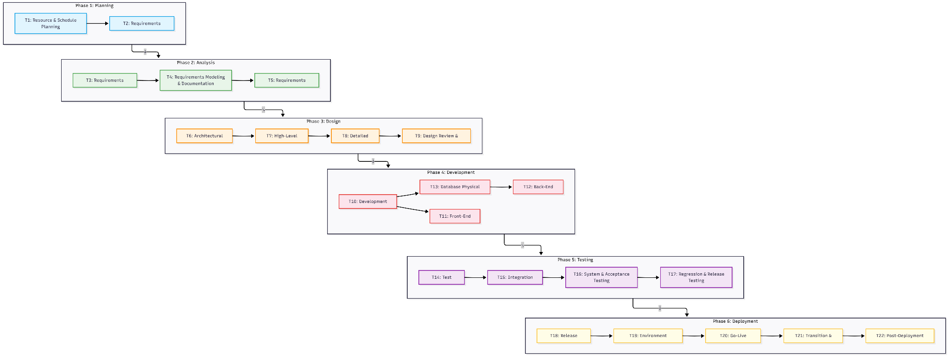

Figure 3: Activity Network Diagram
    - Gantt Chart
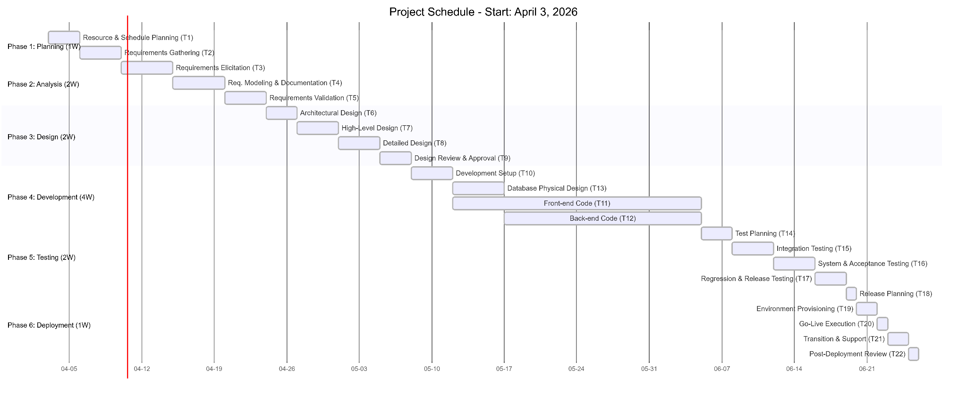

Figure 4: Gantt Chart

Assigning Team Members to Tasks
Table 12: Task-to-Team Member Assignment

Task ID | Assigned to
T1 | Project Manager (othman), Technical Clerk ( moaiad)
T2 | Project Manager (Othman)
T3 | System Analyst (othman ), Requirement Analyst ( othman), Technical Clerk ( moaiad)
T4 | System Analyst (othman ), Requirement Analyst (othman )
T5 | System Analyst (othman ), Technical Clerk ( moaiad)
T6 | Software Engineer ( moaiad&mahmood&othman), Hardware Engineer (mahmood ), Web Designer (moaiad&mahmood&othman )
T7 | Software Engineer ( moaiad&mahmood&othman), Database Engineer ( mahmood )
T8 | Software Engineer ( moaiad&mahmood&othman ), Database Engineer ( mahmood ), Web Designer ( moaiad&mahmood&othman )
T9 | System Analyst (Othman), Software Engineer (Moaiad, Mahmood, Othman), InfoSec Engineer (Ext.)
T10 | Software Engineer (moaiad&mahmood&othman )
T11 | Software Engineer ( moaiad&mahmood&othman )
T12 | Software Engineer ( moaiad&mahmood&othman )
T13 | Database Engineer (Mahmood)
T14 | Software Engineer ( moaiad&mahmood&othman), Software QA Engineer (External)
T15 | Software Engineer (moaiad&mahmood&othman )
T16 | Software QA Engineer (External), System Analyst (Othman)
T17 | Software QA Engineer (External), Software Engineer ( moaiad&mahmood&othman)
T18 | Software QA Engineer (External), System Analyst (Othman)
T19 | Software QA Engineer (External)
T20 | System Administrator ( mahmood ), Project Manager (othman ), Software Engineer  (moaiad&mahmood&othman)
T21 | System Administrator (Mahmood), Database Engineer (Mahmood)
T22 | System Administrator (Mahmood), Software Engineer (Moaiad, Mahmood, Othman), InfoSec  Engineer (Ext.)

Monitoring and Controlling Mechanisms
Earned value management

Table 13: Earned Value Management Progress Tracking

Phase | Estimated cost | Cumulative estimate | Estimated duration | Stage completed | Actual cost of Phase to  date | Actual cost of the project  to date
Planning | 2,500 JD | 2,500 JD | 2 weeks | 80% | 900 JD | 900 JD
Analysis | 4,500 JD | 7000 JD | 2 weeks | 0% | Not yet  begun | Not yet  begun
Design | 6,000 JD | 13,000 JD | 2 weeks | 0% | Not yet  begun | Not yet  begun
Implementation | 12,000 JD | 25,000 JD | 4 weeks | 0% | Not yet  begun | Not yet  begun
Testing | 7,000 JD | 31,000 JD | 2 weeks | 0% | Not yet  begun | Not yet  begun
Deployment | 3,000 JD | 34,000 JD | 1 week | 0% | Not yet  begun | Not yet  begun

- 𝑃 = 80%

- Planned Value (𝑃𝑉 ) = 2,500 JD

- Actual Cost (𝐴𝐶) = 900 JD

- Earned Value (𝐸𝑉 ) = 2000JD

- Cost Variance (CV) = 1,100 JD
  - We have saved 2,200 JD on the planning phase

- Schedule Variance (𝑆𝑉 ) = (-500) JD
  - This indicates delayed progress in the planning phase.

- Cost Performance Index (𝐶𝑃𝐼)= (2.22)
  - We are under budget. The team is spending less than planned to accomplish the work.

- Schedule Performance Index (𝑆𝑃𝐼) = (0.8)
  - We are behind schedule. The progress is slower than expected.

- Estimate to Complete (𝐸𝑇𝐶) = (14,414.414) JD

- Estimate at Completion (𝐸𝐴𝐶) = 15,315.315 JD
- Based on the information we gained from EVM analysis, we have to expedite our schedule.

Table 14: Time and Cost Options

Activity | Estimated duration (days) | Crash time (days) | Cost/day (JD)
T1 | 5 | 3 | 200
T2 | 4 | 4 | 200
T3 | 3 | 3 | 300
T4 | 5 | 4 | 450
T5 | 2 | 2 | 300
T6 | 5 | 5 | 300
T7 | 5 | 5 | 300
T8 | 4 | 4 | 300
T9 | 4 | 4 | 300
T10 | 5 | 4 | 250
T11 | 20 | 17 | 350
T12 | 20 | 19 | 400
T13 | 10 | 18 | 450
T14 | 3 | 3 | 250
T15 | 4 | 4 | 250
T16 | 4 | 4 | 300
T17 | 3 | 2 | 300
T18 | 1 | 1 | 300
T19 | 1 | 1 | 250
T20 | 1 | 1 | 250
T21 | 2 | 1 | 150
T22 | 2 | 2 | 300

Table 15: Schedule Expediting Table

Eligible activities | Activity chosen | Time for each path (Days) |  |  | Cost (JD/day) | Cumulative cost (JD)
 |  | 83 | 83 | 73
T1,T4, T10,T11,T12, T17,T21 | T21 | 82 | 82 | 72 | 150 | 150
T1,T4, T10,T11,T12, T17 | T1 | 81 | 81 | 71 | 200 | 350
T1,T4, T10,T11,T12, T17 | T1 | 80 | 80 | 70 | 200 | 550
T4, T10,T11,T12, T17 | T10 | 79 | 79 | 69 | 250 | 800
T4, ,T11,T12, T17 | T17 | 78 | 78 | 68 | 300 | 1100
T4, ,T11,T12, T17 | T17 | 77 | 77 | 67 | 300 | 1400
T4, ,T11,T12, | T11 | 76 | 77 | 67 | 350 | 1750
T4, ,T11,T12, | T11 | 75 | 77 | 67 | 350 | 2100
T4, ,T11,T12, | T11 | 74 | 77 | 67 | 350 | 2450
T4, ,T12, | T12 | 74 | 76 | 67 | 400 | 2850
T4 | T4 | 73 | 75 | 66 | 450 | 3300

Risk Analysis
    - Effects and Causes
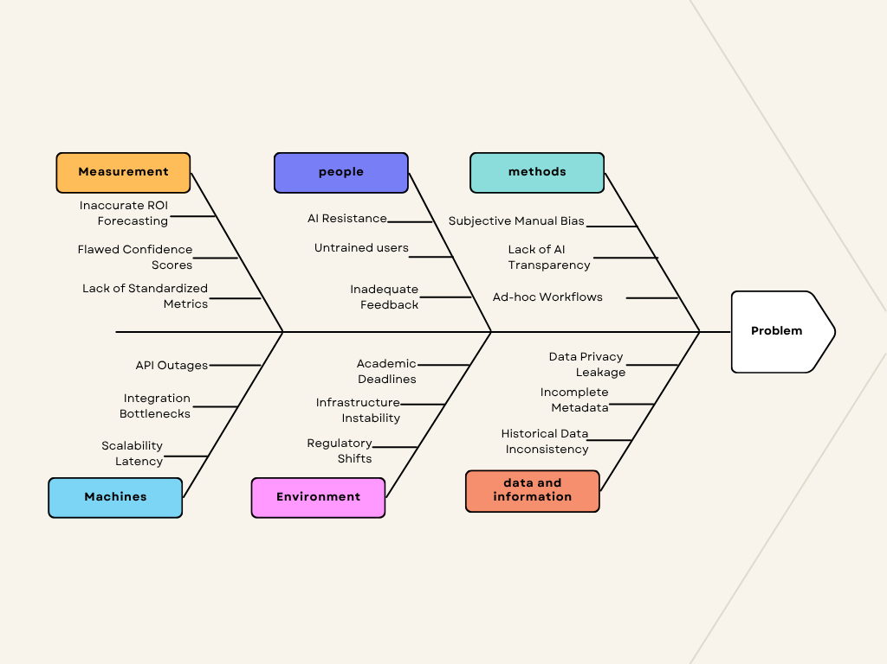

Figure 5: Fishbone Diagram

Communication Plan
Our team will maintain communication through online meetings using Google Meet and instant messaging using a WhatsApp group to assign tasks and ensure that everyone is updated on progress and deadlines. Communication Methods:
- In-Class Meetings:
  - Held every Thursday and Saturday to discuss progress, issues, and next steps.
- Out-of-Class Meetings:
  - Through Discord whenever there is a need for rapid discussion.
- Messaging:
  - A WhatsApp group for updates and daily coordination.
- Version Control:
  - GitHub is used for tracking code updates and version history.
  - We also use GitHub to store and organize our documentation created using Typst, ensuring all of us can access the latest versions easily.

Software Requirements Specifications

System Overview and Context Diagram

3.1.1 System Overview: The Smart Task Delegation System is an intelligent, cloud-native platform designed to revolutionize organizational productivity by automating the transition from task creation to execution. Unlike traditional project management tools that rely on manual triage, this system functions as an autonomous orchestration layer that bridges the gap between managers and employees.

The system utilizes Natural Language Processing (NLP) to parse unstructured task descriptions and Machine Learning (ML) models to evaluate a multidimensional matrix of employee skill sets, historical delivery velocity, and real-time availability. Its primary purpose is to eliminate administrative bottlenecks and subjective bias by ensuring that every task is routed to the individual best equipped to complete it at that specific moment.
Core System Operations:

Intelligent Ingestion: Captures tasks from various inputs (text, voice, or documents) and extracts key metadata such as urgency and required expertise.

Dynamic Routing: Employs an AI matching engine to rank and assign personnel based on current workloads and competency alignment.

Visibility & Analytics: Provides managers with live dashboards for progress tracking and predictive forecasting to identify potential project risks before they occur.

Feedback Integration: Maintains a human-in-the-loop (HITL) approach where employees provide feedback on assignments, allowing the AI to refine its routing logic over time.
3.1.2 Context Diagram

