QUICKBOX FINANCIAL MANAGEMENT SYSTEM (QFMS)

Master Enterprise Architecture, Integrated Requirements, Data Schema & UI Wireframe Specifications
Document Version: 2.0.0 (Consolidated Master Standard)
Classification: Enterprise Architecture & Technical Specification
Status: Approved for Production Implementation & Handover
Target Domain: Corporate Double-Entry Accounting, General Ledger, AP/AR, 3-Way Matching, Payroll/WPS, Fixed Assets, Tax/VAT & Statutory Financial Reporting
Integrated Platform Basis: QuickBox Unified Enterprise Architecture (React 19 + Vite + Supabase/PostgreSQL)
Language Standard: 100% English

Table of Contents
- Executive Summary & System Objectives
- Unified System Architecture & Shared Master Data Model
- Integrated Entity Relationship Diagram (ERD) & Schema Specification
- Automated General Ledger (GL) Engine & Movement Trigger Matrix
- Core Functional Module Specifications
- Security, Compliance & Regulatory Framework
- Frontend UI Transformation Mapping
- Technical Implementation Plan & Work Breakdown Structure (WBS)
- Quality Assurance & Acceptance Verification Matrix
- Finance UI Wireframes Catalog & Visual Design Specifications

1. Executive Summary & System Objectives

1.1 Strategic Vision & Business Purpose
The QuickBox Financial Management System (QFMS) delivers an institutional-grade, real-time double-entry accounting platform engineered for complete operational convergence with the QuickBox Inventory and Hospitality Management Platform.
In traditional enterprise architectures, inventory sub-ledgers and financial general ledgers operate in disconnected data silos, requiring batch synchronizations, periodic manual reconciliations, and complex data pipeline ETLs. QuickBox eliminates this latency and operational overhead through a Single-Database Unified Architecture where physical warehouse transactions (such as receiving purchase shipments, issuing departmental requisitions, or fulfilling sales orders) immediately trigger balanced, double-entry journal vouchers in the General Ledger.
+-------------------------------------------------------------------------------+
| QUICKBOX ENTERPRISE PLATFORM |
| |
| +--------------------------+ +------------------------------+ |
| | PHYSICAL INVENTORY | | FINANCIAL GENERAL LEDGER | |
| | - Goods Receipts (GRN) | Real-Time | - Double-Entry Postings | |
| | - Stock Deliveries (SO) | ==========> | - Automated AP / AR | |
| | - Internal Requisitions | Event Bus | - 3-Way Matching & PPV | |
| | - Cycle Count Adjusts | | - Perpetual Valuation | |
| +--------------------------+ +------------------------------+ |
| \ / |
| \ / |
| +---------------------------+ |
| | SHARED MASTER DATA MODEL | |
| | - Unified Parties | |
| | - Cost Centers & Budgets | |
| | - Unified PostgreSQL DB | |
| +---------------------------+ |
+-------------------------------------------------------------------------------+

1.2 Mission-Critical Objectives
- Mathematical Invariant Enforcement: Every transaction posted to the General Ledger strictly enforces the fundamental accounting equation:
$$∑\text{Debits}≡∑\text{Credits} \text{and} \text{Assets}≡\text{Liabilities}+\text{Equity}$$
- Zero Master Data Duplication: Vendors, customers, contractors, and dual-role commercial partners reside within a single master parties directory, while departmental hierarchies, warehouses, and fiscal budgets map to unified cost_centers.
- Automated Sub-Ledger Convergence: Eliminates manual period-end journal entries for inventory movements by auto-generating balanced vouchers with automated Purchase Price Variance (PPV) calculations and GR/IR interim clearing.
- Statutory Regulatory Compliance: Full alignment with IFRS (International Financial Reporting Standards), GAAP (Generally Accepted Accounting Principles), GCC 5% Standard VAT Filings, and statutory Wage Protection System (WPS) SIF file generation.
- Real-Time Financial Intelligence: Delivers instant, verifiable Balance Sheets, Profit & Loss (Income) Statements, Statements of Cash Flows, and Trial Balances updated dynamically upon transaction commit.

2. Unified System Architecture & Shared Master Data Model

2.1 Single Database Schema Philosophy
Rather than maintaining separate database instances or loosely coupled microservice databases for inventory and finance, QuickBox operates on a single unified relational PostgreSQL database (via Supabase).
================================================================================
UNIFIED RELATIONAL DATABASE SCHEMA
================================================================================
INVENTORY DOMAIN ENTITIES FINANCIAL DOMAIN ENTITIES
------------------------ -------------------------
• purchase_orders • bills (FK -> purchase_orders)
• purchase_order_lines • bill_lines (FK -> po_lines)
• goods_receipt_notes (GRN) • invoices (FK -> sales_orders)
• grn_lines • invoice_lines (FK -> so_lines)
• stock_movements • journal_entries (FK -> movements)
• stock_movement_lines • journal_lines (FK -> accounts)
• inventory_items • accounts (Chart of Accounts)
• item_categories • fixed_assets & depreciation_schedules
• warehouse_locations • payroll_runs & payslips
• tax_periods & tax_returns
\ /
\ /
SHARED MASTER DATA ENTITIES
---------------------------
• parties (Customers & Vendors)
• cost_centers (Departments & Budgets)
• fiscal_years & fiscal_periods
================================================================================

Key Architectural Advantages:
- ACID Transactional Integrity: Warehouse physical stock updates and corresponding General Ledger journal vouchers execute within the same atomic database transaction (BEGIN ... COMMIT). If a ledger entry fails validation, the inventory movement is rolled back, preventing reconciliation drift.
- Direct Relational Foreign Keys: Foreign Keys link financial records directly to operational records (bills.purchase_order_id, invoices.sales_order_id, journal_entries.stock_movement_id).
- Zero ETL Latency: Financial reporting aggregates live transaction rows directly, eliminating multi-hour data synchronization batch pipelines.

2.2 Shared Master Data Architecture

2.2.1 Unified Counterparty Directory (parties)
QuickBox abolishes distinct “Customer” and “Vendor” tables. All counterparties are modeled in the unified parties table: - A supplier providing linens is assigned is_vendor = TRUE. - A corporate client booking event halls or room blocks is assigned is_customer = TRUE. - An enterprise partner (e.g., an airline or distributor) that supplies goods while simultaneously purchasing hospitality services is assigned is_customer = TRUE and is_vendor = TRUE (Dual-Role Partner). - The system maintains distinct ar_balance and ap_balance metrics per party, enabling automated Net Settlement Offsetting.
+------------------------------------------------------------------------------------+
| UNIFIED PARTY RECORD |
| Party ID: PTY-00088 | Name: Apex Technologies | Tax Reg: TRN-10029481900003 |
+------------------------------------------------------------------------------------+
| Role: DUAL-ROLE PARTNER (Customer + Vendor) |
| Payment Terms: Net 15 Days | Credit Limit: $50,000.00 |
+------------------------------------+-----------------------------------------------+
| ACCOUNTS RECEIVABLE SUB-LEDGER | ACCOUNTS PAYABLE SUB-LEDGER |
| - Outstanding Invoices: $8,400.00 | - Open Vendor Bills: $680.00 |
+------------------------------------+-----------------------------------------------+
| NET SETTLEMENT POSITION: +$7,720.00 (Net Receivable Due to QuickBox) |
+------------------------------------------------------------------------------------+

2.2.2 Unified Cost Center & Departmental Hierarchy (cost_centers)
A shared cost_centers table establishes organizational hierarchy across operational units, warehouse stores, and financial reporting: - Cost centers (CC-100 Housekeeping, CC-200 Kitchen/F&B, CC-300 Facilities, CC-400 Front Office) own warehouse sub-inventories. - Departmental consumption requisitions automatically debit the associated cost center’s operating expense account. - Departmental payroll disbursements and capex fixed assets link directly to the cost center for granular variance analysis against annual fiscal budgets.

2.3 Technology Stack Specifications
Architectural Layer | Technology Selection | Version / Standard | Operational Role
Frontend Framework | React | 19.0.0 | High-density component rendering with React Server Component support
Build Tooling | Vite | 6.0+ | Lightning-fast HMR and optimized tree-shaken production bundles
State Management | React Context API | Native React 19 | Cross-domain state synchronization (FinanceContext consuming InventoryContext)
Data Grids & Tables | TanStack Table | v8 | High-performance sorting, filtering, and accordion virtualization
Financial Charting | Recharts & Chart.js | 2.15+ / 4.4+ | Continuous area cash-flow curves, asset donuts, and budget progress bars
Iconography | Phosphor Icons | 2.1+ | Enterprise UI icons (CurrencyDollarSimple, Receipt, Scales, BookOpen)
Backend & Database | Supabase / PostgreSQL | PostgreSQL 16 | Relational storage, RLS security policies, and real-time CDC triggers
Decimal Precision | Fixed-Point Decimal | numeric(18, 4) | Zero binary floating-point rounding error across monetary calculations

3. Integrated Entity Relationship Diagram (ERD) & Schema Specification

3.1 Complete Unified Mermaid ERD
The following diagram defines the unified database schema, capturing all entities across the Inventory, Procurement, Shared Master Data, and Financial Accounting domains, along with their explicit foreign key relationships:
erDiagram
%% ==========================================
%% SHARED MASTER DATA DOMAIN
%% ==========================================
PARTIES ||--o{ PURCHASE_ORDERS : "issues_po_to"
PARTIES ||--o{ SALES_ORDERS : "receives_so_from"
PARTIES ||--o{ BILLS : "billed_by_vendor"
PARTIES ||--o{ INVOICES : "billed_to_customer"
PARTIES ||--o{ PAYMENTS : "party_transacted"
COST_CENTERS ||--o{ COST_CENTERS : "parent_hierarchy"
COST_CENTERS ||--o{ WAREHOUSE_LOCATIONS : "manages_location"
COST_CENTERS ||--o{ REQUISITIONS : "requests_supplies"
COST_CENTERS ||--o{ JOURNAL_LINES : "allocated_cost_center"
COST_CENTERS ||--o{ EMPLOYEES : "department_assignment"
COST_CENTERS ||--o{ FIXED_ASSETS : "custodian_department"
COST_CENTERS ||--o{ BUDGET_ITEMS : "department_budget"
FISCAL_YEARS ||--o{ FISCAL_PERIODS : "subdivided_into"
FISCAL_YEARS ||--o{ BUDGETS : "budget_fiscal_year"
FISCAL_PERIODS ||--o{ JOURNAL_ENTRIES : "posted_in_period"
FISCAL_PERIODS ||--o{ TAX_PERIODS : "tax_aligned_period"
FISCAL_PERIODS ||--o{ PAYROLL_RUNS : "executed_in_period"
%% ==========================================
%% INVENTORY & PROCUREMENT DOMAIN
%% ==========================================
ITEM_CATEGORIES ||--o{ INVENTORY_ITEMS : "categorizes"
ITEM_CATEGORIES ||--|| ACCOUNTS : "gl_inventory_asset_account"
ITEM_CATEGORIES ||--|| ACCOUNTS : "gl_cogs_account"
ITEM_CATEGORIES ||--|| ACCOUNTS : "gl_variance_account"
INVENTORY_ITEMS ||--o{ PURCHASE_ORDER_LINES : "ordered_item"
INVENTORY_ITEMS ||--o{ GRN_LINES : "received_item"
INVENTORY_ITEMS ||--o{ STOCK_MOVEMENT_LINES : "moved_item"
INVENTORY_ITEMS ||--o{ REQUISITION_LINES : "requisitioned_item"
INVENTORY_ITEMS ||--o{ SALES_ORDER_LINES : "sold_item"
PURCHASE_ORDERS ||--|{ PURCHASE_ORDER_LINES : "contains_po_items"
PURCHASE_ORDERS ||--o{ GOODS_RECEIPT_NOTES : "fulfilled_by_grn"
PURCHASE_ORDERS ||--o{ BILLS : "billed_via_ap"
GOODS_RECEIPT_NOTES ||--|{ GRN_LINES : "contains_grn_items"
GOODS_RECEIPT_NOTES ||--|| STOCK_MOVEMENTS : "triggers_physical_receipt"
PURCHASE_ORDER_LINES ||--o{ GRN_LINES : "received_po_line"
SALES_ORDERS ||--|{ SALES_ORDER_LINES : "contains_so_items"
SALES_ORDERS ||--o{ INVOICES : "billed_via_ar"
SALES_ORDERS ||--o{ STOCK_MOVEMENTS : "triggers_physical_dispatch"
REQUISITIONS ||--|{ REQUISITION_LINES : "contains_req_items"
REQUISITIONS ||--o{ STOCK_MOVEMENTS : "triggers_internal_issue"
STOCK_MOVEMENTS ||--|{ STOCK_MOVEMENT_LINES : "contains_movement_lines"
STOCK_MOVEMENTS ||--o| JOURNAL_ENTRIES : "auto_generates_gl_voucher"
%% ==========================================
%% FINANCIAL GENERAL LEDGER & ACCOUNTS
%% ==========================================
ACCOUNTS ||--o{ ACCOUNTS : "parent_account_tree"
ACCOUNTS ||--o{ JOURNAL_LINES : "debited_or_credited"
ACCOUNTS ||--o| BANK_ACCOUNTS : "gl_cash_account_link"
ACCOUNTS ||--o{ FIXED_ASSETS : "asset_cost_account"
ACCOUNTS ||--o{ FIXED_ASSETS : "accum_deprec_account"
ACCOUNTS ||--o{ FIXED_ASSETS : "deprec_expense_account"
JOURNAL_ENTRIES ||--|{ JOURNAL_LINES : "comprises_lines"
JOURNAL_ENTRIES ||--o| JOURNAL_ENTRIES : "reversal_of_entry"
JOURNAL_ENTRIES ||--o| BILLS : "posts_ap_liability"
JOURNAL_ENTRIES ||--o| INVOICES : "posts_ar_receivable"
JOURNAL_ENTRIES ||--o| PAYMENTS : "posts_cash_settlement"
JOURNAL_ENTRIES ||--o| PAYROLL_RUNS : "posts_payroll_expense"
JOURNAL_ENTRIES ||--o| TAX_RETURNS : "posts_vat_settlement"
%% ==========================================
%% ACCOUNTS PAYABLE & 3-WAY MATCHING
%% ==========================================
BILLS ||--|{ BILL_LINES : "contains_bill_lines"
BILLS ||--o{ THREE_WAY_MATCHES : "matched_in_engine"
GOODS_RECEIPT_NOTES ||--o{ THREE_WAY_MATCHES : "grn_matched"
PURCHASE_ORDERS ||--o{ THREE_WAY_MATCHES : "po_matched"
BILLS ||--o{ PAYMENT_ALLOCATIONS : "settled_by_payment"
%% ==========================================
%% ACCOUNTS RECEIVABLE & REVENUE
%% ==========================================
INVOICES ||--|{ INVOICE_LINES : "contains_invoice_lines"
INVOICES ||--o{ PAYMENT_ALLOCATIONS : "settled_by_receipt"
%% ==========================================
%% TREASURY, CASH & RECONCILIATION
%% ==========================================
BANK_ACCOUNTS ||--o{ PAYMENTS : "disburses_or_deposits"
BANK_ACCOUNTS ||--o{ BANK_TRANSACTIONS : "feeds_statement_lines"
BANK_ACCOUNTS ||--o{ BANK_RECONCILIATIONS : "reconciled_in_session"
BANK_RECONCILIATIONS ||--o{ RECONCILIATION_MATCHES : "matches_lines"
BANK_TRANSACTIONS ||--o| RECONCILIATION_MATCHES : "matched_bank_tx"
PAYMENTS ||--o{ PAYMENT_ALLOCATIONS : "allocates_funds"
%% ==========================================
%% WORKFORCE PAYROLL & WPS
%% ==========================================
EMPLOYEES ||--o{ PAYSLIPS : "receives_compensation"
PAYROLL_RUNS ||--|{ PAYSLIPS : "processes_batch"
PAYSLIPS ||--|{ PAYSLIP_LINES : "itemizes_components"
%% ==========================================
%% FIXED ASSETS & DEPRECIATION
%% ==========================================
FIXED_ASSETS ||--|{ DEPRECIATION_SCHEDULES : "has_amortization_schedule"
DEPRECIATION_SCHEDULES ||--o| JOURNAL_ENTRIES : "triggers_monthly_deprec"
%% ==========================================
%% STATUTORY TAX & VAT COMPLIANCE
%% ==========================================
TAX_PERIODS ||--o| TAX_RETURNS : "filed_in_tax_period"
%% ==========================================
%% BUDGETING & VARIANCE ANALYSIS
%% ==========================================
BUDGETS ||--|{ BUDGET_ITEMS : "contains_budget_items"
%% ==========================================
%% ENTITY DEFINITIONS & KEY SCHEMAS
%% ==========================================
PARTIES {
uuid party_id PK
varchar party_code UK "PTY-00042"
varchar legal_name "Global Linens & Supply LLC"
boolean is_customer "True for client accounts"
boolean is_vendor "True for supplier accounts"
varchar payment_terms "Net 30, Net 15, COD"
numeric credit_limit "Max credit threshold"
varchar tax_registration_num "GCC TRN Number"
numeric ar_balance "Current receivable balance"
numeric ap_balance "Current payable balance"
boolean is_active "Operational active flag"
}
COST_CENTERS {
uuid cost_center_id PK
varchar cost_center_code UK "CC-100, CC-200"
varchar cost_center_name "Housekeeping, Kitchen"
uuid parent_id FK "Recursive hierarchy"
uuid manager_id "Department Head User ID"
numeric annual_budget "Approved fiscal budget"
numeric mtd_spent "Current month consumption"
boolean is_active "Operational active flag"
}
ACCOUNTS {
uuid account_id PK
varchar account_code UK "10100, 13110, 20200, 50110"
varchar account_name "Chart of Accounts Title"
varchar account_type "Asset, Liability, Equity, Revenue, Expense"
varchar normal_balance "DEBIT or CREDIT"
uuid parent_account_id FK "Recursive COA Tree"
varchar currency_code "USD, AED, EUR"
boolean is_reconciled "Bank / Reconcilable Flag"
boolean is_active "Operational active flag"
}
JOURNAL_ENTRIES {
uuid journal_id PK
varchar voucher_number UK "JV-2026-00412"
date posting_date "Effective accounting date"
uuid period_id FK "Fiscal Period reference"
varchar source_module "INVENTORY, AP, AR, PAYROLL, MANUAL"
varchar source_document_ref "GRN-2026-004, SO-DEL-901, BILL-089"
uuid stock_movement_id FK "Nullable link to Inventory Movement"
uuid bill_id FK "Nullable link to AP Bill"
uuid invoice_id FK "Nullable link to AR Invoice"
uuid payroll_run_id FK "Nullable link to Payroll Run"
text memo "Description of transaction"
numeric total_debit "Total voucher debit amount"
numeric total_credit "Total voucher credit amount"
boolean is_balanced "Enforces Debit == Credit"
varchar status "Draft, Posted, Reversed"
uuid created_by "Authorizing User or SYSTEM_AUTO_GL"
timestamp created_at "Creation timestamp"
}
JOURNAL_LINES {
uuid line_id PK
uuid journal_id FK "Parent Journal Voucher"
integer line_number "Sequential index 1..N"
uuid account_id FK "GL Account Reference"
uuid cost_center_id FK "Department allocation"
uuid party_id FK "Nullable party sub-ledger"
numeric debit "Debit Amount"
numeric credit "Credit Amount"
text description "Line item memo"
}
BILLS {
uuid bill_id PK
varchar bill_number UK "BILL-2026-089"
uuid vendor_id FK "References PARTIES(party_id)"
uuid purchase_order_id FK "Direct link to PURCHASE_ORDERS"
date bill_date "Vendor invoice issue date"
date due_date "Payment settlement deadline"
numeric subtotal "Amount before tax"
numeric tax_amount "5% Input VAT"
numeric total_amount "Total invoice liability"
numeric paid_amount "Settled amount"
varchar match_status "Unmatched, Perfect, PPV_Flagged, Approved"
varchar payment_status "Draft, Pending_Approval, Scheduled, Paid, Overdue"
}
THREE_WAY_MATCHES {
uuid match_id PK
uuid bill_id FK "References BILLS"
uuid po_id FK "References PURCHASE_ORDERS"
uuid grn_id FK "References GOODS_RECEIPT_NOTES"
numeric po_amount "Authorized PO total"
numeric grn_amount "Valued received total"
numeric bill_amount "Billed vendor total"
numeric ppv_variance "Price variance dollar delta"
numeric ppv_percentage "Price variance percentage"
numeric qty_variance "Quantity variance delta"
varchar status "PERFECT, PPV_HOLD, QTY_HOLD, OVERRIDDEN"
text notes "Tolerance & audit rationale"
}
INVOICES {
uuid invoice_id PK
varchar invoice_number UK "INV-2026-0412"
uuid customer_id FK "References PARTIES(party_id)"
uuid sales_order_id FK "Direct link to SALES_ORDERS"
date invoice_date "Issue date"
date due_date "Payment deadline"
numeric subtotal "Amount before tax"
numeric tax_amount "5% Output VAT"
numeric total_amount "Total receivable claim"
numeric balance_due "Remaining unpaid amount"
varchar status "Draft, Sent, Paid, Overdue, Cancelled"
}

3.2 Cross-Domain Foreign Key Integration Matrix
The following table explicitly details the cross-module relational foreign keys that bridge the Inventory and Financial sub-systems:
Financial Entity | Column / Foreign Key | Target Inventory / Shared Entity | Cascade Rule | Business Integration Purpose
bills | purchase_order_id | purchase_orders.po_id | ON DELETE RESTRICT | Direct 3-way matching of vendor invoices against authorized purchasing contracts.
bill_lines | po_line_id | purchase_order_lines.po_line_id | ON DELETE RESTRICT | Line-by-line item verification and SKU price variance tracking.
invoices | sales_order_id | sales_orders.so_id | ON DELETE RESTRICT | Automated invoice drafting immediately upon warehouse delivery confirmation.
invoice_lines | so_line_id | sales_order_lines.so_line_id | ON DELETE RESTRICT | Granular revenue matching and contract delivery verification.
journal_entries | stock_movement_id | stock_movements.movement_id | ON DELETE RESTRICT | Complete traceability of automated inventory GL postings back to physical warehouse transactions.
journal_lines | cost_center_id | cost_centers.cost_center_id | ON DELETE RESTRICT | Departmental cost allocation for requisition consumption and departmental reporting.
journal_lines | party_id | parties.party_id | ON DELETE RESTRICT | Unified AR/AP sub-ledger control linking directly to General Ledger lines.
item_categories | asset_account_id | accounts.account_id | ON DELETE RESTRICT | Automatic determination of the debit/credit asset account when inventory is received or relieved.
item_categories | cogs_account_id | accounts.account_id | ON DELETE RESTRICT | Automatic determination of the Cost of Goods Sold expense account upon customer dispatch.
item_categories | variance_account_id | accounts.account_id | ON DELETE RESTRICT | Automatic absorption of cycle count adjustments, shrinkage, and write-offs.

4. Automated General Ledger (GL) Engine & Movement Trigger Matrix

4.1 Real-Time Event-Driven Architecture
The QuickBox Automated GL Engine monitors physical inventory state transitions and operational lifecycle events. Whenever an operational document transitions to a qualifying terminal state (e.g., GRN marked Received, SO marked Dispatched, Requisition marked Fulfilled), the system executes an atomic transaction that generates a balanced double-entry journal_entry record.
[ Warehouse Event ] ---> [ Event Bus / CDC Trigger ] ---> [ GL Engine Rules Evaluator ]
|
v
[ Immutable GL Voucher (JV) ] <--- [ Balance Invariant Verified ] <--- [ Build Balanced Dr/Cr Lines ]

4.2 10-Event Accounting Transaction Matrix
The following transaction matrix specifies the exact debit and credit postings executed for every physical warehouse movement and financial settlement event:
Event ID | Operational Business Event | Source Document | Debit Account (DR) | Credit Account (CR) | Valuation / Calculation Method
EV-01 | Goods Receipt from Supplier | Goods Receipt Note (GRN) | 13110 Inventory Asset – Category Specific | 20200 GR/IR Interim Clearing Account | Received Quantity $×$ Purchase Order Unit Price
EV-02 | 3-Way Match & Vendor Bill Approval | Vendor Bill (BILL) vs PO vs GRN | 20200 GR/IR Clearing Account51200 Purchase Price Variance (if Bill > PO) | 21010 Trade Accounts Payable51200 PPV Gain (if Bill < PO) | Clears GR/IR liability; recognizes AP liability; absorbs PPV variance
EV-03 | Sales Order Delivery & Dispatch | Sales Dispatch Note (SO_DELIVERY) | 50110 Cost of Goods Sold (COGS) | 13110 Inventory Asset – Category Specific | Dispatched Quantity $×$ Perpetual Unit Cost (AVCO or FIFO Queue)
EV-04 | Customer Invoice Generation | Commercial Invoice (INVOICE) | 11100 Accounts Receivable (Trade Debtors) | 40100 Sales Operating Revenue22200 Output VAT Payable (5%) | Billable Selling Price + 5% Statutory Output VAT
EV-05 | Departmental Supplies Requisition | Store Issue Voucher (REQUISITION) | 61200 Department Supplies Expense (CC-XXX) | 13110 Inventory Asset – Category Specific | Issued Quantity $×$ Current Average Cost (AVCO)
EV-06 | Cycle Count Stock Adjustment (Gain) | Physical Count Audit (STOCK_COUNT) | 13110 Inventory Asset – Category Specific | 51900 Inventory Adjustment Gain | Positive Variance Quantity $×$ Current Unit Cost
EV-07 | Cycle Count Stock Adjustment (Loss) | Physical Count Audit (STOCK_COUNT) | 51950 Inventory Shrinkage & Loss | 13110 Inventory Asset – Category Specific | Negative Variance Quantity $×$ Current Unit Cost
EV-08 | Damaged Goods / Scrap Write-Off | Scrap Voucher (SCRAP_VOUCHER) | 51960 Spoilage, Damage & Scrap Expense | 13110 Inventory Asset – Category Specific | Scrapped Quantity $×$ Historical Unit Cost
EV-09 | Return to Vendor (RTV) | Vendor Return Note (RETURN_NOTE) | 20200 GR/IR Clearing Account | 13110 Inventory Asset – Category Specific | Returned Quantity $×$ Original Receipt Cost
EV-10 | Landed Cost Capitalization | Customs / Freight Bill (FREIGHT_BILL) | 13110 Inventory Asset (Capitalized to Stock) | 21010 Trade Accounts Payable | Freight & Customs allocated by Item Value or Weight

4.3 Automated 3-Way Matching Engine & PPV
The 3-Way Matching Engine cross-verifies three primary data artifacts before authorizing vendor disbursement: 1. Purchase Order (PO): Contractual authorized unit prices, quantities, and terms. 2. Goods Receipt Note (GRN): Physical count of items inspected and accepted into warehouse stores. 3. Vendor Bill (AP Invoice): Billed unit prices, total item charges, and tax assessments.
+---------------------------------------------+
| PURCHASE ORDER (PO) |
| Authorized Price: $12.00 | Qty Ordered: 100 |
+---------------------------------------------+
|
+---------------+---------------+
| |
v v
+-----------------------------+ +-----------------------------+
| GOODS RECEIPT NOTE (GRN) | | VENDOR BILL (AP) |
| Accepted Qty: 100 units | | Billed Unit Price: $12.50 |
| GR/IR Value: $1,200.00 | | Billed Total: $1,250.00 |
+-----------------------------+ +-----------------------------+
| |
+---------------+---------------+
|
v
+---------------------------------------------+
| 3-WAY MATCHING ENGINE |
| Price Delta: +$0.50/unit (+4.17%) |
| Total Variance: +$50.00 PPV |
| Tolerance Check: Exceeds 2.0% Threshold |
| Result: PPV FLAGGED -> Requires Approval |
+---------------------------------------------+

Tolerance Rules & Automated Variance Allocation:
- Price Tolerance Cap: Configured per SKU category (Default: $±2.0\%$ or maximum absolute cap of $\$50.00$).
- Within Tolerance: Automatically posts to the General Ledger:
$$\text{Debit GR/IR }(20200) \$1,200.00+\text{Debit PPV Expense }(51200) \$50.00=\text{Credit AP }(21010) \$1,250.00$$
- Exceeds Tolerance: The bill is placed in PPV_HOLD status, freezing automated payment scheduling until a Controller or Finance Manager executes an explicit approval or issues a vendor debit note.

4.4 Perpetual Inventory Valuation Engines
QFMS natively supports two perpetual inventory valuation policies configured at the category level:

1. Moving Weighted Average Cost (AVCO)
Recalculates unit valuation immediately upon each incoming shipment receipt:
$$\text{New Unit Cost}=\frac{(\text{Current On-Hand Qty}×\text{Current Unit Cost})+(\text{Received Qty}×\text{Received Unit Cost})}{\text{Current On-Hand Qty}+\text{Received Qty}}$$

2. First-In, First-Out (FIFO) Valuation Queues
Maintains a discrete queue of incoming cost layers (layer_id, receipt_date, qty_remaining, unit_cost). When sales orders or departmental requisitions consume inventory, costs are relieved sequentially from the oldest open layer until exhausted.

5. Core Functional Module Specifications

5.1 Enterprise Chart of Accounts (COA) Hierarchy
The QuickBox COA is structured across five standardized numerical tiers:
Tier Range | Primary Classification | Normal Balance | Sub-Categories | Control Ledger Examples
10000 – 19999 | Assets | DEBIT | Current Assets, Liquid Cash, Receivables, Inventory, Prepayments, Fixed Assets | 10100 Operating Cash, 11100 Accounts Receivable, 13110 Linens Inventory, 15100 PP&E Gross, 15200 Accum. Depreciation (Contra-Asset)
20000 – 29999 | Liabilities | CREDIT | Current Liabilities, Interim Clearing, Payables, Accruals, Statutory VAT, Long-Term Debt | 20200 GR/IR Interim Clearing, 21010 Trade Accounts Payable, 22100 Accrued Payroll, 22200 Output VAT Payable, 25100 Bank Term Facilities
30000 – 39999 | Equity | CREDIT | Share Capital, Retained Earnings, Current Year Surplus | 30000 Contributed Share Capital, 32000 Retained Earnings (Prior), 33000 Current Year P&L Summary
40000 – 49999 | Revenue | CREDIT | Operating Revenue, Hospitality Services, F&B Sales, Discounts | 40100 Room & Lodging Revenue, 40200 Food & Beverage Revenue, 40900 Sales Discounts Allowed (Contra-Revenue)
50000 – 69999 | Expenses | DEBIT | Cost of Goods Sold (50000), Inventory Variances (51000), Operating Overhead & Payroll (60000) | 50110 Linens COGS, 51200 Purchase Price Variance, 51950 Shrinkage Loss, 61200 Department Supplies, 63100 Salaries & Wages

5.2 General Ledger & Double-Entry Journal Postings
- Multi-Line Vouchers: Supports complex multi-debit and multi-credit vouchers with row-level cost center allocations.
- Strict Real-Time Equilibrium: Rejects any voucher submission where $∑\text{Debits}≠∑\text{Credits}$.
- Immutable Posting Engine: Posted vouchers cannot be edited or deleted. Adjustments require an authorized, timestamped Reversal Journal Entry (is_reversal = TRUE) referencing the original voucher ID.

5.3 Accounts Payable (AP) & Vendor Disbursements
- Automated Bill Creation: Generates AP bills directly from purchase orders upon 3-way match clearance.
- Landed Cost Allocation: Capitalizes freight, shipping insurance, and customs tariffs into inventory asset values based on item value or physical weight.
- Automated Payment Runs: Aggregates approved vendor bills by payment terms (Net 30, Net 15, COD) and generates batch electronic fund transfer (EFT) disbursements.

5.4 Accounts Receivable (AR), Invoicing & Cash Collections
- Automated Delivery Invoicing: Dispatched sales orders or checked-out hospitality guest folios draft customer invoices in real time.
- Multi-Tier Aging Analysis: Categorizes outstanding receivables across aging buckets: Current (0–30 Days), 31–60 Days, 61–90 Days, and 90+ Days Overdue.
- Payment Allocation & Settlement: Matches customer remittances to outstanding invoices with support for partial payments, credit notes, and customer deposits.

5.5 Treasury, Cash Management & Bank Reconciliation
- Multi-Account Liquidity Management: Tracks operating accounts, payroll accounts, and petty cash vaults in real time.
- Automated Statement Ingestion: Ingests standard MT940, CAMT.053, and OFX/CSV bank statement files.
- Algorithmic Rule Matching: Automatically reconciles bank statement lines against General Ledger cash transactions based on date proximity, reference numbers, and exact dollar amounts.

5.6 Fixed Asset Register & Depreciation Modeling
- Asset Lifecycle Tracking: Manages capital acquisitions, asset tags, custodian departments, and historical cost bases.
- Automated Depreciation Runs: Executes monthly straight-line or declining-balance depreciation schedules with automated journal voucher posting:
$$\text{Debit: }65100\text{ Depreciation Expense} | \text{Credit: }15200\text{ Accumulated Depreciation (Contra-Asset)}$$

5.7 Workforce Payroll Processing & Wage Protection System (WPS)
- Gross-to-Net Compensation: Computes base salaries, housing allowances, transport stipends, overtime, social security withholdings, and loan deductions.
- WPS SIF File Generation: Exports statutory Salary Information File (SIF) format required by central banks and ministries of human resources across GCC jurisdictions.
- Automated Payroll Accrual:
$$\text{Debit: }63100\text{ Salaries Expense} | \text{Credit: }22100\text{ Accrued Payroll Payable}$$

5.8 Statutory Tax & VAT Management
- GCC Standard 5% VAT Engine: Automatically segregates 5% Output VAT on revenue invoices and 5% Input VAT on vendor bills.
- Tax Period Settlement: Computes net statutory liability:
$$\text{Net VAT Payable}=\text{Output VAT Collected}−\text{Input VAT Recoverable}$$
- Settlement Voucher: Posts the tax settlement voucher upon filing with national tax authorities.

5.9 Real-Time Statutory Financial Statements
- Balance Sheet: Categorized into Assets, Liabilities, and Equity with real-time equilibrium validation ($Δ\$0.00$).
- Profit & Loss (Income Statement): Gross Revenue, Net Revenue, COGS, Gross Profit, OPEX, and Net Operating Income (EBIT).
- Statement of Cash Flows: Indirect method categorizing Operating Activities, Investing Activities (Capex), and Financing Activities.
- Trial Balance: Complete tabular audit report verifying total debits equal total credits across all active Chart of Accounts codes.

6. Security, Compliance & Regulatory Framework

6.1 Role-Based Access Control (RBAC) & Segregation of Duties
To protect organizational funds and prevent fraud, QuickBox enforces strict Segregation of Duties (SoD) across operational and accounting roles:
System Role | General Ledger Postings | 3-Way Match Override | Bill Approval & Payment | Requisition Creation | Fixed Asset Depreciation | VAT Return Filing
Warehouse Storekeeper | Read Only (Auto-GL) | No Access | No Access | Fulfilled Only | No Access | No Access
Department Head | View Departmental Lines | No Access | No Access | Create / Submit | View Custodian Assets | No Access
Staff Accountant | Create Draft Postings | Review Variances | Create Bills / Draft EFT | View Only | View Schedules | Prepare Draft Return
Financial Controller | Post & Reverse Journals | Approve PPV Overrides | Authorize Payment Runs | Review Budgets | Execute Monthly Run | Review & Approve VAT
Chief Financial Officer | Full Master Access | Final Authorization | Executive Sign-off | Master Policy Admin | Capital Plan Admin | Final Tax Sign-off

6.2 Immutable Audit Trails & Forensic Verification
- Cryptographic Hash Chaining: Every General Ledger posting generates a SHA-256 tamper-evident digital signature combining the transaction timestamp, voucher number, line items, user ID, and the cryptographic hash of the prior ledger entry.
- Append-Only Storage: Postings cannot be modified or purged from the database. Any unauthorized database tampering immediately invalidates the hash chain, triggering security alerts.

7. Frontend UI Transformation Mapping

7.1 Data Table Transformation: From Legacy Reservations to Financial Workstations
To maximize UI ergonomics, the high-density data grid architecture is directly mapped from legacy reservation views to corporate financial transaction workstations:
Legacy Reservation Column | New Financial Column | Data Type & Format | UI Behavior & Operational Function
Checkbox | Select | Boolean Checkbox | Multi-select for batch payment runs, bulk journal posting, or audit export.
Booking ID | Voucher / Doc Ref | String (JV-2026-00412, BILL-089) | Monospace font; click navigates to deep transaction breakdown or source document.
Guest Name | Account / Party Title | Text (Global Linens, Main Operating) | Bold title; displays counterparties or primary ledger account names.
Room | Account Classification | Category Tag | Visual pill tag (Current Assets, Operating Expense, Trade Liabilities).
Source | Cost Center / Dept | Department Code (CC-100, CC-200) | Cost center tag identifying departmental budget allocation.
Check-In Date | Posting Date | ISO Date (15 Aug 2026) | Effective accounting posting date in bold monospace format.
Check-Out Date | Due / Value Date | ISO Date (31 Aug 2026) | Settlement deadline for bills/invoices or bank clearance value date.
Orders | Debit Amount ($) | Currency ($1,250.00) | Right-aligned monetary value formatted to 2 decimal places.
Amount | Credit Amount ($) | Currency ($0.00 / $1,250.00) | Right-aligned monetary value formatted to 2 decimal places.
Balance | **Running Balance ($)**|CumulativeCurrency|Computedcumulativebalance($Prior + Debit - Credit$).
Status (Pill) | Reconciliation Status | Status Badge | Visual pill: 🟢 Balanced / Paid, 🟡 Pending Review, 🔴 Overdue / Unbalanced.
Self Check-In | Bank / Entity Logo | Image URL (/logos/chase.png) | Institution, client, or supplier brand icon.
Menu (⋯) | Action Controls | Interactive Popover | Action links: Inspect Journal, Audit Trail, Download PDF.

7.2 Restructured Navigation Shell (Sidebar.jsx)
The application sidebar introduces a dedicated, high-contrast FINANCE navigation section while maintaining operational continuity with warehouse inventory modules:
quickbox Enterprise OS
├── OVERVIEW
│ └── Dashboard Summary (/overview)
├── WAREHOUSE INVENTORY
│ ├── Inventory Grid (/inventory/items)
│ ├── Stock In / Out (/inventory/movement)
│ ├── Housekeeping Stores (/inventory/housekeeping)
│ └── Food & Beverage Stores (/inventory/fnb)
├── PROCUREMENT & LOGISTICS
│ ├── Suppliers & Vendors (/procurement/directory)
│ ├── Purchase Orders (/procurement/orders)
│ └── Auto-Reorder Requests (/procurement/reorder)
├── ------------------------------------------------
├── FINANCE & ACCOUNTING <-- [DEDICATED FINANCE HEADER]
│ ├── Financial Dashboard (/finance/dashboard) - [F1]
│ ├── General Ledger (/finance/general-ledger) - [F2]
│ ├── 3-Way Matching Engine (/finance/3-way-matching) - [F3]
│ ├── Accounts Payable & Bills (/finance/accounts-payable) - [F4]
│ ├── Accounts Receivable & AR (/finance/accounts-receivable) - [F5]
│ ├── Master Party Directory (/finance/parties) - [F6]
│ ├── Valuation Rules & Mapping (/finance/valuation-rules) - [F7]
│ ├── Cost Centers & Budgets (/finance/cost-centers) - [F8]
│ ├── Fixed Asset Register (/finance/fixed-assets) - [F9]
│ ├── Payroll Processing & VAT (/finance/payroll-vat) - [F10]
│ └── Financial Statements (/finance/financial-statements) - [F11]
└── SYSTEM & GOVERNANCE
├── Audit Logs & History (/system/audit)
└── Enterprise Settings (/system/settings)

7.3 State Management Architecture (FinanceContext.jsx)
The frontend state architecture links the finance state container directly to the inventory state container:
// FinanceContext.jsx — Consumes Master Data directly from InventoryContext
import React, { createContext, useContext, useReducer, useEffect } from 'react';
import { useInventory } from './InventoryContext';
const FinanceContext = createContext();
export function FinanceProvider({ children }) {
// Consumes shared master data directly from InventoryContext (Zero Duplication)
const { parties, costCenters, itemCategories, stockMovements } = useInventory();
// Internal Finance State Store
const [financeState, dispatch] = useReducer(financeReducer, initialFinanceState);
// Automated GL Listener: Listens for completed stock movements
useEffect(() => {
if (stockMovements && stockMovements.length > 0) {
const latestMovement = stockMovements[0];
if (latestMovement.status === 'COMPLETED' && !latestMovement.isPostedToGL) {
dispatch({ type: 'AUTO_POST_STOCK_MOVEMENT', payload: latestMovement });
}
}
}, [stockMovements]);
return (
<FinanceContext.Provider value={{ ...financeState, parties, costCenters, dispatch }}>
{children}
</FinanceContext.Provider>
);
}
export const useFinance = () => useContext(FinanceContext);

7.4 Floating Toast Alerting System
- Real-Time Risk Monitoring: Evaluates liquid cash balances against minimum reserves, tracks delinquent customer receivables (>30 days overdue), and detects unposted or unbalanced journal entries.
- Visual Alert: Anchored at the top-right viewport with interactive direct-action buttons (Review Accounts, Dismiss).

8. Technical Implementation Plan & Work Breakdown Structure (WBS)

8.1 Phased Implementation Roadmap
Phase 1: Master Schema & Database Migrations (Weeks 1–2)
├── Unified Parties Table Migration & De-duplication
├── Cost Centers & Hierarchy Setup
└── Chart of Accounts & GL Voucher Tables
Phase 2: Automated GL Posting Engine & Trigger Pipelines (Weeks 3–4)
├── Event Bus Subscriptions (GRN, SO Dispatch, Requisitions)
├── 3-Way Matching Engine & PPV Tolerance Rules
└── Perpetual Valuation Engines (AVCO & FIFO)
Phase 3: React 19 State Architecture & Context Integration (Weeks 5–6)
├── InventoryContext + FinanceContext Shared Data Store
├── Real-Time Event Dispatchers & Idempotency Handlers
└── Floating Toast Alerting System
Phase 4: Frontend UI Workstations (F1 – F11) (Weeks 7–9)
├── Financial Dashboard & Executive Analytics (F1)
├── General Ledger & Accordion Vouchers (F2)
├── 3-Way Matching & Payables/Receivables (F3, F4, F5)
├── Parties, Valuation Rules & Cost Centers (F6, F7, F8)
└── Fixed Assets, Payroll/VAT & Financial Statements (F9, F10, F11)
Phase 5: End-to-End Testing, Audit Verification & Handover (Week 10)
├── Mathematical Invariant Validation Suite
├── GCC VAT & WPS SIF Export Verification
└── Production Acceptance Sign-off

8.2 Detailed Work Breakdown Structure (WBS)
Task ID | Phase / Deliverable | Technical Description | Dependency | Output / Verification
WBS-1.1 | Schema Migration | Consolidate customers and vendors into unified parties table. | None | Zero party duplication in database.
WBS-1.2 | COA Schema Setup | Deploy 5-tier Chart of Accounts schema with normal balances. | None | SQL seed script with 100+ accounts.
WBS-1.3 | Foreign Key Wiring | Add explicit FK constraints linking bills.purchase_order_id and invoices.sales_order_id. | WBS-1.1 | ERD integrity validation tests pass.
WBS-2.1 | Auto-GL Engine | Build trigger pipeline for physical inventory movements (EV-01 to EV-10). | WBS-1.2 | Unit tests verifying $∑Dr≡∑Cr$.
WBS-2.2 | 3-Way Match Service | Implement PO vs GRN vs Bill matching algorithm with PPV tolerances. | WBS-1.3 | Automated variance categorization.
WBS-2.3 | Valuation Engine | Build perpetual AVCO and FIFO queue valuation calculations. | WBS-2.1 | Automated sub-ledger $≡$ GL equality.
WBS-3.1 | Context Integration | Implement FinanceContext.jsx consuming shared data from InventoryContext.jsx. | WBS-1.1 | React state integration tests pass.
WBS-3.2 | Toast Alerts | Develop ToastNotification.jsx for low liquidity and overdue AR. | WBS-3.1 | Real-time viewport alerts trigger.
WBS-4.1 | Views F1 – F3 | Build Financial Dashboard (F1), GL (F2), and 3-Way Matching (F3). | WBS-3.1 | Pixel-perfect parity with wireframes.
WBS-4.2 | Views F4 – F6 | Build AP (F4), AR (F5), and Master Party Directory (F6). | WBS-3.1 | Data tables with filtering & actions.
WBS-4.3 | Views F7 – F9 | Build Valuation Rules (F7), Cost Centers (F8), and Fixed Assets (F9). | WBS-3.1 | Dynamic config forms & progress bars.
WBS-4.4 | Views F10 – F11 | Build Payroll/VAT (F10) and Statutory Financial Statements (F11). | WBS-3.1 | 5-tab statements with balance banner.
WBS-5.1 | Compliance Audit | Verify WPS SIF format and 5% GCC VAT calculation engine. | WBS-4.4 | Regulatory test vectors pass 100%.
WBS-5.2 | Final Verification | Execute end-to-end integration test suite and forensic audit. | WBS-5.1 | Final handover verification report.

9. Quality Assurance & Acceptance Verification Matrix
Verification Domain | Specific Test Condition | Expected Acceptance Threshold | Verification Method
Accounting Invariants | General Ledger postings must maintain zero debit/credit delta. | $∑\text{Debits}−∑\text{Credits}≡\$0.00$ on 100% of vouchers. | Automated database constraint & test suite.
Sub-Ledger Reconciliation | Perpetual Inventory Asset account balance must match total warehouse valuation. | General Ledger Acct 13110 $≡∑(\text{SKU Qty}×\text{Unit Cost})$ ($Δ=0.00\%$). | Automated reconciliation query.
Relational Integrity | Every vendor bill and customer invoice must reference valid operational documents. | Zero orphaned bills or invoices; 100% valid Foreign Key links. | PostgreSQL FK constraint validation.
Shared Master Data | Master parties must not duplicate records across customer and vendor roles. | Zero duplicate records; dual-role entities use single party_id. | Unique constraint on Tax ID / Legal Name.
WPS Compliance | Exported payroll SIF files must comply with central bank formatting standards. | 100% compliant SIF structure with valid employer/employee MOL IDs. | Regulatory parser validation script.
VAT Accuracy | 5% Output VAT and 5% Input VAT must calculate with fixed-point accuracy. | Exact 5.000% calculation without binary float rounding artifacts. | Decimal precision test vectors.
Visual Parity | React 19 UI views must achieve 100% structural fidelity with Wireframes F1–F11. | Exact layout, metric cards, table schemas, action buttons, and sub-tabs. | Visual screenshot & auditor inspection.

10. Finance UI Wireframes Catalog & Visual Design Specifications
This section presents the comprehensive catalog and structural design specifications for all eleven (11) high-density Financial UI views (F1 through F11). All visual assets are embedded directly from the project repository.

10.1 View F1: Financial Performance Overview & Executive Dashboard
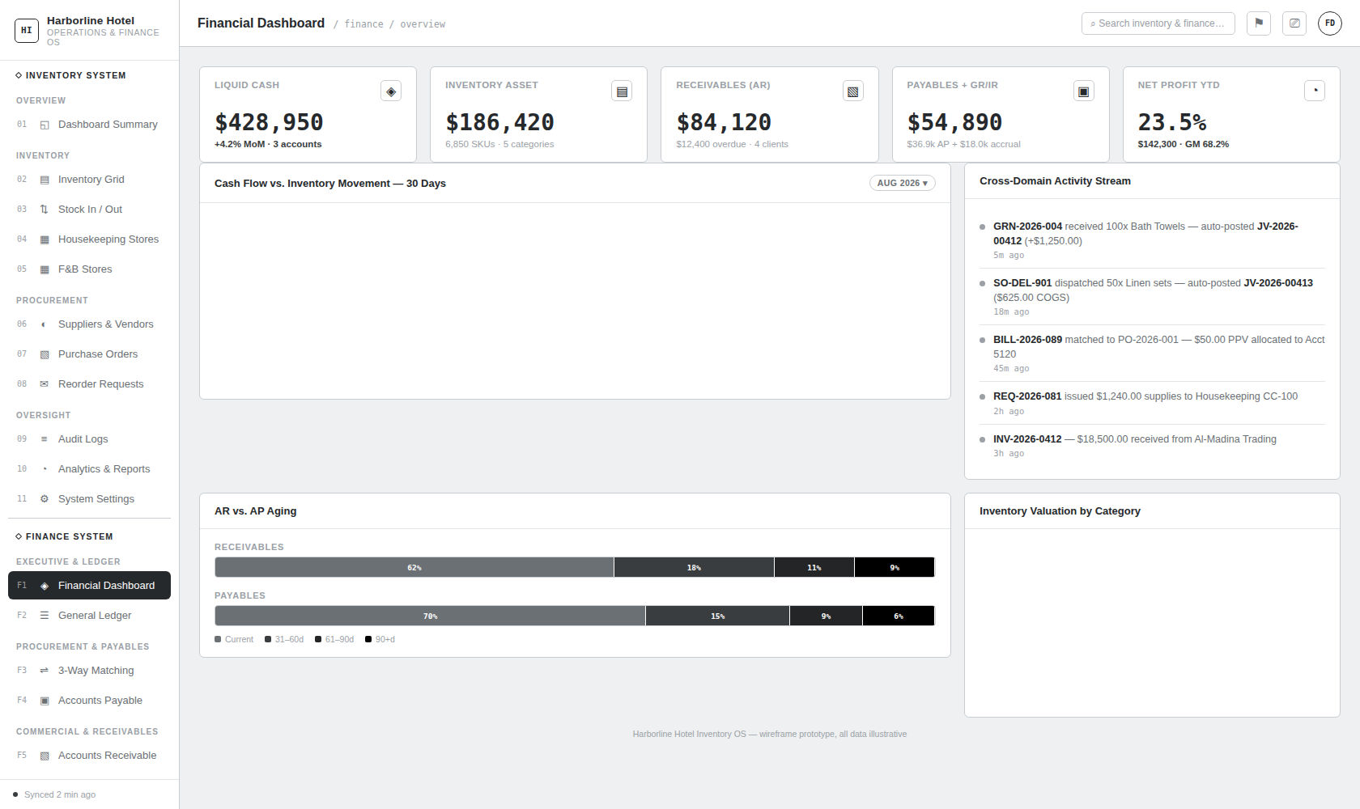
F1: Financial Dashboard

Structural & UI Specifications:
- Route Path: /finance/dashboard (Navigation: FINANCE > Financial Dashboard)
- Primary Executive Purpose: Delivers real-time corporate liquidity tracking, balance sheet asset valuation, working capital aging, and live automated General Ledger feed activity.
- Top Metric Cards (5 Cards Grid):
  - Liquid Cash: $428,950.00 (+4.2% MoM across 3 commercial bank accounts).
  - Inventory Asset: $186,420.00 (6,850 active SKUs across 5 merchandise categories).
  - Receivables (AR): $84,120.00 ($12,400.00 overdue across 4 client accounts).
  - Payables + GR/IR: $54,890.00 ($36,890.00 trade AP + $18,000.00 GR/IR accrual).
  - Net Profit YTD: 23.5% ($142,300.00 EBIT, Gross Margin 68.2%).
- Visual Charts & Analytic Workstations:
  - Cash Flow vs. Inventory Movement (30 Days): High-resolution continuous area line chart comparing daily Cash Inflow (solid curve) versus Cash Outflow (dashed curve).
  - Inventory Valuation by Category: High-density donut chart breaking down total warehouse capital (Equipment 29.1%, Linens 25.8%, F&B 18.5%, MRO 16.6%, Toiletries 10.0%).
  - Cross-Domain Activity Stream: Real-time chronological audit feed showing auto-posted GL vouchers triggered by warehouse events (GRN-2026-004 $→$ JV-2026-00412, SO-DEL-901 $→$ JV-2026-00413, BILL-2026-089 $→$ PPV, REQ-2026-081 $→$ CC-100).

10.2 View F2: General Ledger & Double-Entry Journal Postings
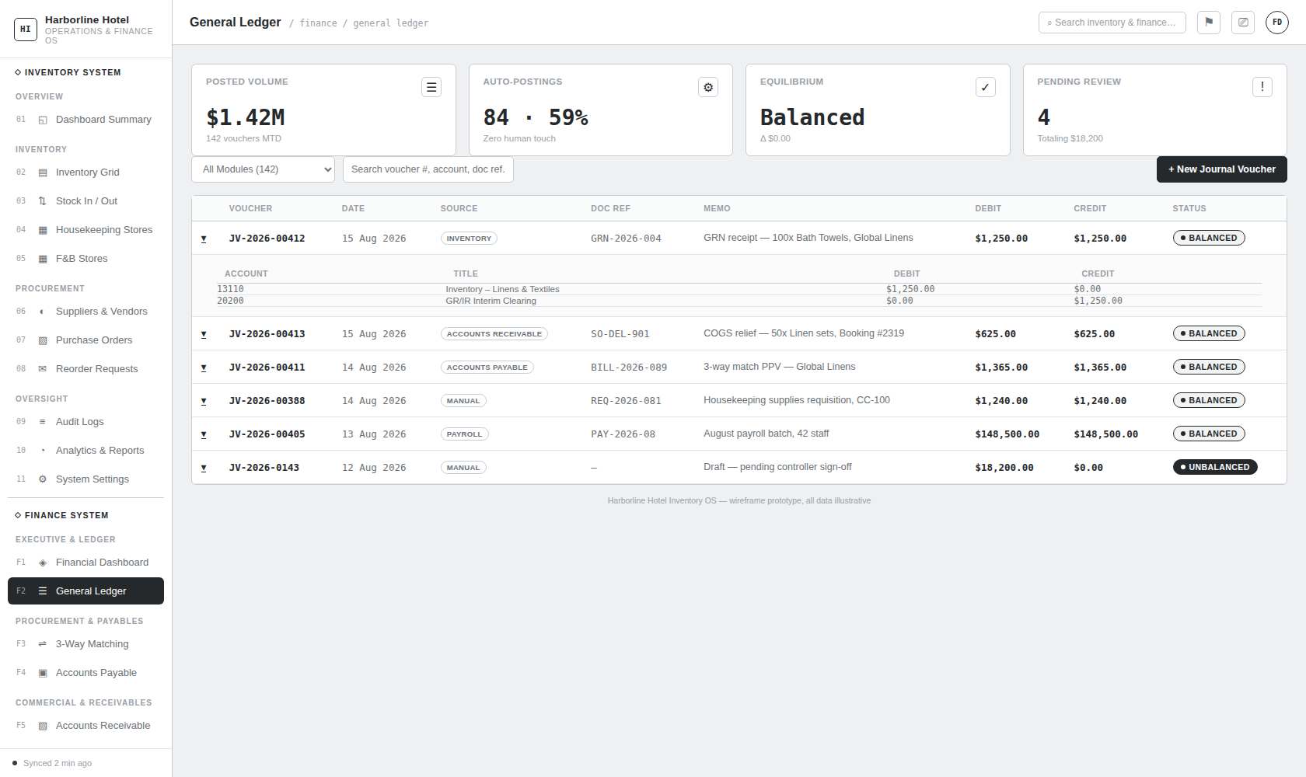
F2: General Ledger & Journal Entries

Structural & UI Specifications:
- Route Path: /finance/general-ledger (Navigation: FINANCE > General Ledger)
- Primary Executive Purpose: Provides the complete double-entry transaction record with interactive accordion drill-downs into multi-line debit/credit distributions.
- Top Metric Cards (4 Cards Grid):
  - Posted Volume: $1.42M (142 journal vouchers MTD).
  - Auto-Postings: 84 (59%) (Zero human touch, 100% automated from inventory events).
  - Equilibrium: Balanced ($Δ \$0.00$ debit/credit delta).
  - Pending Review: 4 (Totaling $18,200.00 in draft suspense).
- Filter Bar & Action Controls:
  - Module Category Dropdown: All Modules (142), Inventory Automated (84), Accounts Payable (24), Accounts Receivable (18), Payroll (12), Manual (4).
  - Search Toolbar: Filter by voucher number (JV-2026-XXXX), GL account code, document reference, or transaction memo.
  - Primary CTA: + New Journal Voucher (opens multi-line voucher creation modal).
- Master Table Schema:
  - Columns: [Expand Icon], Voucher #, Date, Source Module Tag, Doc Ref, Memo, Debit ($), Credit ($), Status Badge.
  - Accordion Sub-Table: Clicking any row expands the internal double-entry breakdown displaying Account Code, Account Title, Debit Amount, Credit Amount, and verification status.

10.3 View F3: Automated 3-Way Matching Engine & PPV
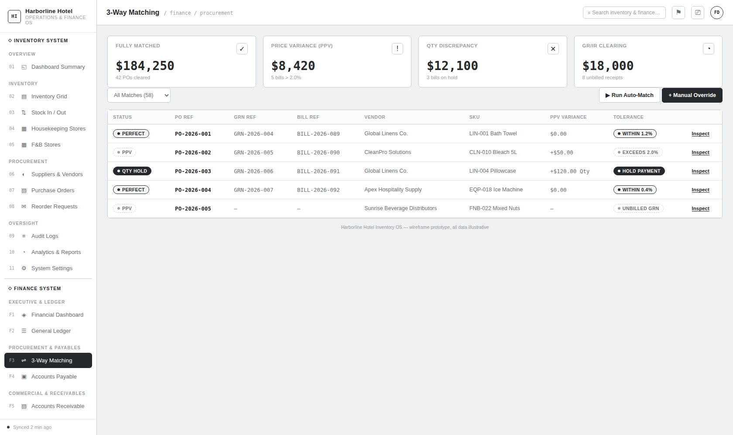
F3: 3-Way Matching Engine

Structural & UI Specifications:
- Route Path: /finance/3-way-matching (Navigation: FINANCE > 3-Way Matching)
- Primary Executive Purpose: Automated cross-verification of Purchase Orders (POs), Goods Receipt Notes (GRNs), and Vendor Bills to prevent fraudulent or erroneous disbursements.
- Top Metric Cards (4 Cards Grid):
  - Fully Matched: $184,250.00 (42 POs cleared for payment).
  - Price Variance (PPV): $8,420.00 (5 bills exceeding 2.0% threshold).
  - Qty Discrepancy: $12,100.00 (3 bills placed on payment hold).
  - GR/IR Clearing: $18,000.00 (8 unbilled warehouse receipts).
- Filter Bar & Action Controls:
  - Filter Tabs: All Matches (58), Perfect Match (42), PPV (5), Qty Mismatch (3), Unbilled GRN (8).
  - Action Buttons: ▶ Run Auto-Match (triggers batch reconciliation algorithm), + Manual Override (controller variance authorization).
- 3-Way Matching Table Schema:
  - Columns: Match Status Badge (Perfect, PPV, Qty Hold), PO Ref, GRN Ref, Bill Ref, Vendor Name, SKU / Item, PPV Variance ($), Tolerance Rule Status, Inspect Action Link.

10.4 View F4: Accounts Payable & Vendor Bills
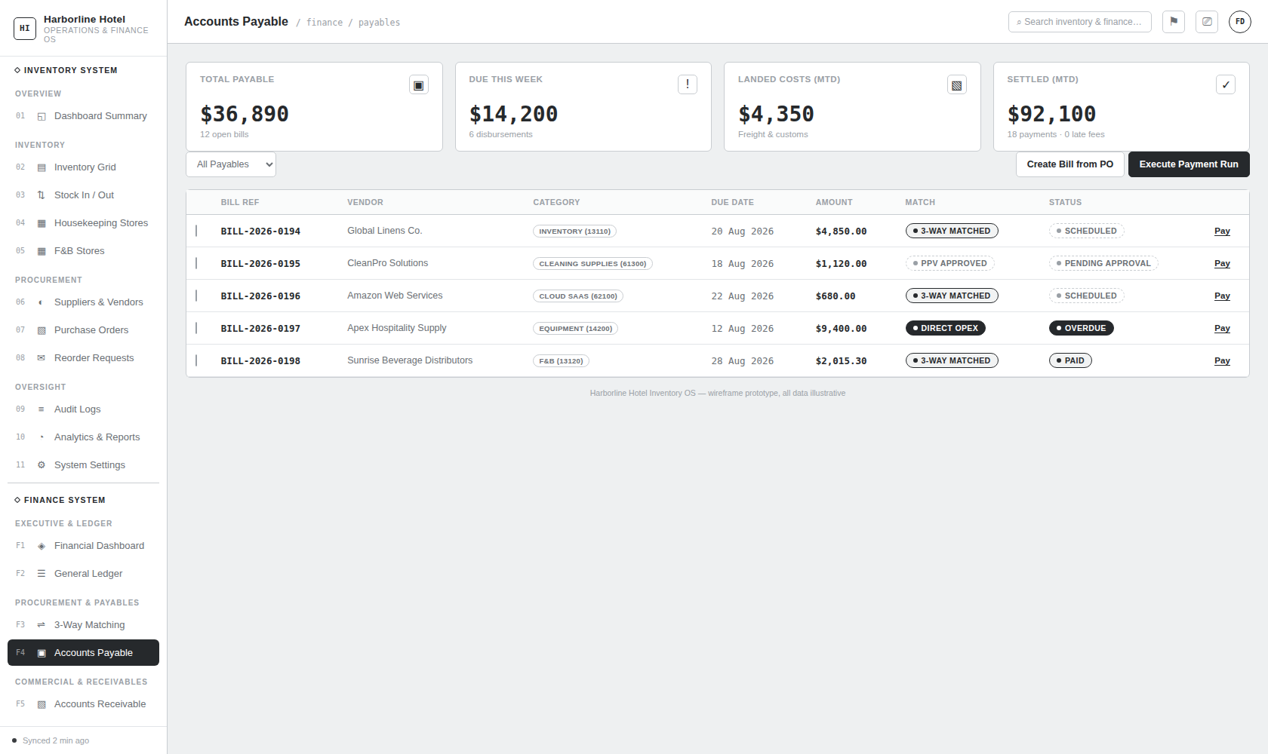
F4: Accounts Payable & Vendor Bills

Structural & UI Specifications:
- Route Path: /finance/accounts-payable (Navigation: FINANCE > Accounts Payable)
- Primary Executive Purpose: Manages trade liabilities, landed cost capitalization, vendor payment schedules, and batch disbursement execution.
- Top Metric Cards (4 Cards Grid):
  - Total Payable: $36,890.00 (12 open vendor bills).
  - Due This Week: $14,200.00 (6 urgent disbursements).
  - Landed Costs (MTD): $4,350.00 (Capitalized freight & customs).
  - Settled (MTD): $92,100.00 (18 payments executed, 0 late fees).
- Filter Bar & Action Controls:
  - Filters: All Payables, PO-Backed, Direct Opex, Landed Costs, Overdue.
  - Action Buttons: Create Bill from PO (drafts AP bill directly from PO items), Execute Payment Run (launches batch EFT modal).
- Payables Table Schema:
  - Columns: Select Checkbox, Bill Ref, Vendor Name, Category / Expense Account Tag, Due Date, Total Amount ($), Match Status Badge, Payment Status Badge (Scheduled, Pending Approval, Overdue, Paid), Pay Action Link.

10.5 View F5: Accounts Receivable & Customer Invoicing
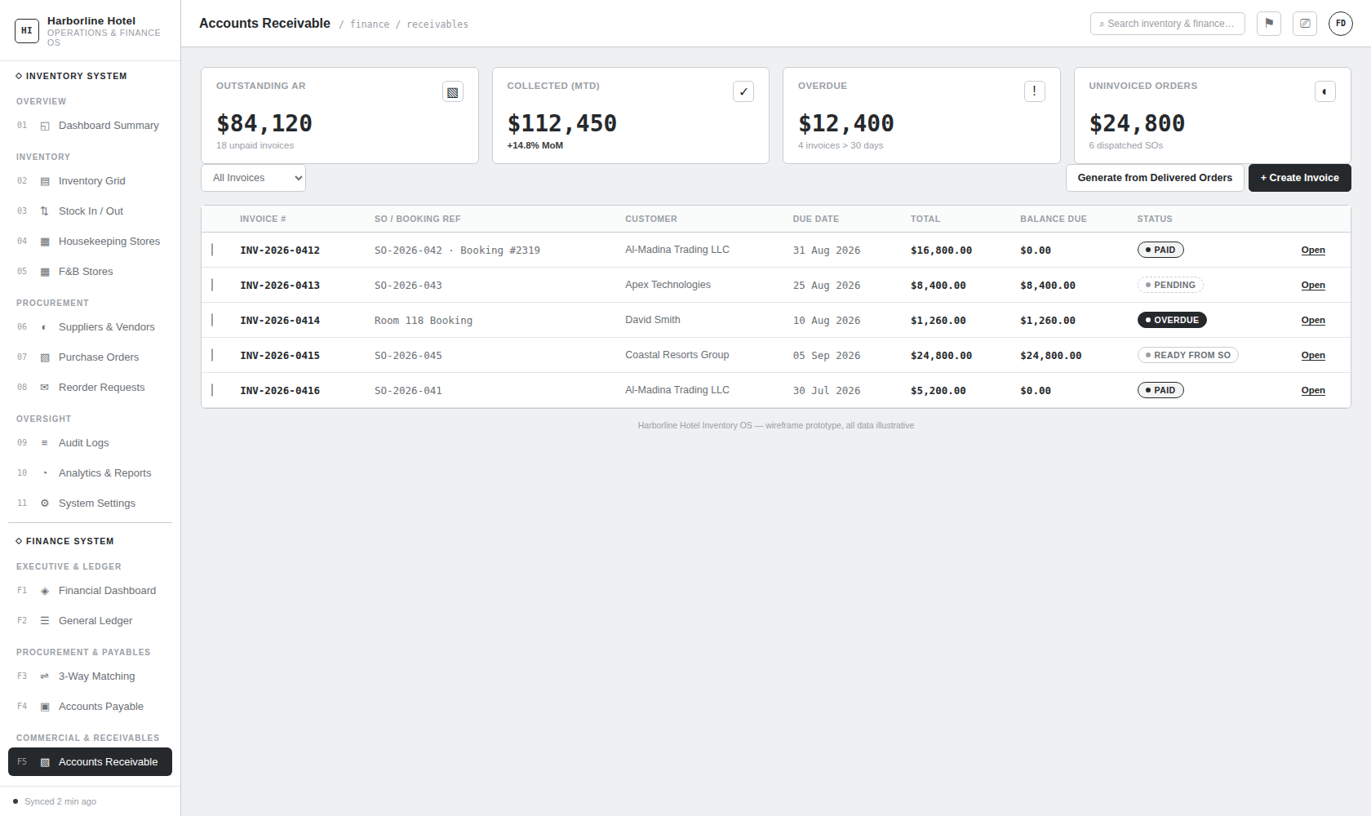
F5: Accounts Receivable & Customer Invoices

Structural & UI Specifications:
- Route Path: /finance/accounts-receivable (Navigation: FINANCE > Accounts Receivable)
- Primary Executive Purpose: Manages customer billing, cash collection pipelines, invoice aging, and automated invoice drafting from sales orders.
- Top Metric Cards (4 Cards Grid):
  - Outstanding AR: $84,120.00 (18 unpaid customer invoices).
  - Collected (MTD): $112,450.00 (+14.8% MoM cash collection surge).
  - Overdue: $12,400.00 (4 invoices > 30 days overdue).
  - Uninvoiced Orders: $24,800.00 (6 dispatched sales orders ready for billing).
- Filter Bar & Action Controls:
  - Filters: All Invoices, Ready from SO, Draft, Sent / Pending, Paid, Overdue.
  - Action Buttons: Generate from Delivered Orders (batch invoice drafting), + Create Invoice (manual invoice creation).
- Receivables Table Schema:
  - Columns: Select Checkbox, Invoice #, SO / Booking Reference, Customer Name, Due Date, Total Amount ($), Balance Due ($), Status Badge, Open Action Link.

10.6 View F6: Unified Master Party Directory
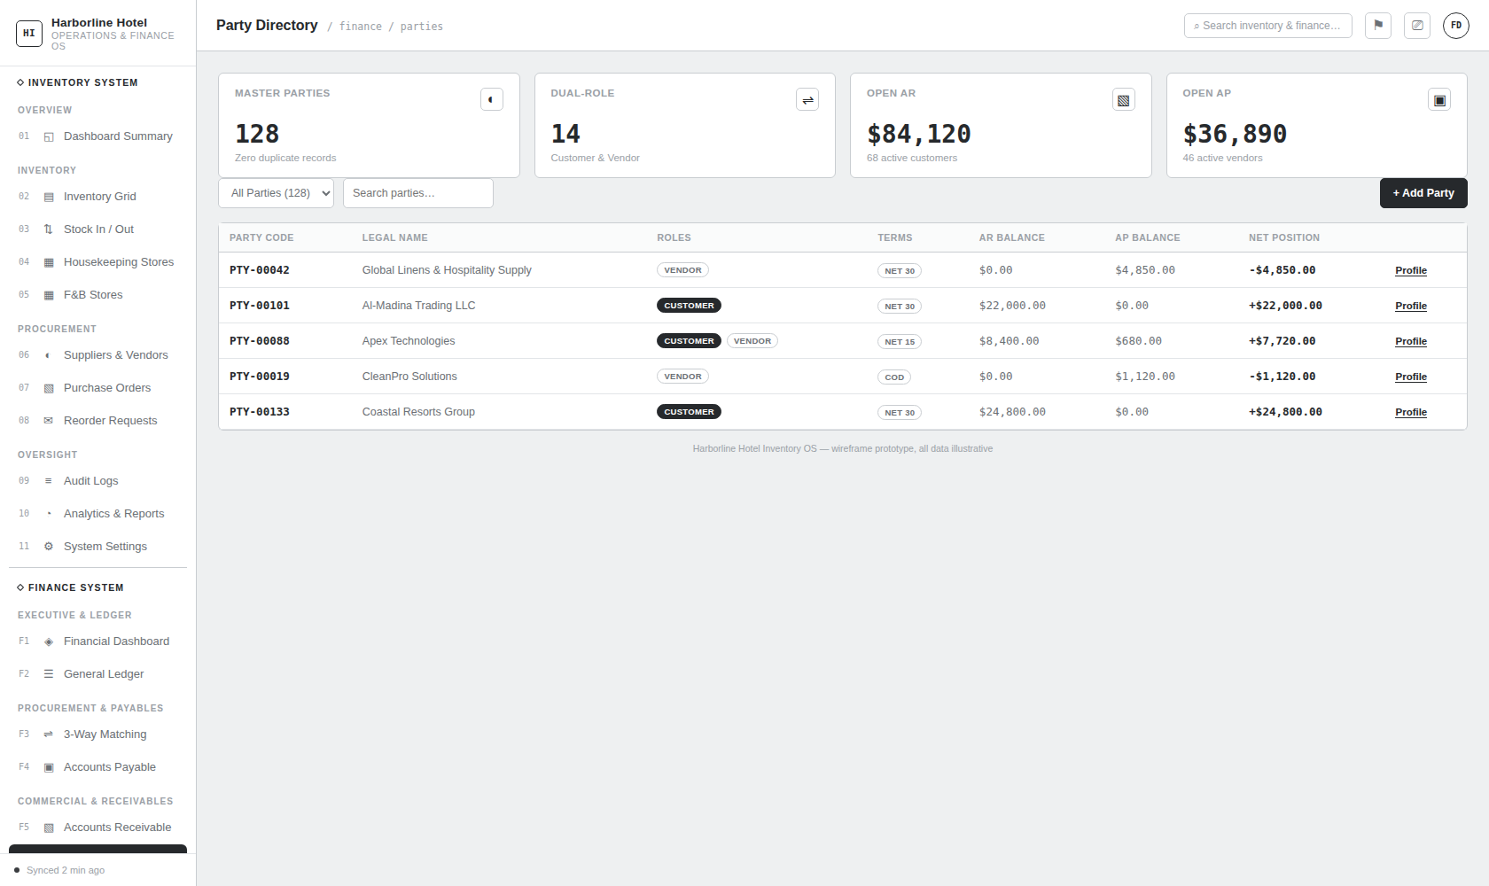
F6: Unified Party Directory

Structural & UI Specifications:
- Route Path: /finance/parties (Navigation: FINANCE > Party Directory)
- Primary Executive Purpose: Centralized single-database directory for all commercial counterparties (Customers, Vendors, and Dual-Role Partners) with net settlement position tracking.
- Top Metric Cards (4 Cards Grid):
  - Master Parties: 128 (Zero duplicate records across inventory and finance).
  - Dual-Role: 14 (Entities operating simultaneously as Customer and Vendor).
  - Open AR: $84,120.00 (68 active customer accounts).
  - Open AP: $36,890.00 (46 active supplier accounts).
- Filter Bar & Action Controls:
  - Role Filters: All Parties (128), Customers (68), Vendors (46), Dual-Role (14).
  - Search Toolbar: Instant search by legal name, tax registration number (TRN), or party code.
  - Primary CTA: + Add Party (opens master party registration modal).
- Parties Table Schema:
  - Columns: Party Code (PTY-XXXXX), Legal Entity Name, Role Badges (Customer, Vendor), Payment Terms Tag, AR Balance ($), AP Balance ($), Net Settlement Position ($), Profile Action Link.

10.7 View F7: Inventory Valuation Rules & GL Account Mapping
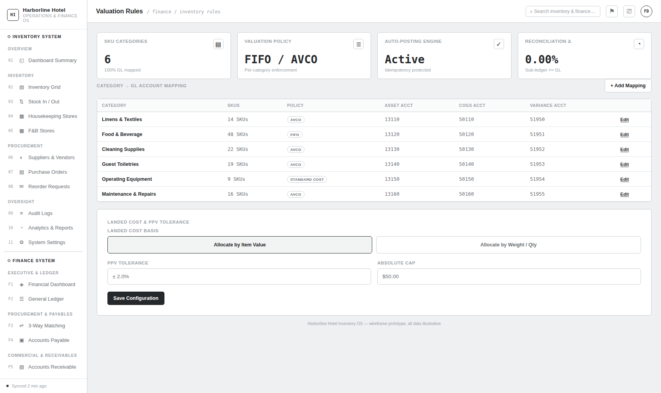
F7: Valuation Rules & Account Mapping

Structural & UI Specifications:
- Route Path: /finance/valuation-rules (Navigation: FINANCE > Valuation Rules)
- Primary Executive Purpose: Configures perpetual inventory valuation policies, Chart of Accounts mapping per category, and landed cost / PPV tolerance thresholds.
- Top Metric Cards (4 Cards Grid):
  - SKU Categories: 6 (100% mapped to active GL control accounts).
  - Valuation Policy: FIFO / AVCO (Per-category algorithmic enforcement).
  - Auto-Posting Engine: Active (Idempotency and balance-check protected).
  - Reconciliation $Δ$: 0.00% (Sub-ledger inventory value $≡$ GL asset account).
- Category GL Mapping Grid:
  - Table Columns: Category Name, SKU Count, Valuation Policy Tag (AVCO, FIFO, Standard Cost), Asset Account Code, COGS Account Code, Variance Account Code, Edit Action Link.
- Landed Cost & PPV Tolerance Configuration Card:
  - Landed Cost Basis Radio Options: Allocate by Item Value vs. Allocate by Weight / Qty.
  - PPV Tolerance Settings: Tolerance Percentage input (default ± 2.0%), Absolute Dollar Cap input (default $50.00), Save Configuration action button.

10.8 View F8: Cost Center Hierarchy & Internal Requisitions
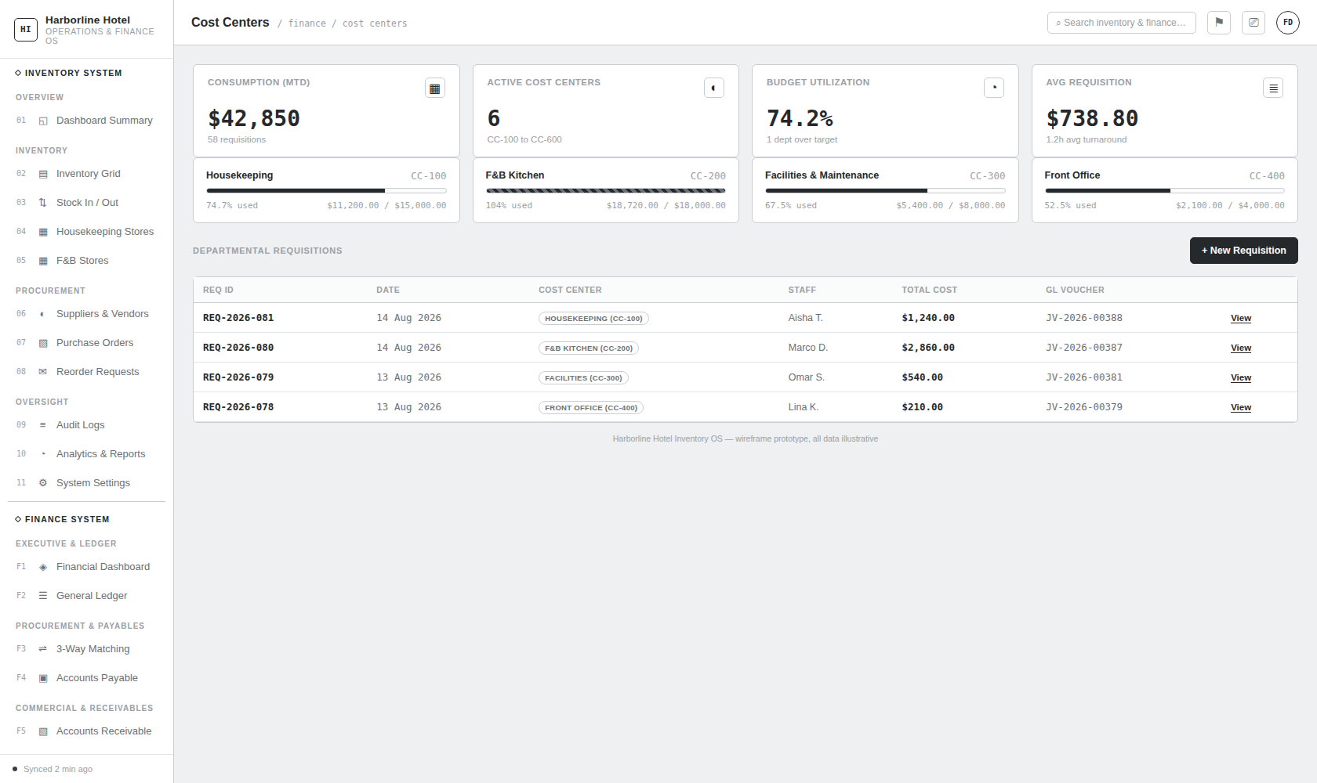
F8: Cost Centers & Internal Requisitions

Structural & UI Specifications:
- Route Path: /finance/cost-centers (Navigation: FINANCE > Cost Centers)
- Primary Executive Purpose: Departmental budget utilization monitoring, operational cost tracking, and internal warehouse stock requisition management.
- Top Metric Cards (4 Cards Grid):
  - Consumption (MTD): $42,850.00 (58 internal requisitions fulfilled).
  - Active Cost Centers: 6 (CC-100 Housekeeping to CC-600 Executive).
  - Budget Utilization: 74.2% (1 department over annual budget target).
  - Avg Requisition: $738.80 (1.2h average fulfillment turnaround).
- Departmental Budget Progress Cards:
  - Renders progress tracking cards per department with visual percentage fill bars: Housekeeping CC-100 (74.7%), F&B Kitchen CC-200 (104.0% - Warning Highlight), Facilities CC-300 (67.5%), Front Office CC-400 (52.5%).
- Departmental Requisitions Table Schema:
  - Columns: Requisition ID (REQ-2026-XXX), Date, Cost Center Tag, Requesting Staff, Total Cost ($), Auto-Generated GL Voucher (JV-XXXX), View Action Link.

10.9 View F9: Fixed Asset Register & Depreciation Schedules
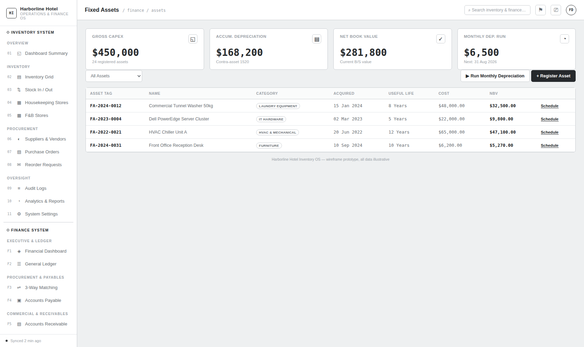
F9: Fixed Assets Register

Structural & UI Specifications:
- Route Path: /finance/fixed-assets (Navigation: FINANCE > Fixed Assets)
- Primary Executive Purpose: Fixed asset registry, capital expenditure tracking, depreciation schedule calculation, and net book value (NBV) monitoring.
- Top Metric Cards (4 Cards Grid):
  - Gross Capex: $450,000.00 (24 registered capital assets).
  - Accum. Depreciation: $168,200.00 (Contra-asset account 15200).
  - Net Book Value (NBV): $281,800.00 (Current Balance Sheet carrying value).
  - Monthly Dep. Run: $6,500.00 (Scheduled for automatic posting on 31 Aug 2026).
- Filter Bar & Action Controls:
  - Asset Category Filters: All Assets, Laundry & Equipment, HVAC & Mechanical, IT & POS, Vehicles, Furniture.
  - Action Buttons: ▶ Run Monthly Depreciation (executes monthly amortization run), + Register Asset (opens capital asset registration modal).
- Fixed Assets Table Schema:
  - Columns: Asset Tag (FA-YYYY-XXXX), Asset Description / Name, Category Tag, Acquisition Date, Useful Life (Years), Historical Cost ($), Net Book Value ($), Schedule Action Link.

10.10 View F10: Workforce Payroll Processing & Statutory VAT Compliance
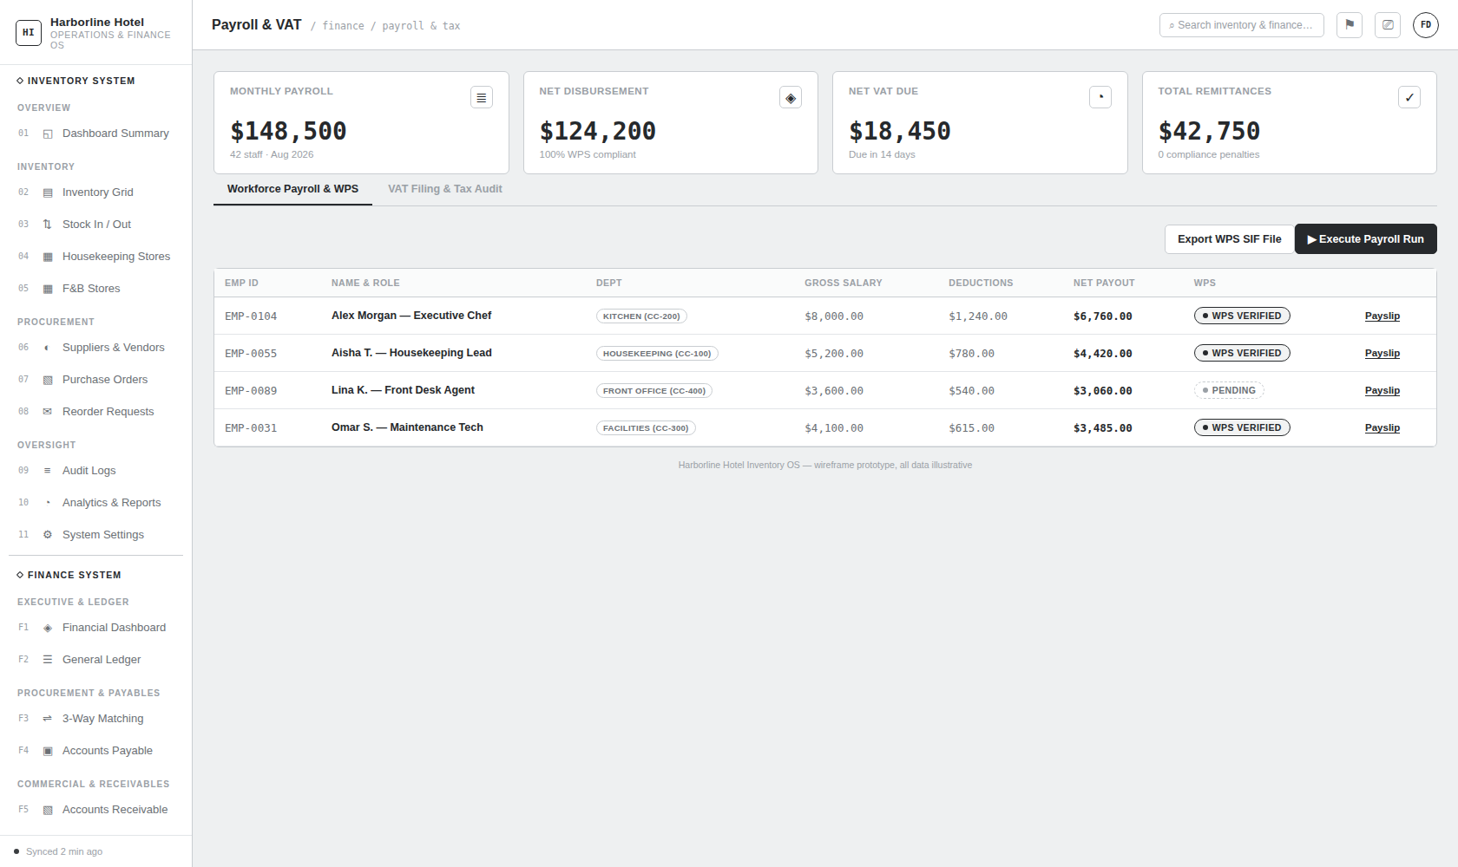
F10: Payroll & VAT Tax Management

Structural & UI Specifications:
- Route Path: /finance/payroll-vat (Navigation: FINANCE > Payroll & VAT)
- Primary Executive Purpose: Dual-workstation view managing gross-to-net salary disbursements, Wage Protection System (WPS) compliance, and statutory GCC 5% VAT filings.
- Top Metric Cards (4 Cards Grid):
  - Monthly Payroll: $148,500.00 (42 staff members, August 2026 period).
  - Net Disbursement: $124,200.00 (100% WPS SIF compliant).
  - Net VAT Due: $18,450.00 (Statutory return due in 14 days).
  - Total Remittances: $42,750.00 (Zero compliance penalties incurred).
- Dual-Tab Workstation Layout:
  - Tab 1: Workforce Payroll & WPS:
    - Action Buttons: Export WPS SIF File (generates statutory salary file), ▶ Execute Payroll Run (posts salary expense & liability vouchers).
    - Table Columns: Employee ID, Name & Position, Department / Cost Center, Gross Base Salary, Deductions & Withholdings, Net Payout, WPS Compliance Badge (WPS Verified / Pending), Payslip Action Link.
  - Tab 2: VAT Filing & Tax Audit:
    - VAT Summary Calculation Panel:
$$\begin{aligned}\text{Taxable Sales Revenue}&=\$642,000.00 \\ \text{Output VAT Collected (5\%)}&=+\$32,100.00 \\ \text{Taxable Inbound Purchases}&=\$273,000.00 \\ \text{Input VAT Recoverable (5\%)}&=−\$13,650.00 \\ \text{Net VAT Payable to Tax Authority}&=\$18,450.00\end{aligned}$$
    - Action Button: Submit VAT Return & Post Settlement (posts settlement voucher to General Ledger).
    - VAT Transaction Audit Table: Date, Document Ref, Party Name, Tax Type (5% Output / 5% Input), Taxable Base Amount ($), Tax Amount ($).

10.11 View F11: Statutory Financial Statements (IFRS/GAAP) & Audit Trail
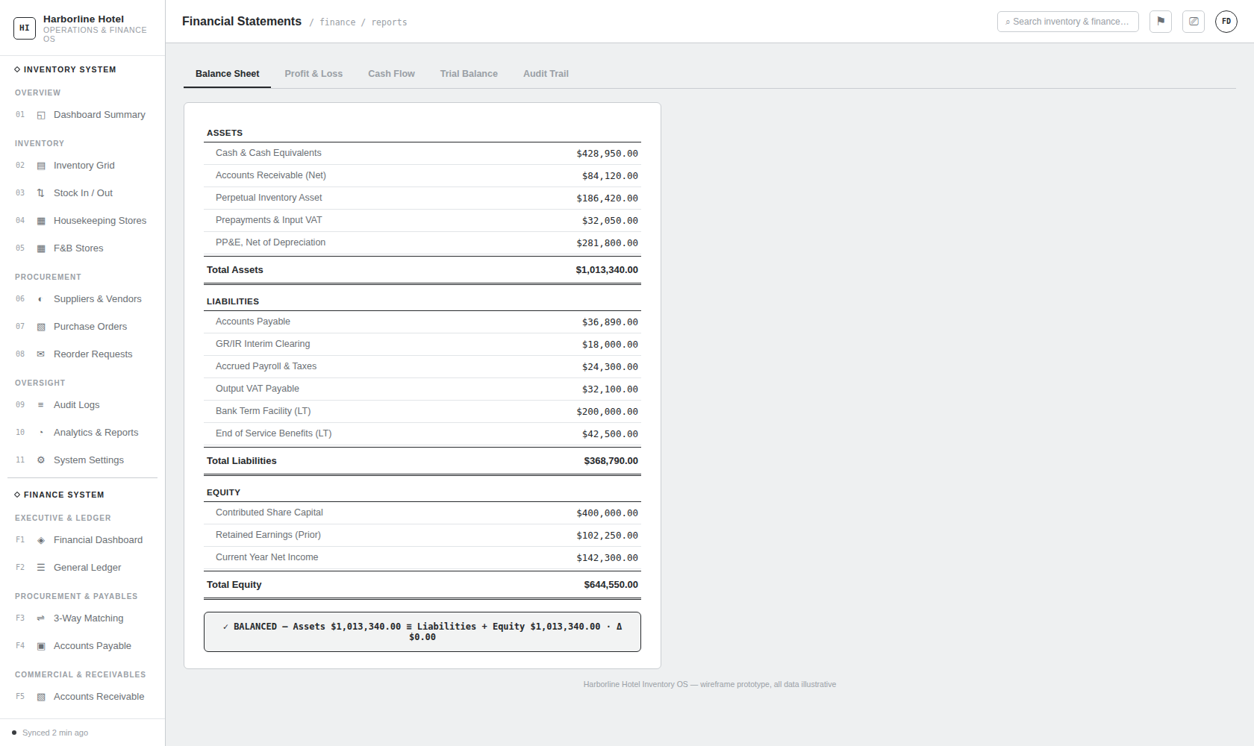
F11: Statutory Financial Statements

Structural & UI Specifications:
- Route Path: /finance/financial-statements (Navigation: FINANCE > Financial Statements)
- Primary Executive Purpose: Real-time generation of statutory financial reports, balance sheet equilibrium verification, and cryptographic audit logs.
- 5-Tab Multi-Report Architecture:

1. Tab 1: Balance Sheet (stab-bs)
- Assets ($1,013,340.00):
  - Cash & Cash Equivalents: $428,950.00
  - Accounts Receivable (Net): $84,120.00
  - Perpetual Inventory Asset: $186,420.00
  - Prepayments & Input VAT: $32,050.00
  - PP&E, Net of Accumulated Depreciation: $281,800.00
- Liabilities ($368,790.00):
  - Trade Accounts Payable: $36,890.00
  - GR/IR Interim Clearing Account: $18,000.00
  - Accrued Payroll & Taxes: $24,300.00
  - Output VAT Payable: $32,100.00
  - Bank Term Facility (Long-Term): $200,000.00
  - End of Service Benefits (Long-Term): $42,500.00
- Equity ($644,550.00):
  - Contributed Share Capital: $400,000.00
  - Retained Earnings (Prior Years): $102,250.00
  - Current Year Net Income: $142,300.00
- Equilibrium Validation Banner:
$$✓ BALANCED\text{ — Total Assets }\$1,013,340.00≡\text{Liabilities }(\$368,790.00)+\text{Equity }(\$644,550.00)⋅Δ \$0.00$$

2. Tab 2: Profit & Loss / Income Statement (stab-pl)
- Net Revenue: Gross Revenue ($\$620,000.00$) $−$ Sales Discounts ($\$14,500.00$) = $605,500.00
- Cost of Goods Sold (COGS): Linens ($\$42,100.00$) + F&B ($\$88,400.00$) + Amenities ($\$24,800.00$) + PPV Variance ($\$1,200.00$) = -$192,500.00
- Gross Profit: $413,000.00 (Gross Margin: 68.2%)
- Operating Expenses (OPEX): Salaries ($\$148,500.00$) + Department Supplies ($\$42,850.00$) + Rent/Facilities ($\$38,200.00$) + Depreciation ($\$6,500.00$) + G&A ($\$16,250.00$) = -$270,700.00
- Net Operating Profit (EBIT): $142,300.00 (Operating Margin: 23.5%)

3. Tab 3: Statement of Cash Flows (stab-cf)
- Cash from Operating Activities: Net Income ($\$142,300.00$) + Depreciation Non-Cash ($\$6,500.00$) $−$ Working Capital Adjustments ($\$12,400.00$) = +$136,400.00
- Cash from Investing Activities: Capital Expenditures (Capex additions) = -$45,000.00
- Cash from Financing Activities: Debt Service & Dividends = -$25,000.00
- Net Cash Movement: +$66,400.00 $→$ Ending Cash Balance: $428,950.00

4. Tab 4: Trial Balance (stab-tb)
- Tabular account listing across all active Chart of Accounts codes.
- Verifies overall equilibrium:
$$Total Debits: \$1,824,930.00 ≡ Total Credits: \$1,824,930.00 (Δ Balanced)$$

5. Tab 5: Tamper-Evident Audit Trail (stab-audit)
- Forensic chronological log of all accounting actions:
  - Columns: Timestamp, Action Type (STOCK_RECEIPT, PO_3WAY_MATCHED, INVOICE_GENERATED, PAYROLL_EXECUTED), Source Module, Document Reference, Authorizing Agent / SYSTEM_AUTO_GL, Cryptographic SHA-256 Hash, Verification Badge.

Document Sign-off & Verification
This Master Final Document consolidates all requirements, relational schemas, automated GL trigger matrices, technical work breakdown structures, and visual wireframe specifications into an authoritative engineering standard for the QuickBox Financial Management System.
Document Status: Ready for Production Execution & Independent Forensic Audit.

