FINANCIAL SYSTEMS RESEARCH
Financial Management System
Jordan Business & Accounting Management Research

Table of Contents
1. Business Plan Development تطوير خطة العمل
2. Account Reconciliation مطابقة الحسابات
3. Account Management إدارة الحسابات
4. Internal Controls Implementation تنفيذ الضوابط الداخلية
5. Tender / Bid Auditing تدقيق على العطاءات
6. Cash Flow Improvement تحسين التدفق النقدي
7. Social Security الضمان الاجتماعي
8. Income Tax Preparation إعداد ضريبة الدخل
9. Fixed Assets الأصول الثابتة
10. Expense Classification & Management تصنيف المصروف وإدارتها
11. Deduction Calculation حساب الاقتطاعات
12. Payroll Processing / Salary Issuance إصدار الرواتب
13. Monitoring Tax Exemptions & Tax Updates متابعة نزول الإعفاءات والضرائب
14. Fixed Expenses المصاريف الثابتة
15. Reporting Concepts التقارير
16. Written Financial Policy سياسة مالية مكتوبة

Introduction
This document explains the financial and accounting topics that must be understood before software requirements are written. For each topic, it describes what the process is, why it matters, how it normally works in practice, the main data or documents involved, and a practical example.

Important
This document includes the current Jordanian tax, social-security, and other statutory rates relevant to the financial processes discussed. These figures are provided as a business reference based on the applicable rules at the time of this research. As rates, exemptions, thresholds, and regulations may change, they should be verified against the latest official Jordanian regulations before being applied. Company-specific approval limits and internal policies should also be confirmed during the Requirements phase.

1 | Business Plan Development تطوير خطة العمل
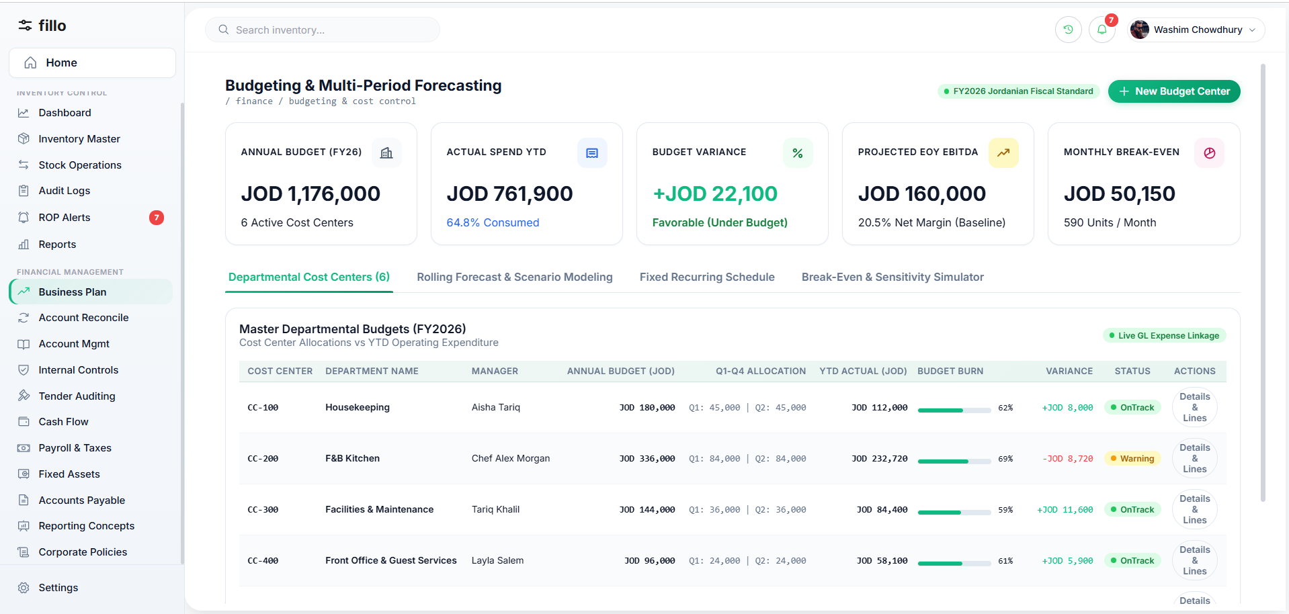
Figure 1: Business Plan Development — System View
A financial business plan translates management goals into expected revenue, costs, cash needs, budgets and forecasts. It creates a baseline that management can compare with actual performance and helps identify funding needs before problems occur.
How It Works in Practice
STEP 1  Management defines goals and the planning period. | STEP 2  Finance reviews historical results and gathers assumptions for sales, pricing, staffing, rent, operating costs and planned investments.
STEP 3  Revenue, expense and monthly cash-flow estimates are prepared and reviewed. | STEP 4  The approved budget becomes the baseline; actual results are compared with it and significant variances are investigated.
STEP 5
Forecasts may be updated as conditions change, while the original approved budget remains available for comparison.

Key Data & Documents  Prior-year results, sales assumptions, cost estimates, staffing plans, capital spending and financing assumptions. | Practical Example  A company plans a new branch. Finance estimates setup cost, monthly rent, salaries, utilities and expected sales. The cash forecast shows that the branch will require head-office funding during its first months, allowing management to plan the cash requirement in advance.

2 | Account Reconciliation مطابقة الحسابات
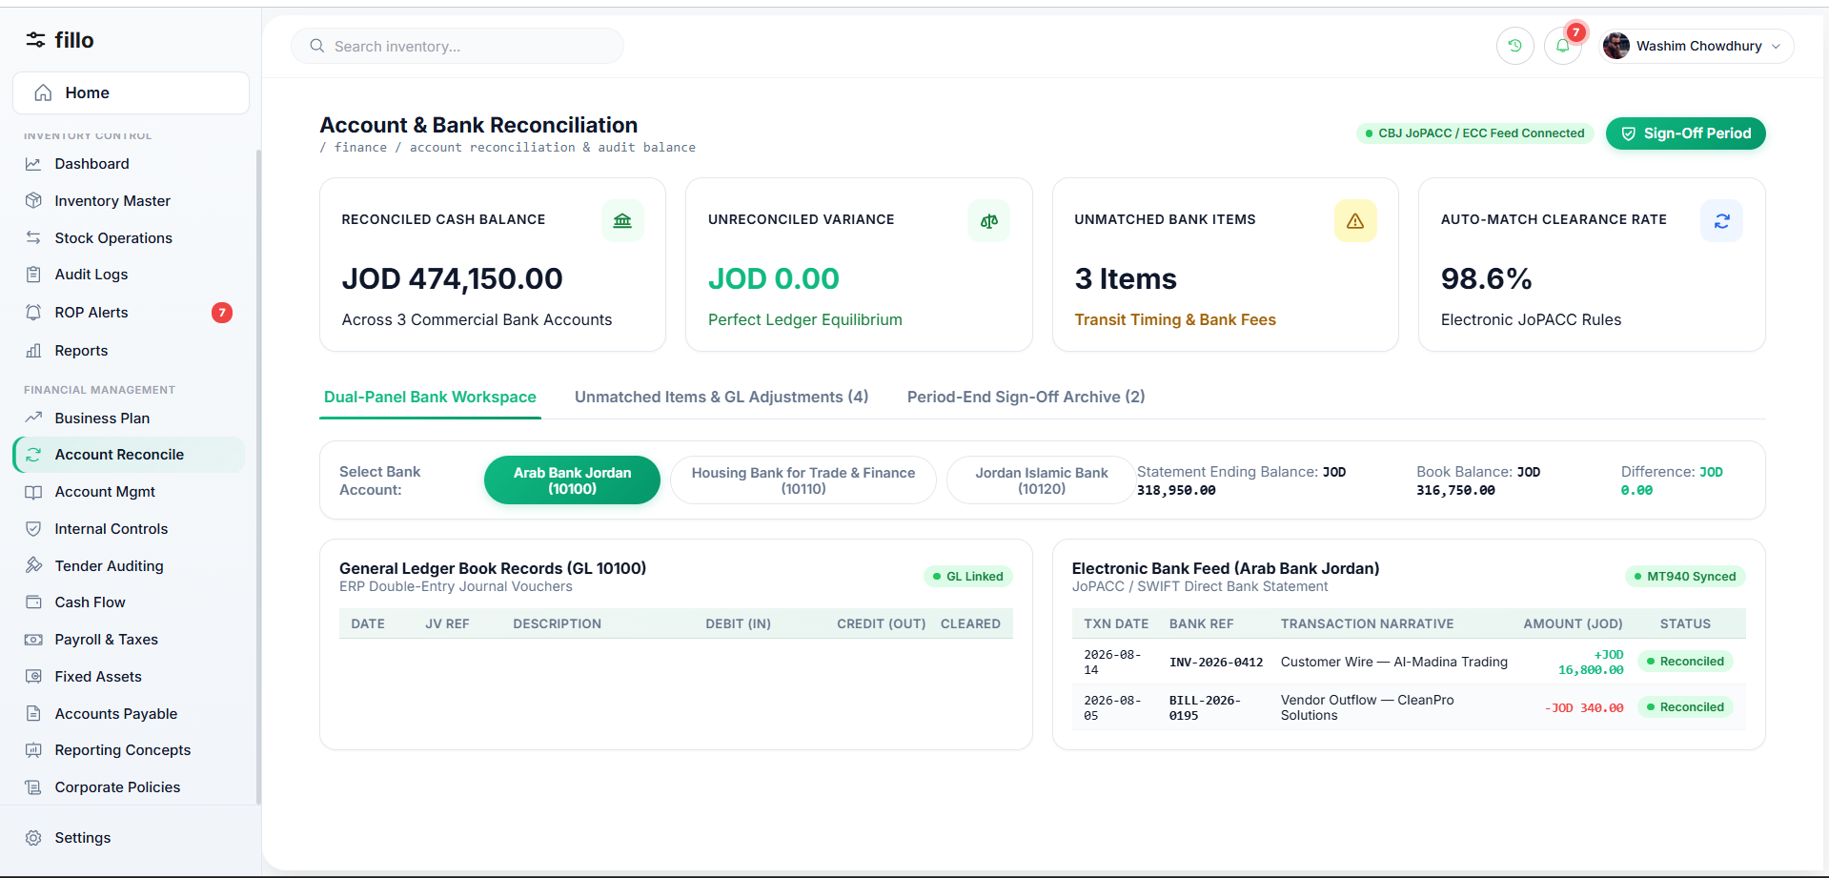
Figure 2: Account Reconciliation — System View
Reconciliation compares the company's accounting record with an independent source, such as a bank, supplier or customer statement. The purpose is to confirm that balances agree or explain every difference.
How It Works in Practice
STEP 1  Select the account and period. | STEP 2  Obtain the independent statement for the same period.
STEP 3  Match transactions by date, amount and reference. | STEP 4  Investigate unmatched items such as timing differences, bank charges, duplicate entries or posting errors.
STEP 5  Post justified adjustments to the books, then recalculate the balances. | STEP 6  A reviewer approves the completed reconciliation before the period is considered closed.

Key Data & Documents  General-ledger detail, external statements, receipts, deposit slips, bank notices and supporting documents for unmatched items. | Practical Example  The cash ledger shows JOD 10,000 and the bank statement JOD 9,800. The accountant identifies a JOD 200 bank fee missing from the books, records it, and the adjusted book balance becomes JOD 9,800.

3 | Account Management إدارة الحسابات
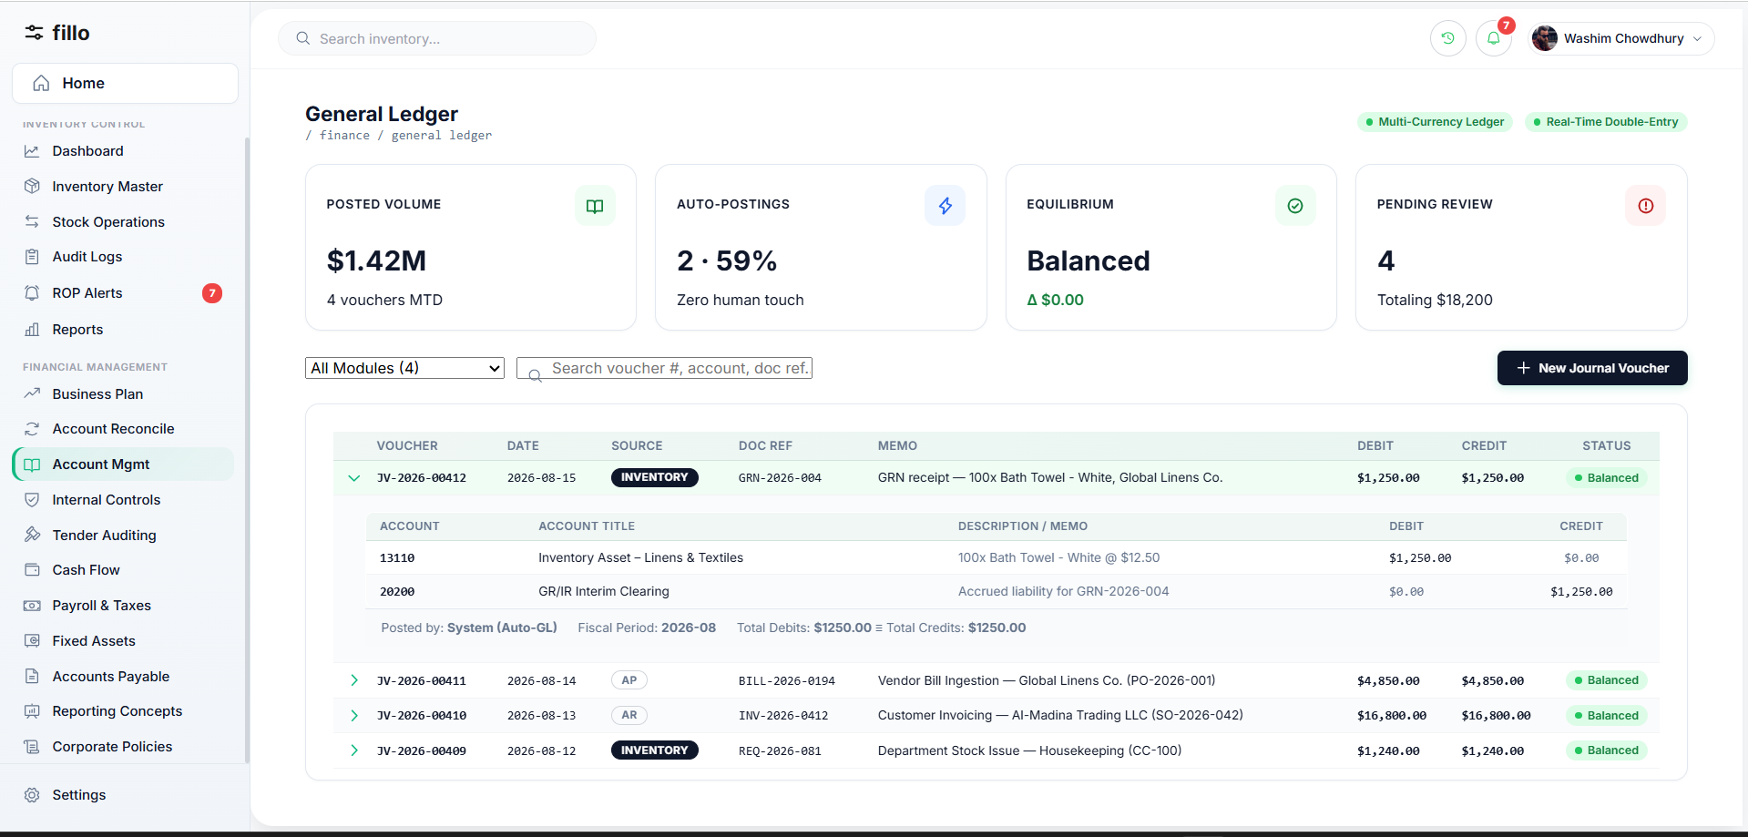
Figure 3: Account Management — System View
Account management maintains the Chart of Accounts (CoA) and ensures transactions are recorded in the correct asset, liability, equity, revenue or expense accounts. A consistent CoA is essential because reporting, reconciliation, budgeting and tax work all depend on correct classification.
How It Works in Practice
STEP 1  Maintain account codes, names, types and hierarchy. | STEP 2  Create new accounts through a controlled process rather than ad hoc during data entry.
STEP 3  Post transactions to the correct accounts and review account activity regularly. | STEP 4  Investigate unusual balances or amounts left in suspense/clearing accounts.
STEP 5
Deactivate unused accounts instead of deleting them so historical transactions remain traceable.

Key Data & Documents  Chart of Accounts, journal entries, transaction history, invoices, receipts and account status information. | Practical Example  A JOD 2,000 office-rent payment is posted as Debit Rent Expense / Credit Bank. The same posting then flows correctly into expense, cash and management reports.

4 | Internal Controls Implementation تنفيذ الضوابط الداخلية
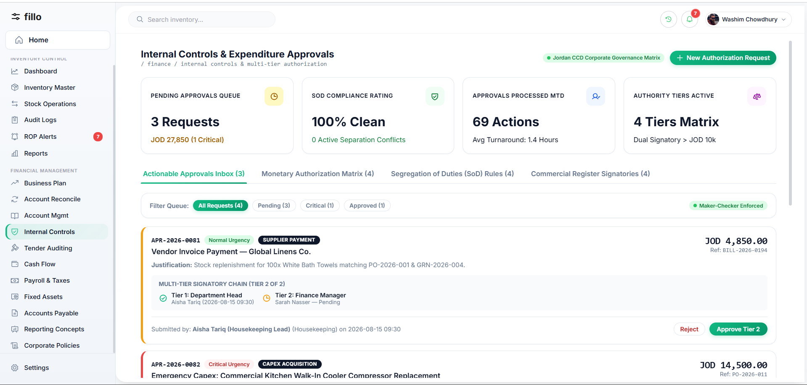
Figure 4: Internal Controls Implementation — System View
Internal controls are rules that make financial activity authorized, accurate and traceable. They reduce the risk of error or fraud through approvals, segregation of duties, access restrictions, reconciliations and audit trails.
How It Works in Practice
STEP 1  Identify sensitive activities such as large payments, payroll changes, vendor changes and unusual journal entries. | STEP 2  Assign roles so incompatible duties are separated; the person creating a sensitive transaction should not normally approve it.
STEP 3  Apply approval thresholds and route transactions to the required authority. | STEP 4  Record who created, edited, approved, rejected or cancelled each controlled transaction.
STEP 5
Lock closed periods and handle later corrections through controlled adjustments.

Key Data & Documents  User roles, approval matrix, monetary thresholds, audit logs, transaction status and supporting evidence. | Practical Example  An accountant enters a JOD 10,000 supplier payment. Because it exceeds the approval threshold, it remains pending until the Finance Manager reviews and approves it.

5 | Tender / Bid Auditing تدقيق على العطاءات
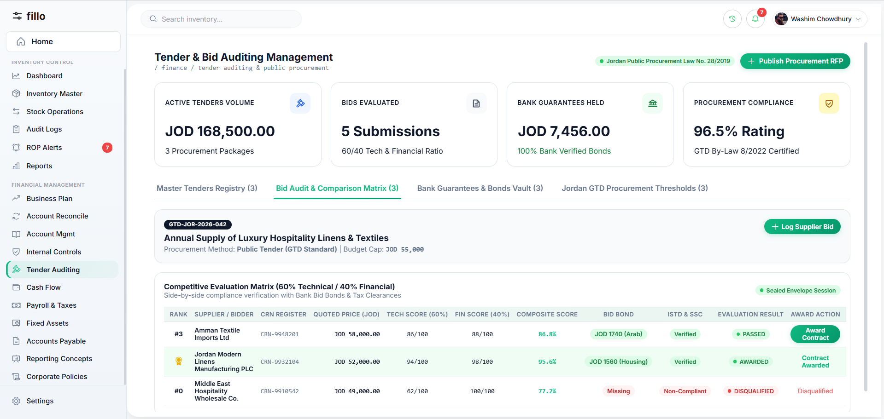
Figure 5: Tender / Bid Auditing — System View
Tender auditing provides a fair, documented financial review of supplier bids. The selected offer should represent the best value against agreed criteria, not automatically the lowest price.
How It Works in Practice
STEP 1  Define the requirement, budget and evaluation criteria before bids are reviewed. | STEP 2  Receive and log supplier offers with price, taxes/fees, payment terms and delivery information.
STEP 3  Compare bids consistently against the agreed criteria and verify budget availability. | STEP 4  Document the evaluation and reason for the selected supplier.
STEP 5
Obtain the required approval and retain all bids, evaluation notes and decisions for audit.

Key Data & Documents  Tender documents, supplier bids, evaluation criteria, pricing schedules, payment terms, budget confirmation and approval records. | Practical Example  Three suppliers quote JOD 20,000, JOD 18,500 and JOD 19,000. The JOD 19,000 offer may be selected if its warranty and delivery score make it the best overall value; the reason is documented and approved.

6 | Cash Flow Improvement تحسين التدفق النقدي
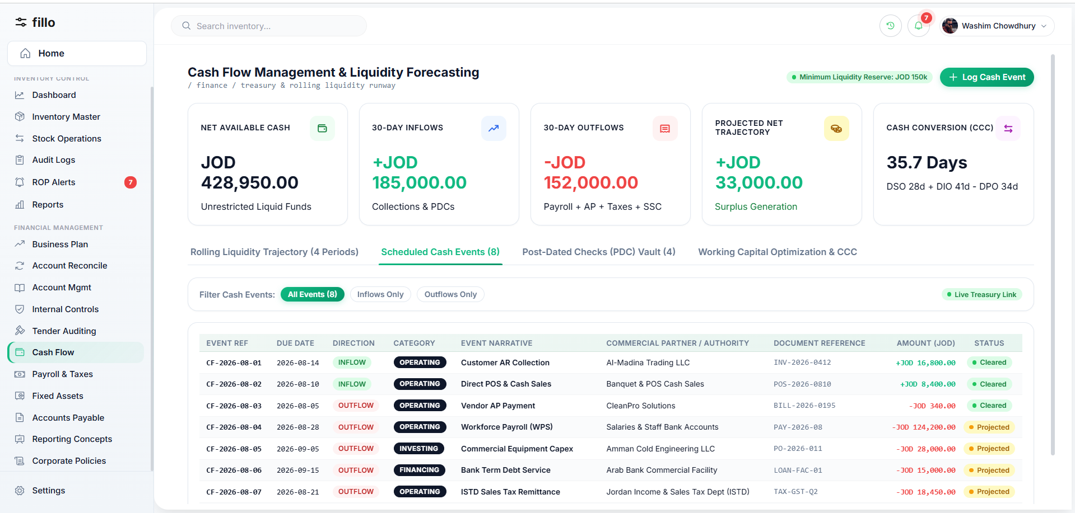
Figure 6: Cash Flow Improvement — System View
Cash flow focuses on the timing of actual cash receipts and payments. A profitable company can still face a liquidity problem if customers pay later than payroll, suppliers or taxes are due.
How It Works in Practice
STEP 1  Start with current reconciled cash balances. | STEP 2  List expected customer receipts by due date and expected payment behavior.
STEP 3  List planned outflows such as suppliers, payroll, loans, taxes and fixed expenses. | STEP 4  Build a rolling forecast and identify dates where cash may fall below the required level.
STEP 5
Take action before the shortage occurs, then update the forecast as actual receipts and payments happen.

Key Data & Documents  Bank balances, receivable aging, payable due dates, payroll schedules, loan payments, taxes and recurring obligations. | Practical Example  Sales are strong but customers pay on 90-day terms. The forecast identifies an expected JOD 8,000 payroll shortfall several weeks early, giving management time to accelerate collections or arrange funding.

7 | Social Security الضمان الاجتماعي
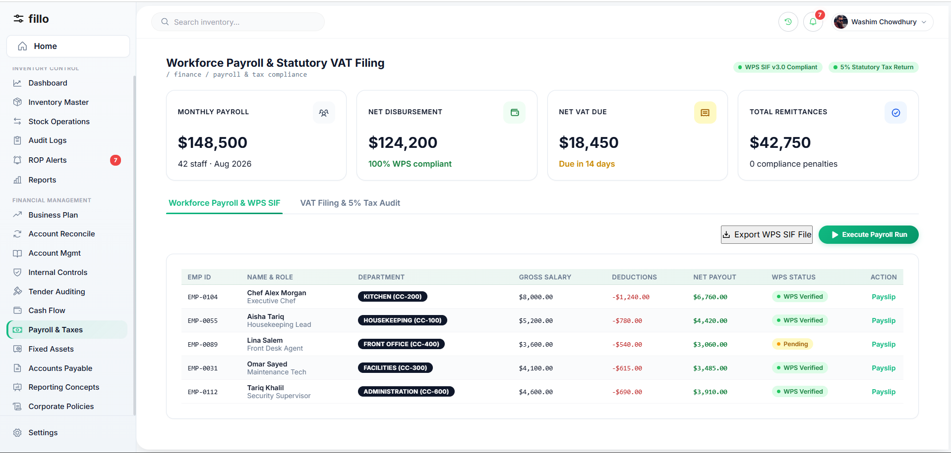
Figure 7: Social Security — System View
From the finance perspective, social security is part of payroll compliance: applicable employee contributions are deducted from pay and employer contributions are recorded as an additional company cost. Rates and eligibility rules can change and therefore must be tied to an effective rule.
How It Works in Practice
STEP 1  Determine employee eligibility and the rule applicable to the payroll period. | STEP 2  Calculate the employee contribution on the eligible salary basis.
STEP 3  Calculate the employer contribution separately. | STEP 4  Record the employee portion as a payroll deduction and the employer portion as a company expense/liability.
STEP 5
Prepare the records required for payment/reporting and retain the calculation basis.

Key Data & Documents  Employee salary and eligibility data, effective contribution rules, payroll-period calculations and contribution records. | Practical Example  During payroll, the currently approved contribution rule is applied to an eligible employee. Both the employee deduction and employer contribution are recorded with the rule version used for that period.

8 | Income Tax Preparation إعداد ضريبة الدخل
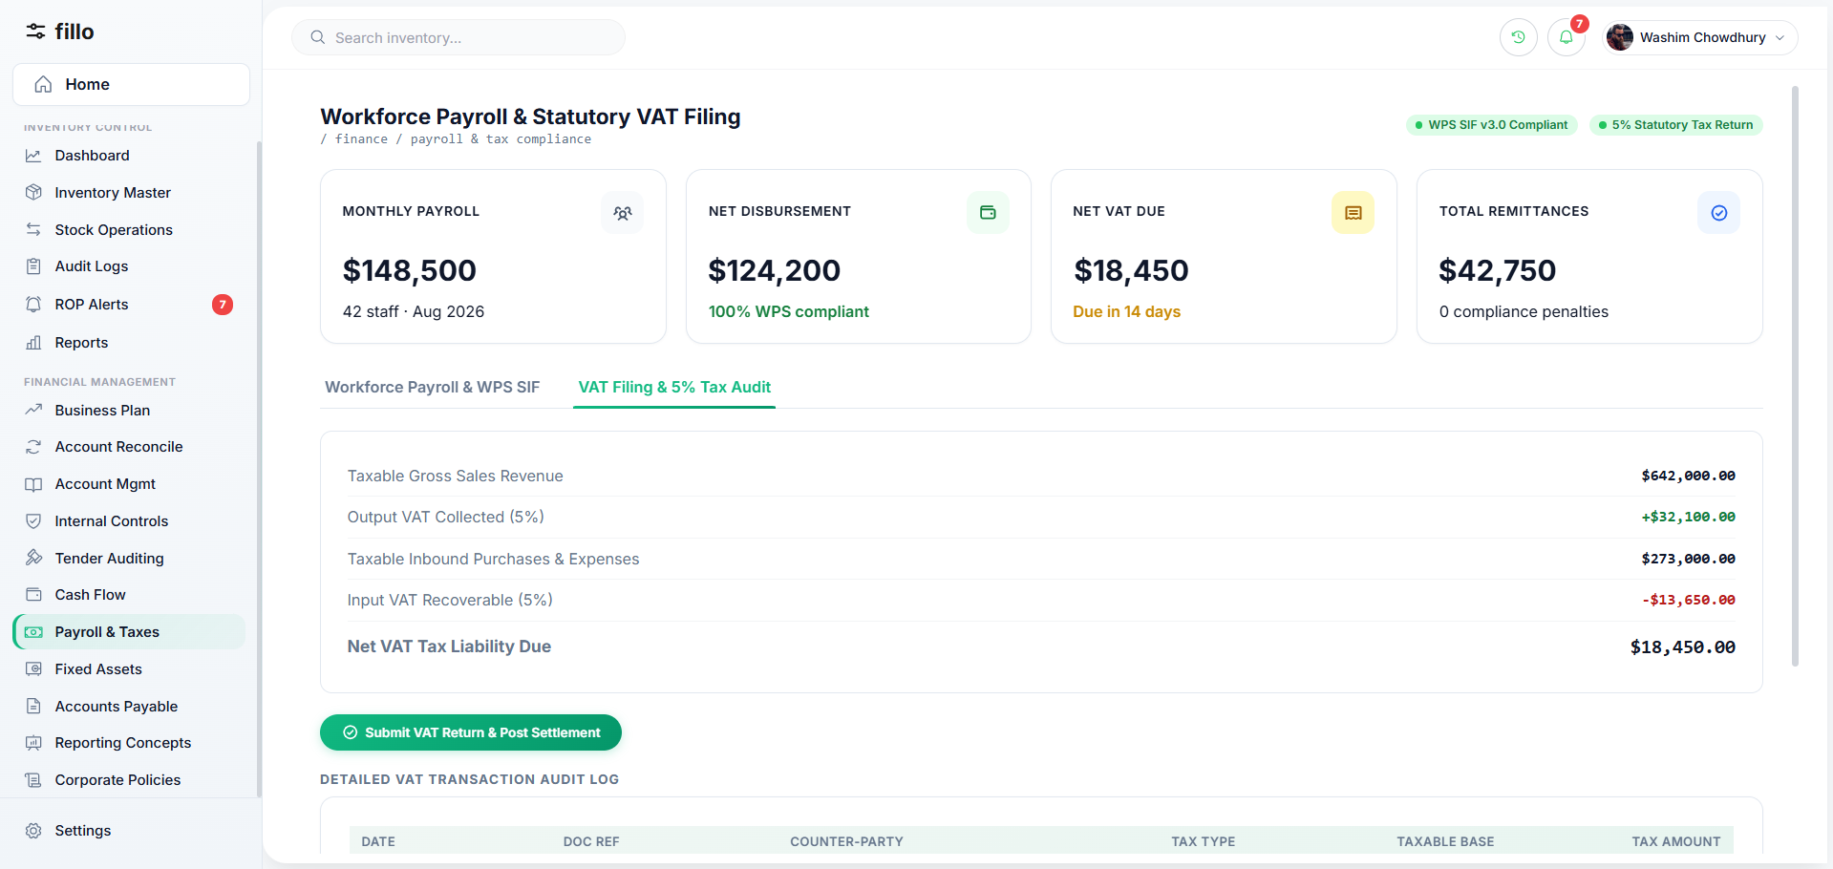
Figure 8: Income Tax Preparation — System View
Income-tax preparation organizes accounting results into the information needed to calculate and support the company's tax position. Accounting profit and taxable income can differ because some items require tax-specific treatment or adjustment.
How It Works in Practice
STEP 1  Close and review the accounting period and ensure relevant accounts are reconciled. | STEP 2  Classify revenue and expenses according to their tax treatment.
STEP 3  Identify and document required tax adjustments. | STEP 4  Apply the validated tax rules and exemptions effective for the period.
STEP 5
Calculate the tax position, review it and retain working papers supporting every adjustment.

Key Data & Documents  Reconciled revenue/expense data, tax classifications, fixed-asset/depreciation information, adjustments and the applicable rule version. | Practical Example  At year end, finance starts from accounting profit, identifies any non-deductible items or applicable exemptions, documents the adjustments and derives taxable income with a traceable working paper.

9 | Fixed Assets الأصول الثابتة
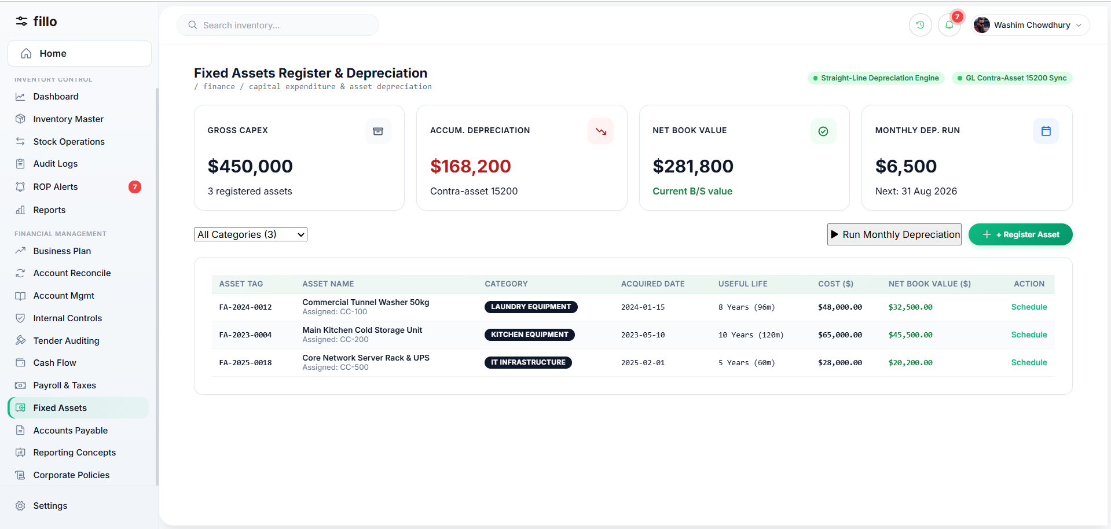
Figure 9: Fixed Assets — System View
Fixed assets are long-term resources such as equipment, vehicles and furniture. Their cost is normally allocated over their useful life through depreciation rather than treated like an ordinary short-term expense.
How It Works in Practice
STEP 1  Register the asset with cost, acquisition date, category and location/custodian. | STEP 2  Assign the approved useful life, residual value where applicable and depreciation method.
STEP 3  Calculate and record periodic depreciation. | STEP 4  Track historical cost, accumulated depreciation and carrying amount.
STEP 5
Record transfers, impairment/adjustments where applicable, and eventual disposal or retirement while preserving history.

Key Data & Documents  Asset register, purchase invoice, acquisition cost/date, useful life, depreciation method, accumulated depreciation and disposal information. | Practical Example  Equipment costing JOD 10,000 with a five-year straight-line life and no residual value produces JOD 2,000 depreciation per year. After year one, accumulated depreciation is JOD 2,000 and carrying amount is JOD 8,000.

10 | Expense Classification & Management تصنيف المصروف وإدارتها
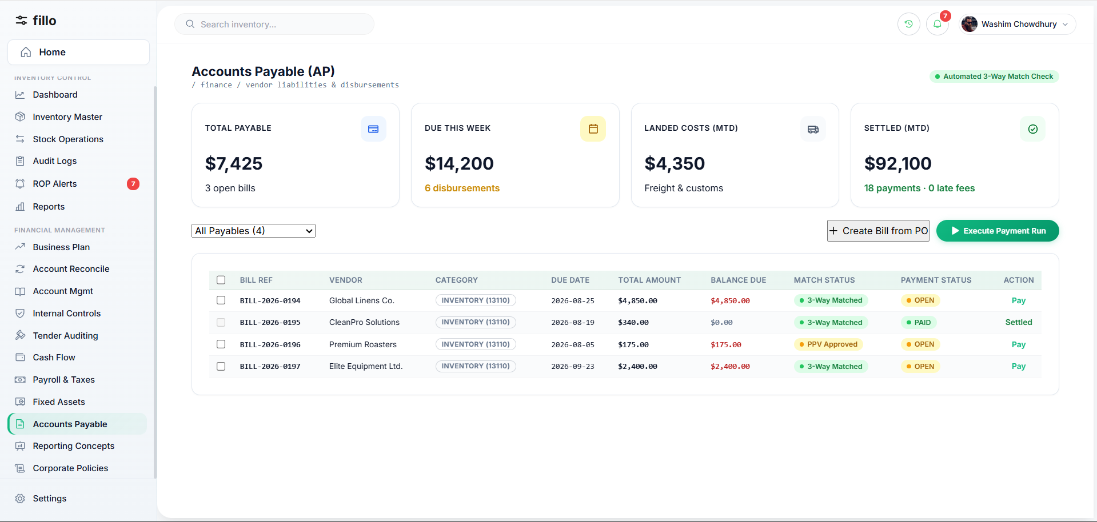
Figure 10: Expense Classification & Management — System View
Expense management captures company spending, assigns it to the correct account/category and cost center or project where relevant, verifies supporting evidence, obtains approval when required and makes the spending available for analysis.
How It Works in Practice
STEP 1  Enter or import the expense with date, amount, vendor and description. | STEP 2  Attach the invoice or receipt.
STEP 3  Classify the expense to the appropriate account/category and cost center/project where needed. | STEP 4  Route it for approval according to policy, then post the approved expense.
STEP 5
Review spending by category and period to identify trends, variances or misclassification.

Key Data & Documents  Invoices, receipts, vendor information, expense categories, cost centers/projects and approval history. | Practical Example  A JOD 500 electricity invoice is classified as Utilities Expense. At month end it is included in utilities spending and can be compared with the budget.

11 | Deduction Calculation حساب الاقتطاعات
Figure 11: Deduction Calculation — System View
Deductions are authorized amounts subtracted from gross earnings to calculate net pay. They may be statutory or company/employee-authorized and can use fixed amounts, percentages or approved formulas.
How It Works in Practice
STEP 1  Determine gross earnings for the payroll period. | STEP 2  Identify which deductions apply to the employee.
STEP 3  Calculate each deduction using the applicable rule. | STEP 4  Total deductions and calculate net pay.
STEP 5
Show a line-by-line breakdown and handle any manual exception through an authorized, documented adjustment.

Key Data & Documents  Gross earnings, deduction types, applicability, effective calculation rules and approved manual adjustments. | Practical Example  Gross earnings are JOD 1,000. If the applicable deductions total JOD 100, net pay is JOD 900. The payslip should show each deduction separately rather than only one unexplained total.

12 | Payroll Processing / Salary Issuance إصدار الرواتب
Figure 12: Payroll Processing / Salary Issuance — System View
Payroll processing converts approved employee compensation inputs into reviewed and finalized salary payments. It combines gross earnings, deductions, employer contributions, approvals, payslips and the related accounting impact.
How It Works in Practice
STEP 1  Open the payroll period and load eligible employees. | STEP 2  Collect approved salary, allowance, overtime and employee-change inputs.
STEP 3  Calculate gross pay, deductions, employer contributions and net pay. | STEP 4  Review anomalies and route the payroll run for approval.
STEP 5  After approval, finalize payment, generate payslips and post the accounting entries. | STEP 6  Lock the finalized payroll; later corrections use controlled adjustments rather than rewriting history.

Key Data & Documents  Employee master data, period-specific payroll inputs, deduction/contribution rules, calculated results and approval records. | Practical Example  An employee has JOD 1,000 basic salary plus JOD 100 allowance and JOD 150 total deductions. Net pay is JOD 950. After the payroll run is reviewed and approved, payment and payslip are generated.

13 | Monitoring Tax Exemptions & Tax Updates متابعة نزول الإعفاءات والضرائب
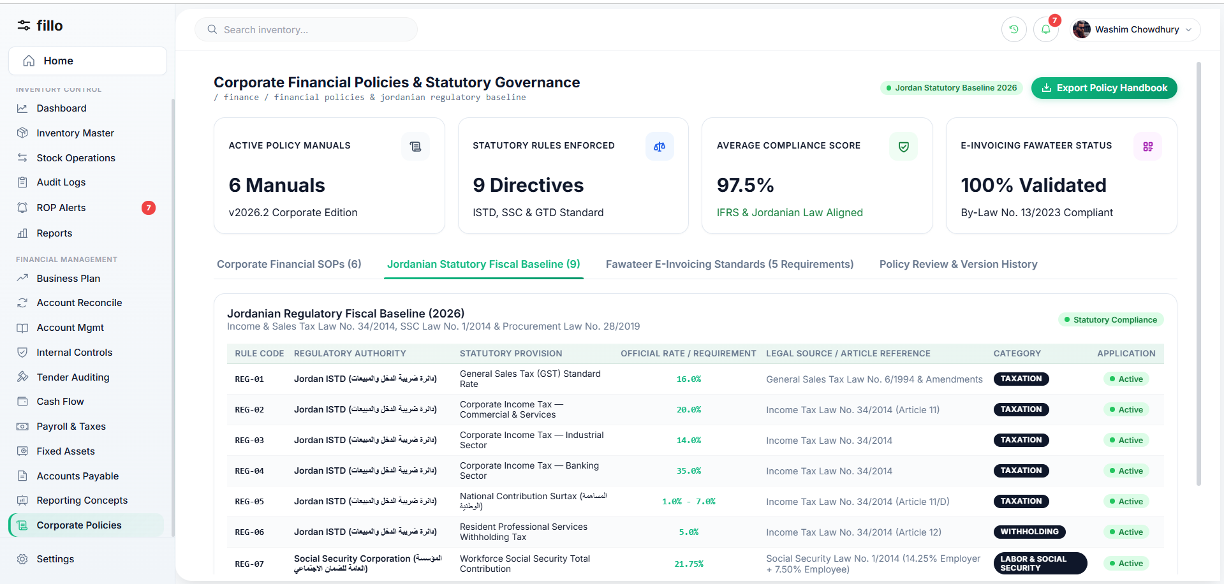
Figure 13: Monitoring Tax Exemptions & Tax Updates — System View
Tax rates, exemptions and thresholds change over time. Finance must track approved official changes and apply each rule according to its effective date while preserving the version used for historical calculations.
How It Works in Practice
STEP 1  Review applicable official updates. | STEP 2  Record the new rule, source/reference and effective date.
STEP 3  Validate and approve the change internally before use. | STEP 4  Preserve the previous rule rather than overwriting it.
STEP 5
Apply the new version only to transactions/periods for which it is effective.

Key Data & Documents  Official notices, old/new rule values, effective dates, source references and approval history. | Practical Example  An exemption threshold changes on October 1. September calculations remain linked to the old rule, while eligible October transactions automatically use the new version.

14 | Fixed Expenses المصاريف الثابتة
Figure 14: Fixed Expenses — System View
Fixed expenses are recurring costs whose amount or timing is predictable, such as rent, insurance, loan repayments and subscriptions. They form a baseline for budgeting, cash planning and variance analysis.
How It Works in Practice
STEP 1  Register each fixed-expense commitment with amount, frequency and contract reference. | STEP 2  Accrue or record the expense in the correct period, even if payment timing differs.
STEP 3  Compare actual versus budgeted fixed costs and investigate material differences. | STEP 4  Track contract renewals, escalation clauses and expiry dates.
STEP 5
Include fixed expenses in the cash-flow forecast so that their payment dates are always visible.

Key Data & Documents  Contracts, lease agreements, loan schedules, insurance policies, subscription records and approval documentation. | Practical Example  Monthly office rent of JOD 3,000 is accrued on the first of each month. Even if the landlord invoices late, the expense appears in the correct period's reports and cash forecast.

15 | Reporting Concepts التقارير
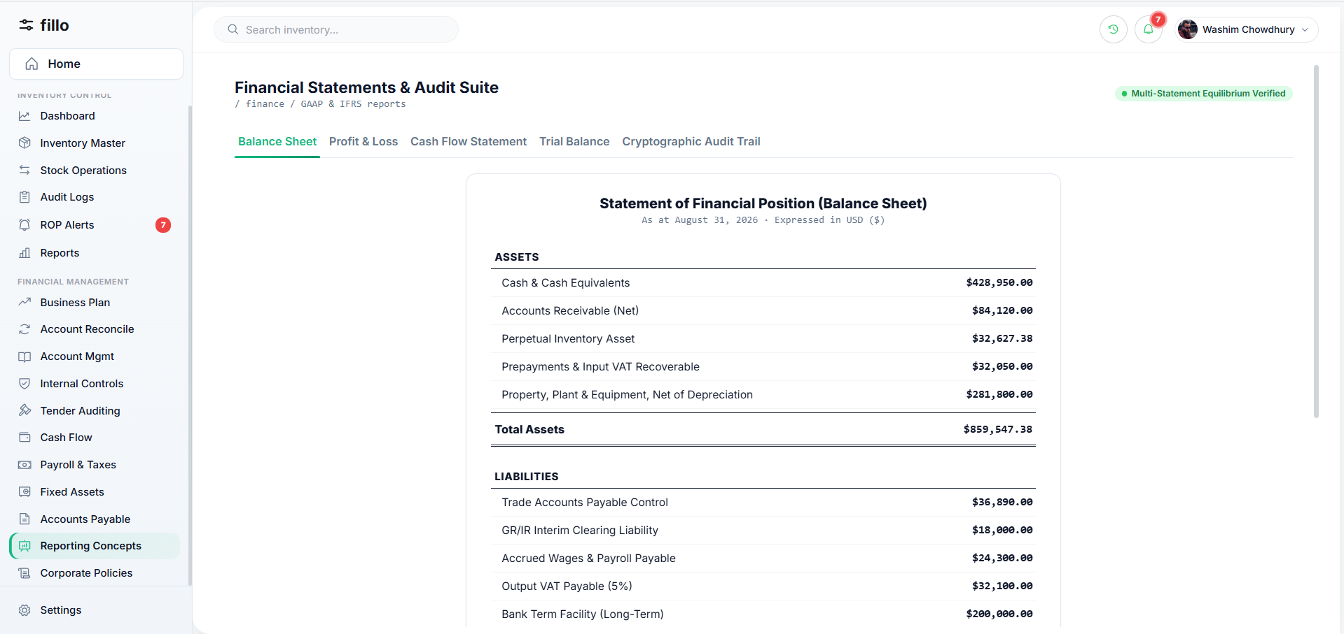
Figure 15: Reporting Concepts — System View
Financial reports summarize the company's financial position, performance and cash flow. Standard reports include the Balance Sheet, Income Statement (Profit & Loss), Cash Flow Statement and Trial Balance. They serve management, auditors and regulators.
How It Works in Practice
STEP 1  Ensure all transactions for the period are posted, reconciled and approved. | STEP 2  Generate the standard financial statements from the ledger.
STEP 3  Verify internal consistency (e.g., the Balance Sheet must balance; the Trial Balance debits must equal credits). | STEP 4  Review reports for completeness and reasonableness before distribution.
STEP 5
Distribute to authorized stakeholders and archive the period's official reports.

Key Data & Documents  General ledger, sub-ledger balances, reconciliation status, prior-period comparatives and supporting schedules. | Practical Example  At month end, the system produces a Balance Sheet showing total assets equal total liabilities plus equity, an Income Statement showing net income, and a Trial Balance where total debits equal total credits.

16 | Written Financial Policy سياسة مالية مكتوبة
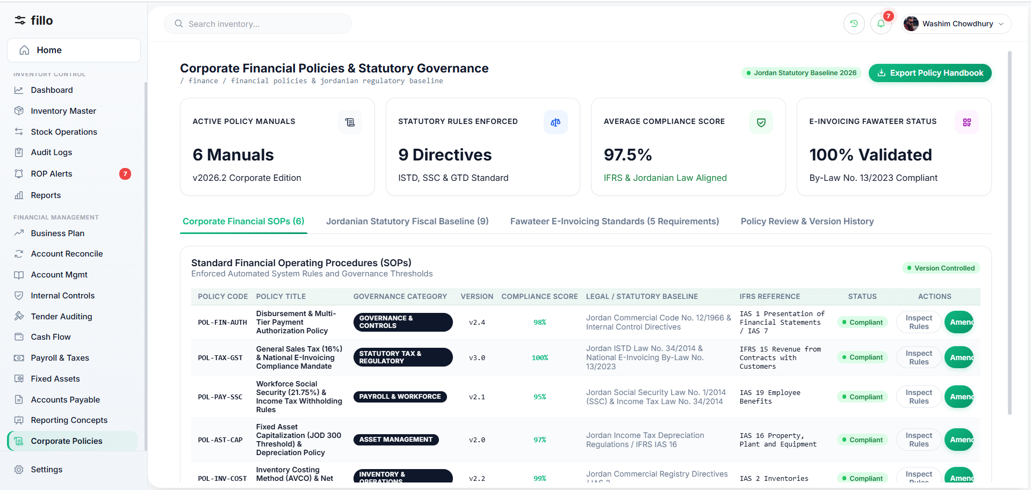
Figure 16: Written Financial Policy — System View
A written financial policy is a formal document that defines the rules, authority limits, procedures and standards that govern all financial activities. It provides the framework within which all other financial processes operate.
How It Works in Practice
STEP 1  Draft policies covering key areas: approvals, procurement, expense limits, payroll, asset management and reporting. | STEP 2  Align policies with applicable laws and regulations (e.g., Jordanian tax law, social security law, procurement law).
STEP 3  Obtain management and board approval for each policy. | STEP 4  Communicate policies to all relevant staff and incorporate them into system workflows.
STEP 5
Review and update policies periodically or when regulations change, maintaining a version history.

Key Data & Documents  Policy documents, approval records, version history, regulatory references and compliance checklists. | Practical Example  The Disbursement Policy states that any payment above JOD 1,000 requires Finance Manager sign-off and above JOD 10,000 requires dual signature of the Managing Director and CFO. The system enforces these thresholds automatically.

How the Topics Connect
The sixteen topics above are not independent tasks; they form an interconnected financial management system. The Business Plan (1) sets the targets that Budgeting and Forecasting measure against. Account Management (3) provides the Chart of Accounts structure used by every other module. Account Reconciliation (2) validates the data that feeds into Reporting (15). Internal Controls (4) govern the approval flows across all processes. Cash Flow (6) depends on Payroll (12), Fixed Expenses (14), and Accounts Payable data. Social Security (7), Income Tax (8), Deductions (11) and Tax Monitoring (13) collectively form the compliance layer. Fixed Assets (9) feeds both the Balance Sheet reports and depreciation expenses. Expense Classification (10) ensures costs are categorized correctly for all reporting. Tender Auditing (5) controls procurement spending. Finally, Written Financial Policy (16) provides the governance framework within which all other processes operate.

Closing Note & Next Step
This research document provides the foundational understanding required to write detailed software requirements for the Financial Management module. The next step is to translate each topic's processes, data elements and business rules into specific functional requirements, wireframes and acceptance criteria.

