UI/UX Usability Report
Best and Worst Practices
A Comprehensive Analysis of Usability Design
Made by / Mahmoud Awad Saad
Supervisor / Rania Hussien Ibraheem
Date: April 2026

Executive Summary
This report examines usability principles through ten real-world examples, analyzing five instances of excellent usability design and five cases of poor usability implementation. Each example demonstrates how thoughtful design decisions can enhance or hinder user experience across both digital products and physical objects.

Part 1: Examples of Good Usability

1. Shaker Bottle with Internal Mixing Ball

Context: Fitness and nutrition preparation
Usability Strengths:
- The internal plastic shaker ball (whisk ball) provides effortless powder dissolution
- Users can achieve smooth, lump-free protein shakes with minimal effort
- The design leverages mechanical agitation to solve a common user pain point
- Requires no special technique or learning curve
Design Principle: Affordance and efficiency through thoughtful mechanical design


2. Pump-Dispenser Toothpaste
Context: Daily hygiene routine
Usability Strengths:
- Eliminates product waste by dispensing precise, controlled amounts
- One-handed operation improves accessibility
- Standing design prevents mess and keeps countertops clean
- Users can extract nearly 100% of product, maximizing value
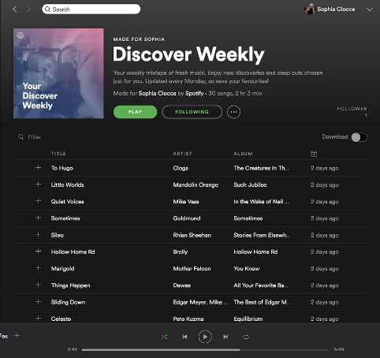
- No squeezing or rolling required
Design Principle: Precision control and waste reduction through improved dispensing mechanism

3. Spotify's Discover Weekly Playlist
Context: Music streaming and discovery platform
Usability Strengths:
- Personalized music recommendations delivered automatically every Monday
- Zero user effort required—the system learns from listening behavior
- Consistently refreshes content, preventing decision fatigue
- Low-risk exploration—users can easily skip songs they don't like
- Creates habit formation through predictable weekly delivery
Design Principle: Intelligent automation that anticipates user needs and reduces cognitive load

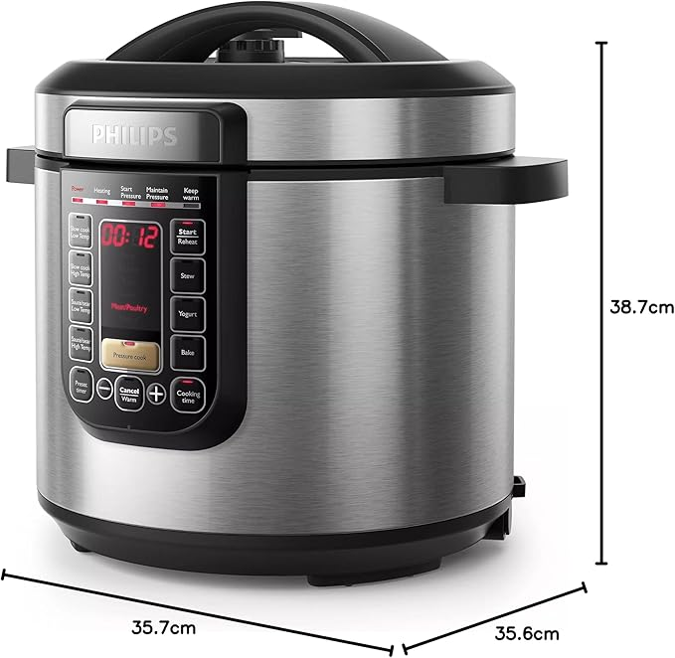
4. Instant Pot Pressure Cooker
Context: Kitchen appliance for meal preparation
Usability Strengths:
- Combines multiple cooking functions (pressure cook, slow cook, sauté, steam) in one device
- Pre-programmed settings eliminate guesswork for common dishes
- Clear digital display shows cooking mode, time, and pressure level
- Safety mechanisms prevent user error (lid won't open under pressure)
- Reduces kitchen clutter by replacing 7+ separate appliances
Design Principle: Consolidation and guided workflows that simplify complex tasks

5. Google Maps 'Share ETA' Feature
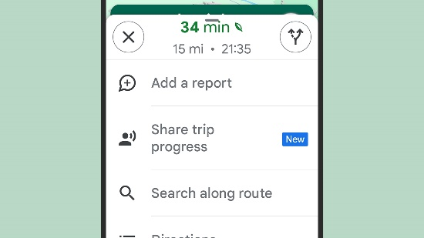
Context: Navigation and real-time location sharing
Usability Strengths:
- One-tap sharing of live location and estimated arrival time
- Automatically updates recipients as route conditions change
- Reduces need for 'Where are you?' text messages
- Works across different phone platforms
- Automatically stops sharing when destination is reached (privacy by design)
Design Principle: Proactive information sharing that reduces communication friction

Part 2: Examples of Bad Usability

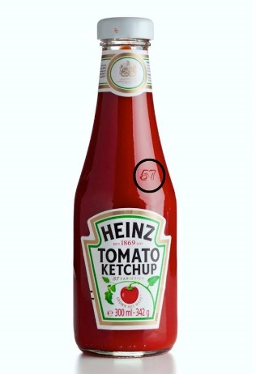
1. Ketchup Bottles with Bottom Dispensing
Context: Glass ketchup bottles in restaurants
Usability Problems:
- Product settles at the bottom, forcing users to shake or hit the bottle
- Inconsistent flow leads to either nothing or excessive dispensing
- Slippery glass surface makes gripping difficult
- Creates mess and frustration during use
- Requires learning the 'correct' technique (hitting the '57' spot)
Design Failure: Gravity-dependent design that fights natural physics and user expectations

2. Hotel Shower Controls with Unlabeled Temperature Indicators
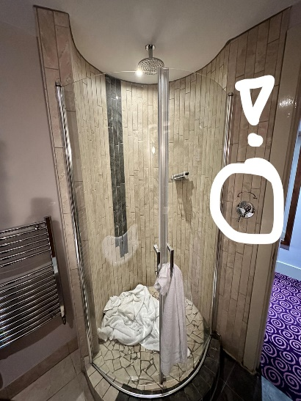
Context: Hotel bathroom fixtures
Usability Problems:
- Opaque symbols (single dots, lines, or unmarked dials) provide no clear hot/cold indication
- Users must test water temperature through trial and error
- Risk of scalding or freezing shocks
- No universal standard—every hotel uses different iconography
- Wastes water during temperature adjustment phase
Design Failure: Lack of clear signifiers and inconsistent mental models across implementations

3. LinkedIn's Notification Settings
Context: Professional social networking platform
Usability Problems:
- Notification preferences scattered across multiple settings pages
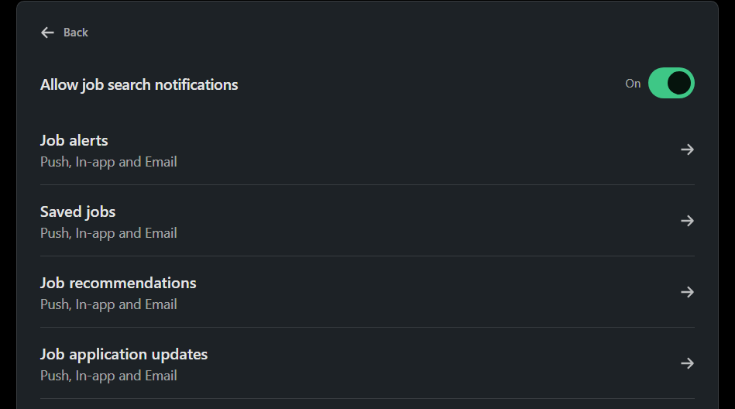
- No centralized control panel for all notification types
- Complex hierarchy: email vs. push vs. in-app notifications managed separately
- Default settings extremely aggressive, requiring extensive customization
- Changed preferences sometimes don't persist after app updates
- Users receive unwanted notifications despite opting out
Design Failure: Poor information architecture and lack of user control over communication preferences

4. USB-A Connector (Non-Reversible Design)
Context: Universal Serial Bus hardware interface
Usability Problems:
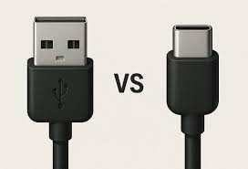
- 50/50 chance of correct insertion, but users fail 80% of the time on first attempt
- No clear visual indicator of correct orientation
- Requires flipping, sometimes multiple times, to connect
- Frustrating user experience for a daily task
- Forces users to look at connector in poor lighting conditions
Design Failure: Asymmetrical design without clear affordances (since addressed by USB-C)

5. Microsoft Windows Update Forced Restarts
Context: Operating system maintenance
Usability Problems:
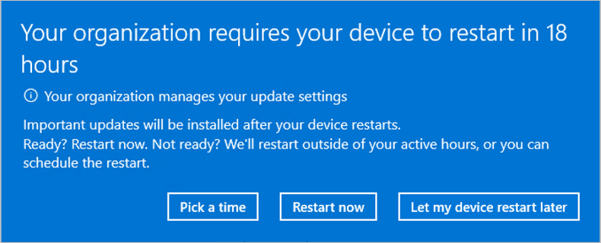
- Interrupts users during active work without adequate warning
- 'Schedule restart' option often ignored by the system
- Users lose unsaved work when forced restarts occur
- Notification fatigue leads users to dismiss legitimate warnings
- 'Active hours' setting frequently ineffective
- Creates distrust between user and operating system
Design Failure: System priorities override user agency, creating adversarial relationship

Key Takeaways

Principles of Good Usability:
- Eliminate friction in common workflows
- Provide clear feedback and status indicators
- Respect user control and preferences
- Anticipate needs through intelligent defaults
- Design for error prevention rather than error correction

Common Usability Failures:
- Unclear signifiers that require trial and error
- System-centric design that ignores user context
- Poor information architecture that scatters related controls
- Lack of feedback during critical operations
- Asymmetrical designs without visual orientation cues

Conclusion
Usability is not about adding features—it's about removing friction. The best designs become invisible, allowing users to accomplish their goals without conscious thought about the interface itself. Both digital and physical products benefit from user-centered design principles: clear signifiers, immediate feedback, error prevention, and respect for user autonomy.
The examples in this report demonstrate that good usability often stems from empathetic observation of real user behavior, while bad usability typically results from designing for systems rather than people.

