* Deutsch-Jozsa time complexity:  
   Hadamard gates on the qubits: O(n)

Measurement: O(1)

* Classical Algorithm:

Worst-case time complexity: O(2^n)

Best-case time complexity: O(1) (if early difference found)

|  |  |  |
| --- | --- | --- |
|  | Classical Algorithm | Deutsch-Jozsa Algorithm |
| Time complexity | O(2^n) | O(n) |
| Accuracy | 100% | 100% |
| Qbits used |  | 2 |

|  |  |  |
| --- | --- | --- |
|  | Classical Algorithm | Grover’s Algorithm |
| Time complexity | O(N) | O(√N) |
| Accuracy | 100% | 100% |
| Qbits used |  | 2 |

**Deutsch-Jozsa:**

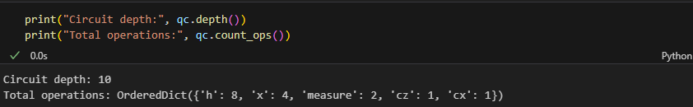**Grover's Algorithm:**

**Challenges:**

|  |  |
| --- | --- |
| Noise | Unintended changes in qubit state |
| Decoherence | Loss of quantum information over time |
| Scalability | Hard to scale beyond a few hundred qubits |
| Measurement | Requires many repeated runs for accuracy |