***Name***: ***Mahmoud Mohamed Abd Elsatar Mohamed***

***B.N: 870***

***Section: 39***

***Topic: operating systems***

*Screenshots****:***

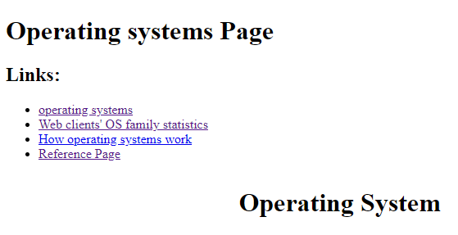

***Source code:***

