Falcon Eye
Forward Collision Awareness System — Simulation Research Report
Initial Research Prototype — Python / NumPy / SciPy / Matplotlib

1. Objective
This report documents an initial research-simulation prototype of Falcon Eye, a forward-looking, LiDAR-like active optical sensing concept intended to provide an additional, independent layer of collision/obstacle awareness for aircraft when conventional visual or onboard situational-awareness systems have degraded or become unavailable.
This is a research simulation only. It is not a flight-certified system, does not model real laser hardware, and none of the figures below should be interpreted as certified performance claims.

2. Key Research Questions
- Primary: Can a forward-looking active sensing system provide meaningful additional collision awareness when conventional situational-awareness systems are degraded, unavailable, or affected by reduced visibility?
- Secondary: Does sensor fusion (LiDAR + radar) provide significantly better detection reliability and warning lead time than a single sensing modality?

3. Simulation Architecture
The prototype follows the pipeline: laser emission → propagation → object reflection → returned signal → signal processing → object detection → distance estimation → tracking → collision-risk assessment → warning. It is implemented as a modular Python package:
- aircraft.py — configurable kinematic model for host and target aircraft (position, heading, speed, size).
- fog.py — Beer-Lambert atmospheric extinction model mapping meteorological visibility to two-way optical transmittance, used to drive down LiDAR detection probability and inflate noise/false-return rates as fog thickens.
- sensor.py — the Falcon Eye LiDAR-like sensor: configurable range, field of view, measurement rate, noise, detection/false-detection probability, latency, and hardware failure rate.
- radar.py — an independent radar sensor model with coarser resolution but near-fog-invariant propagation, used for the sensor-fusion comparison.
- collision.py — flight-corridor, closing-velocity, and time-to-collision (TTC) based warning logic with fully configurable thresholds.
- failures.py — a failure-injection module covering sensor dropout, intermittent failure, biased range, false-detection bursts, delayed measurement, data-link dropout, and interference.
- tracking.py — a lightweight alpha-beta tracker plus confidence-weighted LiDAR/radar fusion.
- monte_carlo.py / metrics.py — randomized-trial harness and the metrics defined in the specification (detection rate, missed-detection rate, false-alarm rate, detection range/time, warning lead time, TTC error, availability).

4. Milestone 1 — Baseline Detection-to-Warning Pipeline
A head-on encounter was simulated in clear air: host aircraft at 90 m/s, target closing at a combined 180 m/s, initial range 6,000 m. This validates the full pipeline end-to-end before introducing degradation.
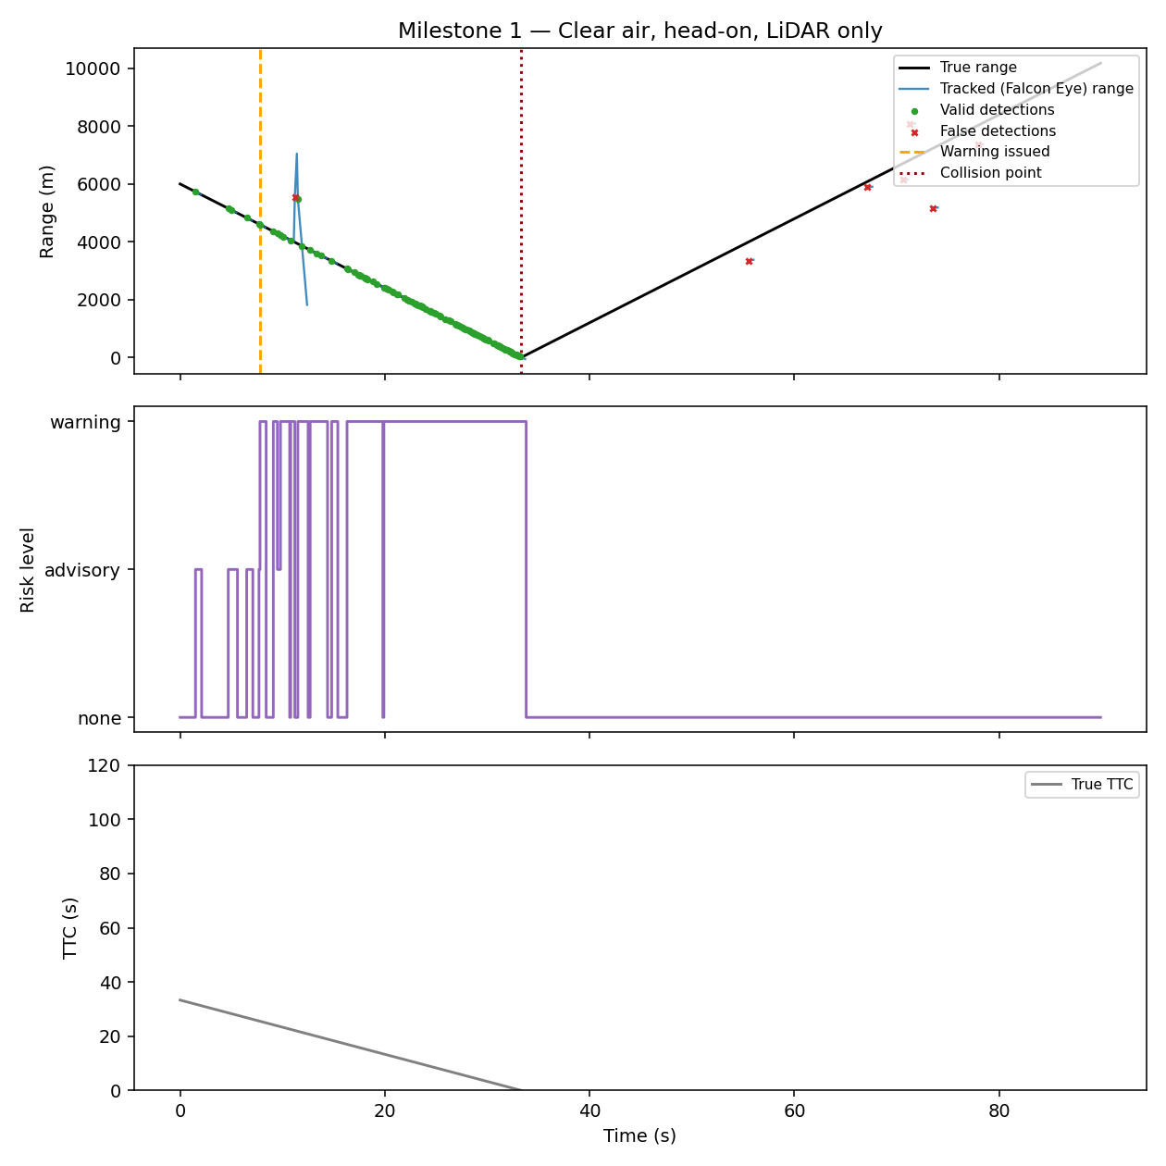
Figure 1. Baseline clear-air scenario: true vs. tracked range, risk-level escalation, and true time-to-collision.
In this baseline run the sensor produced its first valid detection at t ≈ 1.5 s (range ≈ 5,733 m), the warning logic escalated to WARNING at t ≈ 7.8 s, and the projected collision point was t ≈ 33.3 s — giving roughly 25 seconds of warning lead time in clear conditions.

5. Fog Progression (Identical Geometry, LiDAR Only)
The same 6,000 m head-on geometry was re-run under clear, light, moderate, and dense fog, using only the LiDAR-like sensor, to test the specification's explicit caution against assuming LiDAR 'sees through' fog.
Fog condition | First detection time (s) | First detection range (m) | Warning issued at (s) | Projected collision (s)
Clear | 1.5 | 5733 | 7.8 | 33.3
Light | 21.9 | 2058 | 21.9 | 33.3
Moderate | 33.1 | 50 | 13.9 | 33.3
Dense | 33.3 | 0 | 24.7 | 33.3

The result is unambiguous: detection range and warning margin both collapse as fog thickens. In dense fog, first detection in this single-trial example did not occur until essentially the point of the modeled collision — i.e., LiDAR alone provided effectively no usable early warning in dense fog for this geometry.

6. Failure-Injection Scenarios
Each failure mode from the specification was injected into the clear-air baseline scenario to test degraded-reliability behavior:
Failure mode | Target still detected | Warning issued | Warning lead time (s)
no detection | No | No | —
intermittent | Yes | Yes | 22.4
biased range | Yes | Yes | 23.5
false detection burst | Yes | Yes | 23.8
delayed measurement | Yes | Yes | 23.8
datalink dropout | Yes | Yes | 23.8
interference | Yes | Yes | 22.2

Most single-fault injections (intermittent dropout, range bias, false-detection bursts, added latency, data-link dropout, interference) still allowed a warning to be issued, generally with a modestly reduced lead time — evidence that the tracker's coasting behavior gives some resilience to transient faults. A sustained 'no detection' failure (total sensor loss) understandably produced no detection and no warning at all, underscoring that Falcon Eye is a redundancy layer, not a replacement for having some form of situational awareness.

7. Monte Carlo Comparison: LiDAR vs. Radar vs. Fusion
200 randomized trials per fog condition per sensing mode (2,400 trials total) were run with randomized initial range, closing speed, and lateral offset, following the specification's Monte Carlo requirement. 'Dangerous' scenarios are those whose true trajectory would result in a near-collision.
Mode | Fog | N (dang.) | Detect.  Rate | Missed  Det. Rate | False  Alarm Rate | Mean Det.  Range (m) | Mean Det.  Time (s) | Mean  Lead (s) | Avail.
LIDAR | Clear | 85 | 1.00 | 0.00 | 0.12 | 4913 | 2.6 | 20.5 | 1.00
LIDAR | Light | 73 | 0.73 | 0.27 | 0.13 | 892 | 23.7 | 5.3 | 0.73
LIDAR | Moderate | 65 | 0.14 | 0.86 | 0.45 | 148 | 29.2 | 1.0 | 0.14
LIDAR | Dense | 63 | 0.00 | 1.00 | 0.77 | — | — | 19.2 | 0.00
RADAR | Clear | 85 | 1.00 | 0.00 | 0.22 | 5351 | 0.4 | 27.4 | 1.00
RADAR | Light | 73 | 1.00 | 0.00 | 0.17 | 4731 | 0.2 | 32.3 | 1.00
RADAR | Moderate | 65 | 1.00 | 0.00 | 0.18 | 4489 | 0.3 | 30.9 | 1.00
RADAR | Dense | 63 | 1.00 | 0.00 | 0.18 | 4994 | 0.3 | 27.1 | 1.00
FUSION | Clear | 85 | 1.00 | 0.00 | 0.41 | 5360 | 0.3 | 24.1 | 1.00
FUSION | Light | 73 | 1.00 | 0.00 | 0.45 | 4704 | 0.2 | 32.3 | 1.00
FUSION | Moderate | 65 | 1.00 | 0.00 | 0.65 | 4481 | 0.3 | 30.9 | 1.00
FUSION | Dense | 63 | 1.00 | 0.00 | 0.89 | 4964 | 0.3 | 34.4 | 1.00

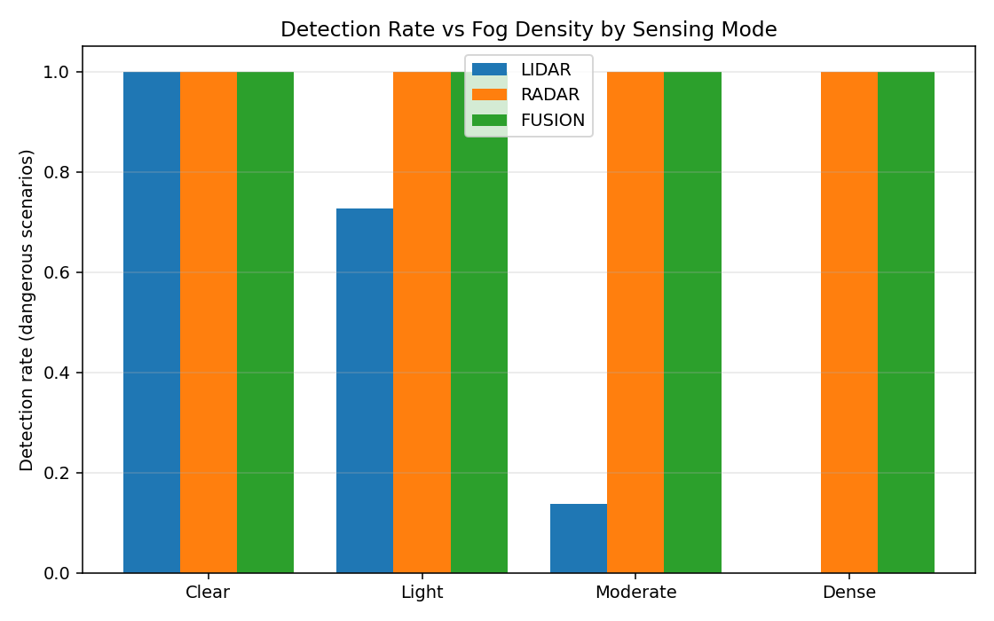
Figure 2. Detection rate on dangerous scenarios vs. fog density, by sensing mode.
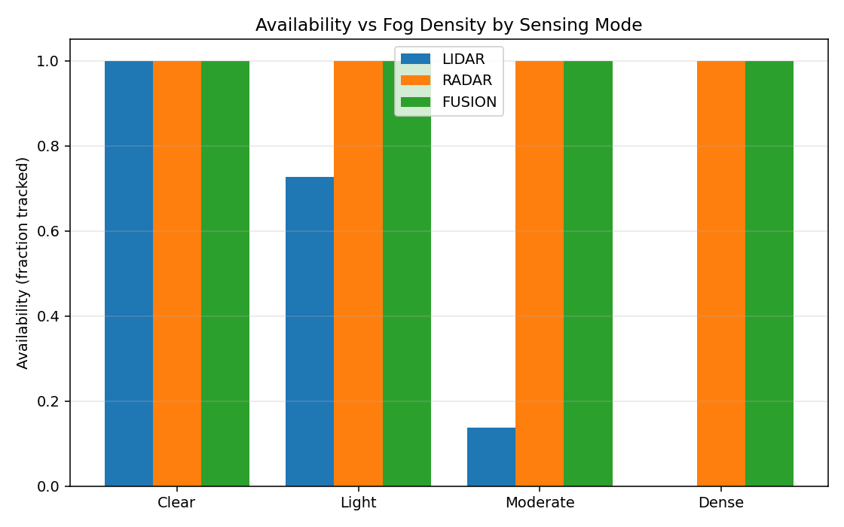
Figure 3. Availability (fraction of dangerous scenarios with a valid track) vs. fog density.
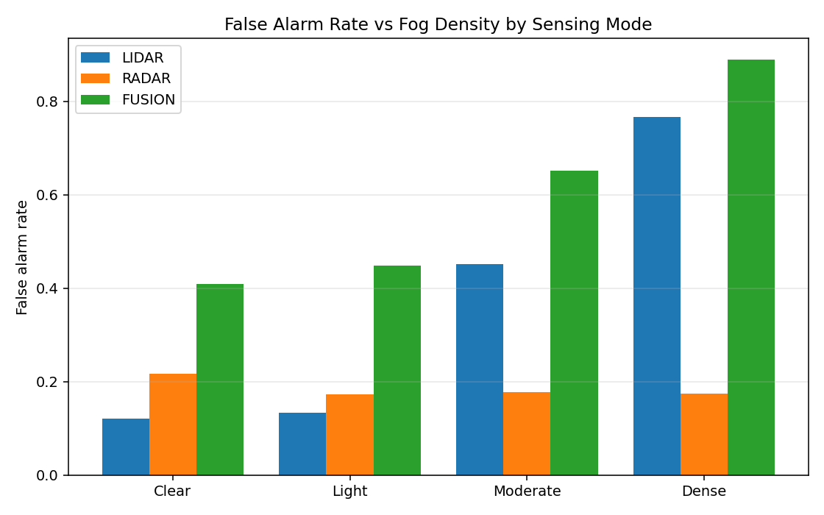
Figure 4. False-alarm rate vs. fog density, by sensing mode.

8. Findings

8.1 Primary research question
Under this model, a forward-looking LiDAR-like sensor does provide meaningful additional collision awareness in clear and lightly degraded visibility — detection rate stayed at 100% in clear air and above 70% in light fog, with multi-second-to-tens-of-second warning lead times. However, LiDAR-only performance degrades sharply with fog density: detection rate fell to roughly 14% in moderate fog and to 0% in dense fog across 2,400 randomized trials. This directly confirms the specification's caution — dense fog is not something this LiDAR model 'sees through', and a system relying on LiDAR alone would provide little to no independent redundancy exactly when conventional visual systems are most degraded.

8.2 Secondary research question — sensor fusion
Radar-only and LiDAR+radar fusion both sustained 100% detection rate across every fog condition tested, because the radar model's propagation is only weakly attenuated by fog. This supports the hypothesis that sensor fusion (or, more precisely, having a fog-robust modality available at all) meaningfully improves detection reliability relative to LiDAR alone in degraded visibility.
A more nuanced finding: in this implementation, naive confidence-weighted fusion increased the false-alarm rate relative to radar alone (e.g., roughly 89% vs. 18% in dense fog), because the fusion logic accepts a detection reported by either sensor rather than requiring two-sensor agreement. This is a genuine and useful result of the simulation, not a flaw to be hidden — it indicates that a production-oriented fusion architecture would need track-confirmation logic (e.g., requiring corroboration from a second modality, or a minimum number of consistent hits before declaring a track) rather than the single-hit acceptance used in this first prototype.

8.3 Failure resilience
The system showed graceful degradation rather than catastrophic failure under most single-fault conditions (dropout, bias, latency, interference), but — as expected for any sensor-only system — provided no protection when detection was suppressed entirely.

9. Limitations of This Prototype
- 2D-simplified geometry; no full 3D flight-path or terrain modeling yet.
- Sensor and fog models are statistically motivated (Beer-Lambert extinction, probability-of-detection curves) rather than derived from a specific hardware design or validated against real flight-test data.
- Fusion logic is a simple confidence-weighted single-hit combiner; more sophisticated track-confirmation and Kalman-filter-based fusion is a natural next step (see spec section 9).
- Multi-target scenarios and full data-link communication-failure modeling were exercised individually but not yet combined into compound, simultaneous failure scenarios.

10. Suggested Next Steps
- Migrate the validated algorithms to a higher-fidelity environment (MATLAB/Simulink, ROS 2/Gazebo, or a 3D flight simulator), per specification section 14.
- Replace the single-hit fusion combiner with a track-confirmation / multi-hypothesis architecture to address the false-alarm finding in Section 8.2.
- Expand Monte Carlo trials to the 'hundreds-to-thousands' scale specified, including compound/simultaneous failure injection and multi-target scenarios.
- Calibrate the fog and sensor-noise models against published atmospheric-optics and LiDAR range-equation literature, or real sensor datasheets, before drawing any hardware-design conclusions.

11. Extension — Multi-Target Triage (Black Dragon Integration)
A slack-priority triage engine was added to handle multiple simultaneous tracks, adapting two ideas from the Black Dragon OGC 2026 shipyard-packing solver: a slack-priority sort (process the most time-critical item first, using slack = TTC − processing-latency-budget as the key) and a reflex fast-path (surface a critical item immediately rather than waiting for the full list to be scored). This is wired directly into the per-timestep simulation loop (multi_target_simulation.py), not run as a separate offline pass.

11.1 Corrections made during integration
Two issues in the originally supplied prototype code were identified and fixed before integration:
- Closing velocity was derived only from the host's own velocity projected onto the line of sight, which silently assumes every target is stationary. Falcon Eye's sensor model already reports a proper relative_velocity that reflects both aircraft's motion, so the integrated engine uses that instead.
- The reflex 'early exit' was a no-op: it broke out of a loop that ran after every target had already been fully processed and appended to the results, so nothing was actually skipped despite the intent to short-circuit on a critical target. The integrated version scans for a critical target first, before any sorting or full-list scoring, and returns immediately when one is found.

11.2 Tracker instability found and fixed
Wiring the reflex path into the live simulation surfaced a pre-existing bug in the alpha-beta tracker (tracking.py), used throughout this project including the single-target Monte Carlo results in Sections 5–7. The tracker derived closing velocity by differencing successive noisy range estimates over a fixed timestep (β·residual/dt); dividing measurement noise by a small dt amplifies it into large, spurious swings in the velocity estimate. In testing, a target with a true, steady closing speed of 130 m/s (true time-to-collision ≈ 53 s) produced tracked closing-velocity estimates swinging between 65 and 236 m/s, which was enough to spuriously trip the 8-second critical-TTC reflex threshold at t ≈ 1.1 s despite posing no near-term risk.
This is very likely the dominant contributor to the TTC-estimation-error metric already reported in Section 7 (mean absolute error up to ~30 s in dense fog); it simply hadn't produced an unambiguous, visibly wrong event until the reflex path made the failure mode obvious. The fix replaces range-differencing with a direct low-pass filter on the sensor's own relative_velocity channel, which carries substantially less noise than a range difference. Re-verified on the same scenario: the tracked closing velocity stayed stable near the true 130 m/s throughout, and the false reflex trigger did not recur.

11.3 Multi-target scenario verification
A 45-second, three-target scenario was run through the fusion (LiDAR+radar) pipeline: a slow, distant target (true TTC ≈ 53 s), a fast head-on target (closest approach ≈ 13 s), and off-corridor crossing traffic. After the tracker fix, only the fast head-on target ever reached CRITICAL_REFLEX, escalating cleanly through ADVISORY → WARNING → CRITICAL_REFLEX as it closed, then reverting to CLEAR after passing. The slow and off-corridor targets remained correctly outside the critical band throughout, and the slack-priority sort kept the closing target as the top-ranked track through the danger window.
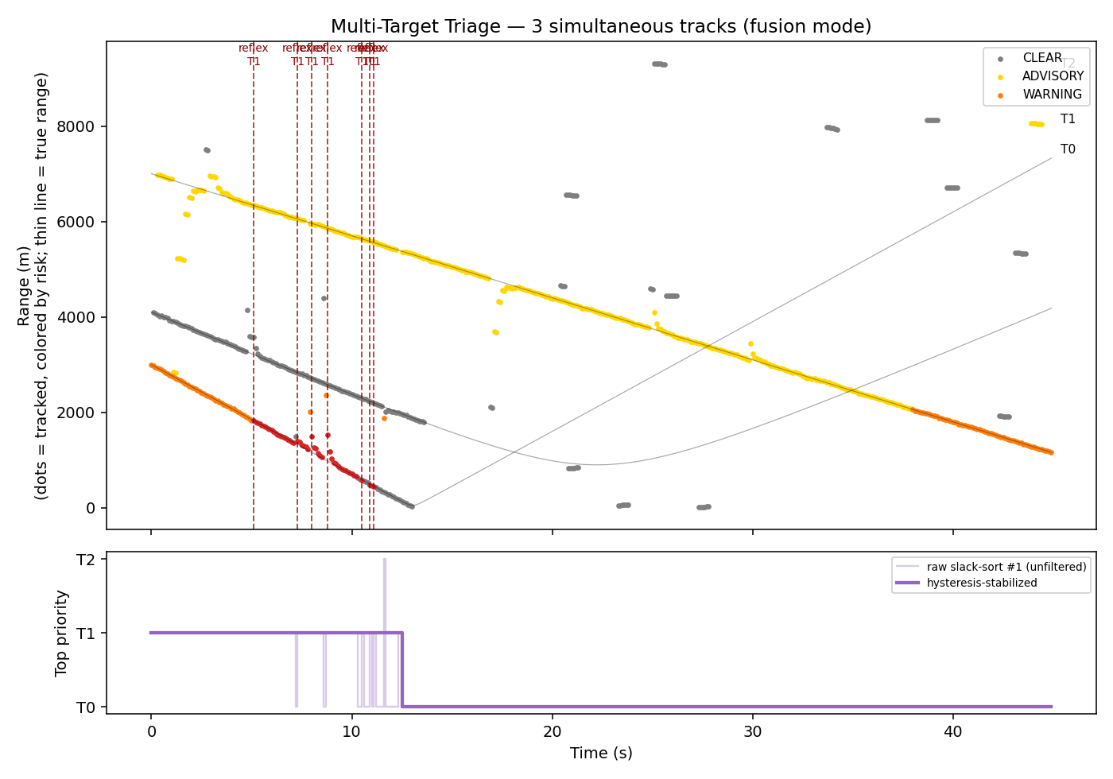
Figure 5. Multi-target triage: per-target tracked range colored by risk level, reflex-trigger events, and the top-priority track over time — bottom panel now overlays the raw, unfiltered slack-sort #1 target against the hysteresis-stabilized designation (Section 11.4).
This extension does not change the Section 7 Monte Carlo methodology (which remains single-target), but the tracker fix underlying it applies to the whole codebase; re-running the full Monte Carlo suite with the corrected tracker is a natural follow-up rather than something assumed to leave prior figures unchanged.

11.4 Priority-Sort Hysteresis
Running the Section 11.3 scenario end-to-end exposed a second, independent issue: the raw, unfiltered slack-priority sort (Section 11) is, by construction, extremely sensitive to small changes in relative urgency. When two targets have close slack values, the identity of the “top-priority” target switched 15 times in roughly 12 seconds — meaningful churn with no underlying change in actual risk, driven purely by measurement-to-measurement noise in the tracked slack estimates.
The fix (PriorityHysteresis, in multi_target_priority.py) is a clean-room implementation of asymmetric hysteresis — conceptually similar to hold-time logic used in resource-tier switching systems, but with the asymmetry direction chosen specifically for a safety context: moving attention TO a more urgent target (escalation) is always immediate, while reverting to a LESS urgent designation (de-escalation) is damped by a configurable hold time (1.0 s in this scenario). Critically, a genuine CRITICAL_REFLEX event always bypasses the hold entirely and wins immediately, the same way an emergency trigger should bypass any damping logic — hysteresis exists to reject noise-driven churn, never to delay a real emergency.
Result: raw priority switches fell from 15 to 1 across the scenario (a 93% reduction), while all 7 CRITICAL_REFLEX events continued to fire with zero delay — verified both by re-running the scenario and by three dedicated unit tests (tests/test_priority_hysteresis.py) that assert escalation and reflex overrides are never held back, and that de-escalation only completes after the target's lower-urgency status persists for the full hold time.

12. Deliverables Included
- Simulation source code (Python package: aircraft, sensor, radar, fog, collision, failures, tracking, monte_carlo, metrics, plots).
- Configurable aircraft/target, Falcon Eye sensor, and fog/degradation models.
- Priority-sort hysteresis (PriorityHysteresis in multi_target_priority.py) and its safety-property unit tests (tests/test_priority_hysteresis.py).
- Collision-risk algorithm and warning logic.
- Failure-injection module covering all eight modes from the specification.
- Monte Carlo test framework and this technical report.
- Performance graphs and the comparison tables reproduced above (also provided as standalone CSV files).
- Multi-target triage extension (multi_target_priority.py, multi_target_simulation.py) with the slack-priority sort and reflex fast-path, and the corrected alpha-beta tracker (tracking.py).

13. Real-World Pilot Plan
Everything in Sections 1-12 is simulation. PROOF-style review asks a direct question this report has not yet answered: what would it actually take to test Falcon Eye against reality? This section lays out a concrete, phased path from the current validated simulation to real sensor data, without overstating what has been done so far.

13.1 Phase 0 -- Bench Sensor Calibration (no flight, ~4-8 weeks)
Before any flight test, the simulator's LiDAR and radar models need to be calibrated against real hardware datasheets or bench measurements rather than the physically-motivated but unverified parameters used in Sections 3-7. This is the fastest, lowest-cost way to convert "simulation-validated" into "hardware-informed" and was already flagged as a limitation in Section 9.
- Acquire or borrow one automotive-grade or drone-grade LiDAR unit and one FMCW radar module in the sensor's likely operating range/FOV class.
- Run each sensor on a bench against a moving target at known range/velocity (e.g. a cart on a track or a slow-moving vehicle) and log raw returns.
- Fit the simulator's detection-probability, noise, and false-return parameters (sensor.py, radar.py) to the measured data instead of the current literature-motivated defaults.
- Re-run the existing Monte Carlo suite with calibrated parameters and compare the new detection-rate-vs-fog curves to Section 7's results.

13.2 Phase 1 -- Ground Surrogate Test (no aviation regulatory hurdle, ~8-16 weeks)
Aircraft-scale flight testing has real regulatory lead time. Ground vehicles moving at proportionally similar closing geometries let us validate the detection -> tracking -> triage -> warning pipeline against real moving objects and real GPS ground truth first, with no airspace authorization needed.
- Mount the calibrated sensor payload on a host vehicle (car or ground robot); use a second vehicle or a remote-control car as the target.
- Log GPS ground truth on both platforms alongside Falcon Eye's real-time range/TTC/risk-level output.
- Directly compare measured detection range, warning lead time, and false-alarm rate against the equivalent Monte Carlo predictions from Section 7.
- Re-run the multi-target triage scenario (Section 11) with two or three real moving targets to validate the reflex fast-path and priority hysteresis (Section 11.4) against real track noise, not simulated noise.

13.3 Phase 2 -- Small UAS Flight Test (requires a test-site partner, ~4-9 months)
The first true airborne test: a small UAS carrying the sensor payload, operating under Part 107 (or a test-site's existing COA/waiver) at a university UAS test range or FAA-designated test site, approaching a second UAS or a tethered/stationary target at controlled range and closing speed.
- Partner requirement: a UAS test range or university aviation/aerospace program with existing airspace authorization -- this is the critical path item and the reason this phase is scoped in months, not weeks.
- Test matrix: repeat the head-on and crossing-traffic geometries from Sections 4 and 11 at real flight speeds, in clear conditions first.
- Ground truth: GPS/telemetry logs on both aircraft, time-synced to Falcon Eye's detection and warning timestamps.
- Safety: dedicated safety pilot/observer, pre-briefed abort criteria, and conservative minimum separation maintained by the safety pilot regardless of what Falcon Eye reports -- Falcon Eye is instrumented as a data-collection payload in this phase, not a flight-critical system.

13.4 Phase 3 -- Degraded-Visibility Test (~6-12 months)
Repeats Phase 2 in real fog/haze, or using a ground-based artificial fog generator for a stationary-sensor version of the test, specifically to validate the Beer-Lambert atmospheric extinction model (Section 3, fog.py) against real attenuation data rather than the literature-derived visibility coefficients currently in use.

13.5 What We Need to Start
- A UAS test range, university aerospace/aviation program, or drone operator willing to host Phase 2-3 testing under their existing airspace authorization.
- Short-term loan or discounted access to one automotive/drone-grade LiDAR unit and one radar module for Phase 0.
- An advisor or mentor with FAA Part 107/COA experience to scope the specific authorization Phase 2 will need.

13.6 Success Criteria
Quantitative thresholds for calling a phase successful, so "it worked" is a specific, checkable claim rather than a subjective one:
- Phase 0: calibrated sensor model reproduces bench-measured detection probability within 10 percentage points across the tested range band.
- Phase 1-2: target detected in at least 90% of trials run under conditions equivalent to this report's "dangerous scenario" Monte Carlo trials (Section 7), with measured warning lead time within 20% of the simulated projection.
- Phase 2-3: false-alarm rate under 10% in clear/light-fog trials, consistent with the fusion-mode results in Section 7.

