

License path & KYC framework

BuyOut is:
- Aggregating debts
- Showing refinance offers
- Facilitating loan buyout
- Potentially enabling application submission
BuyOut is:
- Credit broker
- Loan comparison / referral platform
- Debt advisory / restructuring facilitator
- Refinance marketplace
- Possibly payment facilitator | Do we handle flows?

Segments

Segments | Action needed | What is required? | Why?
Salaried Expat | - See (Debts, loans etc.)  - Decide (BuyOut recommendation)  - Switch (Offers acceptance)  - Track (New loans performance) | - Open banking access  - Access Credit score  - Provide extra required documents (Salary doc etc…)  - Digital signature for new refinance loans | - To provide debt dashboard  - To List debts  - To offer refinance options  - To track loans performance
Emirati Government Employee
BNPL User
Credit Score Repair
Ethically Conscious Muslim

UAE KYC framework
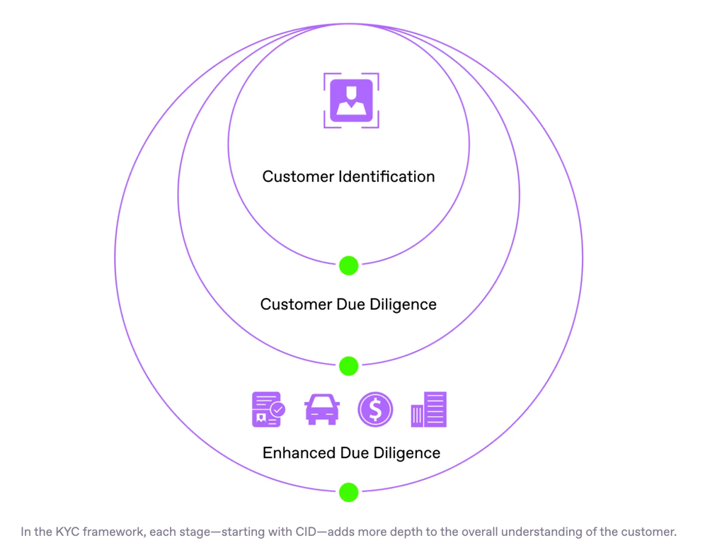

- Customer Identification Program (CIP): Verifying the customer's identity using official documents. (Stage 1)
- Customer Due Diligence (CDD): Gathering information to understand the customer's activities and assess risk. (Stage 1)
- Enhanced Due Diligence (EDD): Applying additional scrutiny for higher-risk customers or transactions. (Stage 2)

Minimum KYC Required | Phase 1 – Marketplace Model
We conduct the following actions:
- Collect users’ data (Name, phone number, employer, address, etc…)
- Show refinance offers (Bank A offers this refinance loan with these terms and rates)
- Submit applications to banks (Sharia-compliant contracts to be created and submitted to the partnered lender)
- We don’t handle cash or monthly payment at this stage
Based on the regulatory framework we need:

Customer Identification program (Basic digital KYC, Primary, secondary KYC)
Why?
- Prevent identity fraud
- Meet AML standards
- Satisfy lender requirements

Required Data:
- Emirates ID (front & back) (KYC provider, digital) – Primary
- Passport copy (for expats) (Can eliminate if Emirates ID is provided) – Secondary
- Mobile OTP verification – Primary
- Email verification – Secondary
- Facial liveness check (recommended) – Primary
- Date of birth – (from Emirates ID) Primary
- Nationality – (From Emirates ID) Primary
- Residential address – (From Emirates ID) Primary

Customer Identification program
Primary | Emirates ID | Mobile OTP | Facial liveness | Date of birth | Nationality | Residential address
Secondary | Passport copy | Email verification

PEP & Sanctions Screening (AML)

Do we Need Full AML Program?
Yes — but lighter than banks.
We need:
- AML policy
- MLRO (Money Laundering Reporting Officer) (Verify)
- Suspicious activity reporting framework
- Record keeping (5 years typical)
What needs to be implemented:
- UAE sanction lists
- UN sanctions
- Politically exposed persons (PEPs)
Because:
We are facilitating financial services.
This can be done via:
- Third-party AML provider (D&B UAE, ASC Global UAE, IQ-EQ, Uqudo)
- API screening
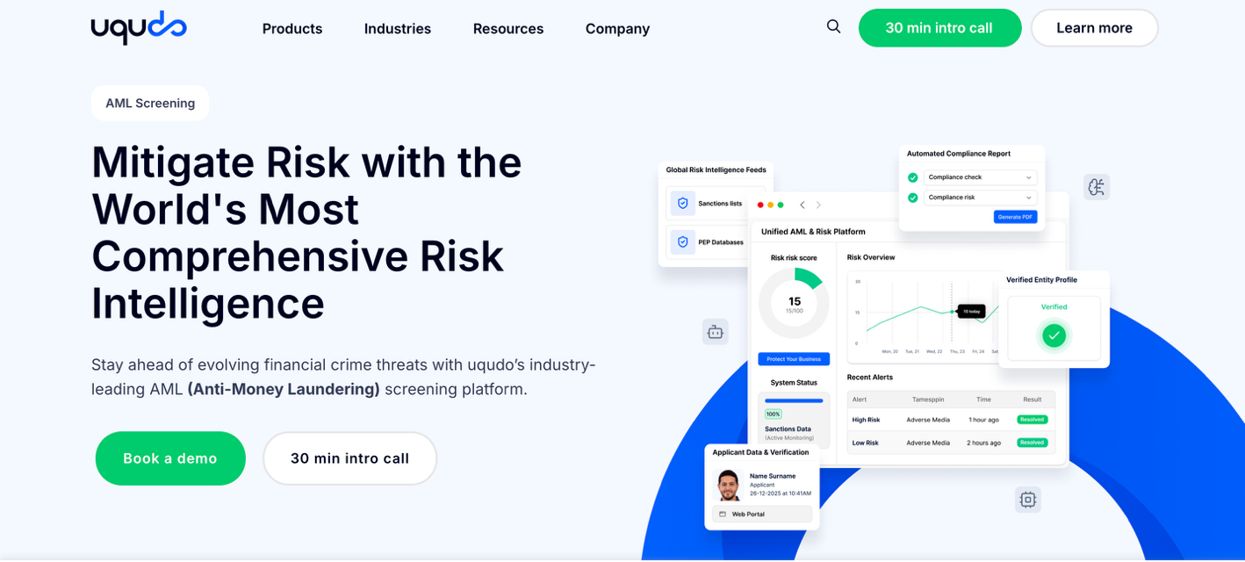

Basic Risk Scoring
Why?
Banks will not accept incomplete or risky profiles.
Risk scoring elements:
- Income range
- Employer
- Debt-to-income estimate
- Existing liabilities
This can be done through Open finance providers:

- Lean
- Trabut
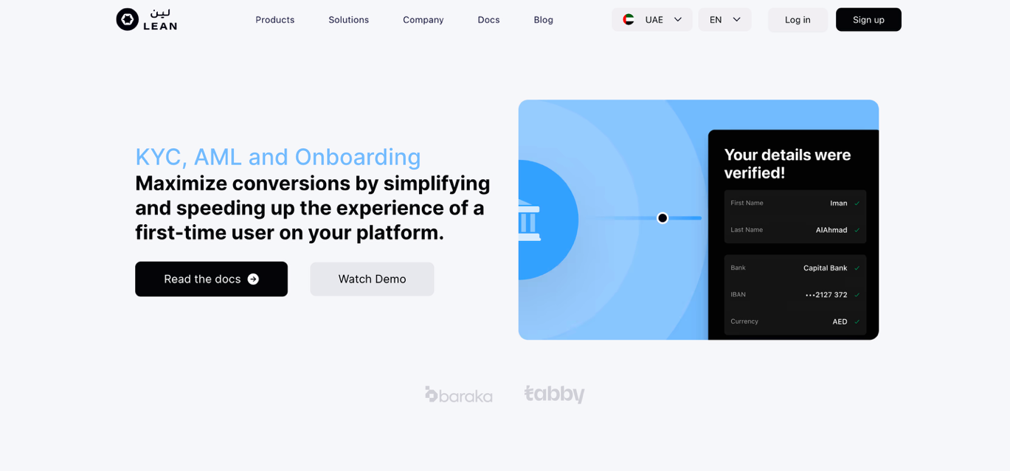

If we Integrate Open Banking (Lean / Tarabut)
Then we must have stronger data compliance, and no extra KYC is required beyond CIP:
- Get explicit consent (Inform users once on-board)
- Store data securely
- Comply with UAE Open Finance framework
- Have cybersecurity standards

What we Do NOT Need (Phase 1)
Since banks and lenders will do deep underwriting, we likely do not need:
- Full source-of-funds verification
- Enhanced due diligence (unless high-risk)
- Continuous transaction monitoring
- Financial crime investigation team
But we will need:
- Verify identity
- Compliance basics
- Basic AML
- Secure data storing

KYC Stack (Practical)
Minimum:
- Emirates ID scan + OCR
- Facial verification (liveness)
- Sanctions screening API
- Mobile OTP verification
Optional but strong:
- Credit scores pull integration
- Open banking account verification
- Device fingerprinting (fraud prevention)
For Phase 1 BuyOut (no fund handling):
Required:
- Identity verification
- Sanctions & PEP screening
- Basic AML framework
- Consent-based data collection
- Secure storage compliance
Not required (For this stage)
- Full bank-level AML infrastructure
- Deep financial investigations
- Payment institution license

Compliant Onboarding Flow (Optimized for Conversion)
This is how it should work:
Step 1 – Account Creation
- Mobile OTP
- Email verification
- Consent acceptance (data + open banking)
Step 2 – Identity Verification
- Emirates ID scan (OCR)
- Selfie liveness match
- Auto extraction of details
Step 3 – Sanctions & PEP Screening (backend)
Step 4 – Debt Dashboard Data Collection
- Manual input OR
- Open banking connection
- Credit bureau pull (with consent)
Step 5 – Risk & Eligibility Score
- Internal soft scoring
- Debt-to-income estimate
- Pre-offer matching
Step 6 – Show Offers
Step 7 – Submit to Lender
Critical:
KYC must not feel heavy.
Keep under 2–3 minutes total.

AML Policy Structure (You Need This Before Launch)
Even if you’re not a bank.
Your AML framework must include:

A. Customer Due Diligence (CDD)
- Identity verification procedures
- PEP screening rules
- Enhanced due diligence triggers

B. Risk-Based Approach
Define:
- Low risk: salaried employee, stable income
- Medium risk: multiple high-value loans
- High risk: foreign PEP, cash-heavy background

C. Suspicious Activity Reporting
If user:
- Submits fake ID
- Uses mismatched identity
- Appears on sanctions list
You must:
- Flag internally
- Possibly report (depending on severity)

D. Record Keeping
Keep:
- ID documents
- Verification logs
- Consent logs
- Screening results
Retention:
Usually 5 years

E. MLRO Appointment
You must assign:
Money Laundering Reporting Officer
Even in small team.

Data Compliance (Very Important)
Because you handle:
- Financial data
- Credit information
- Identity data
You must comply with:
- UAE data protection law
- Open finance consent requirements
- Secure encryption at rest & in transit
- Access control logging

KYC / AML Cost Estimate Per User
UAE fintech pricing:

Identity Verification (Emirates ID + Liveness)
Vendors charge:
5 – 15 AED per verification
Average for budget planning:
~10 AED per user

PEP & Sanctions Screening
~3 – 8 AED per user
Let’s assume:
5 AED per user

Fraud / Device Fingerprinting (Optional but smart)
~2 – 5 AED per user

Total Estimated KYC Cost Per User
Conservative estimate:
15 – 25 AED per verified user
If 1,000 users/month:
~15,000 – 25,000 AED monthly KYC cost

UAE Regulatory License Path
Your classification depends on what you do.
If we:
- Aggregate debts
- Show refinance offers
- Refer users to banks
- Do NOT hold funds
- Do NOT make lending decisions
You likely fall under:

Option A – Commercial Broker / Financial Services Brokerage (Non-Lender)
Possible structures:
- Mainland LLC with activity: “Credit Brokerage”
- DIFC fintech license (if positioning as tech infra)
- ADGM fintech innovation license
Most practical for early stage:
Mainland commercial brokerage license + proper AML framework
We do NOT initially need:
- Full Central Bank lender license
- Deposit-taking approval
- Payment service provider license (if no fund handling)

If we are Later:
- Handle repayments
- Take instalment % directly from banks
- Intermediate funds
Then you may trigger:
- CBUAE supervision
- Payment services regulation
- Stored value facility rules

Do You Automatically Need an Open Finance License?
Not necessarily.
It depends on how you access the data.
There are 2 models:

Model A — You Integrate Through a Licensed Open Finance Provider (Recommended Early)
Example providers in UAE:
- Tarabut
- Lean Technologies
In this model:
- They hold the regulatory relationship
- They are licensed / approved TPPs
- They handle secure data pipes
- You act as a client of theirs

Result:
You DO NOT need your own Open Finance license (initially).
This is the safest and smartest Phase 1 route.

Model B — You Connect Directly to Banks via Open Finance APIs
If you:
- Register as Third Party Provider (TPP)
- Connect directly to banks
- Store raw bank data
Then you likely need:
- CBUAE authorization as Open Finance participant
- Strong cybersecurity certification
- Regulatory reporting
- Possibly capital requirements
This is heavy.
Not recommended at MVP stage.

What License Do You Need for BuyOut Phase 1?
If your structure is:
- Marketplace
- Referral platform
- Debt dashboard
- No fund custody
- Using Lean/Tarabut for data access
Then:
You likely need:
✔ Commercial license (Financial Brokerage / Credit Brokerage activity)
✔ AML policy
✔ Data protection compliance
✔ Contract with licensed Open Finance provider
You do NOT need:
✖ Open Finance TPP license
✖ Payment service provider license
✖ Lending license
As long as you:
Do not hold funds.

Open Finance Compliance You Still Must Follow
Even if Lean/Tarabut is licensed:
You must:
- Obtain explicit user consent
- Clearly disclose data usage
- Store data securely
- Allow user data deletion
- Not reuse data beyond consent scope
Consent must be:
Clear.
Granular.
Time-bound.

What Triggers Regulatory Upgrade?
You trigger deeper regulation if you:
- Store full transaction histories long-term
- Monetize raw financial data
- Repackage financial data to third parties
- Provide account information services independently
- Initiate payments
Then CBUAE oversight increases.

Strategic Recommendation for BuyOut
Phase 1 (MVP):
✔ Use Lean or Tarabut
✔ Stay broker / marketplace
✔ Do not hold funds
✔ Do not initiate payments
✔ Store minimal necessary financial data
Phase 2:
✔ Explore direct Open Finance registration
✔ Consider embedded payment license
✔ Expand compliance team

Why This Is Important for Investors
If you say:
“We pull bank data.”
Investors will ask:
Under which regulatory structure?
You must confidently answer:
“We integrate via licensed Open Finance providers under UAE framework.”
That signals maturity.

The Big Risk If Done Wrong
If you bypass Open Finance rules:
- Banks block integration
- CBUAE can fine or suspend
- Insurance won’t cover data breach
- Expansion to KSA becomes impossible
Fintech regulation compounds.

Final Answer
At this stage:
You do NOT need your own Open Finance license.
You DO need:
✔ Commercial brokerage license
✔ AML/KYC framework
✔ Contract with licensed Open Finance provider
✔ Proper consent management
✔ Strong cybersecurity posture

Missing from framework and Open finance path:
- Formal legal license mapping opinion
- Defined EDD triggers
- Ongoing monitoring logic
- Data protection documentation
- Vendor governance framework

