**Name** : Mahmoud Ali Mohamed Kotait

**B.N** : 859

**Date** : 06/06/2021

**Topic** : Programming Languages

In fact , I am choose this topic because Our world is developing rapidly with the science of technology, and programming has now become an essential in our daily life, but some people wonder about the importance of programming and what happens in the absence of programming in our daily lives?

and me in this topic I am write about programming in 4 items like :

Definition of programming , Levels of programming , different of Syntax in other programming Languages and finally Hopes for every one need to learn programming.

**ScreenShots :**

Page :

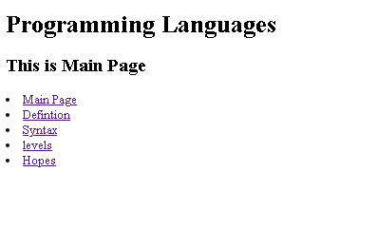

Source Code :

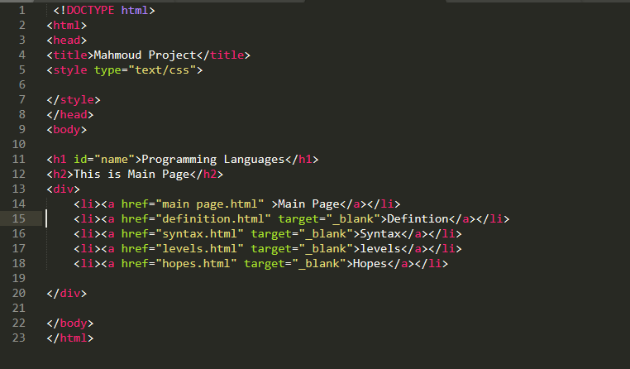

Page :

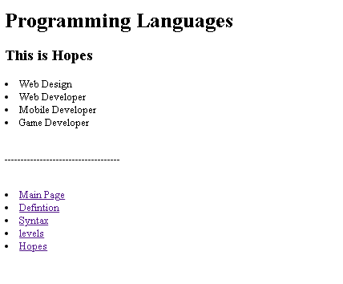

Source Code :

