**Main Page**

**1**

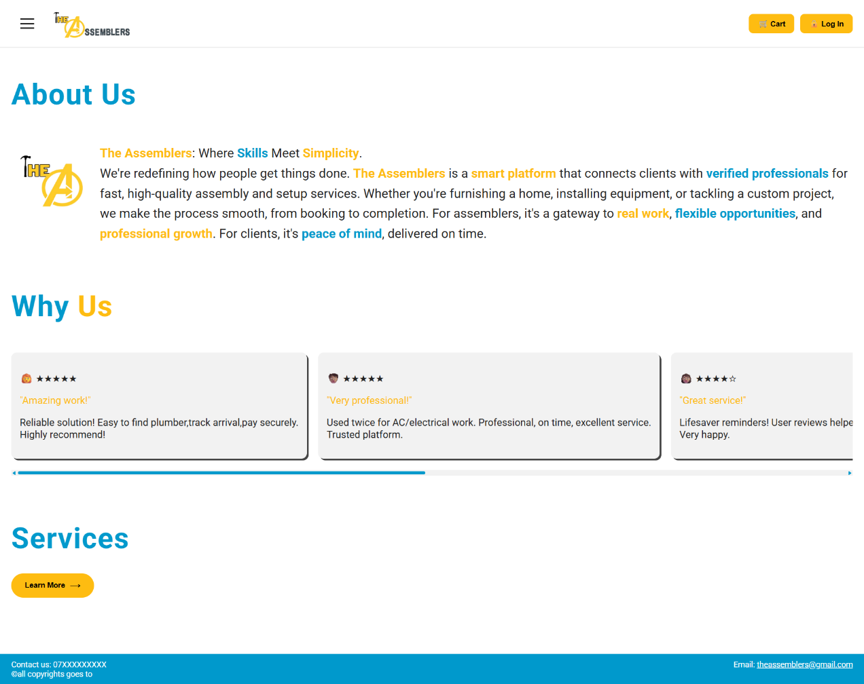

**3**

**2**

**4**

1. **Navigation Menu   
   The three-line icon in the top-left corner opens a neat, collapsible panel listing the site’s main pages (Become an Assembler, Services, Our Assemblers, Help Center) so you always know where to go without cluttering the header.**
2. **Learn More Button   
   That bright yellow button beneath “Services” invites you to dive into full details about each offering—what’s included, how it works, and the pricing—making it easy to explore everything at a glance.redirects user to the services page.**
3. **Cart & Log In**

* **Cart: A quick snapshot of any services you’ve selected, ready for review before booking. redirects user to the checkout page if logged in,**
* **Log In: Redirects user to login page.**

**Services Page**

* **bookings, view past orders, and update your profile.**

1. **Footer Contact Bar  
   A slim blue strip at the bottom of every page displaying our support phone number and email address, so help is always within sight no matter where you are on the site.**
2. A blue sign with white text

   AI-generated content may be incorrect.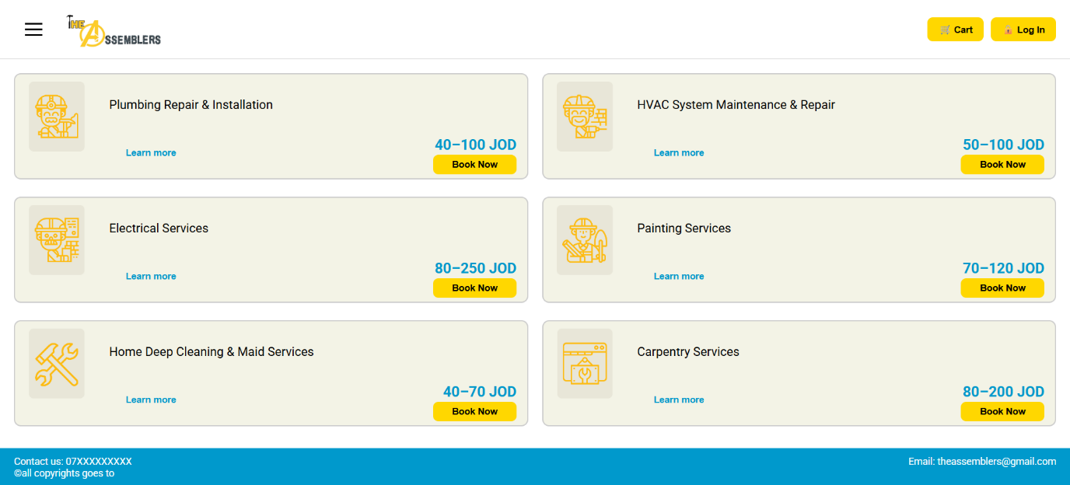

**The services page displays a list of home services with pricing and action buttons. Each service section includes a "Learn more" button, a price range, and a "Book Now" button that triggers a login-related pop-up.**

**How to Book A Service**

**Once the user chooses their desired service a pop up will show asking them to log in or sign up.**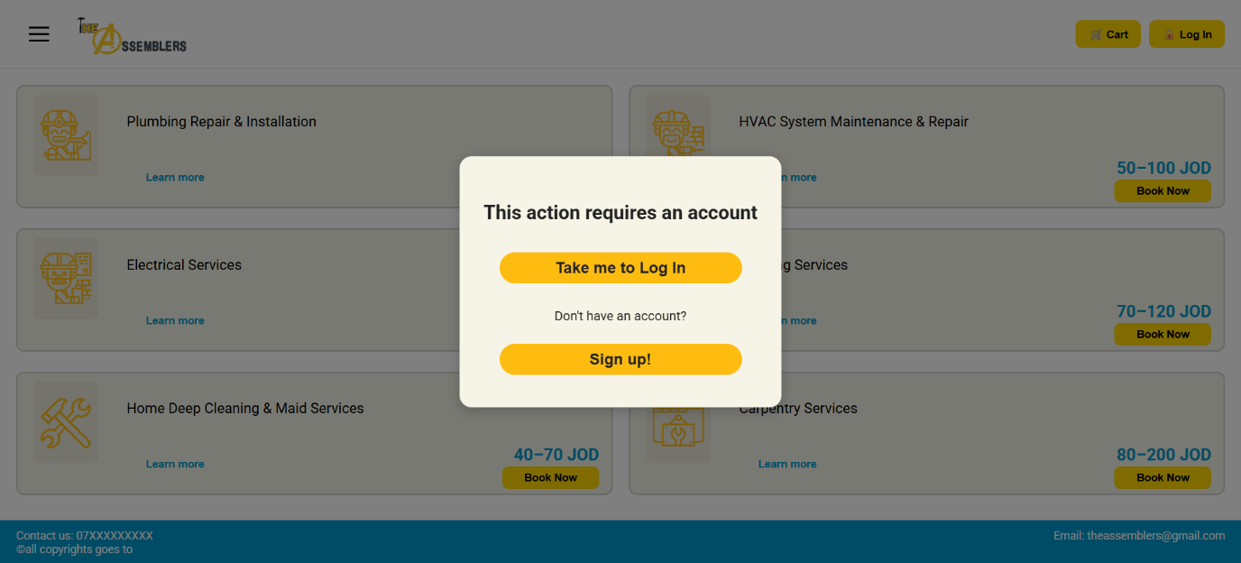

**1**

**2**

**1-If the user already has an account they can click on Take me to Log In and it will redirect the user to the login page shown below.**

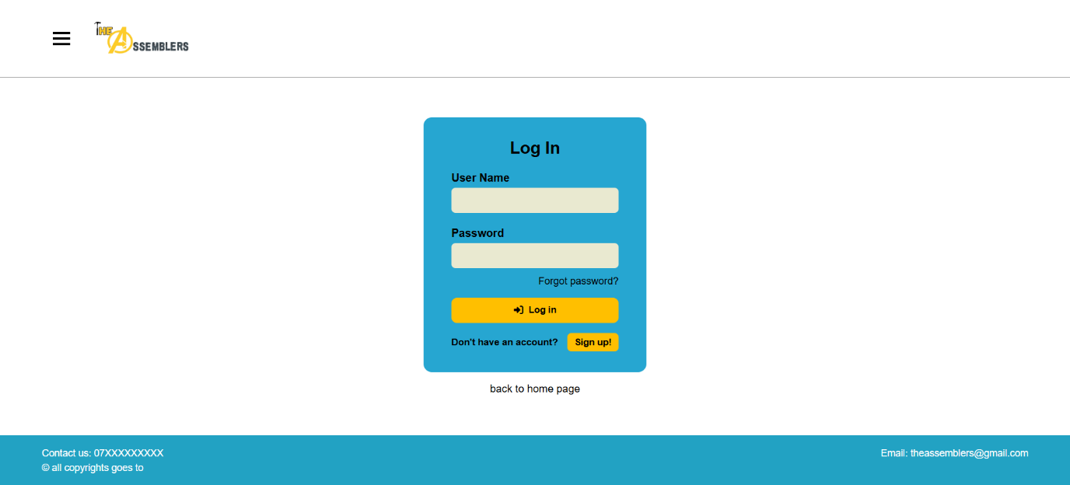

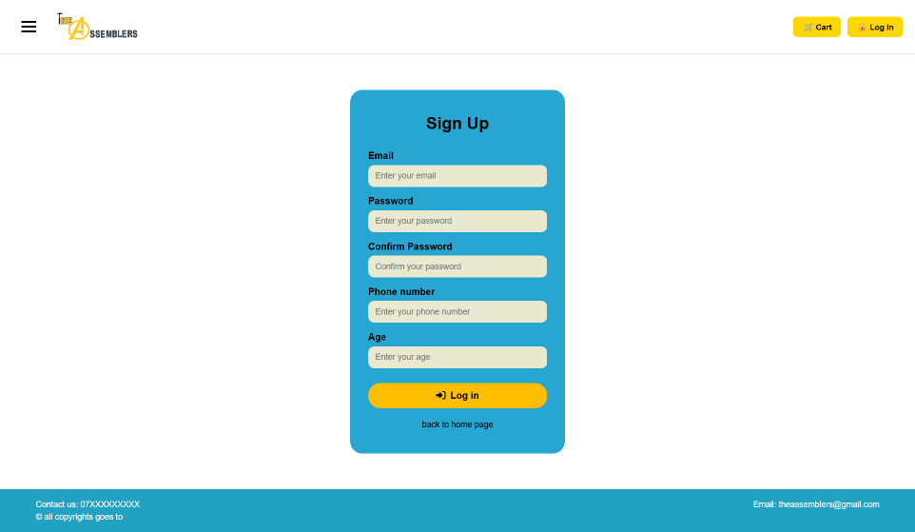**2- If the user doesn’t have an account by clicking the Sign Up button they will be redirected to the Sign Up page shown below.**

**Once the user has logged in, they will be redirected to the client dashboard where they can Book a new service by clicking the book now button, which redirects them to the logged in services page.**

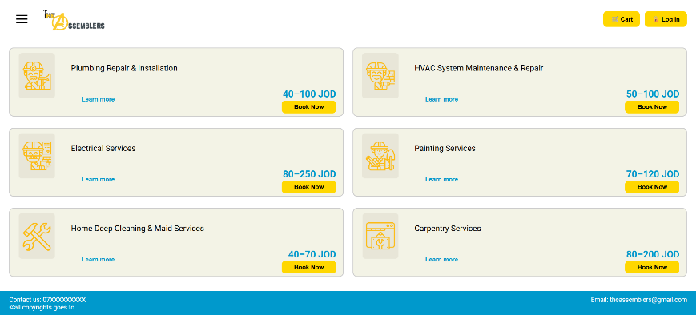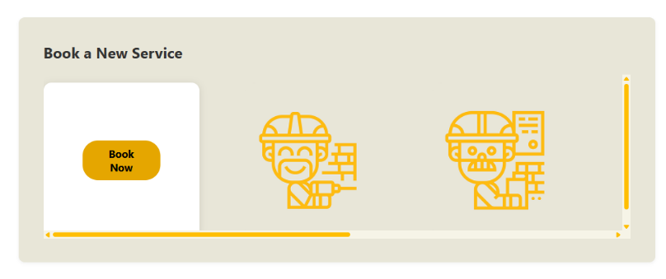

**The user decides what service they want to book and clicks on the book now button which shows a pop up that asks them to select their preffered time slot and assembler**

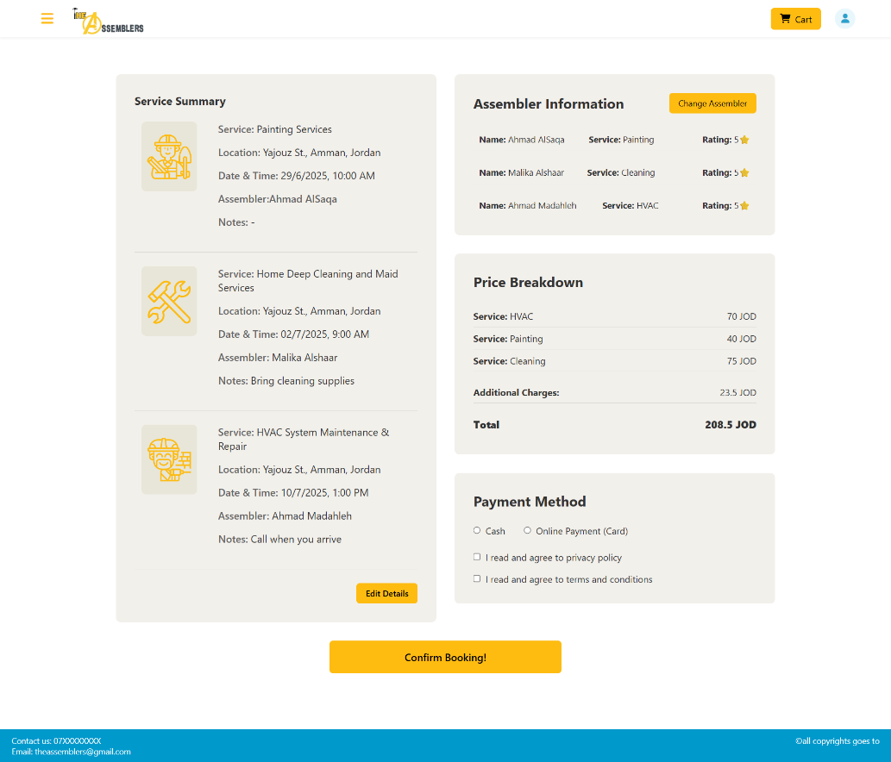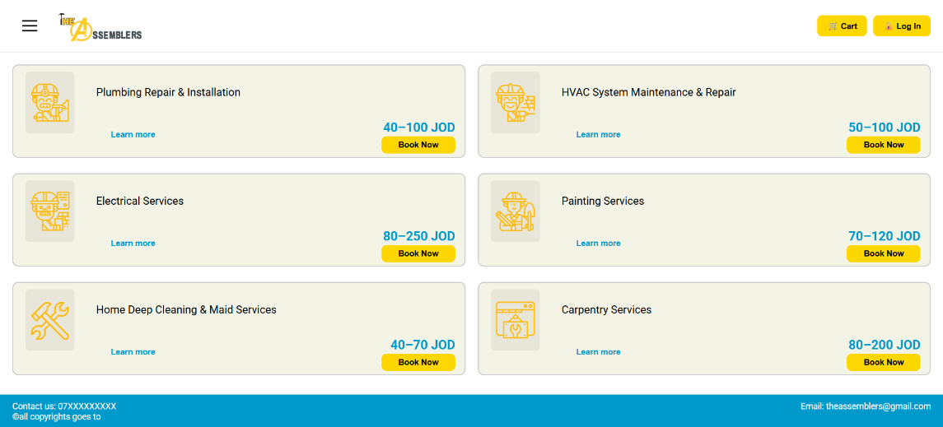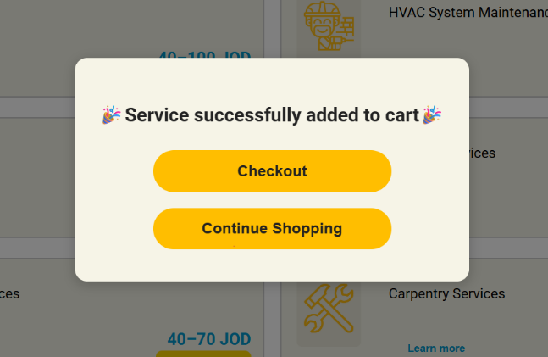

**The user selects their payment method and agrees to privacy policy and terms and conditions.**

**If the user chooses Online payment they will be redirected to the payment gateway**

**The user selects their preferred time slot and Assembler and clicks add to cart which shows a pop up informing them that the service has been successfully added to the cart with two button options:**

**Option 1 : Checkout which redirects them to the checkout page**

**Option 2: Continue shopping which closes the pop up and allows them to browse the rest of the services.**

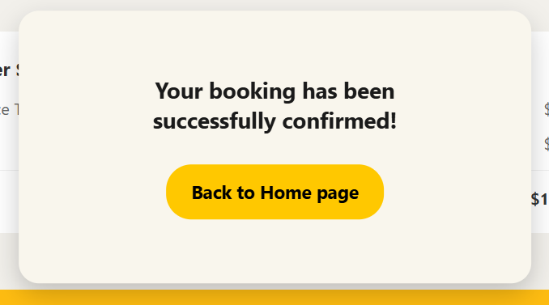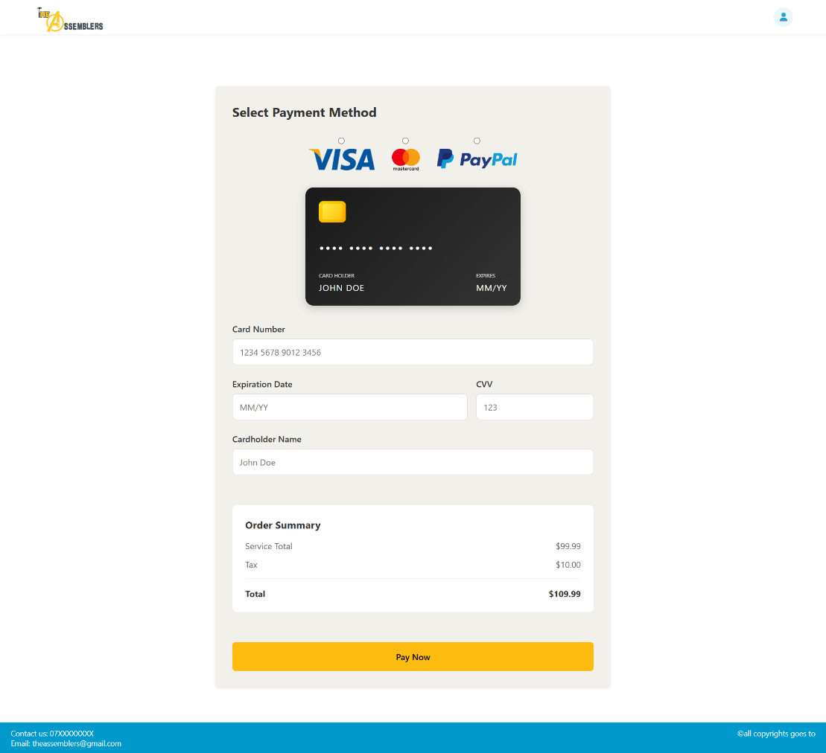

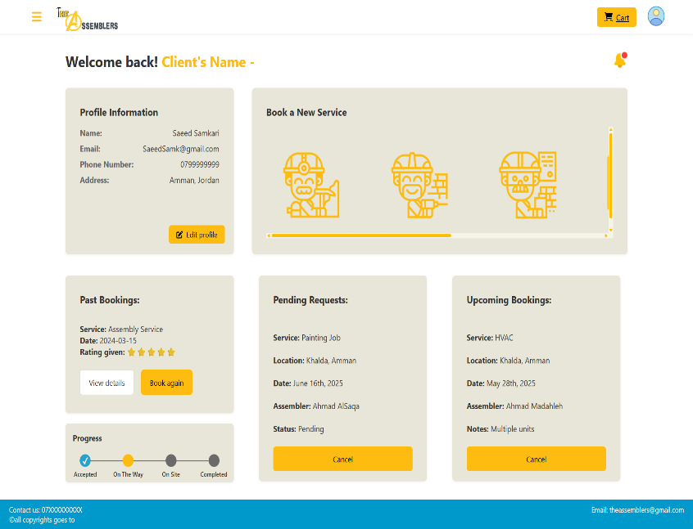

**The user selects their payment method , fills the required fields and clicks pay now to complete booking the service , a pop up shows up informing the client that their booking has been successfully confirmed. The Back to Home page button redirects user to their client dashboard.**

**Our Assemblers Page**

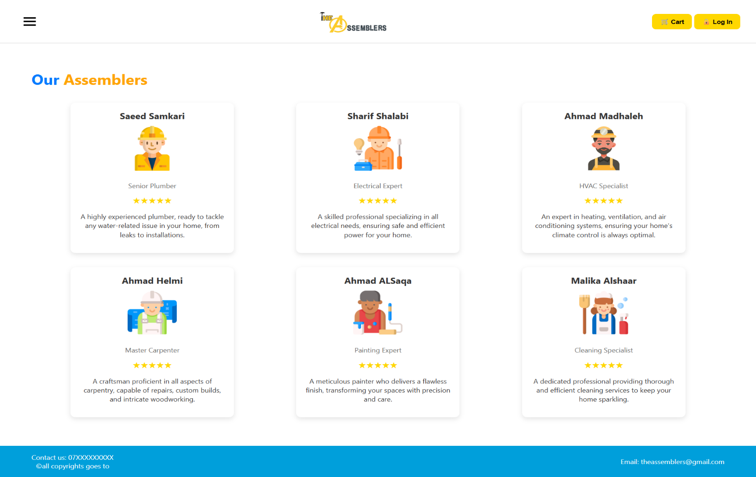

**This page introduces the professional team at The Assemblers, showcasing their expertise in various home maintenance and improvement services. Each specialist is highly rated and ready to assist with your home service needs.**

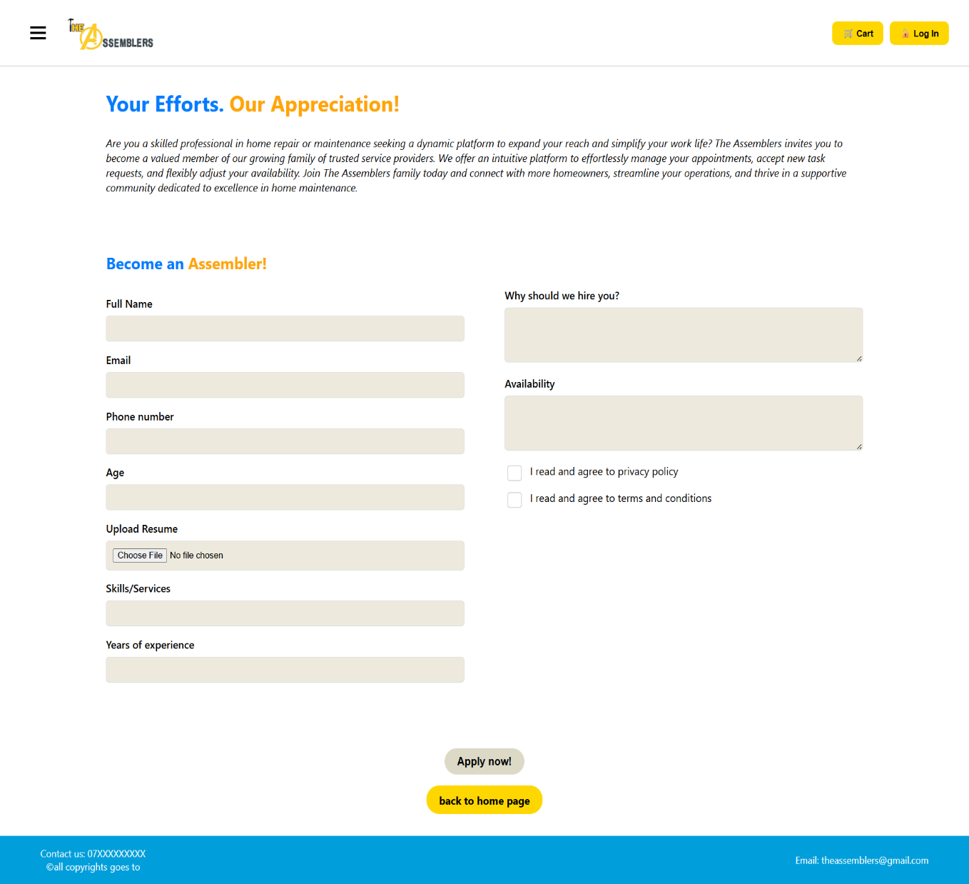**Become An Assembler Page**

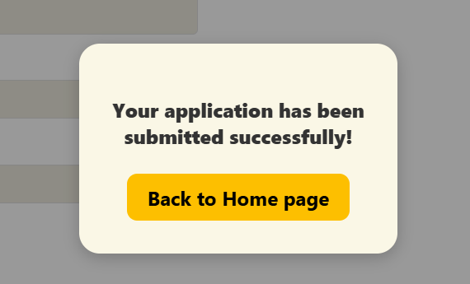

**This page is designed for skilled home repair and maintenance professionals who wish to join The Assemblers platform. It provides an opportunity to apply as a service provider, offering tools to manage appointments, accept task requests, and connect with homeowners.**

**How to Apply**

**The user should fill all fields and upload the required documents such as their cv/resume then agree to the privacy policy and terms and conditions. Once the user has clicked the Apply now! Button it will display a pop up informing them that their application has been submitted successfully and is to be reviewed by the administrator.**

**Log in Page**



**The login page allows the user to enter their email address and password credentials to log into their account if it exists, if not the user can click on the sign up button to create an account .if the user forgot their password they can click on the forgot password? Button to reset their password.**

**Sign Up Page**

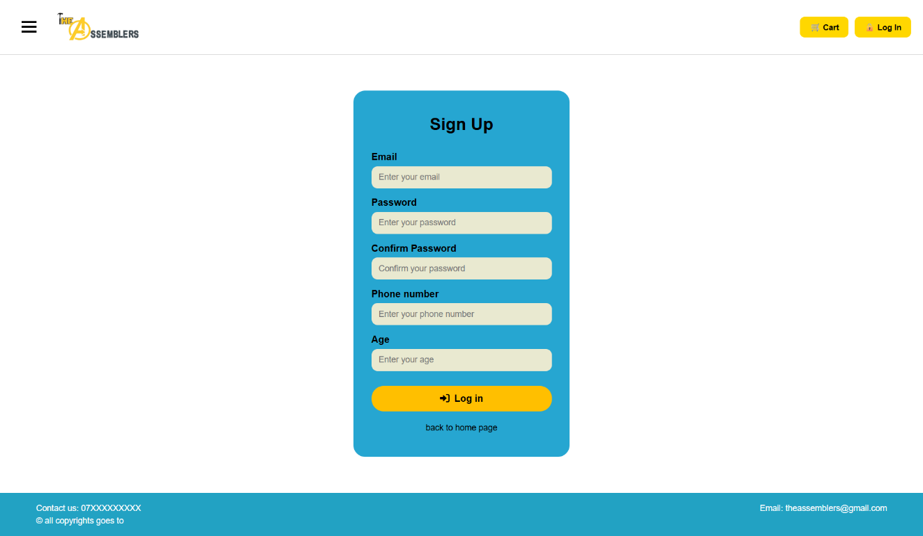

**The sign up page allows the user to create a new account in order to be able to use the website functionalities by filling the required fields and then log in using the account created.**

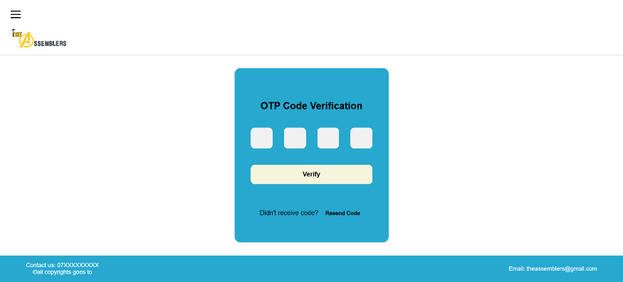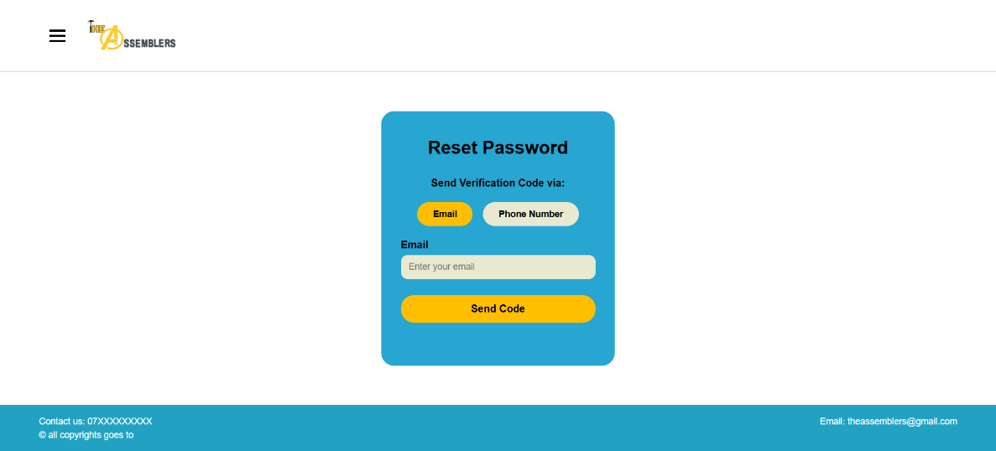**Reset Password Page**

**The Reset Password page allows the user to get a OTP in order to be able to change their password, once the user has written their email/phone number and click send code they will be redirected to the OTP page where they will be asked to enter the OTP received.**

**OTP Verification Page**

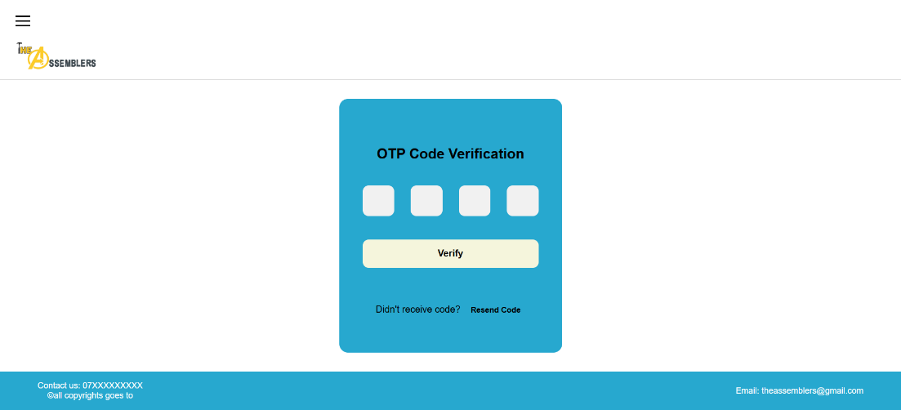

**The OTP Verification page displays fields for the user to enter the OTP received on their email/phone number and the verify button redirects the user to the New Password page.**

**New Password Page**

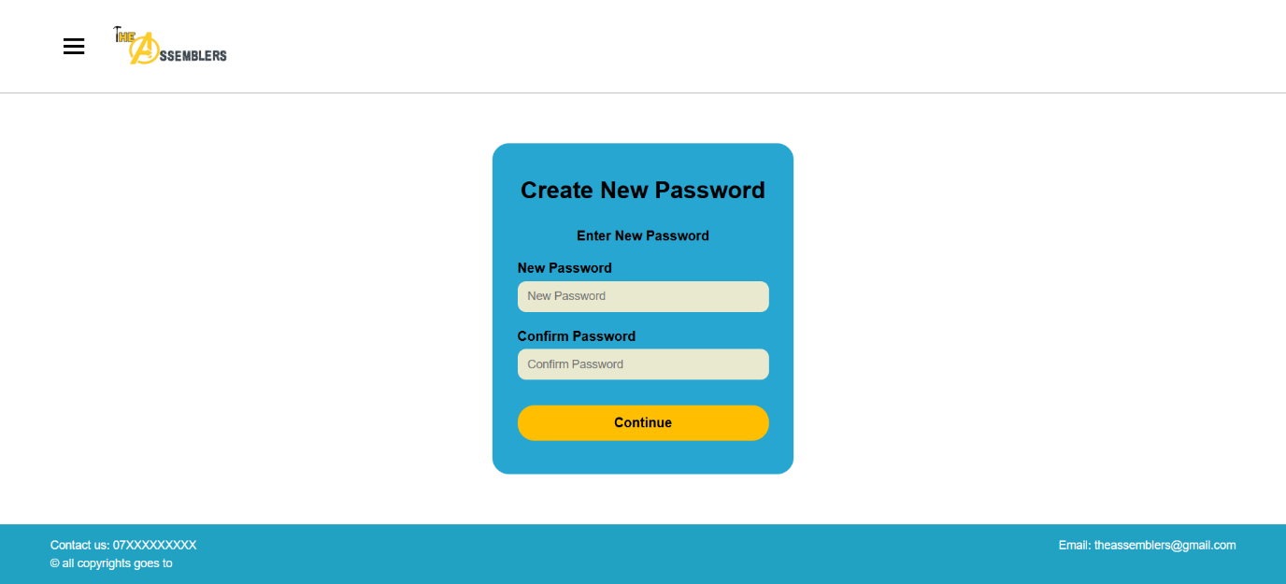**The new password page allows the user to change their forgotten password and the continue button redirects them to the login page.**

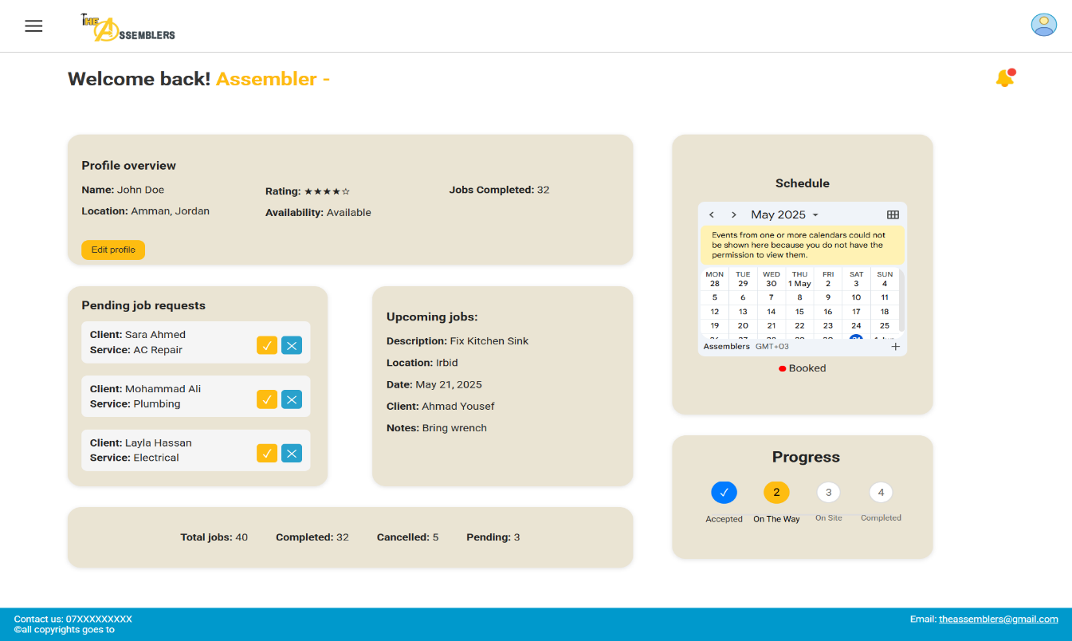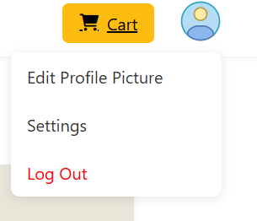**Assembler Dashboard Page**

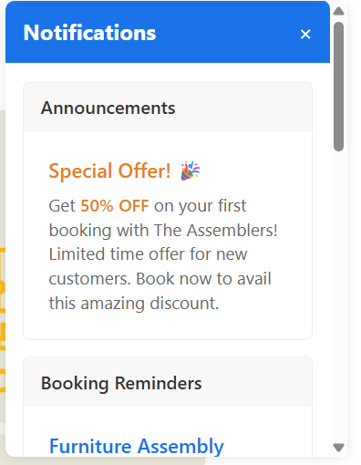

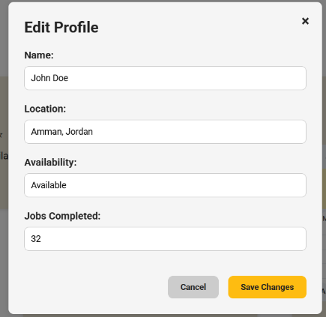

**This dashboard provides a service professional ("Assembler") with an overview of their profile, job requests, upcoming tasks, schedule, and work progress. The assembler can deny pending jobs by clicking on the x next to the pending jobs which will cause the request to disappear. The edit profile button allows the user to enter/edit their information, the profile button on the top right allows the user to log out, edit profile picture, and access account settings, the notifications button allows the user to view announcements, upcoming bookings and booking reminders**

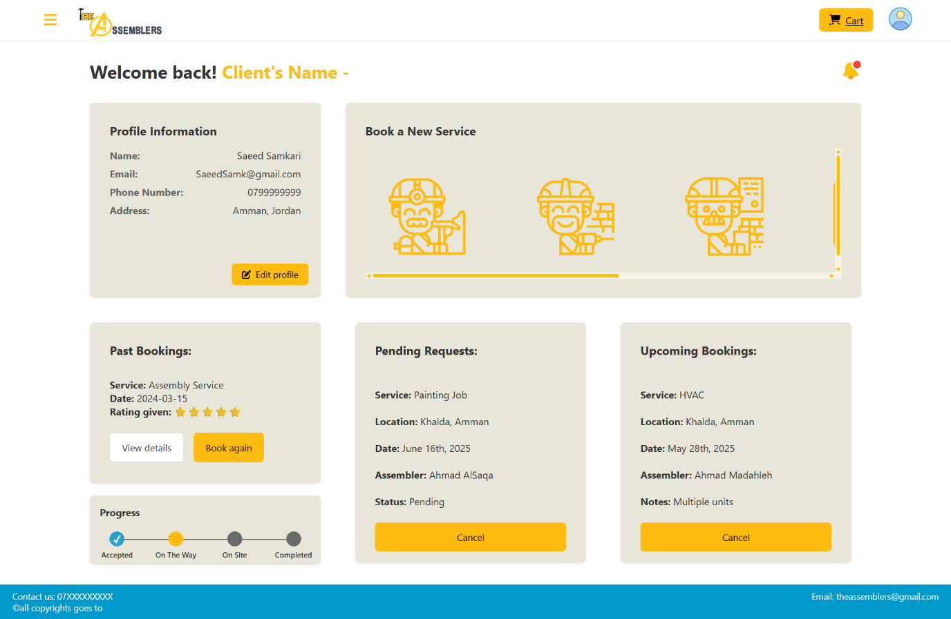**Client Dashboard Page**

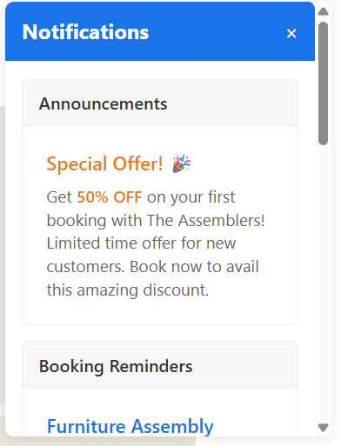

**The client dashboard page allows the client to view their profile information, services they can book, past bookings, pending requests ,upcoming bookings and their current booking’s progress. The view details button displays details about the past bookings, the book a service button shows up on hover on any of the services leading the client to the booking process, the book again button allows the user to rebook a service, The edit profile button allows the user to enter/edit their information, the profile button on the top right allows the user to log out, edit profile picture, and access account settings, the notifications button allows the user to view announcements, upcoming bookings and booking reminders.**

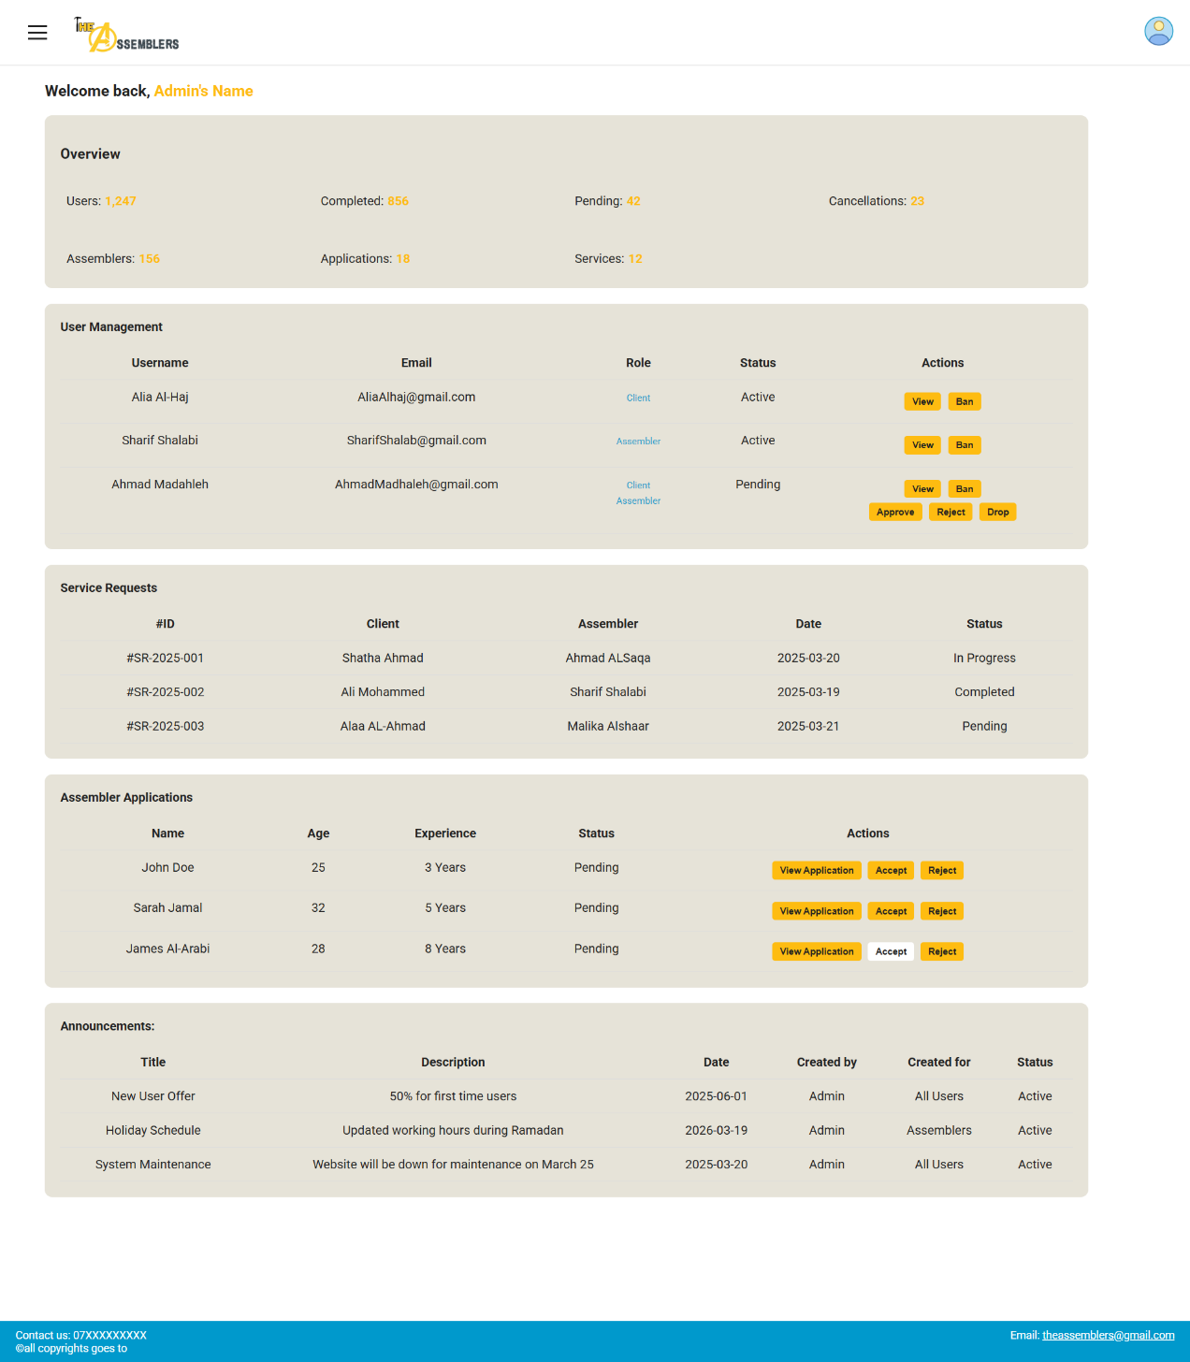**Admin Dashboard Page**

**This dashboard provides administrators with a centralized control panel to manage users, service requests, assembler applications, and announcements.**

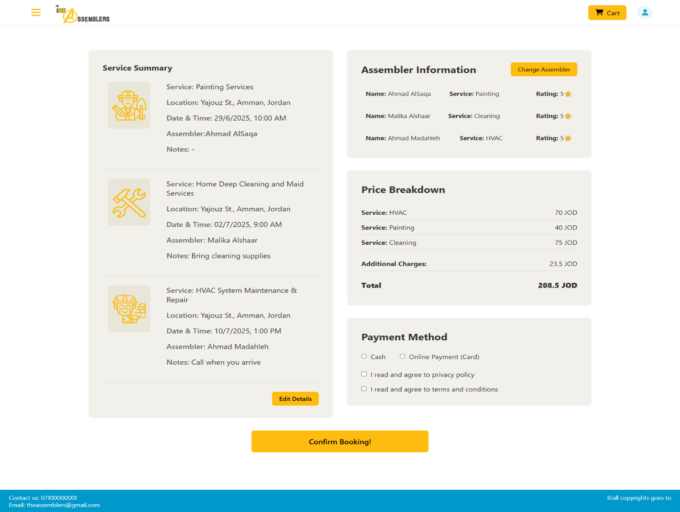**Checkout Page**

**This page allows users to review service details, assembler information, pricing, and payment options before confirming a booking. The user selects their payment method and agrees to privacy policy and terms and conditions .If the user chooses Online payment they will be redirected to the payment gateway.**

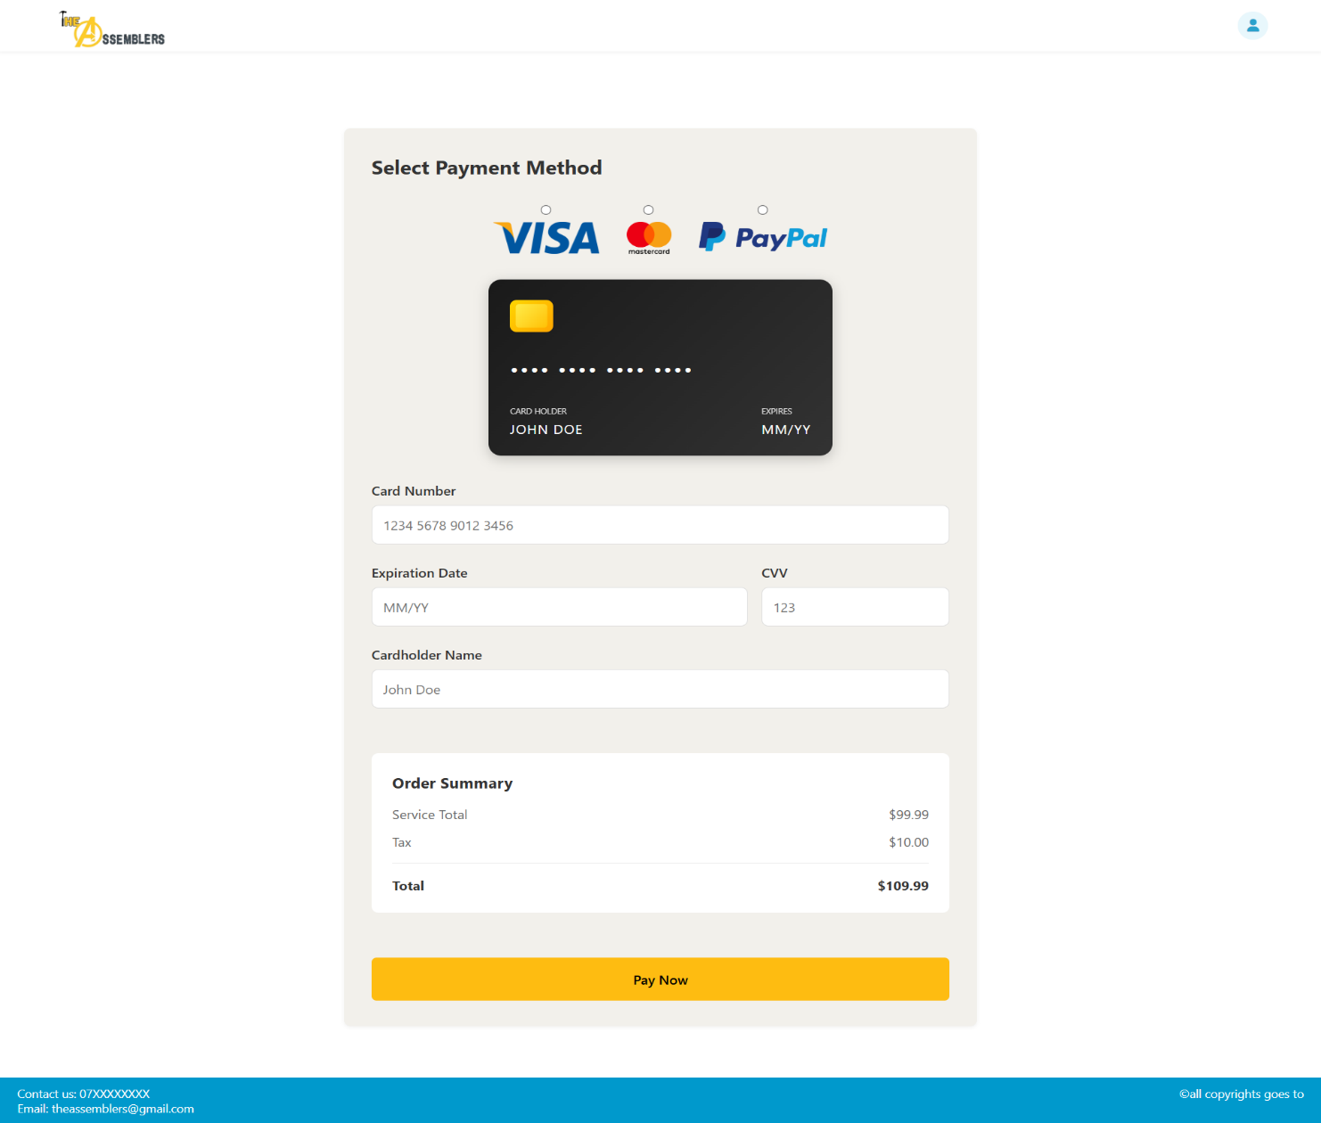**Payment Gateway Page**

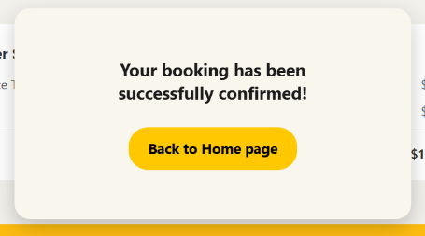

**The payment gateway page allows the user to choose payment method and enter their billing information and fill all required fields in order to complete their booking successfully, the pay now button once clicked informs user that their booking has been confirmed**