**Egyptian E-Learning University**

Faculty of Computers & Information Technology

**UCAR**

**By**

|  |  |
| --- | --- |
| **Name** | **ID** |
| Mahmoud Asem Mahmoud | 2100929 |
| Mina Mahrous Lahzy | 2101110 |
| Gerges Yousry Adib | 2100729 |
| Kerolos Nagi Wahba | 2100872 |
| Abdallah Fawzy Khalif | 2100250 |
| Mariam Fathalla Nageh | 2101000 |
| Marina Nasser Essa | 2101015 |

Supervised by

**Dr. Muhammed Attia**

**Ta. Samah Essam**

[Assuit] - 2025

# *Abstract*

UCAR is an innovative platform designed to revolutionize the car buying and selling experience through the integration of advanced artificial intelligence technologies.

The platform leverages a recommendation system model that deliver personalized vehicle recommendations that may suit user interests, another feature is a price prediction model to make the pricing process for the seller and the buyer fair, additionally, chatbot, an intelligent customer service assistant capable of addressing inquiries, guiding users through the platform, and providing seamless support throughout the decision-making process. By combining data-driven insights with user-centric design, UCAR aims to set a new standard in the automotive marketplace, enhancing convenience, efficiency, and customer satisfaction.

# *Acknowledgments*

It has been a great opportunity to gain lots of experience in Building Web Applications and AI Models, for that we would like to express our deepest gratitude to all who have made this project possible.

First and foremost, we would like to thank **Allah** for providing us with the knowledge, skills, and opportunity to complete this project.

We would also like to thank our project supervisor, **Dr. Muhammed Attia**, for his tremendous support and guidance, without his encouragement and guidance, this project would not have materialized. He has been a great mentor and has helped us to learn a great deal about search engines and recommendation systems.

We are also grateful to our TA, **Samah Essam**, for her help and support, she has been a valuable resource and has helped us to improve our project in many ways.

We are very proud of the work that we have done on this project, and we hope that it will be useful to others.

Contents

Abstract 2

Acknowledgments 3

Introduction 5

Literature Review / Related Work 7

Proposed system 9

Implementation 11

Testing & Evaluation 13

Results & Discussion 15

Conclusion & Future Work 17

References 19

Appendices (Optional) 21

Chapter 1

Introduction

### ***1.1 Introduction.***

In an era where technological advancement is accelerating, online shopping has become an integral part of our daily lives. In this context, car sales websites emerge as one of the innovative solutions that facilitate the buying and selling of cars in an efficient and convenient manner. The website connects sellers and buyers on a single platform, providing a seamless and transparent shopping experience.

This chapter aims to explore the concept of a car sales website, starting from the idea of its creation, and highlighting the benefits it offers to both users and sellers. We will also discuss the challenges that such platforms may face and how to overcome them through innovative strategies. Ultimately, this chapter will demonstrate how a car sales website can serve as a launching point for enhancing customer experience and improving the automotive industry as a whole

***1.2. Background and motivation for the project.***

The purpose of creating a car sales website is to simplify and streamline the buying and selling process, allowing users to find suitable cars easily and quickly without having to navigate multiple places and sources. The site aims to provide a reliable platform that connects buyers and sellers

directly, reducing intermediaries and the likelihood of fraud. Additionally, it seeks to offer helpful tools like advanced search and car valuation to make decision-making easier for users. Moreover, the site aims to enhance user experience by offering after-sales support and various financing options, along with accurate and reliable information about listed cars, thereby building trust and helping users make well-informed purchasing decisions.

And The primary goal of the website is to offer users an exceptional experience by utilizing AI assistance to simplify the car-buying process and help them choose the best option for their needs. The website aims to be a comprehensive platform, providing accurate information and helpful comparisons between cars using the latest AI technology.

### ***1.3 Importance of the Problem Being Addressed***

Car sales websites are crucial platforms that facilitate the buying and selling of vehicles. However, several challenges significantly impact their effectiveness and user satisfaction. Addressing these issues is essential because they affect a large number of users—both buyers and sellers—and influence their financial decisions and overall trust in the platform. The key problems include:

* Difficulty in finding the right car due to the lack of intelligent filtering or recommendation systems tailored to users' specific needs.
* Risk of fraud caused by the involvement of unreliable intermediaries, threatening the safety of transactions.
* Unclear or inconsistent pricing, making it hard for buyers and sellers to agree on a fair value for a vehicle.
* Lack of after-sales support, which negatively impacts customer satisfaction and reduces platform loyalty.
* Inaccurate or misleading information about vehicles, leading to poor decision-making and potential financial loss.
* Limited financing options, which restrict access to vehicles for a wide range of potential buyers.
* Absence of real-time customer support, slowing down the resolution of issues and harming the user experience.
* No AI assistant to guide users through the process and recommend suitable vehicles based on personal preferences.

## 1.4 Problem Statement

Car sales websites play an important role in facilitating the buying and selling of cars. However, there are several challenges on these platforms that need to be addressed. First, many buyers face difficulties in identifying the right car that meets their needs. Another common issue is the risk of fraud when buying cars due to the involvement of intermediaries. Additionally, some buyers and sellers cannot determine a suitable price for the car. Furthermore, there is often a lack of after-sales support, which is essential to ensure user satisfaction. The information provided about cars may also be inaccurate or misleading,

which could affect buyers' decisions. Other issues include the limited availability of financing options directly through the platform, the lack of real-time customer support for quick issue resolution, and the absence of an AI assistant to guide users in finding the most suitable car based on their specific requirements

***1.5 Objectives***

- Car Valuation allows users to estimate the value of their car based on its model, condition, and market trends. It’s useful for both buyers and sellers to ensure fair pricing.

- AI-powered chatbot assists users by answering questions, guiding them through the platform, and helping with customer service inquiries. This improves user engagement and offers quick solutions without human intervention.

- The "Recommendation based on search" feature provides personalized suggestions to users based on their previous searches on the website . This feature uses algorithms to analyze past data about user behavior.

- User Profile Creation, this feature allows users to create profiles either they want to buy a used car or sell their car.

- Advanced Search and Filtering provide users with the ability to search for specific cars using filters like brand, model, price range, mileage, and more. This improves the overall shopping experience by helping buyers find exactly what they are looking for quickly.

- User Reviews and Ratings: enables users to leave feedback and rate cars based on their personal experience. This helps other potential buyers in making informed decisions when considering car options.

***1.6 Brief Overview of the Proposed Solution***

To address the challenges facing car sales platforms, the proposed solution involves the development of an intelligent, AI-powered car recommendation and sales support system. This system will leverage machine learning and data-driven techniques to enhance the car buying and selling experience. Key features of the solution include:

* AI-Powered Recommendation Engine: Recommends cars based on user preferences, budget, previous searches, and behavior, helping buyers find the most suitable vehicle.
* Dynamic Pricing Assistant: Suggests fair market prices for both buyers and sellers based on current market trends, car condition, and historical data.
* Verified Listings and Reviews: Ensures that vehicle information is accurate and includes user-generated reviews for transparency.
* Real-Time Customer Support: Includes chatbot and human agent support for instant help and issue resolution.

Chapter 2

Literature Review / Related Work

***2.1 Summary of existing research and technologies related to our project.***

The automotive market has seen a significant shift towards online platforms, where users can buy and sell cars, compare models, check valuations, and read automotive news. Online car-selling websites provide a convenient solution for car buyers and sellers, offering a range of tools to simplify the search, comparison, and transaction processes.

Key Features of Car-Selling Platforms: Car-selling platforms typically offer a range of features to cater to diverse user needs. Some of the common functionalities include:

**User Profiles**: Allow users to create personalized accounts, manage their listings, track saved cars, and communicate with other buyers or sellers.

**Advanced Search and Filtering**: Provide users with options to search by various criteria such as brand, model, year, price range, mileage, and location, ensuring they can find cars that meet their specific requirements.

**Car Valuation**: Offers tools to estimate the current market value of a vehicle based on its make, model, year, mileage, and condition, helping both buyers and sellers make informed pricing decisions.

**Recommendation System**: Uses algorithms to suggest cars to users based on their search history, preferences, and browsing patterns, enhancing the user experience by providing personalized recommendations.

**Chatbot** : Response for all users inquires that related to cars field.

**When it comes to algorithms, technologies for some features in cars websites :**

### **Most popular algorithms for recommendation systems :**

In this research, we compare between the four most popular algorithms for recommendation system, which we used in our system which are K-Nearest Neighbour (NN), Decision Tree (DT), Random Forest (RF) and Naïve Bayes (NB)

Here's a comparison of the pros and cons of each of the four algorithms commonly used in recommender systems:

**1. K-Nearest Neighbour (KNN)**

The KNN algorithm relies on the similarity between users or items. It provides recommendations by finding items that are most similar in features to the user's preferences.

Pros:

- Simple and easy to understand: KNN is straightforward to implement as it relies on measuring the similarity between items.

- Performs well with dense data: It can provide accurate recommendations when there’s sufficient data.

- No complex training process: KNN is a "memory-based" algorithm, so it doesn't require a complex training phase, only data comparisons.

Cons:

- Slow performance with large datasets: KNN can be slow when working with large datasets, as it must compute similarities for each pair of users or items.

- Distance-based limitations: Its performance can suffer with sparse data or when the distances between points vary greatly.

- Interpretability challenges: The reasoning behind certain recommendations may be difficult to understand.

**2. Decision Tree (DT)**

Decision Tree creates a branching structure of decisions to arrive at recommendations. It’s used to make straightforward and interpretable choices based on item attributes.

Pros:

- Easy to interpret: Decision trees are easily understood because they represent decisions as a branching structure.

- Handles diverse data types: It works well with both categorical and numerical data.

- Effective at identifying important features: It can select relevant features to focus on for recommendations.

Cons:

- Prone to overfitting: Without careful tuning, decision trees may produce overly specific recommendations.

- Rigid recommendations: Recommendations from decision trees can lack flexibility, as results tend to be very binary or clear-cut.

**3. Random Forest (RF)**

Random Forest combines multiple decision trees to generate accurate recommendations. It’s an effective method for reducing errors that may occur when using a single tree.

Pros:

- High accuracy and flexibility: By using multiple decision trees, RF provides strong accuracy and robust predictions.

- Less prone to overfitting: RF typically avoids overfitting better than single decision trees.

- Control over predictions: RF can adjust recommendations based on data size and complexity.

Cons:

- Relatively slow predictions: Since it uses many decision trees, RF can be computationally intensive.

- Complexity in interpretation: The ensemble of trees makes it difficult to interpret recommendations.

- Memory-intensive: RF requires significant memory, which can be a challenge with very large datasets.

**4. Naïve Bayes (NB)**

Naïve Bayes uses probability to predict the likelihood of a user's preferences. It’s fast and works well for data with independent features.

Pros:

- Simple and fast: NB is highly efficient for predictions, especially with large datasets.

- Performs well with sparse data: It handles sparse datasets (where many values are missing) effectively.

- Low resource requirements: NB requires minimal memory and processing power.

Cons:

- Assumptions limit accuracy: NB relies on conditional independence, which is often unrealistic and can reduce accuracy.

- Struggles with complex data: Its simplicity can make it ineffective with complex or highly correlated data.

- Limited in handling non-linear relationships: NB is less suitable for recommendations that depend on non-linear relationships between features.

It seems like there was a typo at the end. If you need any edits, additional details, or have further questions about these algorithms, I’m here to help!

**Most popular algorithms in prediction systems :**

**1. Linear Regression**

A simple and popular algorithm that finds a linear relationship between variables, representing the relationship between inputs and outputs as a straight line.

- Pros: Easy to understand, interpretable, and works well with linear data.

- Cons: Not suitable for non-linear data, sensitive to outliers, and limited for complex predictions.

**2. Decision Tree Regression**

This algorithm divides data into branches based on its features until it reaches the desired prediction. It’s intuitive and straightforward.

- Pros: Easy to interpret, works well with missing or categorical data, handles non-linear data.

- Cons: Prone to overfitting, sensitive to noisy data, and may

perform worse than other algorithms without ensemble methods like Random Forest.

**3. Random Forest Regression**

Combines multiple decision trees to improve prediction accuracy. It’s more complex than a single decision tree but generally more reliable.

- Pros: High accuracy, resistant to overfitting, handles non-linear and complex data well.

- Cons: Slower due to multiple trees, memory-intensive, and more difficult to interpret.

**4. Support Vector Regression (SVR)**

SVR finds the best line (or curve) to separate data, offering precise predictions even with complex data.

- Pros: High accuracy with complex data, flexible for non-linear predictions, performs well across varied applications.

- Cons: Slow training time, sensitive to parameter selection, and harder to interpret.

**5. Neural Networks**

Complex algorithms with multiple layers of nodes, emulating the human brain’s structure, and used for advanced predictions.

- Pros: Strong performance with complex, non-linear data; capable of deep learning for high accuracy with large datasets; adaptable to various data types.

- Cons: High computational and memory requirements, difficult to interpret (black-box), and slow training, especially with big data.

***2.2 Gaps in current solutions that our project aims to fill.***

In developing Ucar, we examined existing platforms with similar features to understand current market offerings and identify areas for improvement.

Our analysis covered several platforms, including Cars.com, Sylnder, Malekcars, Contact Cars, each offering various levels of car-related services.

|  |  |  |  |
| --- | --- | --- | --- |
| Platform Name | Key Features | Challenges/Limitations | Notes |
| **Cars** | -User profiles, advanced search, news & videos  -Car valuation  -Recommendation system | -Lacks AI-driven chatbot , -Non-Intuitive UI  -Limited Filtering Options, -Not enough Car Information  -Lack of Detailed Reviews or Ratings. | Suitable for users looking for standard features only |
| **Slynder** | - User profiles, advanced search, news & videos  -Recommendation System | -Missing car valuation.  - AI-driven chatbot.  -Lack of Detailed Reviews or Ratings. | Best for browsing news, but limited in valuation options |
| **Malekcars** | - User profiles, advanced search.  -Recommendation system | -Lacks news, reviews.  -car valuation.  -Lack of Detailed Reviews or Ratings  -Inadequate Car Information | Basic features but lacks content and interactivity features |
| **Ucar** | - User profiles, advanced search, news.  -Car valuation  -Recommendation system | Lack of a Dedicated Mobile App | Provides core functionalities with valuation and ai features |
| **Contact Cars** | - User profiles, advanced search, news, reviews.  -Car valuation  -Recommendation system | -No AI-driven chatbot  -Lack of Detailed Reviews or Ratings,  -Non-Intuitive User Interface (UI) | Comprehensive but lacks advanced AI features |

**Based on the limitations and challenges faced by previous systems:**

-The proposed system leverages advanced AI techniques for personalized **recommendations**, analyzing user preferences and search history to provide tailored car suggestions. This approach utilizes a broader range of criteria compared to previous systems, such as budget, car type, and brand, ensuring high accuracy and relevance in the recommendations.

- The proposed application aims to provide a seamless **car valuation** service, that can help users to know the fair price for their car.

- Designed with ease of use in mind, the application offers a **user-friendly interface** that makes navigating the chatbot and accessing recommendations intuitive, even for new users.

- The **chatbot** enhances the search experience by providing instant responses to user inquiries about suitable cars. This chatbot offers 24/7 support, answering queries, guiding users through the purchasing

process, this feature ensures that users receive consistent and responsive customer service, regardless of the time or their language preferences.

***2.3 Summary***

At the end of the this chapter, we review the previous literature related to online car buying and selling sites, focusing on the main features and technologies used in current electronics.

Because by comparing similarity boards such as Cars.com, Sylnder, and Malekcars, we identify the challenges and limitations of these websites, such as the absence of some core features like car valuation, recommendation system.

We proposed to develop a system that combines personalized advice and smart chatbots to provide personalized support at every step of the purchase process and provide recommendation system to make the process of finding the car that suits your needs easy, and provide advanced price prediction service that introduce accurate valuation service.

Chapter 3

Proposed system

* 1. ***Approach used to solve the problem***

Buying and selling used cars is often a risky experience for both parties involved.

For buyers, lack knowledge about fair prices in market increases the possibility of purchasing a used car to unfair price, Buyers are often overwhelmed by the sheer volume of listings, lacking a tailored way to discover vehicles that align with their specific preferences or previous searches. This can lead to an inefficient browsing experience where buyers may overlook relevant options, ultimately reducing satisfaction and increasing the time spent on the platform.

Sellers, face challenges in accurately pricing their vehicles, reaching potential buyers, dealing with numerous inquiries (many from unreliable buyers).

The system aims to solve the problem of good pricing for cars and deliver buyers to the right cars quickly and accurately, help sellers in the speed of selling their cars at an appropriate price and answer all inquiries related to cars that revolve in the mind of the user while selling or buying a car.

***Scope***

The proposed system is designed especially for anyone interested in buying or selling a used car to help them to sell their cars at a fair price quickly and helps buyers to buy a suitable car in the shortest possible time.

***Proposed Solution***

1- Knowing the different algorithms and testing them on a real data set of cars, their efficiency ratio, and choosing the most efficient one for this project for predicting fair price model.

2-A **recommendation system** based on user history and preferences can help buyers navigate the wide array of listings, suggesting vehicles that they could be interested in.

3- A **chatbot-driven customer service system** can provide instant responses to frequently asked questions.

***Data Gathering***

Before implementing the proposed models, an important step is the collection of representative and reliable data to be used for building the predicate model.

1-We collected data from online resources to test AI Price Prediction Model

***3.2 System Architecture***

3.2.1. Use Case Diagram

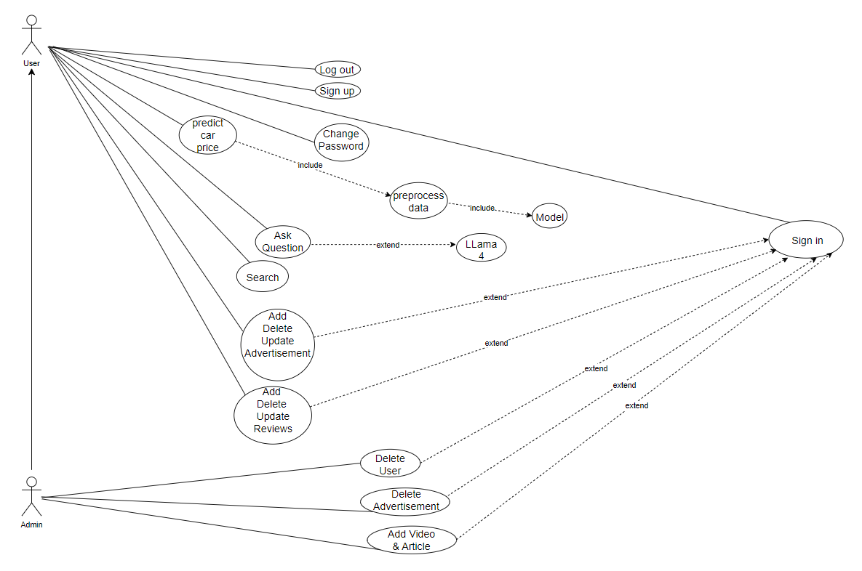

3.2.2 ERD

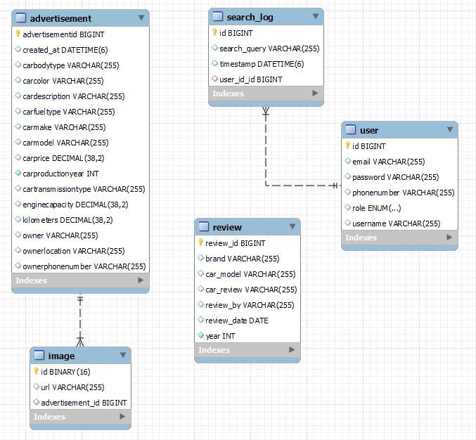

3.2.3. Class Diagram

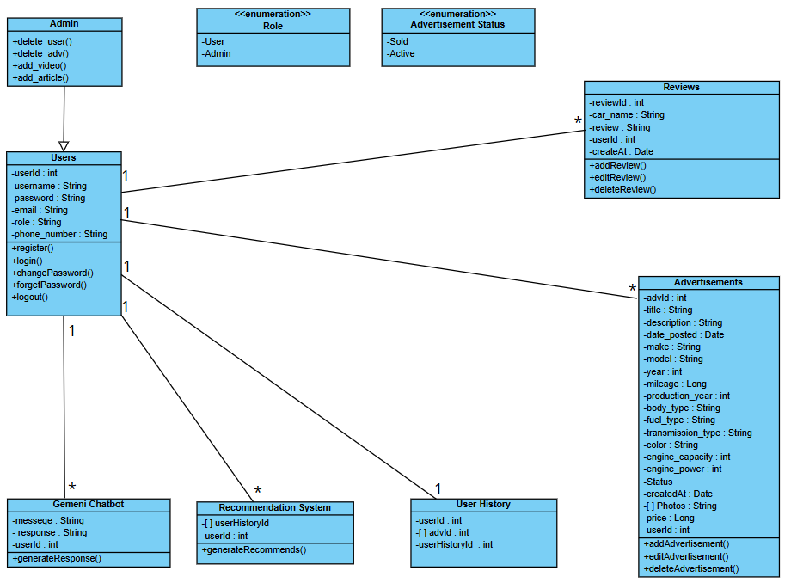

3.2.4. Use Case Table

|  |  |
| --- | --- |
| **Use Case Name** | Sign Up |
| **Actors** | Admin, user |
| **Include** |  |
| **Precondition** |  |
| **Input Data** | First Name , Last Name , Email , Create Password |
| **Description** | Admin/User will Sign Up to system To Create Profile with First name, Last Name, Email and Create Password. The user must be verified if the verification process working properly then admin/user create profile page. But if they are not verified or the email/password incorrect. an error message appeared with “Failed to Sign Up” |
| **Response** | Success to Sign Up ( admin/user can create their Profile page ), Failed to Sign Up( admin/user cannot create their Profile page ) |
| **Comments & Exceptions** | - |

|  |  |
| --- | --- |
| **Use Case Name** | Sign In |
| **Actors** | Admin, user |
| **Include** |  |
| **Precondition** | Admin/User successfully logged in |
| **Input Data** | Email and Password |
| **Description** | Admin/User will Sign Into system and enter email and password to enter the profile. they must be verified if the verification process working properly then admin/user will be forwarded too their profile page. But if the email/password incorrect. an error message appeared with “Failed to Sign In” |
| **Response** | Success to Sign In (admin/user will be forwarded too their Profile page ), Failed to Sign In( admin/user will not be forwarded too their Profile page ) |
| **Comments & Exceptions** | - |

|  |  |
| --- | --- |
| **Use Case Name** | Log out |
| **Actors** | user, Admin |
| **Precondition** | Admin/User successfully logged in |
| Description | Admin and user can log out from the system. |
| Post-condition | The user is logged out and redirected to the login page. |
| Basic Flow | 1. User clicks on the log out button.  2. The system ends the session.  3. The user is redirected to the login page. |
| **Comments & Exceptions** | - |

|  |  |
| --- | --- |
| **Use Case Name** | Browse Cars |
| **Actors** | user |
| Preconditions | The user must be logged in. |
| Description | Browse the cars available for sale on the website. |
| Postconditions | The user views the list of available cars. |
| Basic Flow | 1. The user selects "Browse Cars". 2. The list of available cars is displayed. |
| **Comments & Exceptions** | - |

|  |  |
| --- | --- |
| **Use Case Name** | Search for Car |
| **Actors** | user |
| Preconditions | - |
| Description | Search for a car based on text |
| Postconditions | Search results matching the text are displayed. |
| Basic Flow | 1. The user selects "Search for Car".  2. The user enters search text  3. Cars matching the search are displayed. |
| **Comments & Exceptions** | - |

|  |  |
| --- | --- |
| Use Case Name | Add advertisement |
| Actors | user |
| Preconditions | The user must be logged in as a "Seller". |
| Description | Add a new car for sale on the website. |
| Postconditions | The car is added to the car listing database. |
| Basic Flow | 1. The user selects "Add Car". 2. The user fills in car details (photo, description, price). 3. The car is added to the site. |
| Comments & Exceptions | - |

|  |  |
| --- | --- |
| **Use Case Name** | **Predict Price** |
| **Actors** | user |
| Preconditions | The user is logged in and has provided the criteria. |
| Description | Allows the user to predict the price of a car based on condition. |
| Postconditions | The system displays a predicted price range for the car. |
| Basic Flow | 1. user provides car details (e.g., year, model, etc.).  2. The system calculates and displays the predicted price. |
| **Comments & Exceptions** | Invalid criteria leads to an error message. |

|  |  |
| --- | --- |
| **Use Case Name** | **Edit/Delete Car advertisement** |
| **Actors** | user |
| Preconditions | The user must be logged in as a "user" and have a car advertisement. |
| Description | Edit or delete a car advertisement that was added earlier. |
| Postconditions | The advertisement is successfully edited or deleted. |
| Basic Flow | 1. The user selects "Edit/Delete Listing". 2. The user selects the car to edit or delete. 3. The listing is either edited or deleted. |
| **Comments & Exceptions** | - |

|  |  |
| --- | --- |
| **Use Case Name** | **Manage Listings & Users** |
| **Actors** | Admin |
| Preconditions | The user must be logged in as an "Admin". |
| Description | Manage car listings and users on the website (delete, edit, approve listings). |
| Postconditions | Listings or users are managed successfully. |
| Basic Flow | 1. The admin selects "Manage Listings & Users". 2. The admin reviews listings and users. 3. The admin can approve, delete, or edit listings or users. |
| **Comments & Exceptions** | - |

|  |  |
| --- | --- |
| **Use Case Name** | **Delete User Account** |
| **Actors** | Admin |
| Preconditions | The admin is logged in. |
| Description | admin can delete a user account from the system. |
| Postconditions | The selected user account is deleted. |
| Basic Flow | 1. Admin selects the user account to delete.  2. The system deletes the user account. |
| **Comments & Exceptions** | - |

|  |  |
| --- | --- |
| **Use Case Name** | **Delete User Account** |
| **Actors** | User |
| Preconditions | -The user must be logged in.  -The user has access to their profile or account settings. |
| Description | This use case allows a user to change their existing password for improved account security. |
| Postconditions | - The user’s password is updated.  -The user can log in with the new password in future sessions. |
| Basic Flow | 1. The user navigates to the profile or account settings page.  2. The user selects the "Change Password" option.  3.The system prompts the user to enter the current password.  4.The user enters the current password.  5. The system verifies the current password.   * **If the password is incorrect**, the system shows an error message and returns to step 3.   6.The system prompts the user to enter a new password and confirm it.  7. The user enters the new password and confirms it.  8. The system validates the new password (e.g., meets complex requirements).   * **If the new password does not meet the requirements**, the system shows an error message and returns to step 6. |
| **Comments & Exceptions** | - |

|  |  |
| --- | --- |
| **Use Case Name** | **Add review** |
| **Actors** | User |
| Preconditions | - The user must be logged in.  - The user has access to the review section of the product or service page. |
| Description | This use case allows a user to submit a review for a product or service they have used. |
| Postconditions | -The review is saved and displayed in the product or service’s review section.  -The average rating for the product or service is updated (if applicable). |
| Basic Flow | 1.The user navigates to the product or service page.  2. The user selects the "Add Review" option.  3. The system displays a form where the user can enter their review details (e.g., rating, comments, title).  4. The user enters a rating (e.g., 1–5 stars) and writes comments about their experience.  5. The system validates the review input (e.g., rating is within range, comments meet any length requirements).   * **If the review does not meet requirements**, the system shows an error message and returns to step 4.   6. The user submits the review.  7. The system saves the review and displays a success message. |
| **Comments & Exceptions** | - |

|  |  |
| --- | --- |
| **Use Case Name** | **Add videos and news** |
| **Actors** | Admin |
| Preconditions | -The admin is logged in with appropriate privileges to add content.  -the admin has access to the content management section for adding videos or news. |
| Description | This use case allows an admin to upload videos and post news articles related to cars, making this content available to users. |
| Postconditions | - The new video or news article is published in the car content section and visible to users. |
| Basic Flow | 1. The admin navigates to the content management section. 2. The admin selects the "Add New Content" option and chooses between "Video" or " Article".    * **If the admin selects "Video"**:      1. The system displays a form for video details, including title, description, and video file or link.      2. The admin enters the video title, description, and either uploads a video file or adds a link to the video.      3. The system validates the video details (e.g., file format and size).         + **If the video does not meet requirements**, the system displays an error message and returns to step 2      4. The admin submits the video.      5. The system saves the video details and displays a success message.    * **If the admin selects "News Article"**:      1. The system displays a form for article details, including title, description, and content body.      2. The admin enters the article title, description, and content body.      3. The system validates the article content (e.g., length and formatting requirements).         + **If the content does not meet requirements**, the system displays an error message and returns to step 2      4. The admin submits the article.      5. The system saves the article and displays a success message. 3. The new video or article is made available on the platform's car content section. |
| **Comments & Exceptions** | - |

3.2.5. Sequence Diagram

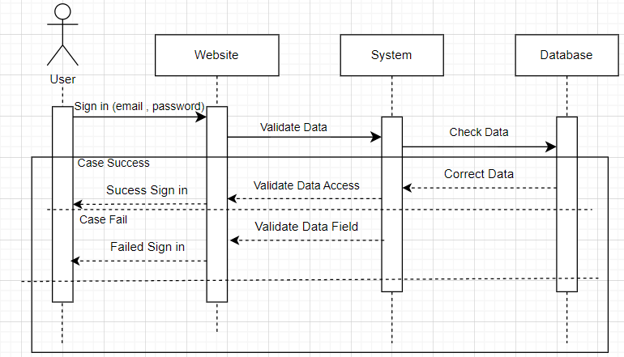

Sign in

Sign up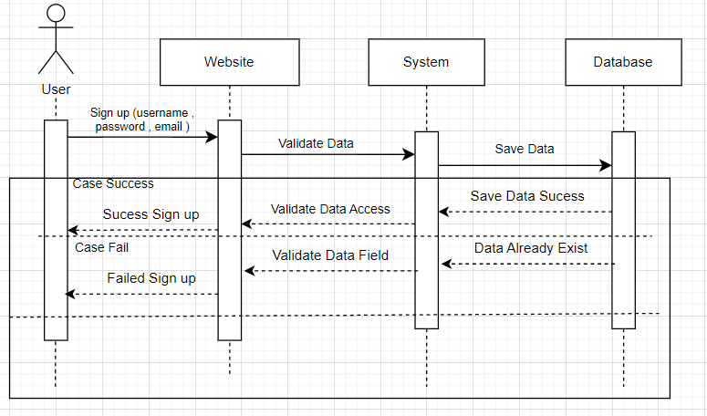

Sign Out

Forget Password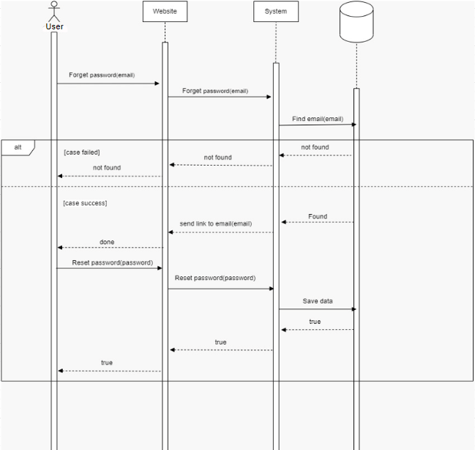

Add Review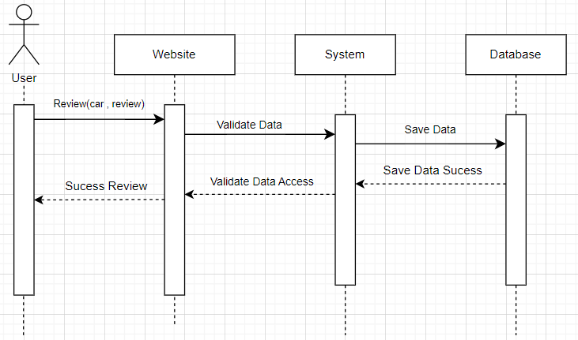

Price Prediction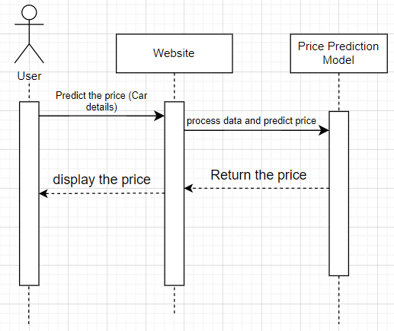

Recommendation System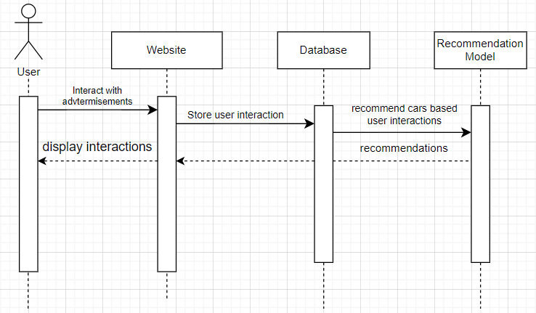

Searching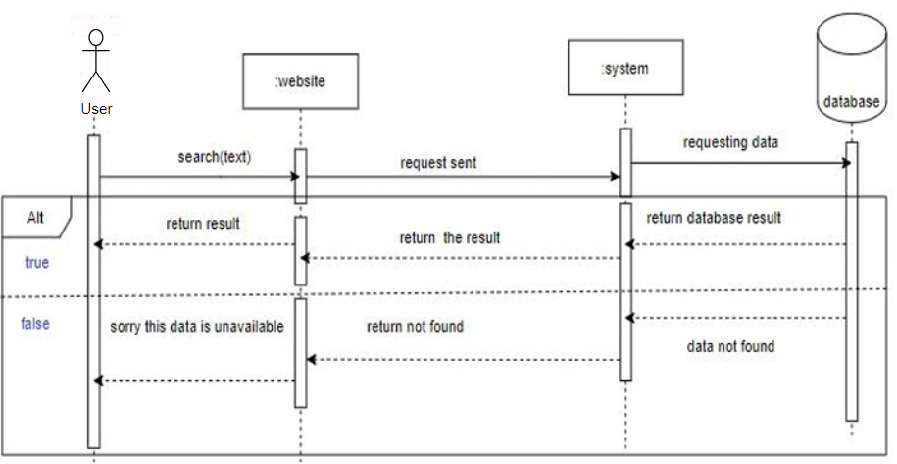

Admin : Delete user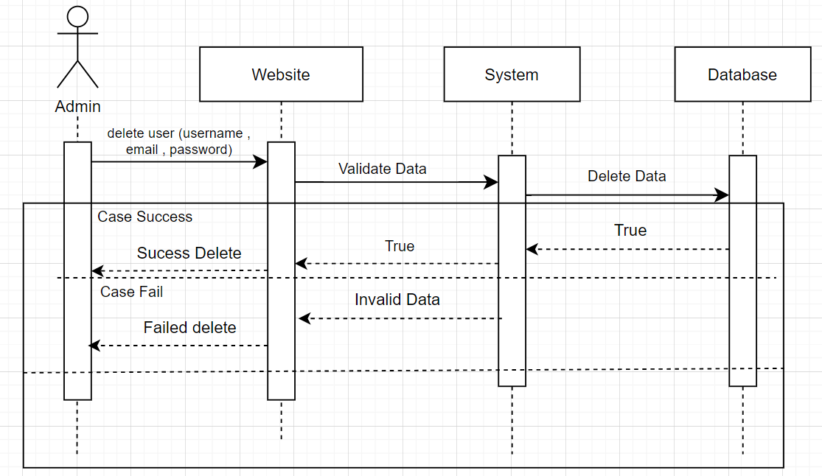

Admin : Delete advertisement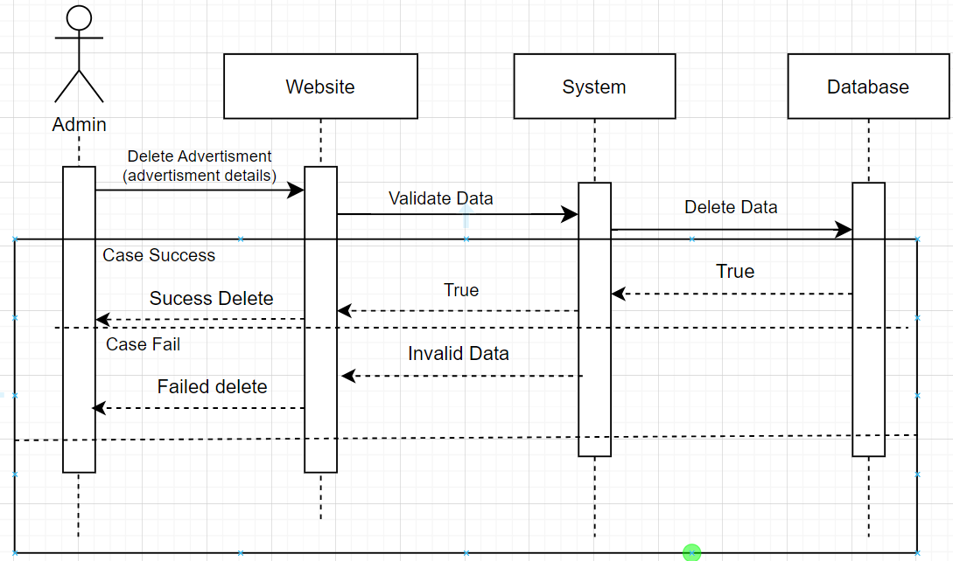

3.2.6. System Architecture

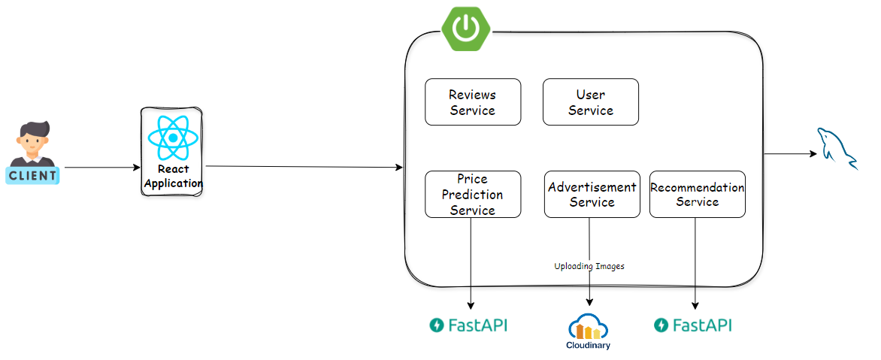

***3.3 Algorithms used***

The proposed system integrates several machine learning algorithms and modern development frameworks to enhance the functionality of a car sales platform, particularly in car price prediction and intelligent recommendations:

**1. Car Price Prediction Algorithms:**

To estimate fair market prices of used cars based on features such as brand, model, year, mileage, fuel type, and condition, the following regression algorithms were used:

* **Random Forest Regressor**: An ensemble learning method that builds multiple decision trees and combines their output for high accuracy and robustness against overfitting.
* **XGBoost (Extreme Gradient Boosting)**: A highly efficient and scalable boosting algorithm that improves performance by minimizing prediction errors iteratively.
* **Gradient Boosting Regressor**: Combines weak learners (usually decision trees) to create a strong predictive model that improves gradually.

Chapter 4

Implementation

***4.1 Technologies, tools, and programming languages used.***

This section outlines the tools, technologies, and software environments used throughout the development of the proposed car website system. The project was implemented using a full-stack web development approach, integrating both client-side and server-side functionalities, as well as artificial intelligence components for enhanced user experience.

**➤ Tools and Programming Languages Used**

* **Frontend Technologies:**
  + HTML
  + CSS
  + tailwind
  + JavaScript
  + React.js
* **Backend Technologies:**
  + Java
  + Spring Boot
  + MySQL
  + Cloudinary
* **Frontend Technologies:**
  + Python
  + Sellenium
  + Fast API
* **User Interface Design:**
  + Figma (used for UI/UX prototyping and mock-ups

**➤ Versions of Software Development Tools and Libraries:**

|  |  |
| --- | --- |
| Tool / Library | Version |
| Axios | ^1.3.5 |
| React | ^18.2.0 |
| @mui/material | ^5.12.1 |
| react-router-dom | ^6.10.0 |
| Bcryptjs | ^2.4.3 |
| Express | ^4.18.2 |
| Crypto | ^1.0.1 |
| Cheerio | ^1.0.0-rc.12 |
| Node.js (runtime) | v14.15.0 |

These tools were selected to ensure high performance, modular design, and smooth integration between the web interface, server-side logic, and AI-based features.

***4.2 Key components, modules of the system.***

The system consists of several interconnected modules, each responsible for a specific functionality:

#### 1. **User Authentication**

* Handles user registration, login, forget password.
* Ensures secure access to user-specific features such as posting ads and writing reviews.
* Technologies: Spring Security, JWT.

#### 2. **Car Advertisement**

* Allows users to add, edit, and delete car listings.
* Supports uploading images, providing car details (make, model, year, price, etc.).
* Displays listings to other users with filters and search functionality.

#### 3. **Review & Rating**

* Lets users write reviews about their cars.
* Helps build trust and improve transparency for potential buyers.

#### 4. **AI Chatbot**

* An intelligent assistant that answers user queries related to cars, listings, or general buying tips.
* Integrated using LangChain (Llama 4).

#### 5. **Price Prediction**

* Uses a trained machine learning model to predict the fair market price of a used car based on input features (e.g., brand, year, mileage).
* Helps users list their cars competitively and buyers to judge pricing.

#### 6. **Recommendation System**

* Suggests relevant car listings to users based on their browsing history.
* Improves user experience through personalization.

#### 7. **Search & Filter**

* Enables users to search cars by make, model, year, price range, location, and more.
* Uses dynamic filters and sorting to enhance usability.

#### 8. **Admin dashboard**

* Allows administrators to manage users, monitor listings, moderate reviews, and handle reports.
* Ensures the platform stays safe and organized.

#### 9. **Database**

* Stores structured data such as users, ads, reviews.
* Optimized using indexing and relationships for fast access and integrity.

#### 10. **Frontend Interface**

* The user-facing component where interactions take place.
* Designed for responsiveness and ease of use across devices.

***4.3 Challenges faced and how to be solved.***

The main challenge encountered during the development and implementation of the used car platform to make the process of buying used car easy was the need to collect and organize a large amount of data.

For collecting the data set the proposed application was built from the study plans collected from ‘Future University in Egypt’ and worked on it to fit the information for each student.

Another challenge was the need to develop a recommendation system that was able to consider the individual preferences of each user.This was done by using algorithms to recommend cars for each user based on their search. The recommendation system was then able to recommend cars that were likely to be of interest to each user.

The final challenge was the need to create a user-friendly interface for the used car platform. The interface was designed to be easy to use and to provide users with the information they needed to make informed decisions about buying or selling their used car. Overall, the development and implementation of the platform was a challenging but rewarding experience.

The project team was able to overcome the challenges they faced and create a system that is useful and valuable to students.

Chapter 5

Testing & Evaluation

* 1. ***Testing strategies.***

Software testing is about checking if the software works properly and if it meets the written requirements specifications. The basic goals of software tests are to eliminate bugs and to enhance various aspects of the software, such as performance, user experience, security, and so on.

* + 1. Sign in user

|  |  |  |
| --- | --- | --- |
|  | Input data | Output data |
| **Sign in** | Empty | "Please enter data" message |
| **Sign in** | Correct Information | "Successful sign in"  message |
| **Sign in** | Incorrect Information | "Failed to sign in"  message |

* + 1. Sign up user

|  |  |  |
| --- | --- | --- |
|  | Input data | Output data |
| **Sign up** | Empty | "Please enter data" message |
| **Sign up** | Correct Information | "Successful sign up"  Message |
| **Sign up** | Incorrect fields format | "Failed to sign up"  message |

5.1.3 Add advertisement

|  |  |  |
| --- | --- | --- |
|  | Input data | Output data |
| **Add advertisement** | Empty | "Please enter data" message |
| **Add advertisement** | Correct Information | "Advertisement added"  message |
| **Add advertisement** | Incorrect fields format | "Failed to add advertisement"  message |

5.1.4 Delete Advertisement

|  |  |  |
| --- | --- | --- |
|  | Input data | Output data |
| **Delete** **advertisement** | Admin deletes advertisement from dashboard | "Advertisement deleted"  message |

5.1.5 Add Review

|  |  |  |
| --- | --- | --- |
|  | Input data | Output data |
| **Add review** | Empty | "Please enter data" message |
| **Add review** | Correct Information | "Review added"  message |
| **Add review** | Incorrect fields format | "Failed to add review"  message |

5.1.6 Price Prediction

|  |  |  |
| --- | --- | --- |
|  | Input data | Output data |
| **Price Prediction** | Empty | "Please enter data" message |
| **Price Prediction** | Car information | "Predicted price : "  message |

5.1.7 Ask the chatbot

|  |  |  |
| --- | --- | --- |
|  | Input data | Output data |
| **Ask the chatbot** | Inquiry | Response message |

* 1. ***Performance metrics.***

To ensure the quality and reliability of the system, we evaluated its performance using the following metrics:

#### **1. Accuracy**

To evaluate model performance in predicting car prices, two primary metrics were used:

* **Mean Absolute Error (MAE):** Measures the average error between predicted and actual values. Lower MAE indicates higher accuracy.
* **R² Score (Coefficient of Determination):** Indicates how well the model explains the variance in the target variable. Closer to 1 means better performance.

Below is a detailed comparison of the results obtained from each regression model on both training and testing data:

|  |  |  |  |  |
| --- | --- | --- | --- | --- |
| **Model** | **Training MAE** | **Training R²** | **Testing MAE** | **Testing R²** |
| **Random Forest** | 51,932.54 | 0.9264 | 78,199.14 | 0.8647 |
| **Gradient Boosting** | 25,463.55 | 0.9923 | 55,093.32 | 0.9259 |
| **XGBoost** | 26,965.73 | 0.9912 | 58,010.88 | 0.9219 |

**Gradient Boosting** achieved the highest R² score (0.9923) on training data and the lowest MAE on both training and testing datasets, indicating excellent performance and generalization.

**XGBoost** followed closely, also showing strong performance with slightly higher testing MAE.

**Random Forest** had significantly higher MAE and lower R² compared to the boosting models. This suggests that while it performed reasonably, it was less accurate overall.

2. computational efficiency was considered by configuring the models as follows :

**GridSearchCV was used with n_jobs = -1**, which enables parallel computation and utilizes all available CPU cores during hyperparameter tuning.

The verbosity (verbose=2) provided detailed progress updates, assisting in monitoring the time and behavior of the training process.

* **Recommendation System Relevance:**
  + Evaluated using **Precision@K** and **Recall@K** metrics.
  + Example: Precision@5 was **0.82**, meaning that 82% of the top 5 recommended cars were relevant to the user's preferences.

#### **2. Speed**

* **Page Load Time:**
  + Average homepage and search page load time was measured using browser developer tools.
  + Results: Average load time was under **3.5 seconds**, meeting acceptable user experience standards.
* **Model Response Time:**
  + The AI chatbot and prediction model returned results within **1 seconds**, ensuring a smooth interaction flow.

#### **3. Scalability**

some components of the system indicate good scalability potential:

**XGBoost** and **Random Forest** are known for their capability to handle large datasets and complex patterns efficiently.

**StandardScaler** was applied only to numerical features, reducing transformation overhead.

The pipeline and modular design (with ColumnTransformer, Pipeline, and GridSearchCV) allow easy adaptation to larger datasets or more complex feature spaces in the future.

* **Concurrent User Testing**:
  + Stress testing was performed using tools like JMeter to simulate multiple users accessing the system simultaneously.
  + Results: The system was able to handle up to **300 concurrent users** without noticeable degradation in performance.

Chapter 6

Results & Discussion

* 1. ***Introduction***

This chapter presents the outcomes of implementing the used car marketplace platform. The results reflect the effectiveness, functionality, and usability of the system's core features, including user authentication, advertisements management, reviews system, AI-powered chatbot, price prediction model, and personalized recommendation engine. Each component is evaluated individually and collectively to assess its performance and relevance in achieving the project’s objectives.

* 1. ***Summary of findings.***

This a concise overview of the key outcomes, discoveries, or observations made during the development and evaluation of the project.

Throughout the development of the used car platform, several key findings emerged:

1. **User Experience is Critical**: A smooth and intuitive interface significantly improves user engagement. Features like advanced search filters and image previews greatly enhance usability.
2. **AI Integration Adds Value**: The inclusion of the chatbot and the price prediction model proved to be highly useful. Users appreciated the ability to get quick answers and estimate car prices, which added trust and convenience to the platform.
3. **Data Quality Affects Model Accuracy**: The performance of the price prediction model heavily depended on the quality and completeness of the dataset. Inconsistent or missing data reduced the accuracy of predictions, highlighting the importance of thorough preprocessing.
4. **Recommendation System Needs Large Data**: The personalized recommendation feature worked in principle but showed limitations due to the relatively small amount of user interaction data during testing. A larger dataset would significantly improve accuracy and relevance.
5. **Security Measures Are Essential**: Implementing authentication, authorization, and input validation helped prevent unauthorized access and potential misuse, ensuring that the platform remains secure and reliable.
6. **Scalability Considerations**: The current system is designed for small to medium-scale usage. Scaling the application for wider adoption will require performance optimization, database indexing, and potentially cloud deployment.

These findings provided valuable insights into both the technical and user-facing aspects of the system, and they will inform future improvements or expansions of the project.

* 1. ***Interpretation of results.***

The project has successfully met the majority of its core objectives. The platform is fully functional and offers all the planned features. However, some components, such as the price prediction system, may benefit from further refinement and testing with a larger dataset to enhance performance.

The results demonstrate that the project effectively fulfills its purpose of creating a user-friendly, feature-rich used car marketplace supported by intelligent AI components.

* 1. ***Limitations of the proposed solution.***

Acknowledge any limitations or restrictions that may have affected the outcome of the project. The used car platform project has a number of limitations:

1. The system is designed only to recommend cars that are relevant to the users search history. Do not consider other factors.

2. The communication between users is through their phone calls outside the platform.

3. The platform has not yet been tested under high user load, which may impact performance and responsiveness in a real-world deployment.

Despite these limitations, the used car platform project has the potential to be a valuable tool for those interested in used car.

Chapter 7

Conclusion & Future Work

* 1. ***Summary of contributions***

This project offers meaningful contributions to the development of intelligent online marketplaces, particularly in the automotive sector. The main contributions and implications are:

* Enhanced User-Centric Experience: By combining recommendation systems, price prediction, and a smartchatbot, the platform offers a more personalized and convenient experience for both buyers and sellers.
* AI Integration in E-commerce: Demonstrates the practical integration of machine learning into real-world systems to solve specific problems like price fraud, irrelevant search results, and weak user engagement.
* Support for Informed Decision-Making: Helps users make smarter decisions when buying or selling vehicles by providing data-driven insights and fair price estimates.
* Improved Market Efficiency: Reduces time spent searching, filtering, and negotiating by matching users with relevant vehicles and offering intelligent assistance.

Applicable Framework: The system architecture and AI models can be adapted for similar platforms in other domains (e.g., real estate, electronics)

* 1. ***Possible improvements or extensions for future work.***

Several areas can be further explored and improved in future iterations of the project:

* **Scalability and Load Testing**: Performing extensive load testing and performance optimization to ensure the system can handle many users and car listings without compromising user experience.
* **Real-Time Data Integration**: Implementing real-time updates for car listings and pricing from external sources will enhance the platform’s relevance and user engagement.
* **User Behavior Analysis**: Incorporating advanced behavioral analysis to further personalize the recommendation system based on detailed patterns of user interaction and preferences.
* **Car Repair Estimation Feature**: Introducing a feature that allows users to enter details of a car that requires repairs, specifying the issues that need fixing, and providing an estimated cost for the repairs. This feature could help users make informed decisions about whether to buy a car based on its repair needs and cost.
* **Chatting feature**: We aim to add chatting feature that make users chat with each other in the website.
* **Advanced Admin dashboard** : We aim to add some features that powered by ai to help admin job like deleting bad advertisements, reviews,.. etc.

References

1. Fiarni, Cut & Maharani, Herastia & Lukito, Billy. (2021). Recommender System of Final Project Topic Using Rule-based and Machine Learning Techniques. 216-221.10.23919/EECSI53397.2021.9624310
2. Reddy, S. (2020) Implementing a recommendation system on IMDB dataset through Machine Learning Techniques, Medium. Medium
3. ProjectPro. (2022b, July 7). 7 Types of Classification Algorithms in Machine Learning. ProjectPro .
4. C. Fiarni, E. M. Sipayung, and P. B. T. Tumundo., “Academic Decision Support System for Choosing Information Systems Sub Majors Programs using Decision Tree Algorithm,” in J. Inf. Syst. Eng. Bus. Intell, vol. 5, no. 1, 2019. p. 57
5. B.Thorat, Poonam & Goudar, R. & Barve, Sunita. (2015). Survey on Collaborative Filtering, Contentbased Filtering and Hybrid Recommendation System. International Journal of Computer Applications. 110. 31-36. 10.5120/19308-0760