

Auto Trader Technical Integration Proposal

Dealer-Scoped Indexed Intelligence And Governed Deal Handoff
Prepared by Loom AI Labs
Prepared for: Technical discussion with Auto Trader
Date: 8 October 2026
Proposal status: Request for technical validation and a bounded pilot path. LoomAI has no Auto Trader sandbox or production access, certification, endorsement or participating retailer yet.
Purpose: Answer the technical questions raised in the 6 October 2026 meeting: the exact API use cases, requested data, data movement, indexing, authentication, AI authority boundary, Deal handoff, and decisions required for a pilot.

Proposed Pilot And API Surface

Proposed first pilot
One named retailer receives one isolated LoomAI deployment for its website. A visitor can:
- discover the retailer's permitted stock through a deployment-local index kept current from Auto Trader Stock Sync;
- compare selected vehicles using indexed evidence and governed live facts;
- combine vehicle facts with separately owned retailer policy documents; and
- explicitly confirm one handoff into Auto Trader through POST /deals.
Auto Trader remains the stock, advertiser-product and Deal authority. LoomAI does not create a marketplace, cross-retailer corpus, parallel lead inbox or post-creation Deal workflow.

Partnership opportunity
- Auto Trader supplies the trusted inventory and Deal capabilities for each participating retailer.
- LoomAI turns those capabilities into an intelligent, installable workspace on the retailer's website.
- Visitors can discover, compare and understand vehicles through natural language grounded in current data.
- Governed conversations can qualify intent and collect the minimum consented details needed for a handoff.
- Confirmed opportunities return to Auto Trader's Deal flow, improving completion and lead quality without creating a competing lead system.

Intelligent workspace experience
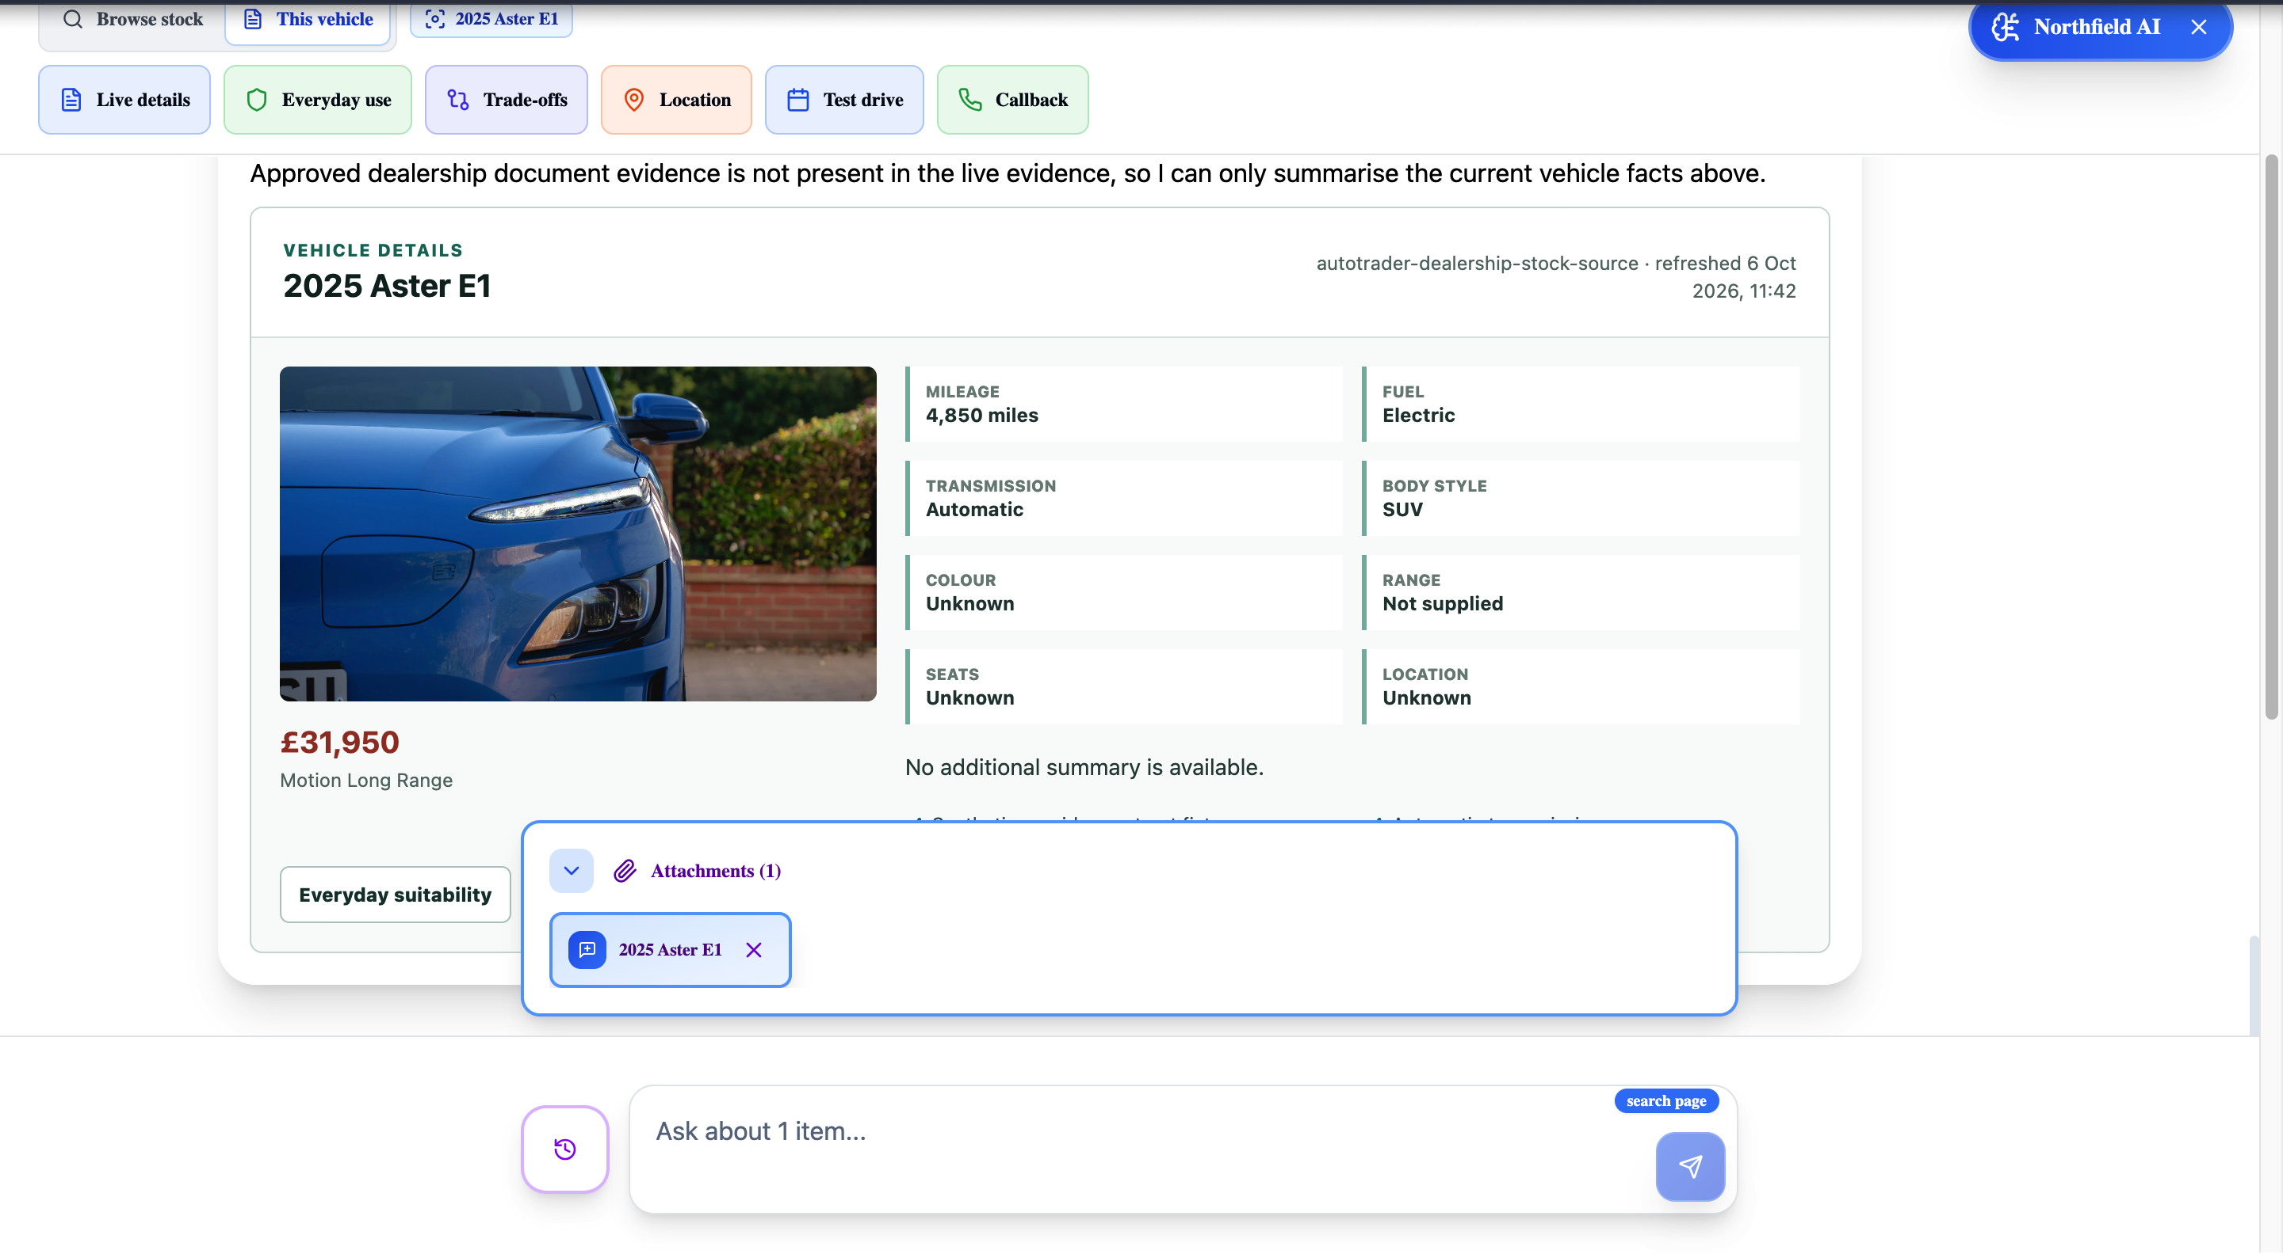
The dealership experience can expand from a docked assistant into an AI-enabled workspace with contextual tools, attached vehicle context, indexed evidence, live facts and governed customer actions. It is not limited to a chatbot response stream.
Use | Endpoint or mechanism | Public capability | Proposed treatment
Authenticate | POST /authenticate | Integration authentication | Connector-only key/secret exchange; cache bearer token until expiry
Indexed dealer stock | Paginated GET /stock, Stock Notifications, targeted GET /stock?...&stockId=... | Stock Sync | Required first-pilot ingestion and freshness path; maintain a deployment-only projection and remove stale stock
Governed live lookup | GET /search?advertiserId=... | Search | First-pilot query-time companion for current dealer-scoped reads and verification
Customer handoff | POST /deals?advertiserId=... | Deal Updates | Explicitly confirmed first name, last name, email and trusted stock target
LoomAI requests dealer-scoped Stock Sync and Search, not Search Adverts. The first pilot does not request Stock Updates, price/availability writes, media writes, Deal lifecycle updates, messages, finance or part exchange.

Current evidence versus requested access
- Implemented with synthetic data: token exchange, advertiser binding, paginated stock reads, signed notifications, targeted refresh, field projection, indexing/removal, grounded answers and governed confirmation.
- Not yet proven: Auto Trader credentials, exact sandbox behavior, granted capabilities, permitted AI processing, permitted indexing or Deal creation.

Retailer-Isolated Deployment Architecture
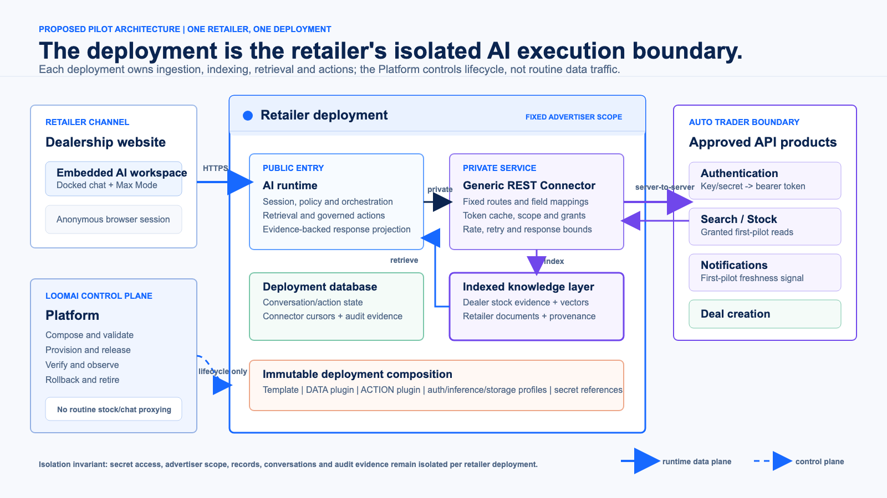

What one deployment contains
Component | Technical responsibility
AI runtime | Browser session, typed intent, retrieval, policy, confirmation and safe response
Private connector | Fixed Auto Trader hosts/routes, token cache, advertiser injection, grants, rate/retry bounds and response projection
Indexing pipeline | Baseline ingestion, notification verification, targeted refresh, projection, embedding, upsert and deletion
Deployment database | Conversation/action state and connector cursor, replay and bounded audit state
Indexed knowledge layer | Dealer-scoped stock evidence, vectors, retailer documents, provenance and freshness metadata
Immutable composition | Template, DATA/ACTION plugins, profiles, limits and protected secret references
The LoomAI Platform is the control plane used to compose, release, verify, rollback and retire a deployment. Routine customer queries and Auto Trader API calls stay in the retailer deployment data plane rather than passing through a shared LoomAI gateway.

Isolation and authority invariants
- One deployment has one non-overridable advertiser binding.
- Browser and model cannot choose host, route, method, credential, token, advertiser or capability grant.
- The connector is private and returns only approved projected fields.
- Auto Trader credential scope follows Auto Trader policy; each deployment has isolated secret access even if a credential is integration-scoped.
- Records, conversations, index content and audit state are not shared between retailer deployments.

Indexed Data Flow And Freshness
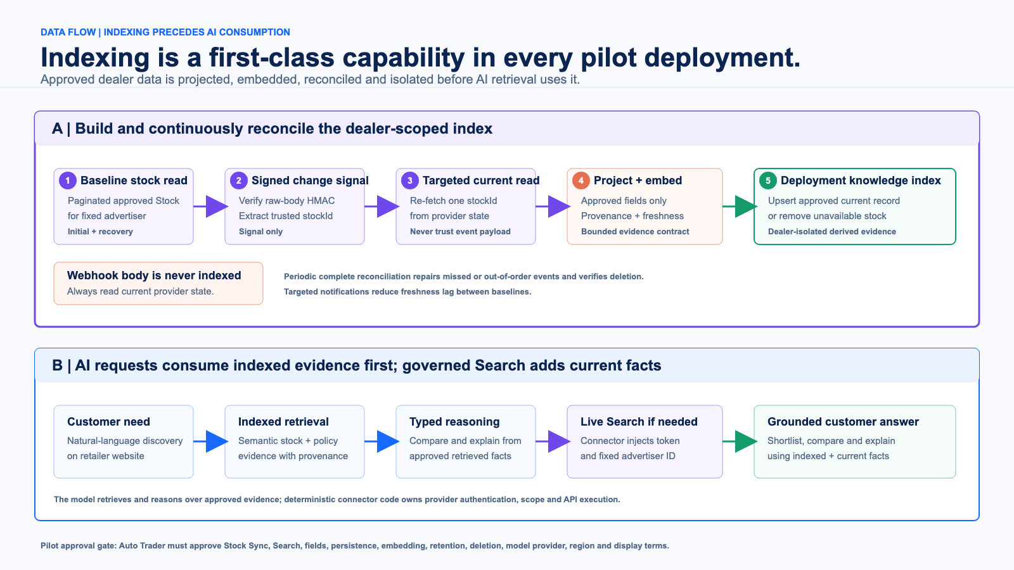

First-pilot indexed mode: Stock Sync
A DATA plugin performs a paginated baseline for the fixed advertiser, reduces each response to the approved field allowlist and builds a deployment-local search/vector projection. A signed notification is treated only as a change signal: the connector verifies the raw-body HMAC, extracts stockId, fetches the current record and then upserts or removes the projected record. A periodic complete baseline repairs missed or out-of-order events and proves deletion.
The index supports semantic discovery and comparison alongside separately owned retailer documents. It is derived evidence, not the stock system of record. Pilot acceptance requires a successful initial baseline, targeted freshness updates and verified removal of unavailable stock.

Query-time cooperation: Search
For a request needing a current dealer-scoped lookup or verification, the connector injects the fixed advertiser and token, calls Search and projects only approved response fields. Those facts may be combined with indexed evidence for the current answer. Search complements the synchronized index; it does not replace the first-pilot indexing and freshness path.

Requests rehearsed by the current synthetic simulator
POST /authenticate
GET /stock?advertiserId=<fixed>&lifecycleState=FORECOURT&page=1&pageSize=200
PUT <deployment webhook> AutoTrader-Signature: t=<epoch>,v1=<hmac>
GET /stock?advertiserId=<fixed>&stockId=<event-stock-id>&page=1&pageSize=1
The operator-only simulator mutation routes are not Auto Trader endpoints.

Proposed data allowlist
Class | Fields | Purpose
Scope/identity | advertiser ID, stock ID, search ID | Isolation and trusted targeting
Freshness | provider update time, version, lifecycle, published status | Staleness and removal
Vehicle | make, model, derivative, year, fuel, body, transmission, mileage | Search and comparison
Commercial | displayed GBP price | Current shortlist fact
Descriptive/media | selected features, approved primary image reference | Explanation and presentation
Registration, VIN, supplied price, free advert copy, reservation state, customer data, Deals, messages, finance, part exchange, valuations and response metrics are excluded unless separately justified and approved.

Authentication And Governed Search
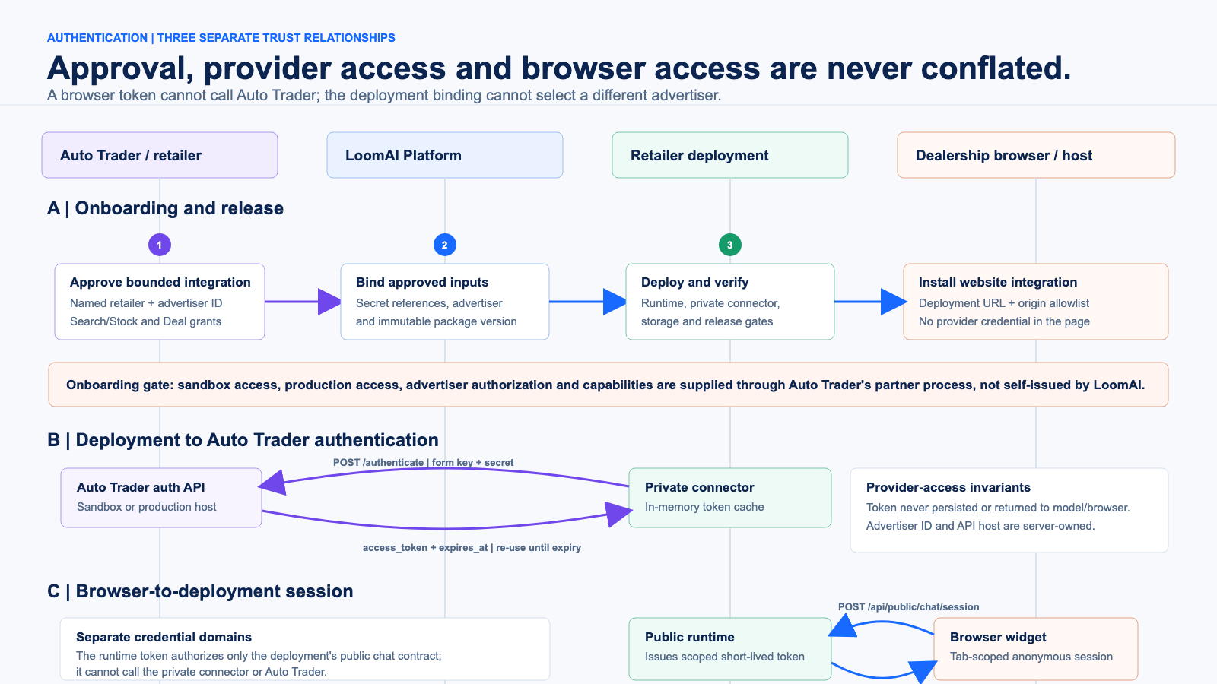

Three separate trust relationships
- Onboarding: Auto Trader approves the integration, named retailer, advertiser and capabilities; LoomAI binds references and releases a verified deployment package.
- Provider authentication: the private connector exchanges key and secret for a 15-minute bearer token and reuses it until expiry.
- Browser session: the retailer site obtains a short-lived deployment runtime token. That token cannot call the connector or Auto Trader.
POST /authenticate HTTP/1.1
Host: api-sandbox.autotrader.co.uk
Content-Type: application/x-www-form-urlencoded
key=<protected-value>&secret=<protected-value>
{"access_token":"<token>","expires_at":"<ISO timestamp>"}

Search request and projected response
GET /search?advertiserId=<trusted-advertiser-id>&fuelType=Electric HTTP/1.1
Host: api-sandbox.autotrader.co.uk
Authorization: Bearer <connector-owned-token>
{
"stockId": "<trusted-stock-id>",
"vehicle": {"make":"Example","model":"SUV","fuelType":"Electric"},
"displayedPriceGBP": 31950,
"sourceUpdatedAt": "<provider timestamp>"
}
The JSON above is LoomAI's proposed reduced projection, not the full Auto Trader response. The model may propose typed filters and reason over returned facts; deterministic code owns advertiser scope, validation, execution and field projection.

Confirmed Deal Handoff And Pilot Decisions
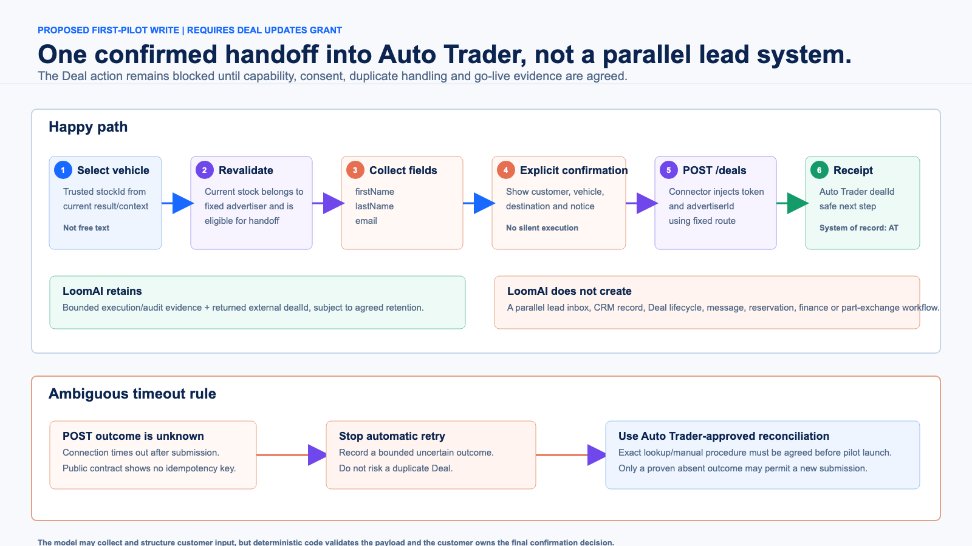

The only proposed first-pilot write
After a customer selects a current vehicle, LoomAI revalidates that the trusted stockId belongs to the fixed advertiser. The UI displays the vehicle, destination, privacy wording and exact customer fields. Only explicit confirmation resumes the pending action.
POST /deals?advertiserId=<trusted-advertiser-id> HTTP/1.1
Host: api-sandbox.autotrader.co.uk
Authorization: Bearer <connector-owned-token>
Content-Type: application/json
{
"consumer": {
"firstName": "<confirmed-first-name>",
"lastName": "<confirmed-last-name>",
"email": "<confirmed-email>"
},
"stockId": "<trusted-stock-id>",
"advertiserId": "<trusted-advertiser-id>"
}
{"dealId":"<auto-trader-deal-id>"}
LoomAI retains only bounded execution evidence and the returned dealId. It does not create a second lead record or manage the Deal after handoff. Because the public create contract shows no idempotency key, an ambiguous timeout is not blindly retried; Auto Trader must define the reconciliation procedure.

Decisions required from Auto Trader
- Confirm Stock Sync and Search as the dealer-site read capabilities and provide a test advertiser or named-retailer onboarding route.
- Approve the exact field projection, model/provider, processing region, no-training/retention terms, image/display rules and consumer attribution.
- Approve Stock Sync persistence/embedding for the pilot and define retention, deletion, notification registration and freshness obligations.
- Confirm that Deal Updates may create this externally originated Deal and define consent, duplicate and ambiguous-timeout handling.
- Define sandbox/go-live tests, rate limits, support ownership and production promotion evidence.
Technical intent: Auto Trader grants the retailer, capability, data and Deal boundary. LoomAI makes that boundary usable by AI without giving the model API authority.

Official contract references: Authentication, Search, Stock, Notifications, and Create a Deal.

