Book Title Recognition
Text detection
Image
Processing
Text processing
Text recognition

Pipeline used :

(this may seem stupid but actually it works !!!!)
Text detection

Image Bounding Boxes

Image
Processing

Bounding Boxes Cropped Title Image

Text detection

Title Image Bounding Boxes Of Title

Text recognition

Bounding Boxes Of Title Text Results + Noise

Text processing

Text Results + Noise Possible Title

First stage -Text detection :

EAST (An Efficient and Accurate Scene Text Detector) was used to detect the text areas on book covers after that we would apply Non-max suppression to remove overlapping boundary boxes .
Here is an example after applying EAST
(not very good actually)
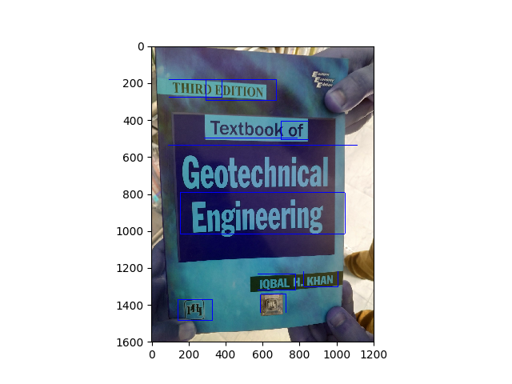
applying this directly to the text recognition would result in unwanted data and meaningless words
so we assumed that the title of the book is the biggest text on the book cover and if we could crop the image of the cover and applying it to EAST we would get much better results .

Second stage -Image processing (Crop and Merge):

in this stage we followed our assumption and to crop just the title we did the following
first :
we merged the bounding boxes that are close to each other
the we sorted the results
second:
we assumed that the biggest box will be the title and we cropped that box out of the image
some results:
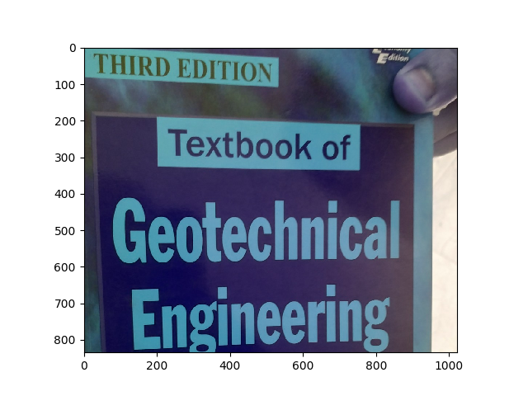
after that we apply this cropped image to text detection once again for more accurate results.

Third stage -Text detection :

Following our assumption we took the result we got from the processing stage and we process it once again using EAST to detect the text the result were actually pretty good as expected .

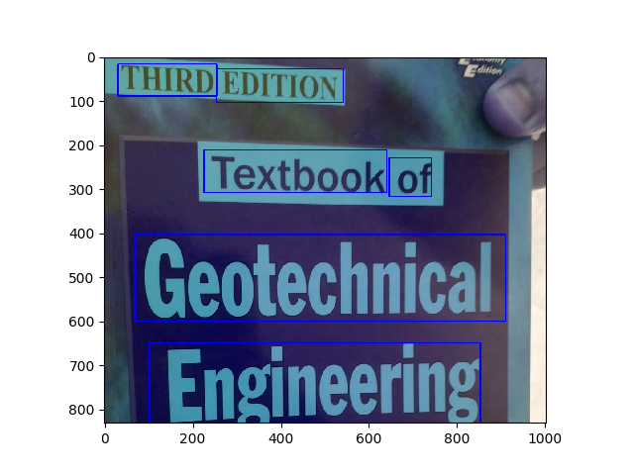

Although we got more accurate bounding boxes we suffered from slower performance due to applying the EAST detector twice .

Such a problem may be solved in future by having a data base with all the scanned images and then applying simpler image processing techniques to match the image from a user with the image already stored in our database without the need of executing our main pipeline …

Forth stage – Text Recognition :

Please Note :
that we tried to make some image processing in this stage as
in our pipeline, the proposed technique was OTSU adaptive thresholding
but we found out that Tesseract (OCR) actually applies the same image processing
step.

Here we used Tesseract to handle text recognition ,,,
The results were improved after using our third stage merge and corp
for example :

before using third stage :

text : THIRD EDITION Texthaok of Rantachnical Enoineering KHANTleS

after using third stage :

THIRD EDITION Textbook of Geotechnical Engineering

Final Stage Text Processing:

here we applied some simple text processing methods :

-removing punctuation.
-removing single characters from the list of results.
-removing duplication.
-removing unnecessary words like edition number

in the future we would add auto-correction to fix simple mistakes in the result.

