SDLC Approach

Incremental Development

4/13/2022

Errors Team

1. **Introduction**

When it comes to build a new software system, the project team starts to choose an appropriate SDLC approach depending on several factors such as time schedule, cost, clear user requirements, familiar technology, complexity, schedule visibility, advantages and disadvantages of each approach and how the approach can fit with the system nature. So accordingly, we have chosen incremental development approach.

2. **Incremental Development**

Incremental development is a method of building software products in which a system is built piece-by-piece. The final requirement specification is clear from the beginning, and everyone knows the end result clearly. The system is broken down into small sub-systems which are designed, built and tested independently. This allows partial utilization of the product, but the full system isn't usable unless until the development is entirely done.

A good analogy to understand this model is looking at how a mason builds a wall. How the final wall should look like is already clear in their mind, and starting from zero they lay out the wall brick by brick. The wall becomes fully usable only when the construction is entirely done.

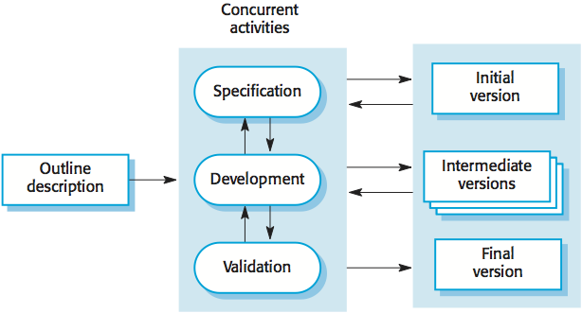

3. **Why Incremental Development?**

- We have chosen incremental approach as it is appropriate for a small-time range project and this in line with our project.

- Costs are reduced if we want to change something in the system according to customer requirements.

- We can keep up with customer easily to get his feedback on development work that has been done.

- It is possible to deliver and deploy useful software to the customer rapidly.

- It requires less analysis and documentation that has to be redone.

- Customers will be able to gain value and experience and use system early.

- Each increment is a prototype to help elicit for later increments.

-Lower risk of overall project failure.

4. **Incremental Approach Problems and Solutions**

- Problem: It is important to produce regular deliverables to measure progress.

- Solution: We intend to use version control system such as GitHub to keep information about each increment and to have the ability to produce deliverables regularly.

- Problem: System structure will be corrupted as new increments are added and software changes become increasingly difficult and costly.

- Solution: It is important to perform refactoring regularly to improve the software.