
SmartMarket
Multi-Branc E-
Commerce System
Prepared By:
Mahmoud Mohamed Anwer · ID: 230105170 · Instructor:
Eng. Soliman Younis
LARAVEL 12
PHP 8.2
MYSQL
XAMPP
What is SmartMarket?
SmartMarket is a professional e-commerce platform designed for businesses that operate through multiple branches —

unifying customers, inventory, and administration in one intelligent system.
Online Product Selling
Inventory Management
Order Tracking
Branch Monitoring
Centralized Administration
Problem & Solution
Existing Problems
Difficult branch

inventory management
Manual order

processing
Weak reporting systems
Limited security
Poor customer

experience
Proposed Solution
A centralized smart system connecting
customers
,
branches
, and
administrators
in one unified platform —

eliminating manual processes and enabling real-time

visibility across all operations.


System Architecture
MVC Architecture
View
Renders pages with Blade templates.
Controller
Processes business logic and requests.
Model
Handles DB operations and relationships.
SmartMarket follows the Model-View-Controller pattern, ensuring clean separation of concerns across the application.
Organized Structure
Easy Maintenance
High Scalability

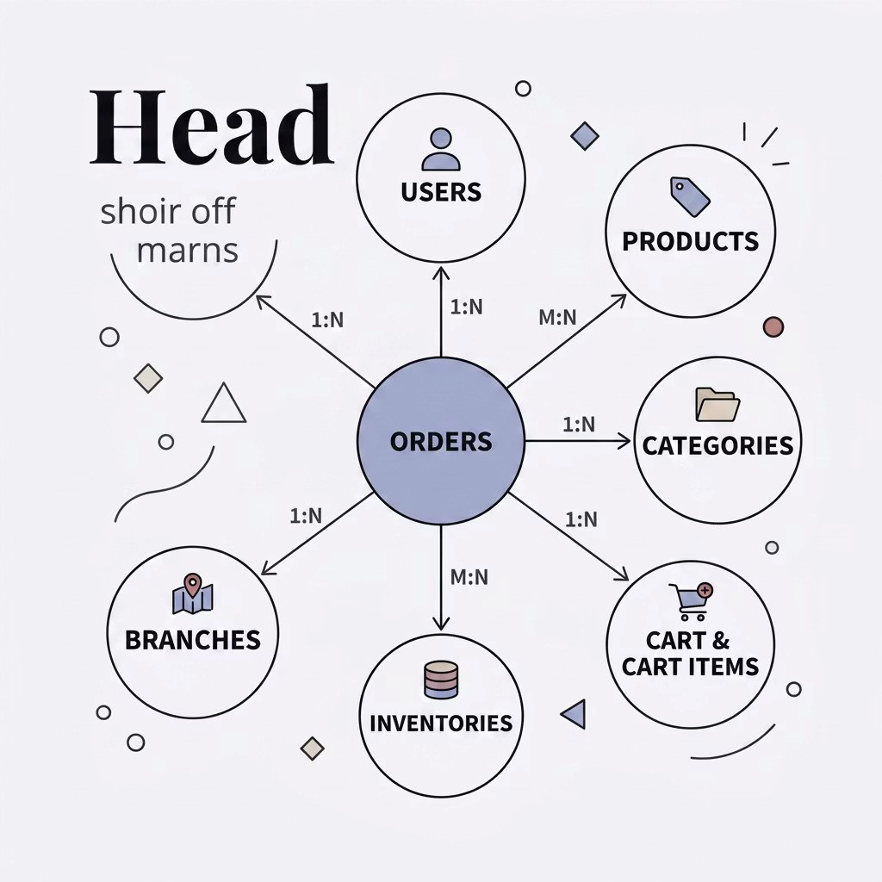
Database Design
Main Tables
Users
Products
Categories
Branches
Inventories
Orders
Cart & Cart Items
Relations ips
One-to-One
One-to-Many
Many-to-Many


Main Features
Customer Features
Browse products
Shopping cart
Checkout system
Order tracking
Admin Features
Product management
Inventory control
Reports dashboard
User management

Security Features
SQL Injection Prevention
XSS Protection
CSRF Protection
Secure Authentication
Rate Limiting
Secure File Upload Validation
Result: A safer and more reliable system for all users.


Admin Das board
Das board Includes
Revenue statistics
Total orders
Top-selling products
Low stock alerts
Branch performance reports
Advantages
Better monitoring
Faster decisions
Improved inventory management

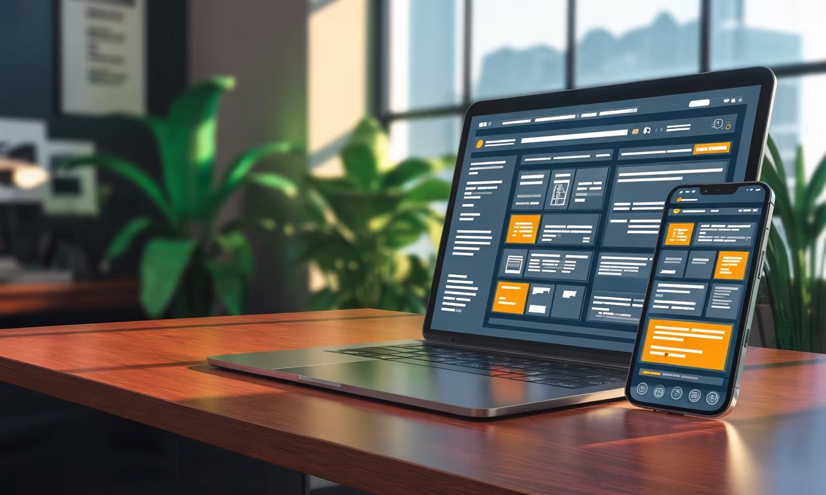
UI/UX Design
Design Style
Dark + Orange T eme
Responsive Layout
Mobile Friendly
Professional Das board
Tools Used
Blade Templates
HTML5 & CSS3
JavaScript
Font Awesome

Conclusion
Project Achievements
1
Built a secure e-commerce platform
2
Implemented multi-branch inventory management
3
Developed responsive user interface
4
Applied modern Laravel security practices
Future Enhancements
Online Payment Gateway
Mobile Application
AI Product

Recommendations
Thank You
— Mahmoud Mohamed Anwer · ID: 230105170

